UNIT 1
Introduction to Information Assurance
- This chapter introduced the concepts of Information Assurance, Information Security, and Information Warfare.
- These concepts are all inter-related and play major roles in the protection and defense of information systems and the information that the systems process, store and transmit.
- The definitions of these terms may vary somewhat; as well as which concept is a subset of the other.
- This "what came first, the chicken or the egg" issue is not important. What is important is that protection professionals focus on the threats, vulnerabilities and risks associated with the protection and defense of information and information systems, then develop a holistic program to protect and defend these valuable assets.

- Information Assurance and Its Subset - Information Security
- Information assurance (IA) is about protecting your information assets from:
- Destruction
- Degradation
- Manipulation and
- Exploitation by an opponent.
- The difficulty with achieving this is that one day a party may be collaborating on a project and therefore need access to confidential information, and the next day that party may be an opponent.
- In 1996 the United States (US) Department of Defense defined information assurance as:
"Actions taken that protect and defend information and information systems by ensuring their availability, integrity, authentication, confidentiality and nonrepudiation.
This includes providing for restoration of information systems by incorporating protection, detection and reaction capabilities."

- Information security (InfoSec) can be defined as:
"The protection of information against unauthorized disclosure, transfer, modification, or destruction. Whether accidental or intentional"

- Information security and information assurance are concerned with both intentional and unintentional attacks.
- Information assurance covers areas not covered by information security, such as perception management.

- Information assurance can be considered at three levels:

- Physical
- Information infrastructure
- Perceptual.
- These three levels are considered in Table 1.1
Table 1.1 Characteristics of Information Assurance
Characteristics and Components | Security Measure
Knowledge and understanding in human decision space. | Physical and technical measures to maintain accurate, objective perception of the security state of the system and the information contained in the system  Personnel measures to maintain personnel security to protect from insider attacks, and to provide protection from psychological operations.
Information and data manipulation ability maintained in cyberspace | Makes use of cyber defensive techniques, such as encryption, intrusion detection, integrity analysis, etc.
Data and data processing activities that are managed and performed in the physical space | Physical access controls and facility protection.  Personnel management and security.  Contingency planning and disaster recovery.

- In information security, an exposure:
- is a form of possible loss or harm against an information asset.
- That information asset may be either logically based (i.e, 1's and O's inside a computer), or physically based (i.e. paper, nuts and bolts or hardware).
- Examples of exposure include:
- Unauthorized disclosure of data,
- Modification of data,
- Denial of legitimate access to the information asset.

- Interruption, Interception, Modification and Fabrication
The following factors adversely impact Information Assurance (IA):
- Interruption
- In an interruption an information asset of the system becomes unusable, unavailable or lost.
- For example, the physical theft or physical destruction of a computer system would be viewed as an interruption.
- The removal of information or software from an information system would also be viewed as an interruption.

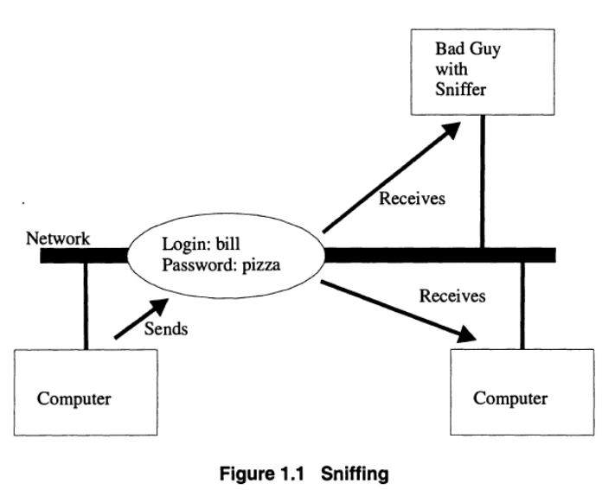
- Interception
- An interception means that some unauthorized party has gained access to an information asset.
- The party can be a program, computer system or person. For example, recording a telephone conversation or monitoring a computer network can be viewed as interception.

- Modification
- Modification of an asset means that some unauthorized party tampers with the asset.
- For example, the unauthorized installation of monitoring software or hardware, or the unauthorized insertion, manipulation or deletion of information can be viewed as modification.

- Fabrication
- Fabrication of an asset means the counterfeiting of an asset.
- For example, an intruder may insert spurious transactions into a computer network.

- Information Assurance in Context
- Information assurance is sometimes referred to as information operations that protect and defend information systems by ensuring their:
- Availability
- Integrity
- Authentication
- Confidentiality
- Non-repudiation.
- This includes providing for restoration of information systems by incorporating protection, detection and reaction capabilities.
- Information assurance is concerned with the containment of, and recovery from, an attack.
- It also defines how attacks are to be detected through the use of a set of indicators and warnings, and, how once an attack has occurred, we should respond to the attack.
- In addition, information assurance deals with deterring attacks and the application of legislation designed to address issues of privacy, computer-related crime, computer forensics and the like.
- The term "information operation" is used to refer to actions taken to affect an opponent's information and information systems while defending one's own information and information systems.
- Figure 1.2 depicts the various components and their relationships that function to set the concept of information assurance in context.
- The owner of the system is the organization, group-of-individuals, or individual that functions as the stakeholder of the security requirements.
- Stakeholders are defined as all those claimants within and without an organization who have a vested interest in decisions faced by the organization in adopting and utilizing information technology.
- The owner possesses a set of assets that have value to the owner.
- The owner may be aware of a set of vulnerabilities that could lead to the loss of an asset.
- In order to protect the asset, the owner imposes a set of protection and defensive counter-measures on the asset in the belief that by doing so that owner is protecting the asset from possible loss, exploitation, abuse or damage by a threat agent.
- The threat-agents are the parties that give-rise-to the threats to the assets of the system.
- An asset of a system can be a physical component of a system such as a hard disk, or it can be a logical component of a system such as a file stored on a hard disk.

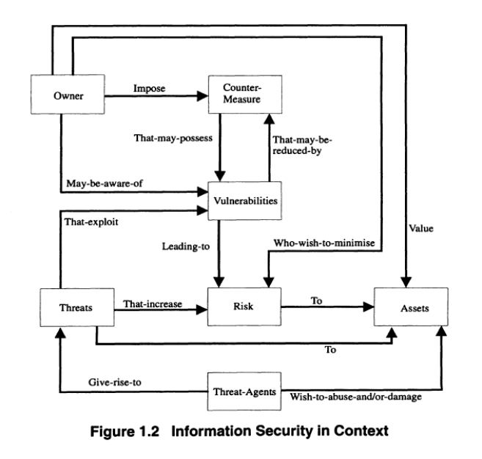

- The objective of a counter-measure is to reduce the vulnerabilities contained in a system.
- However, it should be noted that no counter-measure is perfect and a counter-measure may have the effect of possessing a vulnerability of its own.
- A threat may wish to exploit vulnerability in order to gain access to the assets of a system.
- Thus, a threat has the effect of increasing the risk posed to an asset, and vulnerabilities have the effect of leading to a potential risk.
- The owner will wish to minimize the level of risk posed to the assets, which the owner values.
- In order to minimize the risk, and thus reduce the level of threat posed to the assets by a threat-agent, the owner of the assets may impose a set of security countermeasures.

- Information Warfare (IW)
- "In the practical art of war, the best thing of all is to take the enemy's country whole and intact; to shatter and destroy it is not so good. So, too, it is better to recapture an army entire than to destroy it, to capture a regiment, a detachment or a company entire than to destroy them. Hence to fight and conquer in all your battles is not supreme excellence; supreme excellence consists in breaking the enemy's resistance without fighting." Sun Tzu
- Information warfare (IW) is not new, in fact it has been around for centuries. IW is also not unique to the human species.
- Within nature, many types of plants and animals rely upon some form of IW in order to ensure survival acquisition of key resources. In today's terminology, IW is about information dominance (see Figure 1.3)

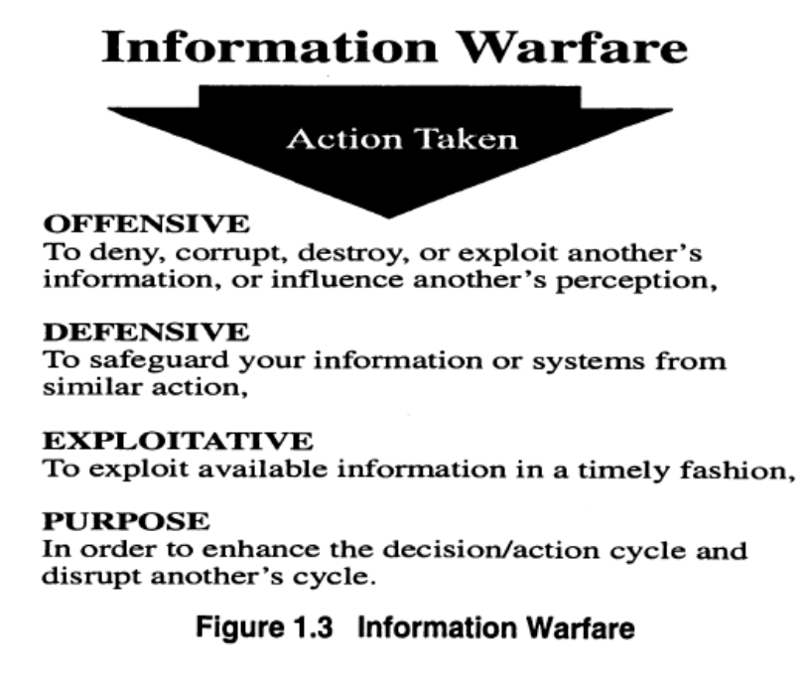

- The offensive part of IW is referred to as information operations, and the defensive part of IW is referred to as information assurance.
- Most countries today are making heavy use of information technology (IT) for the purpose of meeting commerce and government objectives.
- This heavy dependency on IT creates the ability for one country to cripple another without the use of deadly force.
- IW is defined in terms of three types of warfare, and these are:
- Type I involves the managing of the opponent's perception through deception operations and psychological operations. Within military circles this type of IW is often called Truth Projection.
- Type II involves denying, destroying, degrading or distorting the opponent's information flows in order to break down their organization and their ability to co-ordinate operations.
- Type III gathers intelligence by exploiting the opponent's use of information systems.

- In addition, IW can be decomposed down into three classes', and these are:
- Class 1 - Personal IW is waged against an individual's privacy.
- Class 2 - Corporate IW is waged against a business or corporation.
- Class 3 - Global IW is waged against industries, political spheres of influence, global economic forces, and entire countries.
- The art of IW can be summed up as using an information infrastructure to break the opponent's resistance without fighting.
- Consequently, IW offers the ability for a smaller country to neutralize the offensive and defensive potential of a much larger country.
- In more detailed terms, we can define IW as follows:

"The implementation of Information Warfare (IW) is the sequence of actions undertaken by all sides in a conflict to destroy, degrade, manipulate and exploit the information assets of their adversaries. Conversely, information warfare implementation also comprises all the actions aimed at protecting information assets against hostile attempts at destruction, degradation, manipulation and exploitation. It is very easy for any country, group, or individual to develop and deploy information warfare techniques. The term conflict is used to refer to fight or struggle between opposing forces. These forces could be national, corporate, or individual in nature.”

- Nature of the Threat
- All a person needs to enter the world of IW is motive, means and opportunity.
- Motive is a function of the players concerns, commitments and beliefs.
- Means are determined capabilities and availability of technical, and information, based resources.
- Opportunity is a function of access and also includes other factors such as perception and belief.
- For example: an individual may believe in their cause so much that they are prepared to go to prison for it.
- However, most do not believe they will be caught.
- Although anyone can engage in offensive IW, in general offensive players in the world of IW come in six types:
- Insiders
- Hackers
- Criminals
- Corporations
- Governments
- Terrorists.'

- The Insider
- Insiders consist of employees and may also include former employees and contractors. If a company out-sources its IT functions, then the employees of the out-source company may also be considered as insiders.
- Studies have shown that this group is the biggest threat that any organization faces.
- They act as information brokers selling information that belongs to the organization to foreign governments, competitors, and organized crime.
- In addition, insiders can also intentionally, or unintentionally, damage or destroy information and equipment.

- The Hacker
- A hacker was once thought of as a "computer enthusiast”.
- However, thanks to the news media, the hacker has become one who gains unauthorized access to or breaks into computer-based information systems.
- Often for this group of individuals the motives include thrills, challenges and power.
- There are however a growing number of hackers who are breaking into systems for financial reward.

- The Criminal
- Criminals target information that is of value to them, such as bank accounts, credit cards or intellectual property that can be converted into money.

- The Corporation
- Corporations engage in offensive IW when they actively seek intelligence about their competitors or steal their sensitive information, e.g., trade secrets. Money, market position and competitive stance are examples of some of the corporate motivations for using IW tactics.
- In addition, corporations have always engaged in a form of IW even before the term was first used.
- This type of IW is called advertising and marketing.

- Governments and Government Agencies
- Most governments now recognize the need to protect the information assets that their country has created.
- These assets have a financial value for business and can have a value in terms of national security.
- Intelligence agencies seek the military, diplomatic, and economic secrets of foreign governments, foreign corporations, and foreign adversaries.
- They always have; however, they can now do it remotely and with less risk due to information systems vulnerabilities.
- In addition, intelligence and law enforcement agencies seek to protect the information assets of the nation by targeting the activities of criminals and foreign intelligence operatives.
- In times of war, a government may target the national infrastructure of another country in order to help it achieve its objectives.

- Terrorists
- Terrorists are of particular interest because of the damage that they can cause against the information infrastructure such as emergency services, utilities such as water and electricity, and financial services.
- Terrorists are politically motivated and have their own political agenda that they use to select targets.

- Information Operations
- Information operations (10) are about manipulating the Global Information Environment (GIE) to achieve an advantage over one's competitors. It can include legal activities such as marketing and advertising, and illegal activities such as espionage and hacking.
- Information operations are performed in the context of a strategy that has a desired objective (or end state) that may be achieved by influencing a target (the object of influence).
- The following is a definition of information operations and is derived from the US Army military definition:

"Continuous operations within the Global Information Environment (GIE) that enable, enhance and protect friendly organizations ' ability to collect, process and act on information to achieve a competitive advantage across the full range of organizational operations; information operations include interacting with the Global Information Environment (GIE) and exploiting or denying an adversary's information and decision capabilities. "

- The term "organization" is used to refer to commercial, government and/or military organizations.
- The definition is intended to include the wide range of activities of both commercial and military perspective.
- As more organizations (both commercial and military) integrate their supply chains, so more organizations want to share information across supply chains.
- One of the consequences of this is that information security is much harder to achieve and maintain.
- The definition recognizes that Information Operations function at three distinct levels, and these are:
- Physical space
- Cyber-space
- The minds of humans (perception level).

- The Physical Level
- The lowest level is the physical level.
- This level includes computers, physical networks, telecommunications and supporting systems such as power, facilities and environmental controls.
Characteristics and Components | Attacker’s Operation | Defender’s Operations | Desired Effects
Data and data processing activities that are managed and performed in the physical space including:  - Data gathering equipment  - Computers and data processing equipment  - Storage  - Networks  - Electrical Power | Physical attack and destruction, including:  - Electromagnetic (EMP) attack  - Visual Spying  - Intrusion  - Physical scavenging and physical removal  - Wiretapping including:  - Convert channel analysis  - Interference  -Eavesdropping | Physical security (OPSEC), including:  TEMPEST | Technical  To affect the technical performance and capacity of the physical systems, so as to disrupt the capabilities of the defender to function at the physical level
- Also at this level are the people who manage the systems.
- Many organizations have a single system administrator who understands how the system functions.
- If this person is removed from the organization, then the organization will lose its ability to manage information systems and to recover from any potential disaster.
- The characteristics of the physical level are summarized in Table 1.2.
- For example: a programmer, Michael John Lauffenberger, was convicted of logic bombing General Dynamics' Atlas Rocket Database.
- He had quit his job and hoped to be rehired at a premium when the logic bomb went off.
- However, another programmer discovered it.
- This example illustrates the critical dependencies that can exist between the people who create and manage the system and the services offered by the system.

Table 1.2 Characteristics of Physical Level

- The Information Structure Level
- The next layer is the information infrastructure layer, which includes the abstract information that accepts, processes, manages, and stores the information.
- This layer is most commonly considered to be the cyber-space level, at which malicious software and infrastructure exploitation (hacking) occur.
- The effect of disrupting this level is to disrupt the functional behavior of the system.
- The function of this level is to deliver meaningful information to humans so that they can make informed decisions, and control the objects in the physical level.
- Attacks at this level can have effects at both the perception and physical level.
- The characteristics of the information structure level are summarized in Table 1.3.

Characteristics and Components | Attacker’s Operation | Defender’s Operations | Desired Effects
Information and data manipulation ability maintained in cyber-space, including:  - Data Structures  - Process and Programs  - Protocols  - Data content and database | Cyber-based attack including:  - Impersonation  - Piggybacking  - Spoofing  - Network Weaving  - Network Sniffing  - Trojan horse  - Logic bomb  - Malevolent worms  - Virus attacks  - Trapdoors  - Authorization  - Basic active  - Misuse  - Incremental attacks  - Denial of service | Information security technical measures such as:  - Encryption and key management  - Intrusion detection systems and computer misuse detection systems  - Anti-virus software  - Systems auditing  - Use of redundancy  - Security assessment tools  - The use of security Standards such as:  - ITSEC  - BS7799 | Functional  Influence the effectiveness and performance of information functions supporting perception, decision making, and control of physical processes

Table 1.3 Characteristics of Information Structure Level
- Perpetual Level
Characteristics and Components | Attacker’s Operation | Defender’s Operations | Desired Effects
Knowledge and understanding in human decision space:  - Perception  - Beliefs  - Reasoning | Psychological Operations such as:  - Deception  - Blackmail  - Bribery and corruption  - Social Engineering  - Trademark and copyright infringement  - Distortion and fabrication  - Defamation  - Diplomacy  - Civil and public affairs  - Creating distrust | Personnel Security including:  - Psychological Security  - Profiling  - Training and education of staff  - Fake detection including:  - Biometrics  - Watermarks  - Public/private key  - Passwords | Cognitive  Influence decisions and behavior
- The next layer is the perception layer.
- This layer is abstract in nature and is concerned with the management of perceptions of a target. In particular, this layer is about influencing the perceptions of the people who are making the decisions.
- The goal is to get your opponent to make the decisions and to implement the actions that you want.
- This is achieved by controlling the information that your opponent accesses and knowing how the opponent will react after receiving that information - in a way favorable to you.
- The abstract components of this layer include objectives, plans, perceptions, beliefs and decisions.
- The golden rule at the perception layer is that information is power, and whoever controls the flow of information within a given environment will control the behavior of various parties in that environment.

Table 1.4 Characteristics of Perpetual Level

- The MSR Model of Information Assurance
- In 2001, the Maconachy-Schou-Ragsdale model described three states of information:
- Storage
- Transmission
- Processing;
- Three essential countermeasures
- Technology
- Policy
- People;
- Five basic services
- Availability
- Integrity
- Authentication
- Confidentiality
- Nonrepudiation
- The internationally recognized Association for Computing Machinery (ACM) adopted this as an extension of the basic confidentiality, integrity, and availability (CIA) model and an extension of John McCumber’s work in the early 1990s.
- We have identified fundamental expectations and common beliefs acquired through business practices over the years, and we refer to them here as information assurance principles.

- The seven principles specify that information assurance should do the following:
- Be a business enabler
- Protect the interconnecting element of an organization’s systems
- Be cost effective and cost beneficial
- Establish responsibilities and accountability
- Require a robust method
- Be assessed periodically
- Be restricted by social obligations

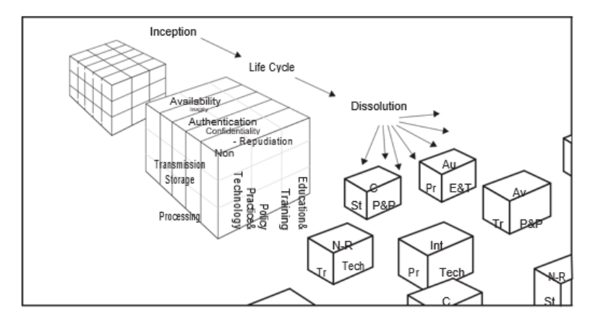

- The MSR model identifies security services, states, and countermeasures, as explained earlier.
- In addition, the model demonstrates the interlocking relationship among these 45 unique combinations.
- It reinforces the idea that senior management and senior executives are responsible for the life cycle of the system and an organization’s information, from inception to dissolution.
- Understanding the distinction between the following terms is crucial for identifying not only the market space but also fundamental concepts in protecting organizations’ information assets:
- Information assurance
- Information security
- Information protection
- Cyber security

- Information Assurance
- Information assurance is the overarching approach for identifying, understanding, and managing risk through an organization’s use of information and information systems.
- As noted in the MSR model, information assurance is concerned with the life cycle of information in an organization through the objectives of maintaining the following services or attributes:
- Confidentiality
- Integrity
- Availability
- Nonrepudiation
- Authentication
- The following are critical elements to remember about information assurance:
- Information assurance includes all information an organization may process, store, transmit, or disseminate regardless of media. Thus, information on paper, on a hard drive, in the mind of an employee, or in the cloud is considered to be “in scope.”
- Information security, information protection, and cyber security are subsets of information assurance.

- Information Security
- Information security is a subdomain of information assurance.
- As noted in the MSR model, information security focuses on the CIA triad.
- Confidentiality
- Integrity
- Availability
- The following are critical elements to remember about information security:
- Like information assurance, information security includes all information an organization may process, store, transmit, or disseminate regardless of media. Thus, information on paper, on a hard drive, in the mind of an employee, or in the cloud is considered in scope.
- Information protection and cyber security are subsets of information security.

- Information Protection
- Information protection is best viewed as a subset of information security.
- It is often defined in terms of protecting the confidentiality and integrity of information through a variety of means such as policy, standards, physical controls, technical controls, monitoring, and information classification or categorization.
- The following are critical elements to remember about information protection:
- Like information security, information protection includes all information an organization may process, store, transmit, or disseminate regardless of media. Thus, information on paper, on a hard drive, in the mind of an employee, or in the cloud is considered in scope.
- Some laws, regulations, and rules specifically cite information protection as a requirement for sensitive information such as personally identifiable information and personal health information.

- Cyber security
- Cyber security is a relatively new term that has largely replaced the term computer security.
- This term is often confused with information assurance and information security.
- Cyber security is used to describe the measures taken to protect electronic information systems against unauthorized access or attack.
- Cyber security is primarily concerned with the same objectives of information security within the scope of electronic information systems’ CIA.
- The following are critical elements to remember about cyber security:
- Cyber security is primarily focused on the protection of networks and electronic information systems. Other media such as paper, personnel, and in some cases stand-alone systems that rely on physical security are often outside the scope of cyber security.
- Cybersecurity often focuses on the vulnerabilities and threats of an information system at the tactical level. System scanning, patching, and secure configuration enforcement are common foci of cyber security.
- Intrusion detection and incident response and other functions commonly run from a security operations center (SOC) are often identified as cyber security functions.

- Information Assurance: Business Enabler
- Information assurance is a business enabler and a competitive advantage rather than an obstacle.
- It allows the organization to achieve its intended objectives.
- The imposition of disruptive rules and procedures comes from a lack of understanding of business requirements.
- Frequently, these rules and procedures unnecessarily disrupt normal business operations.
- Through the implementation and operation of suitable controls, information assurance assists in achieving the organization’s vision and mission by protecting its critical assets and resources.
- Prior to implementation, organizations should identify which controls are to be implemented and weigh the pros and cons associated with each.
- Security rules or procedures used to protect vital assets while simultaneously supporting the organization’s overall vision and mission should be a goal of every senior manager or executive.
- When information assurance is properly implemented, it ensures business confidence and competitive advantage; therefore, assurance should be a primary agenda and not a hindrance or an afterthought.
- Situations exist where a decision may be made not to pursue a new venture or not to adopt a new technology because it cannot be secured appropriately because of unacceptable risk.
- An example is wireless networking.
- Some financial organizations have banned the use of IEEE 802.11 (Wi-Fi) networks until enhanced security standards for these networks become available.
- Thus, information assurance may act as an essential barrier to prevent the adoption of unsafe business practices, rather than as an enabler for business.
- However, a bank developing a secure mobile application for banking may increase customer satisfaction, reduce personnel costs, and gain customers because of convenience differentiation.

- Information Assurance: Protects the Fabric of an Organization’s Systems
- Information systems provide the interconnecting elements of effective management of organizations.
- If, however, the information system does not demonstrate the security elements of the MSR model, management cannot make informed decisions.
- Effective protection from threats requires not only information systems but also information assurance to be an interconnecting, essential part of the entire management system.
- Security efforts are not silo efforts; they are the essential binding fiber.
- Information assurance is a shared responsibility and involves not only the IT organization and other employees.
- Information assurance should be incorporated into the current management strategy system and requires participation from all functional units.
- Any information assurance protection program should take into consideration the people, processes, and technology aspects from the MSR model. If one does not do this, the organization will be unable to garner the required support and will not meet its business objectives effectively.
- Information assurance involves constant review, monitoring, and improvement based on the risk decisions made by management.

- Information Assurance: Cost Effective and Cost Beneficial
- Information has varying value based on its criticality and sensitivity.
- Therefore, the protection requirements should be proportional to the value of the information/assets protected and the associated risk.
- A thorough analysis of the costs and benefits of information assurance may examine either quantitative or qualitative aspects to ensure investment on controls meet expectations.
- Security investments should take into consideration the cost of designing, implementing, and maintaining the controls; the values of information assets; the degree of dependency on the information systems; and the potential risk and impact the organization is likely to face.
- Investing in information assurance is both a horizontal and vertical effort.
- Information assurance is also a crosscutting program.
- All information systems and services of an organization have an information assurance requirement.
- Therefore, an investment should be made in every project for information assurance. This can be thought of as a variable cost.
- The more services, projects, and information the organization chooses to process, store, or transmit, the greater the information assurance requirements will be.
- There is also a fixed-cost aspect to information assurance, which is often the “vertical” aspect of information assurance.
- Organizations need to have an information assurance program firmly established.
- This function of an organization is the anchor for the horizontal security efforts and the management area of information assurance for the organization.
- From this function, common controls and cost-effective security are designed, implemented, and monitored.
- Investments made based on the choice of controls after a risk assessment exercise reduce the impact of information assurance–related losses.
- For example, by implementing an effective incident-handling process, an organization can avoid losses in terms of unnecessary resources devoted to recovering from a major disruptive incident.
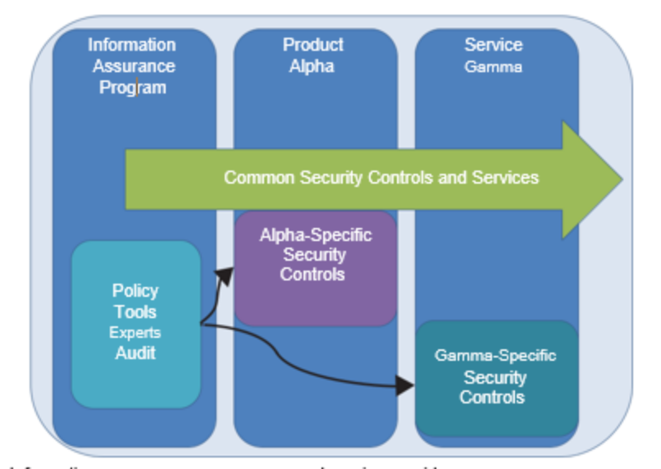

- Information Assurance: Shared Responsibilities
- System owners, including cloud or outsourced service providers, should share information about planned and implemented security controls so that users can be aware of current efforts and know that the relevant systems are sufficiently secure.
- Identified critical systems should meet a predefined baseline acceptance level of security.
- System owners should remember to inform their business users or clients about security controls selected, the nature of the controls implemented, and why the controls are necessary.
- Peter Drucker’s 1968 book The Age of Discontinuity reminds us that knowledge work knows no hierarchy.
- In addition, information itself knows no individual or organizational boundaries. Information is available to those who need it.
- As an information assurance corollary, information can be secured adequately only when all who have access follow established procedures.
- Thus, information assurance is a team effort that transcends the IT function.
- The assignment of responsibilities may be to internal or external parties.
- Clearly defined security responsibilities (both individual and functional level) encourage best practices by users.

- Information Assurance: Robust Approach
- Information assurance requires a complete and integrated approach that considers a wide range of processes.
- This comprehensive approach extends throughout the entire information life cycle. Security controls operate more effectively in concert with the proper functioning of other business process controls.
- Interdependencies within an information system exist by definition; therefore, a thorough study should be performed before a determination of compatibility and feasibility of controls is made.

- Information Assurance: Reassessed Periodically
- Information systems and the environments in which they operate are always evolving.
- Security requirements change rapidly in parallel with emerging technologies, threats, and vulnerabilities.
- Therefore, there are always new risks. Changing from a centralized to a decentralized IT environment and the increasing amount of information processed in a complex environment make operations challenging and security matters an ongoing priority review.
- To assure controls remain relevant, an audit or review should be performed to determine the level of compliance to implemented controls.
- Increases in complexity or rate of change will necessitate more mature change and configuration management (CM) approaches.
- Organizations should continuously monitor the performance of controls by conducting regular assessments of their information systems and ensure information assurance is part of any change management and configuration management processes.
- This will alert management to new risks and the condition of the information systems, data, and networks that may have a negative impact on the mission of the organization.

- Information Assurance: Restricted by Social Obligations
- Organizations must consider social obligations in the implementation of security controls.
- Organizations should balance the rights and desires of the organization versus the rights of organizational employees and customers.
- This involves understanding the security needs of information owners and users.
- Expectations and policies may change concerning the suitable use of security controls.
- Organizations need to balance between security risks they are willing to accept versus human rights or social factors.
- This can lead to solving issues such as security and the workplace privacy conflict. Employee monitoring and a bring-your-own-device (BYOD) policy are areas where social obligations and information assurance often require extensive analysis.

- Implications from Lack of Information Assurance
- Despite the rise of information security incidents, organizations are still unaware of the criticality of information assurance.
- This section discusses the consequences and implications from a lack of information assurance.
- In general, you must apply both due care and due diligence to ensure a system is operating within acceptable social and legal norms.
- Due care is the development and implementation of policies and procedures to aid in performing the ongoing maintenance necessary to keep an information assurance process operating properly to protect assets and people from threats.
- Systems must be working in accordance with the expectations of a reasonable person in a situation. Due care prevents negligence.
- Due diligence is the reasonable investigation, research, and understanding of the risks an organization faces before committing to a particular course of action. The organization should do its homework and ensure ongoing monitoring.
- Penalties from a Legal/Regulatory Authorities
- In the wake of countless corporate scandals and acts of negligence, regulations and laws exist to ensure internal controls are implemented to protect the interests of the public and stakeholders.
- Common themes from various legal/regulatory authorities are:
- Abuse Hacking, theft, password sharing
- Critical infrastructure protection Finance and banking, natural resources, power, water, food, logistics, and military
- Intellectual property Copyright, patent, and trademark
- Privacy Personal information

- Together with the laws, acts, or regulations there are associated penalties.
- Depending on the type of information security breach, the penalty could be, for example, in the form of paying a fine, serving a jail term, or both.

- Loss of Information Assets
- Organizations regularly suffer loss because of the compromise of information assets.
- These losses may be caused by the theft of an asset, data corruption, and other threats.
- In addition to the direct costs involved in replacing assets (for example, the cost of replacing a stolen computer), additional hidden costs are involved.
- These losses may be in the form of additional time spent to reconstruct the data, disruption to the organization’s operation through hacking or other attacks, loss of reputation, financial loss, drop in morale, loss of competitive advantage, or cost of litigation, to name a few.

- Operational Losses and Operational Risk Management
- Although minimizing operational losses is not always recognized as a component of information assurance, in the final analysis it is the primary objective.
- Most organizations do not take the need to identify their sources of risk seriously.
- Despite wide coverage on security-related issues, most organizations are in the dark about the threats and risks to their business and missions.
- Recall that these risks cover the entire MSR model services/ attributes (availability, integrity, authentication, confidentiality, and nonrepudiation).
- The effect of operational or organization-wide risks may not appear to be significant initially, but hidden losses may incur over time.
- Ignoring small inefficiencies leads to higher costs and can eventually erode revenue and profits.
- For example, an organization, providing mobile phone services, is at risk of losing its customers if it cannot provide a call when the customer needs it (lack of availability).
- Unfortunately, ignoring this risk and its implications may be as detrimental to an organization as unplanned downtime of a critical IT system.
- Annual computer crime and security surveys, such as the U.S. Federal Bureau of Investigations Internet Crime Report, have shown that organizations suffer millions of dollars in losses because of the poor implementation of security controls.
- It is easier to determine the action to be taken once the loss sources have been identified.
- There are books in the market on how to manage operations proactively to avoid unwanted operational losses; however, they often overlook information assurance.
- Operational risk management should be a priority concern to stakeholders just like those of other corporate risks.

- Customer Losses
- Organizations lose customers frequently because of poor information assurance practices.
- One example is software that fails to manage credit card data securely. Poorly implemented or nonexistent security controls lead to the loss of customer information (loss of privacy/confidentiality).
- As seen with the December 2013 Target compromise, reports of lost or stolen customer information raise alerts in two areas: poor security practices by the retailers themselves and weaknesses in the software used to process payments through credit card systems.
- Major credit card associations have adopted their own cardholder information assurance programs to be compliant with the Payment Card Industry Data Security Standard (PCI-DSS).
- While compliance with standards such as PCI-DSS does not guarantee an organization will not have incidents, these standards are vital to retaining customer trust and confidence.
- If a customer fears theft of personal information due to lacking or poor security controls provided by a service or embedded in a product, a considerable loss of customers should be expected.
- Frequently, major credit card providers offer a zero-liability protection for online purchases.
- This offer ensures the customer maintains confidence in the credit card provider and that the credit card provider must manage unmitigated fraud risk by accepting a loss due to fraudulent transactions.

- Loss of Image and Reputation
- Reputation or image is another critical asset. Without a good reputation or image, sales drop, customer complaints increase, and revenue decreases.
- Reputation is valuable and must be well managed. In safeguarding the respect and good reputation of the organization, it is vital that personnel and business partners follow best-practice information assurance actions to reduce the probability of something bad happening to critical information.
- All partners share, in common, a risk assumed by one partner.
- The following are some of the issues that affect corporate reputations that are addressed through effective and periodic information assurance training or awareness programs:
- Employee misconduct
- Customer complaints
- Security incidents and breaches

UNIT 2
Computer Security

- Introduction
- Computer security has become an essential part of the modern electronic world.
- Hardware security, which deals with the security of electronic hardware, encompassing its architecture, implementation, and validation, has evolved alongside it into an important field of computer security.
- Like any field of security, the topic of hardware security focuses on attacks crafted to steal or compromise assets and approaches designed to protect these assets.
- The assets under consideration are the hardware components themselves, for instance, integrated circuits (ICs) of all types, passive components (such as, resistors, capacitors, inductors), and printed circuit boards (PCBs); as well as the secrets stored inside these components, for instance, cryptographic keys, digital rights management (DRM) keys, programmable fuses, sensitive user data, firmware, and configuration data.

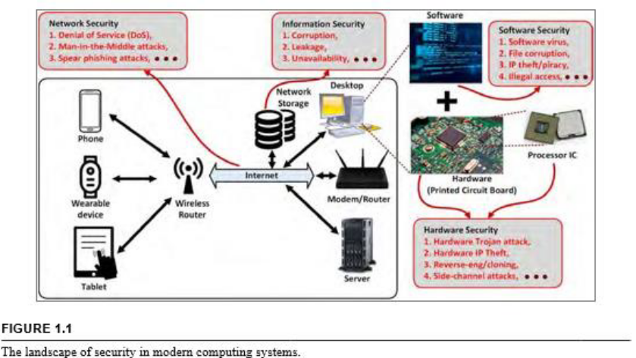

Figure 1.1 illustrates different fields of security related to a modern computing system.

- Network Security
- Denial of Service (DoS)
- Man-in-the-Middle attacks
- Spear phishing attacks

- Information Security
- Corruption
- Leakage
- Unavailability

- Software Security
- Software Virus
- File corruption
- IP theft/piracy
- Illegal access
- Hardware Security
- Hardware Trojan attack
- Hardware IP Theft
- Reverse-eng/cloning
- Side-channel attacks

- Network security focuses on the attacks on a network connecting multiple computer systems, and the mechanisms to ensure its usability and integrity under potential attacks.
- Software security focuses on malicious at-tacks on software, often exploiting different implementation bugs, such as inconsistent error handling and buffer overflows, and techniques to ensure reliable software operation in presence of potential security risks.
- Information security focuses on the general practice of providing confidentiality, integrity, and availability of information through protection against unauthorized access, use, modification, or destruction.
- Hardware security, on the other hand, focuses on attacks and protection of hardware. It forms the foundation of system security, providing trust anchor for other components of a system that closely interact with it.

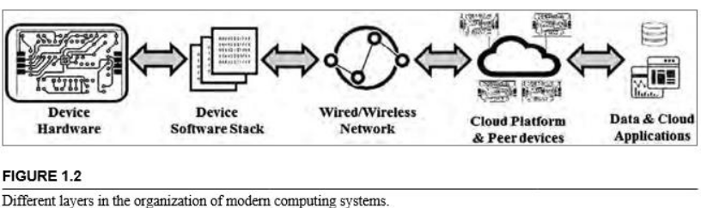
- Overview of a Computing System

- A computing system is a system of interconnected components.
- The following highlights the major components in such a system and their roles:
- Memory for information storage;
- Processor for information processing, and input/output devices (for example, peripheral devices, such as keyboards, printers, and displays) for interfacing with human users or other systems.
- These systems are capable of capturing and transforming information; and communicating them with other computing systems.
- Information storage and processing are often performed on digital data.
- However, in many applications, there is an analog front-end that acquires analog signals from the physical world, conditions and then digitizes them.
- A digital processing unit then performs specific operations on the digital form.
- Optionally, a back-end unit then transforms the processed digital signal into analog to interface with the physical world.
- Traditionally, computing systems have been broadly classified into two categories:
- General-purpose systems
- Embedded systems.
- The first category included systems, such as desktop, laptop, and servers, which had the following characteristics:
- Complex and optimized architecture
- Versatile and easily programmable,
- Suitable for diverse use-case scenarios.
- The second category included systems, such as digital cameras, home automation devices, wear-able health monitors, and biomedical implants, which have the following characteristics:
- Highly customized design
- Tight hardware-software integration,
- Unique use-case constraints.
- Over the years, the gap between these two categories narrowed with embedded systems becoming more flexible, and having more computing power to handle general-purpose applications.
- Two new classes of systems have emerged, which borrow features from both categories:
- Cyber-physical systems
- Internet of things
- In the first class, computer-based information processing systems are deeply intertwined with the Internet and its users, and the physical world.
- Examples of such systems include smart grid, autonomous vehicles, and robotic systems.
- The second class, on the other hand, includes computing systems that connect to the Internet, the cloud, and other endpoint devices, and interact with the physical world by collecting and exchanging data using embedded sensors and con-trolling physical devices through actuators.
- Such devices include smart home automation devices and personal health monitors.
- Both classes of devices increasingly rely on artificial intelligence to make autonomous decisions, to have situational awareness, and to better respond to different usage patterns through learning.
- The distinction between these two classes is getting blurred gradually, with CPS having similar characteristics as IoT devices.
- Devices falling into these classes share many features, which have security implications, such as:
- Long and complex life, during which the security requirements may change;
- Machine-to-machine communication without any human in the loop, which may create an insecure communication link, and need for novel authentication approaches;
- Mass production in the millions with identical configuration, which can help an attacker identify vulnerabilities of one device, and use that knowledge to break into many.

- Moreover, modern computing systems usually do not operate in isolation.
- They are connected with other computers and/or the cloud, which is a collection of computers that provides shared computing or storage resources to a bunch of other computers.
- Figure 1.2 shows different components of a modern computing system, for example, a CPS or IoT system, starting from hardware units to cloud and the data/applications in the cloud.
- Each component in this organization is associated with diverse security issues and corresponding solutions.
- The weakest link in this complex, often physically distributed system usually determines the security of the whole system.
- Achieving security of the entire system requires a significant rethinking on how to integrate specific security solutions for each component into a holistic protection approach.

- Layers of a Computing System
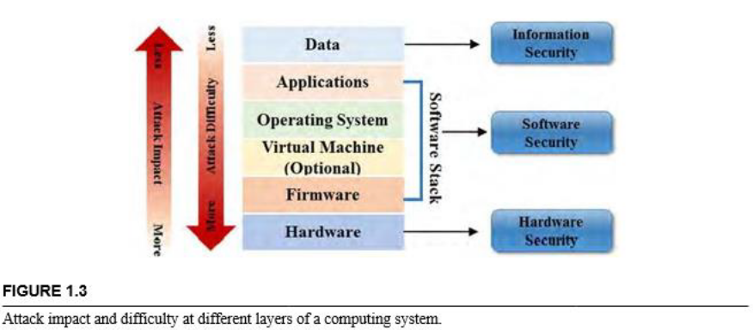

- Modern computing systems can be viewed as an organization consisting of multiple layers of abstraction, as illustrated in Fig. 1.3.
- The hardware layer lies at the bottom of it, followed by the firmware that interfaces with the physical hardware layer.
- The firmware layer is followed by the software stack, comprising of an optional virtualization layer, the operating system (OS), and then the application layer.
- All types of computing systems discussed in the previous sections share this common structure.
- The data being processed by a computing system is stored in the hardware layer in volatile (for example, static or dynamic random-access memory) or non-volatile (such as NAND or NOR flash) memory and accessed by the software layers.
- A system is connected to another system or to the Internet using networking mechanisms that are realized by a combination of hardware and software components.
- Computer security issues span all these layers. While hardware security issues are relatively fewer than those at other layers (as shown in Fig. 1.3), they usually have much larger impacts on system security.
- In particular, they typically affect a much larger number of devices than security issues in software and network, as manifested by the recent discoveries, such as the Spectre and Meltdown bugs in modern processors.

- Electronic Hardware
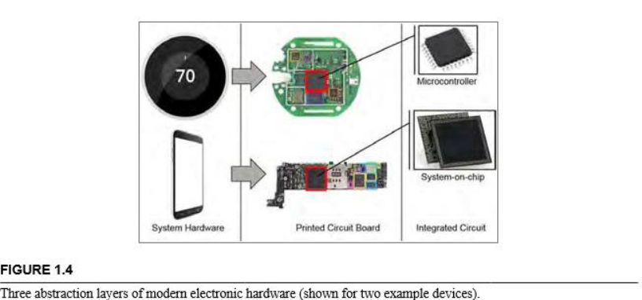

- The hardware in a computing system can, itself, be viewed as consisting of three layers, as illustrated in Fig. 1.4.
- At the top of it, we have a system-level hardware, that is, the integration of all physical components (such as PCBs, peripheral devices, and enclosures) that make a system, such as a smart thermostat, or a smartphone.
- At the next level, we have one or more PCBs, which provide mechanical support and electrical connection to the electronic components that are required to meet the functional and performance requirements of a system.
- PCBs are typically constructed with multiple layers of an insulating substrate (for example, fiberglass) that allow power and signals to be connected among components using conductive metal (e.g., copper) traces.
- At the bottom-most layer, we have active components (such as ICs, transistors, and relays), and passive electronic components. Different layers of hardware abstraction bring in diverse security issues, and require commensurate protections.

- TYPES OF ELECTRONIC HARDWARE
- The ICs or chips used in a PCB do various tasks, such as signal acquisition, transformation, processing, and transfer.
- Some of these chips (for example, an encryption or image compression chip) work on digital signals and are called digital ICs, whereas others work on analog or both types of signals, and called analog/mixed-signal (AMS) chips.
- Examples of the latter type include voltage regulators, power amplifiers, and signal converters.
- The ICs can also be classified based on their usage model and avail-ability in the market. Application-specific integrated circuits (ASIC) represent a class of ICs, which contain customized functionalities, such as signal processing or security functions, and meet specific performance targets that are not readily available in the market.
- On the other hand, commercial off-the-shelf (COTS) ICs are the ones, which are already available in the market, often providing flexibility and programmability to support diverse system design needs.
- These products can be used out-of-the-box, but often needs to be configured for a target application.
- Examples of COTS components include field programmable gate arrays (FPGA), microcontrollers/processors, and data converters.
- The distinction between ASIC and COTS is often subtle, and when a chip manufacturer decides to sell its ASICs into the market, they can become “off-the-shelf” to the original equipment manufacturers (OEMs), who build various computing systems using them.

- WHAT IS HARDWARE SECURITY?
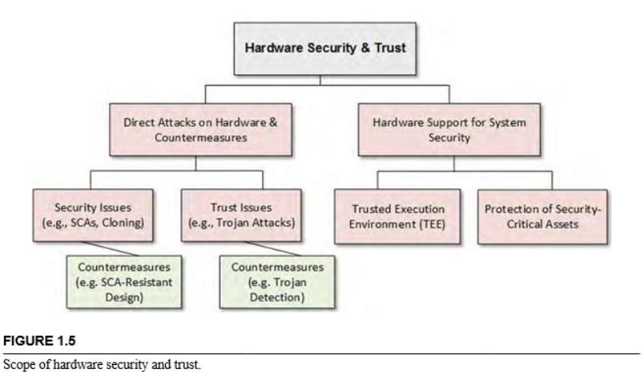

- Information or data security have remained an issue of paramount concern for system designers and users alike since the beginning of computers and networks.
- Consequently, protection of systems and networks against various forms of attacks, targeting corruption/leakage of critical information and unauthorized access, have been widely investigated over the years.
- Information security, primarily based on cryptographic measures, have been analyzed and deployed in a large variety of applications.
- Software attacks in computer systems have also been extensively analyzed, and a large variety of solutions have been proposed, which include static authentication and dynamic execution monitoring.
- Study of hardware security, on the other hand, is relatively new, since hardware has been traditionally considered immune to attacks, and hence used as the trust anchor or “root-of-trust” of a system.
- How-ever, various security vulnerabilities and attacks on hardware have been reported over the last three decades.
- Earlier, they primarily focused on implementation-dependent vulnerabilities in cryptographic chips leading to information leakage.
- However, emerging trends in electronic hardware production, such as intellectual-property-based (IP-based) system on chip (SoC) design, and a long and distributed supply chain for manufacturing and distribution of electronic components—leading to reduced control of a chip manufacturer on the design and fabrication steps—have given rise to many growing security concerns.
- This includes malicious modifications of ICs, also referred to as Hardware Trojan attacks, in an untrusted design house or foundry.
- This is an example of a hardware security is-sue, which can potentially provide a kill switch to an adversary.
- Other examples include side-channel attacks, where secret information of a chip can be extracted through measurement and analysis of side-channels, that is, physical signals, such as power, signal propagation delay, and electromagnetic emission; IP piracy and reverse-engineering, counterfeiting, micro probing attacks on ICs, physical tampering of traces or components in PCBs, bus snooping in PCBs, and access to privileged resources through the test/debug infrastructure.
- They span the entire life-cycle of hardware components, from design to end-of-life, and across all abstraction levels, from chips to PCBs to system.
- These attacks, associated vulnerabilities and root causes and their countermeasures form the field of hardware security.
- Another important aspect of hardware security relates to the hardware design, implementation, and validation to enable secure and reliable operation of the software stack.
- It deals with protecting sensitive assets stored in a hardware from malicious software and network, and providing an appropriate level of isolation between secure and insecure data and code, in addition to providing separation between multiple user applications.
- Two major topics in this area are as follows.
- Trusted execution environment (TEE), such as ARM’s TrustZone, Intel SGX, and Samsung Knox, which protects code and data of an application from other untrusted applications with respect to confidentiality (the ability to observe a data), integrity (the ability to change it), and availability (the ability to access certain data/code by the rightful owner). The confidentiality, integrity, and availability are referred to as CIA requirements. They form three important pillars for secure execution of software on a hardware platform. Establishment of these requirements is enabled by a joint hardware-software mechanism, with hardware providing architectural support for such an isolation, and facilitating effective use of cryptographic functions, and software providing efficient policies and protocols.
- Protection of security-critical assets in an SoC through appropriate realization of security policies, such as access control and information flow policies, which govern the CIA requirements for these assets. Figure 1.5 depicts these focus areas of the hardware security field.

- Hardware Security vs. Hardware Trust
- Hardware security issues arise from its own vulnerability to attacks (e.g., side-channel or Trojan at-tacks) at different levels (such as, chip or PCB), as well as from lack of robust hardware support for software and system security.
- On the other hand, hardware trust issues arise from involvement of un-trusted entities in the life cycle of a hardware, including untrusted IP or computer-aided design (CAD) tool vendors, and untrusted design, fabrication, test, or distribution facilities.
- These parties are capable of violating the trustworthiness of a hardware component or system.
- They can potentially cause deviations from intended functional behavior, performance, or reliability.
- Trust issues often lead to security concerns, for example, untrusted IP vendor can include malicious implant in a design, which can lead to denial of service (DoS), or information leakage attacks during field operation.
- However, trust issues can also lead to other incidents, such as poor parametric behavior (for example, reduced performance or energy-efficiency), or degraded reliability, or safety issues.
- The evolving nature of the global sup-ply chain and the horizontal semiconductor business model are making the hardware trust issues ever more significant.
- It, in turn, is driving new research and development efforts in trust verification and hardware design for trust assurance.

- What Causes Hardware Trust Issues?
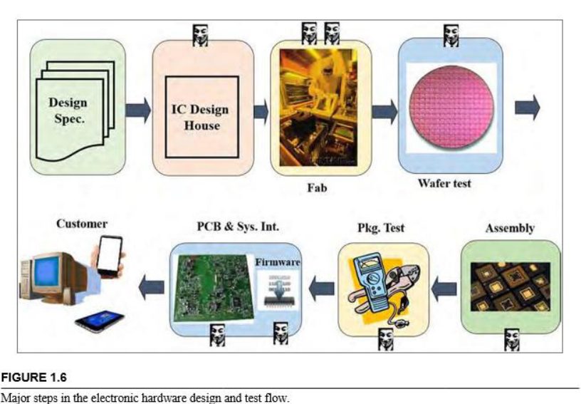

Figure 1.6 shows the major steps in the life cycle of an IC.

- It starts from a design house creating the functional specifications (e.g., data compression, encryption, or pattern recognition) and parametric specifications (e.g., the operating frequency or standby power) of a design.
- Next, it goes through a sequence of design and verification steps, where the high-level description of a design (for instance, an architecture level description) is transformed into logic gates, then into a transistor level circuit, and finally, into a physical layout.
- During this transformation process, a design is verified for correct functional behavior and for performance, power, and other parametric constraints.
- The layout is then transferred to a fabrication facility, which creates a mask for the layout and then goes through a complex sequence of lithography, etching, and other steps to produce a “wafer”, which is typically a circular silicon disk containing a batch of ICs.
- Each IC in the wafers is then individually tested for certain defects using special test patterns. ICs are referred to as “die” at this stage.
- These dies are then cut by diamond saw from the wafer and assembled into a package made of ceramic, or other materials.
- The packaged dies, or ICs, are then tested for compliance with functional and parametric features using another set of test patterns in a manufacturing test facility.
- This step is vital in the life cycle of an IC, since it ensures that defective chips not meeting functional or parametric specifications are discarded, and do not go into the supply chain.
- During the early stage of an IC development process, this step is used to identify and debug design bugs (as opposed to manufacturing defects), and information on identified bugs is fed back to the design team in order to incorporate appropriate correction.
- The testing and debug process for a complex IC is usually facilitated by incorporating specialized structures in a design, which is called design-for-test (DFT) and design-for-debug (DFD) infrastructure, respectively.
- The primary goal behind inserting these structures is to increase the controllability and observability of internal nodes in a design, which are difficult to access from a fabricated chip.
- However, as we discuss later, it inherently creates conflict with security goals, which aim to minimize controllability and observability of these nodes, such that an attacker cannot easily access or control internal circuit nodes.
- For example, direct access to the read/write control for embedded memory in a processor through the DFT/DFD interface can help an attacker leak, or manipulate sensitive data stored in the protected regions of memory.
- The chips that pass manufacturing testing then go into the supply chain for distribution.
- In current business models, most OEMs acquire these chips from a supply chain, and then integrate them in a PCB, install firmware or configuration bitstream into COTS components, and create a complete system.
- This long development cycle of hardware involves multiple third-party vendors and facilities.
- They are often untrusted and globally distributed.
- In Fig. 1.6, the stages marked by red (medium gray in print version) box are usually untrusted, whereas stages marked with yellow (light gray in print) may or may not be untrusted; the ones marked with green (dark gray in print version) are usually trusted.
- In the next section, we describe what kind of attacks can be mounted on a hardware in these stages.
- It is worth noting that, PCB design, fabrication, and test process follow a similar flow, and a horizontal business model—as in the case of IC, where the design and manufacturing companies—is spread around the world to reduce the total production cost.
- Hence, PCBs are often subject to a similar set of vulnerabilities as ICs

UNIT 2.1
Attacks, Vulnerabilities, and Countermeasures

- ATTACKS
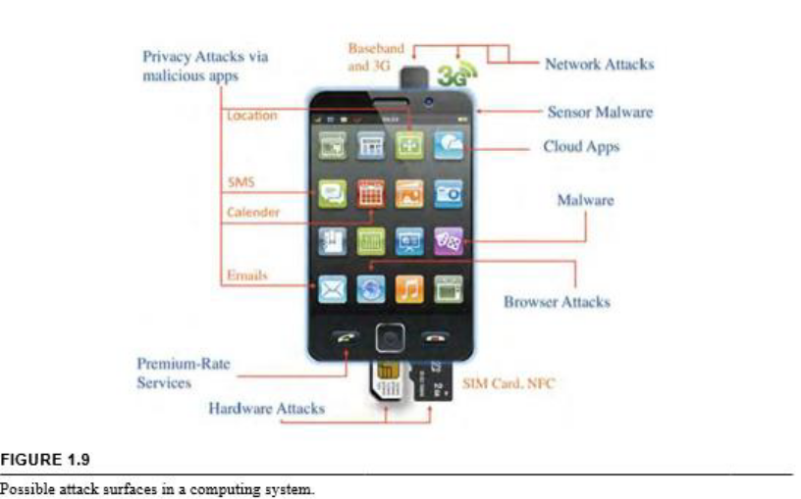

- ATTACK VECTORS
- Attack vectors—as they relate to hardware security—are means or paths for bad actors (attackers) to get access to hardware components for malicious purposes, for example, to compromise it or extract secret assets stored in hardware.
- Example of hardware attack vectors are side-channel attacks, Trojan attacks, IP piracy, and PCB tampering. Attack vectors enable an attacker to exploit implementation level issues (such as, side-channel attacks and PCB tampering) or take advantage of lack of control on hardware production cycle (such as, Trojan attacks).

- ATTACK SURFACE
- Attack surface is the sum of all possible security risk exposures.
- It can also be explained as the aggregate of all known, unknown, and potential vulnerabilities, and controls across all hardware, software, and network components.
- Tapping into different locations, components, and layers (including hard-ware/software) of the target system, an attacker can exploit one or more vulnerabilities and mount an attack, for example, extract secret information from a system.
- Figure 1.9 illustrates major attack surfaces of a smartphone, composed of software, network, data, and hardware components.
- From the figure, it is evident that the total surface area of a system could be large, and hardware is a critical part of it.
- In the context of hardware security, attack surfaces define the level of abstraction in which the attacker focuses on launching a hardware attack.
- Keeping the attack surface as small as possible is a common goal for developing countermeasures.
- With respect to hardware security, three main attack surfaces are as follows.
- Chip Level Attacks
- Chips can be targeted for reverse engineering, cloning, malicious insertion, side-channel attacks, and piracy.
- Counterfeit or fake chips can be sold as original units if the attacker can create a copy that has a similar appearance or features as the original.
- Trojan-infected chips can also find their place in the supply chain, which can pose a threat of unauthorized access, or malfunction.
- Side-channel attacks can be mounted on a chip with the goal to extract secret information stored inside it.
- For example, a cryptochip performing encryption with a private key, or a processor running protected code and/or operating on protected data are both vulnerable to leakage of secret information through this attack.

- PCB-Level Attacks:
- PCBs are common targets for attackers, as they are much easier to reverse-engineer and tamper than ICs.
- Design information of most modern PCBs can be extracted through relatively simple optical inspection (for example, X-Ray tomography) and efficient signal processing.
- Primary goals for these attacks are to reverse engineer the PCB, and obtain the schematic of the board to redesign it and create fake units.
- Attackers may also physically tamper a PCB (for instance, cut a trace or replace a component) to make them leak sensitive information, or bypass DRM protection.

- System-Level Attacks
- Complex attacks involving the interaction of hardware-software components can be mounted on the system.
- By directly focusing on the most vulnerable parts in a system, such as DFT infrastructure at PCB level (for example, JTAG) and memory modules, attackers may be able to compromise the system’s security by gaining unauthorized control and access to sensitive data.

- SECURITY MODEL
- Attacks on hardware systems can take many forms.
- An attacker’s capabilities, physical or remote access of the system, and assumptions of system design and usage scenarios play essential roles in the techniques that can be used to launch an attack.
- In order to describe a security issue or solution, it is important to unambiguously describe the corresponding security model.
- A security model should have two components:
- Threat Model, which describes the threats including, the purpose and mechanism of an attack; and
- Trust Model, which describes the trusted parties or components. In order to de-scribe the security issues arising from malicious implants in third-party IPs, the threat model needs to describe the objective of the attackers, for example, to leak secret from an SoC or to disrupt its functional behavior; and the way the attack is mounted, for instance, through the insertion of a Trojan that triggers malicious memory write operation under a rare internal condition. The trust model needs to describe which parties are trusted, for example, the SoC designer and CAD tools are trusted in this case.

- VULNERABILITIES
- Vulnerabilities refer to weakness in hardware architecture, implementation, or design/test process, which can be exploited by an attacker to mount an attack.
- These weaknesses can either be functional or nonfunctional, and they vary based on the nature of a system and its usage scenarios.
- A typical attack consists of an identification of one or more vulnerabilities, followed by exploiting them for a successful attack.
- Identification of vulnerabilities is usually the hardest step in the attack process.

- Following is a description of some typical vulnerabilities in hardware systems:
- Functional Bug
- Most vulnerabilities are caused by functional bugs and poor design/testing practices.
- They include weak cryptographic hardware implementation and inadequate protection of assets in an SOC.
- Attackers may find these vulnerabilities by analyzing the functionality of a system for different input conditions to look for any abnormal behaviors.
- Additionally, vulnerabilities may be dis-covered accidentally, which makes it easier for an attacker to perform malicious activities using these newly discovered issues in the system.

- Side-Channel Bug
- These bugs represent implementation-level issues that leak critical information stored inside a hardware component (for example processors or cryptochips) through different forms of side-channels.
- Attackers may find these vulnerabilities by analyzing the side-channel signals during operation of a hardware component.
- Many powerful attacks based on side-channel bugs rely on statistical methods to analyze the measured traces of a side-channel parameter.
- Criticality of a side-channel bug depends on the amount of information leakage through a side channel.

- Test/Debug infrastructure
- Most hardware systems provide a reasonable level of testability and debuggability, which enable designers and test engineers to verify the correctness of operation.
- They also provide means to study internal operations and processes running in a hardware, which are essential for debugging a hardware.
- These infrastructures, however, can be misused by attackers, where extraction of sensitive information or unwanted control of a system can be possible using the test/debug features.

- Access control or information-flow issues
- In some cases, a system may not distinguish between authorized and unauthorized users.
- This vulnerability may give an attacker access to secret assets and functionality that can be misused or leveraged.
- Moreover, an intelligent adversary can monitor the information flow during system operation to decipher security-critical information, such as, control flow of a program and memory address of a protected region from a hardware.

- COUNTERMEASURES
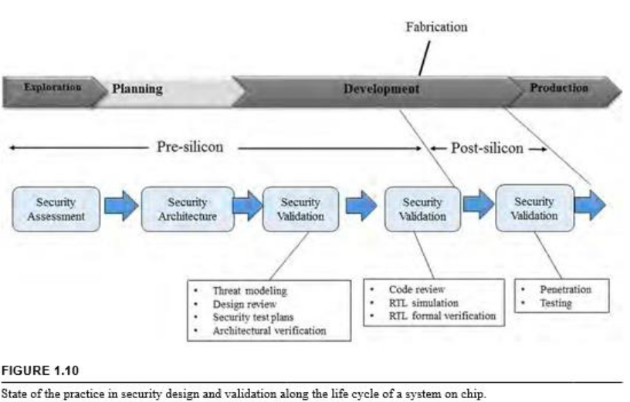

- As hardware attacks have emerged in the past years, countermeasures to mitigate them have also been reported.
- Countermeasures can either be employed at design or test time.
- Figure 1.10 shows the current state of the practice in the industry for SoCs in terms of:
- Incorporating security measures in a design (referred to as “security design”),
- Verifying that these measures protect a system against known attacks (referred to as “security validation”).

- SoC manufacturing flow can be viewed as consisting of four conceptual stages:
- Exploration
- Planning
- Development
- Production.
- The first two stages and part of the development stage form the pre-silicon part of SoC life cycle, which consists of exploring the design space, architecture definition, and then deriving a design that meets design targets.
- Part of the development stage, followed by the production of SoCs, form the post-silicon part of the SoCs’ life, which consists of verifying and fabricating the chips.
- Security assessment is per-formed during the exploration stage, which identifies the assets in a SoC, possible attacks on them, and requirements for secure execution of software, when applicable.
- This step ends up creating a set of security requirements.
- Next, an architecture is defined (referred to as “security architecture”) to ad-dress these requirements, which includes protection of test/debug resources against malicious access, and safeguarding cryptographic keys, protected memory regions, and configuration bits.
- Once the architecture is defined and the design is gradually created, pre-silicon-security validation is performed to make sure the architecture and its implementation adequately fulfill the security requirements.
- Similar security validation is performed after chips are fabricated (referred to as “post-silicon security validation”) to ensure that the manufactured chips do not have security vulnerabilities and, hence, are protected against known attacks. Both pre- and post-silicon security validation come in various forms, which vary in terms of coverage of security vulnerabilities, the resulting confidence, and the scalability of the approach to large designs.
- These techniques include code review and formal verification during pre-silicon validation, fuzzing, and penetration testing during post-silicon validation.

- Design solutions
- Design-for-security (DfS) practices have emerged as powerful countermeasures.
- DfS offers effective low-overhead design solutions that can provide active or passive defense against various attacks.
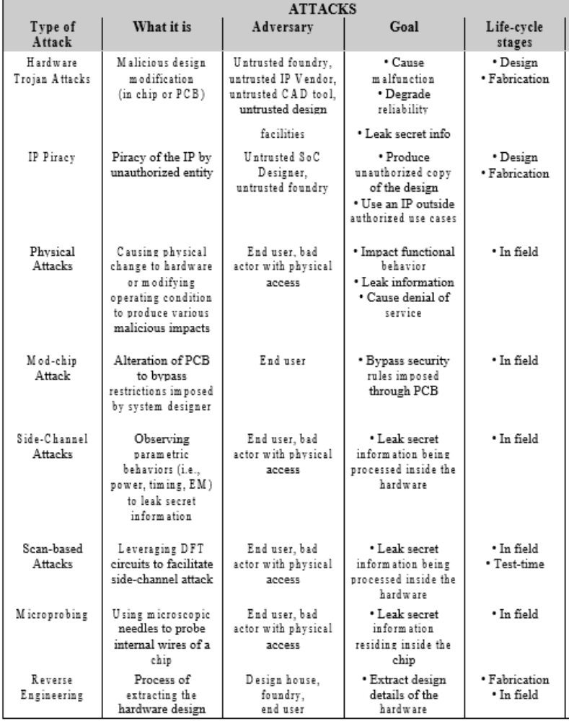
- DfS techniques, such as obfuscation [6], use of reliable security primitives, side-channel resistance (for example, masking and hiding techniques), and hardening schemes for Trojan insertion, can reliably protect against many major attack vectors.
- Likewise, SoC security architecture that is resilient against software attacks has been a significant aspect of SoC platform security.

- Test and verification solutions
- Test and verification techniques have constituted a major category of protection approaches against the diverse security and trust issues.
- Both pre-silicon verification— functional as well as formal—and post-silicon manufacturing testing have been considered as mechanisms to identify security vulnerabilities and trust issues for chips, PCBs, and systems.
- The book covers various DfS and test/verification solutions, which are developed to protect hardware against many vulnerabilities.

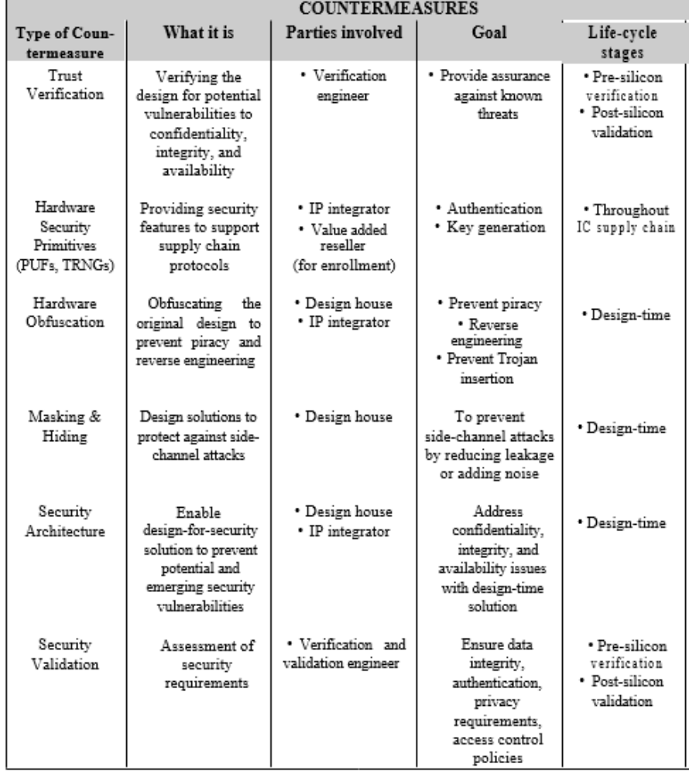

Unit 2.2
HARDWARE TROJANS

- HARDWARE TROJANS
- A hardware Trojan (HT) is defined as a malicious, intentional modification of a circuit design that results in undesired behavior when the circuit is deployed. SoCs that are ‘infected’ by a hardware Trojan may experience changes in their functionality or specification, may leak sensitive information, or may experience degraded or unreliable performance.
- Hardware Trojan poses a serious threat to any hardware design being deployed in a critical operation.
- As the hardware Trojans are inserted at the hardware level, software-level countermeasures may be inadequate to address the threat posed by HT.
- Also, detection of Trojans in a hardware design is challenging as there is no golden version against which to compare a given design during verification.
- In theory, an effective way to detect a Trojan is to activate the Trojan and observe its effects, but a Trojan’s type, size, and location are unknown, and its activation is, most likely, a rare event.
- A Trojan can be, therefore, well-hidden during the normal functional operation of the chip and activated only when the triggering condition is applied.

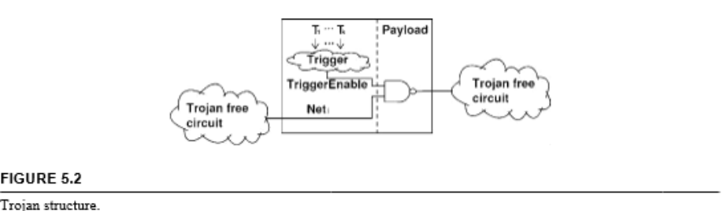
- HARDWARE TROJAN STRUCTURE

- The basic structure of a Trojan in a 3PIP can include two main parts, trigger and payload.
- A Trojan trigger is an optional part that monitors various signals and/or a series of events in the circuit.
- The payload usually taps signals from the original (Trojan-free) circuit and the output of the trigger.
- Once the trigger detects an expected event or condition, the payload is activated to perform malicious behavior.
- Typically, the trigger is expected to be activated under extremely rare conditions, so the payload remains inactive most of the time.
- When the payload is inactive, the IC acts like a Trojan-free circuit, making it difficult to detect the Trojan.
- Figure 5.2 shows the basic structure of the Trojan at gate level.
- The trigger inputs (T1, T2, ..., Tk ) come from various nets in the circuit.
- The payload taps the original signal N eti from the original (Trojan-free) circuit and the output of the Trigger.
- Since the trigger is expected to be activated under rare condition, the payload output stays at the same value most of the time, N eti .
- However, when the trigger is active, that is, TriggerEnable is “0”, the payload output will be different from N eti ; this could result in injecting an erroneous value into the circuit and causing error at the output.

- TROJAN MODELING
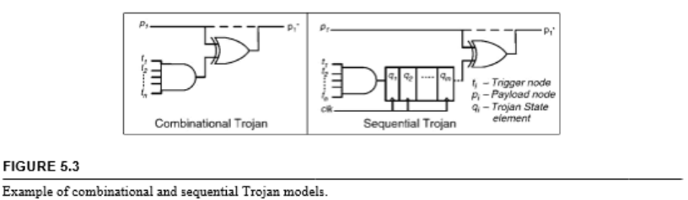

- Many different Trojans have been developed over the years by researchers using different Trojan models to demonstrate the capability and efficacy of their proposed Trojan countermeasure approaches.
- This section discusses the digitally triggered and a digital payload Trojan model that has been most commonly used.
- In this model, it is assumed that a Trojan will be activated by rare circuit node conditions and will have its payload as a critical node in terms of functionality, but low observable node in terms of testing, to evade detection during normal functional testing.
- If the Trojan includes sequential elements, such as rare-event triggered counters, then the Trojan may be even harder to detect.
- Figure 5.3 shows generic models for combinational and sequential Trojans.
- The trigger condition is an n-bit value at internal nodes, which is assumed to be rare enough to evade normal functional testing.
- The payload is defined as a node that is inverted when the Trojan is activated.
- To make it more difficult to detect, one might consider a sequential Trojan, which requires the rare event to repeat 2m times before the Trojan gets activated and inverts the payload node.
- The sequential state machine is considered in its simplest form to be a counter, and the effect of the output on the payload is considered to be an XOR function to have maximal impact.
- In more generic models, the counter can be replaced by any Finite State Machine (FSM) and the circuit can be modified as a function of Trojan output and the payload node. In like manner, the Trojan trigger condition is modeled as an AND function of several rare nodes in order to make the combined event highly rare.
- However, the attacker may choose to reuse existing logic within the circuit to implement the trigger condition, without adding too many extra gates.
- It is worth noting—when choosing rare values at internal nodes as inputs for the Trojan—that the combined rare event must be excitable; otherwise, the Trojan will never be triggered in real life.

- HARDWARE TROJAN EXAMPLES
- Trojans in Cryptographic Engines
- A possible Trojan attack in a cryptoengine can try to subvert the security mechanisms.
- The payload could range from a mechanism that presents dummy keys, predefined by the attacker, instead of the actual cryptographic keys used for sensitive encryption or signature verification operations, to leaking the secret hardware keys via covert side-channels, for example, information leaked through a power trace.
- Figure 5.4 provides an example of such a Trojan, which attempts to leak a secret key from in-side a cryptographic module through power side-channels using a technique called malicious off-chip leakage, enabled by side-channels (MOLES).
- Other targets could be a random number generator used for deriving random session keys for a particular operation, or the debug passwords used for un-locking test mode access to security-sensitive signals.
- Researchers have also proposed leaking such secret information over wireless channels by using low-bandwidth modulation of the transmitted signal.

- Trojans in General-Purpose Processors
- In general-purpose processors, an attacker at the fabrication facility can implement a backdoor, which can be exploited in the field by a software adversary.
- For example, modern processors implement a hardware chain of trust to ensure that malware cannot compromise the hardware assets, such as secret keys and memory range protections.
- By using different stages of firmware and boot code authentication, one can ensure that the operating system (OS) kernel and lower levels, such as hypervisor, are not corrupted.
- However, in such systems, the attacker at an untrusted fabrication facility could implement a backdoor, which disables the secure booting mechanism under certain rare conditions or when presented with a unique rare input condition in the hands of an end-user adversary.
- Likewise, other objectives that could be realized with the help of hardware Trojans would be able to bypass memory range protections using buffer overflow attacks, or gain access to privileged assets by evading the access control protection mechanisms implemented in the hardware.

- HARDWARE TROJANS IN FPGA DESIGNS
- FPGAs are widely used today in an array of embedded applications, ranging from telecommunications and data centers to missile guidance systems.
- Unfortunately, the outsourcing of FPGA production and the use of untrusted third-party IPs has also given rise to the threat of Trojan insertion in them.
- FPGA-based Trojans can be in the form of IP blocks (hard, soft or firm), which get loaded onto a generic FPGA fabric and cause malicious activity (such as denial-of-service and leakage) on the system in which the FPGA is deployed.
- Such FPGA IP-based Trojans are more or less similar to their counter-parts in an ASIC design flow, with the exception of layout-based Trojans, which are not applicable to FPGAs.
- However, Trojans that ‘pre-exist’ in an FPGA fabric and could potentially be inserted by an untrusted foundry or vendor pose unique threats and challenges of their own.
- FPGAs contain a large volume of reconfigurable logic in the form of lookup tables, block RAM, and programmable interconnects, which can be used to realize any arbitrary sequential or combinational design.
- However, there might be a significant amount of reconfigurable logic open to a malicious party (for example, the FPGA foundry or even the FPGA vendor) who can load a hardware Trojan and affect the FPGA-integrated system or compromise the IP loaded onto the FPGA.

- ACTIVATION CHARACTERISTIC
- IP-Dependent Trojans
- A malicious foundry or FPGA vendor may implement a hardware Trojan that can monitor the logic values of several lookup tables (LUTs) in the FPGA fabric.
- Once triggered, such Trojans can corrupt other LUT values, load incorrect values into block RAMs (BRAMs), or sabotage configuration cells.
- Since any arbitrary IP may be loaded onto the FPGA, the malicious foundry or vendor could distribute trigger LUTs throughout the FPGA so that the probability of the Trojan triggering and causing malfunction may increase.

- IP-Independent Trojans
- A malicious foundry or vendor may also implement a Trojan into an FPGA chip that is completely independent of the IP loaded onto it. Such Trojans can occupy a small portion of FPGA resources and malfunction IP-independent but critical FPGA resources, such as digital clock managers (DCM).
- One potential mode of attack would be a Trojan increasing or decreasing the design clock frequency by manipulating the configuring SRAM cells of the DCM unit, which can cause failure in sequential circuits.

- PAYLOAD CHARACTERISTICS
- FPGA device-based Trojans can also bring about unique malicious effects, such as causing malfunction of FPGA resources or leakage of the IP loaded onto the FPGA.

- Malfunction
- Hardware Trojans in FPGA devices can either cause logical malfunction by corrupting LUT(s) or SRAM values, thereby affecting the functionality of the implemented IP, or by causing physical damage to the FPGA device.
- For example, a triggered hardware Trojan could reprogram an I/O port set as an input to become an output I/O port, while suppressing the configuration cells that prevent it from being programmed as such.
- This would cause a high short-circuit current to flow between the FPGA and the system it is connected to, thereby leading to physical device failure.

- IP Leakage
- FPGAs today offer bitstream encryption capabilities in order to protect the IP loaded onto an FPGA device.
- However, such encryption only prevents a direct or unauthorized readback by software.
- A hardware Trojan may circumvent such protection by either leaking the decryption key, or even the entire IP.
- The Trojan may tap the decryption key as it comes out of non-volatile memory, or the actual decrypted IP, which could then be exfiltrated either via covert side-channels (for example, power traces) or through JTAG, USB or I/O ports.

- HARDWARE TROJANS TAXONOMY

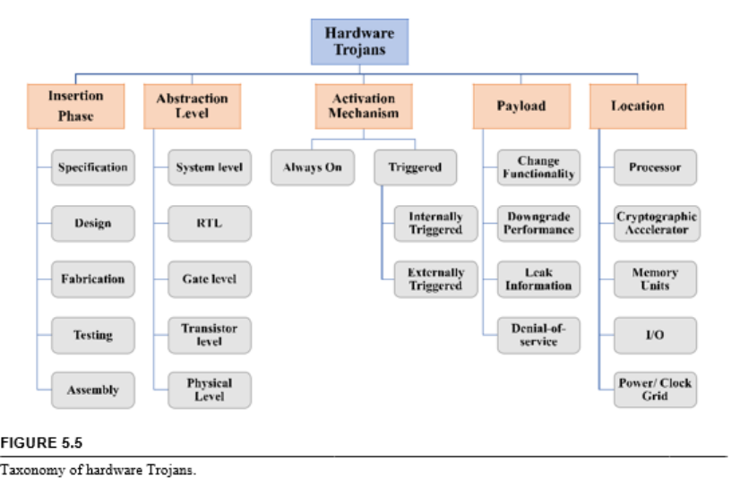

- Developing a better understanding of hardware Trojans and creating effective defenses require a framework that groups similar Trojans together to enable a systematic study of their characteristics.
- Detection, mitigation, and protection techniques can then be developed for each Trojan class along with benchmarks to serve as the basis for comparing countermeasures.
- In addition, experimental implementations can be created for Trojan classes yet to be observed, thereby fostering proactive defense.
- Taxonomy is developed based on hardware Trojans’ physical, activation, and functional characteristics.
- In this regard, hardware Trojans are classified based on five attributes:
- Insertion phase
- Abstraction level
- Activation mechanism
- Payload
- Location (shown in Fig. 5.5).

- INSERTION PHASE
- Hardware Trojans can be inserted throughout SoC design flow.
- As the abovementioned Trojan’s at-tribute suggests, Trojans can also be classified based on the phases in which they are inserted.

- Specification Phase
- In this phase, chip designers define the system’s characteristics: the target environment, expected function, size, power, and delay.
- While the SoC development is in this phase, functional specifications or other design constraints can be altered.
- For example, a Trojan at the specification phase might change the hardware’s timing requirements.

- Design Phase
- Developers consider functional, logical, timing, and physical constraints as they map the design onto the target technology.
- At this point, they can use third-party IP blocks and standard cells.
- Trojans might be in any of the components that aid the design.
- For example, a standard cell library can be tampered with Trojans.

- Fabrication Phase
- During this phase, developers create a mask set and use wafers to produce the masks.
- Subtle mask changes can have serious effects. In an extreme case, an adversary can substitute a different mask set.
- Alternatively, chemical compositions might be altered during fabrication to increase the electromigration in critical circuitry, such as power supplies and clock grids, which would accelerate failures.

- Testing Phase
- The IC testing phase is important for hardware trust, not only because it is a likely phase for Trojan insertion, but also because it provides an opportunity for Trojan detection.
- Testing is only useful for detection when done in a trustworthy manner.
- For example, an adversary who inserted a Trojan in the fabrication phase would want to have control over the test vectors to ensure that the Trojan is not detected during test. Trustworthy testing ensures that the test vectors will be kept secret and faithfully applied, and that the specified actions accept/reject, and binning will be faithfully followed.
- An attacker can take advantage of not-detected (ND) faults by automatic test pattern generation (ATGP) tools.
- By doing so, a Trojan that uses these ND faults will never be activated.

- Assembly Phase
- Developers assemble the tested chip and other hardware components on a printed circuit board (PCB).
- Every interface in a system, where two or more components interact is a potential Trojan insertion site.
- Even if all the ICs in a system are trustworthy, malicious assembly can introduce security flaws in the system.
- For example, an unshielded wire connected to a node on the PCB can introduce unintended electromagnetic coupling between the signal on the board and its electromagnetic surroundings.
- An adversary can exploit this for information leakage and fault injection.

- ABSTRACTION LEVEL
- Trojan circuits can be inserted at various hardware abstraction levels.
- Their functionality and the structure are dependent on the abstraction level at which they are inserted.

- System Level
- At the system level, the different hardware modules, interconnections, and communication protocols used are defined.
- At this level, the Trojans may be triggered by the modules in the target hardware.
- For example, the ASCII values of the inputs from the keyboard can be interchanged.

- Register-Transfer Level
- At the RTL, chip designers describe each functional module in terms of registers, signals, and Boolean functions.
- A Trojan can be easily designed and inserted at the RTL because the attacker has full control over the design’s functionality.
- For example, a Trojan implemented at this level might halve the rounds of a cryptographic algorithm by making a round counter to advance in two steps instead of one.

- Gate Level
- At this level, an SoC is represented as an interconnection of logic gates.
- An attacker can carefully control all aspects of the inserted Trojan, including its size and location.
- For example, a Trojan might be a simple comparator consisting of basic gates (AND, OR, XOR gates) that monitor the chip’s internal signals.

- Transistor Level
- Chip designers use transistors to build logic gates.
- This level gives the Trojan designer control over circuit characteristics, such as power and timing.
- The attacker can insert or remove individual transistors, altering the circuit functionality, or modify transistor sizes to alter circuit parameters.
- For example, a transistor-level Trojan might be a transistor with low gate width that can cause more delay in the critical path.

- Physical Level
- This level describes all circuit components and their dimensions and locations, and is the design’s physical level, where a Trojan can be inserted.
- An attacker can insert Trojans by modifying the size of the wires and distances between circuit elements and reassigning metal layers.
- For example, changing the width of the clock wires, timing critical nets or metal wires in the chip can cause clock skew.

- ACTIVATION MECHANISM
- Some Trojans are designed to be always on, whereas others remain dormant until triggered.
- A triggered Trojan needs an internal or external event to be activated.
- Once the trigger activates a Trojan, it can remain active forever or return to a dormant state after a specified time.

- Internally Triggered
- An internally triggered Trojan is activated by an event within the target device.
- The event might be either time-based or physical-condition-based.
- A counter in the design can trigger a Trojan at a predetermined time, resulting in a silicon timebomb.
- Similarly, a Trojan can trigger when the chip temperature exceeds a certain threshold.

- Externally Triggered
- An externally-triggered Trojan requires external input to the target module to activate.
- The external trigger can be user input or component output. User-input triggers include push buttons, switches, keyboards, or keywords and phrases in the input data stream in a system.
- Component-output triggers might be from any of the components that interact with the target device.
- For example, a Trojan in a cryptomodule can derive its trigger condition from the applied plaintext input and triggers when it observes a specific plaintext, or a combination of plaintext and operating conditions.
- One can also classify the triggered Trojans into two categories:
- Analog triggered
- Analog-triggered Trojans are triggered analog signals, such as temperature and voltage.
- Digital triggered
- Digitally triggered Trojans are triggered by logic-conditions, such as state of the flip-flops, state of a logic net, counter, clock signal, data, instruction, and/or interrupts.

- PAYLOAD
- Trojans can also be characterized by their payload, that is, the malicious effects caused by them when they become activated.
- The severity of these effects on target hardware or systems can range from subtle disturbances to catastrophic system failures.

- Change Functionality
- Trojan can change the functionality of the target device, and cause subtle errors that might be difficult to detect during manufacturing test.
- For example, a Trojan might cause an error detection module to accept inputs that should be rejected.

- Downgrade Performance
- A Trojan can downgrade performance by intentionally changing device parameters.
- These include functional, interface, or parametric characteristics, such as power and delay.
- For example, a Trojan might insert more buffers in the chip’s interconnections and, hence, consume more power, which in turn could drain the battery quickly.

- Leak Information
- A Trojan can also leak information through both covert and overt channels.
- Sensitive data can be leaked via radio frequency, optical or thermal power, timing side-channels, and interfaces, such as RS-232 and JTAG (Joint Test Action Group).
- For example, a Trojan might leak a cryptographic algorithm’s secret key through unused RS-232 ports.

- Denial-of-Service
- A denial-of-service (DoS) Trojan can cause the target module to exhaust scarce resources, such as band-width, computation, and battery power.
- It could also physically destroy, disable, or alter the device’s configuration, for example, causing the processor to ignore the interrupt from a specific peripheral.
- DoS can be either temporary or permanent.

- LOCATION
- A hardware Trojan can be inserted in a single component or spread across multiple components, for example, processor, memory, input/output, power supply, or clock grid.
- Trojans distributed across multiple components can act independently of one another or together as a group to accomplish their attack objectives.

- Random Logic
- A Trojan can be inserted into the random logic portion of an SoC. Detection of such Trojans are extremely challenging since understanding functionality of random logic is difficult, hence making it limited to generate effective test stimuli.
- Size of such logic in an SoC can be quite large.
- Processing Unit
- Any Trojan embedded into the logic units that are part of the processor can be grouped under this category.
- A Trojan in the processor might, for example, change the instructions’ execution order.

- Cryptographic Accelerator
- Cryptomodules are likely target for Trojan insertion as these modules work with assets, such as private keys and sensitive plaintext.
- A Trojan in a cryptomodule can leak the secret key (attack on confidentiality) or replace the key (attack on integrity), and compromise the security of the overall system.

- Memory Units
- Trojans in the memory blocks and their interface units fall in this category.
- These Trojans might alter the value stored in the memory and also blockread or blockwrite access to certain memory locations, for example, change the contents of a programmable read-only memory in an SoC.

- Input/Output Port
- Trojans can reside in a chip’s peripherals or within the PCB.
- These peripherals interface with the external components and can give the Trojan control over data communication between the processor and the system’s external components.
- For example, a Trojan might alter the data coming through a JTAG port.

- Power Supply
- Modern SoCs include many voltage islands, a large number of locally distributed voltage regulators, and dynamic voltage/frequency systems, where the chip frequency is adjusted in the field by changing VDD as the chip ages in the field.
- Trojans could be inserted by an adversary to alter the voltage and current supplied to the chip, causing failures.

- Clock Grid
- Trojans in the clock grid can change the clock’s frequency, insert glitches in the clock supplied to the chip, and launch fault attacks.
- These Trojans can also freeze the clock signal supplied to the rest of the chip’s functional modules.
- For example, a Trojan might increase the clock signal skew supplied to specific parts of a chip, causing hold-time violation on short paths.

Unit 2.3
PASSWORD MANAGEMENT

- Presentation of Contents
- Recent statistics on computer security breaches demonstrate that there has been an explosive growth of successful computer attacks worldwide.
- Valuable personal and corporate information is being compromised, and computer systems that control communications and critical infrastructure operations are being attacked.
- The continued success of these attacks demands answers to questions such as: What is the root cause of the problem? And what steps can be taken to prevent successful attacks?
- In order to address these questions in a systematic fashion, it is important to review the basic components that form the foundation of current computer security.
- Since the roles and interplay of these components are often central to attacks that capitalize on weaknesses of a security system, a clear understanding of these components is a necessary prerequisite for mounting a solid defense.

- CRYPTOGRAPHY
- The first element that comes to mind when a person thinks about computer security is cryptography.
- Cryptography is the process of converting an information-bearing message to something that appears to be completely unintelligible “gibberish,” or performing the inverse process (decoding a cryptographically protected message).
- These processes are referred to as encryption and decryption, respectively.
- There are two basic forms of cryptographic processes:
- Symmetric
- In which the same key is used to encrypt and decrypt a message, and
- Asymmetric
- In which the key employed to encrypt a message is different from the key employed to decrypt the message.

- A cryptographic encryption process consists of an algorithm, such as the data encryption standard three times (triple DES), advanced encryption standard (AES) or a host of others, that takes an input string of char-acters or numbers (the information we wish to protect) and converts the string to “gibberish.”
- In order to do so, it must be set to a predictable initial state, and it requires an encryption key.
- As explained above, in symmetric key cryptography the same key is used to encrypt and decrypt a file.
- Asymmetric cryptography uses different keys for encryption and decryption and so employs a more complex algorithm.
- This difference gives symmetric key cryptography an advantage of faster processing and therefore less computing overhead.

- Symmetric Key Cryptography
- The first fundamental issue with symmetric key cryptography is the process by which the key is transmitted securely between parties that wish to employ the process.
- Clearly the key cannot be transmitted between the parties without any form of protection-its interception by the simplest packet sniffer would effectively yield the key to a listening party that then would have full knowledge of any subsequent communications.
- Encrypting the key in order to send it also requires that this second key be shared between the two parties.
- The requirements for transmission of keys layer upon one another ad infinitum. This simply won’t work.
- The key could be sent by trusted courier.
- This might work for communication between countries or in situations where the stakes are very high (situations involving decoding of missile launch codes or military plans), but in the world of everyday computing the concept of using trusted couriers to hand-deliver specific encryption keys to every possible participant in an encrypted communication is not practical.
- A second fundamental issue with symmetric key cryptography is that a different key is needed for each potential participant.
- The delivery of keys aside, the management of systems where each recipient has a different key rapidly becomes an exponentially more difficult task as the number of recipients grows.
- Key management ultimately limits the value of symmetric key cryptography.

- Asymmetric Key Cryptography
- The issues with symmetric key cryptography were solved in part when, in 1976, a revolutionary paper was published by Whitfield Diffie and Martin Hellman of Stanford University’.
- In this paper, Diffie and Hellman first described “public key cryptography” (also referred to as asymmetric key cryptography or the Diffie-Hellman algorithm).
- In asymmetric key cryptography, complementary keys are employed: one key is used for encryption and a second key is used for decryption.
- Moreover, the encryption process is target-specific-that is, one encrypts a file in a manner that only the intended recipient will hold the second key for decryption.
- In short, the method revealed by Diffie and Hellman removed the need for transmission of a secret key as required in symmetric key cryptography.
- It is important to understand the revolutionary manner in which asymmetric key cryptography works, since its operation has become fundamental to much of today’s cryptographic systems and has bearing on issues related to hacking.
- The Diffie-Hellman algorithm employs a symmetry property in mathematics. That symmetry is:

(EQUATION 1) x(a)(b) = x(b)a

- That is, a number x raised to the power a is then raised to the power b.
- The result is identical to the number x raised to the power b, which is then raised to the power a. As an example, let consider the case where x = 7, a = 2, and b = 3. First calculate x(a) and x(b):
(EQUATION 2) x(a) = 7(2) = 49
(EQUATION 3) x(b) = 7(3) = 343

- Then raising the results of Equation 2 above to the power b=3, we find:

(EQUATION 4) x(a)b = 493 = 117, 649

- Similarly, raising the results of Equation 3 to the power a=2 yields:
(EQUATION 5) x(b)a = 3432 = 117, 649

- This mathematical symmetry, combined with one additional process, establishes the core of asymmetric key cryptography.
- By further modifying the result of the above symmetric process with a modulo function employing a prime number in which the result of the intermediate exponentiation (Equations 2 and 3 above) is divided by a prime number and replaced with the remainder of the division, the process assumes a quality that makes it mathematically nearly impossible to reverse. So, the modified equations become:
(EQUATION 6) x(a) mod p
(EQUATION 7) x(b) mod p

- Imagine that two parties wish to establish an encrypted communication using symmetric key cryptography, but want to avoid the transmission of a secret key due to the fundamental problems cited above.
- For the purposes of illustration, consider the simple case where the key (or “password”) to be used with symmetric key cryptography will consist of a number (the extension of the concept to complex passwords or pass phrases is straight-forward and will not be discussed here).
- Using the cryptographic convention, the two parties will be Alice and Bob.
- Alice and Bob agree in advance to use p = 11 and a base x = 7. Alice chooses her “secret key” (known only to her and never transmitted or shared) a = 2.
- Using Equation 6 above, Alice computes x(a) mod p and sends the result (5) unencrypted to Bob. This is effectively her “Public Key”:
(EQUATION 8) Alice’s public key KA = x(a) mod p = 7(2) mod 11 = 5

- Alice transmits her public key in the clear to Bob. Bob, in turn, chooses his own “secret key” b = 3.
- Using Equation 7 above, Bob computes x(b) mod p (his public key) and sends the result to Alice:
(EQUATION 9) Bob’s public key = KB = x(b) mod p = 7(3) mod 11 = 2

- Alice can now compute the key to be used to communicate with Bob.
- She uses Bob’s public key in conjunction with her own secret key to deter-mine the shared key:
(EQUATION 10) shared key KB(a) mod 11 = 2(2) mod 11 = 4 mod 11 = 4
- Bob, armed with Alice’s public key, uses his own secret key to deter-mine the shared key:
(EQUATION 11) shared key KA(b) mod 11 = 5(3) mod 11 = 125 mod 11 = 4

- Both Alice and Bob now know the shared key to be used in any subsequent encrypted transmissions using symmetric cryptography with the shared key to encrypt or decrypt the messages.
- The beauty of asymmetric key cryptography is that Bob and Alice were able to compute a shared key specific to their encrypted intercommunications without having to transmit the shared key at any time.
- Rather, this asymmetric cryptography involved the sharing of two public keys, which then enabled each of the two parties to determine the shared key to be used for their particular communication.
- It is left as an exercise to the reader to show that the shared key to be used by Alice with a third party that has a different secret key (and therefore a different public key) will employ a different shared key.
- In practice, the prime number p should be at least 300 digits long, and the secret keys “a” and “b” should be at least 100 digits long. With these constraints on a, b, and p, it has been estimated that all of mankind’s computing power will not be able to find the secret key “a” given only x, p, and xa mod p. Note also that x need not be large - the use of 2 or 5 is common.

- PASSWORDS AND KEYS
- A cryptographic key can be comprised of a password.
- Passwords have been used since ancient times to control access to resources, identify a person as an insider, or identify an unknown soldier as friend or foe. In computer security, a password is a secret that should, in principle, be known only to the creator of the password. In this capacity it is referred to as “something you know.”
- As long as the password is sufficiently difficult to guess and has not been written down anywhere, it can have some value in the protection of information when combined with cryptography.
- A password is usually employed as part (or all) of a crypto-graphic key.
- In spite of its name, a “password” need not be a word or phrase at all.
- It may be a string of numbers (a PIN or passcode) or a mixture of letters, numbers, and special characters (such as $#&*@!).
- In fact, the more obscure a string of characters, numbers, and symbols, the more difficult it will be for an attacker to guess the password.
- But, just as complex passwords may be difficult to guess, they may be difficult for the owner to remember.
- The tradeoff between the desirability of “complexity” and the undesirability of “difficulty to memorize” often leads users to one or more of the following actions:
- The length of the password is minimized
- The password is written down
- The complex password uses a substitution mechanism that is easy to remember (for example, the password “strong” might become “$trOng”)

- Password/Key Strength
- In general, strong authentication techniques require that a person prove ownership of a hard-to-guess secret to the target computer.
- In a shared-secret system, a user would transmit the password during the login operation, and the computer would verify that the password matched its internal records.
- More sophisticated systems employ an additional encryption or hashing step to avoid vulnerabilities due to eavesdropping of the communication link.
- An important measure of the strength of a password is to determine the average attack space.
- In this measurement, a mathematical estimate is made of the average number of guesses an attacker would have to make in order to guess the correct password.
- As an example, consider a bicycle lock comprised of four rotating cylinders, each with 10 possible positions (numbers).
- Since each cylinder adds a multiplicative factor of 10 to the number possible combinations that must be tried, a five-cylinder lock is ten times more difficult to guess than a four-cylinder lock.
- The average attack space does not include any time estimate required to guess a pass-word. It is best to avoid time in the comparison of password strengths since, in the computer field, processing speed increases each year, so the time required to break a password gets smaller each year.
- The time factor can be introduced later, after password strengths have been compared based on their average attack space.
- If all possible values of a password are equally likely to occur, then on average an attacker will find the right password after trying half of those possible values.
- Thus, an average attack space reflects the need to search half of the possible combinations, not all of them.
- In practice, password choices have bias which further reduces number of trials before guessing the correct password.
- The average attack space should reflect any bias that might be present when the password was created.
- In the case of a four-digit bicycle lock, dates are relatively easy for people to remember and are often expressed as four digits, so the attack space is likely reduced to reflect possible dates rather than all 10000 combinations.
- Password biases give power to “dictionary attacks.”
- Letter-based pass-words are most likely to employ words that the creator can easily remember.
- Armed with a modest amount of information about the characteristic of the password (such as a hashed version of the password that may have been intercepted during a transmission or retrieved from a database on the target computer) a brute force dictionary attack can proceed through common words in the dictionary and common password hashing algorithms until a match is found.
- Once found, the password has been “guessed” and the system is now cracked.
- Since most trial -and-error attacks are directed against cryptographic systems, and since computer systems measure everything as powers of 2 (representing the fundamental binary nature of bitwise computing), it is convenient to represent average attack spaces in powers of two. If, for example, a dictionary attack finds a password after trying 16,384 words, then the average attack space is:
16384 = 214
- As a calibration of the “difficulty” of an attack space of 214, it is note-worthy that a successful attack on the Data Encryption Standard (DES) by a special purpose computer called Deep Crack2 involved 254 attempts, on average, to attack its 56-bit key.
- An attack space of 240, for example, is relatively easy to crack.
- In 2005, a team of researchers at Cambridge University performed a study of password usage.
- Of the passwords used by the control group in the experiments that sought to create stronger passwords, 35 percent of their passwords were cracked.
- The general population uses passwords that are relatively easy to guess.

- Password/Key Storage and Theft
- In a theft attack, a program of some sort is usually installed on a target computer without the knowledge of the user.
- The installation is usually accomplished by a “Trojan” program that appears to be innocent but whose actual task is to install the theft attack program. The theft attack program is usually designed to produce a window that resembles a login prompt or otherwise invites the user to reveal a password. Users will then type their passwords into this program, where the password is saved or forwarded to the attacker for later use.
- A similar attack program called “phishing” has been developed and is propagated by emails that appear legitimate.
- These programs usually request that the user confirm his account information (including entering his password) or the account will be closed.
- The user’s secret information is then forwarded to the attacker.
- A related attack is spearphishing in which a specific user or organization is targeted by the phishing attack in order to obtain specific information.
- Anti-virus and anti-spyware programs can sometimes detect and delete such attack programs.
- But ultimately the user needs a means to determine whether or not any window being displayed can be trusted.
- If each parent in the chain of windows that spawned a password window can be trusted, then the login prompt window must be trusted and it is safe to enter a pass-word. This concept is called a trusted path.
- One implementation of a trusted path involves the activation of the trusted path through a particular key sequence, such as Ctl-Alt- Del in Windows.
- The keyboard driver captures the sequence and always transfers control to some trusted software that then displays a password login window.
- The unspoken requirement in this logic is that the keyboard driver itself must be trusted.
- That, in turn, means that the operating system running the keyboard driver must be trusted so that bogus keyboard drivers cannot be substituted.
- The OS image that was used to boot up the system may have been altered.
- In fact, even the boot loader might have been altered to read from a compromised location on the disk.
- The demands placed on the chain of trust become progressively more complex.
- If a complete chain of trust can be created from the initial hardware layer down through the password window, the technique of the trusted path offers a defense against password theft.

- Passwords and Authentication
- Passwords are not only used for encryption purposes.
- They also can play a role in authenticating the user.
- Authentication sometimes involves the prior sharing of one or more “secrets” and then the subsequent checking of the secrets being presented by a user against what has previously been shared.
- The process of authenticating a person is different than that of authenticating a computer, because a person is not comprised of numerical information that is relatively easy to access, as is true for a computer.
- Authentication of a person requires the capture of numerical information through the use of a device (a fingerprint, a voice print, an image, a pass-word entered on a keyboard, etc.) that, with some high degree of confidence, should be unique to the intended person.
- Authentication may contain one or more “factors” that are evaluated by the receiving party in determining whether or not a person is in fact who he claims to be.
- These factors may include:
- Something that the user knows (a secret not possibly known by any-one else)
- Something that the user has (something unique in his possession)
- Something that the user “is” (such as a fingerprint)

- Something You Know
- In authentication, passwords fall into the category of “something the user knows.”
- Passwords can be stolen or shared by unwitting users.
- So, the authentication of remote users needs additional components that make spoofing difficult.
- Perhaps authentication should require that the user not only know the password, but also have in his possession some unique piece of hardware, “something you have.”

- Something You Have
- The additional requirement for a piece of hardware creates two-factor authentication in which “something you know” must be accompanied by “something you have.”
- Various tokens and smart -card technologies often provide this second authentication factor.
- Neither factor alone is as strong as the combination.
- A password alone can be cracked, stolen, or learned, enabling an attacker to masquerade as the legitimate user.
- A token alone can be stolen, once again allowing an attacker to spoof an identity.
- Two-factor authentication, however, now requires that the attacker overcome both hurdles.
- There are many examples of hardware devices that are used in two-factor authentication, and these will be discussed more deeply in subsequent chapters of this book.
- They include:
- A magnetic strip card, such as an ID or credit card.
- Proximity card or radio frequency identification (“RFID”). These cards transmit stored information to a monitor via radio frequency electronics embedded within the card.
- Challenge/response cards and cryptographic calculators. These are usually smart cards and perform some sort of cryptographic calculation.

- Why stop at two-factor authentication?
- By adding something that is per-son-specific and is measured, a third authentication factor (or perhaps a replacement of one of the two preceding authentication factors) can add an additional hurdle that significantly raises the difficulty of successful attacks.
- Something You Are
- Humans, like animals, recognize others by evaluating a variety of stimuli and comparing them to stored knowledge about others they have met.
- Facial features (hair color, eye color, smile), body size and shape, manner-isms, sound, perhaps even smell might all contribute to the total set of characteristics that are subconsciously employed in the recognition of others.
- Collectively, we refer to this as “something you are.”
- The degree to which we can find unique characteristics that can be measured and used to uniquely separate people from one another (fingerprint readers, for example) determines whether or not such a measurement can be employed in authentication.
- These personal characteristics must be:
- Easily measured
- Accurate and stable over long periods of time
- Unique, with very low likelihood of false positives and false negatives
- Difficult to spoof or predict

- Devices that accomplish this are called biometrics, and examples include:
- Retinal scan
- Fingerprint reader
- Handprint reader
- Voice print
- Keystroke timing
- Signature

- In order to be able to use a biometric technology to recognize and authenticate a person, his biometric characteristics must be stable over a long period of time, and they must be stored in some concise digital form for future use.
- Fingerprint readers, for example, do not store entire images of a person’s fingerprint.
- Rather, specific inflection points and other stable features within the fingerprint are measured and recorded for later comparison to presented data.
- This raises two immediate concerns.
- First, the biometric characteristic must be stable in order to be recognizable-it doesn’t change.
- This means that there is an average attack space for this fixed characteristic, and it, like any other password, may ultimately be guessed.
- Second, the fact that the characteristic has been stored means that there is a file or database somewhere that an attacker could steal in order to break the system and spoof the target’s identity.
- Biometric devices are very convenient and purported to be unique, but we should not rely entirely on this uniqueness as being an ultimate solution to authentication of passwords.
- Fingerprint readers and the analytical techniques that support them normally have error rates of 5 percent and more.
- Biometric devices will be explored in more detail in subsequent chapters of this book.
- So humans are not the best sources of passwords or other unique, unpredictable strings that can be used for encryption keys or authentication.
- An alternate approach that attempts to solve this predictability uses random number generators to create progressively more complex keys with large average attack spaces.

- RANDOM-NUMBER GENERATORS
- Aside from the generation of keys on an as-needed basis by asking a user to enter a password, the creation of cryptographic keys can also be accomplished through the use of random-number generators.
- A random-number generator returns a random number on request.
- A good random-number generator should have several characteristics in order to satisfy strict mathematical requirements of “randomness.”
- It should:
- Produce numbers that pass major known criteria for “randomness”
- Have no repetitive pattern in its output
- Have no initial conditions that reset the output to repeat a sequence
- Not be spoofable
- Not be susceptible to commandeering, in which the generator is forced to produce a predictable stream
- There are two basic types of random-number generators:
- Pseudo-random-number generators (PRGs)
- Hardware-based random-number generators.

- Pseudo-Random-Number Generators (PRGs)
- PRGs are algorithms that, upon request, return a number spanning some range of values.
- Because they are software-based, delivery of the PRG to remote locations is easily accomplished by email, ftp, or other electronic distribution techniques.
- There are many PRGs in existence, and the degree to which they provide a sequence of numbers that have no discernable pat-tern is an important figure of merit that should be considered when choosing a PRG.
- The techniques used to determine the degree of randomness produced by any source of random numbers is beyond the scope of this book.
- However, PRGs are algorithms, and as such, they can be placed in a predictable state.
- That state might be set by introducing a “seed” number into the algorithm.
- The seed sets the initial conditions from which the PRG proceeds to generate its output.
- The troubling fact is that, if a PRG is set to an initial condition and the sequence of numbers generated are recorded, when set to the same initial conditions the PRG will produce exactly the same sequence of numbers.
- These properties led John von Neumann, considered by some to be the father of modern computer science, to say the following: “Anyone who considers arithmetical methods of producing random digits is, of course, in a state of sin.”

- Hardware-Based Random-Number Generators
- A powerful alternative to the PRG is a hardware-based random-number generator.
- This is a device residing on a local machine or a stand-alone unit that includes electronics that produce random numbers. measurement of a user’s interaction with the computer:
- The user moves the mouse randomly until a sufficiently long key has been built
- The user measures the time interval between typing of letters on the keyboard to produce random numbers that can be used to build a key
- Noisy diodes/thermal noise/field-programmable gate array (“FPGA”) devices:
- Ring oscillators that amplify thermal noise

- In devices that use radioactive decay times:
- A minuscule piece of radioactive material emits particles as it decays.
- The time interval between successive decays is random.

- Radio-frequency (“RF”) noise:
- If properly executed to avoid potential susceptibility to commandeering through overwhelming transmitters, the RF can provide several sources of high-quality noise.

- Hybrid Hardware/Software Random-Number Generators
- An approach to stronger key generation using pseudo-random number generators is to use a hybrid of PRGs and hardware.
- A PRG that is encased in a smart card, for example, could be protected in a way that prevents external access to its operation, including setting of seed conditions, which is one of the paths for commandeering a PRG.
- It could be argued that a hardware-encased PRG loses the portability advantages of a soft-ware-only approach to key generation.
- But the hybrid approach offers an advantage over software-only solutions when combined with key storage, as discussed below.
- Tradeoffs need to be considered in evaluating these approaches.

- Key Generation
- The creation of 100-digit secret keys can be accomplished in several ways.
- Due to the pivotal role that secret keys play in asymmetric key cryptography, it is important (some might argue “essential”) that they have the following properties:
- If created by the user, the key should be difficult to guess-the use of common words should be avoided to prevent vulnerability to dictionary attacks.
- If the key is generated automatically (this is possible since it is generally a one-time process), it must be created using a random number generator that has the characteristics of randomness cited above.

- Key generators must pass at least two “tests” when being evaluated for possible use in cryptography:
- Test 1: Does the output have any discernable pattern?
- Test 2: Can the generator be forced to reproduce its output by resetting initial conditions or through the introduction of external manipulation?
- These tests will be applied to the random -number generators in the chapters that follow.
- A key generator that fails either test could potentially be used to subvert a security system.
- Hardware-based key generators avoid the weaknesses common to PRGs cited above.
- For this and other reasons that will become clear in subsequent chapters of this book, hardware-based computer security implementations and technologies offer enhanced strength over their soft-ware-only counterparts.

UNIT 3
Operating System and Security

- Presentation of Contents
- Some general-purpose tools can be built into computers and operating systems (OSs) that support a variety of protection and security mechanisms.
- In general, the concern is with the problem of controlling access to computer systems and the information stored in them.
- One of the core concepts in all such discussions is the process, which is defined as the execution of a specific piece of code by a particular user at a particular time on a particular processor.

- 4 Four types of overall protection policies, of increasing order of difficulty, have been identified:
- No sharing
- In this case, processes are completely isolated from each other, and each process has exclusive control over the resources statically or dynamically assigned to it.
With this policy, processes often “share” a program or data file by making a copy of it and transferring the copy into their own virtual memory.

- Sharing originals of program or data files
- With the use of reentrant code, a single physical realization of a program can appear in multiple virtual address spaces, as can read-only data files.
- Special locking mechanisms are required for the sharing of writable data files, to prevent simultaneous users from interfering with each other.

- Confined, or memoryless, subsystems
- In this case, processes are grouped into subsystems to enforce a particular protection policy.
- For example, a “client” process calls a “server” process to perform some tasks on data.
- The server is to be protected against the client discovering the algorithm by which it performs the task, while the client is to be protected against the server’s retaining any information about the task being performed.

- Controlled information dissemination
- In some systems, security classes are defined to enforce a particular dissemination policy.
- Users and applications are given security clearances of a certain level, while data and other resources (e.g., input/output [I/O] devices) are given security classifications.
- The security policy enforces restrictions concerning which users have access to which classifications.
- This model is useful not only in the military context but in commercial applications as well.

- Much of the work in security and protection as it relates to OSs can be roughly grouped into three categories.
- Access control
- Concerned with regulating user access to the total system, sub-systems, and data, and regulating process access to various resources and objects within the system.

- Information flow control
- Regulates the flow of data within the system and its delivery to users.

- Certification
- Relates to proving that access and flow control mechanisms per-form according to their specifications and that they enforce desired protection and security policies.

- REQUIREMENTS FOR OPERATING SYSTEM SECURITY
- Requirements. Understanding the types of threats to OS security re-quires a definition of security requirements.
- OS security addresses four requirements:
- Confidentiality
- Requires that the information in a computer system be accessible only for reading by authorized parties.
- This type of access includes printing, displaying, and other forms of disclosure, including simply revealing the existence of an object.

- Integrity
- Requires that only authorized parties be able to modify computer system assets.
- Modification includes writing, changing, changing status, deleting, and creating.

- Availability
- Requires that computer system assets are available to authorized parties.

- Authentication.
- Requires that a computer system be able to verify the identifier of a user, a device or a process.

- Computer System Assets
- The assets of a computer system can be categorized as hardware, software, and data.

- Hardware
- The main threat to computer system hardware is in the area of availability.
- Hardware is the most vulnerable to attack and the least amenable to automated controls.
- Threats include accidental and deliberate damage to equipment as well as theft.
- The proliferation of personal computers and workstations and the increasing use of local area networks (LANs) increase the potential for losses in this area.
- Physical and administrative security measures are needed to deal with these threats.

- Software
- The OS, utilities, and application programs are what make computer system hardware useful to businesses and individuals.
- Several distinct threats need to be considered.
- A key threat to software is an attack on availability.
- Software, especially application software, is surprisingly easy to delete.
- Software also can be altered or damaged to render it useless or dangerous.
- Careful software configuration management, which includes making backups of the most recent version of software, can maintain high availability.
- A more difficult problem to deal with is software modification that results in a program that still functions but that behaves differently from before.
- A final problem is control or possession of software.
- Although certain countermeasures are available, by and large the problem of unauthorized copying of software has not been solved.

- Data
- Hardware and software security typically are concerns of computing center professionals or individual concerns of personal computer users.
- A much more widespread problem is data security, which involves files and other forms of data controlled by individuals, groups, and business organizations.
- Security concerns with respect to data are broad, encompassing confidentiality, control or possession, integrity, authenticity, availability and utility.
- For a sound theoretical treatment of the attributes of information that must be protected through security measures.
- In the case of availability, the concern is with the destruction of data files, which can occur either accidentally or maliciously, and with delays in timely access to data.
- The obvious concern with confidentiality is the unauthorized reading of data files or databases, and this area has been the subject of perhaps more research and effort than any other area of computer security.
- A less obvious secrecy threat involves the analysis of data and manifests itself in the use of so-called statistical databases or data mining, which provide summary or aggregate information and potentially lead to discovery of unpublicized tendencies, relations, or trends.
- Aggregate information does not necessarily threaten the privacy of the individuals involved.
- However, as the use of statistical databases grows, there is an increasing potential for disclosure of personal information through induction or deduction.
- In essence, characteristics of constituent individuals may be identified through careful analysis.
- To take a simple example, if one table records the aggregate of the incomes of respondents A, B, C, and D and another records the aggregate of the incomes of A, B, C, D, and E, the difference between the two aggregates would be the income of E.
- This problem is exacerbated by the increasing desire to combine data sets.
- In many cases, matching several sets of data for consistency at levels of aggregation appropriate to the problem requires a retreat to elemental units in the process of constructing the necessary aggregates.
- Thus, the elemental units, which are the subject of privacy concerns, are available at various stages in the processing of data sets.
- Finally, data integrity is a major concern in most installations.
- Modifications to data files can have consequences ranging from minor to disastrous.

- Design Principles
- Saltzer and Schroeder identify a number of principles for the design of security measures for the various threats to computer systems.
- These include:
- Least privilege
- Every program and every user of the system should operate using the least set of privileges necessary to complete the job.
- Access rights should be acquired by explicit permission only; the default should be “no access.”

- Economy of mechanisms
- Security mechanisms should be as small and simple as possible, aiding in their verification.
- This usually means that they must be an integral part of the design rather than add-on mechanisms to existing designs.

- Acceptability
- Security mechanisms should not interfere unduly with the work of users.
- At the same time, the mechanisms should meet the needs of those who authorize access. If the mechanisms are not easy to use, they are likely to be unused or incorrectly used.

- Complete mediation
- Every access must be checked against the access-control information, including those accesses occurring outside normal operation, as in recovery or maintenance.

- Open design
- The security of the system should not depend on keeping the design of its mechanisms secret.
- Thus, the mechanisms can be reviewed by many experts, and users can have high confidence in them.

- PROTECTION MECHANISMS
- The introduction of multiprogramming brought about the ability to share resources among users.

- This sharing involves not just the processor but also:
    - Memory
    - I/O devices, such as disks and printers
    - Programs
    - Data

- The ability to share these resources introduced the need for protection.
- Pfleeger and Pfleeger point out that an OS may offer protection along this spectrum:
- No protection
- This is appropriate when sensitive procedures are being run at separate times.

- Isolation
- This approach implies that each process operates separately from other processes, with no sharing or communication.
- Each process has its own address space, files, and other objects.

- Share all or share nothing
- The owner of an object (e.g., a file or memory segment) declares it to be public or private.
- In the former case, any process may access the object; in the latter, only the owner’s processes may access the object.

- Share via access limitation
- The OS checks the permissibility of each access by a specific user to a specific object.
- The OS therefore acts as a guard, or gatekeeper, between users and objects, ensuring that only authorized accesses occur.

- Share via dynamic capabilities
- This extends the concept of access control to allow dynamic creation of sharing rights for objects.

- Limit use of an object
- This form of protection limits not just access to an object but the use to which that object may be put.
- For example, a user may be allowed to view a sensitive document but not print it.
- Another example is that a user may be allowed access to a database to derive statistical summaries but not to determine specific data values.

- The preceding items are listed roughly in increasing order of difficulty to implement but also in increasing order of fineness of protection that they provide.
- A given OS may provide different degrees of protection for different objects, users, or applications.
- The OS needs to balance the need to allow sharing, which enhances the utility of the computer system, with the need to protect the resources of individual users.
- This section considers some of the mechanisms by which OSs have enforced protection for these objects.
- Protection of Memory
- In a multiprogramming environment, protection of main memory (random-access memory, or RAM) is essential.
- The concern here is not just security but the correct functioning of the various processes that are active.
- If one process can inadvertently write into the memory space of another process, then the latter process may not execute properly.
- The separation of the memory space of various processes is accomplished easily with a virtual memory scheme.
- Either segmentation or paging, or the two in combination, provides an effective means of managing main memory.
- If complete isolation is sought, then the OS simply must ensure that each segment or page is accessible only by the process to which it is assigned.
- This is accomplished easily by requiring that there be no duplicate entries in page and/or segment tables.
- If sharing is to be allowed, then the same segment or page may appear in more than one table.
- This type of sharing is accomplished most easily in a system that supports segmentation or a combination of segmentation and paging.
- In this case, the segment structure is visible to the application, and the application can declare individual segments to be sharable or nonsharable.
- In a pure paging environment, it becomes more difficult to discriminate between the two types of memory, because the memory structure is transparent to the application.
- Segmentation, especially, lends itself to the implementation of protection and sharing policies. Because each segment table entry includes a length as well as a base address, a program cannot inadvertently access a main memory location beyond the limits of a segment.
- To achieve sharing, it is possible for a segment to be referenced in the segment tables of more than one process.
- The same mechanisms are available in a paging system.
- However, in this case the page structure of programs and data is not visible to the programmer, making the specification of protection and sharing requirements more awkward.
- An example of the hardware support that can be provided for memory protection is that of the IBM System/370 family of machines, on which OS/390 runs.
- Associated with each page frame in main memory is a 7-bit storage control key, which may be set by the OS.
- Two of the bits indicate whether the page occupying this frame has been referenced and changed; these bits are used by the page replacement algorithm.
- The remaining bits are used by the protection mechanism: a 4-bit access-control key and a fetch-protection bit. Processor references to memory and direct memory access (DMA).
- DMA I/O memory references must use a matching key to gain permission to access that page.
- The fetch-protection bit indicates whether the access-control key applies to writes or to both reads and writes.
- In the processor, there is a program status word (PSW), which contains control information relating to the process that is currently executing.
- Included in this word is a 4-bit PSW key.
- When a process attempts to access a page or to initiate a DMA operation on a page, the current PSW key is compared to the access code.
- A write operation is permitted only if the codes match. If the fetch bit is set, then the PSW key must match the access code for read operations.

- User-Oriented Access Control
- The measures taken to control access in a data processing system fall into two categories: those associated with the user and those associated with the data.
- The most common technique for user access control on a shared system or server is the user logon, which requires both a user identifier (ID) and some form of authentication, such as providing a password, a token, or biometric attributes.
- Authentication refers to the binding of a real-world identity (for example, a named employee or a named role in an organization) and the ID being presented.
- The system will allow a user to log on only if that user’s ID is known to the system and if the user knows the password associated by the system with that ID.
- Once a user has established a session, the operating system can then authorize different forms of access (e.g., read, write, append, lock, or execute) to different types of data (e.g., specific files, databases, devices, or communications).
- User access control in a distributed environment can be either centralized or decentralized.
- In a centralized approach, the network provides a logon service, determining who is allowed to use the network and to whom the user is allowed to connect.
- Decentralized user access control treats the network as a transparent communication link, and the destination host carries out the usual logon procedure.
- The security concerns for transmitting passwords over the network must still be addressed. In many networks, two levels of access control may be used.
- Individual hosts may be provided with a logon facility to protect host-specific resources and application.
- In addition, the network as a whole may provide protection to restrict network access to authorized users.
- This two-level facility is desirable for the common case, currently, in which the network connects disparate hosts and simply provides a convenient means of terminal-host access. In a more uniform network of hosts, some centralized access policy could be enforced in a network control center.

- Data-Oriented Access Control.
- Following successful logon, the user is granted access to one or a set of hosts and applications.
-This is generally not sufficient for a system that includes sensitive data in its database.
- Through the user access-control procedure, a user can be identified to the system.
- Associated with each user, there can be a profile that specifies permissible operations and file accesses.
- The OS can then enforce rules based on the user profile.
- The database-management system, however, must control access to specific records or even portions of records.
- For example, it may be permissible for anyone in administration to obtain a list of company personnel, but only selected individuals may have access to salary information.
- The issue is more than just one of level of detail.
- Whereas the OS may grant a user permission to access a file or use an application, following which there are no further security checks, the database management system must make a decision on each individual access attempt.
- That decision will depend not only on the user’s identity but also on the specific parts of the data being accessed and even on the information already divulged to the user.

- A general model of access control as exercised by a file or database management system is that of an access matrix. The basic elements of the model are:
- Subject
- An entity capable of accessing objects.
- Generally, the concept of subject equates with that of process.
- Any user or application actually gains access to an object by means of a process that represents that user or application.

- Object
- Anything to which access is controlled.
- Examples include files, portions of files, programs, and segments of memory.
- Access right
- The way in which an object is accessed by a subject. Examples are read, write, and execute.

- Network considerations for data-oriented access control parallel those for user-oriented access control.
- If only certain users are permitted to access certain items of data, then encryption may be needed to protect those items during transmission to authorized users.
- Typically, data access control is decentralized, that is, controlled by host-based database management systems.
- If a network database server exists on a network, then data access control becomes a network function.

- Typical Kernel Mode Operating System Functions
    - Process Management
- Process creation and termination
- Process scheduling and dispatching Process switching
- Process synchronization and support for interprocess communication
- Management of process control blocks

    - Memory Management
- Allocation of address space to processes Swapping
- Page and segment management

    - I/O Management
- Buffer management
- Allocation of I/O channels and devices to processes

    - Support functions
- Interrupt handling
- Accounting
- Monitoring

- The reason for using two modes should be clear. It is necessary to protect the OS and key OS tables, such as process control blocks, from interference by user programs.
- In the kernel mode, the software has complete control of the processor and all its instructions, registers, and memory.
- This level of control is not necessary, and for safety is not desirable, for user programs.
- Two questions arise:
- How does the processor know in which mode it is to be executing, and how is the mode changed?
- Regarding the first question, typically there is a bit in the program status word that indicates the mode of execution.
- This bit is changed in response to certain events.
- For example, when a user makes a call to an OS service, the mode is set to the kernel mode.
- Typically, this is done by executing an instruction that changes the mode.
- When the user makes a system service call, or when an interrupt transfers control to a system routine, the routine executes the change-mode instruction to enter a more privileged mode and executes it again to enter a less privileged mode before returning control to the user process.
- If a user program attempts to execute a change-mode instruction, it will simply result in a call to the OS, which will return an error unless the mode change is to be allowed.
- More sophisticated mechanisms also can be provided.
- A common scheme is to use a ring-protection structure.
- In this scheme, lower-numbered, or inner, rings enjoy greater privilege than higher-numbered, or outer, rings.
- Typically, ring 0 is reserved for kernel functions of the OS, with applications at a higher level.
- Some utilities or OS services may occupy an intermediate ring. Basic principles of the ring system are:
- A program may access only those data that reside on the same ring or a less privileged ring.
- A program may call services residing on the same or a more privileged ring.

An example of the ring protection approach is found on the VAX VMS OS, which uses four modes:
- Kernel
- Executes the kernel of the VMS OS, which includes memory management, interrupt handling, and I/O operations.

- Executive
- Executes many of the OS service calls, including file and record (disk and tape) management routines.
- Supervisor
- Executes other OS services, such as responses to user commands.

- User
- Executes user programs, plus utilities such as compilers, editors, linkers, and debuggers.

- A process executing in a less privileged mode often needs to call a procedure that executes in a more privileged mode; for example, a user program requires an OS service.
- This call is achieved by using a change-mode (CHM) instruction, which causes an interrupt that transfers control to a routine at the new access mode. A return is made by executing the REI (return from exception or interrupt) instruction.

4. Protection Based on Virtualization
- With the growing availability of memory (e.g., tens to hundreds of gigabytes of RAM), disk space (terabytes to petabytes of storage), faster processors (tens of gigahertz), and multicore systems (potentially thousands of processors working in parallel), virtualization of computers has progressed to practical and widespread usability.
- Instantiations of an operating environment can coexist using shared resources without permitting any direct communication among them.
- Each instantiation is encapsulated and completely protected against intrusion or interference from processes running on other virtual machines sharing the same physical resources.

- FILE SHARING
- Multiuser systems almost always require that files can be shared among a number of users.
- Two issues arise: access rights and the management of simultaneous access.

- Access Rights
- The file system should provide a flexible tool for allowing extensive file sharing among users.
- The file system should provide a number of options so that the way in which a particular file is accessed can be controlled.
- Typically, users or groups of users are granted certain access rights to a file. A wide range of access rights has been used.
- The next list indicates access rights that can be assigned to a particular user for a particular file.

- None
- The user may not even learn of the existence of the file, much less access it.
- To enforce this restriction, the user would not be allowed to read the user directory that includes this file.

- Knowledge
- The user can determine that the file exists and who its owner is.
- The user is then able to petition the owner for additional access rights.

- Execution
- The user can load and execute a program but cannot copy it.
- Proprietary programs often are made accessible with this restriction.

- Locking
- The user can change the status of a logical flag that indicates temporary restrictions on access to data.
- Database management systems provide for locking to control concurrent access to records so that different processes can avoid overwriting each other’s modifications.

- Reading
- The user can read the file for any purpose, including copying and execution.
- Some systems are able to enforce a distinction between viewing and copying.
- In the former case, the contents of the file can be displayed to the user, but the user has no means for making a copy.

- Appending
- The user can add data to the file, often only at the end, but cannot modify or delete any of the file’s contents.
- This right is useful in collecting data from a number of sources.

- Updating
- The user can modify, delete, and add to the file’s data.
- This normally includes writing the file initially, rewriting it completely or in part, and removing all or a portion of the data.
- Some systems distinguish among different degrees of updating.

- Changing protection
- The user can change the access rights granted to other users.
- Typically, only the owner of the file holds this right.
- In some systems, the owner can extend this right to others.
- To prevent abuse of this mechanism, the file owner typically is able to specify which rights can be changed by the holder of this extended right.

- Deletion
- The user can delete the file from the file system.

- These rights can be considered to constitute a hierarchy, with each right implying those that precede it.
- Thus, if a particular user is granted the updating right for a particular file, then that user also is granted these rights: knowledge, execution, reading, and appending.
- One user is designated as owner of a given file, usually this is the person who initially created the file.
- The owner has all of the access rights listed previously and may grant rights to others.
- Access can be provided to different classes of users:
- Specific user
- Individual users who are designated by user ID.
- User groups
- A set of users who are not individually defined.
- The system must have some way of keeping track of the membership of user groups.

- All
- All users who have access to this system. These are public files.

- Simultaneous Access
- When access is granted to append or update a file to more than one user, the OS or file management system must enforce discipline.
- A brute-force approach is to allow a user to lock the entire file when it is to be updated.
- A finer grain of control is to lock individual records during update. Issues of mutual exclusion and deadlock must be addressed in designing the shared access capability.

UNIT 3.2
User Authentication

- Presentation of Contents
- Whether a security system serves the purposes of information asset protection or provides for general security outside the scope of IT, it is common to have three main security processes working together to provide access to assets in a controlled manner.
- These processes are:
- Authentication
- Often referred to as Identification and Authentication, determining and validating user identity.

- Authorization
- Providing users with the access to resources that they are allowed to have and preventing users from accessing resources that they are not allowed to access.

- Accounting
- Providing an audit trail of user actions.
- This is some-times referred to as auditing.

- Identification and Authentication
- A computer system comprised of hardware, software, and processes is very often an abstraction of an actual business model that exists in the real world outside the computer system.
- A financial application, for example, can be considered a model of actual financial relationships between actual organizations and individuals.
- Every element of the actual financial relationship can be projected onto the computer model (financial application), and then the computer model can be used to determine the outcomes of financial interactions between components of the actual system projected into the computer model.
- Actual individuals using a computer system are typically humans (and sometimes applications or services) that exist outside the system.
- The user ID is a projection of an actual individual (or application or service) into the computer system.
- The computer system typically uses an abstract object, called a user account that contains a set of attributes for each actual individual.
- The object has a name (user ID or logon ID) that is used to represent the abstract object to the system.
- Additional attributes of the object may include the full name of the actual user, the department for which he is working, his manager and direct reports, extension number, etc.
- Objects may or may not have credentials as their attributes.
- Apart from the user ID or logon ID, a security system will typically assign users an internal number (Security Identifier) that is used by the system to refer to the abstract object.
- Establishing a unique abstract object in the form of a user account for each individual who will access resources in a computer system is very important.
- This object is used to identify the user in the system; this object is referred to by the system when user access to information assets is defined, and the system will also trace user actions and record an audit trail referring to the actual user by his abstract object ID.
- The user ID is therefore the basis for access control and it also helps to implement accountability.
- Hence, it is essential to have a separate user ID for each user, because each individual has specific access requirements and should be individually kept accountable for his actions.

The process of Authentication is often considered to consist of two distinct phases: (1) identification and (2) (actual) authentication.

- Identification
- Provides user identity to the security system. This identity is typically provided in the form of a user ID.
- The security system will typically search through all the abstract objects that it knows about and find the specific one for the privileges of which the actual user is currently applying.
- Once this is complete, the user has been identified.

- Authentication
- Is the process of validating user identity.
- The fact that the user claims to be represented by a specific abstract object (identified by its user ID) does not necessarily mean that this is true.
- To ascertain that an actual user can be mapped to a specific abstract user object in the system, and therefore be granted user rights and permissions specific to the abstract user object, the user must provide evidence to prove his identity to the system.
- Authentication is the process of ascertaining claimed user identity by verifying user-provided evidence.
- The evidence provided by a user in the process of user authentication is called a credential.
- Different systems may require different types of credentials to ascertain user identity, and may even require more than one credential.
- In computer systems, the credential very often takes the form of a user password, which is a secret known only to the individual and the system.
- Credentials may take other forms, however, including PIN numbers, certificates, tickets, etc.
- Once the individual has been authenticated, the system will associate an initial process to the user (a user shell), and the user will be able to launch other processes.
- All the processes launched by the user access resources (information assets) using the identity of the user, which has already been ascertained by the system.
- User identification and authentication are typically the responsibility of the operating system.
- Before being allowed to create even a single process on a computer, the individual must authenticate to the operating system.
- Applications and services may or may not honor authentication provided by the operating system, and may or may not require additional authentication upon access to them.
- There are typically three components involved in the process of user authentication;
- Supplicant
- The party in the authentication process that will provide its identity, and evidence for it, and as a result will be authenticated.
- This party may also be referred to as the authenticating user, or the client.

- Authenticator
- The party in the authentication process that is pro-viding resources to the client (the supplicant) and needs to ascertain user identity to authorize and audit user access to resources.
- The authenticator can also be referred to as the server.

- Security authority/database:
- Storage or mechanism to check user credentials.
- This can be as simple as a flat file, or a server on the network providing for centralized user authentication, or a set of distributed authentication servers that provide for user authentication within the enterprise or on the Internet.

- In a simple scenario, the supplicant, authenticator, and security data-base may reside on the same computer.
- It is also possible and somewhat common for network applications to have the supplicant on one computer and the authenticator and security database collocated on another computer.
- It is also possible to have the three components geographically distributed on multiple computers.
- It is important to understand that the three parties can communicate independently with one another.
- Depending on the authentication mechanism used, some of the communication channels might not be used — at least not by an actual dialogue over the network.
- The type of communication and whether or not it is used depends on the authentication mechanism and the model of trust that it implements.

- Authorization
- Authorization is the process of determining whether an already identified and authenticated user is allowed to access information resources in a specific way.
- Authorization is often the responsibility of the service pro-viding access to a resource.
- For example, if a user tries to access a file that resides on a file server, it will be the responsibility of the file service to determine whether the user will be allowed this type of access.
- Authorization can provide for granular control and may distinguish between operations such as reading or writing to a file, deleting a file, launching an executable file, etc.
- Before authorization takes place, the user must be identified and authenticated.
- Authorization relies on identification information to maintain access control lists for each service.
- Operating systems typically facilitate the process of authorization by providing authorization tools to applications.
- The operating system will typically provide for a security kernel (or an operating system Security Reference Monitor) that can be used to mediate access to resources by making sure that the operation is authorized.
- Alternatively, applications can implement their own authorization model, and Security Reference Monitor.
- A user can be authenticated using a certain identity but he can request to be authorized to access a resource under a different identity.
- When the user explicitly requests this upon access to an application or resource, this is typically referred to as authorization identity.
- When this is performed by an application or service acting on behalf of the user, this is referred to as impersonation.
- In the case of impersonation, a user may possess an authentication identity that has been ascertained by the authentication process.
- In addition, the user may temporarily or permanently use an authorization identity, if the user is authorized by the operating system or application to impersonate another user by assuming the other user’s identity.
- Impersonation is very useful in client/server computing where a server application running under a server account can access resources on behalf of users connecting to that server.
- Impersonation also allows a user to connect to a server using somebody else’s broader or more restricted access permissions.

- User Logon Process
- Authentication and authorization work very closely together, and it is often difficult to distinguish where authentication finishes and where authorization starts.
- In theory, authentication is only supposed to ascertain the identity of the user.
- Authorization, on the other hand, is only responsible for determining whether or not the user should be allowed access.
- To provide for the logical interdependence between authentication and authorization, operating systems and applications typically implement the so-called user logon process (or login process, also sign-in process).
- The logon process provides for user identification; it initiates an authentication dialogue between the user and the system, and generates an operating system or application-specific structure for the user, referred to as an access token.
- This access token is then attached to every process launched by the user, and is used in the process of authorization to determine whether the user has or has not been granted access.
- The access token structure sits in between user authentication and authorization.
- The access token contains user authorization information but this information is typically provided as part of the user identification and authentication process.
- The logon process can also perform non-security-related tasks.
- For example, the process can set up the user work environment by applying specific settings and user preferences at the time of logon.

- Threats to User Identification and Authentication
- The main goal of user identification and authentication is to validate the identity of the user.
- Computer systems typically require authentication.
- At the same time, attackers try to penetrate information systems and often their goal is to compromise the authentication mechanism protecting the system from unauthorized access.
- Attackers can take different approaches when they attempt to com-promise the user identification and authentication mechanisms of a system.

- Bypassing Authentication
- If an attacker does not have a username and a password or other credentials, and is not able to authenticate to a system, he may try to bypass the authentication process.
- This can be accomplished in a number of ways, depending on the application, and the type of access that attackers have to the computer where the application is running.

- Default Passwords
- One of the major challenges of secure user authentication is represented by default passwords.
- Many software and hardware vendors assign default passwords for built-in users in their operating systems, software, and hard-ware.
- Very often, system architects and engineers implementing a solution are too busy concentrating on the business functionality and features of the system or application, and security is often left in the second place.
- If the system designer or implementer fails to change the default passwords, someone else knowing or guessing what the device may be, might happen to have network access to the device and authentication accordingly.
- System designers and engineers should always change the default passwords on all devices.

- Privilege Escalation
- During the logon process, a user authenticates using a set of credentials.
- When a user tries to access resources, this request is actually performed by processes running on behalf of the user, that use the user access token to be authorized by resource servers. In some cases, users may be able to find a security hole in an application or an operating system.
- Very often, a service or an application may be running with its own account on a server.
- This account may have limited or unrestricted access privileges.
- By providing invalid input, an attacker can change the authentication logic of the service or application and assume the credentials of this application.

- Obtaining Physical Access
- Security is not only a matter of strong authentication mechanisms, secure code, and cryptography.
- There are multiple other factors that affect the security of a system, and physical security is one of them.
- If an attacker has physical access to a computer, he may be able to bypass or alter authentication mechanisms and easily get to the resources needed to access even without authenticating.
- Another physical access attack method would be to modify the password of a user in the local security database on the laptop.
- Many operating systems and products store passwords in a nonreversible (one-way) format, so that they cannot be easily decrypted.
- However, the attacker can select a cleartext password of his choice, encrypt it using the one-way function used by the operating system, and store it in an encrypted format in the security database.
- The attacker can then boot into the local operating system and authenticate using the user account for which he has just changed the password.
- To cover his tracks, the attacker can then just restore the original password database, or just the one-way hash of the original password.

- Password Guessing: Dictionary, Brute Force, and Rainbow Attacks
- One of the oldest types of attacks is password guessing.
- User authentication using a username and password has been available since the dawn of IT, and password guessing attacks have always been relatively easy to implement.
- They have also had surprising success every so often.
- If a system requires the user to authenticate with a username and password, an attacker can try to guess the username and the password, and then authenticate as the actual user.
- Information about usernames can be easily obtained by an attacker. In many cases, the username of a user is the same as the first portion of the user’s e-mail address.
- An attacker may also know the naming convention used by the organization to create user IDs for new users.
- Alternatively, the attacker may even have access to a directory with all the users in the system — which is very likely for attackers internal to the organization.
- To launch the attack, the attacker will try one or more passwords that are likely to be used by the actual user as the password.

- Sniffing Credentials off the Network
- An easy way to obtain user passwords or other credentials might be sniffing traffic off the network.
- Many older operating systems, applications, and services transfer user identification information and credentials across the network in unencrypted form.
- Typical examples include FTP, HTTP, and Telnet.
- In their most simple and default configuration, all these popular protocols do not encrypt the user authentication dialogue; and if someone wants to sniff traffic on the network, he can get hold of plaintext usernames and passwords.
- To protect from password sniffing attacks, user authentication must be properly encrypted.

- Replaying Authentication
- Authentication replay is another popular attack method against user authentication mechanisms.
- It still requires that the user performing the attack has access to the network between the client and the server, or has other means for interfering with the authentication process.
- Authentication replay is a mechanism whereby the attacker may not be able to obtain the plaintext password but will use the encrypted password text to authenticate.
- If a client always sends an encrypted string to the server that provides for user authentication, this encrypted string (which may well be irreversibly encrypted) can be captured by the attacker and presented to the server by the attacker.
- Authentication schemes that use static authentication parameters are susceptible to password replay attacks.
- Many authentication protocols use challenge-response mechanisms for user authentication.

- Downgrading Authentication Strength
- This attack is typically launched against authentication negotiation proto-cols.
- If a client and a server support more than one authentication mechanism, they may wish to negotiate and select the best mechanism.
- Some of the authentication mechanisms may be strong but some may be weak.
- The client can specify an ordered list of authentication mechanisms, and the server can choose one specific mechanism from those provided by the client.
- This can also work vice versa, such that the client may be presented with a choice of mechanisms and select one.
- If a malicious attacker (“man-in-the-middle”) somewhere on the net-work between the supplicant and the authenticator is able to capture and modify traffic, he may be able to alter client and server proposals for authentication mechanisms in such a way that a weak authentication mechanism is selected as the preferred one, or as the only one supported by both ends.
- This may force the client and the server to use a weak algorithm as the only resort.
- This weak authentication mechanism may provide plaintext user passwords or other usable credentials, so the attacker may be able to collect the required information off the wire.

- Imposter Servers
- Another possible attack on user authentication occurs when a user wants to access resources on the network and an attacker introduces an imposter server into the network (instead of the real server).
- The user will try to authenticate to the imposter, thinking that this is the real server. The user may be misled to provide his credentials (such as a plaintext password) to the imposter, and may even submit confidential data.
- To avoid such attacks on user authentication, many authentication mechanisms provide for mutual authentication, whereby not only does the client authenticate to the server, but the server also authenticates to the client.
- In this way, if a server fails to authenticate to the client, the client knows that the server is an imposter and can terminate the authentication process.
- The client also will not send data to the server.

- Man-in-the-Middle Attacks
- “Man-in-the-middle” is a name for an entire set of attacks where the attacker sits somewhere between the client and the server, or between two communicating peers on the network, or as a process between them.
- The attacker is able to receive messages from both parties and send messages to both parties.
- The attacker can therefore either relay a message from one party to the other in its original form, or alter it deliberately before forwarding.
- Man-in-the-middle attacks can be effective against both user authentication and actual user data traffic.
- To protect against such attacks, systems typically implement peer authentication (mutual authentication), channel encryption, and integrity protection.

- Session Hijacking
- Session hijacking is a variant of man-in-the-middle attacks.
- An attacker performing session hijacking has control over the communication channel between the client and the server.
- The attacker may wait for a user to establish a new session and authenticate successfully to the server.
- Once authentication has completed successfully, the attacker can interfere with the established session and assume the identity of one of the parties, not relaying any more traffic to the other party, or relaying it selectively.
- Protection against session hijacking requires the same countermeasures as protection against man-in-the-middle attacks.

- Shoulder Surfing
- A non-IT and potentially nontechnical but still somewhat effective attack is the shoulder surfing attack.
- As the name implies, the attacker can look over the user’s shoulder as the user types in his password to authenticate to the system.
- Users can protect against this type of attack by making sure that no one is looking at them when they are typing in their passwords.
- One-time passwords can be very useful here as well.

- Keyboard Loggers, Trojans, and Viruses
- If an attacker wants to obtain a user password, it may be possible for him to alter software on the user workstation and install a key-logging facility.
- This will typically be a resident program that will collect information about all the keystrokes that the user has made.
- Information is logged into a log file.
- A Trojan or a virus can also intercept communication between the client and the server, and store the obtained information in a database that can later be used for offline analysis.

- Offline Attacks
- Attackers often try to obtain offline access to the user credentials database.
- This database is typically stored in a single file, which may be copied from the authentication server to a location where the attacker has access and can analyze the database file.
- Stealing the password file (credentials database) may be possible if the attacker has administrative permissions on the computer where the authentication server resides, or if the attacker has physical access to the authentication server and can reboot the machine into another operating system with full access to the file system.
- There is considerable risk that an offline attack will succeed, even if the password file is encrypted, and the password is stored in a different, secure location.
- Therefore, to avoid offline attacks, there must be careful planning of physical and administrative access to the authentication servers.

- Social Engineering
- Social engineering is a powerful approach to attacking user authentication.
- Social engineering techniques may involve carrying out a rich set of personal and interpersonal skills.
- A lot of information on social engineering is available in [III].
- Social engineering techniques involve the attacker tricking the user into believing that he (the user) needs to provide specific information or perform a specific action.
- For example, an attacker might pose as a system administrator, call a user, and request him to provide his password because the central authentication database has been lost and user authentication must be reinstated.
- Alternatively, an attacker might request a user to change his password to one that is known to the attacker.
- In both cases, an uneducated user, or even a security professional, might believe that this was a genuine request.
- The best countermeasures against social engineering, which is a non-technical approach, are security policies and procedures, and user awareness training.

- Dumpster Diving and Identity Theft
- Another nontechnical method for attacking user authentication is dumpster diving.
- In today’s world of information, users can release confidential information to the public without even realizing it.
- For example, an individual can dispose of his bank statements and drop them in a trash bin.
- An attacker can, however, search through the trash and find those bank statements.
- Using the information provided there, in combination with nontechnical methods (such as social engineering) and technical methods, an attacker might be able to authenticate to the bank’s Web portal and submit transactions on behalf of the actual user.
- The attacker can, in general, assume the identity of the victim and carry out other attacks apart from transferring funds.

Unit 5
Public Key Cryptography and SSL
- Presentation of Contents
- One-way functions, functions that are easy to compute and “hard” to invert, are an extremely important cryptographic primitive.
- Probably the best known and simplest use of one-way functions is for passwords.
- In a time-shared computer system, instead of storing a table of login passwords, we can store, for each password w, the value f(w).
- Passwords can easily be checked for correctness at login, but even the system administrator cannot deduce any user’s password by examining the stored table.

- Digital Signatures
- A digital signature is a mathematical scheme for demonstrating the authenticity of a digital message or documents.
- A valid digital signature gives a recipient reason to believe the message was created by a known sender.
- Digital signatures are commonly used for:
- Software distribution and
- Financial transactions.
- A major benefit of public key cryptography is that it provides a method for employing digital signatures.
- Digital signatures enable the recipient of information to verify the authenticity of the information’s origin and also verify that the information is intact.
- Thus, public key digital signatures provide:
- Authentication and
- Data integrity.
- A digital signature also provides evidence of non-repudiation, which means that it prevents the sender from claiming that he or she did not actually send the information.
- These features are every bit as fundamental to cryptography as privacy, if not more.
- A digital signature serves the same purpose as a handwritten signature.
- However, a handwritten signature is easy to counterfeit.
- A digital signature is superior to a handwritten signature in that it is nearly impossible to counterfeit, plus it attests to the contents of the information as well as to the identity of the signer.
- Some people tend to use signatures more than they use encryption.
- For example, you may not care if anyone knows that you just deposited $1,000 in your account, but you do want to be sure it was a bank teller you were dealing with.
- The basic manner in which digital signatures are created is illustrated in Figure 2.1
- Instead of encrypting information using someone else’s public key, you encrypt it with your private key.
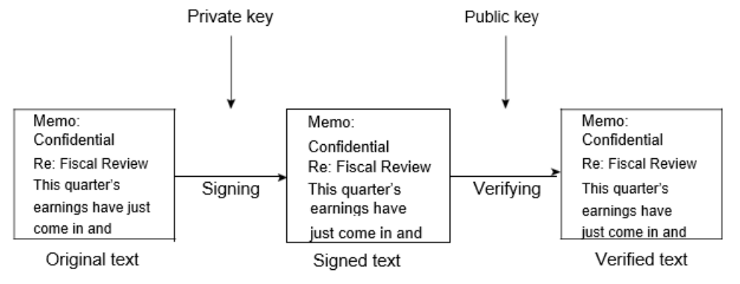
- If the information can be decrypted with your public key, then it must have originated with you.

- Hash Functions
- A hash function is any well-defined procedure or mathematical function that converts a large variable amount of data into a small amount of data, usually using a single integer that may serve as an index to an array.
- The value returned by a hash function is called a hash value.
- The system described above has some problems.
- It is slow, and it produces an enormous volume of data at least double the size of the original information.
- An improvement on the above scheme is the addition of a one-way hash function.
- A one-way hash function takes variable-length input, in this case, a message of any length (it can even be thousands or millions of bits), and produces a fixed-length output (for example, 160 bits).
- The hash function ensures that, if the information is changed in any way, even by just one bit, an entirely different output value is produced.
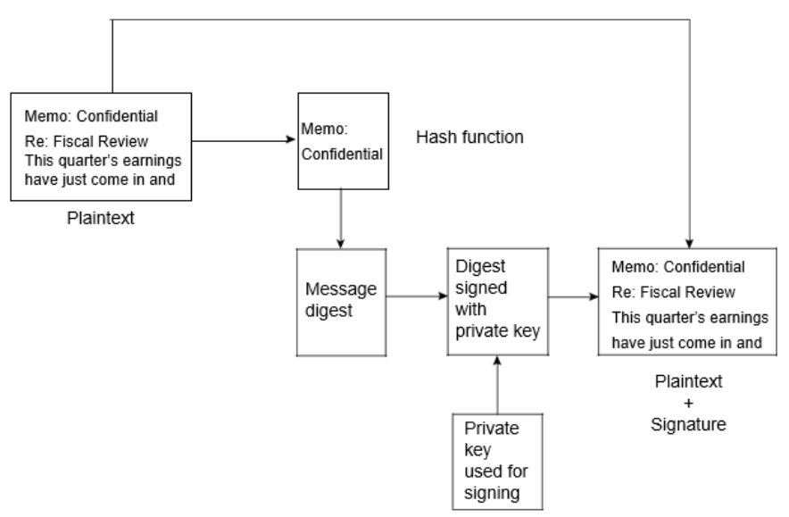
- PGP uses a cryptographically strong hash function on the plaintext the user is signing. This generates a fixed-length data item known as a message digest. (Again, any change to the information results in a totally different digest.)
- Then PGP uses the digest and the private key to create the “signature.”
- PGP transmits the signature and the plaintext together.
- Upon receipt of the message, the recipient uses PGP to recompute the digest, thus verifying the signature.
- PGP can encrypt the plaintext or not; signing plaintext is useful if some of the recipients are not interested in or capable of verifying the signature.
- As long as a secure hash function is used, there is no way to take someone’s signature from one document and attach it to another or to alter a signed message in any way.
- The slightest change in a signed document will cause the digital signature verification process to fail.
- Digital signatures play a major role in authenticating and validating other PGP users’ keys.

- One issue with public key cryptosystems is that users must be constantly vigilant to ensure that they are encrypting to the correct person’s key.
- In an environment where it is safe to freely exchange keys via public servers, man-in-the-middle attacks are a potential threat.
- In this type of attack, someone posts a phony key with the name and user ID of the user’s intended recipient.
- Data encrypted to, and intercepted by, the true owner of this bogus key is now in the wrong hands.
- In a public key environment, it is vital that you are assured that the public key to which you are encrypting data is in fact the public key of the intended recipient and not a forgery.
- You could simply encrypt only to those keys which have been physically handed to you.
- But suppose you need to exchange information with people you have never met; how can you tell that you have the correct key?
- Digital certificates, or certs, simplify the task of establishing whether a key truly belongs to the purported owner.
- Webster’s dictionary defines a certificate as “a document containing a certified statement, especially as to the truth of something.”
- A certificate is a form of credential.
- Examples might be your passport, your social security card, or your birth certificate.
- Each of these has some information on it identifying you and some authorization stating that someone else has confirmed your identity.
- Some certificates, such as your driver’s license, are important enough confirmation of your identity that you would not want to lose them, lest someone use them to impersonate you.
- A digital certificate is data that functions much like a physical certificate.
- A digital certificate is information included with a person’s public key that helps others verify that a key is genuine or valid.
- Digital certificates are used to thwart attempts to substitute one person’s key for another.
- A digital certificate consists of three things:
- A public key
- Certificate information (“identity” information about the user, such as the name and user ID)
- One or more digital signatures
- The purpose of the digital signature on a certificate is to state that the certificate information has been attested to by some other person or entity.
- The digital signature does not attest to the authenticity of the certificate as a whole; it vouches only that the signed identity information goes along with, or is bound to, the public key.
- While some security experts believe it is not a good practice to mix professional and personal identity information on one key, but rather have separate keys for each, you will come across certificates containing a public key with several associated identities (for example, the user’s name and corporate email account, the user’s nickname and home email account, or the user’s maiden name and college email account—all in one certificate).
- The list of signatures of each of those identities may differ; signatures usually attest to the authenticity of one of the identities, not that all three are authentic.
- For example, suppose your coworker, Alice, asks you to sign her certificate.
- You look it up on the server and see that Alice has two pieces of identity information associated with the certificate.
- The first one reads “Alice Petucci, alice@securecompany.com.”
- Depending on how well you know Alice, you might want to choose to sign only the one that relates to the Alice you know at work.
- When a user encrypts plaintext with PGP, PGP first compresses the plaintext.
- Data compression saves modem transmission time and disk space and, more importantly, strengthens cryptographic security.
- Most cryptanalysis techniques exploit patterns found in the plaintext to crack the cipher.
- Com-pression reduces these patterns in the plaintext, thereby greatly enhancing resistance to cryptanalysis. (Files that are too short to compress or that don’t compress well aren’t compressed.)
- PGP then creates a session key, which is a one-time-only secret key.
- This key is a random number generated from the random movements of your mouse and the keystrokes you type.
- This session key works with a very secure, fast conventional encryption algorithm to encrypt the plaintext; the result is ciphertext.
- Once the data is encrypted, the session key is then encrypted to the recipient’s public key.
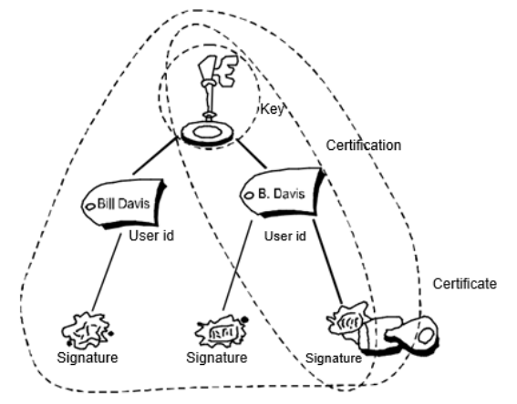
- This public key-encrypted session key is transmit-ted along with the ciphertext to the recipient.

- RANDOM KEY GENERATION
- A key is a value that works with a cryptographic algorithm to produce a specific cipher text.
- Keys are basically really big numbers.
- Key size is measured in bits; the number representing a 1024-bit key is enormous.
- In public key cryptography, the bigger the key, the more secure the cipher text.
- However, public key size and conventional cryptography’s secret key size are totally unrelated.
- A conventional 80-bit key has the equivalent strength of a 1024-bit public key.
- A conventional 128-bit key is equivalent to a 3000-bit public key.
- Again, the bigger the key, the more secure, but the algorithms used for each type of cryptography are very different and thus comparison is like that of apples to oranges.
- While the public and private keys are related, it’s very difficult to derive the private key given only the public key; however, deriving the private key is always possible given enough time and computing power.
- This makes it very important to pick keys of the right size: large enough to be secure, but small enough to be applied fairly quickly.
- Additionally, you need to consider who might be trying to read your files, how determined they are, how much time they have, and what their resources might be.
- Larger keys will be cryptographically secure for a longer period of time.
- If what you want to encrypt needs to be hidden for many years, you might want to use a very large key.
- Of course, who knows how long it will take to deter-mine your key using tomorrow’s faster, more efficient computers?
- There was a time when a 56-bit symmetric key was considered extremely safe.
- Keys are stored in encrypted form.
- PGP stores the keys in two files on your hard disk; one for public keys and one for private keys. These files are called keying.
- As you use PGP, you will typically add the public keys of your recipients to your public keying.
- Your private keys are stored on your private keying.
- If you lose your private keying, you will be unable to decrypt any information encrypted to keys on that ring.

- AUTHENTICATION METHODS
- All methods of authentication require you to specify who or what you are and to relay the appropriate credentials to prove that you are who you say you are.
- These credentials generally take the form of something you know, something you have, or something you are.
- What you know may be a password.
- What you have could be a smart card.
- What you are pertains to the field of biometrics, in which sophisticated equipment is used to scan a person in some sense to provide authentication.
- The important element is to recognize that different mechanisms provide authentication services with varying degrees of certainty.
- Choosing the proper authentication technology largely depends on the location of the entities being authenticated and the degree of trust placed in the particular facets of the network.

- EMAIL SECURITY
- In the last few years, several important research papers have examined how to protect information or resources from unauthorized users.
- Password authentication is the most commonly used method because it is easy to use and relatively inexpensive.
- The user name and password are often used in the real world.
- It’s a method that is based on “what you know” for authentication.
- It is the simplest way of authentication and it provides each user with a unique user name and a secret password.
- Unfortunately, it is also easy to get attacked by password guessing.
- The biggest problem of a good password is that users forget them easily.
- Although most users can remember one or two IDs and passwords for sites they often visit, it is becoming impossible to remember several different IDs and passwords for sites that are visited less frequently.
- As long as a user can enter the correct user name and password, the computer and system will assume that the operator who using the computer is the legal user or original user.
- Actually, many of the users often use a character string, which is easy to guess, such as the date of a birthday, telephone number, or a pet’s name to prevent forgetting their password.
- Many users also write down the password on paper and hide it some place where they think it might be safe.
- Thus, it may cause the information to get lost or to be stolen.
- Even if one can ensure that the user name and password won’t be stolen, it’s still not very safe.
- This is because the user’s name and password are stored in a static state in a data-base.
- Thus, the name and password need to be transferred on the network platform and over computers’ memories during the authentication process.
- The authentication information will be the same every time, so it is easy to get attacked by Trojan horses or spy monitors watching traffic on the network.
- Thus, from a security point of view, using a user name and password is an unsecure method for authentication.
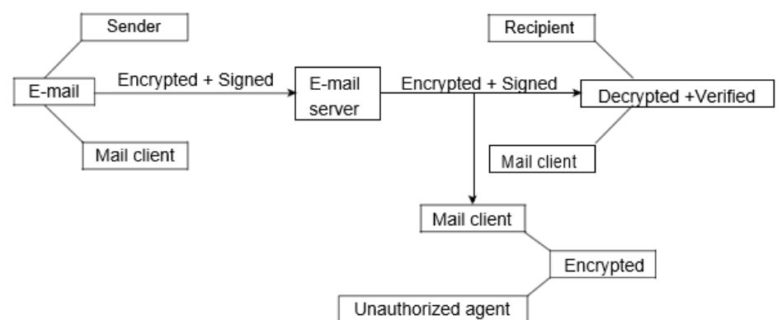

- CHALLENGE HANDSHAKE AUTHENTICATION PROTOCOL
- The Challenge Handshake Authentication Protocol (CHAP) is used to peri-odically verify the identity of the peer using a 3-way handshake.
- CHAP is a remote access authentication protocol that is used in conjunction with a Point-to-Point Protocol (PPP) to provide security and authentication to users of remote resources.
- The process of authentication works in the following manner:
- After the link establishment phase is complete, the authenticator sends a challenge message to the peer.
- The peer responds with a value calculated using a one-way hash function.
- The authenticator checks the response against its own calculation and is acknowledged; otherwise the connection is terminated.
- At random intervals, the authenticator sends a new challenge to the peer, and repeats steps 1 through 3.

- CHAP provides protection against the playback attack by the peer through the use of an incrementally changing identifier and a variable challenge value.
- The use of repeated challenges is intended to limit the time of exposure to any single attack.
- The authenticator is in control of the frequency and timing of the challenges.
- This authentication method depends upon a “secret” known only to the authenticator and the peer.
- The secret is not sent over the link.
- Although the authentication is only one-way, by negotiating CHAP in both directions, the same secret set may easily be used for mutual authentication.
- Since CHAP may be used to authenticate many different systems, the name fields may be used as an index to locate the proper secret in a large table of secrets.
- This also makes it possible to support more than one name/secret pair per system, and to change the secret in use at any time during the session.
- However, CHAP requires that the secret be available in plaintext form.
- The irreversibly encrypted password databases commonly available cannot be used.
- It is not useful for larger installations, since every possible secret is maintained at both ends of the link.
- Most companies and organizations have an open distributed environment, with employees free to access services on servers from workstations located anywhere in the world.
- The server needs to be able to control access to authen-ticated users and also authenticate users’ requests for the service.
- However, in this environment, any of the workstations might not be trusted, and it is hard to authenticate their users through the network.
- One of the potential threats is that an unauthorized user might pretend to be another user to access the workstation.
- Kerberos was developed to address this problem.
- It is a centralized authentication method used to authenticate the user to the server and the server to user.
- Kerberos is an authentication protocol based on conventional encryption that has received widespread support and is used in a variety of systems.
- Kerberos includes the Authentication Server (AS) and Ticket-Granting Server (TGS).
- When a user sends a request to the server for login, then the AS will verify the user’s identity in the system’s database and generate the TGS ticket and a session key to the workstation.
- The workstation decrypts the message and sends the ticket and authenticator to the TGS and server.
- The server verifies the ticket and authenticator; if they are a match, then the server grants access to the services.
- A token is a security device that authenticates the user by having the appropriate permission (such as a password) embedded into the token itself.
- The essence of token-based authentication is that you must have the token in your possession to authenticate yourself to the computer.
- The computer will not recognize you without the token, regardless of whether the token was lost, lent, or stolen.

- Here is a summary of the fundamental properties of tokens from a security standpoint:
- A person must physically possess the token to use it.
- A good token is hard to duplicate.
- A person can lose a token and unintentionally lose access to a critical resource.
- People can detect stolen tokens by taking an inventory of the tokens they should have in their possession.

- Tokens generally fall into two categories:
- Passive and
- Active.

- In both cases, the token incorporates a base secret, and one must copy the base secret to make a working copy of a particular token.
- A passive token is simply a storage device for the base secret. Some examples are:
- ATM cards
- Mechanical keys, and
- Specialized devices like “data keys.”

- An active token can generate different outputs under different circumstances. For example:
- An active token can take part in a challenge response authentication protocol or provide other crypto functions that use the token’s base secret.

- Traditionally, active tokens have been either commercial one-time password tokens or smart cards, though other models have evolved that plug into existing ports on desktop and laptop computers.
- Tokens are a passive authentication method in the form of a plastic card with a magnetic strip.
- Today, they appear everywhere:
- ATM cards
- Credit cards
- Driver’s licenses
- Supermarket VIP cards and
- Employee badges to operate electronic door locks.

- BIOMETRICS
- Biometrics was first introduced in the 1970s and early 1980s.
- This technology gathers the unique physiological or behavioral attributes of a person for storage in a database or comparison with data already found in the database.
- Biometrics look for specific characteristics, often unique and measurable, that allow for the recognition and identification of human.
- These days, biometric technologies are typically used to analyze human characteristics for security purposes.
- Five of the most common physical biometric patterns analyzed for security purposes are taken from:
- Fingerprints
- Hands
- Eyes
- Face and
- Voice.

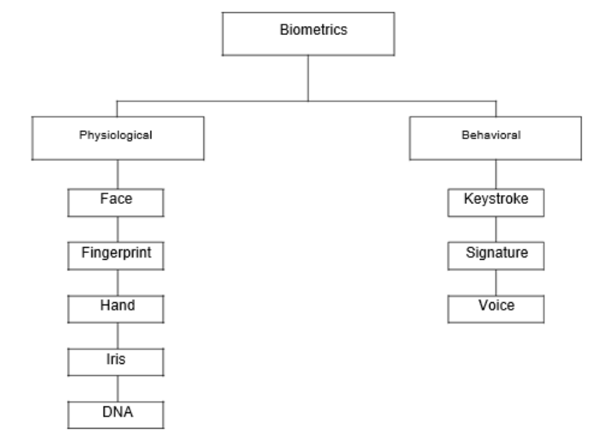
- A definition used in the biometrics industry includes the following:
- The lowest level of security is defined as something you have in your possession, such as an ID badge with a photograph on it.

- The second level of security is something that you know, such as a password used with a computer login or PIN code to use your bank account card on an ATM.

- The highest level of security is information about what you are and something that you do. This is essentially what biometric technology is all about.

- Physiological biometrics use algorithms and other methods to define identities in terms of data gathered from the direct measurement of the human body.
- Biometric information includes that from:
- Fingerprints
- Hand geometry
- Iris and retina scanning
- Facial geometry
- Iris patterns
- Facial features, and
- Retinal blood vessels.

- Behavioral biometrics involves analyzing a specific action of a person.
- How a person talks, signs their name, or types on a keyboard is a method of deter-mining identity when analyzed correctly.
- Biometrics can be defined as either passive or active.
- Passive biometrics does not require a user’s active participation and can be successful without a person even knowing that they have been analyzed.
- Active biometrics does require a person’s cooperation and will not work if they deny their participation in the process.
- Mouse dynamics is one type of biometric that can be used in both active as well as passive monitoring.
- Although biometric technologies differ, they all work in a similar fashion: the user submits a sample that is an identifiable, unprocessed image or recording of the physiological or behavioral biometric via an acquisition device (for example, a scanner or camera).
- This biometric is then processed to extract information about distinctive features to create a trial template or verification template.
- Figure 2.6 shows some often-used biometrics methods.
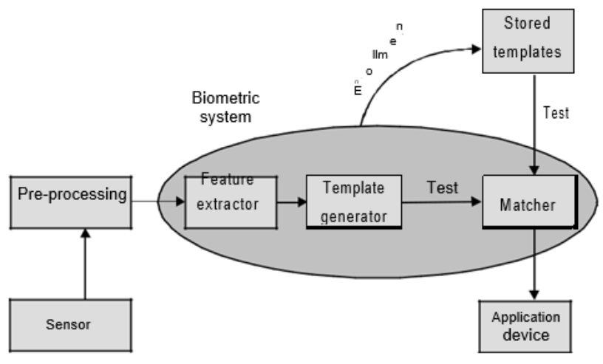

- It can be scanned optically, but the cameras needed are bulky.
- A capacitate technique uses the differences in the electrical charges of the whorls on the finger to detect those parts of the finger touching a chip and not touching it.
- The data is converted into a graph where the ridges are represented by vertices, and the vertices corresponding to the adjacent ridges are connected.
- Each vertex has a number approximating the length of the corresponding ridge.
- At this point, determining matches becomes a problem of graph matching.
- This problem is similar to the classical graph isomorphism problem, but because of the imprecision in measurements, the graph generated from the fingerprint may have different numbers of edges and vertices.
- Thus, the matching algorithm is an approximation.
- Authentication by voice, also called speaker verification or speaker recognition, involves the recognition of a speaker’s voice characteristics or verbal information verification.
- The former uses statistical techniques to test the hypothesis that the speaker’s identity is as claimed.
- The system is first trained on fixed pass-phrases or phonemes that can be combined.
- To authenticate, either the speaker says the pass-phrase or repeats a word (or set of words) composed of the learned phonemes.
- Verbal information verification deals with the contents of utterance.
- The system asks a set of question such as “What is your mother’s middle name?” and “In which city were you born?”
- It then checks that the answers spoken are the same as the answers recorded in its database.
- The key difference is that speaker verification techniques are speaker-dependent, but verbal information verification techniques are speaker-independent, and only rely on the content.
- Authentication by eye characteristics uses the iris and the retina.
- Patterns within the iris are unique for each person.
- Hence, one verification approach is to compare the patterns statistically and ask whether the differences are random.
- A second approach is the correlate the images using statistical tests to see if they match.
- Retinal scans rely on the uniqueness of the patterns made by blood vessels at the back of the eye.
- This requires a laser beam to scan the retina, which is highly intrusive.
- This method is typically used only in more secure facilities.
- Facial recognition consists of several steps.
- First, the face is located.
- If the user places her face in predetermined position (for example, by resting her chin on a support), the problem becomes somewhat easier.
- However, facial features such as hair and glasses may make the recognition harder.
- Techniques for doing this include the use of a neural network and templates.
- The resulting image is then compared with the relevant image in the database.
- The correlation is affected by the differences in the lighting between the current image and the reference image, by distortion, by noise, and by the view of the face.
- The correlation mechanism must be trained.
- Several different methods of correlation have been used, with varying degrees of success.
- An alternative approach is to focus on the facial features, such as the distance between the nose and the chin, and the angle of the line drawn from one to the other.
- Keystroke dynamics methods are now used to identify individuals.
- Many security analysts believe the measurement of keystroke pressure, intervals of keystrokes, and how hard the key is pushed, can help to identify users.
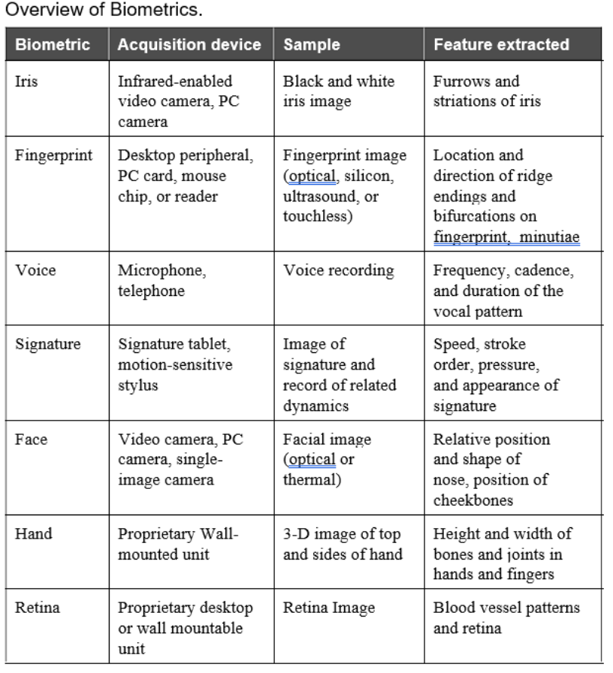

Unit 6
Digital Signatures
- Introduction
- People have used signatures for about as long as they’ve communicated beyond the spoken word — starting with handprints accompanying cave paintings.
- Signatures add everything from a touch of personal sentiment on a greeting card to a certification of authenticity on a painting to a binding agreement on a contract.
- Digital signatures take the concept to a whole new level, as society’s communications and business transactions move from physical representations to bits and bytes. U.S.
- President Ronald Reagan was famous for citing a Russian proverb that advised “trust but verify” — a digital signature does both. This chapter spells out some of the reasons for using digital signatures, explores how the concept has evolved, and explains how rules and standards make the world of digital signatures work.
- Organizations are now bringing online a lot of items that historically have been offline. Enormous savings are possible for government, companies, individuals, and the environment if it’s possible to communicate — and also commit and be held liable — electronically rather than on paper.
- Here are some of the things digital signatures can do:
- Serve as an enabler for a business’s digital strategy
- Provide non-repudiation with the strongest legal value
- Offer “what you see is what you sign” functionality
- Create a legally binding commitment
- Ensure enhanced security
- Provide end-user convenience and mobility
- Offer cost efficiency for all stakeholders

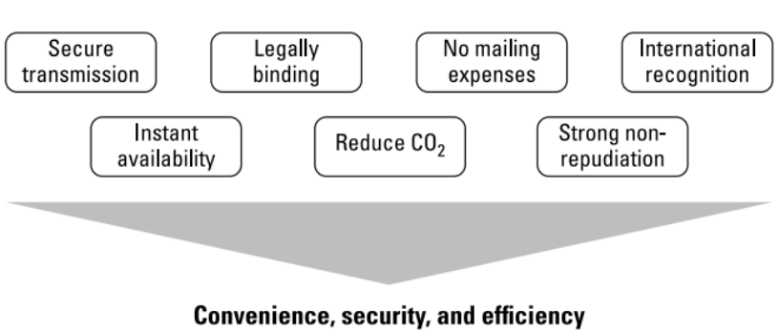
- As shown in Figure below, the benefits of digital signatures add up to convenience, security, and efficiency.
- Every organization determines its strategic priorities: perhaps speed to market and service, or maybe operating cost reduction. Those priorities provide the motivation for using digital signatures now.
- Today’s world is online, and if your organization is online, you need to be professional with your online presence.
- You need to demonstrate how much you care about the quality of those services; one way is through the use of digital signatures.
- It’s a competitive world out there, and everyone wants to obtain a competitive advantage.
- Its best if digital signatures are seen as your advantage, and not your competitor’s.
- A SIGN OF TRUST
- A digital signature provides trust. Some have likened it to a seal on a letter, which is a time-honored symbol designed to create trust in a paper document, but it’s a whole lot more than that.
- The trust a digital signature brings can take a number of forms, best illustrated by example.
- An organization wants to send out a tender document to selected companies, asking them to bid for a range of services.
- Such documents are often regarded as confidential or sensitive.
- If that’s the case, the document would probably be encrypted and sent to the specified recipients, who would be provided with the encryption key needed to read the document.
- But what if this organization specifically does not want to send this tender document out encrypted?
- Say it’s a public-sector body wanting to demonstrate transparency?
- Maybe encryption is not appropriate, but it’s still necessary to demonstrate the document is “authentic” with a source of origin that can be traced.
- It’s also important to certify that the document is complete and that it hasn’t been modified en route to its recipients.
- The use of a digital signature achieves these objectives.
- Within the tender, data such as tender dates, quantity measurements, and quality considerations are all details that responding organizations must be able to rely upon.
- This trust is established by encrypting the tender document with a private key, which the responding companies can verify using the corresponding public key.

- A Tool for Building Confidence
- Digital signatures have been available since the mid-1970s and started being deployed into business services in the late 1980s.
- Usage at scale started some years later, but the concept did not catch on as quickly as anticipated, compared to digital services overall. Has the tide now turned forever? It certainly seems so.
- Digital signatures are about trust.
- Within the past decade, billions of consumers have become comfortable spending time and trans-acting business online, using multiple device types.
- This requires trust so it isn’t surprising that take-up, usage, and interest in digital signatures is now, at long last, growing.
- Digital communication and digital business are now natural and mainstream — services pretty much have to be online.
- Digital services are commercially critical in order to satisfy customer demands quickly and economically.
- What’s more, today’s consumers expect such services to be not only prompt, but also convenient and easy to use.
- Banks, in particular, are driving everything online, making major reductions in their physical presence.
- Their efforts are due in large part to evaporating footfall.
- At the same time, there’s an ever-growing range of cybersecurity threats and scams making the headlines, and that is a destabilizing factor for everyone.
- Organizations appear to believe they have adequate disaster-recovery options in place to help them deal with major actual or perceived challenges.
- The resilience of online systems and services matters like never before, and is taken for granted by the majority of consumers who are frustrated when technology malfunctions.
- When correctly deployed, digital signatures can be among the range of valuable, confidence-lifting countermeasures available to businesses operating in the ultra-digital landscape.
- The value of a digital signature is dependent upon sound implementation and management of cryptographic techniques.
- This requires discipline and rules to ensure interoperability with existing systems.
- It takes teamwork and partnership to make technology adoption run and grow smoothly.
- To use digital signatures successfully for a prolonged period of time, you’ve got to get business and technical considerations to work in harmony.
- That’s easy to say, but rather difficult to accomplish and sustain for years or even decades.
- In a word, it takes rules. To get the level of trust you’re seeking from digital signatures, it takes a set of widely recognized and accepted rules.
- Those who live or do business in the European Union know the EU loves its rules, and with so many member states transacting business with one another, it needs those rules.
- In the case of digital or electronic signatures, the EU saw the value early on.
- The European Parliament issued Directive 1999/93/EC in — you guessed it! — 1999, providing a great start on a Community Framework for Electronic Signatures.
- This directive was well intentioned and should have encouraged the use and take-up of digital signatures. But it didn’t.
- Why didn’t it work out? A big reason is that 1999/93 didn’t require EU members to use common technical standards.
- There wasn’t the cooperation or technical interoperability to make cross-border electronic transactions practical.
- By contrast, the adoption of chip payment cards shows how interoperability can lead to success.
- So, maybe 1999/93/EC didn’t get it right first time, but that didn’t matter much because the marketplace wasn’t ready to accept and adopt the technology, anyway.
- Consumer confidence and take-up of online services was in its infancy.
- Remember, this was more than three years before the launch of Facebook, and seven and a half before the launch of the iPhone!
- Fast-forward 15 years or so, when 1999/99/EC was superseded by regulation 910/2014, focusing on electronic identification and trust services for electronic transactions in the internal market.
- This eIDAS Regulation was published in July 2014 and became internal market-effective two years later.
- Member states were given until July 1, 2017 to migrate to this new regulation.
- Digital signatures have now been reenergized.
- There’s a desire and commitment to put the technology and supporting services to work.
- Consumers have the technology available now, they can use it, and they do!
- They way this story has unfolded reflects a truth in the wider discipline of cryptography, when applied to business and everyday life.
- Cryptography used to be the responsibility of a few people in the IT department.
- These days, cryptography matters to business like never before.
- The use of digital signatures and cryptography can provide major business opportunities and benefits, but can also introduce unforeseen development and managerial issues.
- Such issues can, in turn, give rise to significant but unexpected costs and constraints for your business, often years after the original decisions were taken.
- That’s a very good reason to use the products and services of vendors that have a proven track record of experience and knowledge.

- EMV CHIP CARDS AND INTEROPERABILITY
- Almost everyone uses credit or debit cards, and many people have several.
- They’re ideal for buying everything from a coffee to a major appliance or even a car.
- But those extra-secure cards with embedded chips have taken a good while to become commonplace, and they would not have without solid technical (interoperability) standards.
- Payment chip cards were introduced domestically in France in early 1990s.
- Later, international card schemes combined to develop the EMV framework/specification for global use.
- The United Kingdom (UK) introduced them in late 1997, started national rollout in 2003, and has moved onto EMV-based contactless cards.
- Still, EVM payment cards retain their magnetic stripe and have embossed details.
- Why? To allow global interoperability.
- EMV is global, and chip cards are used in Europe, Asia, and Australia, plus the United States and Canada.
- But it has taken more than 20 years to reach its current maturity.
- What drivers contributed to chip card adoption? First, commercial necessity.
- Fraud losses in the early 1990s were unsustainable; some-thing had to be done.
- Progress was made possible by technical standards (the “framework,” if you will).
- Standards ensured chips and the data in them complied to specifications and functioned with point-of-sale terminal infrastructure.
- Meanwhile, the payment messages transmitted by merchants to acquirers and card schemes had to conform to the standards, too.
- Interoperability was a complicated achievement consumer’s take for granted.
- You may be starting to see the parallel between where payment cards were a decade ago and where digital signatures are now.
- A global system won’t gain traction and succeed without interoperability and convenience/ease of use.
- Consider this maxim that EMV illustrates: Once a mechanism becomes established, subsequent rates of deployment and innovation accelerate.
- Chip cards were the first new thing in decades, and subsequent evolution of contactless cards has been impressive.

