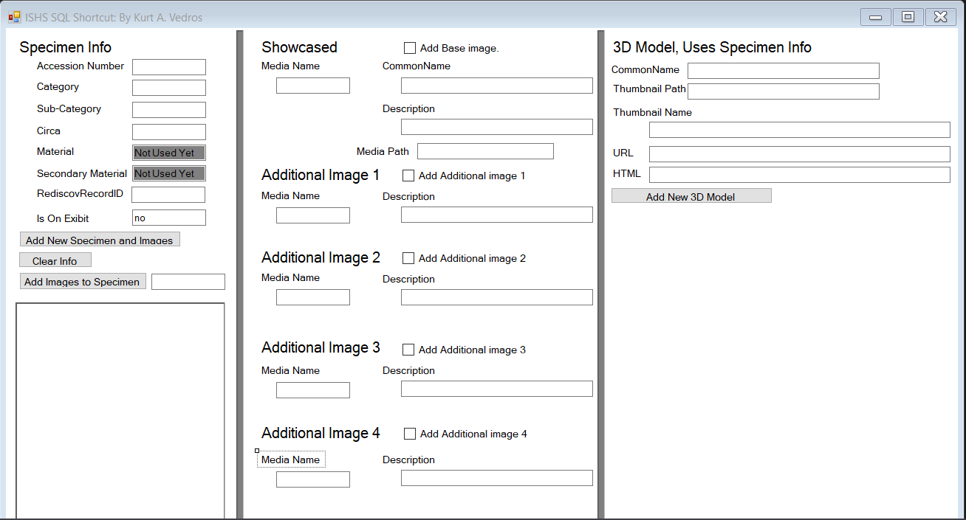

Under Specimen Info

AccessionNumber is the number associated to the artifact.

Category is the category the artifact is listed, example clothing, weapon or documentation.

Sub-Category is a second category the artifact has.

Circa is the century the artifact is from.

Material and Second Material is no longer used in the database by owners request.

RediscovRecordID is the ID number linking to another database with information on the artifact.

Is On Exbit is a bit info on whether or not to display the artifact on the web.

Under Showcased (used for 2D Images)

Media is the file name of the image to upload. Note that the media file had to contain the image as well as the spliced images created using an application called Image Composite Editor.

CommonName is the name the webpage will display.

Description is a small description how editors use. Common to state if it’s a front or side view image.

Media Path is the file location on the desktop that you wish to upload.

CheckBoxes was created to be able to upload multiple images of the same artifact as onces.

(Note: better ways to do this but since max was usually only up to 4 additional images was needed and I was the only one to be using this program I did it this way.)

Under 3D Model

CommonName is the name the webpage will display.

Thumbnail Path is the file location of the sample image to display.

Thumbnail Name is the file name of the sample image to display.

URL and HTML is used to pull from a site that contains the 3D image.