Kurt Leadley

Web231

Assignment 9.2

July, 24th 2019

Steps with pictures:

**Step 1:** Press the F12 key:

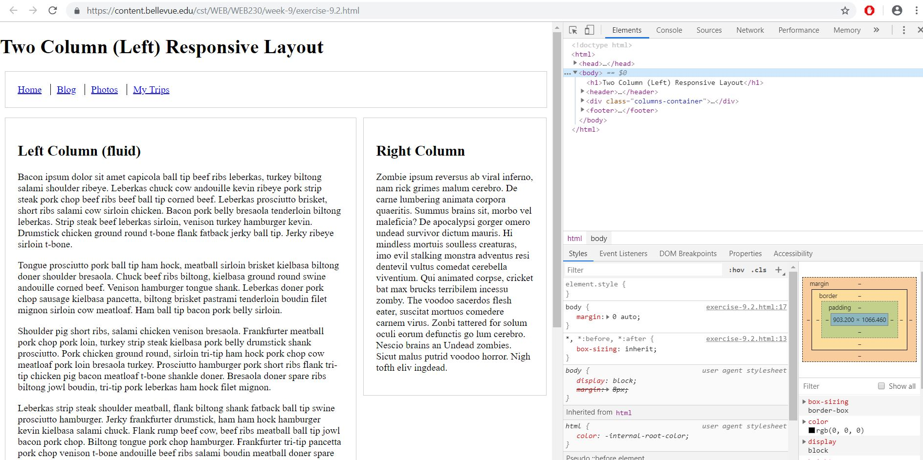

**Step 2:** Right click the element you want to inspect and choose “Inspect”. The element should be highlighted a light blue in your inspector. Make sure you have chosen the “Elements” tab if you do not see your highlighted element.

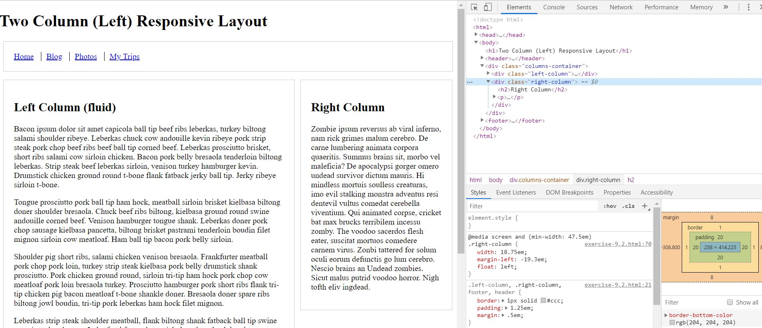

**Step 3:** Style the element by adding *background-color: steelblue; color: white;* to the element selector in the “Styles” section of the inspector. I circled the bolded out areas. The bold indicates that editing those parts of the CSS will affect the element. I chose to place the background and text color in *element.style{}* however. This only works in the browser, you would have to specifically target the element in the CSS to change the background and font color (not by adding it to element.style).

I chose element.style though because the selector *.left-column, .right-column, footer, header {}* would add background color to the footer and header. Which is not in the instructions. I also chose not to style the @media query because that would only add background color at certain resolutions.

To truly style the left and right div, you would want to add to your CSS:

*.right-column, .left-column {background-color:steelblue; color:white;}*

The Styles section of the inspector though are a good area to test out styles before actually adding them to your real CSS file or style tag.

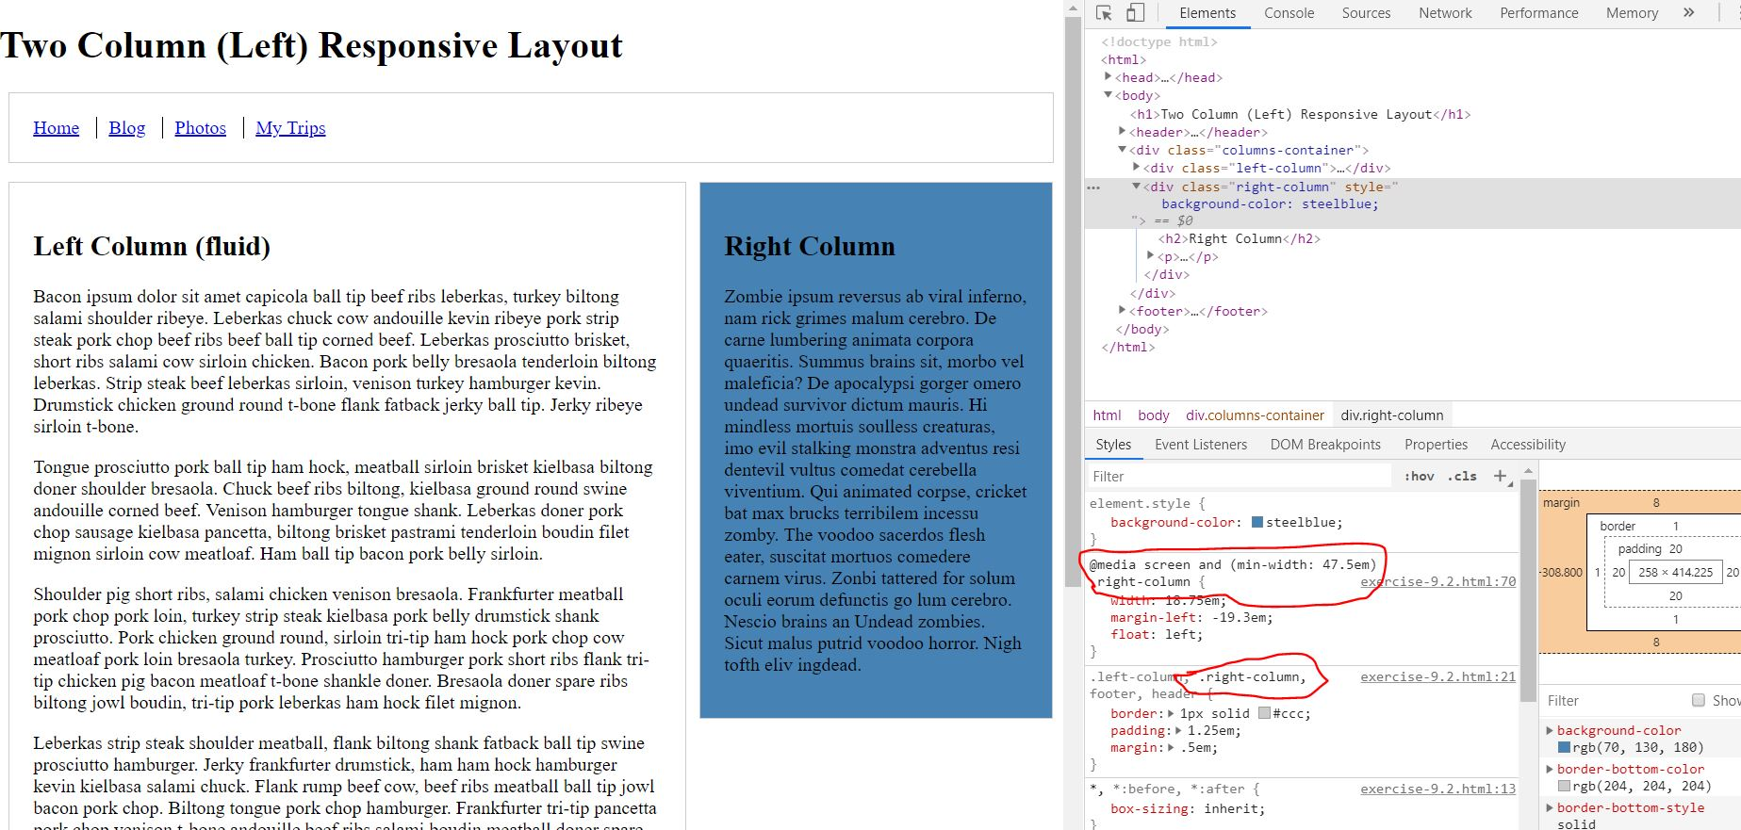

**Step 4**: Select the left column div and repeat the process you did for the right column.

