Kurt Leadley

Web231

Assignment 9.3

July, 25th 2019

Step 1: Open your html file in the Firefox browser and press the F12 key.

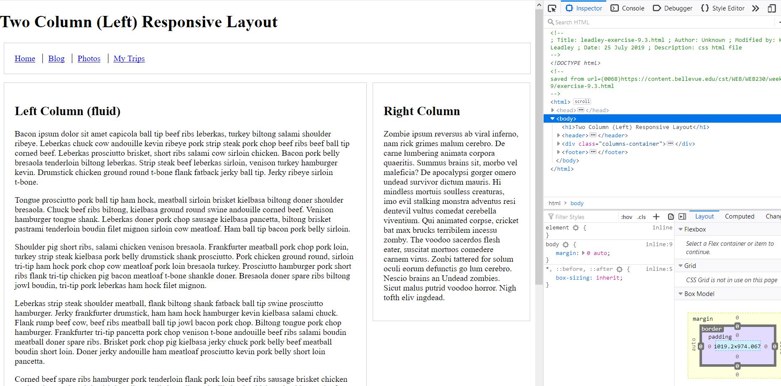

Step 2: Right click the header and select “Inspect Element”. The element should get highlighted blue in the inspector. If you don’t see it, make sure you have the “Elements” tab selected

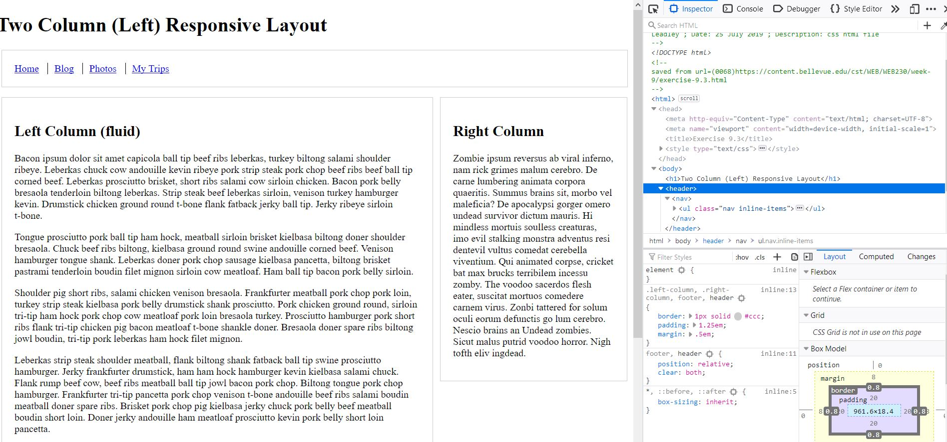

Step 3: We want to add steelblue background to the header and footer. You can see on the right that there is a *footer, header {}* CSS selector. Add *background-color:steelblue;*  and *color:white;* to that selector.

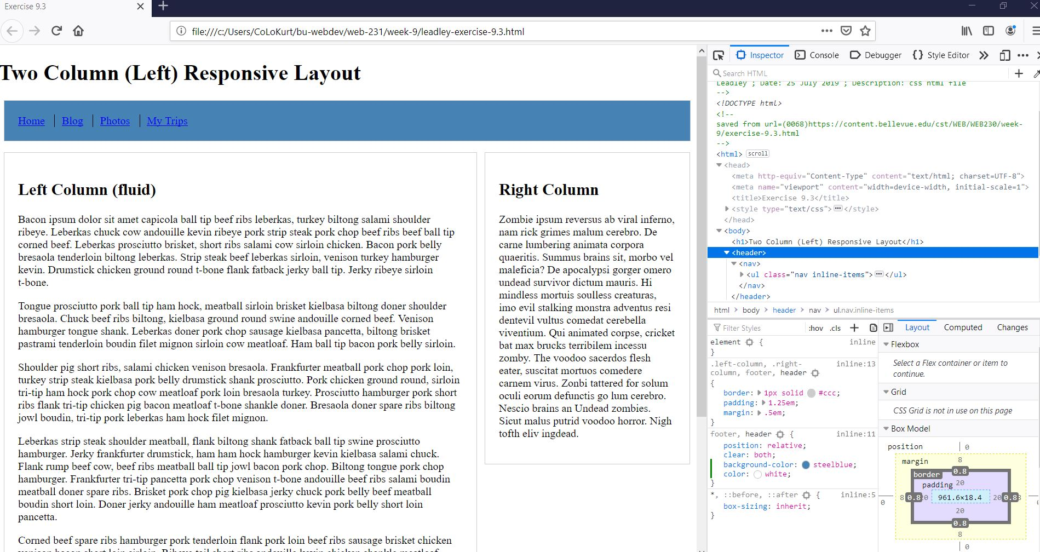

Step 5: We need to add CSS to this HTML file. At the top of the inspector, click on the “{}Style Editor” tab

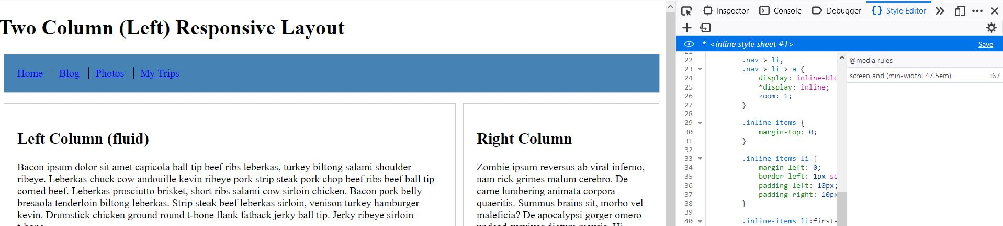

Step 6: On line 12, add *footer a, header a {color:white}* to the css file. This should color your links in the header and footer.

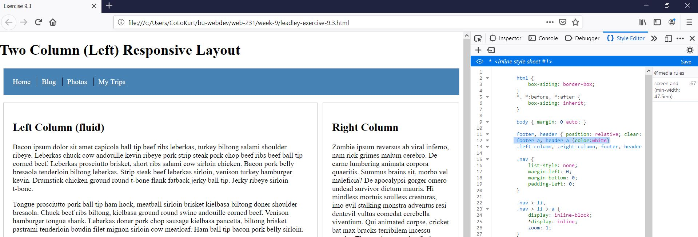

Step 7: If you like, you can save the CSS file. Your other modified CSS from the element inspector will be added to the CSS file as well.

Final shot of edited site:

