Kurt Leadley

Web 330

Assignment 1.5

Professor Krasso

# Personal Portfolio: Market Research

## Portfolio 1: <http://chuckgroom.com/>

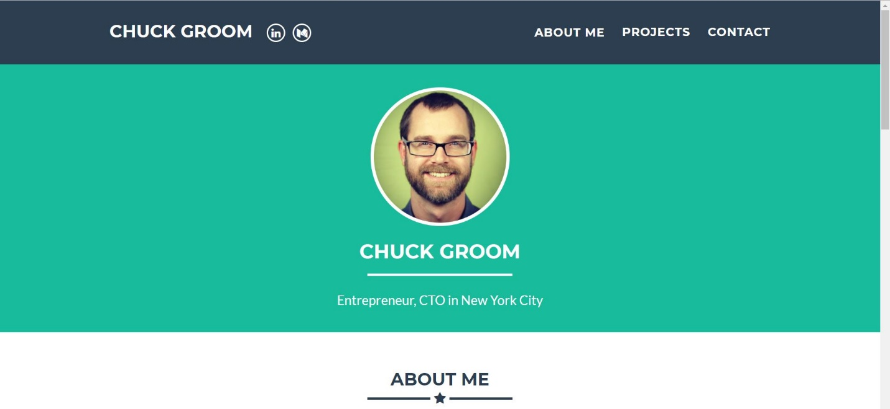

**Features:**

* Top nav bar follows you on scroll.
* The nav links send you to parts of the one pager.

**Layout:** Single column nav, single column header, two column about section, two column project section, 1 column contact me section, 1 column footer. Multi-colimn “Projects” and “About me” sections stack on mobile.

**Style:**

* Pacific Northwest color scheme (think Oregon Ducks, Vancouver Canucks, Seattle Seahawks).
* Lato font,15px default.

**Overall Functionality:**

* Mobile responsive
* navigation (even though it is a single pager)
* contact me form
* social media links

**Advantages:**

* Simple layout makes it easy to navigate.
* Short and to the point.
* There are options to dig deeper into his experience if you follow the links.

**Disadvantages:**

* Puts personal interests in the “Projects” section.
* Not a fan of the giant header section with no content. Very basic, but he is a software guy and not a web designer, so.....
* Nothing really “pops”

## Portfolio 2: <https://brittanychiang.com/>

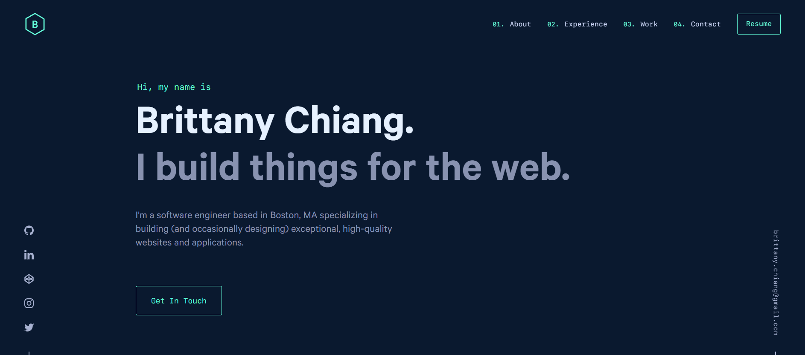

**Features:**

* Nav bar disappears and reappears depending on scroll direction.
* Nav Links link you to parts of her one pager.
* ‘Where I’ve worked’ section shows and hides divs based on the company you pick.

**Layout:** Alternates between 1,2 or 3 column sections from top to bottom. Not a concrete feel to the layout

**Style:**

* Another Pacific Northwest color scheme. Must be popular these days.
* The general feel of the website is that you are inside of an IDE when you are scrolling around.

**Overall Functionality:**

* Links
* Mobile responsive
* Divs hide and show on command
* Social media and email links stick with you as you scroll

**Advantages:**

* Very unique look to the site.
* The site being able to hide and show divs is a nice touch because it lets the user decide if he wants to dive further, or just glance by it.
* A link to her real resume!
* The email and social links that stick in your browser when scrolling up or down (desktop mode only)

**Disadvantages:**

* Her photo is not seen till you scroll down.
* You lose the navigation bar unless you scroll up.

Portfolio 3: <http://kalynnakano.com/>

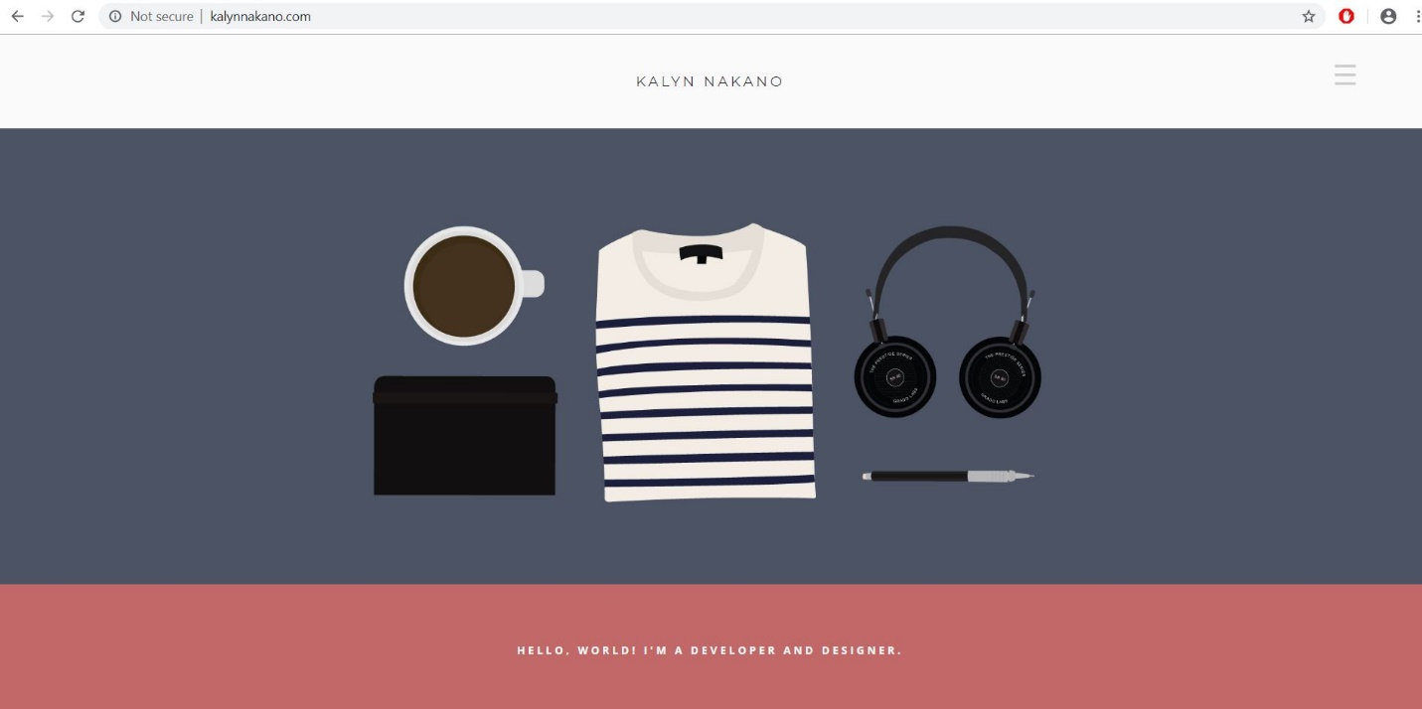

**Features:**

* Custom drawn illustrations (I think)
* Hamburger navigation

**Layout:**

Straight down the middle top to bottom. Mostly 1 column, some 2 column sections. Not all of his divs are aligned. Example:

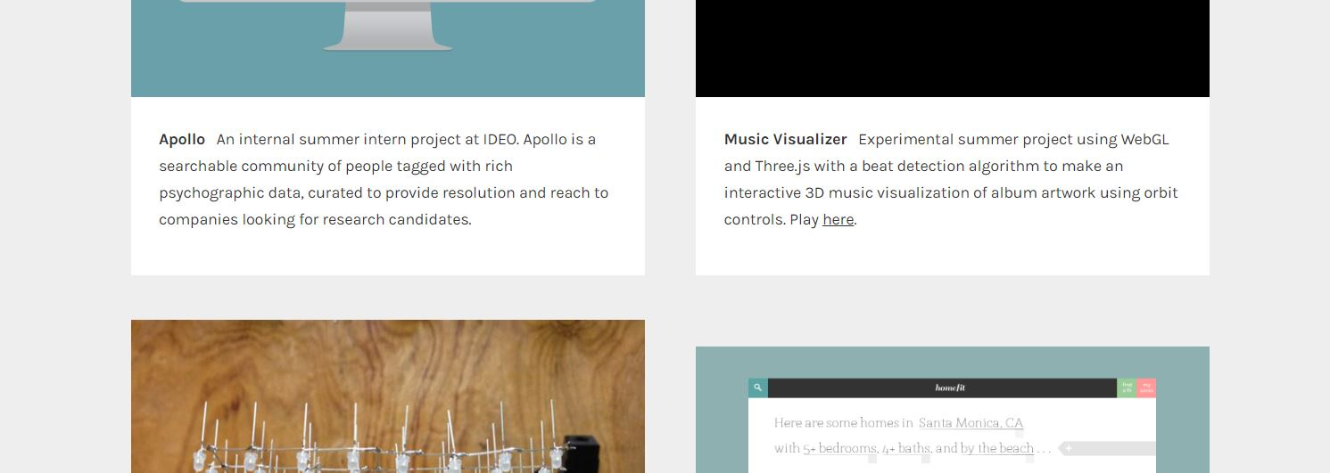

**Style:**

* Not really sure. He changes fonts and font weights in some sections for the same element in other areas.
* Background color changes 4 times from top to bottom.

**Overall Functionality:**

* Not much. Just a hamburger menu and some links

**Advantages:**

* It has personality. For example, the coffee mug, headphones illustration,
* The section where he is adding properties of himself to a Kalyn object is a nice touch.

**Disadvantages:**

* You can barely see the navigation.
* The cell phone section makes no sense to me.
* Some of the divs don’t line up.

## **Winner:** <https://brittanychiang.com/>

This 1 pager to me is way better than the other two. It has personality and functionality without having too much junk in your way. Specific advantages it has over the other two sites are the hidden divs for work experience, the link to her real resume, the social media and email bars that follow you around and the cool introduction animation on page load.

