Upstate Computer Repair

TECHNICAL DESIGN DOCUMENT

|  |  |
| --- | --- |
| **Author** | Kurt Leadley |
| **Last Updated** | 2/27/2020 7:25 PM |
| **Version Number** | 1.0.0 |

**Version History**

|  |  |  |  |
| --- | --- | --- | --- |
| **Name** | **Date** | **Reason for Change** | **Version** |
| Leadley, Kurt | 2/27/2020 | First Build | 1.0.0 |
|  |  |  |  |
|  |  |  |  |
|  |  |  |  |
|  |  |  |  |
|  |  |  |  |
|  |  |  |  |
|  |  |  |  |
|  |  |  |  |
|  |  |  |  |

**Table of Contents**

SECTION 1: INTRODUCTION 3

Purpose 3

Terminology 3

Related Documents 3

Reviewers 3

Required Skills 4

SECTION 2: Architecture 4

Physical Architecture 4

Logical Architecture 4

SECTION 3: PROCESS DESIGN 5

Object Relational Diagram(s) 5

NoSQL Data Structure 5

Wireframes 5

SECTION 4: REFERENCES 6

# SECTION 1: INTRODUCTION

## Purpose:

## 

Upstate Computer Repair is an upstart computer repair shop in Saratoga Springs, New York. Frank Fernando has reached out to our web development firm to build out the website for his store. This website will allow customers to select from an array of services to be applied to their computer. Once the services are selected, the user will have an option to submit their order. When an order is complete, the customer will be given an invoice. There will be no online payment option. Another feature of the website will include a dashboard for an administrator to add / remove / delete / modify the different services provided by Upstate Computer Repair. This feature will include the ability for the administrator to enter how many hours was taken to complete all the repairs.

## Terminology:

|  |  |
| --- | --- |
| **Name** | **Comments** |
| MEAN Stack | MongoDB, Express, Angular, and Node.js |
| VS Code | Development IDE |
| SoapUI | API testing tool |
| MongoDB Compass | Database development IDE  https://www.mongodb.com/products/compass |
| Angular Material | Will use Angular material for a consistent design  <https://material.angular.io/> |
| Flex-layout | <https://github.com/angular/flex-layout> |
| CSS Grid | Will use CSS grid in conjunction with flex-layout for responsive design  https://css-tricks.com/snippets/css/complete-guide-grid/ |
| Heroku | Will host website using Heroku  https://www.heroku.com/ |

## Related Documents:

**Style Guide:** *(created with Angular material.io’s color tool,* [*https://material.io/resources/color*](https://material.io/resources/color)***)***

|  |  |  |
| --- | --- | --- |
| **Color Assignment** | **Hex Code** | **Use** |
| Primary Color | ***#3f747a*** | Nav and footer background color |
| Secondary Color | ***#e53835*** | Use for buttons / nav |
| S - Light | ***#ff6e60*** | Use for error messages |
| P - Light | ***#6ea3a9*** | Use for order submission message |
| Fill color | ***#E1E2E1*** | Background area, offwhite color |

**Font:**

Oxonium

<https://fonts.google.com/specimen/Oxanium>

<link href="https://fonts.googleapis.com/css?family=**Oxanium**&display=swap" rel="stylesheet">

## Reviewers:

Kurt Leadley - Developer, Solution Architect

Professor Eltayeb - Project Manager

Frank Fernando - Client

|  |  |  |
| --- | --- | --- |
| **Approvers** | **Name** | **Date** |
| **Approved By (**Client Acceptors, can be more than one) | Kurt Leadley | 10/27/2020 |
| **Approved By** (Project Manager) | Professor Eltayeb | Pending |
| **Approved By (**Developer, Solution Architect) | Kurt Leadley | 10/22/2019 |
| **Approved By (**Client) | Frank Fernando | 10/27/2020 |

## Required Skills:

* Javascript
* Angular
* MongoDB, NoSQL
* Express
* Heroku
* Node.js
* CSS, CSS Grid, Bootstrap
* Angular Material
* Angular CLI
* SOAP UI

# 

# SECTION 2: Architecture

## Physical Architecture

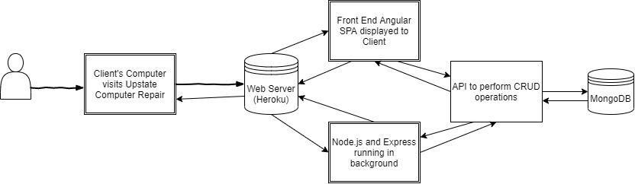

## Logical Architecture

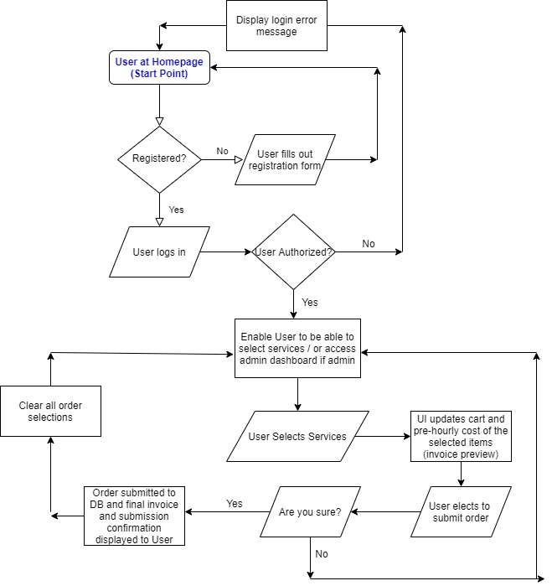

# SECTION 3: PROCESS DESIGN

## Object Relational Diagram:

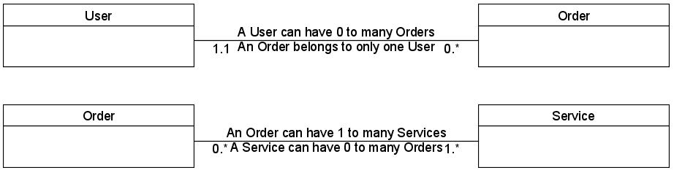

## NoSQL Data Structure:

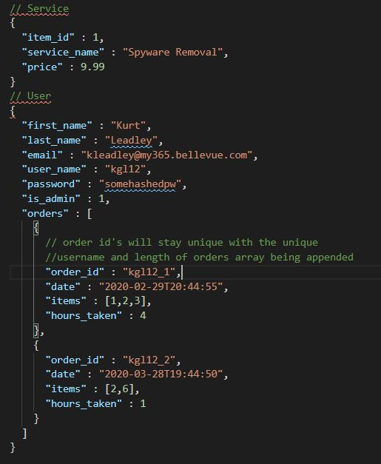

## 

## 

## 

## 

## 

## Wireframes

*(This wireframe will use the angular material library and color scheme shown in the previous style guide section. A custom logo and side image will be selected as well)*

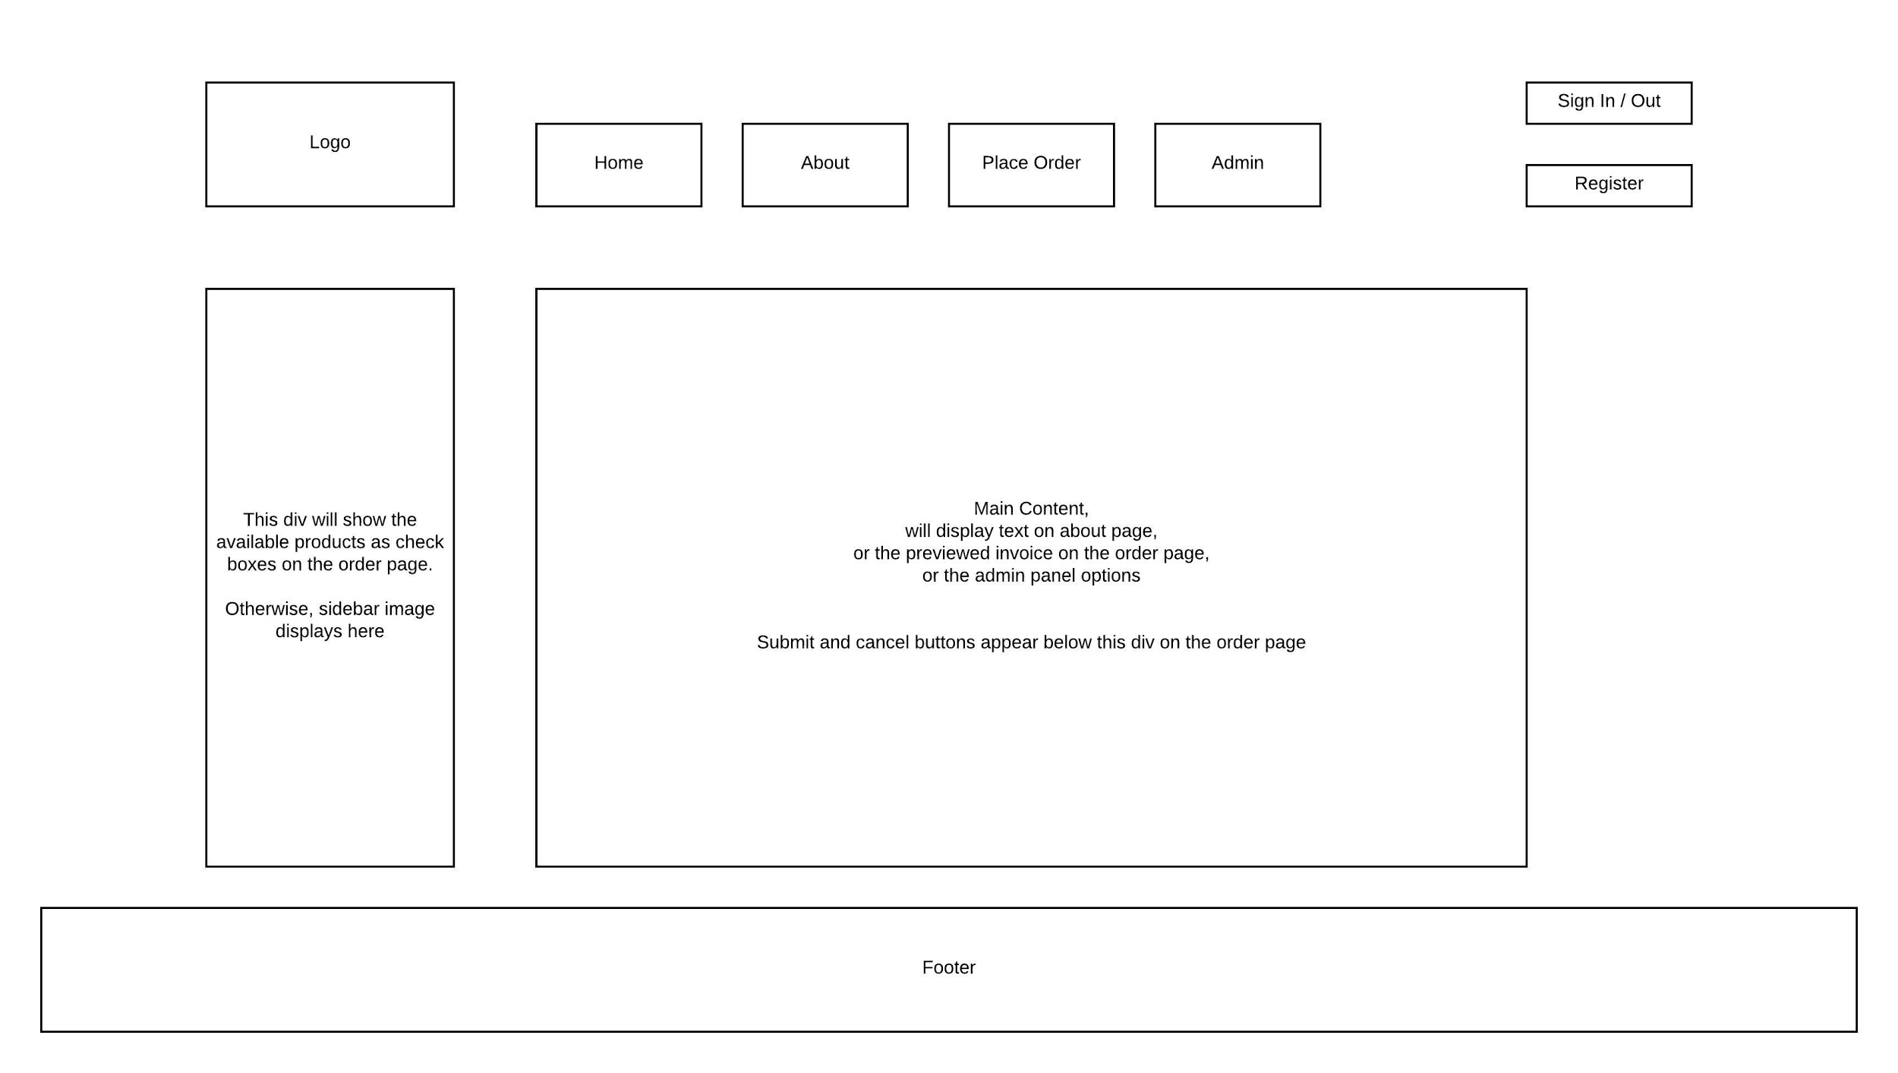

# SECTION 4: REFERENCES

1. A Complete Guide to Grid. (2019, Sep 13). Retrieved from <https://css-tricks.com/snippets/css/complete-guide-grid/>
2. Holmes, S., & Harber, C. (2019). *Getting Mean with Mongo, Express, Angular, and Node*. Shelter Island, NY: Manning.
3. Fain, Yakov; Moiseev, Anton. (2019) *Angular Development with TypeScript*. Shelter Island, NY: Manning Publications Co.
4. Material Design. (n.d). Retrieved from <https://material.io/>