Mid-Project Deliverable

CSCI311 – Software Process Management

The Team

|  |  |  |  |
| --- | --- | --- | --- |
|  |  |  |  |
| James Wilson |  |  | *Project Manager* |
| James Glennan |  |  | *Software Architect* |
| Joshua Brown |  |  | *System Data Specialist* |
| Kurt Robinson |  |  | *Tool Specialist and Change Control Manager* |
| Peter Brown |  |  | *Requirements Analyst and User Interface Engineer* |

|  |  |  |  |
| --- | --- | --- | --- |
|  |  |  |  |
| Feasibility Study |  |  | 1 |
| Risks |  |  | 8 |
| SRS |  |  | ? |
| Detailed Plan |  |  | ? |
| Milestones |  |  | ? |
| Objectives |  |  | ? |
| Archive Map |  |  | ? |
| Visual Data Document |  |  | ? |
| Progress Report |  |  | ? |
| Code of Conduct |  |  | ? |
| Project diaries |  |  | ? |
| Contributions |  |  | ? |
|  |  |  |  |

Feasibility Study

Looking into Software Design and Collaboration Tools

# Executive Summary

This document outlines some of the considerations associated with developing a source code, bug tracking, and software design collaboration tool. Although individually these tools have existed independently of each other, it has been decided that I would be best to incorporate these tools into a ‘super collaboration’ tool, giving all the power of source control, mixed with bug tracking and reporting; while allowing communications between the team to be tracked during the software development process.  
One such software comes close in providing this service, but with the ready availability of multiple tools are open-source or freeware, so why not apply a mix readily existing tools, providing the development community at large, with the tools necessary to complete complex design tasks with minimal concern.

# Product Services

The problem with a product such as this is that, a single all in one solution isn’t readily available on the market, software such as ‘Bugzilla’, is able to accurately keep track of bugs, whereas software such as ‘Gource’ is excellent visual tool for seeing member contributions to software repositories. But none of these packages do everything, ‘Unfuddle’ probably being the closes

## Gource

One aspect of the software that’s being commissioned is being able to graphically visualise the changes being performed to the repository, by tracking the logs (through trunks, commits and checkouts) (acaudwell, 2013). Gource, another open source project provides an amazing display to visualise the data as it makes changes- of course this software is inherently limited since it provides no real other features related to this specification.

## Bugzilla

According to the Bugzilla website, this open source software tracks bugs and code changes, allows you to communicate with teammates and submit/review patches (Bugzilla.org, 2012). It markets itself as being able to “reduce downtime, increase productivity, raise customer satisfaction, and improve communication”.

## Fossil

Fossil (Fossil, 2014) is probably the closest to the sort of software that we’re after. It provides a web-based interface with graphical tools, bug tracking and support for creating your own wiki. The main issues with using this software is that email control, since the requirements specify importing project emails into the source control, although the use of the Wiki could work around this.

## Unfuddle

Unfuddle appears to fill most of the requirements, allowing bug tracking and management of source code, this software can also allow collaboration through a messaging service and wiki. The major downside of this software is that unlike all the previous software, its not freeware, and requires a minimum $15 a month (Unfuddle).

## Product/Service Marketplace

The only reputable competition to this software came from Unfuddle, and with their signup fees, would be a major upset, especially for the casual developer who prefers to use free and easy tools.  
All the other tools failed to capture all the necessity, and it should be noted that even Unfuddle still doesn’t quite do what’s required, its just happens to be the closest thing.  
This sort of software, due to its cost, would be targeted at developers and businesses that can both afford and are large enough to require using a comprehensive source control strategy. Smaller developers have to rely on existing open source and freeware tools, in order to collaborate and create their products, its here that exists a niche market for the serious but small developer.

# Marketing Strategy

Since this software is more likely to be used in-house, there doesn’t really require marketing a program like this. However, if this program is to be released externally, then it should be released as free, allowing for all users to popularise its use and become a staple of the software development community. In order to generate a profit (or at least break-even), advertising space can be bought to complement this software and pay for its development. As well as this, for large organisations a premium service can be offered that gives companies extra support and training for its staff, for a nominal fee, and as such generating a profit.

# Technology Considerations

## Development Environment

This service would potentially be used by a wide number of users each with many different Operating Systems and Configurations, as such, to combat this, the service needs to be platform independent, which can be achieved through use of a web service, requiring a web browser.

## Web Services

|  |  |  |
| --- | --- | --- |
| Service | Advantages | Disadvantages |
|  |  |  |
| Apache | Supports FastCGI  Has a module for PHP  Widely used and well documented  Good support  Runs on all Operating Systems (Best on Linux)  Open source (Free) | Can be very heavy as it supports many features |
|  |  |  |
| Nginx | Supports FastCGI  Runs on all Operating System (Best on Linux)  Extremely Lightweight  Growing and becoming more popular  Open source (Free)  Has easiest to read configuration | Does not support as many features as Apache  Relatively new to other web servers  Not as mature or tested |

## Language Implementation

|  |  |
| --- | --- |
| Language | Features |
|  |  |
| PHP | Object Oriented  Weakly Typed  Just in Time Compilation  Normally has a web server running in front of it (Nginx, Apache, ISS) |
|  |  |
| Java | Object Oriented  Strongly Typed  Compiled to byte code, ten interpreted by Java VM  Normally has a web server running in front of it (Apache Tomcat, Oracle) |
|  |  |
| C++ | Object Oriented  Strongly Typed  Compiled  Robust  Not easy to parse files with |
|  |  |
| Ruby on Rails | Object Oriented  Can easily parse files  Database management somewhat automatic  Easy to learn  High Overhead |

## Storage Solution

|  |  |
| --- | --- |
| RDBMS | Features |
|  |  |
| SQLITE | Creates files on disk containing data, not good for reading from or storing large amounts of data  Does not support all SQL statements  Does not support multiple users |
|  |  |
| MySQL | Widely supported and widely used on the web  Implements well with scripting language such as PHP or Ruby  Open source |

# Organisation and Staffing

### James Wilson – *Project Manager*

James is directing the group as well as coordinating back and front-end integration. James will monitor the individual module’s development direction and progress as well as ensuring that weekly reporting/testing suites are behind provided for the relevant sections.

### James Glennan – *Software Architect*

James is required to help implement software solutions and learn new languages that may be required. This job will require specific detail in ensuring that tests are designed for all of the system’s modules as well as ensuring that code is implemented as efficiently as possible.

### Joshua Brown – *System Data Specialist*

Josh has experience in database implementation and as such is fully capable of designing and implementing our data storage solution.

### Kurt Robinson – *Tool Specialist and Change Control Manager*

Kurt is hosting the software repository as well conducting research and learning about specific open-source components that can be implemented in to this project. He is tasked with third party implementation, as well as liaising with the relevant authorities to ensure that the product’s modules connect cohesively.

### Peter Brown – *Requirements Analyst and User Interface Engineer*

Peter is in charge of implementing the front-end of the software, specifically regarding how our user interacts with the product. Peter will also ensure that the interfaces are intuitive, and well documented such that anybody with limited knowledge of these systems will be able learn how to use the product.

# Schedule

For a more comprehensive schedule, please see the project plan.

1. Environment Set Up
2. Set up development environment
3. Set up MySQL database
4. Set up coding environment
5. Set up website tools
6. Milestone – Environment Set Up
7. Iteration 1.1 – Website Construction
8. Analysis
9. Design
10. Development
11. Testing
12. Review
13. Milestone – Website Constructed
14. Iteration 1.2 – User Management System
15. Analysis
16. Design
17. Development
18. Testing
19. Review
20. Milestone – User Management System Complete
21. Iteration 2.1 – Import Data
22. Analysis
23. Design
24. Code
25. Testing
26. Review
27. Milestone – Import Data Complete
28. Iteration 2.2 – Data Translation
29. Analysis
30. Design
31. Code
32. Testing
33. Review
34. Milestone – Data Translation Complete
35. Iteration 2.3 – Data Manipulation
36. Analysis
37. Design
38. Code
39. Testing
40. Review
41. Milestone – Data Manipulation Complete
42. Iteration 2.4 – Data Visualisation
43. Analysis
44. Design
45. Code
46. Testing
47. Review
48. Milestone – Data Visualisation Complete
49. Develop Final Test Script
50. Deployment
51. User Manual
52. Testing with Client
53. Approved By Client
54. Evaluation

## Financial Projections

At this stage there isn’t a real projection of financial income due to the nature of this software. If the above suggestions are taken on-board, that is, use the software to advertise and offer training programs, it can be assumed that money can be made. However this hinges on the fact that this software must become popular to start with, and that is why it will be released as freeware.

## Findings and Recommendations

It is our recommendation that software be immediately be commissioned to fill a need since collaboration isn’t cost effectively managed by any existing software. The conclusion being that a better and more tailored piece of software can be developed, that meets the requirements specified for this project.

This product will be designed around a three module system. Front-end that interfaces with the user, back-end that parses and stores the RAW data and the middle component that provides the bridge between both by making sense of the raw data and delivering it to the front to be displayed in a aesthetic and intuitive way. To do this, a web server utilising Nginx, will serve a web page that draws its data from a MYSQL database imported by our Ruby on Rails back-end reader. We believe this modular design will assist in ease of development, as well as allowing us to make modification as we go to ensure correctness and function of the system.

Risks

Risks that are taken throughout the course of this project

risks

Software Requirements Specification

Requirements provided that our software must meet

Srs?

Detailed Plan

An in depth view of our project plans

Dp lol

Milestones

Goals that we will work to achieve each week

# Mid-Project Deliverable

## Due April 8th

This milestone involves producing a report of what progress we have made in the planning stages of this project. I chose to produce a Gantt chart so that we can decide on our milestones and list each task that we have to undertake during development so that we can keep track during this project. All members are required to produce different sections of this report as displayed in the table below.

Tools that we require in order to reach this milestone include are Microsoft Word, as no development is required yet since it is all documentation and Microsoft Project, for creating the GANTT chart. In this stage it is very simple.

|  |  |  |
| --- | --- | --- |
| Resources | Tasks | Duration in Days |
|  |  |  |
| Peter | SRS Document | 8 |
|  | Risk Management | 2 |
|  |  |  |
| Jamie | Feasibility Study | 9 |
|  | Code of Conduct | 1 |
|  |  |  |
| Kurt | Progress Reports | 8 |
|  | Milestones Document | 2 |
|  |  |  |
| Josh | Archive Map | 1 |
|  |  |  |
| James | Objectives | 2 |
|  |  |  |
| Josh, James | Detailed Project Plan | 8 |
| Josh, Peter | Visual Data Document | 1 |

# 

# Environment set up

## Due April 9th

Setting up our development environment includes preparing our MySQL database with our tables prepared to store the imported data. Website hosting also must be set up with necessary tools ready such as user profile creation and security. Our coding environment must be set up identically across each group members computers so that there will be less risk of file incompatibility that may arise when using different versions of software.

|  |  |  |
| --- | --- | --- |
| Resources | Tasks | Duration in Days |
|  |  |  |
| Josh | Set up MySQL Database | 2 |
|  |  |  |
| James | Set up coding environment | 2 |
|  |  |  |
| Peter | Set up website tools | 2 |

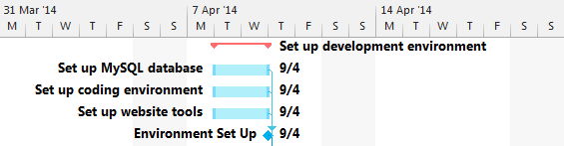

# Iteration 1.1 - Website Constructed

## Due April 17th

When development begins the iterations are split into two paths iterating at the same time (1.1, 1.2 and 2.1, 2.2) as they are not dependent of each other and have different resources assigned to those tasks.

The analysis and design tasks run simultaneously over a day. This is where research of website construction occurs and Peter begins to plan how development takes place. Once developed over multiple days Peter must then test all aspects of what he created and produce a test report then review the work he has done over the last week.

|  |  |  |
| --- | --- | --- |
| Resources | Tasks | Duration in Days |
|  |  |  |
| Peter | 1.1 Analysis | 1 |
|  | 1.1 Design | 1 |
|  | 1.1 Development | 4 |
|  | 1.1 Testing | 1 |
|  | 1.1 Review | 1 |

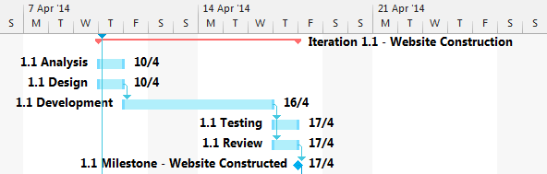

# Iteration 1.2 – User Management System

## Due April 23rd

This milestone is achieved through developing the user management system on the website. This means enabling a log in service for those accessing the program and giving users different permissions based on their position (such as Administrator, Project Manager, General User).

|  |  |  |
| --- | --- | --- |
| Resources | Tasks | Duration in Days |
|  |  |  |
| Peter | 1.2 Analysis | 1 |
|  | 1.2 Design | 1 |
|  | 1.2 Development | 5 |
|  | 1.2 Testing | 1 |
|  | 1.2 Review | 1 |

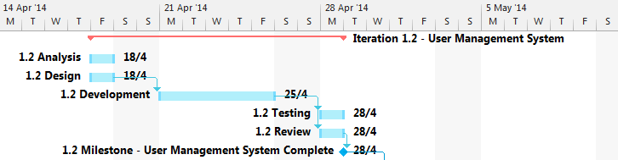

# Iteration 2.1 – Import Data

## Due April 21st

This milestone is achieved by successfully importing the data from the Python SVN page, bugs page and archive files supplied to us into files saved to the client’s computer.

|  |  |  |
| --- | --- | --- |
| Resources | Tasks | Duration in Days |
|  |  |  |
| Josh, Jamie | 2.1 Analysis | 2 |
|  | 2.1 Design | 2 |
|  | 2.1 Development | 4 |
|  | 2.1 Testing | 1 |
|  | 2.1 Review | 1 |
|  |  |  |
|  |  |  |

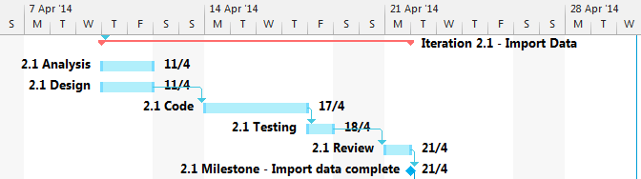

# Iteration 2.2 – Data Translation

## Due April 30th

This milestone is achieved through successfully translating the data imported in iteration 2.1 into data that can be stored within the MySQL database so that it can be accessed through the GUI to show visualisations and be able to be manipulated.

|  |  |  |
| --- | --- | --- |
| Resources | Tasks | Duration in Days |
|  |  |  |
| James, Kurt, Josh, Jamie | 2.2 Analysis | 2 |
|  | 2.2 Design | 2 |
|  | 2.2 Development | 3 |
|  | 2.2 Testing | 1 |
|  | 2.2 Review | 1 |

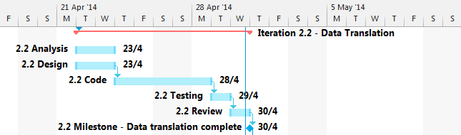

# Iteration 2.3 – Data Manipulation

## Due May 14th

Once we have our data translated and accessible from the database we can then begin to code the data manipulation module which should allow the user (who has the correct permission) to locate any data they wish from the database, edit its attributes, then save it.

|  |  |  |
| --- | --- | --- |
| Resources | Tasks | Duration in Days |
|  |  |  |
| James, Josh, Jamie | 2.3 Analysis | 2 |
|  | 2.3 Design | 2 |
|  | 2.3 Development | 5 |
|  | 2.3 Testing | 2 |
|  | 2.3 Review | 1 |

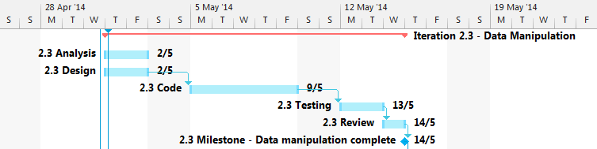

# Iteration 2.4 – Data Visualisation

## Due May 14th

This iteration runs concurrently with iteration 2.3 as they do not depend on each other. They both needed iteration 2.2 complete to access that data. This milestone is achieved by successfully using data stored in the database to convert into a visualisation such as a graph or other appropriate diagram.

|  |  |  |
| --- | --- | --- |
| Resources | Tasks | Duration in Days |
|  |  |  |
| Peter, Kurt | 2.4 Analysis | 2 |
|  | 2.4 Design | 3 |
|  | 2.4 Development | 5 |
|  | 2.4 Testing | 1 |
|  | 2.4 Review | 1 |

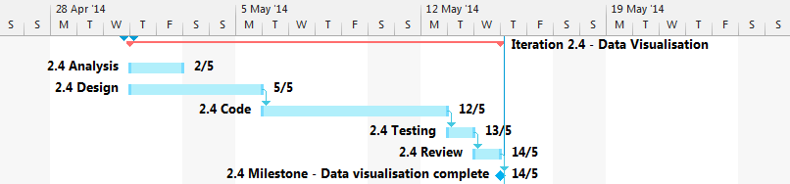

# Approval Testing with Client

## Due May 20th

This milestone is when we expect to have a fully functional program ready to use. As a part of deployment we plan to create a user manual to aid those who may need guidance in using this software. Once we sit down with our client and walk them through our product and receiving approval we will then be able to commence work on our final report.

|  |  |  |
| --- | --- | --- |
| Resources | Tasks | Duration in Days |
|  |  |  |
| Peter, Kurt | User Manual | 1 |
|  |  |  |
| James | Testing with Client | 1 |

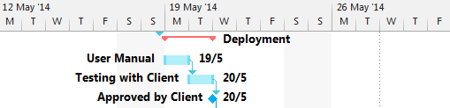

# Submit Final Report

## Due May 20th

Just with the first milestone of the mid-project delivery, this report requires Microsoft word in order to complete documentation. All members of the group are again taking part in this stage with tasks assigned to each.

Once we have completed each section of the final report we will go over it together to ensure that it is of substantial quality and is presented to the client in a well formatted manner.

|  |  |  |
| --- | --- | --- |
| Resources | Tasks | Duration in Days |
|  |  |  |
| Peter | Business Case  Meta-Report | 1  2 |
|  |  |  |
| Jamie | Test phase details, plans and cases | 2 |
| Kurt | UML Diagrams  Effort Estimation | 3  1 |
|  |  |  |
| Josh, James | Architecture Design | 3 |
|  |  |  |
| All Members | Quality Check Final Report | 1 |
|  |  |  |
|  |  |  |

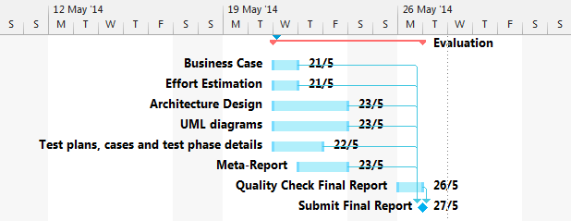

Objectives

subtitle

a

Archive Map

An in depth view of our project plans

as

Visual Data Document

An in depth view of our project plans

as

Progress Report

An in depth view of our project plans

# Progress Report for 19th March

## Week One

The project assigned requires us to develop a piece of software that serves as a dashboard capable of visualising data in a meaningful way and allowing the user to manipulate the given data. This progress report was written two days after our first meeting and its purpose is to provide an insight into how development of this project is coming along.

As we have only had one day since our first meeting we were still able to go over our project specification and identify who the stakeholders of the software would be, we also discussed some requirements that the software would have to fulfil as well as some resources that we would require in order to properly develop this software.

During our meeting we dedicated some time into opening the archive files given to us and conducting research to get an early idea of what type of data we would have to work with throughout this project.

## Decision Table

|  |  |  |
| --- | --- | --- |
| Description | Decision | Priority |
|  |  |  |
| Design Methodology | We have chosen to follow the agile development methodology.  It is preferable to each group member as we wish to complete tasks in bursts using an incremental and iterative method. | Neutral |
|  |  |  |
| Programming Language | Our choices were between Cocoa, C++, Java or Visual Basic.  Our final decision will be based on ease of use and its ability to support a GUI, for now it is undecided as it is not a high priority at this point in time. | Low |

## Issues Faces

A large issue we had was not being able to have a group formed until the third week of semester, leaving us only four weeks to complete all our tasks until the first deliverable rather than 6. This means that we will need to organise frequent and extended group meetings in order to produce a quality report in time.

## Action Items

### Completed

*No action items had been set the previous week*

### Assigned

Action items that were assigned at the end of the meeting that we planned to have completed by the next week included a design plan, business case, an initial SRS, measuring effectiveness, milestones, risk analysis and a git repository created for the project.

## Current Status

## 

Our Gantt chart does not show us much regarding how much has been completed since we have only had one day to put work into the task.

# Progress Report for 26th March

## Week Two

This week we had all members present during the Tuesday tutorial so we were able to set a weekly date that we can all get together and simultaneously work on this project. The date chosen that suited us best was on Wednesdays at 5:30pm.

We were able to meet with the client and we gathered some requirements including security details, database updating, and user details. These are taken into more detail within the SRS document.

Peter has chosen to handle development on the front end of the software. Meaning he will handle the website and data visualisation while the others focus on the technical back end tasks.

## Decision Table

|  |  |  |
| --- | --- | --- |
| Description | Decision | Priority |
|  |  |  |
| RDBMS* | We have chosen to use MySQL as our RDBMS due to its capabilities of supporting concurrent updating across multiple clients since our software will need to support many users at once. | Neutral |
|  |  |  |
| Team Roles | We all discussed preferable parts of the project that we would like to be a part of and were able to determine team roles from this. From doing this we were able to assign tasks to people with the role that would best suit them. Those roles are shown in this report. | High |
|  |  |  |
| Programming Language | We revisited this decision as we have looked into developing the software to be based inside a browser. This gave us two options of languages being PHP, JavaScript and Ruby. JavaScript has a tool named D3js tool that can be used to show graphs and visualise data aesthetically. However most of us decided that Ruby would be the best language for us to develop in as it also has many tools available and it is a simple language for us to learn. | Neutral |

*RDBMS: Relational Database Management System

## Issues

We had a small issue with communication where two members of our group had left early before our meeting with the client. However we were successfully able to complete our meeting with only three of us and gather more essential requirements.

## Action Items

### Completed

Through further discussion regarding development of the project we were able to come up with a design plan. A risk management report was also completed during the week and the milestones were decided on through creation of the Gantt chart. A git repository was also created with each team member added as collaborators.

### Assigned

Jamie and Kurt were assigned the feasibility study, Peter and Kurt were assigned the SRS, James and Josh were assigned the detailed plan. Everybody was advised to look into the Ruby language in their own time to become more familiar with what we will be coding with.

## Current Status

## 

Once we were given team roles we were than able to work on our given tasks. We are now currently working on the SRS, Progress reports (this document), feasibility study and a project plan. The milestones document still requires completion.

# Progress Report for 2nd April

## Week Three

This week we spent time looking through the Python SVN, bugs website and archive files for bug reports, test cases, execution traces/logs, emails, discussions and emails. We were only able to find the bug reports and emails for now. We are searching for this data so that when we get to our import data stage we would immediately know where the data would come from, thus saving time for ourselves in the future. Peter and Josh also conducted a meeting with our client and received more requirements for the SRS.

The Wednesday meeting consisted of checking up with each other’s progress and helping each other out so we could gain a mutual understanding of different parts of the project.

## Decision Table

|  |  |  |
| --- | --- | --- |
| Description | Decision | Priority |
|  |  |  |
| How to import data | We decided to use Ruby’s integrated unarchiver to access the data supplied to us in the Python archive files. Importing data is an integral part of our project which was why it was classed as a high priority task. | High |
|  |  |  |
|  |  |  |

## Issues

We had an issue with locating the data in SVN and the Python Archives. As we still had current tasks to complete before the deliverable we decided to put this issue on hold for a week while we focused on our report.

## Action Items

### Completed

Action items from last week required more than a week to complete, hence why no items have been completed. Members also studied Ruby during the week.

### Assigned

A code of conduct is to be completed by Jamie, Objectives were assigned to James, completion of an archive map was assigned to Josh, Peter and Josh were also assigned to have a visual data document completed.

## Current Status

## 

We have one week until our deliverable is due and each team member is still working on the same task as the previous week. The milestones document has also been completed.

# Progress for 7th April

## Week Four

This is the last week before our deliverable is due, therefore all tasks must be completed before the 8th of April (tomorrow).

All sections of the mid-project deliverable have been complete and we just have to format the document and prepare it for submission.

We must now progress to the iterative execution stage where our Front-end team and our Back-End team will branch off into completing different iterations.

## Decision Table

|  |  |  |
| --- | --- | --- |
| Description | Decision | Priority |
|  |  |  |
| Design Methodology | We originally decided on agile development however we have specifically chosen feature-driven development. We feel that this would suit our project as we have design our development phases into iterations. (See Milestones Document) | Low |
|  |  |  |

## Issues

Because of the first couple of weeks being behind on meetings and progress, we decided that we would host a secondary meeting on the Friday to ensure that all deliverables would be completed.

## Action Items

### Completed

All action items from last week have been completed in time for the deliverable.

### Assigned

Josh has been assigned to set up our MySQL database, James has been assigned to set up our code development environment, Jamie has been assigned to locate the required data from SVN and the Python archives while Peter has been assigned to set up tools required to host a website and begin development on that.

## Current Status

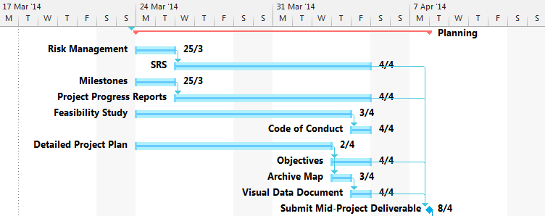

All tasks within planning phase of the project is complete and we are prepared to submit our report for the next milestone on the 8th of April. We are now ready to prepare for our execution stage and setting up the development environment.

Code of Conduct

A guide we agree to follow when working together

1. Respect and Courtesy  
   We as a team will endeavor to treat each other, as they would want to be treated. Understand that disagreement is a natural part of teamwork, but that steps should be undertaken to minimize the harm from disagreement including rational (not heated) debate and by democratic vote.
2. Accountability  
   Every member must ensure that they are accountable for the action they take, this includes not only the mistakes, but also the good work that they perform. Each member must also ensure that they perform and deliver the workload that they have committed to, not only as a project, but in minor tasks that they have been asked to perform.
3. Quality  
   It is of the utmost importance that all products delivered are of the utmost quality and that all members do not supply untidy or ill-prepared components; this includes code, as well as reports.
4. Collaborate  
   Never be afraid to ask for, or offer help. Everyone has their own experience, forte’s and weakness. It is of the utmost importance that we collaborate and be supportive to one and another.
5. Responsibility

Each member has responsibilities that they have been allocated, as noted in the Project Plan and Feasibility Study:

### Peter Brown-Requirements Analyst and User Interface Engineer

Peter is in charge of implementing the front-end of the software, specifically regarding how our user interacts with the product. Peter will also ensure that the interfaces are intuitive, and well documented such that anybody with limited knowledge of these systems will be able learn how to use the product.

### James Glennan- Software Architect

James is required to help implement software solutions and learn new languages that may be required. This job will require specific detail in ensuring that tests are designed for all of the system’s modules as well as ensuring that code is implemented as efficiently as possible.

### Kurt Robinson- Tool Analyst and Change Control Manager

Kurt is hosting the software repository as well conducting research and learning about specific open-source components that can be implemented in to this project. He is tasked with third party implementation, as well as liaising with the relevant authorities to ensure that the product’s modules connect cohesively.

### James Wilson- Project Manager

James is directing the group as well as coordinating back and front-end integration. James will monitor the individual module’s development direction and progress as well as ensuring that weekly reporting/testing suites are being provided for the relevant sections.

Joshua Brown- System Data Specialist

Josh has experience in database implementation and as such is fully capable of designing and implementing our data storage solution.

If a problem with an element of this project is found, it is the responsibility of that person to contact the relevant authority within the group.

Project Diaries

An in depth view of our project plans

as

Contributions

Agreement of each team members level of contribution to the project

|  |  |  |
| --- | --- | --- |
| James Wilson – jw192 |  |  |
| Contributed |  |  |
|  |  |  |
| Jamie Glennan – jg631 |  |  |
| Contributed |  |  |
|  |  |  |
| Josh Brown – jb740 |  |  |
| Contributed |  |  |
|  |  |  |
| Kurt Robinson – kr185 |  |  |
| Contributed |  |  |
|  |  |  |
| Peter Brown - pb864 |  |  |
| Contributed |  |  |

# Feasibility Works Cited

Unfuddle. (n.d.). *Unfuddle Signup.* Retrieved 03 26, 2014, from https://unfuddle.com/signup

acaudwell. (2013, 04 26). *Gource-Software Version Control Visualisation.* Retrieved 03 26, 2014, from https://code.google.com/p/gource/

Bugzilla.org. (2012, 11 19). Retrieved 03 26, 2014, from http://www.bugzilla.org/about/

Fossil. (2014, 03 15). *Fossil.* Retrieved 03 26, 2014, from https://www.fossil-scm.org/index.html/doc/tip/www/index.wiki