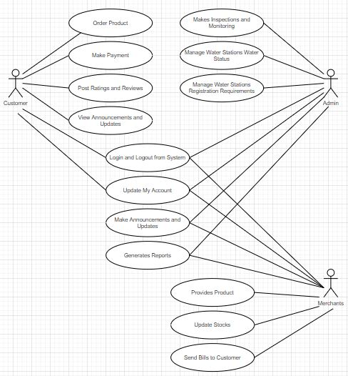

The figure shows the use case diagram of H2Order: Smart Ordering and Monitoring for Water Refilling Businesses in Nasugbu, Batangas which includes the following such as the major user of the proposed system which are the Customer, Admin and Merchant which generally illustrate the different processes and functions that can only accessed by the specified users.

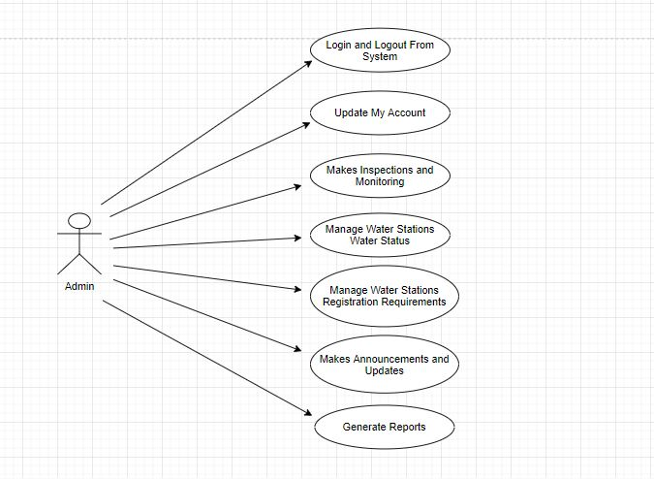

The figure shows wherein the ‘admin’ can login and logout their account from the system and also can updates their accounts too. It can also allow admin to conduct activities such as the inspections and monitoring of all registered water refilling stations around the Nasugbu Municipality. The admin also control the management of the registration which are conducted to provide different requirements for water refilling merchants wherein they are authorized to operate a water refilling station business. Lastly, the admin can post any announcements and updates regarding to any problems or changes in order to generate the effective and efficient transactions throughout.

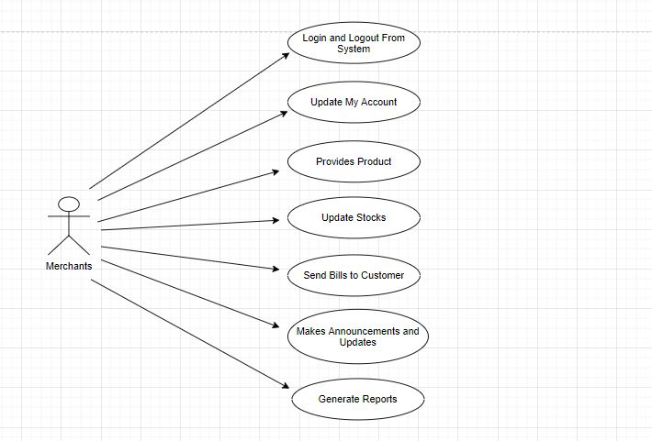

The figure illustrate the different functions and activities of the ‘merchants’. First, each merchants’ account can log in and also log out from the system. Moreover, the update of account can also access by the merchant if there are any changes to modify. Third, the merchant allow to provide their numerous products and can update the inventory of stocks to sustain continuous transaction. The system also permit the merchant to send any way bill or any form of transaction to have transparency for the buyer and also for the merchant. In addition, the merchant allows to post any announcements and updates regarding to the delivery status, loyalty program, discounts and more. And lastly, allow any merchant to generate their required report effectively without having discrepancy or any void information collected.

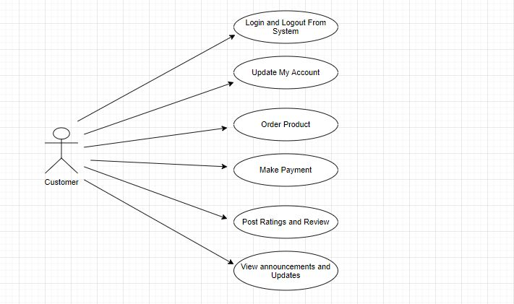

The ‘customer’ figure has also 6 functions which they can operate as they are the significant user of the system. First, the customer can also log in and log out their specified accounts from the system and also can update their profile account if they are changing their contact number, home address or any payment method. Also, customer can order any desired products to the authorized water refilling stations and can choice their prefer payment method. In instance, the customer can display any ratings and review whether the quality of product and service of the water refilling station is excellent or poor. Lastly, the customer can view any published announcements and updates by the different merchants and the admin.