Describe some real-world applications of AI.

Artificial Intelligence (AI) has numerous real-world applications across various industries, helping improve efficiency, accuracy, and decision-making processes. Here are some examples:

**1. Healthcare**

* **Diagnostics**: AI-powered systems can analyze medical images (like X-rays, MRIs, and CT scans) to detect conditions such as cancer, fractures, and infections with high accuracy. For example, AI models like Google's DeepMind have been used to predict eye diseases and assist in diagnosing early-stage cancers.
* **Personalized Treatment**: AI helps in tailoring treatment plans based on individual patient data, including genetics, lifestyle, and medical history. This is especially useful in oncology and genomics.
* **Drug Discovery**: AI accelerates drug development by predicting the effectiveness of drug compounds and helping in the identification of new potential drugs. AI tools have helped pharmaceutical companies like Pfizer and Moderna develop COVID-19 vaccines quickly.

**2. Automotive Industry**

* **Self-Driving Cars**: Companies like Tesla, Waymo, and Uber are using AI to develop autonomous vehicles. AI systems process data from sensors (e.g., cameras, lidar) and make real-time decisions to drive vehicles safely on the road.
* **Driver Assistance Systems**: Features like automatic emergency braking, lane-keeping assist, and adaptive cruise control are powered by AI, making driving safer and more efficient.

**3. Finance**

* **Fraud Detection**: AI is used by banks and financial institutions to detect unusual transaction patterns that may indicate fraudulent activity. Machine learning algorithms analyze large volumes of transaction data in real-time.
* **Algorithmic Trading**: AI algorithms can analyze market data, predict trends, and make trading decisions at speeds far beyond human capabilities.
* **Credit Scoring**: AI helps in determining the creditworthiness of individuals and businesses by analyzing financial histories, transaction patterns, and other relevant factors.

**4. Retail and E-Commerce**

* **Personalized Recommendations**: Online stores like Amazon and Netflix use AI to recommend products or content based on user behavior, preferences, and previous purchases.
* **Inventory Management**: AI-powered systems predict demand and optimize stock levels, reducing overstocking and stockouts.
* **Customer Support**: AI chatbots and virtual assistants, such as those used by companies like Shopify, help customers with product inquiries, order tracking, and issue resolution, providing 24/7 support.

**5. Entertainment**

* **Content Creation**: AI is used to generate music, art, and even stories. For example, OpenAI’s GPT models are capable of writing articles or creative pieces, and AI tools can compose music in the style of famous composers.
* **Video Games**: AI is used to create intelligent NPCs (non-playable characters) that respond dynamically to player actions, offering more immersive gaming experiences.

**6. Manufacturing**

* **Predictive Maintenance**: AI monitors the health of machinery, predicting when maintenance or repair is needed, preventing costly downtime, and improving production efficiency.
* **Robotics**: AI-driven robots are used in assembly lines for tasks like packaging, welding, and quality control. They work alongside human workers, improving speed and precision.

**7. Agriculture**

* **Precision Farming**: AI-powered drones and sensors monitor crop health, soil conditions, and weather patterns, allowing farmers to optimize irrigation, fertilization, and harvesting.
* **Crop Prediction**: AI analyzes data to predict crop yields and assist in making better decisions regarding planting and harvesting times.

**8. Smart Cities**

* **Traffic Management**: AI analyzes traffic patterns and adjusts traffic signals to optimize the flow of vehicles, reducing congestion and improving road safety.
* **Energy Management**: AI optimizes the energy consumption of buildings and public infrastructure, contributing to sustainability efforts by adjusting heating, cooling, and lighting based on usage patterns.

**9. Cybersecurity**

* **Threat Detection**: AI is used to identify and mitigate cybersecurity threats in real-time by analyzing network traffic and detecting anomalies or known attack patterns.
* **Automated Response**: AI systems can autonomously take action in response to detected threats, such as isolating affected systems or blocking malicious traffic.

**10. Natural Language Processing (NLP)**

* **Speech Recognition**: Virtual assistants like Amazon’s Alexa, Google Assistant, and Apple’s Siri use AI to understand and respond to voice commands, making interaction with devices hands-free.
* **Translation Services**: AI-powered translation tools like Google Translate use NLP to break down language barriers, providing instant translations of text or speech.

**11. Education**

* **Adaptive Learning**: AI is used to create personalized learning experiences, where educational software adapts to the needs and pace of individual students, enhancing their understanding of topics.
* **Automated Grading**: AI can assist in grading assignments and exams, allowing educators to focus more on teaching and less on administrative tasks.

**12. Logistics**

* **Route Optimization**: AI helps in optimizing delivery routes, reducing fuel costs, and improving delivery times for companies like FedEx, UPS, and Amazon.
* **Warehouse Automation**: AI-driven robots are used in sorting, storing, and retrieving items in large warehouses, improving efficiency and reducing errors.

**13. Human Resources**

* **Recruitment**: AI tools can help in screening resumes, identifying the best candidates based on job requirements, and automating repetitive tasks in the hiring process.
* **Employee Engagement**: AI-based tools monitor employee engagement and sentiment by analyzing communication patterns, allowing HR departments to take action to improve workplace morale.

**14. Space Exploration**

* **Mars Rovers**: NASA's Mars rovers use AI to navigate the Martian surface, making decisions about where to move, where to collect data, and how to avoid obstacles without human intervention.
* **Satellite Data Analysis**: AI helps analyze satellite images to study earth’s weather, monitor climate change, and track deforestation.

These are just a few examples of AI's real-world applications, but the technology is continually evolving, and new use cases are emerging in almost every field. AI is transforming industries and making processes smarter, faster, and more efficient.

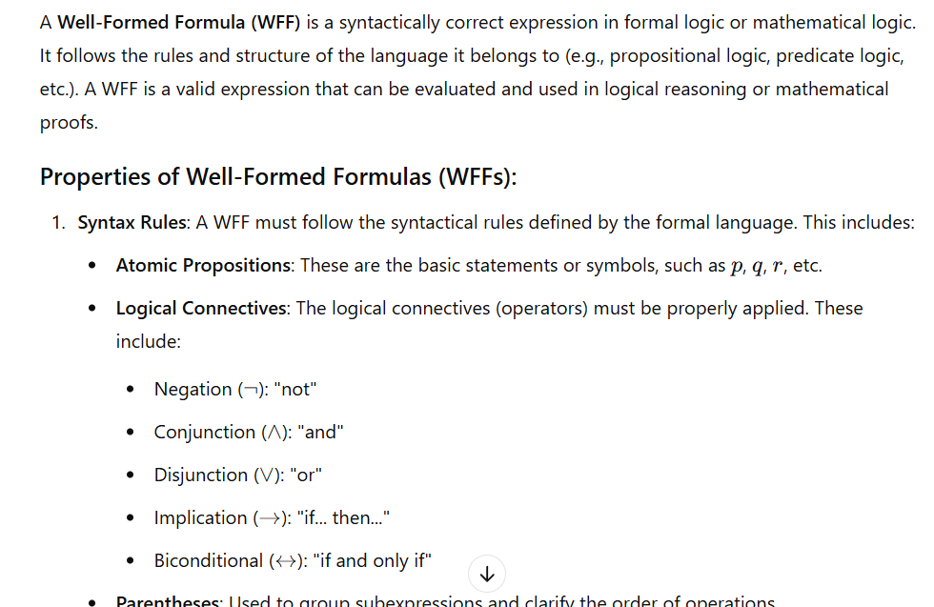

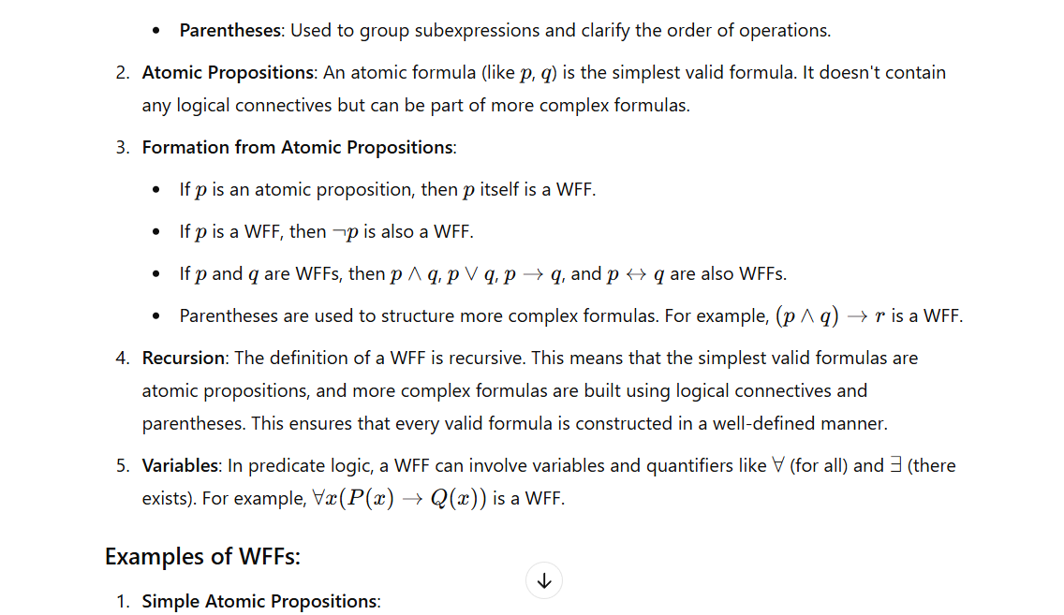

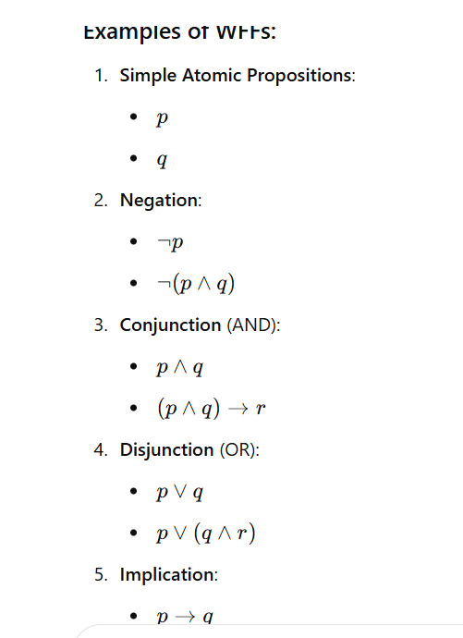

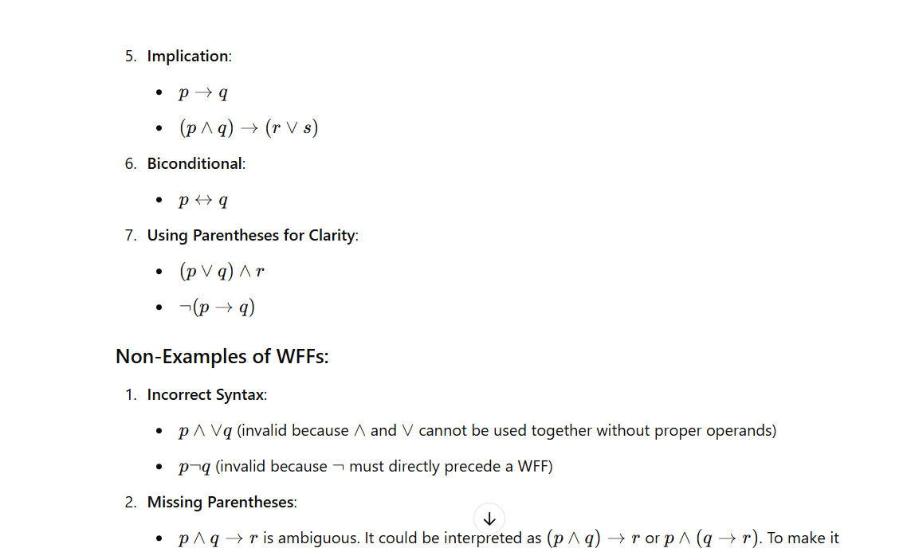

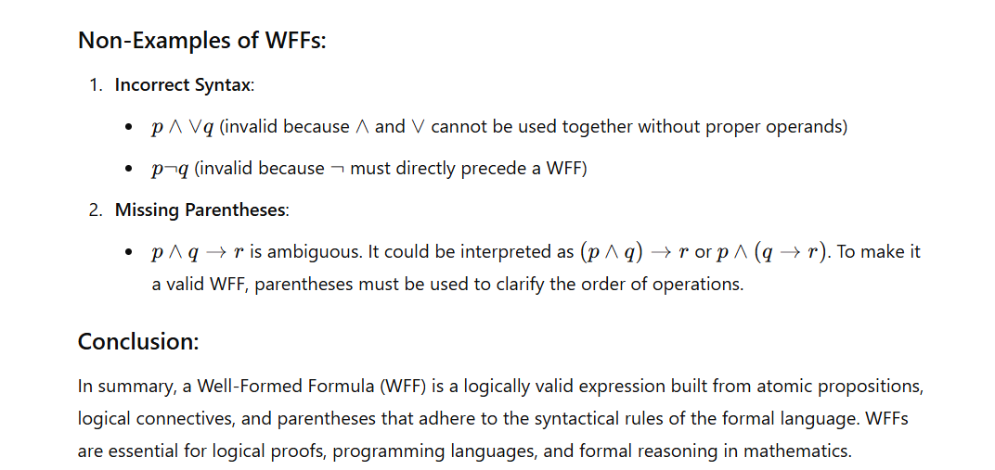

Demonstrate the difference between Tanh and Sigmoid Activation Functions with examples.

The Tanh (hyperbolic tangent) and Sigmoid activation functions are commonly used in neural networks to introduce non-linearity into the model. They each have distinct mathematical forms, ranges, and characteristics that influence their behavior in training and inference. Below is a detailed comparison of the two functions, including their definitions, properties, and examples.

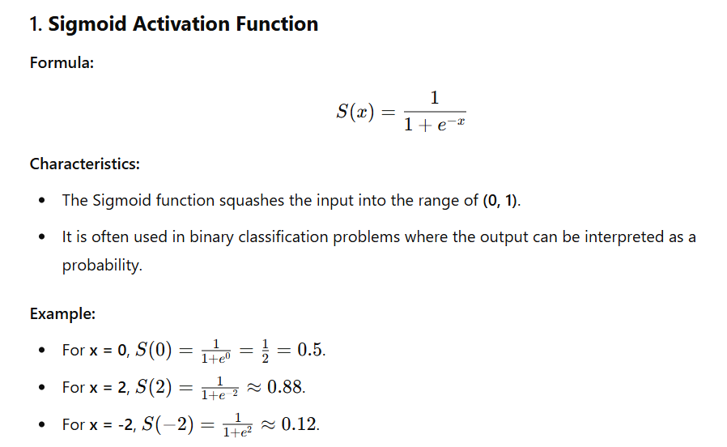

**Graph:**

* The Sigmoid function produces an "S" shaped curve, with outputs near 0 for negative values of xxx, and outputs near 1 for large positive values of xxx.

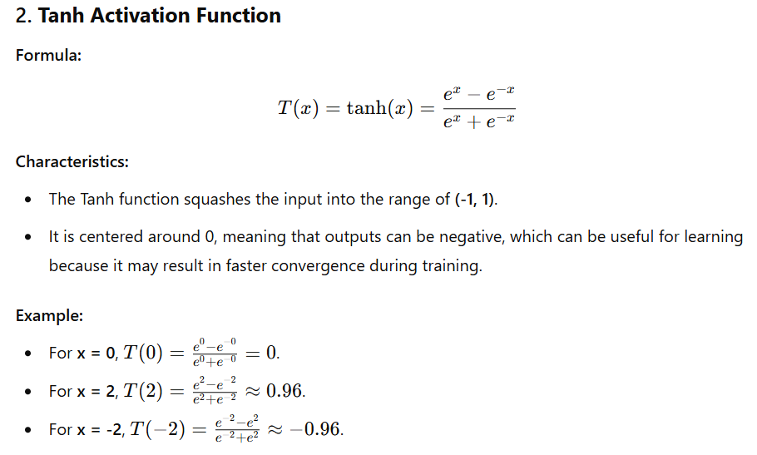

**Graph:**

* The Tanh function produces an "S" shaped curve as well but with a range from -1 to 1. The function is symmetric around the origin (0, 0).

**Key Differences:**

| **Feature** | **Sigmoid** | **Tanh** |
| --- | --- | --- |
| **Range** | (0, 1) | (-1, 1) |
| **Output at x=0** | 0.5 | 0 |
| **Centering** | Not centered around 0 (asymmetrical) | Centered around 0 (symmetric) |
| **Gradient at extremes** | Gradients tend to be very small (vanishing gradients) | Gradients also tend to be small but not as extreme |
| **Common Use** | Binary classification, output probabilities | Hidden layers of neural networks, especially for hidden state values in RNNs |

Describe the steps for converting a formula into clausal form.

Converting a formula into clausal form is an important process in logic and automated reasoning, particularly in propositional logic and first-order logic. Clausal form is a conjunction of disjunctions of literals, which makes it suitable for algorithms like resolution. Here are the steps to convert a formula into clausal form:

▎Steps to Convert a Formula into Clausal Form

1. Eliminate Implications and Biconditionals:

• Replace implications (A → B) with (¬A ∨ B).

• Replace biconditionals (A ↔️ B) with (¬A ∨ B) ∧ (A ∨ ¬B).

2. Move Negations Inward (Negation Normal Form):

• Use De Morgan's laws to push negations inward:

• ¬(A ∧ B) becomes (¬A ∨ ¬B)

• ¬(A ∨ B) becomes (¬A ∧ ¬B)

• Apply double negation elimination: ¬(¬A) becomes A.

3. Standardize Variables (if using First-Order Logic):

• Rename variables to ensure that all quantifiers use unique variable names. This helps avoid confusion when dealing with nested quantifiers.

4. Skolemization:

• Remove existential quantifiers by replacing them with Skolem functions or constants.

• For a formula of the form ∃x P(x), replace x with a Skolem constant if there are no universal quantifiers in scope, or replace it with a Skolem function if there are universal quantifiers.

5. Convert to Conjunctive Normal Form (CNF):

• Distribute disjunctions over conjunctions to achieve CNF.

• Use the distributive law:

• A ∨ (B ∧ C) becomes (A ∨ B) ∧ (A ∨ C).

• Ensure that the formula is a conjunction of disjunctions.

6. Extract Clauses:

• Identify the clauses from the CNF expression. Each clause is a disjunction of literals.

• A literal is either an atomic proposition or its negation.

▎Example

Let’s illustrate these steps with an example formula:

Example Formula: ∀ x (P(x) → Q(x))

Step 1: Eliminate Implications

• Convert P(x) → Q(x) to ¬P(x) ∨ Q(x) .

• The formula becomes: ∀ x (¬P(x) ∨ Q(x)) .

Step 2: Move Negations Inward

• There are no negations to move inward in this case.

Step 3: Standardize Variables

• The variable x is already unique, so we can proceed.

Step 4: Skolemization

• Since there are no existential quantifiers, this step does not apply.

Step 5: Convert to CNF

• The formula is already in CNF: ¬P(x) ∨ Q(x) .

Step 6: Extract Clauses

• The clause extracted from the formula is ¬P(x), Q(x) .

▎Final Result

The final result in clausal form is a set of clauses, which in this case consists of one clause: ¬P(x), Q(x) .

By following these steps systematically, you can convert any logical formula into its clausal form, which is essential for many automated reasoning techniques.

Q] Describe the steps for converting a formula into clausal form.

Steps to Convert into Clausal Form:

1] Eliminate Implication → Replace A ⇒ B with ¬A ∨ B.

2] Apply De Morgan’s Laws → Reduce the scope of negation.

3] Standardize Variables → Ensure each quantifier binds a unique

variable.

4] Move Quantifiers Left → Rewrite the formula so all quantifiers are at

the beginning.

5] Eliminate Existential Quantifiers → Replace them with Skolem

functions/constants.

6] Drop Universal Quantifiers → Remove ∀ quantifiers as they are

implicit.

7] Convert to Conjunction of Disjunctions → Use distributive laws to

ensure the formula is in CNF (Conjunctive Normal Form).

8] Separate into Clauses → Each conjunction forms an independent

clause.

9] Standardize Variables in Clauses → Rename variables so no two

clauses use the same variable name.

These steps ensure the formula is in clausal form, which is useful for

logic-based reasoning systems

Illustrate the working of the Alpha-Beta algorithm with an example

* Alpha-beta pruning is a modified version of the minimax algorithm. It is an optimization technique for the minimax algorithm.
* **Alpha-Beta Pruning** is an optimization technique for the minimax algorithm used in decision-making and game theory. It reduces the number of nodes evaluated in the game tree by eliminating branches that cannot possibly influence the final decision. By maintaining two values, **Alpha** (the best value for the maximizer) and **Beta** (the best value for the minimizer), Alpha-Beta pruning avoids exploring branches where the outcome is already worse than a previously explored option. This allows the algorithm to make decisions more efficiently, speeding up the search process without affecting the final result.
* Alpha-beta pruning can be applied at any depth of a tree, and sometimes it not only prune the tree leaves but also entire sub-tree.
* The two-parameter can be defined as:

**Alpha:** The best (highest-value) choice we have found so far at any point along the path of Maximizer. The initial value of alpha is **-∞**.

**Beta:** The best (lowest-value) choice we have found so far at any point along the path of Minimizer. The initial value of beta is **+∞**.

How It Works (Step by Step) :

Understanding Minimax

● In games, players take turns:

● MAX (the first player) tries to get the highest score

● MIN (the opponent) tries to get the lowest score

● The minimax algorithm checks all possible moves and selects the

best one.

The Problem with Minimax :

It examines all possible moves, even when some moves are clearly bad.

This wastes time and computing power.

Solution: Alpha-Beta Pruning

● Instead of checking every move, Alpha-Beta pruning stops evaluating

some moves if they won’t impact the final decision.

● It uses two values:

● Alpha (α): The best (highest) value MAX can get.

● Beta (β): The best (lowest) value MIN can get.

● If at any point α ≥ β, further searching is stopped because the

opponent will never let us reach this state

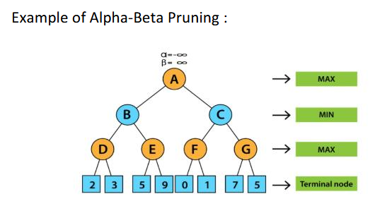

Imagine a game tree with nodes labeled A, B, C, D, E, F, and G.

MAX plays first, then MIN, then MAX again.

We evaluate the tree from left to right while applying alpha-beta

pruning.

Step-by-step process:

Start at Node A (MAX’s Turn)

Alpha (α) = -∞ (worst-case scenario for MAX)

Beta (β) = +∞ (worst-case scenario for MIN)

Move to Node B (MIN’s Turn)

At Node D, we find values 2 and 3, so the MIN value here is 3.

This value is passed up to Node B as β = 3.

Move to Node E (MAX’s Turn)

At Node E, we find 5, so α at E becomes 5.

Since α (5) is greater than β (3) at Node B, we stop searching further at B.

(Pruning happens!)

Move to Node C (MIN’s Turn)

At Node F, we evaluate 0 and 1, so MAX at F selects 1.

Node C now has β = 1, which is smaller than α = 3 at Node A.

Pruning at Node C

Since α at A (3) is greater than β at C (1), we prune (ignore) Node G.

This saves us from unnecessary calculations.

Final Decision at Node A (MAX’s Turn)

A takes the maximum of its children (3 and 1), so the final value at A is 3.

Explain the difference between simple reflex agents and goal-based agents

Here’s a comparison between **Simple Reflex Agents** and **Goal-Based Agents** in a table format with 15 key points:

| **Point** | **Simple Reflex Agents** | **Goal-Based Agents** |
| --- | --- | --- |
| **1. Definition** | Agents that make decisions based on the current state only, using predefined rules. | Agents that act to achieve specific goals, considering future states and actions. |
| **2. Memory** | No memory of past actions or states. | Maintain memory of past actions to track progress towards goals. |
| **3. Decision Making** | Based on immediate percepts (current state). | Based on a goal or desired state to be achieved. |
| **4. Knowledge** | Operates using a set of simple, predefined rules. | Uses knowledge about the environment to plan actions. |
| **5. Flexibility** | Less flexible, as it reacts to the environment in a fixed way. | More flexible, able to adapt actions to reach goals. |
| **6. Complexity** | Simple, with low computational cost. | More complex, as it involves reasoning and planning. |
| **7. Action Selection** | Takes action based solely on current conditions. | Takes action based on future consequences and goals. |
| **8. Environment** | Suitable for environments with limited complexity or well-defined rules. | Suitable for dynamic or complex environments requiring planning. |
| **9. Example** | A thermostat adjusting temperature based on current readings. | A robot navigating to a specific location using a map. |
| **10. Goal Orientation** | No specific goal, reacts to stimuli or conditions. | Always works towards achieving a particular goal. |
| **11. Adaptability** | Poor adaptability, as actions are fixed. | Highly adaptable, as goals and plans can change dynamically. |
| **12. Use of Heuristics** | Often relies on a set of predefined heuristic rules. | Uses heuristics to search and plan the best path to the goal. |
| **13. Efficiency** | More efficient in simple environments, as actions are direct. | Less efficient due to reasoning and search for solutions. |
| **14. Complexity of Design** | Easier to design and implement due to simplicity. | Requires a more detailed design and planning algorithms. |
| **15. Examples of Use** | Automated vacuum cleaners, simple robots. | Self-driving cars, game-playing agents, intelligent assistants. |

**Summary:**

* **Simple Reflex Agents** react to the environment based on predefined rules, without considering future outcomes or goals, making them simpler but less flexible.
* **Goal-Based Agents** plan and act towards specific goals, using memory, reasoning, and adaptability, making them more complex but capable of handling more sophisticated tasks.

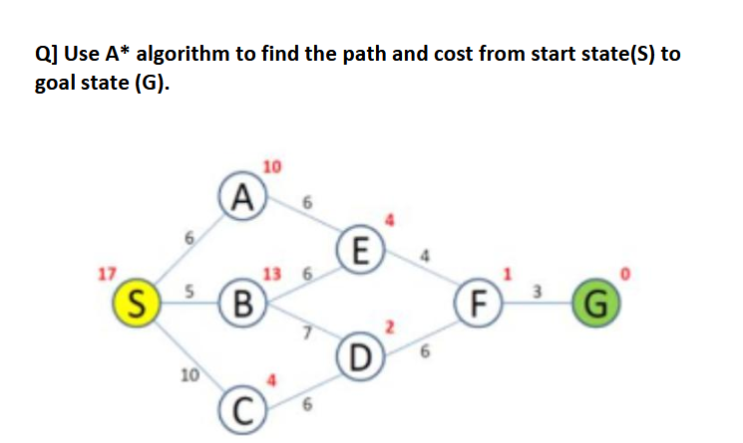

formula:

f(n)=g(n)+h(n)

Where:

g(n) = cost from the start node to node n

h(n) = heuristic estimate from node n to the goal

Step 1: Initialize :

We start at S, with h(S) = 17.

Step 2: Expand S

Neighbors of S:

A: g(A) = 6 → f(A) = 6 + 10 = 16

B: g(B) = 5 → f(B) = 5 + 13 = 18

C: g(C) = 10 → f(C) = 10 + 4 = 14

Choose C (smallest f-value = 14).

Step 3: Expand C

Neighbors of C:

D: g(D) = 10 + 6 = 16 → f(D) = 16 + 2 = 18

Now we have:

A (16), B (18), D (18)

Choose A (smallest f-value = 16).

Step 4: Expand A

Neighbors of A:

E: g(E) = 6 + 6 = 12 → f(E) = 12 + 4 = 16

Now we have:

E (16), B (18), D (18)

Choose E (smallest f-value = 16).

Step 5: Expand E

Neighbors of E:

F: g(F) = 12 + 4 = 16 → f(F) = 16 + 1 = 17

Now we have:

F (17), B (18), D (18)

Choose F.

Step 6: Expand F

Neighbors of F:

G: g(G) = 16 + 3 = 19 → f(G) = 19 + 0 = 19

Now we have:

G (19), B (18), D (18)

Choose B or D (both f = 18).

Step 7: Expand D

Neighbors of D:

F (already visited, ignore)

Now we have:

G (19), B (18)

Choose B.

Step 8: Expand B

Neighbors of B:

E (already visited)

D (already visited)

Since no new nodes were found, go back to G.

Final Path:

S→A→E→F→G

Total Cost:

6+6+4+3=19

The AO algorithm* is a type of informed search algorithm used for

decision-making problems. It works with an AND-OR graph, where

different types of nodes represent different conditions.

Key Concepts :

● AND Nodes → These require all child nodes to be solved before

moving forward.

● OR Nodes → These require only one child node to be solved before

moving forward.

● This algorithm helps in making optimal decisions while searching for

a solution.

Working of AO Algorithm* :

AO* uses an evaluation function to decide the best path:

f(n)=g(n)+h(n)

where:

● g(n) = Cost from the start node to the current node.

● h(n) = Estimated cost from the current node to the goal.

● f(n) = Total cost (actual + estimated).

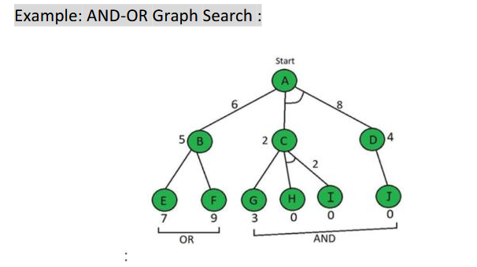

Step 1: Evaluate Paths from A :

Path A → B

f(A→B)=g(B)+h(B)=1+5=6

Path A → (C AND D)

f(A→C+D)=g(C)+h(C)+g(D)+h(D)=1+2+1+4=8

Since 6 < 8, we select A → B as the best path.

Step 2: Evaluate Paths from B :

Path B → E

f(B→E)=g(E)+h(E)=1+7=8

Path B → F

f(B→F)=g(F)+h(F)=1+9=10

Since 8 < 10, we select B → E.

Step 3: Updating the Heuristic :

We update B’s heuristic since its actual value is different from its

estimated value.

Now, f(A → B) = 9 (previously 6).

Since the other option A → (C+D) has a lower cost (8 < 9), we now

explore that path instead.

Step 4: Evaluate Paths from C and D :

Path C → G

f(C→G)=g(G)+h(G)=1+3=4

Path C → (H AND I)

f(C→H+I)=g(H)+h(H)+g(I)+h(I)=1+0+1+0=2

Since 2 < 4, we choose C → (H AND I).

Path D → J

f(D→J)=g(J)+h(J)=1+0=1

Now, A → (C+D) = 5, and since the tree is solved, we have the final

solution.