**Library E-Commerce website**

ER Diagram:

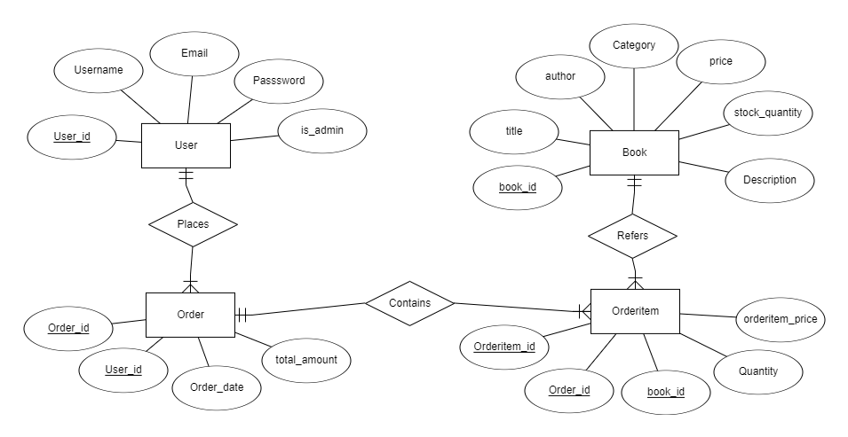

A User can have many Orders.

An Order belongs to one User.

An Order can have many Orderitem.

An Orderitem belongs to one Order.

A Book can have many Orderitem.

An Orderitem references one Book.

Planning to create the pages for my project:

1.login page

2.signup page

3.Profile page

4.books detail page

5.admin page

6.cart page