**DEERWALK INSTITUTE OF TECHNOLOGY**



**ARTIFICIAL INTELIGENCE**

**LAB 1: ANIMAL GUESSING GAME USING BINARY SEARCH TREE**

|  |  |  |  |
| --- | --- | --- | --- |
| **SUBMITTED BY:** |  |  | **SUBMITTED TO:** |
| **NAME: DIPAL MALLA** |  |  |  |
| **PROGRAM: B.SC.CSIT (FIFTH SEM)** |  |  |  |
| **ROLL NO.: 0508** |  |  |  |
| **SECTION: A** |  |  |  |
| **DATE: 23 FEB 2018** |  |  | **BIRODH RIJAL** |

**KATHMANDU, NEPAL**

**2018**

**PROBLEM**

To build Animal Guessing Game by implementing Binary Search Tree.

**BACKGROUND**

Animal guessing game is a simple problem of AI that implements binary search tree. The game works as follows:

1. The program asks the user to think an animal and it tries to guess based on series of questions.
2. The user can reply only YES or NO.
3. After some questions, the program asks for user’s confirmation.
4. If the guess turns wrong, the program asks user about his/her opinion about the animal with appropriate question that the user thinks best represent that animal.
5. The program stores that information and uses for next round.
6. The user can play the game as many times as he/she wants.

**METHODOLOGY**

The program was implemented using python and the code is as below which implements a Binary Search Tree.

The root node consist of the first question and asks user for its value. The next node depends upon the value choose by the user. If your answer matches with the program’s answer, it’s the leaf node and the program asks if the user wants to play again or not. But if the answer doesn’t match, a new node is added to the program which asks for the correct answer. Then, a series of questions is asked to add data (node) about the option the user thinks. And the process gets repeated unless the user wants to end the game.

**PROGRAM CODE**

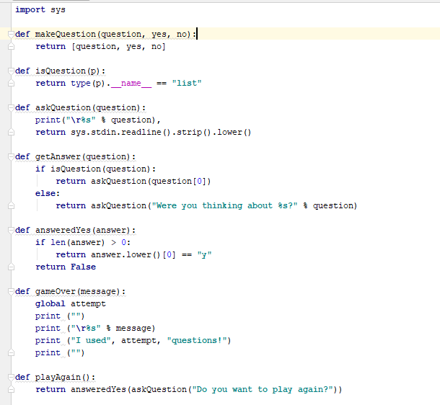

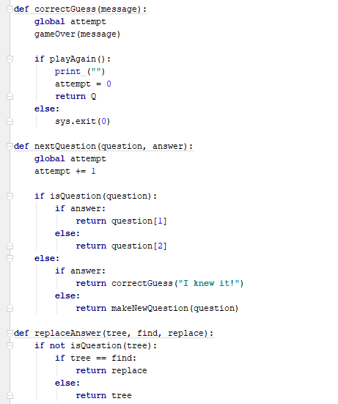

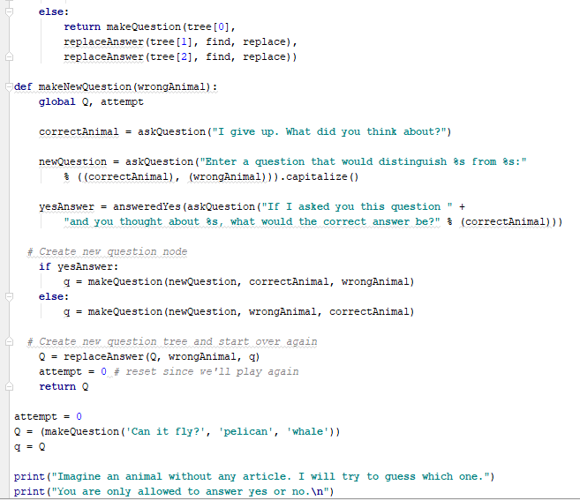

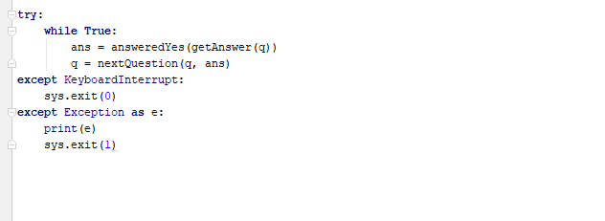

**OUTPUT**

