**GROUP 3**

|  |  |
| --- | --- |
| NAMES | Reg No |
| IGIHOZO Felicite | 23RP02056 |
| MUKANDAYISENGA Mediatrice | 23RP02261 |
| KUBWUMUKIZA Seth | 23RP01335 |
| CYIZA KWIZERA Christophe | 23RP00559 |
| ISHEMA Abdon | 23RP02206 |
| UWIMANA Jean Nepomuscene | 23RP00667 |
| NYIRANSHUTI Elizabeth | 23RP01198 |
| NISHIMWE Josiane | 23RP01590 |
| NISHIMWE Marie Louise | 23RP02004 |

**DOCKER INSTALLATION AND CONFIGURATION**

1. List down steps by steps of download and install Dockers.

**Requirements**

1. Windows 10 with 64 bit
2. 2004 or higher version of Pro
3. 1909 version or higher for Enterprise or Education Version

**Specifications**

1. While choosing for windows 10 or 11 with 64 bit, it must be having higher level of translation
2. 4GB RAM or Higher version but not less
3. BIOS settings should have hardware virtualization support enabled.
4. Hyper V feature, WSL 2 feature and Container feature should be enabled in windows.
5. Windows supported by Microsoft need to be updated, if computers have older versions of windows.

### ****Step 1: Downloading Docker****

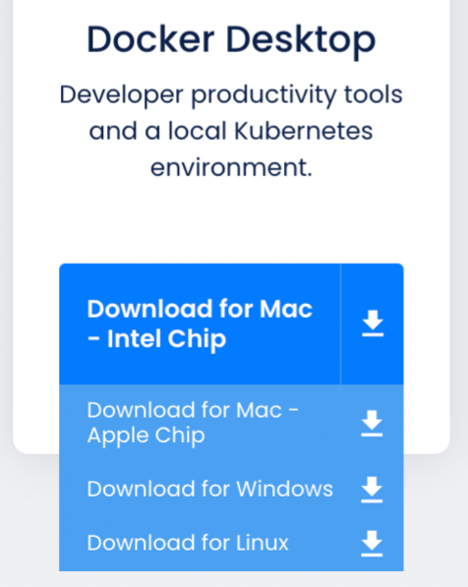

open the downloaded installer and begin the installation.

### ****Step 2: Configuration****

To run Linux on Windows, Docker requires a virtualization engine. Docker recommends using WSL 2

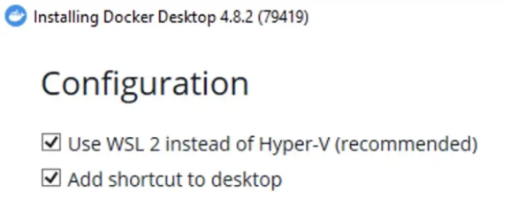

### ****Step 3: Running the installation****

Click Ok, and wait a bit…

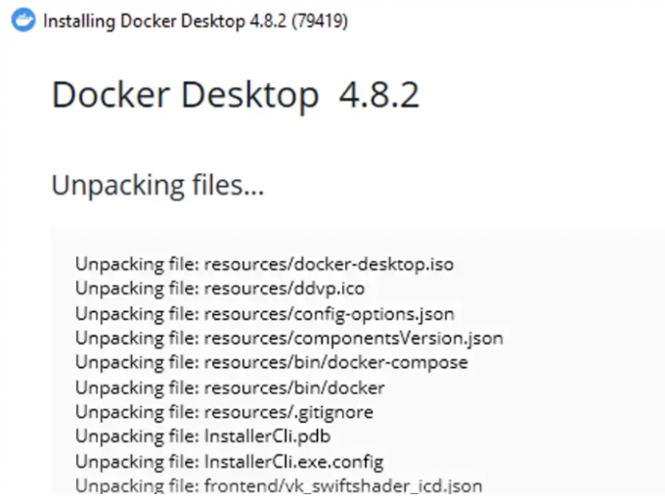

### ****Step 4: Restart****

For Docker to be able to properly register with Windows, a restart is required at this point.

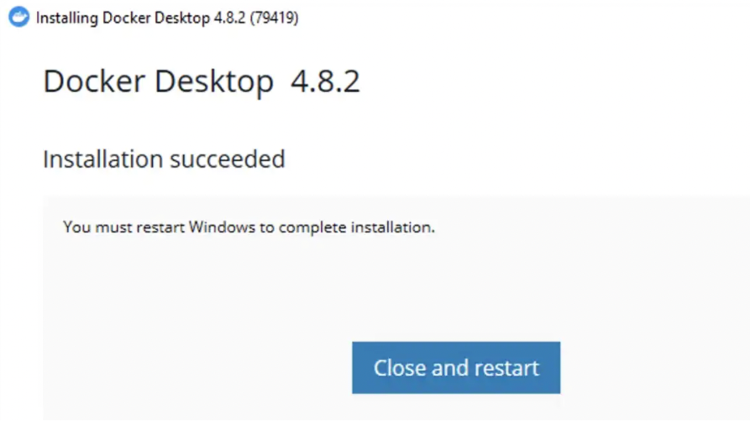

### ****Step 5: License agreement****

After the restart, Docker will start automatically and you should see the window below:

### ****Step 6: WSL 2 installation****

After you accept the license terms, the Docker Desktop window will open. However, we are not done yet. Since we have selected WSL 2 as our virtualization engine, we also need to install it. **Don’t click Restart just yet!**

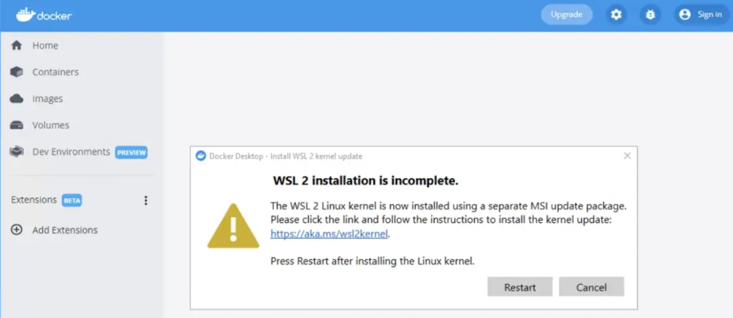

Checking the software installation

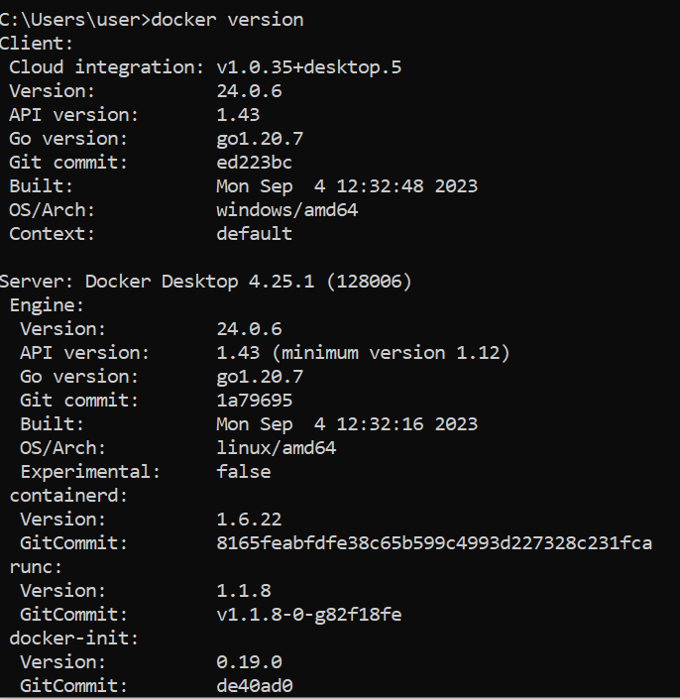

### ****Step 7 — Starting Docker Desktop****

If Docker Desktop did not start on its own, simply open it from the shortcut on your Desktop.

If you wish, you can do the initial orientation by clicking Start.

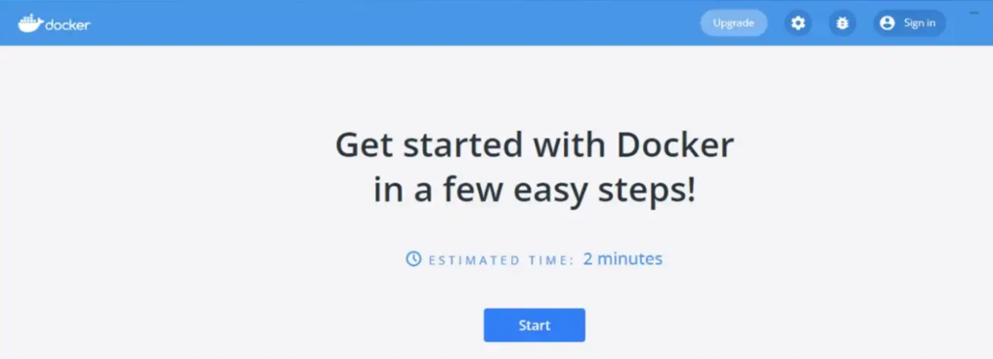

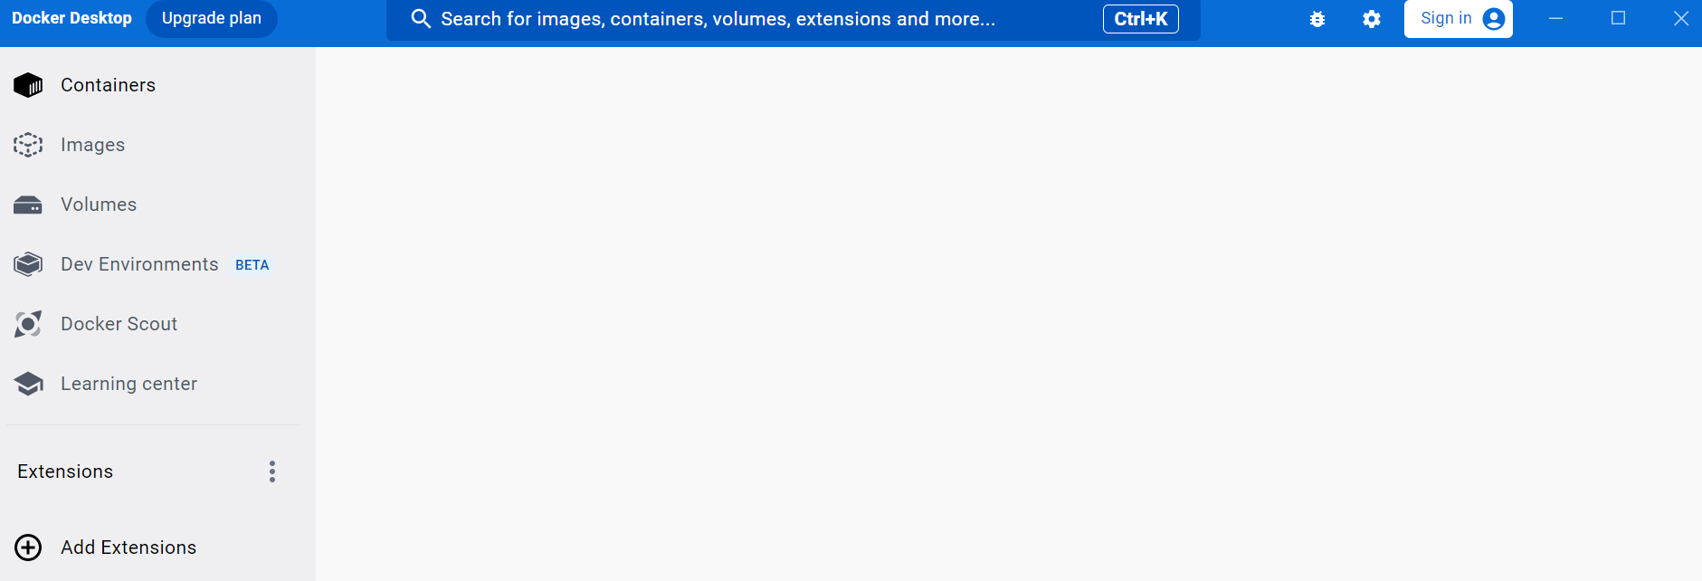

### ****Step 8— Testing Docker****

Open your favorite command line tool and type in the following command:

docker run hello-world

This will download the hello-world Docker image and run it. This is just a quick test to ensure everything is working fine.

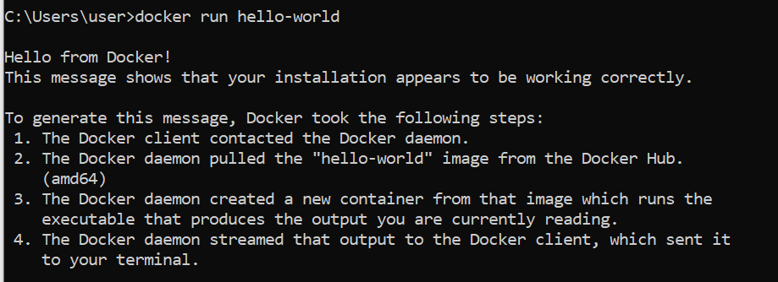

Demo Creation

Create Container and Image

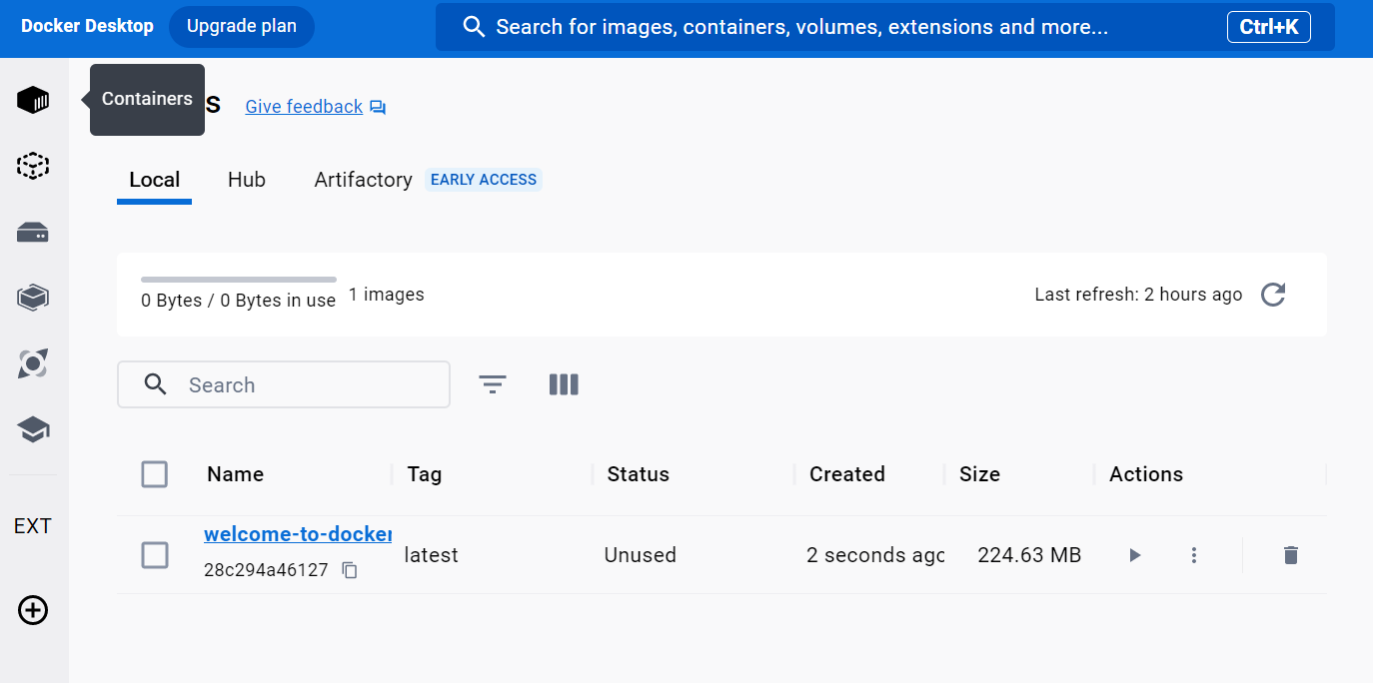

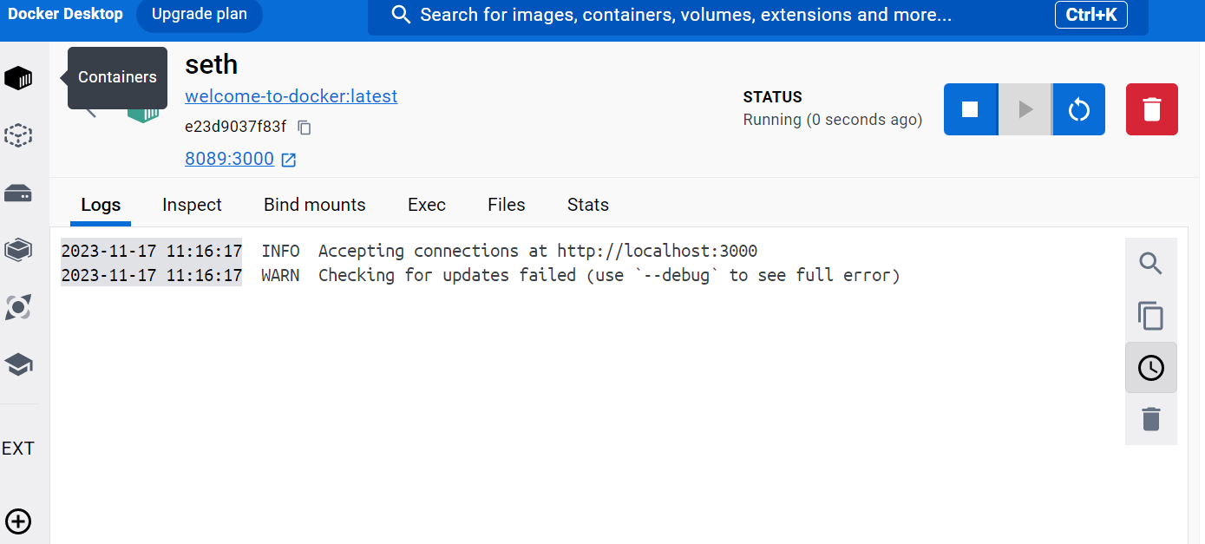

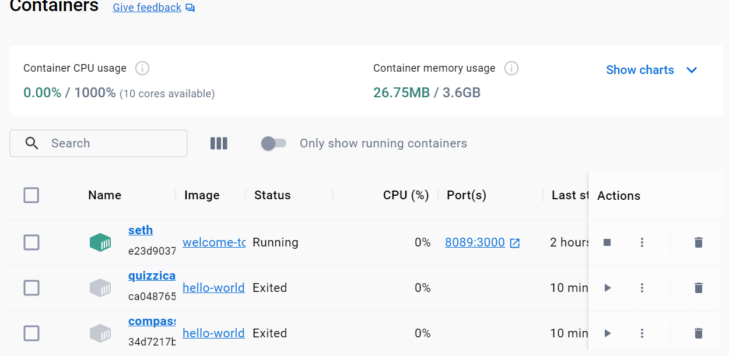

**Viewing our container**

