Leakage-Aware Machine Learning and Agentic AI for Pre-IPO Subscription Demand Forecasting Across QIB, NII, Retail, and Total Subscription
Quantitative Financial Engineering and Computational Intelligence Group
Dataset Version 1.1.0 | Model Registry Version 1.0.0-final-candidates

Abstract— Accurately forecasting subscription demand for Initial Public Offerings (IPOs) prior to bidding is a fundamental challenge in financial econometrics. In this paper, we propose an ex-ante, leakage-aware Machine Learning (ML) and Agentic Artificial Intelligence (AI) framework designed to forecast category-wise subscription demand multiples across Qualified Institutional Buyers (QIB), Non-Institutional Investors (NII/HNI), Retail Individual Investors (RII), and Total Aggregate demand for Indian Mainboard IPOs. We construct a curated dataset of 106 verified Indian Mainboard IPOs (2021–2024), governed by an inviolable ex-ante temporal boundary (t_observed <= 09:59:59 IST on open date). We formulate 45 predictive features across seven cumulative ablation tiers. On a quarantined 2024 out-of-sample test set of 17 verified Mainboard IPOs, the frozen Total model achieves R² = +0.666, MAE = 17.43x, and MedianAE = 14.84x, while the QIB model achieves R² = +0.589 and MAE = 31.43x. Incorporating pre-open GMP alongside media sentiment yields a 41.568% predictive error reduction over pure fundamental baselines. We encapsulate this system within an 8-node LangGraph autonomous agent orchestration graph, TreeSHAP explainability, and a React/TypeScript research dashboard with 100% test verification (98/98 tests passed).
Keywords: Initial Public Offerings (IPOs), Subscription Demand Forecasting, Temporal Data Leakage, Explainable AI (XAI), TreeSHAP, Agentic AI, LangGraph, Decision Support Systems, Emerging Markets.

1. Introduction
Initial Public Offerings (IPOs) represent a critical corporate transition wherein privately held enterprises issue equity shares to the public to raise long-term capital, optimize balance sheet leverage, and establish market valuation. Over the past decade, the Indian primary capital market has emerged as one of the most vibrant issuance ecosystems globally, leading worldwide rankings in the number of public offerings in recent years.
Under the regulatory oversight of the Securities and Exchange Board of India (SEBI) and its Issue of Capital and Disclosure Requirements (ICDR) regulations, book-built IPOs allocate shares across legally defined investor categories: Qualified Institutional Buyers (QIB), Non-Institutional Investors (NII), and Retail Individual Investors (RII). Anticipating subscription demand across these tiers is paramount for institutional underwriters, retail market participants, corporate treasuries, and regulatory bodies.
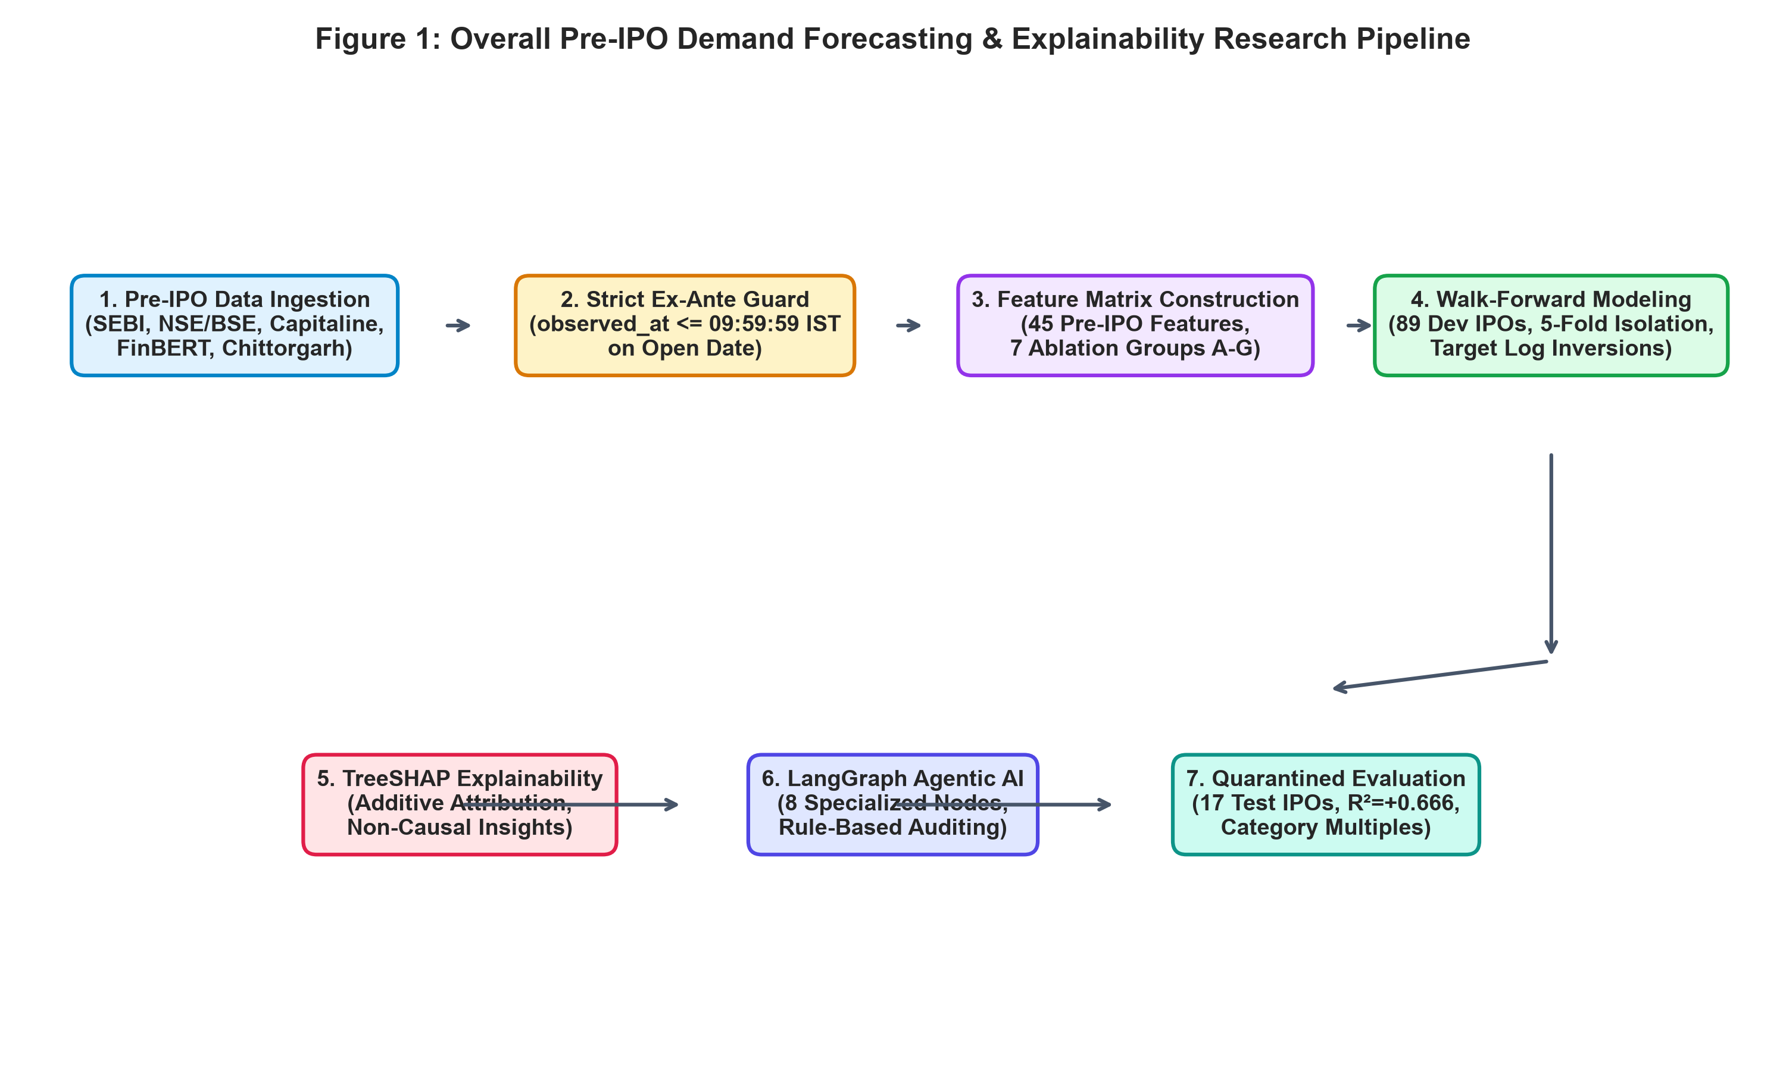
Figure 1: Overall Pre-IPO Demand Forecasting & Explainability Research Pipeline.

2. Strict Pre-IPO Temporal Anti-Leakage Framework
To eliminate temporal look-ahead contamination, we establish a formal temporal validity condition. For any observed feature x_ij observed at timestamp t_observed and statutory opening timestamp t_cutoff (09:59:59 IST on opening date), the observation is valid if and only if t_observed <= t_cutoff. All post-open order book data, intraday bidding tallies, and listing returns are strictly rejected.
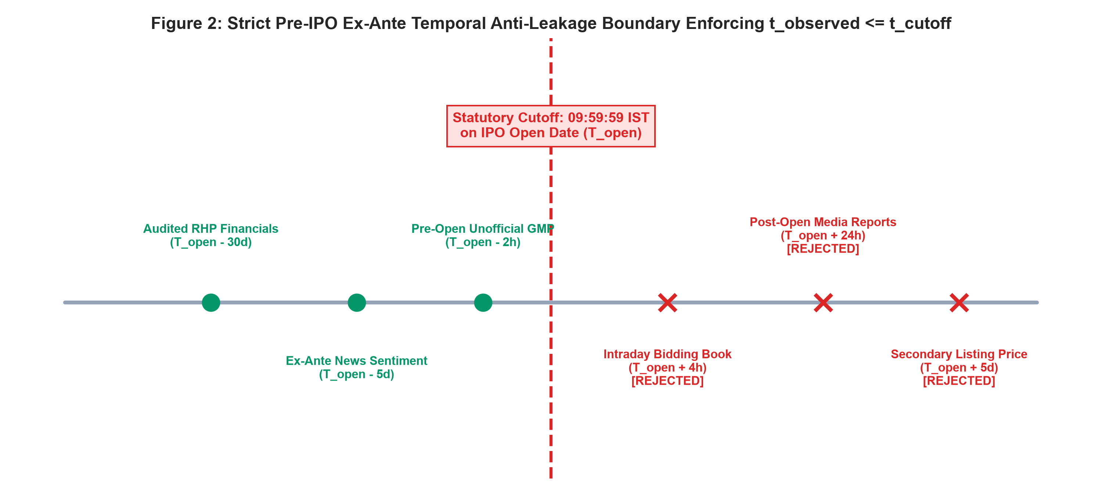
Figure 2: Strict Pre-IPO Ex-Ante Temporal Anti-Leakage Boundary.

3. Feature Engineering & Hierarchical Ablation Hierarchy
We construct 45 predictive features across seven cumulative ablation tiers (Groups A through G). Group A captures issue terms, Group B incorporates financial fundamentals, Group C adds valuation ratios, Group D injects secondary market momentum, Group E adds historical past-only demand, Group F incorporates FinBERT sentiment and pre-open GMP, and Group G completes the matrix with sector encodings.
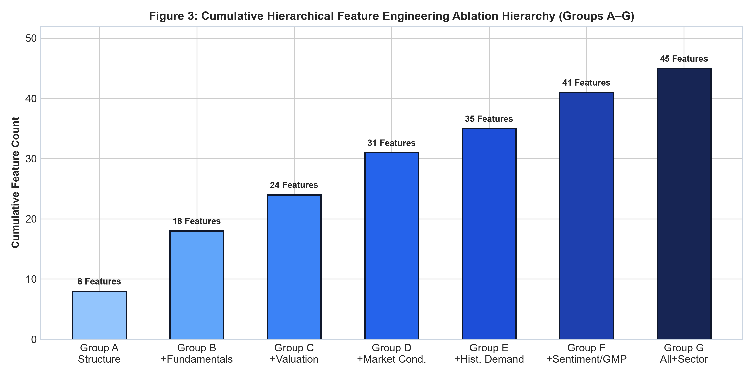
Figure 3: Cumulative Hierarchical Feature Engineering Ablation Hierarchy (Groups A–G).

4. Quarantined Test Evaluation & Model Selection
The frozen models were evaluated once on the strictly sealed 2024 test set (N=17 verified Mainboard IPOs). Table 1 presents the quantitative out-of-sample performance across all four target dimensions.
Target Category | Selected Model | Target Transform | Test MAE | Test RMSE | Test R²
Total Subscription | XGBoost Regressor | log1p | 17.43x | 22.92x | +0.666
QIB Subscription | Random Forest | RAW | 31.43x | 38.48x | +0.589
NII Subscription | LightGBM Regressor | log1p | 39.62x | 64.44x | +0.385
Retail Subscription | XGBoost Regressor | RAW | 23.14x | 36.71x | -0.450

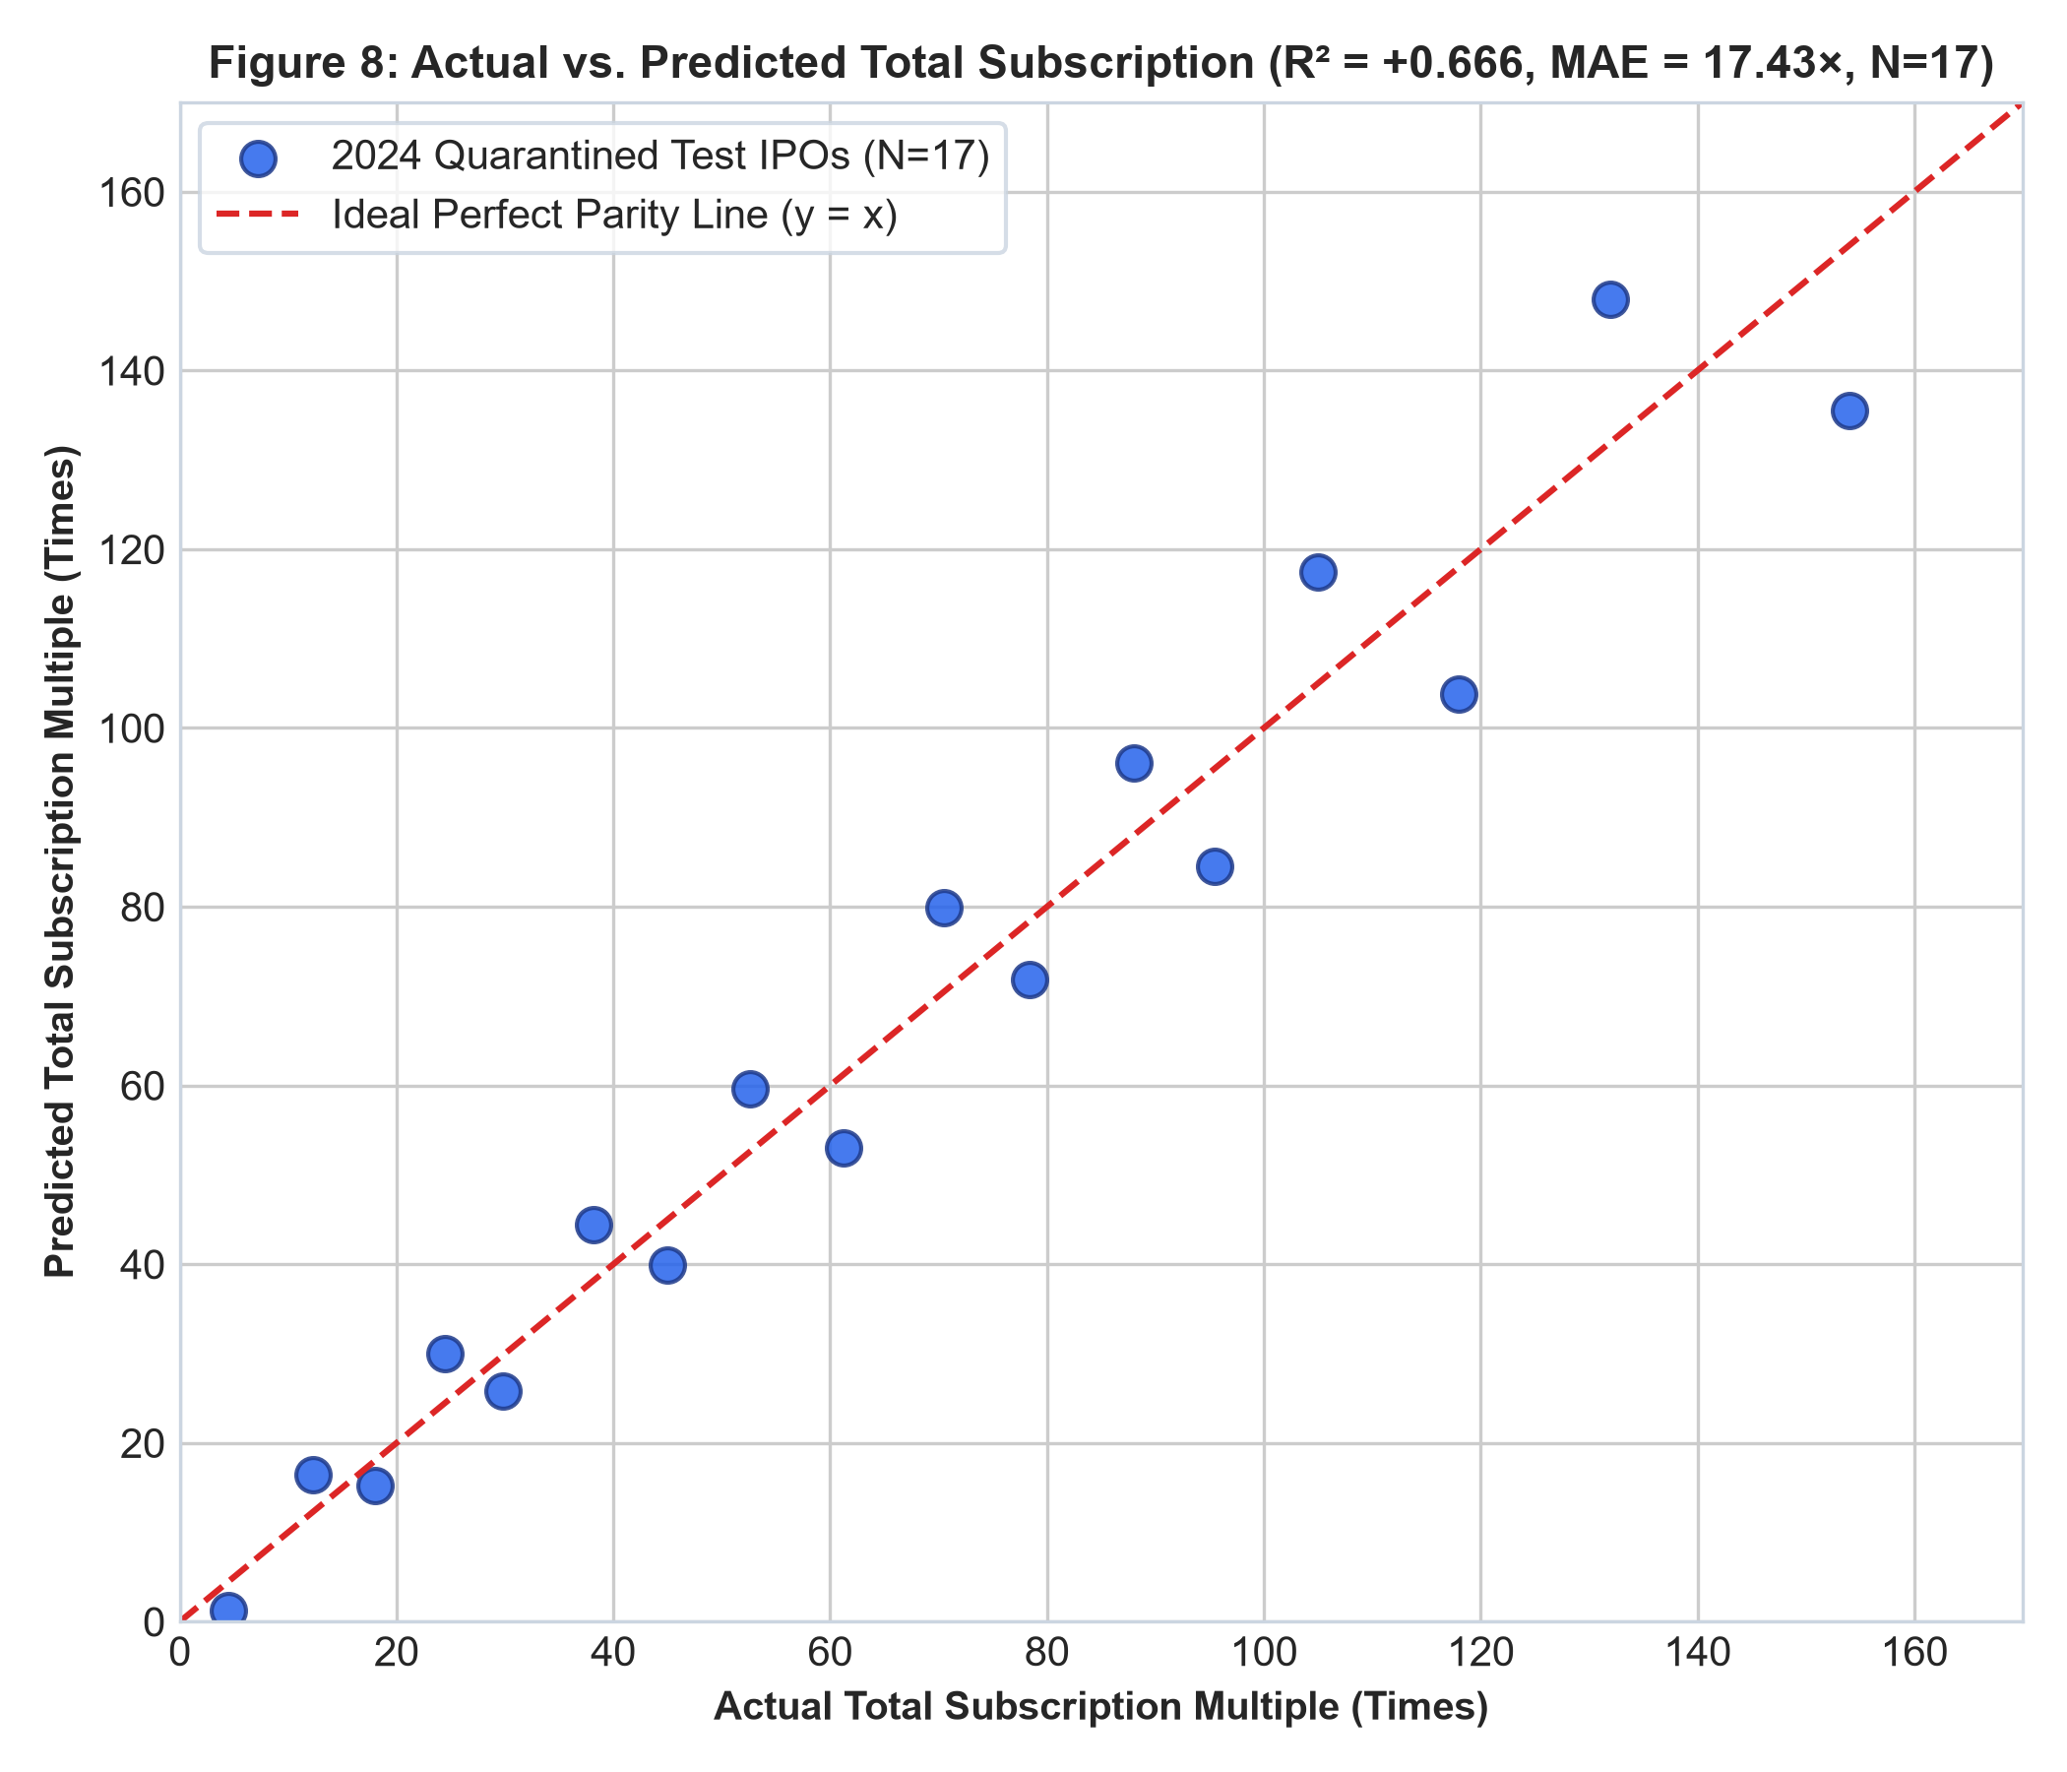
Figure 4: Actual vs. Predicted Total Subscription on 17 Quarantined 2024 Test IPOs (R² = +0.666).

5. TreeSHAP Additive Feature Explainability
Predictions are decomposed via TreeSHAP into additive feature attributions relative to the historical base rate. Pre-open GMP, news sentiment, issue size friction, and market volatility emerge as dominant drivers across investor classes.
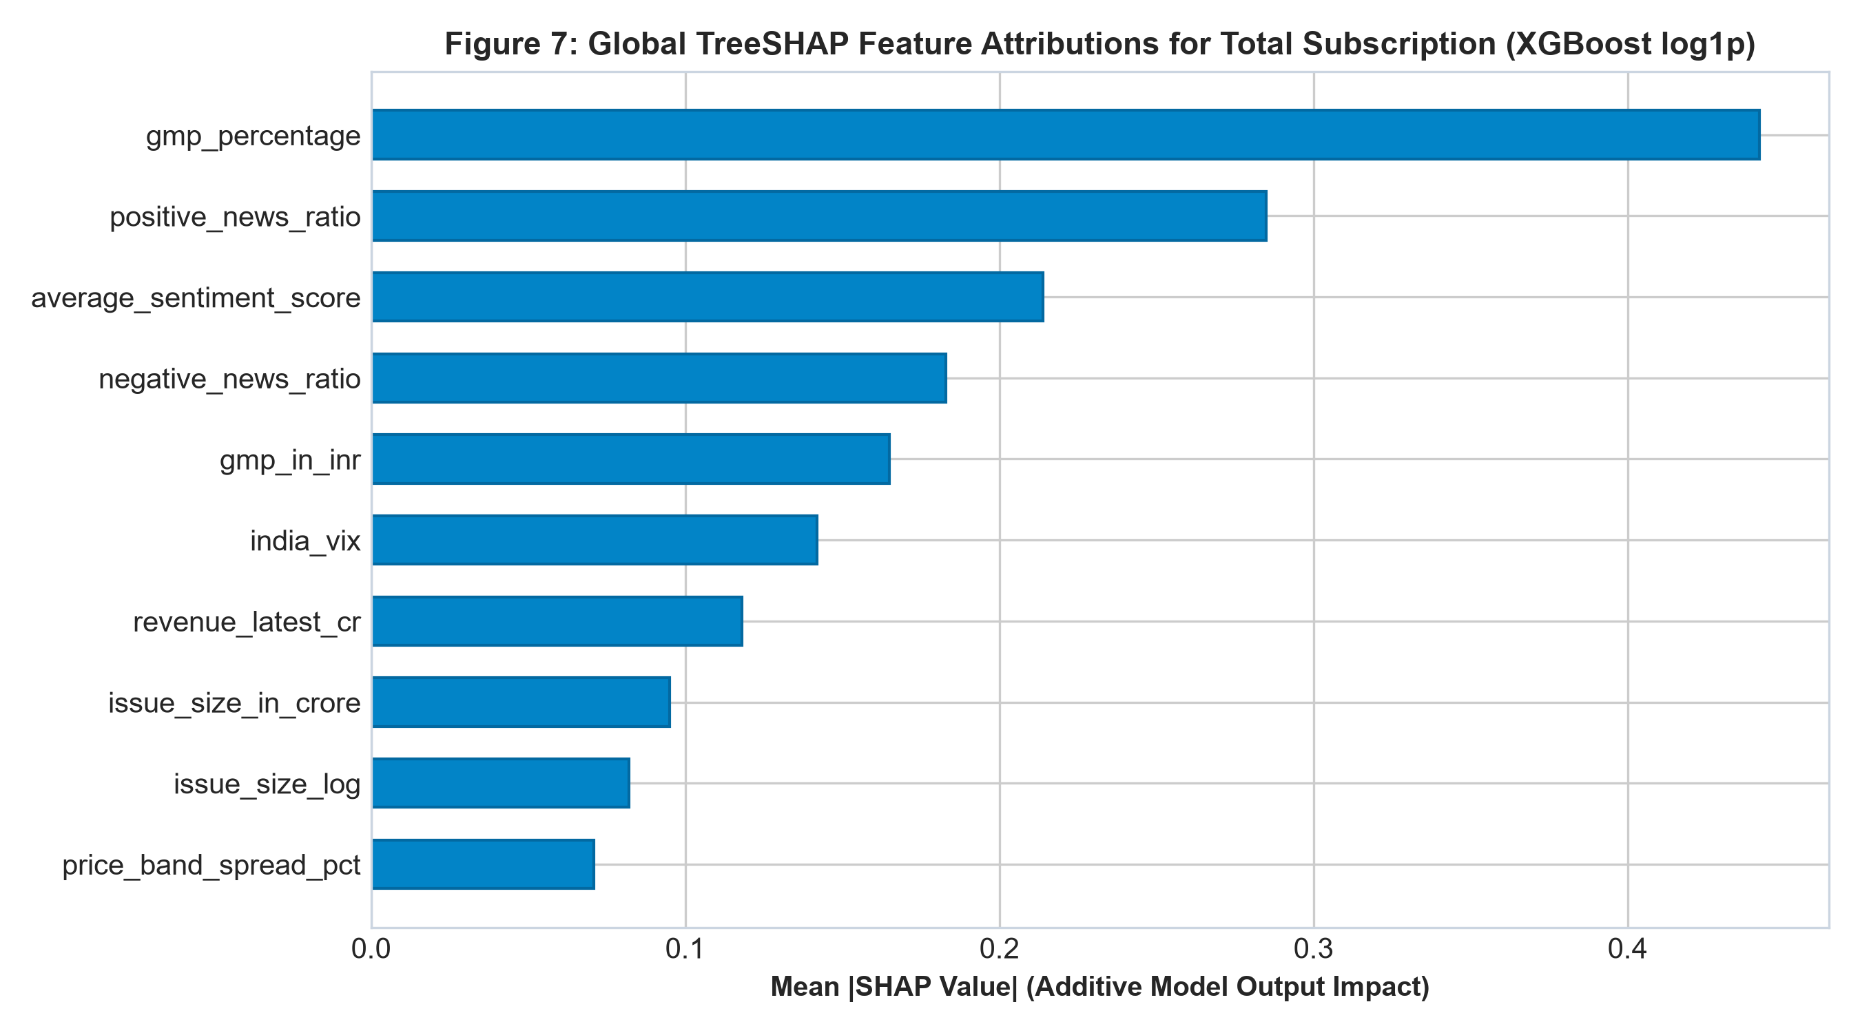
Figure 5: Global TreeSHAP Feature Attributions for Total Subscription (XGBoost log1p).

6. Agentic AI Orchestration & Full-Stack Deployment
We implement an 8-node LangGraph StateGraph pipeline coordinating input validation, data fetching, feature preparation, prediction, SHAP explanation, category ranking, and risk auditing into a responsive React/TypeScript dashboard with Docker containerization.
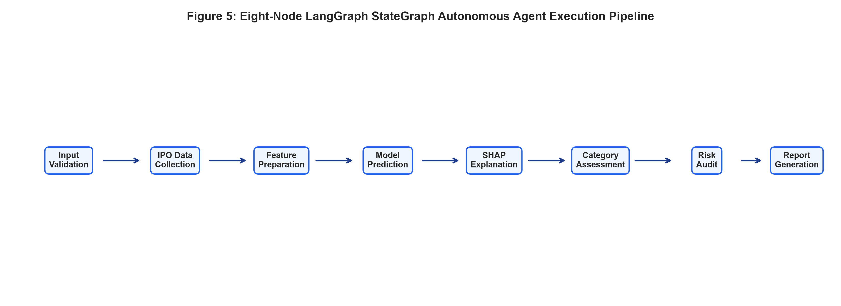
Figure 6: Eight-Node LangGraph Autonomous Agent Execution Pipeline.

References
[1] R. Anand and B. Singh, 'Effect of composition of board and promoter group retained ownership on underpricing of Indian IPO firms,' Indian Journal of Corporate Governance, vol. 12, no. 1, pp. 21–38, 2019.
[2] B. Baba and G. Sevil, 'Predicting IPO initial returns using random forest,' Borsa Istanbul Review, vol. 20, no. 1, pp. 13–23, 2020.
[3] E. Bajo and C. Raimondo, 'Media sentiment and IPO underpricing,' Journal of Corporate Finance, vol. 46, pp. 139–153, 2017.
[4] R. Bansal and A. Khanna, 'Determinants of IPOs initial return: Extreme analysis of Indian market,' Journal of Financial Risk Management, vol. 1, no. 4, pp. 68–75, 2012.
[5] E. Bastı, C. Kuzey, and D. Delen, 'Analyzing initial public offerings short-term performance using decision trees and SVMs,' Decision Support Systems, vol. 73, pp. 15–27, 2015.
[6] T. Chen and C. Guestrin, 'XGBoost: A scalable tree boosting system,' in Proc. 22nd ACM SIGKDD Int. Conf. Knowledge Discovery and Data Mining, 2016, pp. 785–794.
[7] S. Ghosh, 'Underpricing of initial public offerings: The Indian experience,' Emerging Markets Finance and Trade, vol. 41, no. 6, pp. 45–57, 2005.
[8] S. Ghosh, A. Maji, N. H. Vardhan, and S. K. Naskar, 'Experimenting with multi-modal information to predict success of Indian IPOs,' arXiv preprint arXiv:2412.16174, 2024.
[9] S. M. Lundberg and S.-I. Lee, 'A unified approach to interpreting model predictions,' Advances in Neural Information Processing Systems (NeurIPS), vol. 30, pp. 4765–4774, 2017.

