EXPERIMENT-5
write a program to store length and breadth and calculate area
create variables to store name(string), age(integer), is_graduated(boolean) print all details and display data types using typeof operator
WAP to check whether a number is even or odd
find largest of 3 numbers

<!DOCTYPE html>
<html>
<head>
<title>Area Calculator</title>
</head>
<body>

<h2>Area of Rectangle</h2>

<input type="number" id="length" placeholder="Enter length">
<input type="number" id="breadth" placeholder="Enter breadth">
<button onclick="calculateArea()">Calculate</button>

<p id="result"></p>

<script>
function calculateArea() {
let length = document.getElementById("length").value;
let breadth = document.getElementById("breadth").value;

let area = length * breadth;

document.getElementById("result").innerText = "Area = " + area;
}
</script>

</body>
</html>
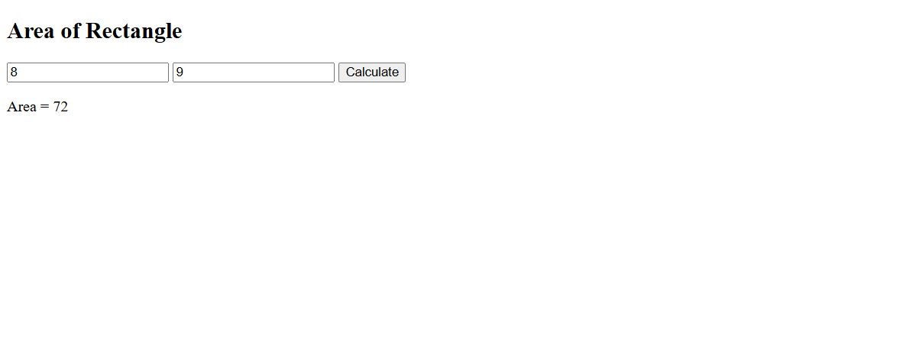

<!DOCTYPE html>
<html>
<head>
<title>Data Types</title>
</head>
<body>

<h2>User Details</h2>

<button onclick="showDetails()">Show Details</button>

<p id="output"></p>

<script>
function showDetails() {
let name = "Kush";
let age = 20;
let is_graduated = false;

let result = `
Name: ${name} (${typeof name}) <br>
Age: ${age} (${typeof age}) <br>
Graduated: ${is_graduated} (${typeof is_graduated})
`;

document.getElementById("output").innerHTML = result;
}
</script>

</body>
</html>
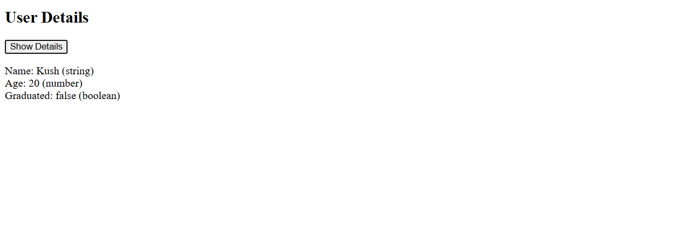
<!DOCTYPE html>
<html>
<head>
<title>Even or Odd</title>
</head>
<body>

<h2>Even or Odd Checker</h2>

<input type="number" id="num" placeholder="Enter number">
<button onclick="checkEvenOdd()">Check</button>

<p id="result"></p>

<script>
function checkEvenOdd() {
let num = document.getElementById("num").value;

if (num % 2 == 0) {
document.getElementById("result").innerText = "Even Number";
} else {
document.getElementById("result").innerText = "Odd Number";
}
}
</script>

</body>
</html>
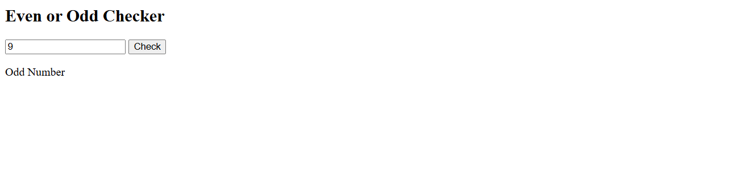
<!DOCTYPE html>
<html>
<head>
<title>Largest Number</title>
</head>
<body>

<h2>Find Largest of 3 Numbers</h2>

<input type="number" id="n1" placeholder="Enter first number">
<input type="number" id="n2" placeholder="Enter second number">
<input type="number" id="n3" placeholder="Enter third number">

<button onclick="findLargest()">Find Largest</button>

<p id="result"></p>

<script>
function findLargest() {
let a = parseFloat(document.getElementById("n1").value);
let b = parseFloat(document.getElementById("n2").value);
let c = parseFloat(document.getElementById("n3").value);

let largest;

if (a >= b && a >= c) {
largest = a;
} else if (b >= a && b >= c) {
largest = b;
} else {
largest = c;
}

document.getElementById("result").innerText = "Largest = " + largest;
}
</script>

</body>
</html>
