EXPERIMENT-9
Question 1: Copy a student object and modified the copied one without affecting the original one.
(Clone of object)
Code:
const student = {
name: "Kush",
age: 20
};
const clonedStudent = structuredClone(student);
clonedStudent.name = "Kush";
console.log(student);
console.log(clonedStudent);
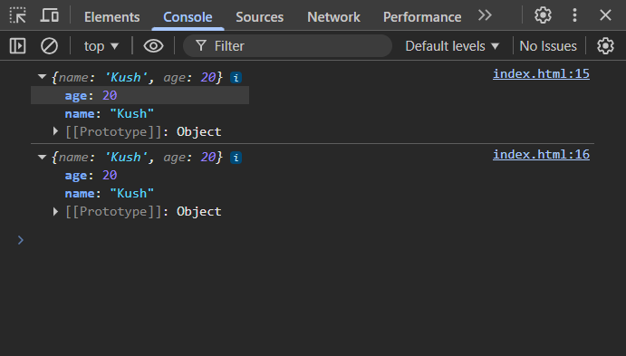

Question 2: Create a student object where student has Name, Marks stored as object then remove
one subject recalculate the total after removal of subject.
Code:
const student = {
name: "Kush",
marks: { math: 80, science: 80, english: 80 }
};
delete student.marks.english;
const total = Object.values(student.marks)
.reduce((sum, m) => sum + m, 0);
console.log(student);
console.log("Total:", total);
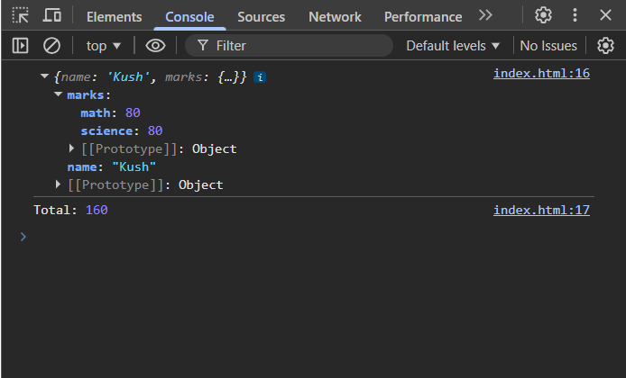

Question 3 In the same previous ques, store Marks as subject wise object, find total of thoery and
practical subject wise for each student and then find total.
Code:
let students = [
{
name: "Kush",
marks: {
math: { theory: 80, practical: 20 },
science: { theory: 70, practical: 25 }
}},
{
name: "Deepak",
marks: {
math: { theory: 85, practical: 15 },
science: { theory: 75, practical: 20 }
}}
];
let topTheory = { name: "", score: 0 };
let topPractical = { name: "", score: 0 };
let topOverall = { name: "", score: 0 };
students.forEach(s => {
let theory = 0, practical = 0;
for (let sub in s.marks) {
theory += s.marks[sub].theory;
practical += s.marks[sub].practical;
}
let total = theory + practical;
if (theory > topTheory.score) topTheory = { name: s.name,
score: theory };
if (practical > topPractical.score) topPractical = { name: s.name,
score: practical };
if (total > topOverall.score) topOverall = { name: s.name, score:
total };
});
console.log(topTheory);
console.log(topPractical);
console.log(topOverall);
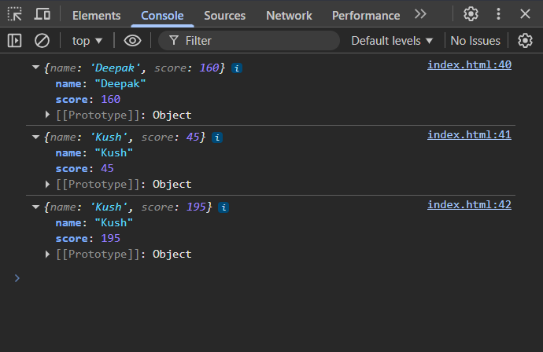

Question 4: Create array of students with Marks, Calculate average marks assigned grades (A,B and
C) then group students into one object.
Code:
console.log("Kushagra 2401010029");
let students = [
{ name: "Kush", marks: [80, 70, 90] },
{ name: "Deepak", marks: [60, 65, 70] },
{ name: "Sahdev", marks: [40, 50, 45] }
];
let result = { A: [], B: [], C: [] };
students.forEach(s => {
let total = s.marks.reduce((a, b) => a + b, 0);
let avg = total / s.marks.length;
let grade = avg >= 75 ? "A" : avg >= 60 ? "B" : "C";
result[grade].push({ name: s.name, avg });
});
console.log(result);


Question 5: Create two objects, one contains student personal info like Name and Age other one
contains Marks, Now merge both object into one, print the merged object.
Code:
console.log("Kushagra 2401010029");
let personal = {
name: "Kush",
age: 20
};
let marks = {
math: 80,
science: 75
};
let merged = { ...personal, ...marks };
console.log(merged);
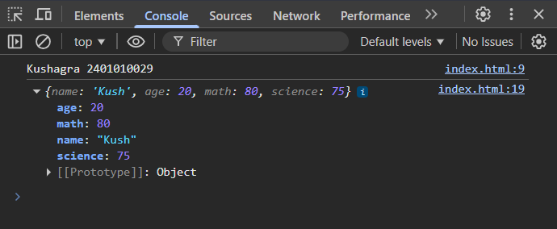

Question 6: Given an array of students objects Stores name and age and now convert this array
into object use student name as keys and store full student object as value.
Code:
console.log("Kushagra 2401010029");
let students = [
{ name: "Kush", age: 20 },
{ name: "Deepak", age: 19 }
];
let obj = {};
students.forEach(s => {
obj[s.name] = s;
});
console.log(obj);
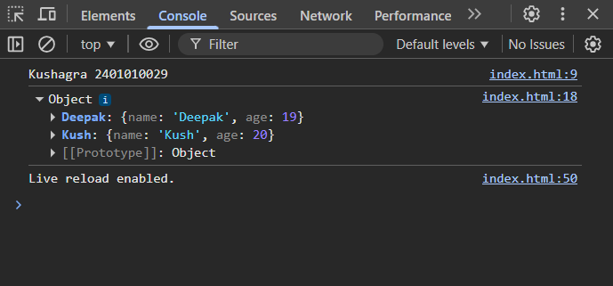

Question 7: Create array of students where each student has Name, Marks in two tests and now
calculate the total marks of test 1 and test 2 then find the student who needs highest
improvement.
Code:
console.log("Kushagra 2401010029");
let students = [
{ name: "Kush", test1: 50, test2: 80 },
{ name: "Deepak", test1: 60, test2: 70 },
{ name: "Sahdev", test1: 40, test2: 90 }
];
let maxImprovement = -Infinity;
let studentName = "";
students.forEach(s => {
let improvement = s.test2 - s.test1;
if (improvement > maxImprovement) {
maxImprovement = improvement;
studentName = s.name;
}
});
console.log(studentName, maxImprovement);
