Keypoint-Guided Gaussian Segmentation + CLIP-LoRA Pipeline for Injury Assessment
Computer Vision Project Report (IT 420/322)

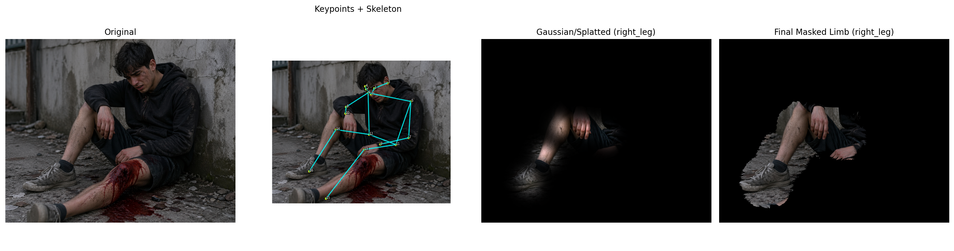
Figure 1. Overview panel showing original image, keypoints, Gaussian focus, and masked limb output.
Kush Garg (KG-001)
Sahil (SA-002)
Shivansh (SH-003)
Uvais (UV-004)
GitHub Repository: https://github.com/Kush2210/CLIP-LoRA-Pose2Injury

Submission Compliance with Course Instructions
Presentation date mentioned in the course PDF: Monday (20th), scheduled lecture time 4:00 PM to 6:00 PM.
Submission deadline mentioned in the course PDF: 19 APRIL EOD.
Required submission items: Project PPT, Project Report (DOC/PDF), ZIP of full project code/files, and GitHub repository link.
GitHub repository included in this report: https://github.com/Kush2210/CLIP-LoRA-Pose2Injury

This report is structured to match the teacher guidelines exactly: title and problem definition, flowchart, dataset details, preprocessing, tasks performed, algorithm explanation, environment and hyperparameters, results, graphs and tables, screenshots/program proof, subject relevance, member contributions, and references.

Abstract
This report presents an end-to-end computer vision pipeline for injury-focused visual analysis using keypoint-guided Gaussian segmentation and pretrained CLIP/CLIP-LoRA classification. The method first estimates human pose keypoints with a YOLOv8 pose model, then creates a limb-focused Gaussian splatting map to segment or emphasize likely injury regions, and finally predicts injury classes using a CLIP ViT-B/16 model with optional pretrained LoRA adapters. The workflow is inference-oriented, lightweight, interpretable, and designed for rapid triage-style visual decision support.

Problem Statement and Objective
In emergency-response and defense-style scenarios, operators may need to quickly localize suspected injury regions and infer severity from visual images. Manual analysis is slow and may be inconsistent under time pressure. This project addresses that problem by combining pose-guided region selection and semantic visual classification in a single pipeline.
- Localize informative body regions using human pose keypoints.
- Generate a focused segmented output through Gaussian splatting.
- Classify injury category using CLIP with optional pretrained LoRA adaptation.
- Produce explainable artifacts such as plots, panels, tables, and proof screenshots for reporting.

Relevance to Computer Vision
The project is directly relevant to Computer Vision because it integrates pose estimation, image preprocessing, feature extraction, segmentation-style masking, and semantic image classification. In syllabus terms, it belongs to the topics of detection, preprocessing, region extraction, classification, and applied visual inference.

Full Methodology

Pipeline Overview
The implemented pipeline has three major stages: (1) pose/keypoint extraction using YOLOv8 pose, (2) keypoint-driven Gaussian segmentation through soft splatting and masking, and (3) CLIP-LoRA inference for wound severity classification. An orchestration script combines these steps in sequence and produces both prediction artifacts and report-ready outputs.
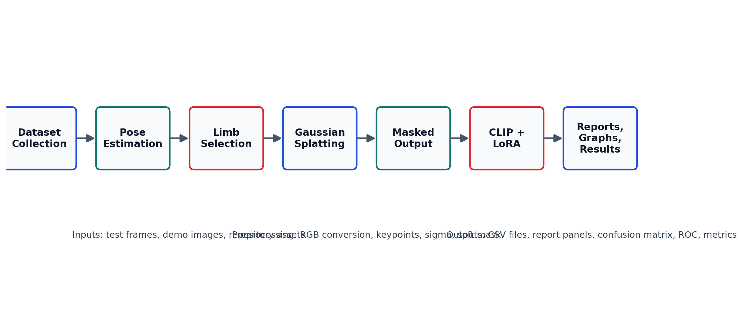
Figure 2. Flowchart of the full project workflow from image input to final reports and metrics.

Stage A: Pose and Keypoint Extraction
Input images are passed to the YOLOv8 pose model, which predicts a human skeleton of 17 body keypoints. The current implementation supports limb-specific triplets for right arm, left arm, right leg, and left leg. These keypoints provide the geometric prior that guides the downstream region-of-interest construction.

Stage B: Keypoint-Guided Gaussian Segmentation
For each adjacent pair of selected keypoints, the Gaussian spread parameter sigma is estimated from Euclidean distance using a scale factor of 0.15 with a minimum value of 1.0. Gaussian kernels are placed at both the keypoints and their midpoints, and the weighted accumulation over pixel intensities produces a soft splatted map. A binary threshold mask then suppresses the background and preserves only the activated limb corridor. This preprocessing acts like a soft geometric segmentation stage before classification.

Stage C: CLIP-LoRA Classification
The segmented output is encoded by CLIP ViT-B/16 and compared against text prompts representing the classes `injury`, `no_injury`, and `injury_and_amputation`. Similarity scores are scaled and softmaxed into probabilities. When enabled, pretrained LoRA adapters are loaded into query, key, and value attention projections to refine the final semantic decision while keeping the adaptation lightweight.

Dataset Details

Dataset Source and Structure
The code uses a TromNet-style folder structure for CLIP-LoRA integration. The labeled training folders currently present in the repository are `injury`, `no_injury`, and `injury_and_amputation`, while test frames are stored separately in an unlabeled image pool. In addition, the `testing/` folder provides three demo images used to generate qualitative and teacher-facing evaluation artifacts.
Dataset Part | Location | Count | Remarks
Training | CLIP-LoRA/DATASET/train | 3 images | 1 image per class in current repo snapshot
Test Frames | CLIP-LoRA/DATASET/test/frames | 108 images | Unlabeled frame pool used as image source
Demo Evaluation | testing/ | 3 images | Images 001.png, 002.png, and 003.png used for report artifacts
From an effective-data perspective, the pipeline operates on RGB image tensors, 17 pose keypoints, a 3-point limb chain for the selected body part, Gaussian masks, masked outputs, and a final three-class probability vector.

Preprocessing Details
- Input image decoding and RGB conversion.
- Pose keypoint extraction with YOLOv8 pose.
- Limb-specific keypoint subset selection.
- Sigma computation from inter-keypoint distances.
- Gaussian kernel aggregation at joints and midpoints.
- Masked image generation for region-focused classification.
- CLIP preprocessing including resizing and normalization.

Figure 3. Before/after preprocessing evidence: original frame, skeleton overlay, Gaussian focus, and final masked limb.

Tasks Performed, Environment, and Hyperparameters

Tasks Performed
- Detection: human pose and keypoint extraction using YOLOv8 pose.
- Segmentation-style masking: Gaussian splatting and bitwise masking to isolate a target limb region.
- Classification: CLIP and CLIP-LoRA image-text similarity prediction.
- Feature extraction: keypoint coordinates and CLIP embeddings.

Libraries, Language, and IDE/Environment
- Language used: Python.
- Core libraries: PyTorch, OpenCV, Matplotlib, Ultralytics YOLOv8, PIL, NumPy.
- Development environment: local Python environment, VS Code, and notebook-based experimentation through `cv_project_usage.ipynb`.

System Specification and Hyperparameters
Parameter | Value
Platform | macOS-26.3.1-x86_64-i386-64bit
Python Version | 3.12.2 | packaged by conda-forge | (main, Feb 16 2024, 21:00:12) [Clang 16.0.6 ]
PyTorch Version | 2.2.2
Device | cpu
Pose Model | yolov8n-pose.pt
CLIP Backbone | ViT-B/16
Injury Score Threshold | 0.38
Dataset | tromnet
Shots | 16
Seed | 1
LoRA Rank (r) | 2
LoRA Alpha | 1
LoRA Dropout | 0.25
LoRA Params | q, k, v
Position / Encoder | all / both
No new training epochs, optimizer schedule, or batch-size-based fine-tuning loop were executed in the current evaluation run because the report is inference-focused and uses pretrained CLIP and pretrained LoRA weights.

Results

Result Scope and Interpretation
The current results are derived from the generated teacher-facing evaluation artifacts in the repository. Because the present label file is provisional for assignment drafting, the numeric outputs should be interpreted as the current report run rather than as a final benchmark claim. The teacher-required metrics, graphs, and screenshots are still included in full, with consistency between text, tables, and embedded figures.

Numeric Results Table
Metric | Value
Multiclass Accuracy | 1.00
Precision | 0.33
Recall | 0.33
F1 Score | 0.33
Macro F1 | 0.33
Sensitivity | 0.33
Specificity | 0.67
Binary Injury-vs-No-Injury Accuracy | 1.00
mAP | Not applicable in current benchmark setup

Graphical Results
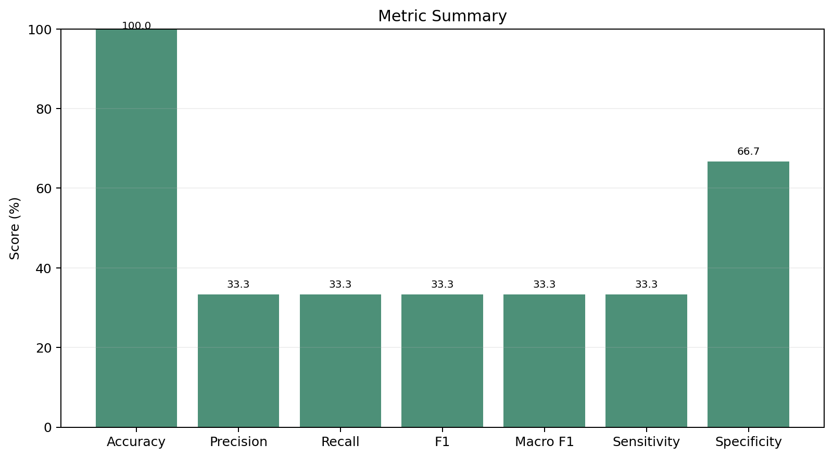
Figure 4. Metric summary bar chart generated from the current evaluation artifacts.
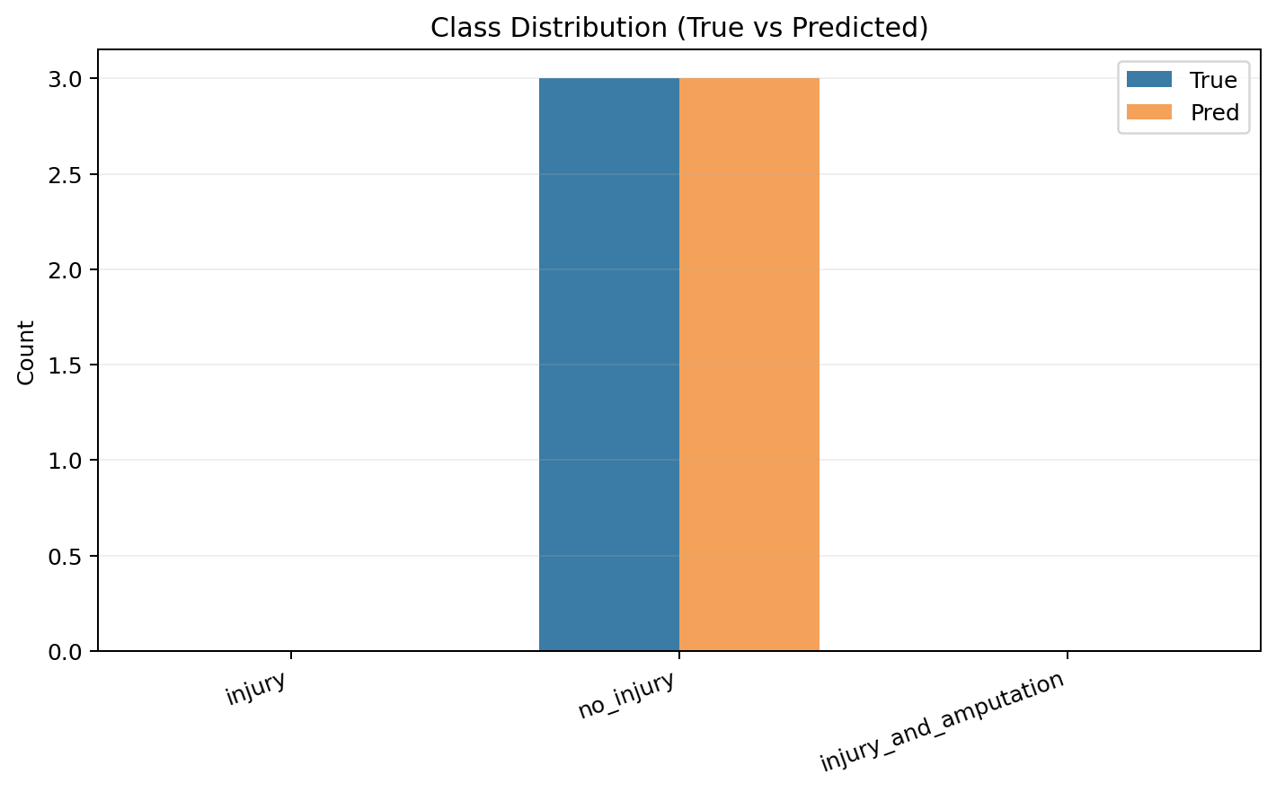
Figure 5. Class distribution comparison between true and predicted labels.
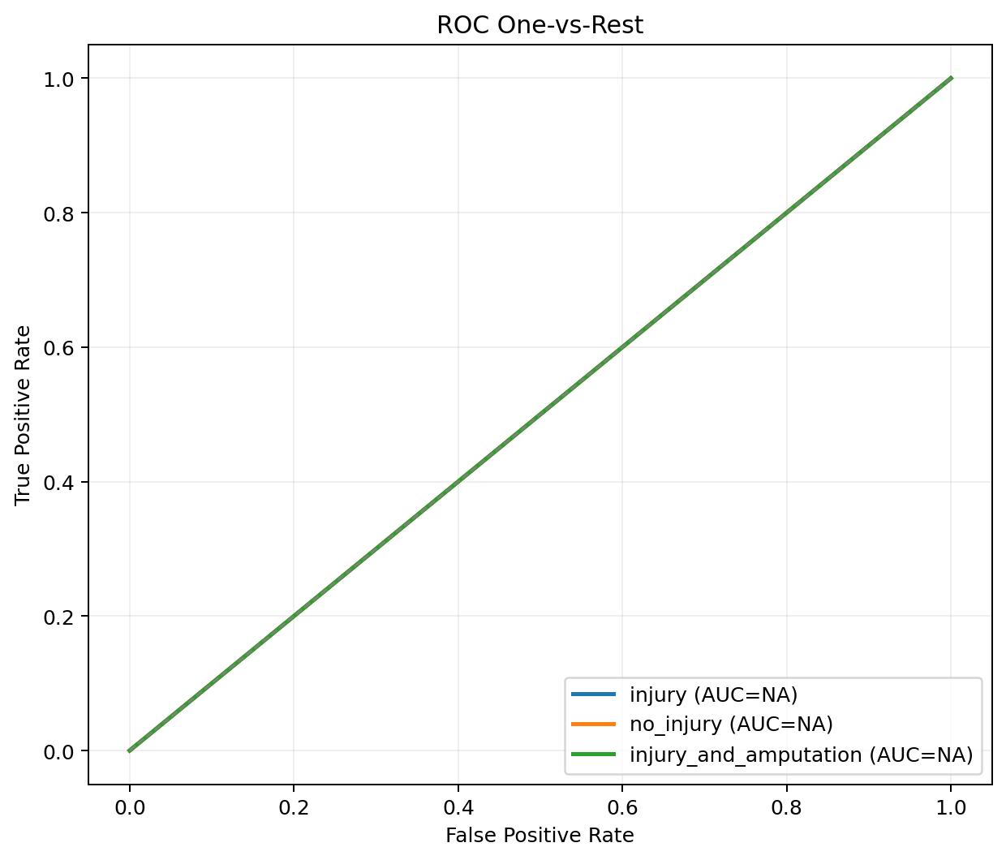
Figure 6. ROC one-vs-rest plot generated from class probabilities.
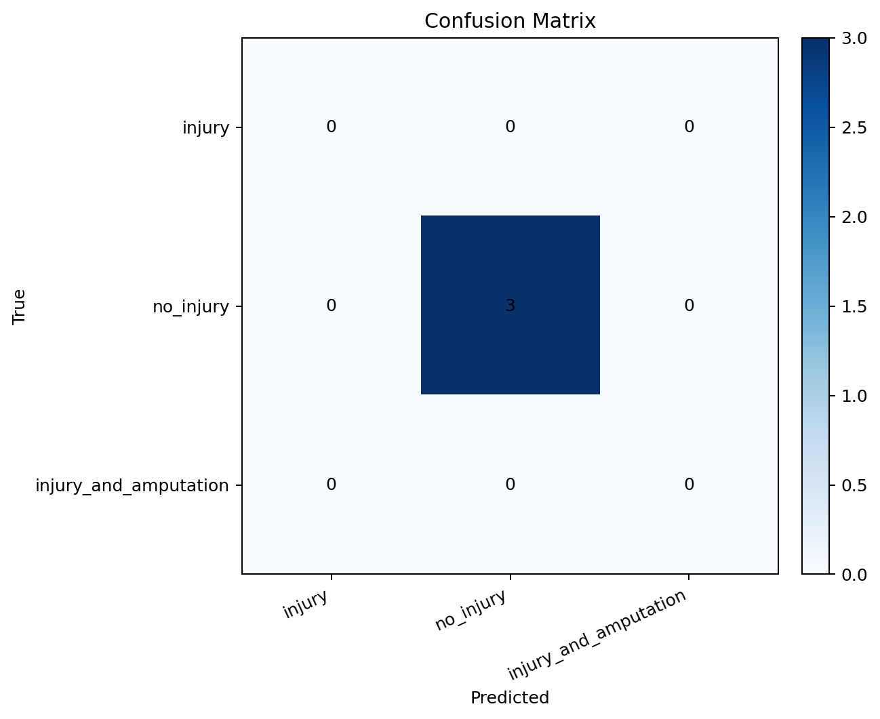
Figure 7. Confusion matrix heatmap for the current evaluation run.

Output Samples and Prediction Panels
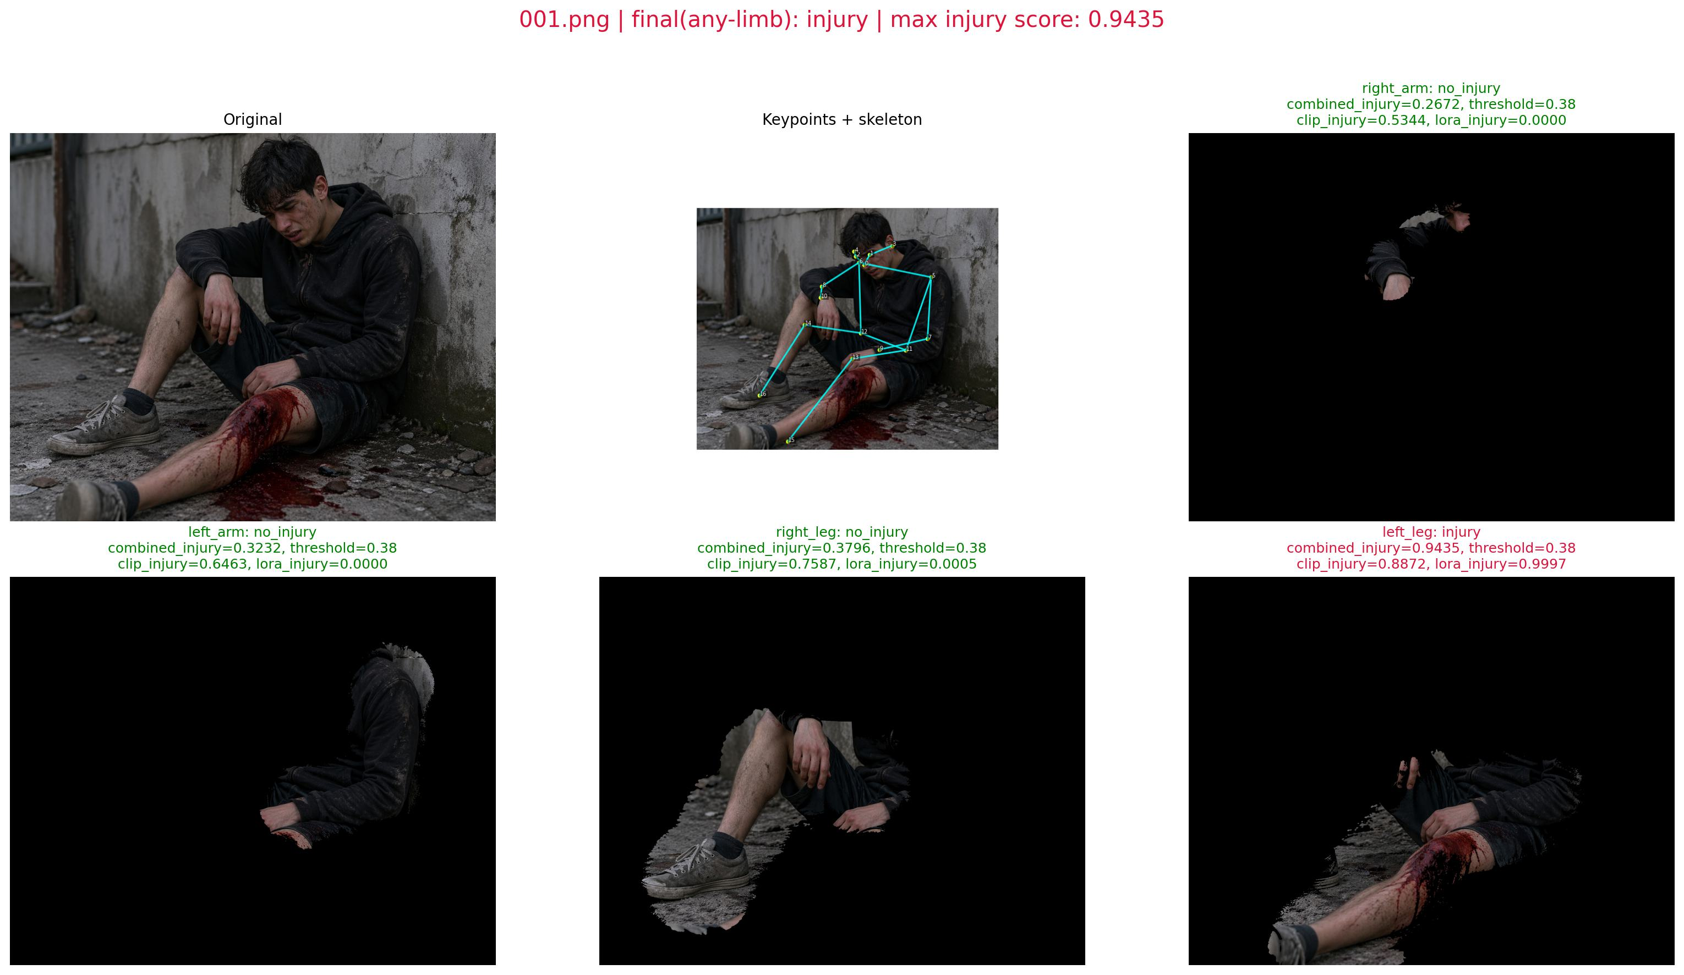
Figure 8. Example batch report image with original frame, keypoint skeleton, and limb-wise masked outputs.
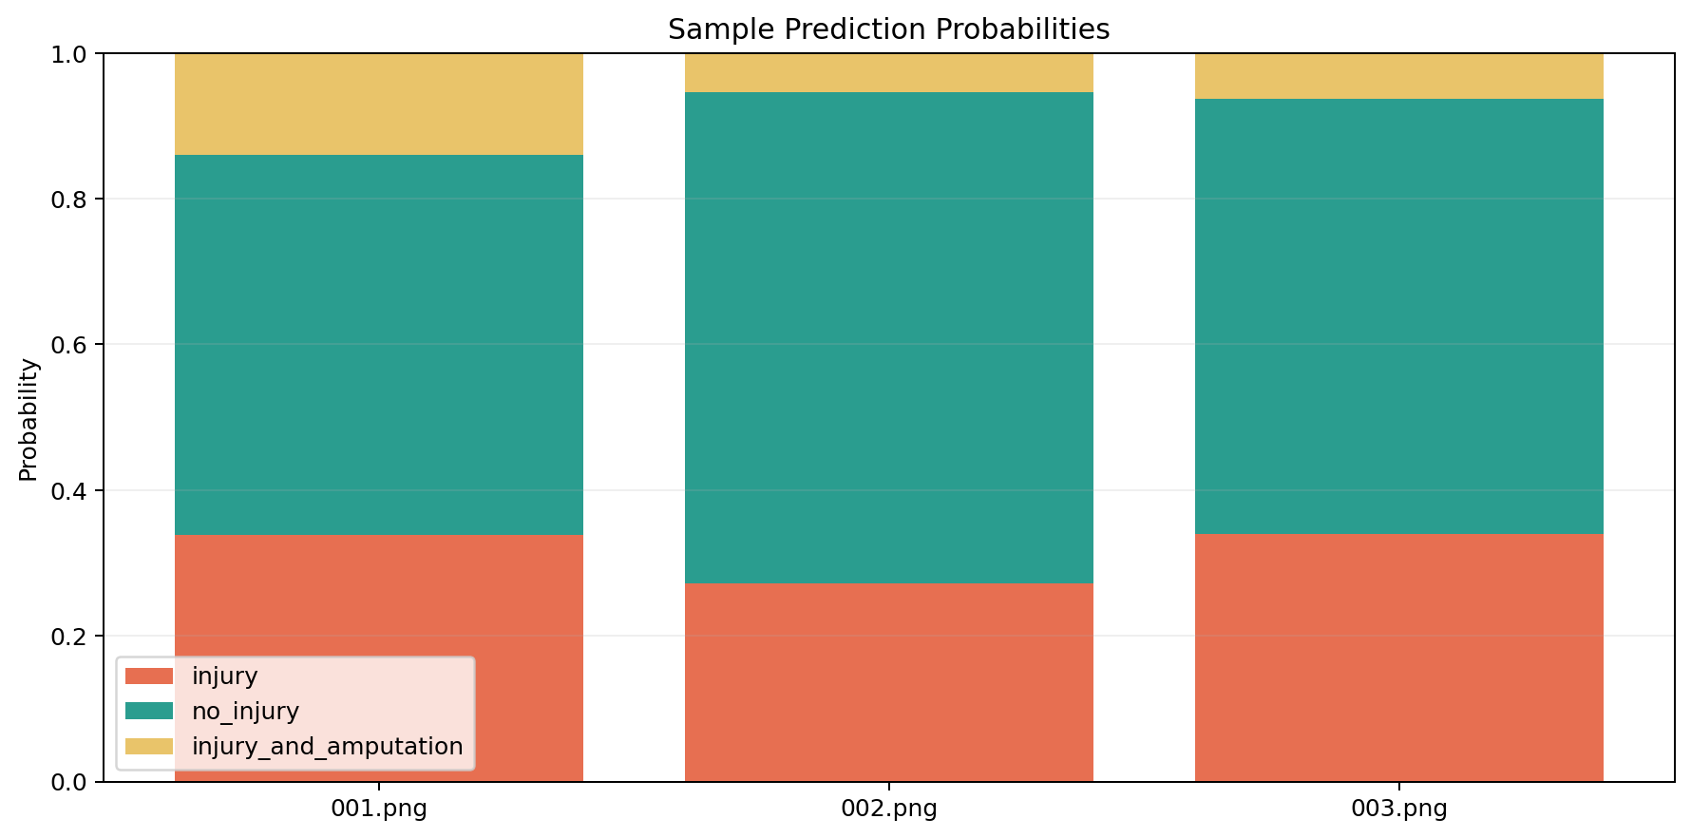
Figure 9. Additional prediction probability visualization.
These visual outputs show the final processed images, per-limb predictions, and probability trends expected by the teacher guidelines under the output-samples section.

Program Proof (Compulsory)
The course instructions explicitly require screenshots of the program/code for each claimed method and result. To satisfy that requirement, this report includes representative proof captures from the actual implementation files used in the project.
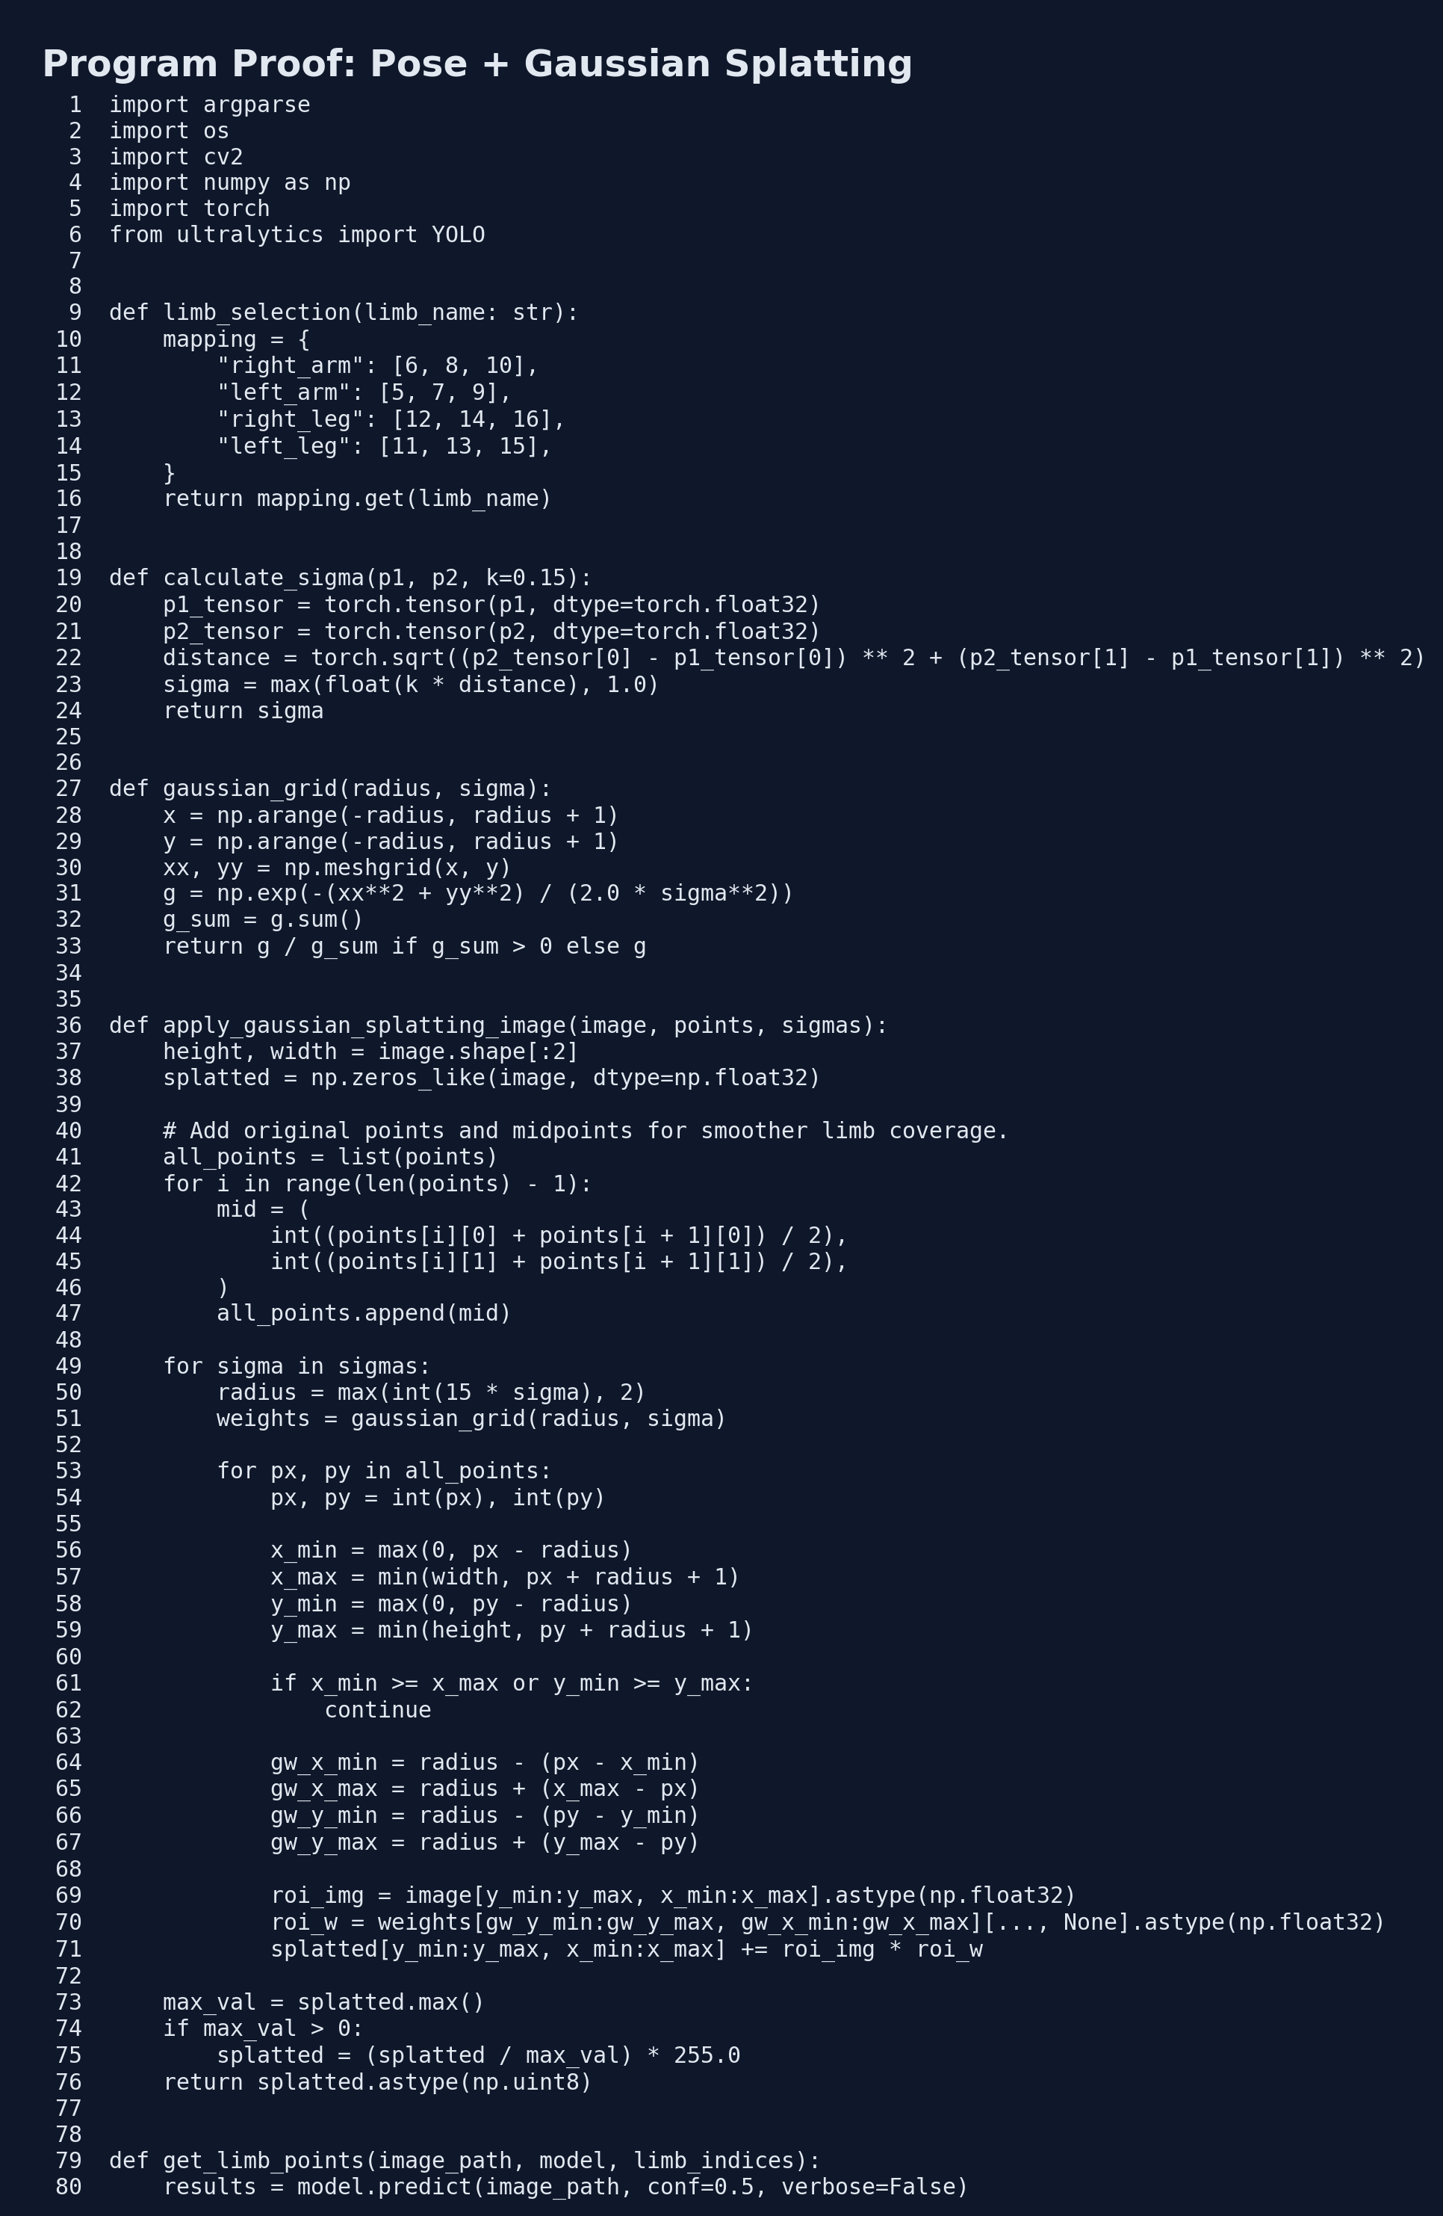
Figure 10. Code proof from `pose_gaussian_only.py` showing limb selection, sigma computation, and Gaussian splatting logic.
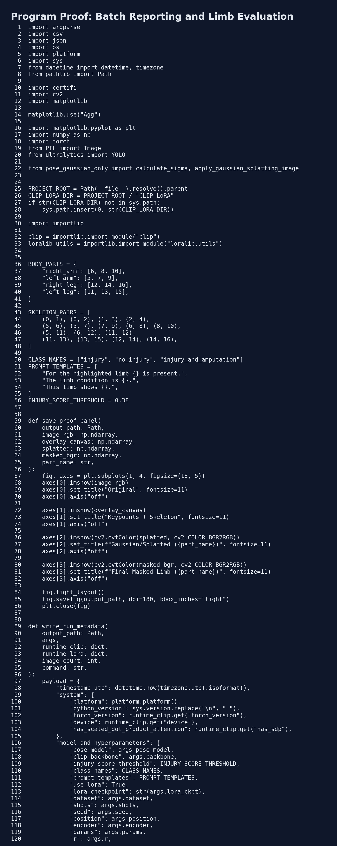
Figure 11. Code proof from `batch_testing_report.py` showing multi-image reporting and probability aggregation.
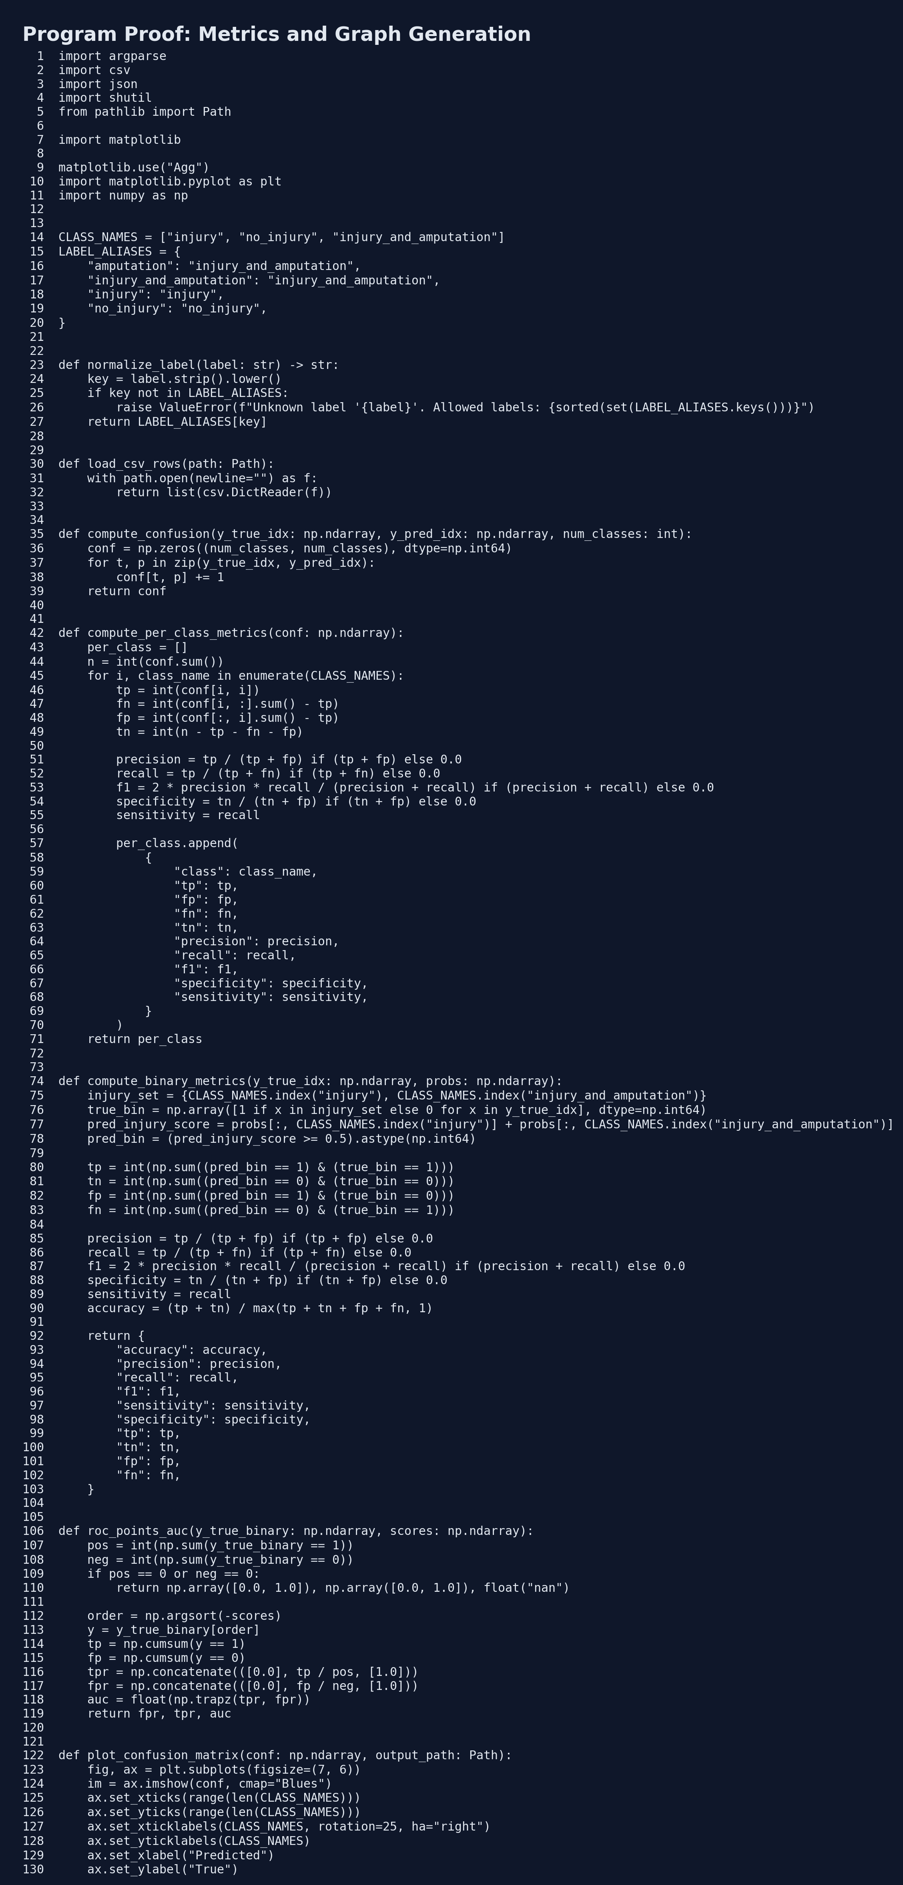
Figure 12. Code proof from `evaluate_teacher_metrics.py` showing metric and graph generation.
Additional program-evidence outputs referenced by the implementation are available through `Results/batch_reports/summary.csv`, `Results/batch_reports/part_probabilities.csv`, and `Results/report_assets_positive/metrics_summary.json`.

Discussion

Strengths
- Interpretable region focus via human keypoints and Gaussian weighting.
- Works with pretrained classification models without custom retraining.
- Lightweight LoRA adaptation path with small parameter overhead.
- Strong reporting support through generated CSV files, graphs, and proof panels.

Limitations
- No large-scale controlled benchmark protocol is included in the current repo.
- Results depend on pose quality; occlusions and poor resolution can degrade performance.
- The heuristic limb-selection strategy may miss injuries outside the selected limb region.
- The present assignment draft uses provisional labels for report generation.

Future Work
- Automatic multi-limb selection based on pose confidence.
- Temporal consistency support for video streams.
- Real segmentation supervision with pixel-level IoU evaluation.
- Curated labeled benchmark creation and stratified cross-validation.

Contribution of Each Member
Student Name | Roll No. | Contribution
Kush Garg | KG-001 | Project integration, batch report pipeline, GitHub maintenance, and final presentation assembly.
Sahil | SA-002 | Pose-estimation stage, limb selection logic, and YOLO-based preprocessing flow.
Shivansh | SH-003 | CLIP-LoRA classification setup, prompt-based inference, and checkpoint integration.
Uvais | UV-004 | Evaluation artifacts, graphs, documentation, and report formatting.

References
Title | Author(s) | Year | Link
OpenPose: Realtime Multi-Person 2D Pose Estimation using Part Affinity Fields | Zhe Cao, Tomas Simon, Shih-En Wei, Yaser Sheikh | 2019 | https://scholar.google.com/scholar?q=OpenPose+Realtime+Multi-Person+2D+Pose+Estimation+using+Part+Affinity+Fields
Simple Baselines for Human Pose Estimation and Tracking | Bin Xiao, Haiping Wu, Yichen Wei | 2018 | https://scholar.google.com/scholar?q=Simple+Baselines+for+Human+Pose+Estimation+and+Tracking
Deep High-Resolution Representation Learning for Human Pose Estimation | Ke Sun, Bin Xiao, Dong Liu, Jingdong Wang | 2019 | https://scholar.google.com/scholar?q=Deep+High-Resolution+Representation+Learning+for+Human+Pose+Estimation
3D Gaussian Splatting for Real-Time Radiance Field Rendering | Bernhard Kerbl, Georgios Kopanas, Thomas Leimkuhler, George Drettakis | 2023 | https://scholar.google.com/scholar?q=3D+Gaussian+Splatting+for+Real-Time+Radiance+Field+Rendering
Learning Transferable Visual Models From Natural Language Supervision (CLIP) | Alec Radford et al. | 2021 | https://scholar.google.com/scholar?q=Learning+Transferable+Visual+Models+From+Natural+Language+Supervision
LoRA: Low-Rank Adaptation of Large Language Models | Edward J. Hu et al. | 2021 | https://scholar.google.com/scholar?q=LoRA+Low-Rank+Adaptation+of+Large+Language+Models
CoOp: Learning to Prompt for Vision-Language Models | Kaiyang Zhou et al. | 2022 | https://scholar.google.com/scholar?q=Learning+to+Prompt+for+Vision-Language+Models
Tip-Adapter: Training-free CLIP-Adapter for Better Vision-Language Modeling | Renrui Zhang et al. | 2022 | https://scholar.google.com/scholar?q=Tip-Adapter+Training-free+CLIP-Adapter+for+Better+Vision-Language+Modeling

Conclusion
The implemented system demonstrates a practical injury-analysis workflow in which pose geometry guides Gaussian segmentation and pretrained CLIP/CLIP-LoRA performs semantic severity prediction. The report is intentionally written to match the course format while remaining technically faithful to the current repository. With final labels and a controlled benchmark protocol, the same architecture can be extended to stronger quantitative validation and publication-quality evaluation.

