**Name: Kush P. Brahmbhatt**

**No.: +91 95588 30905, +91 81604 13207**

**Software Engineering Assessment**

**Module - 1**

**1. What is software? What is software engineering?**

**Software** - Software is the collection of codes, programs and data that tells the computer how to perform the tasks on the user input or user interaction.

**Software Engineering** – Software Engineering is an engineering professional approach towards Software Development or Production.

**2. Explain types of software.**

- There are 4 types of Software: System Software, Application Software, Programming Software and Utility Software

**System Software:**

- System Software manages and controls the computer hardware so that other software applications and programs can run.

- E.g.: Windows OS, MacOS, and Unix (Linux).

**Application Software:**

- Application Software is a type of software which is designed and programmed for end-users to perform specific tasks and programs.

- E.g.: Browser, Graphic Designing Apps, Video Editing Apps, Social Media Apps, etc.

**Programming Software**

- Programming Software is a type of software which is designed and programmed for developers, coders and computer enthusiasts.

- Programming Software can be used to code, debug, maintain, or otherwise support in Software Development or Production.

- E.g.: Code Editors (Visual Studio Code, Sublime Text, Vim, NeoVim, etc.),

IDE (Visual Studio, NetBeans, Eclipse, Android Studio, IntelliJ IDEA, Atom, etc.)

**Utility Software**

- Utility Software provides additional functionality to the operating system or performs specific tasks, such as antivirus software, disk cleaners, and backup programs.

**3. What is SDLC? Explain each phase of SDLC**

- SDLC: Software Development Life Cycle.

- It’s a professional structured used by Software Developers to plan, design, develop, test, deploy and maintain the software application in a specific way.

**SDLC Phases:**

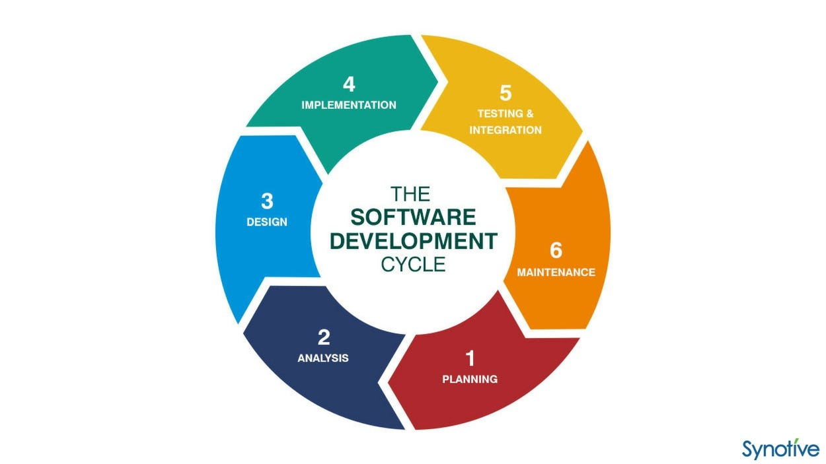

i) Planning

- Planning phase involves gathering requirements/needs, defining project scope, and creating a roadmap for the development process.

- Planning phase includes activities such as conducting feasibility studies, identifying risks, and creating a project plan for Software Development.

ii) Analysis

- In this Analysis phase, developers analyze the requirements which were gathered in the Planning Phase.

- They define the software’s functionalities, User Interfaces (UI), data structures and what technology/language to code on.

iii) Design

- In this Design Phase, Developers create a blueprint for the software application based on the requirements/needs and analysis.

- Software application blueprint is as designed using software like: Figma, Adobe XD, Sketch.

- Developers design the User Interface (UI), User Experience (UX), System Architecture, Database Structure, etc.

- The main goal is to create a detailed design plan for developers to look up on.

iv) Implementation

- Implementation Phase is also called as Coding or Programming Phase.

- In these phase, actual coding of the software application takes place.

- Developers write code according to the design specifications and requirements which were established in the previous 3 phases.

- Developers follow professional coding standards and best practices to ensure the code is readable, efficient, bug-free, maintainable, and has scalable infrastructure.

v) Testing

- In this Testing phase, Testing and Checking the bugs of the software application takes place.

- Testing Phase is a crucial phase where developers identify and fixes the defects which were in the software.

- Testing Phase involves various types of testing such as:

* Unit Testing
* Integration Testing
* System Testing
* UI/UX Testing
* User Acceptance Testing

- Most of the developers hate these Testing phases lmao.

- Main goal is to check that the software behaves as expected and meets quality standards.

vi) Deployment

- After the software application has been thoroughly Tested and Approved by the Testers and Developers then it is ready for Deployment Phase.

- Deployment Phase involves activities such as installation, configuration, data migration and checking environmental variables/keys.

- Developers use free deployment platforms such as: GitHub Pages, Vercel, Netlify, Railway, Render, etc.

vii) Maintenance

- Maintenance Phase involves maintaining and enhancing the software application over its lifecycles as mentioned in the requirements.

- Maintenance Phase includes activities such as:

* Fixing Bugs
* Fixing Glitches
* Adding New Features
* Optimizing Performance
* Checking/Updating DB Storage
* Addressing User Feedbacks

- Main goal of this phase is to ensure that the software remains effective and relevant over time as per mentioned in the requirements.

**4. What is DFD? Create a DFD diagram on Flipkart**

- DFD: Data Flow Diagram.

- DFD is a graphical representation of the data flow through a system.

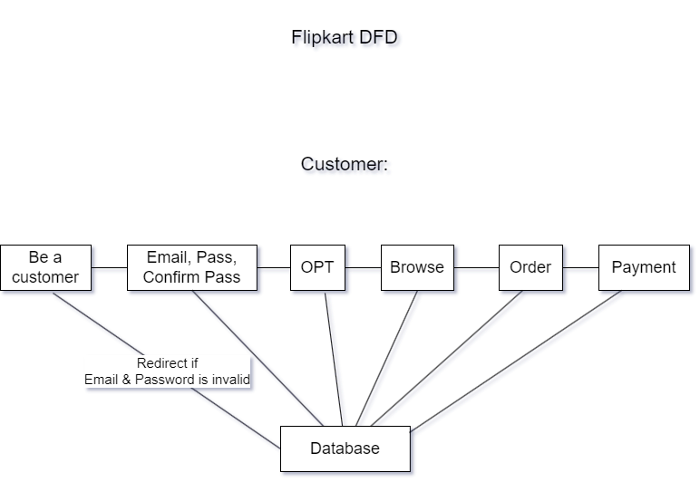

**5. What is Flow Chart? Create a flowchart to make addition of two numbers**

- A Flow Chart is the visual representation of a process, using various symbols connected by arrows to depict the flow of steps.

- Each symbol has a specific meaning and represents a specific action or decision in the process.

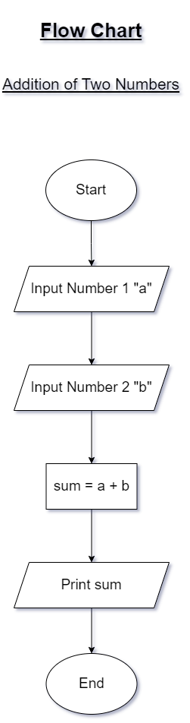

**6. What is Use case Diagram? Create a Use-Case on bill payment on PayTm.**

- UCD: Use Case Diagram.

- A UCD is a graphical representation of how users interact with a software.

- It shows various use cases, actors (main actor, secondary actor) and their interactions with the software.

