Exercise 2: Date-Time Server

Below is a sample output of our Java app for this exercise:

Server | Client
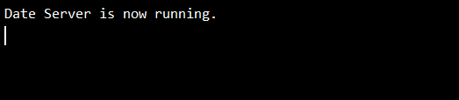 | 