Autonomous Working Capital System
ETH Global Mumbai Hackathon

1. Overview
A receivables-backed credit protocol for AI-agent businesses. It turns buyer-confirmed future revenue into USDC working capital that a team of agents can spend today, then repays lenders automatically when the customer pays.
One verified receivable, one shared credit ceiling, many agents.

2. Problem
- Agents pay immediately for APIs, compute, data, tools and other agents.
- Customers pay 30 to 60 days after the work is done.
- A profitable agent can still stop operating because of a temporary cash gap.

3. How It Works
- Verify. The buyer confirms the invoice. Hedera tokenizes it with one canonical ID, so it can never be financed twice.
- Fund. A borrowing base is calculated from the receivable. 1inch Aqua lenders with matching risk rules compete, and the cheapest eligible capital is selected.
- Spend. Arc issues one USDC credit facility. The lead agent splits it into sub-budgets, and subagents pay for services autonomously through x402 on Hedera.
- Repay. The customer pays into a fixed Arc repayment router. Lenders receive principal and fee first, and the operator receives the remainder.

4. Technology Roles
Layer | Role | Prize track
Hedera | Trust and identity. Receivable token (Asset Tokenization Studio), HCS audit trail, KYA identity and reputation, x402 payments. | Tokenize Anything; AI Agents That Pay: x402
1inch Aqua + SwapVM | Capital market. Lender positions with their own risk rules, risk-priced APR, custom credit instruction, multi-lender matching. | Build an Aqua App
Arc | Credit and settlement. USDC credit facility, borrowing-base limit, shared agent budget, repayment router. | Best DeFi / Onchain Finance App; Advanced Stablecoin Logic

5. Security and Guarantees
Risk | Control
Fake or double-financed invoice | Buyer confirmation, then one canonical receivable ID with a lifecycle lock.
Repayment bypass | Payment route is fixed to the router before lending, so lenders are paid before the operator.
Over-borrowing | Debt never exceeds the borrowing base. Subagent budgets are reservations, so more agents never means more credit.
Rogue subagent | KYA identity, merchant allowlist, daily and per-transaction limits.
Stale data, AI error | Stale claims stop borrowing. Credit decisions are deterministic; AI only explains.

6. System Architecture
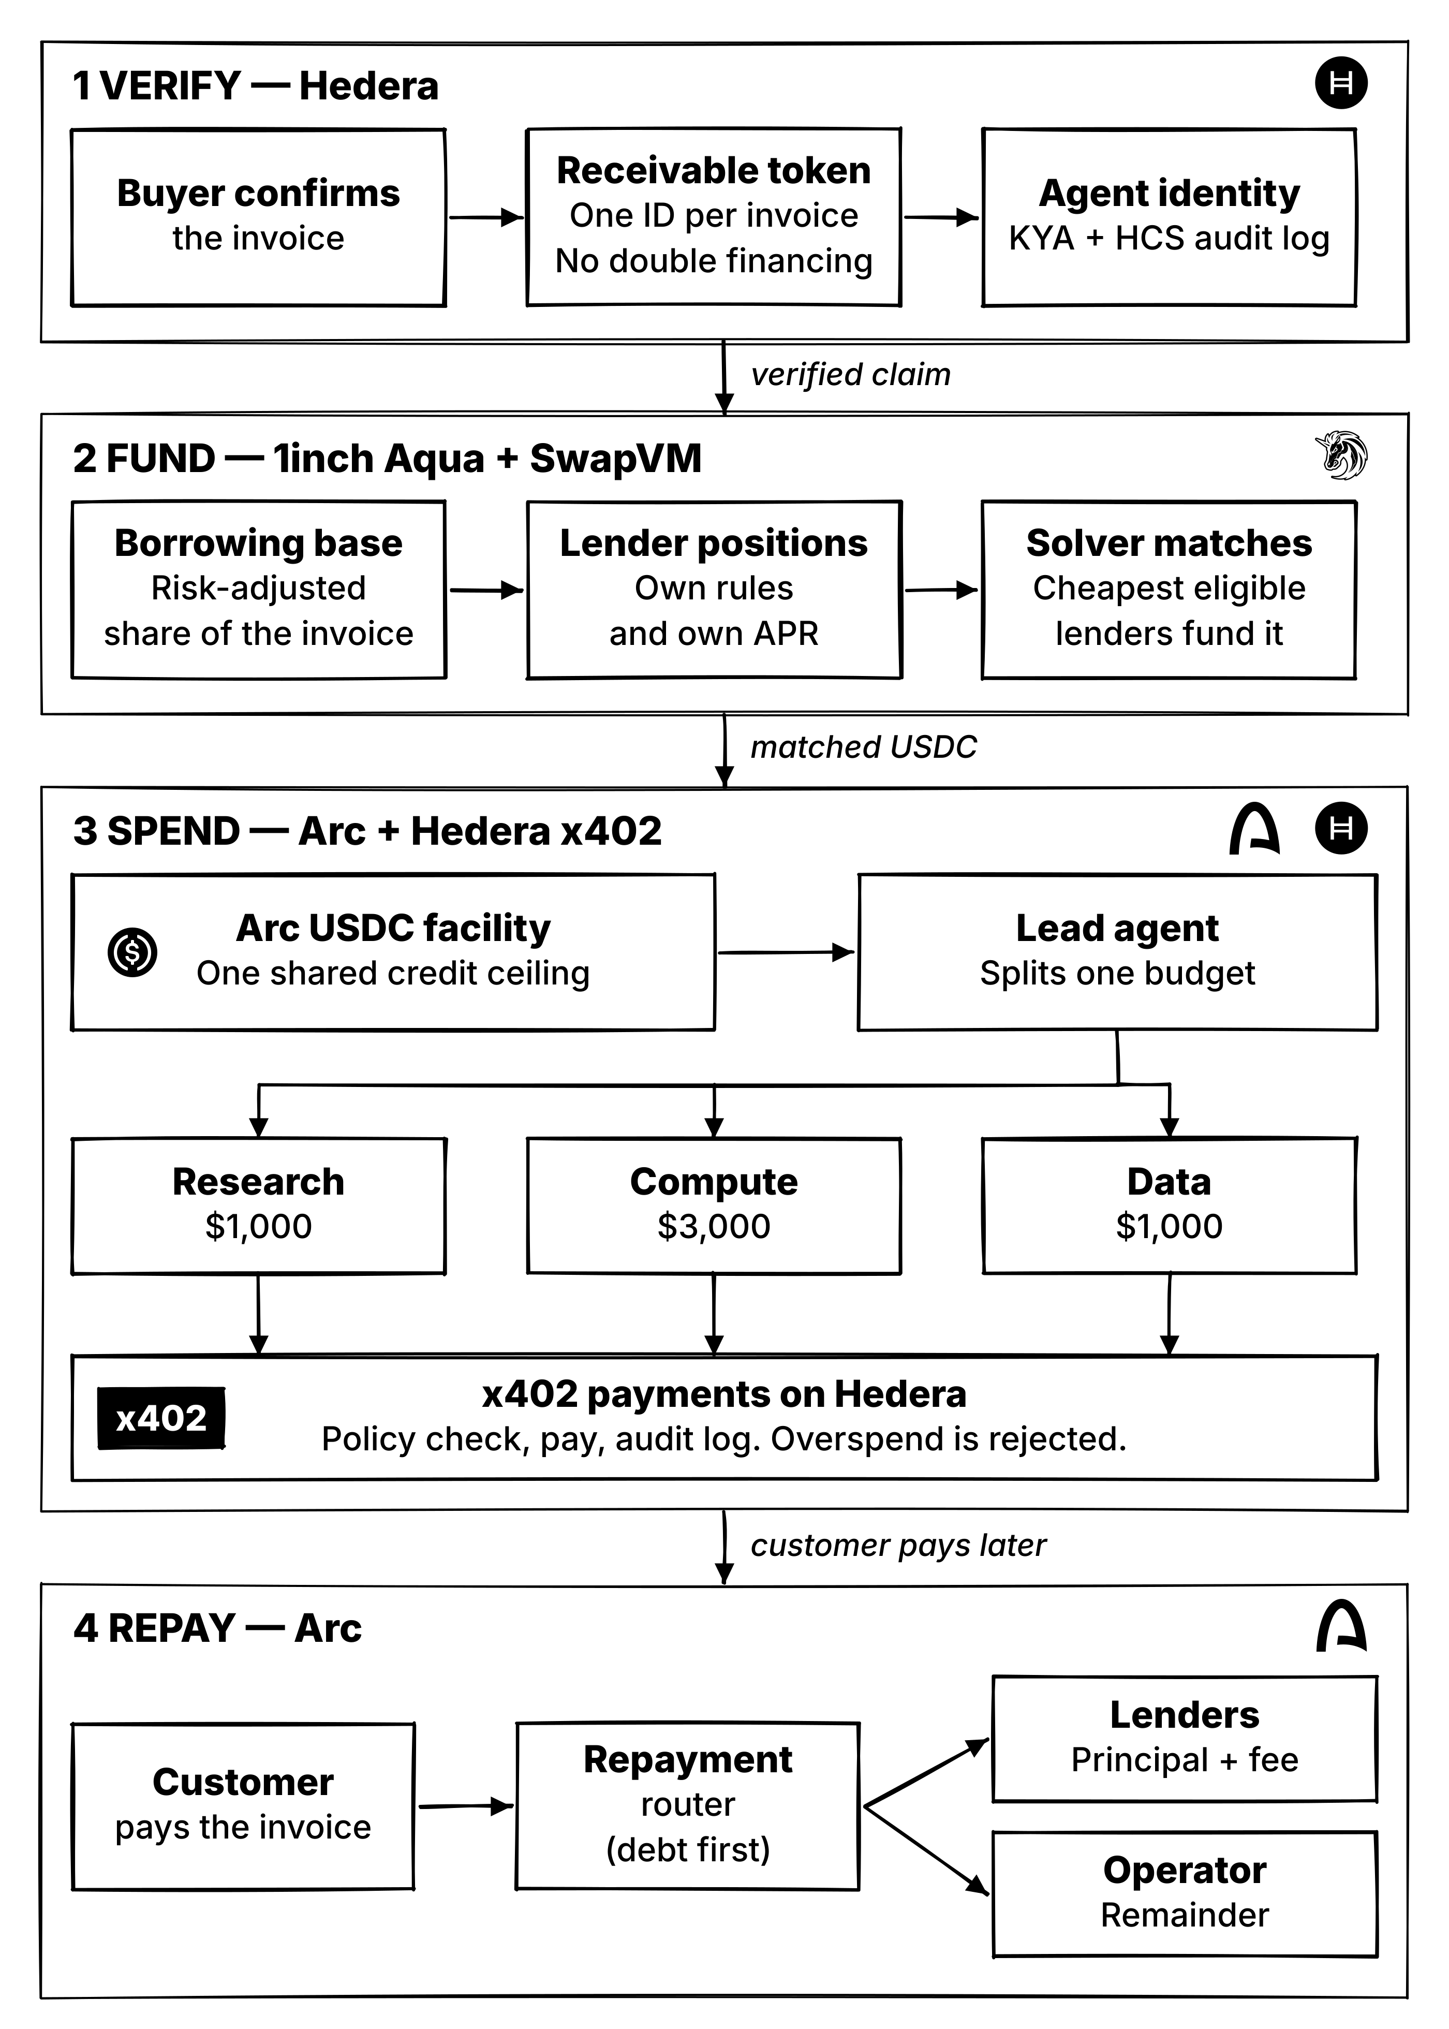

7. Worked Example
Step | Result
Invoice | $10,000 from RetailCo, Net 30.
Borrowing base | 75% advance rate gives $7,500.
Lenders matched | Alice $4,000 at 7% and Bob $2,000 at 8.5% fund $6,000. Charlie at 13% is not needed.
Shared budget | Research $1,000, Compute $3,000, Data $1,000, Reserve $1,000.
x402 payment | Research agent pays $0.25 USDC automatically. The spend is logged on HCS.
Overspend | Compute agent requests $5,500 and is rejected: GLOBAL_CREDIT_LIMIT_EXCEEDED.
Repayment | Customer pays $10,000: $6,100 to lenders (principal plus $100 fee), $3,900 to the operator.
Final state | Debt is $0, the receivable is repaid, and credit is ready for the next invoice.

8. MVP Scope
Priority | Scope
P0 Core | One invoice and buyer. Hedera receivable, HCS event and KYA identity. Arc facility with borrowing base. Shared budget across 2 to 3 agents. One live x402 payment, one rejected overspend, automatic repayment waterfall.
P1 Strong | Aqua lender positions, custom SwapVM credit instruction, two lender offers, cheapest-lender solver.
P2 Wow | Dynamic rate curve, three lenders, treasury agent with atomic flash refinancing (14% to 8%, debt unchanged).
Out of scope | Production KYC, fiat banking, governance, liquidations, multiple collateral types, token launch.

9. Demo Flow (3 to 4 minutes)
- Invoice is confirmed and tokenized on Hedera.
- Borrowing base and matched Aqua funding appear as Arc credit.
- Lead agent delegates sub-budgets.
- Research agent pays $0.25 through x402 and the audit event is shown.
- Compute agent overspend is rejected.
- Customer pays and the payment splits automatically to lenders and operator.
- Final state: debt $0, receivable repaid, facility ready for the next claim.
Optional: treasury agent refinances from 14% to 8% in one atomic transaction.

10. Differentiation
- Versus simple agent credit: backed by verified receivables and repaid from customer revenue.
- Versus invoice factoring: built for agent teams sharing one ceiling, with autonomous spending and programmable lenders.
- Versus generic DeFi lending: collateral is an accepted future cash flow, underwritten on buyer quality.

