

SCHOOL OF ENGINEERING
ENGG341 Individual Project

Android Meets Aerodynamics
Final Report

Kush Patel
Mechanical Engineering
May 2026

Supervisor: Dr/Professor Sebastian Timme
Project No. 241

School of Engineering
University of Liverpool
Brownlow Hill, Liverpool, L69 3GH

Abstract:
This project presents the development of an interactive mobile application to improve the accessibility of thin aerofoil theory for rapid aerodynamic analysis. Traditional analytical approaches can be time-consuming and unintuitive when exploring variations in aerofoil geometry and angle of attack. To address this, a Kotlin-based Android application was developed to perform real-time computations with dynamic visualisation.
Thin aerofoil theory is implemented numerically using θ-substitution and the trapezium rule to evaluate the governing integrals. Key aerodynamic parameters, including lift coefficient (Cl) and zero-lift angle (αₗ₀), are computed alongside graphical representations of aerofoil geometry and lift curve behaviour, with an overlay system enabling direct comparison between configurations.
Validation against theoretical predictions and external tools demonstrated strong agreement with minimal numerical error. Results are produced within milliseconds, ensuring real-time usability.
Overall, the application provides an efficient tool linking aerodynamic theory with visual understanding for rapid aerofoil evaluation and comparison.

Nomenclature:

Symbol | Description | Units
C_{l} | Lift Coefficient | -
α | Angle of Attack | Degrees
α_{L=0} | Zero lift angle | Degrees
m | Max Camber | -
p | Camber position | -
t | Thickness ratio | -
x | Chordwise position | -
θ | Transformed coordinate | rad

Table of Contents
Chapter 1: Introduction 6
1.1 Aerofoil History and Uses: 6
1.2 Research Aim: 6
Chapter 2: Literature Review 8
2.1 Aerofoil Nomenclature: 8
2.2 The Thin Aerofoil theory: 9
2.3 Assumptions in thin Aerofoil theory: 10
2.4 Alternative Aerofoil Analysis Methods: 10
2.4.1 Panel Based Methods: 11
2.4.2 CFD 11
2.4.3 Experimental Testing 11
2.5 Research Gap and Project Justification: 12
Chapter 3: Methodology 13
3.1 Overview of the Computational Model: 13
3.2 Input Parameterisation and NACA Geometry: 13
3.3 Numerical Thin Aerofoil Solver: 13
3.4 Integration Methods: 14
3.5 Zero-lift angle and Lift Coefficient calculation: 15
3.6 Aerofoil Visualisation and Graphical Interface: 16
3.6.1 Aerofoil Creation: 16
3.6.2 Graph Creation: 17
3.6.3 Overlay System: 18
Chapter 4: Implementation 19
4.1 Application Architecture 19
4.2 User Input and Data Storage 20
4.3 Numerical Calculation Implementation 22
4.4 Aerofoil Rendering Implementation 24
4.5 Graph Rendering Implementation 27
4.6 Overlay System Implementation 28
4.7 User Interface and Interaction Design 29
4.8 Debugging, Testing, and Refinement 30
Chapter 5: Results 31
5.1 Validation of Numerical Model 31
5.1.1 Numerical Solver 31
5.1.2 Angle Validation: 31
5.1.3 Comparison of different solver methods: 32
5.2 Effect of Camber and Geometry 36
5.2.1 Symmetric vs Cambered Aerofoils 37
5.2.2 Effect of Camber Magnitude 37
5.2.3 Effect of Camber Position 37
5.2.4 Effect of Thickness 38
5.2.5 Extreme Camber Cases 38
5.2.6 Summary of Geometric Effects 39
5.3 Graphical/Overlay Comparison Analysis 39
5.3.1 Lift Curve Comparison 39
5.3.2 Geometry Overlay Comparison 40
5.3.5 Limitations of Overlay Comparisons 41
5.4 Performance and Usability Analysis 41
5.4.1 Computational Performance 41
5.4.2 Usability Evaluation 42
5.4.3 User Experience Observations 42
5.5 Limitations of Results 43
5.5.1 Theoretical Limitations 43
5.5.2 Numerical Limitations 43
5.5.3 Scope Limitations 43
5.5.4 Validation Limitations 44
5.5.5 Implications for Users 44
5.5.6 Summary of Limitations 44
Chapter 6: Conclusion: 46
6.1 Project aim: 46
6.2 Project achievements: 46
6.3 Key Findings/insights 46
6.4 Evaluation 47
6.5 Future Improvements 47
6.6. Final Summary: 48
References: 49

Chapter 1: Introduction

1.1 Aerofoil History and Uses:
Aerofoils are the cross-sectional shapes of wings, blades, and lifting surfaces, designed to generate aerodynamic forces under specific operating conditions (Corda, 2017). Their geometry plays a critical role in determining lift, drag, and overall performance (Corda, 2017). They are widely used in applications such as aircraft wings, helicopter rotors, wind turbine blades, and missile fins, where they directly influence stability, efficiency, and manoeuvrability.
The classification of aerofoils has changed dramatically since the invention of the first aircraft in the early 20th century. A large number of aerofoil families, such as RAE, DVL, NACA, and TsAGI, have been created for either general purpose or particular types of aircraft flying at different speed regimes (Zhonghua et al., 2021).
A key engineering challenge lies in balancing aerodynamic performance requirements across different aircraft types. Aerofoil geometries must be carefully tailored to their intended function, as design priorities vary significantly between balancing lift, drag, stability and operating conditions. This is further illustrated by the Fokker F-28 Mk. 6000, which was designed for operation from short runways at low to medium altitudes. While its aerofoil geometry enabled the high lift coefficients required for short take-off and landing performance, it also resulted in increased induced drag, reducing overall fuel efficiency (Corda, 2017). This demonstrates the critical importance of the lift-to-drag ratio in aerofoil design, where improvements in one performance aspect often come at the expense of another.

1.2 Research Aim:
The primary aim of this project is to develop an application for rapid aerodynamic analysis based on thin aerofoil theory. Despite its computational efficiency, the theory presents practical limitations, including the lack of direct visualisation of aerofoil geometry and the need for repeated manual calculations when parameters are varied. These make the method time-consuming and prone to error, particularly when comparing multiple aerofoil configurations.
In addition, the theory is typically expressed in terms of the mean camber line, whereas aerofoils are commonly identified using standardised profiles such as NACA series. This creates a disconnect between the mathematical model and physical aerofoil geometry, making it difficult for users to intuitively understand how changes in aerofoil shape influence aerodynamic performance.
This project aims to develop an interactive mobile application that applies thin aerofoil theory to enable rapid and accurate calculation of aerodynamic parameters. The tool allows users to input standard aerofoil geometries and dynamically adjust parameters such as camber and angle of attack, with results generated in real time. In addition, the application provides a visual representation of the aerofoil and its mean camber line, improving conceptual understanding by directly linking geometry to aerodynamic behaviour.
This project contributes through integration and accessibility rather than new theory, combining numerical implementation, real-time visualisation, and comparative analysis within a single portable platform. The value lies in reducing the friction between theoretical understanding and practical exploration, enabling rapid parametric study that would be impractical through manual methods.
By combining the efficiency of analytical methods with the visual clarity associated with CFD tools, the project seeks to provide a practical tool for both learning and preliminary aerofoil design.
Objectives:
- Implement thin aerofoil theory within a mobile application to calculate aerodynamic parameters for NACA 4-digit aerofoils at user-defined angles of attack.
- Generate accurate aerofoil geometries using standard thickness distribution equations, including upper and lower surface profiles derived from input parameters.
- Generate clear diagrams for the aerodynamic results and aerofoil geometry to enable clear interpretation direct comparison between aerofoil configurations.
- Develop an intuitive user interface that supports real-time parameter adjustment and immediate feedback on aerodynamic performance.

Chapter 2: Literature Review
2.1 Aerofoil Nomenclature:
An aerofoil shape is the two dimensional cross-section (Anderson, 2017; Corda, 2017), parallel to the flow direction of a three-dimensional wing. The curved shape of an aerofoil is designed to produce much greater lift far more efficiently (Corda, 2017). A mean camber line is a concept used in simplified modelling for aerodynamics (Anderson, 2017). An aerofoil is taken as the locus of points halfway between the upper and lower surfaces, which creates an infinitely thin line between the trailing and leading edges.
In the early 1930’s, NACA – the forerunner of NASA – constructed a series of experiments on various aerofoil shapes. Many of these NACA aerofoils are in common use today, identified by their logical numbering system, which gives important information such as maximum camber size and position in the “four-digit” family (Anderson, 2017).

This naming system is particularly useful in computational modelling. A NACA 4-digit aerofoil uses a general equation where camber position (p) and camber size (m), are used as coefficients in a general equation. Other types of NACA aerofoils have a similar system, although a table is often used to get their individual equations with slightly different parameters. This is useful because parameters and coefficients can be substituted quickly and easily, avoiding additional technical complications and reducing calculation time compared with manual methods.
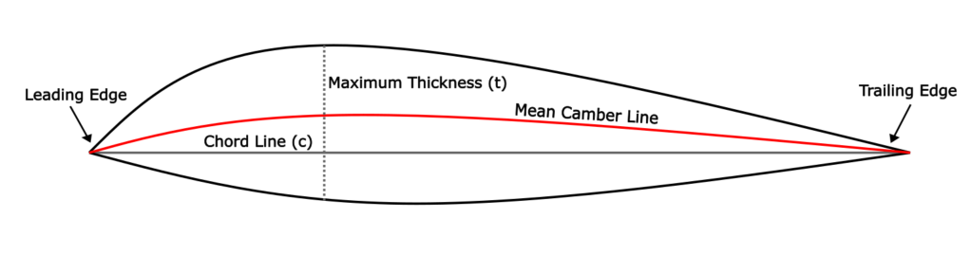
Figure 1 - Diagram of a cross section of an aerofoil

2.2 The Thin Aerofoil theory:
Thin aerofoil theory models an aerofoil by replacing its finite thickness geometry with the mean camber line. A vortex sheet, made of individual vortex filaments, of varying strength is distributed along this line to satisfy the flow tangency condition. The resulting circulation determines lift through the Kutta–Joukowski relationship.
$$L^{'}= ρ_{∞}V_{∞}Γ$$ | Equation (1)
To obtain a physically realistic solution, the Kutta condition is applied at the trailing edge. This states that flow leaves the sharp trailing edge of the aerofoil smoothly. This condition determines a unique circulation value. This is proved as the pressures at the outer edges of the boundary layers on the upper and lower surfaces are the same on the trailing edge (Salazar and Liu, 2025).
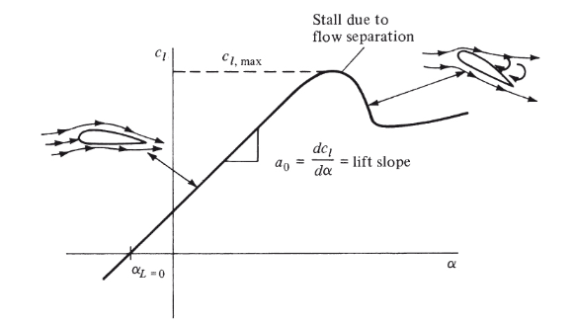
Figure 2 – A graph showing the proportional relationship between the lift coefficient and the angle of attack on aerofoils. The point of stalling is C_{l, max}. (Source: Anderson, 2017)
Figure 2 shows that lift varies linearly with angle of attack, while camber shifts the zero-lift angle to a negative value. Therefore, for cambered aerofoils, the final lift coefficient prediction becomes:
$$C_{l}=2π\left(α-α_{L=0}\right)$$ | Equation (2)
Thin aerofoil theory remains widely useful because it provides rapid lift estimation with minimal computational cost (Anderson Jr., 2017). This makes it suitable for educational tools and preliminary aerodynamic design. However, the theory neglects viscosity, finite thickness effects, flow separation and strong compressibility effects, reducing accuracy at high angles of attack or near stall (Anderson Jr., 2017).
For this reason, the present project adopts thin aerofoil theory as a computationally efficient core model, while later comparisons with XFOIL are used to examine the influence of these neglected effects.

2.3 Assumptions in thin Aerofoil theory:
The assumptions used in thin aerofoil theory simplify the calculations by removing specific physical effects and dynamic flow conditions. This allows the aerodynamic behaviour to be represented using simple analytical expressions, but also introduces limitations in accuracy when compared with more detailed numerical methods. Thin aerofoil theory assumes inviscid, incompressible, and irroational flow, neglecting viscous shear stresses. This allows lift to be predicted solely from circulation and camber line geometry (Xiang et al., 2025).
Without the inviscid assumption, the flow is no longer governed purely by potential flow behaviour, because viscosity introduces skin-friction drag, boundary-layer growth, and the possibility of flow separation (Xiang et al., 2025). For moderate angles of attack with attached flow, the lift-curve slope often remains close to the theoretical value of 2π per radian, although it is typically reduced slightly from the ideal prediction. As the angle of attack increases towards stall, the deviation becomes significantly larger.
Incompressible flow assumes that the fluid density remains constant throughout the flow field. Classical thin aerofoil theory was derived for low-speed aerodynamic conditions, where density changes are sufficiently small to be neglected. This simplifies the governing equations and allows the standard lift-curve slope of 2π per radian to be applied directly (Anderson Jr., 2017).
If the flow is compressible, the pressure distribution changes because density is no longer constant. For subsonic compressible flow, the primary effect is an increase in lift coefficient relative to the incompressible prediction. This is commonly approximated using the Prandtl–Glauert correction (Brennen, 2004):
$$C_{l, comp} = \frac{C_{l,incomp}}{\sqrt{1 - M^{2}}}$$ | Equation (3)
Additionally, predictive accuracy decreases as angle of attack increases. Thin aerofoil theory assumes that the angle is sufficiently small for the standard small-angle trigonometric approximations to remain valid:
$$\sin\left(α\right)≈ α$$
$$\tan\left(α\right)≈ α$$
$$\cos\left(α\right)≈ 1$$
Therefore, the incompressible and small-angle assumptions remain appropriate for rapid preliminary aerodynamic estimation at low-speed, low-angle operating conditions, but their accuracy reduces progressively as Mach number and angle of attack increase.

2.4 Alternative Aerofoil Analysis Methods:
While thin aerofoil theory provides a rapid analytical method for estimating lift characteristics, a range of alternative aerodynamic analysis techniques are available when greater accuracy is required. These methods increase in computational cost and complexity, but can model physical effects neglected by simplified theory, such as viscosity, flow separation, finite thickness, and nonlinear aerodynamic behaviour.

2.4.1 Panel Based Methods:
These approaches represent the aerofoil surface using a series of discrete panels, each with singularity elements such as sources or vortices distributed along the surface. The governing potential-flow equations are then solved numerically to satisfy the surface boundary conditions (Murali, 1988). Compared with thin aerofoil theory, panel methods account for the full aerofoil geometry rather than only the mean camber line, allowing improved prediction of pressure distribution, pitching moment and lift characteristics (Murali, 1988).
A widely used example of this approach is XFOIL, developed by Drela. XFOIL combines a two-dimensional panel method with an integral boundary-layer solver, allowing viscous effects to be approximated while retaining low computational cost. This enables prediction of lift coefficient, drag coefficient, transition location and stall trends more accurately than inviscid analytical methods. Due to this balance between speed and fidelity, XFOIL remains widely used for preliminary aerofoil design, educational studies and low-cost aerodynamic comparison. (Drela and Youngren, 2001)

2.4.2 CFD
CFD solves the governing Navier–Stokes equations numerically across a discretised fluid domain surrounding the aerofoil (Biswal and Kumar Sarkar, 2018). This allows detailed simulation of velocity fields, pressure distribution, turbulence, wake development and separated flow regions. CFD can provide significantly greater realism than thin aerofoil theory or panel methods, particularly at high angles of attack or complex operating conditions. However, it requires greater computational resources, mesh generation effort and user expertise (Biswal and Kumar Sarkar, 2018).

2.4.3 Experimental Testing
Wind-tunnel testing remains an indispensable tool for investigating the aerodynamic behaviour of wind-turbine blades and aerofoils(Ciavatta et al., n.d.). Wind tunnel measurements can directly determine lift, drag, pressure coefficients and stall behaviour under controlled conditions. However, physical testing requires specialist facilities, instrumentation and manufacturing of accurate test models, making it comparatively expensive and time-consuming (Ciavatta et al., n.d.).
Ciavatta, Shen and Deng performed research on aerofoils with wind tunnel testing, the equipment used included: a stepper motor, a belt-drive mechanism, and dual encoders. Additionally, an inhouse bespoke mechanical system was created to support their experiment. Although the results reflected real operating conditions, the required space and cost make such testing more suitable for large-scale programmes than individual geometry studies (Ciavatta et al., n.d.).
The choice of aerodynamic method therefore depends on the balance between speed, accuracy and available resources. Thin aerofoil theory remains valuable where rapid preliminary lift estimation is required. Panel methods such as XFOIL provide a practical increase in fidelity with modest computational cost, while CFD and experimental testing are more appropriate when high-detail validation is required. For the present project, thin aerofoil theory was selected as the core model due to its simplicity, low processing demand and suitability for real-time mobile implementation, while XFOIL was later used as an independent comparison tool to assess the effect of neglected assumptions.

2.5 Research Gap and Project Justification:
Although aerodynamic analysis methods are well established, many existing tools are either highly simplified, technically inaccessible, or computationally intensive. Classical thin aerofoil theory provides a rapid means of estimating lift characteristics, but is commonly presented only through textbooks, spreadsheets or manual calculation methods.
At the other end of the spectrum, higher-fidelity tools such as XFOIL and CFD packages provide improved aerodynamic prediction, but often require desktop platforms, greater technical understanding and more time-consuming workflows.
A practical gap therefore exists between simple analytical theory and more advanced numerical software. There is value in a tool that can rapidly apply thin aerofoil theory while also visually linking aerofoil geometry, camber variation and lift behaviour through an intuitive interface.
The present project addresses this gap through the development of a mobile application that implements thin aerofoil theory for NACA four-digit aerofoils, allowing rapid lift-coefficient estimation together with graphical visualisation of aerofoil geometry and lift-curve behaviour. This aims to improve both accessibility and usability of aerodynamic theory for students and preliminary design applications.

Chapter 3: Methodology

3.1 Overview of the Computational Model:
The application consists of two main components: the NACA parameter solver and the visualisation system. Both of these sections rely on the same user inputs, the NACA digits and the angle of attack. The user’s inputs are applied to the thin aerofoil theory and the predicted lift coefficient and zero lift angle is calculated.
Upon confirming their inputs the aerofoil is generated instantly below the results in a separate graphing space, showing the surfaces and mean camber line in another distinct colour. The freestream velocity direction is also displayed, reinforcing the aerodynamic context of the model.
Aerofoils can be saved and stored in a list, which can then be layered to compare shapes and incident free-stream velocity angles.

3.2 Input Parameterisation and NACA Geometry:
The initial and most important part of the application is retrieving the m and p values from the NACA digits. These are the values that determine the camber position and size, and coefficients for the general mean camber line equations.
Operations are applied to the NACA aerofoil to retrieve these values. The m value is found by dividing the first digit by 100, and the p value is the second digit divided by 10. This is because both of these values are expressed as a fraction of the chord.
Despite thickness not being directly used in the thin aerofoil theory, it is essential for the drawing section of the application. The last two digits are divided by 100, to get the fractional thickness, and stored alongside m and p.
The NACA four-digit family was selected for several practical reasons.
The 4-digit NACA parameters can be directly read from its name, and are usually represented as a percentage of the chord length. This differs greatly from other NACA aerofoils as 5-digit aerofoils use the last 2 digits to indicate thickness, and the 2nd and 3rd digits to determine the maximum camber position (“AeroFoil Help,” n.d.). The maximum camber size is not directly displayed and must be found by using the first digit to determine the design lift coefficient, and cross referencing the value found in a lookup table. The 6-digit NACA family is more complex, as not only are lookup tables required, but the camber position is indicated by the minimum pressure positions along the aerofoil (“AeroFoil Help,” n.d.).
The angle of attack must remain within the range of “small” angles. This is to ensure the thin aerofoil theory works and the small angle identities can be applied.

3.3 Numerical Thin Aerofoil Solver:
The m and p values are used to find the equations for the camber line. The equations used depend on the position of the x-coordinate along the chord, more specifically if it is before or after the maximum camber point. The mean camber line equation(s) for these specific aerofoils are:
$$y_{c}=\frac{m}{p^{2}\left(2p\frac{x}{c}- {\left(\frac{x}{c}\right)}^{2}\right)} x < p$$ | Equation (4) (Anderson Jr., 2017)
$$y_{c}= \frac{m}{{\left(1-p\right)}^{2}}\left(\left(1-2p\right)+ 2p\frac{x}{c}- {\left(\frac{x}{c}\right)}^{2}\right) x ≥ p$$ | Equation (5) (Anderson Jr., 2017)

The equations can be differentiated with respect to x (along the chord of the aerofoil):
$$\frac{dy_{c}}{dx}=\left(\frac{2m}{p^{2}}\right)\left(p-\frac{x}{c}\right)$$ | Equation (6) (Anderson Jr., 2017)
$$\frac{dy_{c}}{dx}=\left(\frac{2m}{{\left(1-p\right)}^{2}}\right)\left(p-\frac{x}{c}\right)$$ | Equation (7) (Anderson Jr., 2017)
The equation used depends on the x-coordinate along the chord, more specifically if it is before or after the maximum camber point. The differentiated function is needed, because thin aerofoil theory requires the camber slope to calculate C_{L} and α_{L=0}.

3.4 Integration Methods:
The application evaluates the required definite integrals using the trapezium rule rather than a fully analytical closed-form solution. This approach was selected for its simplicity, robustness, and low computational cost, while still providing sufficient accuracy for rapid aerodynamic estimation. As thin aerofoil theory is itself an approximate model based on simplifying assumptions, a high-complexity symbolic solution was considered unnecessary for the intended application. The equation for the trapezium rule is:
$\int_{a}^{b}{f(x) ≈ (b-a)\frac{f(a) + f(b)}{2}}$ (Bagdasar, 2013)

The trapezium-rule solver was discretised into 100 sections. This value was selected to provide a suitable balance between numerical accuracy and processing speed, enabling near-instant results on mobile hardware while maintaining stable outputs.
To assess the sensitivity of the solution to section count, a NACA 2412 aerofoil at an angle of attack of 5 ° was tested using varying subdivision numbers. The resulting zero-lift angle and lift coefficient are shown:
Number of Sections | 10 | 30 | 50 | 100 | 500
Zero Lift Angle (4 d.p) | -2.0737 | -2.0777 | -2.0773 | -2.0772 | -2.0772
Lift Coefficient (4 d.p) | 0.7757 | 0.7762 | 0.7761 | 0.7761 | 0.7761
Table 1 shows the change in the lift characteristic results when the numerical integration sensitivity is increased.
The results in table 1 show rapid convergence as the number of sections increases. Minimal variation was observed beyond 50–100 sections, with no meaningful change at four significant figures. Therefore, 100 sections were adopted as an efficient operating value that avoids unnecessary computation while preserving numerical accuracy.

3.5 Zero-lift angle and Lift Coefficient calculation:
To evaluate the integrals used in the theory, the chordwise coordinate x is transformed into an angular coordinate θ using the standard thin aerofoil substitution:
$$x= \frac{c}{2}(1-\cos\left(θ\right))$$ | Equation (8) (Anderson Jr., 2017)
This transformation simplifies the mathematical form of the integrals. Computationally, it makes the integral easier to evaluate numerically.
To get the zero-lift angle, the application uses this equation:
$$α_{L=0}-\frac{1}{π}\int_{0}^{π}{\frac{dz}{dx}\left(\cos\left(θ\right)-1\right)dθ_{0}}$$ | Equation (9) (Anderson Jr., 2017)

To carry out this equation using kotlin, the equation was expanded, and the negative pi was multiplied into the integral, eventually getting this:

$$α_{L=0}=\left(\frac{1}{π}\right) \int_{0}^{π}{\left(\left(\frac{dz}{dx}\right)-\left(\frac{dz}{dx}\right) cos(θ)\right)dθ_{0}}$$ | Equation (10) (Anderson Jr., 2017)

This can be further split into two separate integrals:

$$α_{L=0}=\left(\frac{1}{π}\right)\int_{0}^{π}{\left(\frac{dz}{dx}\right)dθ }- \left(\frac{1}{π}\right)\int_{0}^{π}{\left(\frac{dz}{dx}\right)cosθ dθ}$$ | Equation (11) (Anderson Jr., 2017)

According to the Fourier analysis, the coefficients A₀ and an are:
$α-A_{0}= \frac{1}{π}\int_{0}^{π}{\frac{dz}{dx}{dθ}_{0}}$ (Anderson Jr., 2017)
$A_{0}=α- \frac{1}{π}\int_{0}^{π}{\frac{dz}{dx}{dθ}_{0}}$ (Anderson Jr., 2017)
$A_{n}=\frac{2}{π}\int_{0}^{π}{\frac{dz}{dx}}\cos\left(nθ_{0}\right){dθ}_{0}$ (Anderson Jr., 2017)
The zero-lift angle is calculated with the integral and A coefficient, following the equation.

Using the equation:
$$C_{l}=2π\left(α-α_{L=0}\right)$$ | Equation (2) (Anderson Jr., 2017)

The lift coefficient is calculated, using the zero-lift angle value and the angle input from the user.

3.6 Aerofoil Visualisation and Graphical Interface:
The application includes a multi-layered visualisation interface. Integrating visual aids into the application improves understanding of thin aerofoil theory. Rather than the user entering a set of numbers and generating a set of values, they can see how the parameters can affect the geometry and produce a variation in results.
The interface includes an aerofoil section, where the system takes the NACA parameters and applies the necessary equations to generate an accurate visual of the geometry. This includes an outline of the shape as well as the mean camber line. The model also includes a graphing region, similar to that shown in Figure 2. Using the NACA variables, a line is plotted, with an x-intercept that represents the zero-lift angle of the aerofoil.
To improve the functions, a comparative overlay feature is also included, allowing easy comparison between results and shapes.

3.6.1 Aerofoil Creation:
To create the aerofoil shape, the application must use the parameters of the aerofoil in 3 key equations:
- Thickness distribution
- Mean camber line.
- Upper and lower surfaces
To generate the outline of the aerofoil, the geometry uses these general equations:
The upper surface equations:
$$x_{u} = x - y_{t}sinθ$$ | Equation (10)
$$y_{u} = y_{c} + y_{t}cosθ$$ | Equation (11)

The lower surface equations:

$$x_{l} = x + y_{t}sinθ$$ | Equation (12)
$$y_{l}= y_{c}- y_{t}cosθ$$ | Equation (13)

Where $θ$ is:
$$θ=\tan^{-1}\left(\frac{{dy}_{c}}{dx}​​\right)$$ | Equation (14)

The generated aerofoil coordinates exist in a normalised mathematical space and must be transformed into screen coordinates. This allows the geometry to remain independent of screen size and ensures consistent scaling across devices.
The mean camber line is drawn in a remarkably similar fashion to the surface curve generation. However, to improve the visibility of the curve, a distinct colour is used, allowing the user to clearly see the drawn shape.

3.6.2 Graph Creation:
The geometry construction section of the application is beneficial to the user, as it allows better understanding between the shapes and the thin aerofoil theory. The visual aids help transition the app from a simple calculator to a real aerodynamic tool.
While the aerofoil drawings allow comparison between geometries, the graphing section allows for ease of lift characteristics, specifically how the change in camber can affect the zero-lift angle. The thin aerofoil theory results paired with the visual aid of a graph and the ability to quickly compare visual representations of the parameters elevate this application greatly.
Similar to the graph shown in Figure 2, the x-axis shows the angle of attack and the y-axis shows the lift coefficient. The linear path represents the lift slope (which is constant at 2$π$) and shows the angle of zero lift (the x-intercept). While the gradient shows a constant directly proportional relationship, the x-intercept varies between aerofoils. This improves the application as a comparative tool as it allows users to see the difference in results, rather than only comparing the results from the calculations. The zero-lift angle introduces a horizontal translation of the lift curve, meaning different aerofoils produce parallel lines with varying x-intercepts.
The line is generated by evaluating the lift coefficient at multiple discrete angles of attack, and therefore follows the same process as the aerofoil visualisation: data generation, coordinate transformation, and rendering.
The range of the graph is set to -10 to 10 on the x axis, as a requirement for the thin aerofoil theory is for the angles to be small. The y-axis ranges from -1.5 to 1.5 to encapsulate a large number of possible results from the input parameters.
The zero-lift angle is first determined from the aerofoil geometry, after which the lift coefficient is evaluated for a range of input angles of attack.
The angle range is predetermined to be between -10 and 10 °. Using the range, many angles are iterated and substituted into Equation (1). The lift coefficient is evaluated across a discretised range of angle of attack values. A sufficiently large number of sample points are used to ensure that the resulting curve appears continuous and accurately represents the theoretical relationship.
The calculated values are transformed into screen coordinates using a linear mapping based on the defined plotting ranges. This is achieved through a normalisation and scaling process, similar to the aerofoil generation section.

3.6.3 Overlay System:
While individual lift coefficient and zero-lift angle values provide useful information, they do not directly reveal how variations in aerofoil geometry influence aerodynamic behaviour. To address this limitation, an overlay system was implemented to enable direct visual comparison between multiple aerofoils within the same plotting space. This added feature elevates the application to be used for comparison and testing between geometries, rather than to only collect results.
When an aerofoil is added to the overlay list, both displays are redrawn and all stored aerofoils are rendered sequentially. The thin aerofoil theory is applied to calculate the corresponding zero-lift angle and lift coefficient. The new parameters are used to generate the geometry to create a new aerofoil shape, while the lift curve is generated across the designated range of angles of attack. This produces multiple lift curves plotted on the same axes as well as overlapping aerofoil shapes, allowing direct comparison of aerodynamic characteristics.
In the graph section, the primary distinction between overlays arises from differences in zero-lift angle, which result in horizontal shifts of the lift curves. As the lift slope remains constant under thin aerofoil theory, each aerofoil produces a parallel line, enabling clear visual identification of how camber affects aerodynamic performance.
To improve clarity, each overlay is assigned a unique colour that is consistently applied across all associated visual elements, including the aerofoil geometry, lift curve, and legend entry. A legend is displayed within the plotting region to link each colour to its corresponding aerofoil, ensuring the comparison remains interpretable even with multiple overlays present.
This overlay functionality transforms the application from a simple computational tool into an interactive analysis platform, enabling users to directly relate changes in aerofoil geometry to variations in aerodynamic behaviour.

Chapter 4: Implementation

4.1 Application Architecture
The application was developed using Kotlin within Android Studio and follows an object-oriented architecture, where software is structured around objects that combine data and behaviour. This approach was selected to manage the increasing complexity of the system. The interaction between the thin aerofoil theory, rendering, and the storage of multiple geometries and displays required robustness that this architecture provides.
The overall structure of the application is divided into distinct functional components, each responsible for a specific aspect of the system.
This separation ensures that each part of the application operates independently, improving maintainability, scalability, and code clarity. At a structural level, the application is organised into four main layers: user interface, mathematical computation, geometry generation, and data management.
The user interface layer is responsible for handling user interaction and visual output. This includes classes such as AerofoilFragment, and GraphFragment, which manage navigation and input, as well as custom view classes including CamberLineView and ClAlphaGraphView, which handle graphical rendering. The VisualPageAdapter is used to manage the tab-based interface and MainActivity is used to handle input, trigger the calculations and update the views.
The mathematical computations required for thin aerofoil theory are handled by the ThinAerofoilTheory class. This class implements the numerical methods used to calculate the aerodynamic properties, lift coefficient and zero-lift angle. These computations are written in a procedural style to ensure efficiency and clarity. Equally, the sequence of computations allowed easy comparison to hand calculations and formulas, therefore simplifying the debugging process.
Aerofoil geometry is generated using the Naca4Geometry and Naca4Params classes. These classes are responsible for interpreting NACA 4-digit inputs and producing the corresponding camber line, surface coordinates and thickness distribution used for visualisation.
Data management is handled by the AerofoilRepo class, which stores previously generated aerofoils as objects along with their associated parameters and computed results. This enables the overlay system, allowing multiple aerofoils to be displayed and compared simultaneously.
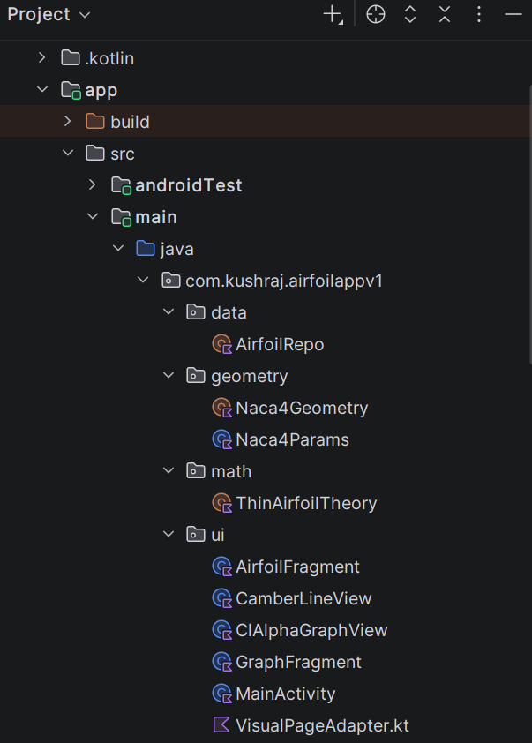
Figure 3 shows the structured layout of the classes and objects.
The application makes use of key object-oriented programming principles. Encapsulation is used to group related data and behaviour within classes such as AerofoilEntry, Naca4Params, and ThinAerofoilTheory, ensuring that each component manages its own state and functionality. Abstraction is applied to hide complex mathematical and graphical operations behind simple method calls, allowing higher-level components to interact with the system without requiring knowledge of the underlying implementation.
While the overall architecture shown in Figure 3 follows an object-oriented approach, the computational components are implemented using procedural methods where appropriate. This hybrid design allows the application to maintain both scalability and computational efficiency.

4.2 User Input and Data Storage
User input is handled through the main interface, where the user enters a NACA 4-digit aerofoil code along with a specified angle of attack. This interaction is managed by the MainActivity class, which is responsible for capturing input values and initiating the calculation process. Basic validation is performed to ensure that valid numerical inputs are provided before further processing occurs, such as pop-ups to display that the NACA code is incorrect, or the angle of attack is not a valid number.
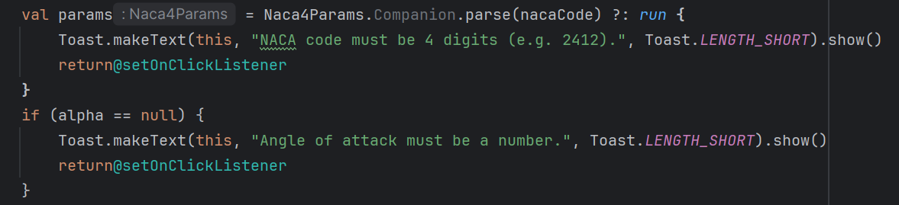
Figure 4 shows the validation used to ensure the inputs are correct
Upon entering, assuming the inputs are correct, the NACA code is passed to the Naca4Params class, which extracts the defining geometric parameters. This represents the first stage of data transformation within the system.
These parameters, along with the angle of attack, are passed to the ThinAerofoilTheory class. This class performs the numerical implementation of thin aerofoil theory, producing the lift coefficient (C_{L}) and zero-lift angle (α_{L=0}).
Following computation, the resulting data is stored within the AerofoilRepo class. This acts as a central data store, maintaining a record of all generated aerofoils along with their associated parameters and computed results. This stored data is essential for enabling the overlay functionality, as it allows multiple aerofoils to be retrieved and compared simultaneously.
The processed data is then passed to the visualisation components of the application. The NACA4Geometry class uses the parameters to generate an array of coordinates for the upper and lower surfaces and the thickness distribution. The CamberLineView class uses the geometric parameters to generate and render the aerofoil shape, while the ClAlphaGraphView class uses the computed aerodynamic values to plot the lift curve. By using the same underlying data for both computation and visualisation, consistency is maintained across all outputs.
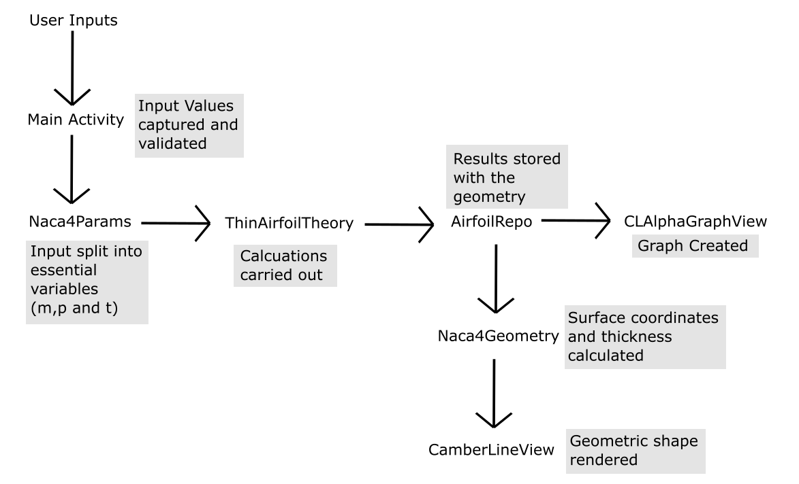
Figure 5 shows a flow chart of the data flow between classes
During development, maintaining consistency between computed results and graphical output was an important consideration. Earlier versions of the application generated geometry and calculations separately, which occasionally led to mismatches. This was resolved by restructuring the data flow so that all components relied on the same stored data objects, ensuring consistency across both numerical and visual outputs.

4.3 Numerical Calculation Implementation
The core functionality of the application is based on the numerical implementation of thin aerofoil theory, which is used to compute key aerodynamic properties including the lift coefficient (Cl) and the zero-lift angle of attack (αₗ₀). These calculations are performed within the ThinAerofoilTheory class, which acts as the central component for all aerodynamic computations.
To facilitate numerical integration, the chordwise coordinate is transformed using the substitution:
$$x=\frac{\left(1-\cos\left(θ\right)\right)}{2}$$ | Equation (8)

This transformation maps the aerofoil chord from 0 to 1, to 0 to π, which simplifies the evaluation of the governing integrals and improves numerical stability near the leading edge.
The gradient of the camber line is evaluated using the standard piecewise NACA 4-digit formulation. This is implemented as a function within the ThinAerofoilTheory class, which returns the slope of the camber line for a given value of x, based on the parameters m and p.
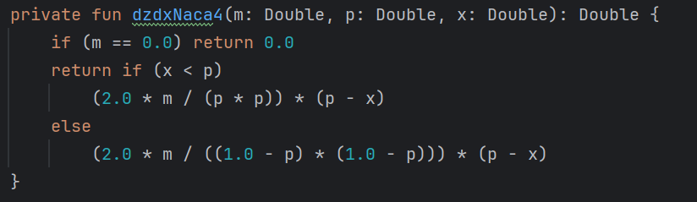
Figure 6 shows the function that returns the slope of the camber line at a specific x-coordinate
Two key integrals are then evaluated numerically using the trapezoidal rule. The first integral represents the mean camber line contribution, while the second incorporates a cosine weighting.
Two key integrals are evaluated numerically:
$$I_{0}= \int_{0}^{π}{\left(\frac{dz}{dx}\right)dθ}$$ | Equation (14.2.1)

$$I_{cos}= \int_{0}^{π}{\left(\frac{dz}{dx}· cosθ\right)dθ}$$ | Equation (14.2.2)
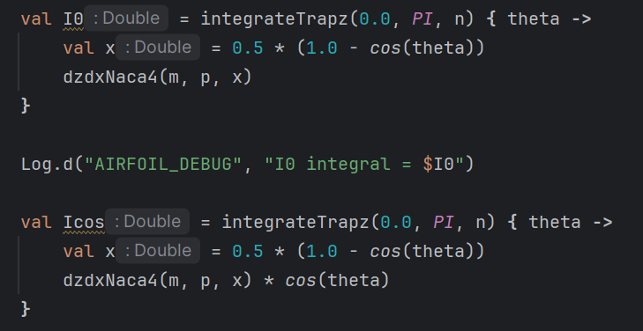
Figure 7 shows the two key integrations carried out, with the x to theta transformation.
These are approximated using the trapezoidal rule over a discretised θ domain. From these integrals, the Fourier coefficient is calculated as:
$$A_{1}=\frac{2}{π} · I_{cos}$$ | Equation (20)
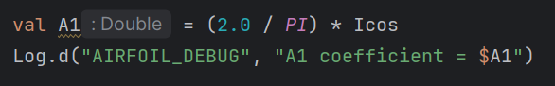
Figure 8 shows the calculated Fourier Coefficient, mirroring Equation (20)

The zero-lift angle is then determined using:
$$αₗ^{0}= \left(\frac{1}{π}\right)· I^{0}- \left(\frac{1}{2}\right)·A_{1}$$ | Equation (21)
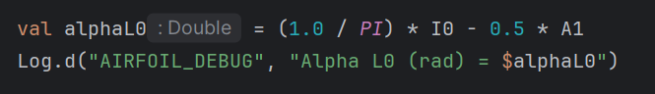
Figure 9 shows the zero-lift angle calculation.
Finally, the lift coefficient is calculated using:
$$c_{l}=2π\left(α-α_{L=0}\right)$$ | Equation (1)
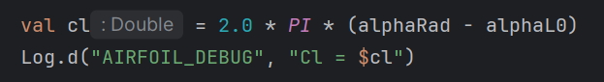
Figure 10 shows the lift coefficient calculation implementation.
This sequence mirrors the analytical derivation of thin aerofoil theory, which allowed intermediate values to be checked during development.
The numerical integration is implemented using the trapezoidal rule within a reusable function, allowing consistent evaluation of both integrals.
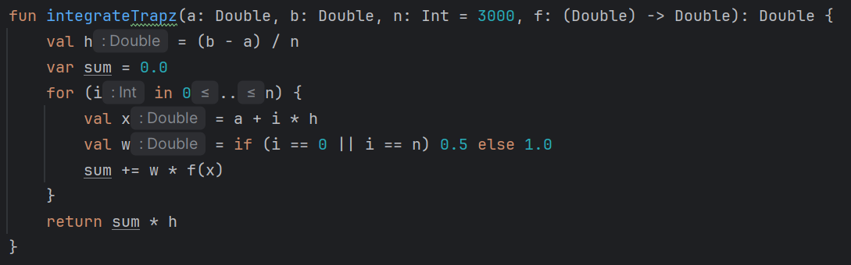
Figure 11 shows the numerical integration function used to evaluate integrals
In implementation, the θ domain was iterated using a fixed step size, with the camber line gradient evaluated at each point and accumulated within a reusable trapezium rule function. This same function was applied to both integrals to ensure consistency and reduce duplication in the numerical solver.

4.4 Aerofoil Rendering Implementation
The application includes a graphical rendering system that converts the computed aerofoil parameters into a visual representation of the aerofoil geometry. This process provides a direct link between the mathematical model and the physical shape of the aerofoil, allowing users to better understand the relationship between camber, thickness, and aerodynamic behaviour.
The aerofoil geometry is generated using the Naca4Geometry class, which implements the standard NACA 4-digit formulation. The aerofoil is defined in normalised chord coordinates, where the chord length extends from x = 0 at the leading edge to x = 1 at the trailing edge. A set of discrete points is generated along the chord to represent the geometry.
The thickness distribution is calculated using the empirical NACA equation:
$$yt​=5t\left(0.2969\sqrt{\frac{x}{c}}​​-0.1260\frac{x}{c}​-0.3516{\left(\frac{x}{c}​\right)}^{2}+0.2843{\left(\frac{x}{c}​\right)}^{3}-0.1015{\left(\frac{x}{c}​\right)}^{4}\right)$$ | Equation (15)

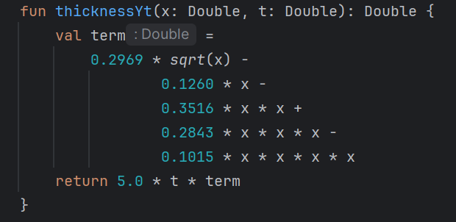
Figure 12 shows the thickness distribution function.
This provides the half-thickness of the aerofoil at each chordwise position. The mean camber line, y_{c}​, is computed using a piecewise function based on the camber parameters m and p, with a corresponding gradient used to determine the local surface angle.
Using these values, the upper and lower surface coordinates are calculated as:
$$x_{u} = x - y_{t}sinθ$$ | Equation (10)
$$y_{u} = y_{c} + y_{t}cosθ$$ | Equation (11)

$$x_{l} = x + y_{t}sinθ$$ | Equation (12)
$$y_{l}= y_{c}- y_{t}cosθ$$ | Equation (13)

where:
$$θ=\tan^{-1}\left(\frac{{dy}_{c}}{dx}​​\right)$$ | Equation (14)

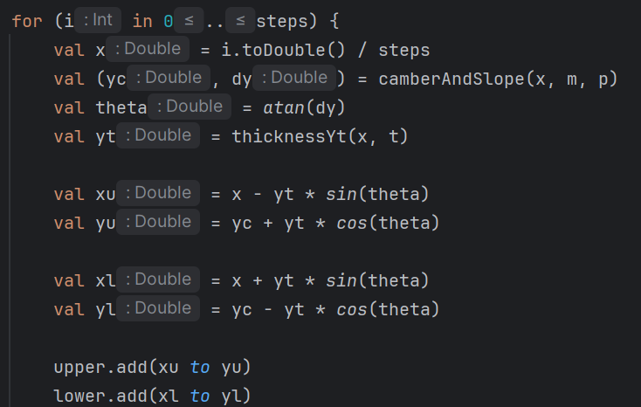
Figure 13 shows the loop that creates the arrays for the upper and lower surfaces.
This ensures that the thickness is applied perpendicular to the camber line, producing an accurate aerofoil shape.
The calculated coordinates are then passed to the CamberLineView class, which is responsible for rendering the aerofoil on the screen. The geometry is scaled from normalised coordinates to the available screen space using a linear mapping. A plotting region is defined within the view, and all coordinates are transformed accordingly to ensure consistent positioning and proportions.
The aerofoil is drawn using Android’s Canvas and Path classes. The upper and lower surfaces are combined to form a continuous closed shape, which is rendered as a smooth outline. The mean camber line is drawn separately using a contrasting colour and dashed style to distinguish it from the outer surface.
To maintain clarity and consistency, all aerofoils are generated dynamically from their defining parameters rather than being stored as static images. This ensures that the visual representation always corresponds directly to the computed geometry and allows for accurate comparison between different aerofoils.
During development, an issue was encountered where multiple aerofoils appeared to overlap with duplicate lines due to both the current and overlay geometries being rendered simultaneously. This was resolved by controlling the rendering order and ensuring that each aerofoil was drawn only once per frame, improving visual clarity when overlays were enabled.

4.5 Graph Rendering Implementation
The application includes a graphical representation of the lift coefficient variation with angle of attack, providing a visual interpretation of thin aerofoil theory. This is implemented using the ClAlphaGraphView class, which dynamically generates and renders the lift curve based on the computed aerodynamic parameters.
The lift coefficient is calculated using the linear thin aerofoil theory relation:
$$C_{l}=2π\left(α-α_{L=0}\right)$$ | Equation (2)
This relationship is used to generate a continuous set of data points across a specified range of angles of attack. Rather than plotting a single point, the application evaluates the lift coefficient at multiple angle values to construct a straight-line graph representing the lift curve.
The thin aerofoil theory produces the most accurate results when small angles are used, therefore the range was specified to be between -10 and 10 °. For each angle in this range, the corresponding lift coefficient is calculated using the same computational method, ensuring consistency between the graph and the numerical output.
These values are then mapped to screen coordinates within a defined plotting region. A bounding box is established within the view to represent the graph area, and all data points are scaled to fit within this region. The horizontal axis represents the angle of attack, while the vertical axis represents the lift coefficient. Since screen coordinates increase downwards, a transformation is applied to invert the vertical axis, ensuring that higher lift coefficients are displayed upwards.
The graph is rendered using Android’s Canvas and Path classes. Consecutive data points are connected using line segments to form a continuous straight line. This reflects the linear relationship predicted by thin aerofoil theory.
In addition to the full lift curve, the application highlights the current operating point corresponding to the user-defined angle of attack. This point is calculated separately and displayed on the graph, allowing the user to see how their selected condition relates to the overall lift behaviour. Equally, the graph and aerofoil rendering sections have a synonymous legend system to show that each geometry produces two distinct and important graphical representations.
The implementation ensures that both the numerical calculations and graphical representation are derived from the same underlying model. This maintains consistency and avoids discrepancies between displayed results and plotted data.

4.6 Overlay System Implementation
A key feature of the application is the overlay system, which allows multiple aerofoils to be displayed simultaneously within the same visualisation space. This functionality enables direct comparison between different aerofoil geometries and their corresponding aerodynamic behaviour, extending the application beyond simple calculation to a comparative analysis tool.
The overlay system is supported by the AerofoilRepo class, which acts as a central data repository. Each aerofoil entered by the user is stored as a structured data object containing its defining parameters, including the NACA code, camber parameters (m, p), thickness (t), angle of attack, and computed aerodynamic results such as lift coefficient and zero-lift angle. This ensures that each aerofoil retains all necessary information for both computation and visualisation.
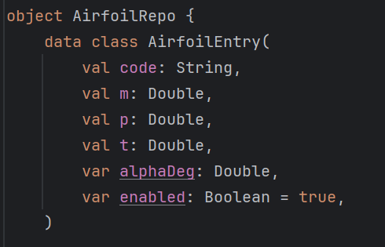
Figure 14 shows the data class for each aerofoil entry
Rather than storing aerofoils as static graphical elements, each entry is stored parametrically. This allows the geometry and associated results to be dynamically regenerated at any time using the same computational and rendering processes as the primary aerofoil. As a result, consistency is maintained between stored data, calculated values, and graphical output.
Users can select multiple aerofoils from the stored list via a selection interface, which enables or disables individual entries. The application limits the number of simultaneously displayed overlays to 5. This is to maintain clarity and performance. Once selected, the relevant aerofoils are passed to the rendering system.
Within the CamberLineView class, overlays are implemented by iterating through the selected aerofoil entries and regenerating their geometry using the Naca4Geometry class. Each aerofoil is drawn sequentially using a distinct colour, allowing them to be visually distinguished while sharing the same coordinate system. The same scaling and transformation logic is applied to all overlays, ensuring accurate alignment along the chord.
The overlay system also integrates with the graph rendering component. Multiple aerofoils can be compared based on their aerodynamic characteristics, with each corresponding to a different lift curve behaviour depending on its camber properties. This enables users to observe how variations in aerofoil geometry influence lift generation.
By combining dynamic data storage, consistent computational modelling, and layered rendering, the overlay system provides a powerful tool for comparative analysis. It allows users to evaluate differences visually and numerically between aerofoils within a single interface, significantly enhancing the functionality and usability of the application.

4.7 User Interface and Interaction Design
Interface decisions prioritised clarity, responsiveness and ease of use. These decisions were guided by the aim of creating an efficient and intuitive tool, while ensuring that the core computational features remained accurate and responsive.
A hybrid object-oriented/procedural structure was used to balance maintainability and computational efficiency. Geometry was generated dynamically from parameters rather than static images, preserving consistency between results and visuals.
To support comparative analysis, the overlay system was implemented with a limit on the number of simultaneously displayed aerofoils. This constraint was introduced to prevent visual clutter and maintain rendering performance, ensuring that the interface remains clear and responsive even when multiple aerofoils are displayed.
A tab-based layout was adopted to separate the aerofoil visualisation and graph display. This allows users to switch between geometric and aerodynamic views without overloading a single screen. In the original implementation, the user would navigate through multiple pages upon selecting certain actions. That interface was ultimately removed, as switching between pages to enter new inputs or check previous results became tedious and slow.
Despite the functionality achieved, several limitations exist within the current implementation. The application is based on thin aerofoil theory, which assumes inviscid, incompressible flow and neglects viscous effects such as boundary layer development and flow separation. As a result, the model is most accurate for small angles of attack and does not capture stall behaviour or nonlinear lift characteristics observed in real aerofoils

4.8 Debugging, Testing, and Refinement
Debugging and testing were used to verify numerical accuracy and graphical consistency. Testing focused primarily on verifying the correctness of the numerical implementation and ensuring consistency between calculated results and graphical outputs.
The numerical calculations were validated using known theoretical cases. For symmetric aerofoils, such as NACA 0012, the zero-lift angle was confirmed to be approximately zero, and the lift coefficient followed the expected linear relationship with a slope of 2π. Additional testing with cambered aerofoils confirmed the presence of a non-zero zero-lift angle, consistent with theoretical predictions.
Debugging was performed using Android Studio’s Logcat functionality, allowing intermediate values such as integral results, Fourier coefficients, and final outputs to be monitored during execution.
The most significant issue encountered during development was related to the implementation of the integral calculations. When solving the equations by hand, symbolic integration allows the Fourier coefficients to be obtained implicitly. However, when applying numerical methods, attempting to replicate this approach directly resulted in inaccurate outputs for the lift coefficient and zero-lift angle.
To resolve this, the implementation was restructured to explicitly compute the required integrals and Fourier coefficients using numerical integration. This ensured that the zero-lift angle and lift coefficient were calculated correctly and consistently across different aerofoil geometries.
The graphical components were also tested to ensure correct scaling, alignment, and consistency between multiple overlays. Issues such as overlapping lines, inconsistent colouring, and visual clutter were identified and resolved through iterative refinement of the rendering logic.
Refinement of the application focused on improving usability and clarity. This included simplifying the user interface, adjusting visual elements such as labels and colours, and removing unnecessary features that did not contribute significantly to user understanding.

Chapter 5: Results

5.1 Validation of Numerical Model

5.1.1 Numerical Solver
To validate that the numerical solver reproduced the analytical thin aerofoil theory accurately, three representative aerofoils—NACA 0012, 2412, and 8812—were tested at an angle of attack of 4°. These cases were chosen to include both symmetric and cambered geometries, ensuring that variations in camber and camber position did not affect numerical accuracy.

NACA | α (°) | C_{L} (hand) (5 d.p) | C_{L} (App) (5 d.p) | Error (%)
0012 | 4 | 0.43865 | 0.43860 | 0.0114%
2412 | 4 | 0.66644 | 0.66640 | 0.0060%
8812 | 4 | 2.11237 | 2.11260 | 0.0109%
Table 2 shows the numerical solver validation cases and their results.
The mean percentage error across these three test cases is 0.0094%. The table shows the app results differ from the hand calculations by 0.01%, which indicates excellent agreement. The slight discrepancy is likely caused by the application rounding results to four decimal places.
Increasing output precision to eight significant figures further reduced the mean error below 0.003%, confirming that numerical integration errors are negligible.

NACA | α (°) | C_{L} (hand) | C_{L} (App) | Error (%)
0012 | 4 | 0.43864908 | 0.43864908 | 0.0%
2412 | 4 | 0.66644398 | 0.66643998 | 0.00060%
8812 | 4 | 2.11237356 | 2.11257034 | 0.00931%
Table 3 shows the validation cases to a higher d.p
Minor variations observed in the 8812 aerofoils suggest that highly cambered sections introduce steeper curvature and therefore slightly higher numerical sensitivity.
This validation demonstrates that the implemented solver reproduces the analytical thin aerofoil theory to within 0.01% accuracy, confirming its reliability as a foundation for subsequent aerodynamic analysis.

5.1.2 Angle Validation:
The program is formulated under the small-angle assumptions inherent to thin aerofoil theory. To reflect this constraint, the C_{L} vs α graph is plotted over the range −10° to 10°, within which aerodynamic behaviour is expected to remain linear.
For the symmetric NACA 0012 aerofoil, the computed lift curve exhibited a constant slope of approximately 2π per radian (Anderson Jr., 2017), confirming the solver’s consistency with theoretical predictions. When cambered sections such as NACA 2412 were tested, the same linear behaviour was observed, with the curve shifted along the α-small axis due to the negative zero-lift angle.

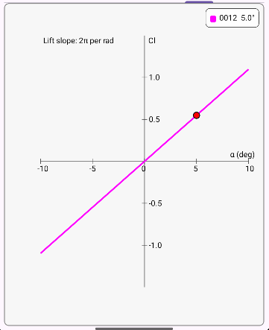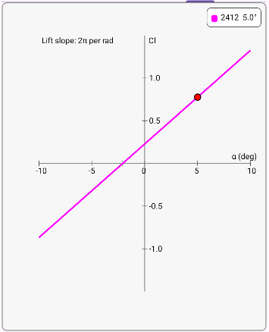
Figure 15 shows the graphs when specific geometries were entered at a 5-degree angle of attack.
When angles were used outside of the small angle range, the predicted lift continued to increase linearly, whereas real behaviour would exhibit stall. This confirms that the model adheres to the small-angle assumptions of the theory.
NACA | C_{L} (0 °) | C_{L} (5 °) | C_{L} (10 °) | C_{L} (20 °) | C_{L} (30 °)
0012 | 0.0 | 0.5483 | 1.0966 | 2.1923 | 3.2899
2412 | 0.2278 | 0.7761 | 1.3244 | 2.421 | 3.5177
Table 4 shows the linear relationship of angle of attack and lift coefficient within the model.
Between 0° and 10°, the lift coefficient increases linearly, matching the theoretical gradient of 2π. However, beyond approximately 10°, the program continues to predict a linear increase, whereas real aerofoils would experience stall and a reduction in lift. This behaviour confirms that the solver correctly implements thin aerofoil theory and remains valid only within its small-angle range.

5.1.3 Comparison of different solver methods:
To evaluate the accuracy of the implemented thin-aerofoil solver, the results were compared against predictions from XFOIL (Drela and Youngren, 2001). This provides a well-validated viscous panel-based solution that captures effects neglected by the thin aerofoil theory (Murali, 1988). With viscosity, compressibility and boundary-layer growth included in its solver, the result is much better aligned with realistic aerofoil performance. This comparison indicates the degree to which the application can predict realistic lift behaviour within its intended operational range.
To compare the accuracy of both methods, lift coefficient values were obtained from both the developed application and XFOIL for several NACA 4-digit aerofoils.
Each was analysed over two different angles of attack. 0 and 4 ° were used at a Reynolds number of approximately eight million, and Mach number 0.22. These conditions cleanly represent moderate subsonic flight.

NACA | α (°) | C_{L} (App) | C_{L} (XFOIL) | Difference
0012 | 0 | 0 | 0 | 0.00%
0012 | 4 | 0.4386 | 0.4655 | 5.78%
2412 | 0 | 0.2278 | 0.2510 | 9.24%
2412 | 4 | 0.6664 | 0.7118 | 6.38%
4412 | 0 | 0.4556 | 0.4972 | 8.37%
4412 | 4 | 0.8942 | 0.9616 | 8.37%
Table 5 shows the lift characteristics of NACA geometries from the app and compared to the XFOIL software, with a percentage difference included.
The comparison in Table 1 shows strong correlation between the application and XFOIL across all tested geometries. The comparison between aerofoils in Table 1 shows that both the application and XFOIL simulation produce similar results, despite using different methods. For each aerofoil, the gradient of the CL–α relation remains linear, but the program consistently under-predicts C_{L} by approximately 5–8% relative to XFOIL.
This trend matches theoretical expectations since thin aerofoil theory neglects viscosity and boundary-layer growth that slightly reduce lift in viscous flow. The discrepancy increases with camber (highest for NACA 4412) due to stronger curvature and higher suction peaks, where viscous losses are more significant even at small angles. Overall, the numerical solver reproduces the inviscid behaviour faithfully while remaining within single-digit percentage deviation from viscous predictions for α ≤ 10°, confirming its reliability for rapid aerodynamic estimation.

To further test the difference between methods, C_{L} vs α graphs were plotted for each aerofoil. These graphs show how the lift coefficient changes with the angle of attack for a real aerofoil model.

Figure 16 shows the lift coefficient variation with angle of attack for a NACA 0012 aerofoil using XFOIL

Figure 17 shows the lift coefficient variation with angle of attack for a NACA 0012 aerofoil using XFOIL

Figure 18 shows the lift coefficient variation with angle of attack for a NACA 0012 aerofoil using XFOIL

NACA | Ideal Lift Slope | Real Lift Slope | % Difference
0012 | 6.2832 | 6.6456 | 5.77%
2412 | 6.2832 | 6.5359 | 4.02%
4412 | 6.2832 | 6.3748 | 1.46%
Table 6 shows the difference in ideal and real lift slopes in selected geometries in XFOIL simulations, with % difference included.
These graphs show a different lift slope to the ideal 2$π$ shown by the thin aerofoil theory (Anderson Jr., 2017). While the greatest difference between the gradients is less than 6%, it shows that the program is limited and creates an estimate based on the limited parameters of the theory. Real results are affected by boundary layer friction and viscous forces that mean the relationship between the lift coefficient and angle is not always constant.
As the thin aerofoil theory shows a linear increase in lift coefficient even with larger angles, XFOIL was used to determine the point at which the behaviour is no longer proportional.
NACA | C_{L} (10 °) | C_{L} (20 °) | C_{L} (30 °) | C_{L} (40 °)
0012 | 1.3751 | 1.8098 | 1.2766 | 0.7898
2412 | 1.1608 | 1.6126 | 1.1633 | 1.3740

Table 7 shows the change in lift coefficient when the angle is increased beyond the small angle assumptions in XFOIl

Figure 19 shows the change in lift coefficient vs angle of attack with simulations performed in XFOIL.
This demonstrates a limitation in the current model. While the results clearly show that large angles produce flow separation and stalling, resulting in a drastic lift change, the model is not equipped to show such results.

5.2 Effect of Camber and Geometry
While validation against analytical solutions confirms that the numerical solver is functioning correctly, it does not by itself demonstrate how changes in aerofoil shape influence aerodynamic performance. A key advantage of the developed application is its ability to rapidly vary NACA geometric parameters and immediately observe the resulting changes in lift behaviour.
For NACA four-digit aerofoils, the primary geometric variables are the maximum camber magnitude, position of maximum camber, and maximum thickness.
Of these, thin aerofoil theory predicts that camber-line shape has the greatest influence on lift coefficient and zero-lift angle, while thickness has no direct effect within the simplified analytical model. All cases were tested at α = 4°, within the small-angle regime where the theory is valid.

5.2.1 Symmetric vs Cambered Aerofoils
The most fundamental comparison is between symmetric and cambered geometries.
NACA | Camber | Camber Position | CL | αL=0
0012 | 0% | — | 0.4386 | 0.0
2412 | 2% | 40% chord | 0.6664 | −2.08
4412 | 4% | 40% chord | 0.8942 | −4.15
Table 8 shows the lift characteristics between symmetric and cambered geometries.
For the symmetric NACA 0012, the zero-lift angle is exactly zero, confirming that lift is produced only when the aerofoil is inclined to the flow. Adding camber shifts the zero-lift angle to a negative value, meaning the cambered aerofoil generates positive lift even at zero geometric angle of attack.

5.2.2 Effect of Camber Magnitude
To isolate the effect of camber magnitude, the camber position was held constant at 40% chord while the first digit was varied.

NACA | Camber (%) | CL​ at 4° | αL=0 (°) | ΔCL​ per 1% camber
0412 | 0 | 0.4386 | 0.0 | —
2412 | 2 | 0.6664 | −2.08 | +0.114
4412 | 4 | 0.8942 | −4.15 | +0.114
Table 9 shows the change in lift characteristics when only camber magnitude was changed.
The lift coefficient increases linearly with camber magnitude, and each 1% of camber adds approximately 0.114 to Cl. The zero-lift angle also shifts by -1.04 per 1% camber increase, confirming the linear relationship between lift and camber for small disturbances.

5.2.3 Effect of Camber Position
To isolate the effect of camber position, the maximum camber was held constant at 4% while the position was varied.
NACA | Camber Position (% chord) | C_{L} at 4° | αL=0 (°)
4112 | 10 | 1.2163 | −7.03
4212 | 20 | 1.0785 | −5.79
4312 | 30 | 0.9713 | −4.82
4412 | 40 | 0.8942 | −4.15
4512 | 50 | 0.8435 | −3.69
4612 | 60 | 0.8136 | −3.42
Table 10 shows the change in lift characteristics when only camber position was changed.
Moving the maximum camber position towards the trailing edge reduces the lift coefficient and the magnitude of the zero-lift angle. Forward camber positions produce higher lift at the same angle of attack. This relationship is non-linear, as moving camber from 10 to 40 % has a larger effect than moving from 40 to 70 %. This is consistent with the theory, as forward camber contributes more strongly to circulation (Anderson Jr., 2017; Corda, 2017).

5.2.4 Effect of Thickness
Although thickness does not appear directly in the thin aerofoil equations (which model only the mean camber line), it was tested to confirm this theoretical prediction.

NACA | Thickness (%) | C_{L} ​ at 4° | αL=0​ (°)
2406 | 6 | 0.6664 | −2.08
2412 | 12 | 0.6664 | −2.08
2418 | 18 | 0.6664 | −2.08
Table 11 shows the change in lift characteristics when only thickness was changed.
This confirms the solver correctly implements the thin aerofoil theory, which only depends on parameters involved in the camber shape and size (Anderson Jr., 2017).

5.2.5 Extreme Camber Cases
To explore the boundaries of the model, highly cambered aerofoils were tested. These geometries exceed typical design practice but demonstrate the solver's behaviour.
NACA | C_{L} ​ at 4° | αL=0
6412 | 1.1220 | −6.23
8412 | 1.3498 | −8.31
8612 | 1.6902 | −11.39
9712 | 2.5139 | −18.83
Table 12 shows the lift characteristics of extreme camber NACA geometries.
At extreme camber values, the predicted zero-lift angles become large negative values (approaching or exceeding −15°). While the thin aerofoil solver continues to produce mathematically consistent results, these predictions become physically unrealistic because:
- The small-angle assumptions break down.
- Real flows would experience separation and stall.
- The camber line geometry deviates significantly from practical aerofoil shapes.
These results highlight the importance of applying thin aerofoil theory only within its valid operating range.

5.2.6 Summary of Geometric Effects
Parameter | Effect on CL | Effect on αL=0​
Increasing camber magnitude | Linear increase | More negative (linear)
Moving camber position rearward | Decrease (non-linear) | Less negative
Increasing thickness | No effect | No effect
Table 13 shows the summary of the geometric effects.

5.3 Graphical/Overlay Comparison Analysis
A key feature of the developed application is its ability to display multiple aerofoils simultaneously, enabling direct visual comparison of both geometry and aerodynamic behaviour. This section presents representative overlay comparisons that demonstrate the relationship between aerofoil shape and lift characteristics.

5.3.1 Lift Curve Comparison
The graphical interface plots lift coefficient against angle of attack for each aerofoil. Under thin aerofoil theory, all lift curves share the same gradient of 2π per radian but differ in their horizontal position according to the zero-lift angle.
Comparison: NACA 0012, 2412, and 4412
NACA | αL=0 (°) | CL​ at α = 0° | CL​ at α = 4°
0012 | 0.0 | 0.0 | 0.4386
2412 | −2.08 | 0.2278 | 0.6664
4412 | −4.15 | 0.4556 | 0.8942
Table 14 shows the NACA geometries used to perform the lift curve comparison.
When overlaid on the same graph, these aerofoils produce three parallel lines. The symmetric NACA 0012 passes through the origin, while the cambered aerofoils are shifted leftward along the angle-of-attack axis. This visualisation immediately conveys that:
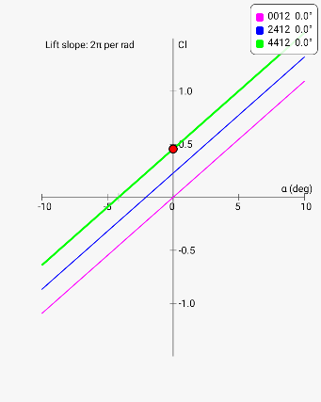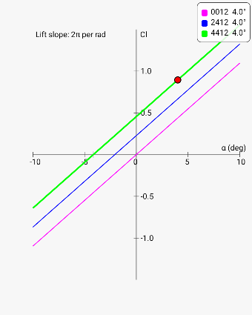
Figure 20 shows the generated graphs of the various NACA aerofoils at both 0 and 5 degrees (as indicated by the red circle)
The parallel nature of the curves confirms that thin aerofoil theory predicts camber affects only the zero-lift angle, not the rate of lift change with angle of attack.

5.3.2 Geometry Overlay Comparison
The aerofoil rendering system allows direct visual comparison of different geometries within the same coordinate space. This enables users to observe how changes in NACA parameters translate to physical shape differences.
Overlaying reveals the progressive increase in camber-line curvature as the first digit increases. Key visual observations include the surfaces, mean camber line and free stream velocity arrows.
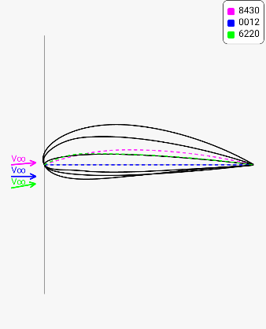
Figure 21 shows the layered aerofoils with the mean camber line and free stream velocity aligned with the legend.
As shown, while the visualisation feature does work as intended, as more aerofoils layer on top of each other the image becomes cluttered. Future work for the model development may include allowing a clear depiction of multiple geometries.

5.3.5 Limitations of Overlay Comparisons
While the overlay system provides valuable comparative insight, several limitations should be noted:
Visual clarity constraints:
- The application limits simultaneous overlays to five aerofoils to prevent visual clutter.
- Highly similar geometries (e.g., NACA 2412 vs 2512) may be difficult to distinguish visually
- Colour selection becomes important when comparing multiple profiles.
Scaling considerations:
- All aerofoils are displayed with normalised chord length, preventing direct comparison of absolute dimensions.
- Thickness variations are visible but may appear subtle at typical display scales.
Theoretical limitations
- The lift curves remain parallel under thin aerofoil theory, which does not capture real variations in lift-curve slope.
- Stall behaviour and non-linear effects at high angles are not represented.
- Comparisons are valid only within the small angle regime.
Despite these limitations, the overlay functionality extends the application beyond simple calculation into comparative analysis, enabling users to develop intuitive understanding of the relationships between aerofoil geometry and aerodynamic performance.

5.4 Performance and Usability Analysis

5.4.1 Computational Performance
The application was designed to provide real-time aerodynamic calculations suitable for mobile deployment. Performance was evaluated based on calculation speed, rendering responsiveness, and overall user experience.
Each stored aerofoil entry requires minimal memory, containing only the NACA parameters, angle of attack, and computed results. The overlay limit of five simultaneous aerofoils ensures that memory consumption remains low even during extended use.
The custom view classes redraw efficiently when parameters change. The use of Android's Canvas and Path classes provides hardware-accelerated rendering on compatible devices. Frame rates remained smooth during parameter adjustment and overlay toggling.

5.4.2 Usability Evaluation
The application interface was designed to minimise complexity while providing access to all core functionalities.
Feature | Evaluation
Input process | Requires only NACA code and angle of attack
Validation | Prevents invalid entries with clear prompts
Response time | Results generated instantly
Navigation | Tab layout separates geometry and graph views
Overlay system | Enables rapid comparison of multiple aerofoils
Accessibility | Easier to use than specialist desktop tools
Table 15 shows the evaluation of each feature within the application, showing the limited complexity of the core functionalities.

Comparison with Alternative Tools
Feature | This Application | XFOIL | Manual Calculation
Setup time | Seconds | Minutes | Minutes
Learning curve | Minimal | Moderate | Low
Visual output | Integrated | Separate plotting | None
Portability | Mobile | Desktop | Paper-based
Overlay comparison | Built-in | Manual | Impractical
Accuracy | Thin aerofoil theory | Viscous panel method | Thin aerofoil theory
Table 16 shows the comparison between alternative simulation tools.
The application occupies a useful middle ground: more accessible than professional tools like XFOIL, yet more capable than manual calculation for rapid comparison and visualisation.

5.4.3 User Experience Observations
Strengths | Areas for Improvement
Real-time visual feedback | No export function
Encourages geometry experimentation | No undo option
Low learning curve | Manual AoA text entry
Clear comparison tools | No parameter guidance
Minimal interface clutter | Limited session saving
Table 17 shows the strengths and weaknesses of the application.

5.5 Limitations of Results
The results presented in this chapter are subject to several limitations arising from the underlying theory, numerical implementation, and application scope.

5.5.1 Theoretical Limitations
Thin aerofoil theory assumes inviscid flow, neglecting boundary layer development, skin friction, and flow separation. As demonstrated in Section 5.1, this results in lift coefficient predictions 5–8% higher than viscous solutions from XFOIL. The discrepancy increases with camber magnitude due to stronger adverse pressure gradients.
The theory assumes constant density throughout the flow field. At the test condition of Mach 0.22, the Prandtl–Glauert correction suggests compressibility would increase lift by approximately 2.5%. This effect is not captured by the current implementation.
The linearisation of thin aerofoil theory requires small angles of attack. Beyond approximately 10°, the small-angle approximations (sin α ≈ α, cos α ≈ 1) introduce increasing error. The application continues to predict linear lift increase at high angles where real aerofoils would experience stall.
The theory models an infinite-span wing with no tip effects. Real finite wings experience induced drag and reduced lift-curve slope due to three-dimensional flow. These effects are not represented.

5.5.2 Numerical Limitations
The trapezoidal integration uses 100 sections, which provides accuracy to approximately 0.01% compared with analytical solutions. Higher section counts would marginally improve precision but were deemed unnecessary given the inherent approximations in the theory itself.
Results are displayed to four decimal places. This truncation introduces minor discrepancies when comparing with hand calculations carried to higher precision, though the differences are negligible for practical purposes.
For highly cambered aerofoils (e.g., NACA 9712), the solver produces mathematically valid but physically unrealistic results. No built-in warnings alert users when parameters exceed practical design limits.

5.5.3 Scope Limitations
The application is restricted to NACA 4-digit aerofoils. Other common families (5-digit, 6-series, supercritical) cannot be analysed. This limits applicability to a subset of available aerofoil geometries.
Thin aerofoil theory does not predict drag. The application provides no information on drag coefficient, lift-to-drag ratio, or aerodynamic efficiency. Users requiring drag estimates must use alternative tools.
Although thin aerofoil theory can predict pitching moment coefficient, this capability was not implemented in the current version. Moment information is relevant for stability analysis but is not available.
The application cannot predict stall angle or maximum lift coefficient. The linear lift model extends indefinitely, providing no indication of when flow separation would occur.
The application analyses steady-state aerodynamic conditions. Unsteady effects such as dynamic stall, flutter, or gust response are beyond the scope of the current implementation.

5.5.4 Validation Limitations
Validation was performed against hand calculations and XFOIL predictions. No experimental wind tunnel data was used for comparison. While XFOIL provides a higher-fidelity reference, it is itself a computational model with its own assumptions and limitations.
Validation focused on representative cases (NACA 0012, 2412, 4412) at selected angles. A comprehensive validation across all possible NACA 4-digit combinations and angle ranges was not performed.
XFOIL comparisons used a fixed Reynolds number of 8,000,000. The effect of Reynolds number variation on the accuracy of thin aerofoil predictions was not systematically investigated.

5.5.5 Implications for Users
User Consideration | Implication
Low angles only | Most accurate below 10°
Drag not included | Use external tools for efficiency
Extreme camber | Interpret cautiously

These limitations do not diminish the utility of the application within its intended scope but define the boundaries of its reliable application.

5.5.6 Summary of Limitations
Category | Key Limitations
Theoretical | Inviscid, incompressible, small-angle, two-dimensional
Numerical | Fixed discretisation, display precision, no extreme-case warnings
Scope | NACA 4-digit only, no drag/moment/stall prediction
Validation | Limited test cases, no experimental comparison
Table 18 shows the summary of limitations split into 4 distinct categories.

Chapter 6: Conclusion:

6.1 Project aim:
The aim of this project was to improve the accessibility and usability of thin aerofoil theory for rapid aerodynamic analysis. This was achieved by developing an interactive application capable of generating aerodynamic results and visualising aerofoil geometry in real time, enabling efficient exploration and comparison of different aerofoil configurations.

6.2 Project achievements:
The developed application successfully meets this aim by integrating numerical implementation of thin aerofoil theory with dynamic graphical visualisation. The computational model produces accurate and consistent results, as demonstrated through validation against theoretical predictions.
In addition to numerical accuracy, the application provides a clear conceptual link between aerofoil geometry and aerodynamic behaviour. The inclusion of real-time visualisation and overlay functionality allows users to directly observe how variations in camber and angle of attack influence lift characteristics. This significantly improves interpretation of the theory.
The novelty of this work lies in integrating established methods into a single accessible tool. By incorporating established theory into an interactive tool with immediate visual feedback, the project addresses a usability gap that existing resources, whether textbooks or professional software, do not fill for learners and early-stage designers.

6.3 Key Findings/insights
The results produced by the application demonstrated several important aerodynamic trends consistent with thin aerofoil theory. Symmetric aerofoils were shown to have a zero-lift angle close to zero, while cambered aerofoils generated positive lift at zero geometric angle of attack and exhibited negative zero-lift angles.
Increasing camber magnitude was found to increase lift coefficient and shift the zero-lift angle further in the negative direction. This confirmed that the mean camber line has a strong influence on circulation and lift generation. Comparisons between multiple aerofoils also showed that small geometric changes can produce noticeable aerodynamic differences.
The overlay visualisation feature further highlighted how aerofoil shape changes correspond to performance changes, making trends easier to identify than from numerical outputs alone. This demonstrates the value of combining computational analysis with visual tools in engineering education and early-stage design work.
Beyond numerical accuracy, a key outcome of the project is its educational impact. By combining analytical theory, real-time computation, and intuitive visualisation, the application provides a learning environment that is far more interactive than traditional textbook or spreadsheet approaches. Users can instantly see how changes in camber, thickness, and angle of attack influence lift behaviour, reinforcing theoretical concepts through direct visual feedback. This positions the tool as a valuable resource for students and early-stage designers who benefit from understanding not only the results of the theory, but also the geometric and physical reasoning behind them.

6.4 Evaluation
The final application performs effectively as a rapid analysis tool within the assumptions of thin aerofoil theory. It provides results significantly faster than manual calculation methods while reducing the risk of arithmetic error. The user interface is straightforward, allowing repeated testing of multiple aerofoils with minimal effort.
A major strength of the project is that it does not simply calculate outputs, but also improves understanding of the underlying aerodynamic principles. By displaying aerofoil geometry and lift-curve behaviour directly alongside results, the application creates a stronger connection between theory and physical interpretation.
However, limitations remain due to the theoretical model used. Thin aerofoil theory assumes incompressible, inviscid flow, small angles of attack, and negligible thickness effects in aerodynamic prediction. As a result, the application is most reliable for low-angle attached flow conditions and cannot accurately predict stall, flow separation, drag, or high-angle nonlinear behaviour. Extreme camber cases also highlight where mathematically valid outputs may become less physically realistic.
This evaluation demonstrates that the application fully meets the project objectives defined at the outset. Thin aerofoil theory was implemented accurately through numerical integration, achieving solver precision within 0.01% of analytical predictions. The geometry-generation system successfully translates NACA parameters into clear, scalable visualisations, while the graphing module provides immediate and consistent lift-curve interpretation. The overlay feature enables direct comparison between aerofoils, fulfilling the aim of improving accessibility and supporting rapid parametric exploration. Collectively, these outcomes confirm that the tool not only performs the required calculations but also enhances user understanding by tightly linking aerodynamic theory with visual representation.

6.5 Future Improvements
Several improvements could further enhance the usefulness of the application. The most significant would be the inclusion of viscous aerodynamic models or integration with higher-fidelity methods such as panel methods or XFOIL-style analysis, allowing drag prediction and improved performance estimation near stall conditions.
Additional interface developments could include data export functions, automated graph generation, expanded aerofoil libraries, and improved comparison dashboards for larger sets of aerofoils. Three-dimensional wing corrections could also be introduced to estimate finite wing effects such as induced drag and aspect ratio influence.
Future improvements could include individual entry deletion, guided parameter explanations, and data export functionality.

Further educational features, such as guided explanations of each calculation step or adjustable numerical methods, could make the application more useful for students studying aerodynamics.

6.6. Final Summary:
Overall, this project successfully transformed a traditionally mathematical and time-consuming aerodynamic theory into an accessible interactive engineering tool. The application demonstrates that thin aerofoil theory can be implemented in a modern digital format that is both computationally efficient and visually intuitive. While bounded by the assumptions of the underlying theory, the project provides a solid foundation for future aerodynamic software development and offers clear value as both an educational and preliminary design resource.

References:
AeroFoil Help [WWW Document], n.d. URL https://aerofoilengineering.com/Help/HelpNacaNames.htm (accessed 4.23.26).
Anderson Jr., J.D., 2017. Fundamentals of Aerodynamics, 6th Edition. ed. McGraw-Hill.
Bagdasar, O., 2013. Concise Computer Mathematics. Springer.
Biswal, B.B., Kumar Sarkar, B., 2018. Advances in Mechanical Engineering. Springer.
Brennen, C.E., 2004. An Internet Book on Fluid Dynamics.
Ciavatta, N., Shen, X., Deng, X., n.d. A User-Defined Angle of Attack Oscillation Control System for Wind-Tunnel Testing for Aerofoils. Institut Catholique d’Arts et Métiers & Northumbria University & Newcastle University.
Corda, S., 2017. Introduction to Aerospace Engineering with a Flight Test Perspective. John Wiley & Sons, Incorporated, Newark, UNITED STATES.
Drela, M., Youngren, H., 2001. XFOIL 6.9 User Primer [WWW Document]. URL https://web.mit.edu/drela/Public/web/xfoil/xfoil_doc.txt (accessed 4.20.26).
Murali, B.K., 1988. Use of Panel Methods for Investigation of Two Dimensional Potential Flows (Ph.D.). Indian Institute of Technology, Bombay (India), India.
Salazar, D.M., Liu, T., 2025. Birth of starting vortex and establishment of Kutta condition. Eur. J. Mech. - BFluids 110, 19–24. https://doi.org/10.1016/j.euromechflu.2024.11.007
Xiang, T., Eyink, G.L., Zaki, T.A., 2025. The origin of vorticity in viscous incompressible flows. J. Fluid Mech. 1011, A33. https://doi.org/10.1017/jfm.2025.134
Zhonghua H. a. N., Zhenghong G. a. O., Wenping S., Lu X.I.A., 2021. On airfoil research and development: history, current status, and future directions. ACTA Aerodyn. Sin. 39, 1–36. https://doi.org/10.7638/kqdlxxb-2021.0396

