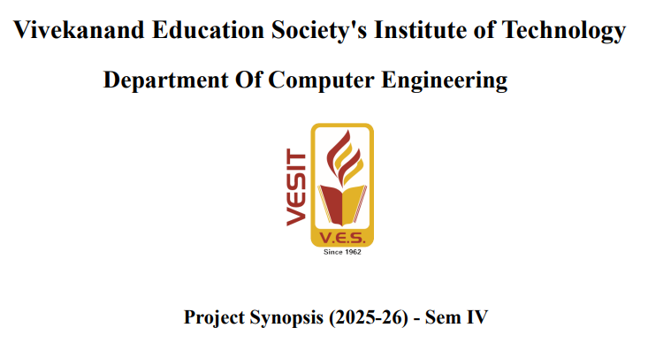

Title of the Project
ShelterConnect: Integrated Digital Management & Outreach System for NMMC Homeless Shelter
Group No.: 37
Cohort Group: Elderly or Child care
Name of The Mentor: Mrs. Rupali Rajendra Soni
Designation: Assistant Professor, Department of Computer Engineering
Sustainable Goal (No 1-17):
- Goal 1: No Poverty
- Goal 2: Zero Hunger
- Goal 3: Good Health and Well-being
- Goal 11: Sustainable Cities and Communities

Group Members
Name | Class | Roll No | Email ID
Tanmay Purushottam Bokade | D7B | 9 | 2024.tanmay.bokade@ves.ac.in
Dhanaraj Sudhakar More | D7B | 41 | 2024.dhanaraj.more@ves.ac.in
Abhay Sudhir Panchal | D7B | 43 | 2024.abhay.panchal@ves.ac.in
Kush Nitesh Patel | D7B | 46 | 2024.kush.patel@ves.ac.in

Organisation Details
- Organisation Name: Ma Aastha Social Development Service Organisation (Operating NMMC Beghar Nivara Kendra)
- Address: Plot No. 240, Sector 4, Ghansoli, Navi Mumbai.
- Status: Government Project (NMMC) operated by NGO
- Contact Person Name: Mr. Rahul Wade
- Contact No: +91 866 939 3309

Executive Summary

Brief Introduction of the Project
The project aims to digitize the operations of the NMMC Beghar Nivara Kendra in Ghansoli. Currently, this three-storey shelter, which houses up to 103 beneficiaries including the elderly and destitute, operates largely on manual record-keeping. Our solution, ShelterConnect, is a web-based application designed to manage beneficiary data, track bed availability in real-time, and provide an interface for public outreach to encourage donations and volunteering.

Major Activities and Outcomes
- Digitization of Records: Converting physical registers into a secure database.
- Web Portal Development: Creating a public-facing website to increase visibility.
- Admin Dashboard: For shelter staff to manage admissions and inventory.
- Outcome: Streamlined operations, increased transparency, and better resource mobilization for the homeless.

Abstract

1. Field Visits
The team visited the NMMC Beghar Nivara Kendra at Plot No. 240, Sector 4, Ghansoli. We inspected the facilities (Ground+2 structure) and held a detailed meeting with the manager, Mr. Rahul Wade, to understand the daily workflow and challenges faced by the staff.

2. Key Outcomes
- Secured approval from the organization to develop a digital solution.
- Identified the specific pain points: lack of digital data and low public awareness.
- Defined the scope of the software requirements (MERN Stack implementation).

3. Key Findings
- Capacity: The center accommodates 103 people with separate sections for men, women, and families.
- Operations: It runs 24/7 offering free meals and medical aid but relies on manual paperwork for admissions.
- Safety & Management: There is a need for a transparent logging system to ensure the safety and proper tracking of beneficiaries, addressing concerns regarding management efficiency.

4. Geotagged Photographs
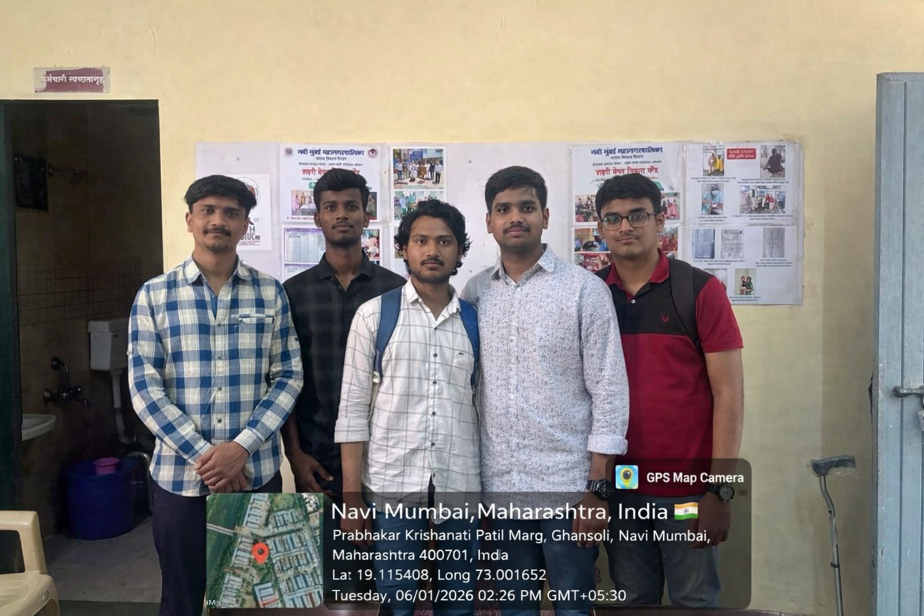
("Team with Mr. Rahul Wade at Ghansoli Shelter".)

5. Impact
The visit confirmed that a digital intervention would significantly reduce administrative burden and potentially increase donations by making the shelter visible to the "digital-first" population of Navi Mumbai.

Introduction

Problem Statement and Objectives
Problem Statement:
The NMMC Beghar Nivara Kendra currently suffers from:
- Manual Record Keeping: Relying on physical registers makes data retrieval difficult and prone to loss.
- Lack of Online Visibility: Despite doing impactful work under the Deen Dayal Antyodaya Yojana, the shelter has low digital presence, limiting potential donations and volunteer support.
- Low Influence: There is no centralized platform for the public to report homeless individuals in need of rescue.
Objectives:
- To develop a Full-Stack Web Application using the MERN stack.
- To automate the admission and discharge process of beneficiaries.
- To create a public portal for awareness, donations, and reporting homeless cases.

Community Involvement
The project bridges the gap between the shelter and the local community. By providing an online platform, local residents can easily donate food or essentials, and social workers can track capacity without physical visits, fostering a supportive ecosystem for the urban poor.

Literature Review / Survey Conducted

Survey/Interview Questions (Discussions with Mr. Rahul Wade)
During the requirement gathering phase, the following questions were addressed

When was the organisation established?

What organisation do ?

Who is the founder or director?

What services are provided?

​Capacity of people keep here?

Which type of people do you keep here ? Eg child senior citizen handicapped like that

​What facilities do you provide?

How do you manage these free services to homeless people

How is the municipal corporation involved?

​Type of organisation

government private or semi government

10. How do you maintain data of homeless people

11. How do you take donation

12. What are your major activities?

What pages do you want on your website? (Home, About, Courses, Contact, etc.)

​Do you have a logo and photos that we can use on the website?

​Do you need features like online registration, enquiry form, or payment?

​Contact & Location

What is your full address?

What are your contact numbers?

What is your email ID?

Do you have social media pages

Data Interpretation
The feedback indicated that while the infrastructure (building, water, food) is available, the management information system is non-existent. The staff agreed that a digital dashboard would help them generate reports for NMMC more efficiently and improve transparency.

Proposed Solution and its Impact & Contribution to SDGs

Proposed Solution
We propose a Web Application built on the MERN Stack (MongoDB, Express.js, React.js, Node.js).
- Public Module: Information about the shelter, "Donate Now" details, and a form to report homeless persons needing rescue.
- Admin Module: Secure login for Mr. Rahul and staff to add/remove beneficiaries, update bed counts, and log daily inventory usage.

Contribution to Sustainable Development Goals (SDGs)
- Goal 1 (No Poverty) & Goal 2 (Zero Hunger): By improving the efficiency of the shelter, we ensure more destitute individuals receive food and shelter.
- Goal 11 (Sustainable Cities): Helping manage urban homelessness contributes to safer, more inclusive cities.

Methodology / Block Diagram
The project will follow the Agile Methodology, allowing for iterative feedback from the NGO mentor.
- Requirement Analysis: (Completed via Field Visit).
- Design: UI/UX prototyping for Admin and User dashboards.
- Development:
  - Frontend: React.js + Tailwind CSS for a responsive design.
  - Backend: Node.js + Express for API handling.
  - Database: MongoDB for storing beneficiary and inventory data.
- Testing: Deployment and UAT (User Acceptance Testing) at the shelter.

Hardware, Software and Tools Requirements
- Hardware: Laptops for development; Desktop/Tablet at the shelter for accessing the portal.
- Software: VS Code, Postman (API testing), Git/GitHub.
- Tech Stack: MongoDB, Express.js, React.js, Node.js.

Proposed Evaluation Measures and its Impact

Evaluation Measures
- Usability Testing: Can the shelter staff (non-technical users) easily add a beneficiary?
- Performance: Does the bed availability update in real-time?
- Adoption Rate: Is the shelter actually switching from paper registers to the digital log after deployment?

Impact
- Operational Efficiency: Reduces time spent on paperwork by 40-50%.
- Transparency: Digital logs create an immutable record of admissions, addressing safety and management concerns.
- Social Connection: Increases community engagement through the digital donation information portal.

Conclusion
The ShelterConnect project is not just a technical requirement but a social initiative. By leveraging modern web technologies, we aim to support the Ma Aastha Social Development Service Organisation in their mission to provide dignity to the homeless. This digitization will serve as a pilot model that could potentially be adopted by other NMMC shelters in the future.

References
- NMMC Social Development Department Guidelines.
- Deen Dayal Antyodaya Yojana – National Urban Livelihood Mission (DAY-NULM) Documentation.
- Interview and Data provided by Mr. Rahul Wade, Manager, Ghansoli Shelter.

