**Reopen Issues:**

1. Home --> move all the labels little bit to right side of screen **(Reopen)**

**QA:** Checked on different systems still having same issues

1. Home --> Decrease font size **(Reopen)**

**QA:** Checked on different systems still having same issues



1. Home --> popular course --> showing some incorrect content **(Reopen)**



1. Checkout --> CVV text must be on left top of the field **(Reopen)** not aligned properly

For your clarification see the expiration date alignment over the field.

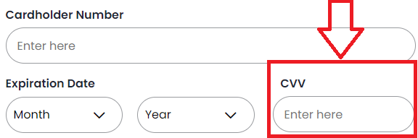

1. Search --> search icon is not as per design it must be inside of filed having some space from the outline of field **(Reopen)**

**QA:** kindly view the given design

