Problem Statement:

Make an API call to eSamudaay's compliance report API, process the response, and prepare a user-friendly and effective UI to display the compliance report to necessary stakeholders.

Solution:

This product helps the business identify the factors that do not meet the government's pre-set compliance.

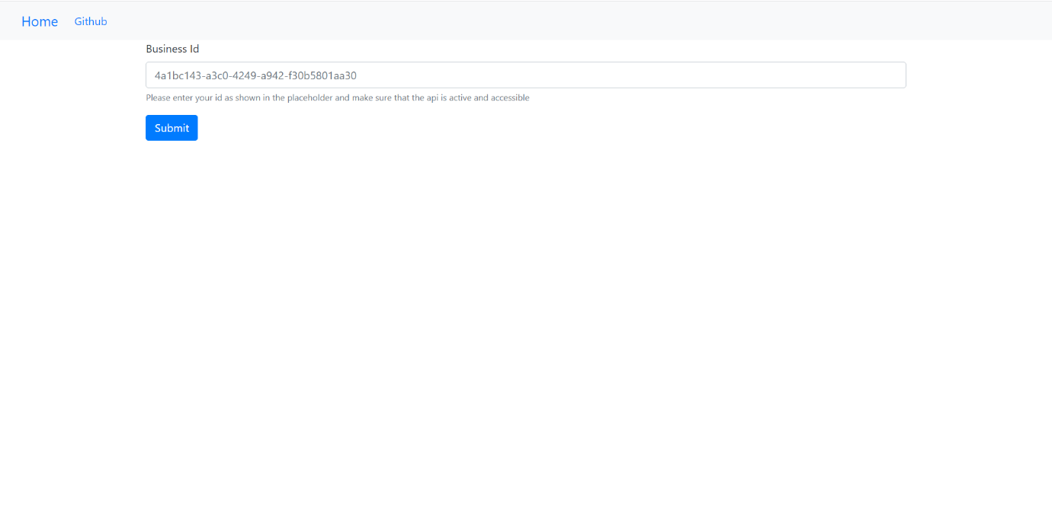

The above shows us the intro page of the product. We must enter the business ID into the text box available and press the submit button to get the results.

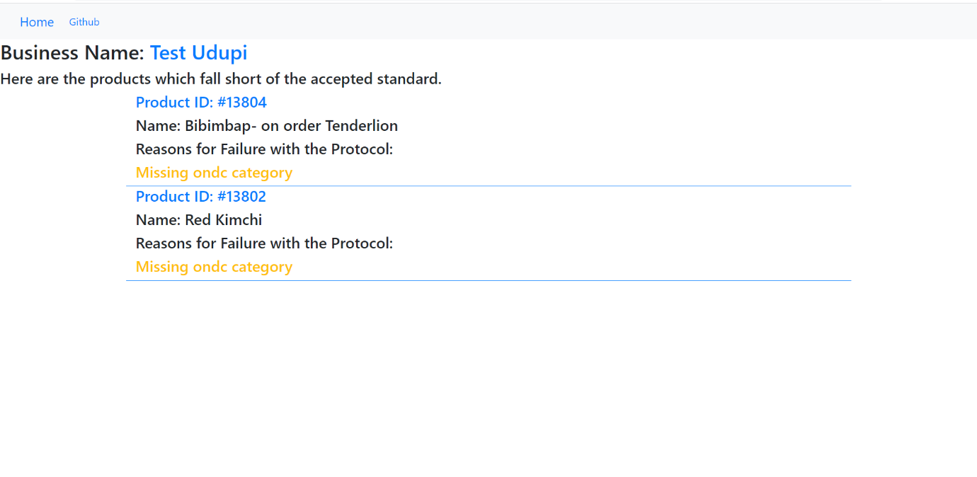

This is the result page. It displays all the products which do not meet the standards of the report. Also stated is a reason for this failure.

Explanation:

The solution provided as two parts: - Front End and Backend.

Front end is constructed using Bootstrap where there are features such as the home page button which will take you to the main page and, a text area where you can input the business ID, which then will display the appropriate results.

The Backend of the same is built using Flask. The contents of the html file is scraped from bs4: BeautifulSoup library and the contents are then processed by the JSON library. Templating library Jinja2 is used to create html format which is then returned to the user through a http request.