**Assignment 8 PCA**

Kushagr Garg (IIT2018107)

**Problem:**

Take 60% data as training set and 40 % data as test set, evaluate your classifier on the following

Factors:

a) Change the value of k and then, see how it changes the classification accuracy. Plot a graph between accuracy and k value to show the comparative study.

b) Add imposters (who do not belong to the training set) into the test set and then recognize it as the not enrolled person.

**Works:**

1. I have detected accuracy for different values of k from 5 to 500 at steps of 5.

Maximum Accuracy Achieved for k = 80

Maximum Accuracy Achieved = 0.9407894736842105

Accuracy Curve:

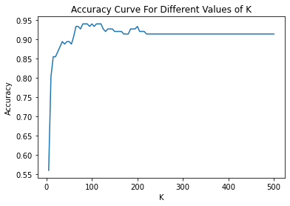

Dataset Used for Model Creation: Images of s1 to s38

Training Set: First 6 images of s1 to s38

Testing Set: Last 4 images of s1 to s38

Training-Testing Split: 60%-40%

1. Imposter Detection:

Dataset Used: All 10 images of s39 and s40.

Results Achieved:

Performing Imposter Detection on images of s39 and s40

s39/1.pgm --- Given Image is Imposter

s39/2.pgm --- Given Image is Imposter

s39/3.pgm --- Given Image is Imposter

s39/4.pgm --- Given Image is Imposter

s39/5.pgm --- Given Image is Imposter

s39/6.pgm --- Given Image is Imposter

s39/7.pgm --- Given Image is Imposter

s39/8.pgm --- Given Image is Imposter

s39/9.pgm --- Given Image is Imposter

s39/10.pgm --- Given Image is Imposter

s40/1.pgm --- Given Image is Imposter

s40/2.pgm --- Given Image is Imposter

s40/3.pgm --- Given Image is Imposter

s40/4.pgm --- Given Image is Imposter

s40/5.pgm --- Given Image is Imposter

s40/6.pgm --- Given Image is Imposter

s40/7.pgm --- Given Image is Imposter

s40/8.pgm --- Given Image is Imposter

s40/9.pgm --- Given Image is Imposter

s40/10.pgm --- Given Image is Imposter