
NETAJI SUBHAS UNIVERSITY OF TECHNOLOGY, DELHI
Department of Computer Science and Artificial Intelligence
A Project Report on
MUDRAFLOW
Online Banking Transaction System
A Database Management Systems Project Report
Submitted by:
Kushagra Mittal, Roll No. 2025UCA1878
Yashwani Jain, Roll No. 2025UCA1804
Neil Kumar Singh, Roll No. 2025UCA1852
Abhishek Roy, Roll No. 2025UCA1862
Class: CSAI, Second Year
Academic Session 2026–27
Live Application: https://mudra-flow.vercel.app/
GitHub Repository: https://github.com/Kushagra-Mittal-07/MudraFlow

ABSTRACT
MudraFlow is an online core banking management system engineered around its relational database engine. In modern commercial software engineering, application tiers frequently attempt to manage transactional states in volatile memory, leaving critical systems vulnerable to lost updates, phantom reads, and financial balance corruption during high-concurrency race conditions. MudraFlow addresses these fundamental flaws by treating the relational database engine (MySQL 8 InnoDB) as the ultimate transactional authority. Customers register with a verified opening deposit, transfer money via IMPS, NEFT, and RTGS, create fixed deposits, and apply for loans, debit cards, and cheque books; bank staff oversee administrative loan approvals, freeze compromised accounts, and settle deposit maturities.
The underlying database schema consists of ten tables normalized to Third Normal Form (3NF) and Boyce-Codd Normal Form (BCNF), governed by seven ACID stored procedures, two deterministic rate functions, two automated triggers, an integrated application view, and composite B-tree performance indexes. Every money movement occurs inside an atomic transaction inside a stored procedure utilizing deterministic row-level locking (SELECT ... FOR UPDATE) executed strictly in ascending account ID order to eliminate concurrency race conditions and deadlocks. An automated trigger logs every balance change into an immutable audit trail, while column-level database privileges guarantee that even the application backend cannot directly modify account balance columns.

INDEX
S. NO. | TOPIC | PAGE NO.
1 | Project Description | 3
2 | Requirement Analysis | 6
3 | ER Model | 8
4 | ER to Relational Schema | 11
5 | Normalization Steps till BCNF | 13
6 | Lossless Decomposition Proof | 16
7 | Dependency Preserving Steps | 18
8 | Minimal Cover of Each Table | 20
9 | Implementation and Concurrency Control | 22
10 | Results and System Verification | 25
11 | Conclusion, Limitations and Future Scope | 28

1. PROJECT DESCRIPTION
1.1 Overview
MudraFlow is a full-featured online banking management system designed to enforce relational database integrity, mathematical normalization, and strict concurrency control directly inside the database tier. In standard banking architectures, customers register with an initial deposit, authenticate securely, transfer funds between accounts, lock capital into fixed deposits, and apply for institutional loans and bank instruments. Simultaneously, bank personnel review underwriting queues, approve or reject service requests, manage account statuses, and execute automated maturity settlements.
Unlike commercial applications that treat relational databases as mere persistent stores, MudraFlow places the transactional engine at the very center of the architecture. Every branch belongs to the same corporate banking network, allowing account numbers and IFSC codes to be validated directly against the bank's internal relational tables without external dependencies. The complete working system is publicly accessible at https://mudra-flow.vercel.app with source code maintained at https://github.com/Kushagra-Mittal-07/MudraFlow.
1.2 Objectives
- Relational Schema Design: To formulate a comprehensive relational schema in Third Normal Form (3NF) and Boyce-Codd Normal Form (BCNF) eliminating relational anomalies.
- ACID Transactional Integrity: To guarantee that all financial debits and credits execute as indivisible atomic units inside database stored procedures.
- Pessimistic Concurrency Control: To prevent lost updates, race conditions, and deadlocks during concurrent multi-account transactions using ordered row-level locks.
- Automated Audit Logging: To maintain an immutable record of all historical balance adjustments through automated database triggers.
- Principle of Least Privilege: To configure column-level database user privileges such that neither staff users nor the application backend can directly edit balance fields.
1.3 Problem Statement & Banking Invariants
Many simplistic banking applications execute balance updates by reading the current balance into application memory, performing arithmetic calculations in code, and dispatching raw SQL UPDATE statements. This pattern introduces severe vulnerabilities: two simultaneous transfer requests can read the identical initial balance, resulting in lost updates and catastrophic double-spending. Furthermore, a system crash occurring between separate debit and credit statements creates or destroys money.
MudraFlow resolves this vulnerability by establishing the Fundamental Banking Ledger Invariant across all database operations:
For every account a, Balance(a) = Total Credits(a) - Total Debits(a) in the Transaction Ledger.
Balances can never be modified through application SQL updates. Every balance change must be accompanied by an immutable ledger entry inside a single ACID transaction.
1.4 Business Rules & Constraints
Rule / Constraint | System Enforcement & Description
Three Ingress Channels Only | Money enters the banking ecosystem exclusively through: (1) verified opening deposit at signup, (2) approved loan disbursement, or (3) matured fixed deposit payout. Direct cash deposits/withdrawals are disallowed.
Stored Procedure Encapsulation | Application servers and bank staff can never issue UPDATE account SET balance. All balance modifications are strictly confined inside DEFINER stored procedures.
Two-Factor Verification | Registration requires demo OTP (123456). Login requires Customer ID and bcrypt password (5 consecutive failed attempts trigger a 10-minute account lockout). Fund transfers require dual password and OTP validation.
Transfer Mode Limits | IMPS transfers are limited to a maximum of Rs 5,00,000; NEFT transfers permit arbitrary amounts; RTGS transfers strictly require a minimum amount of Rs 2,00,000.
Account Status Enforcement | Accounts tagged with FROZEN status are rejected from participating as either sender or receiver across all transfer modes.

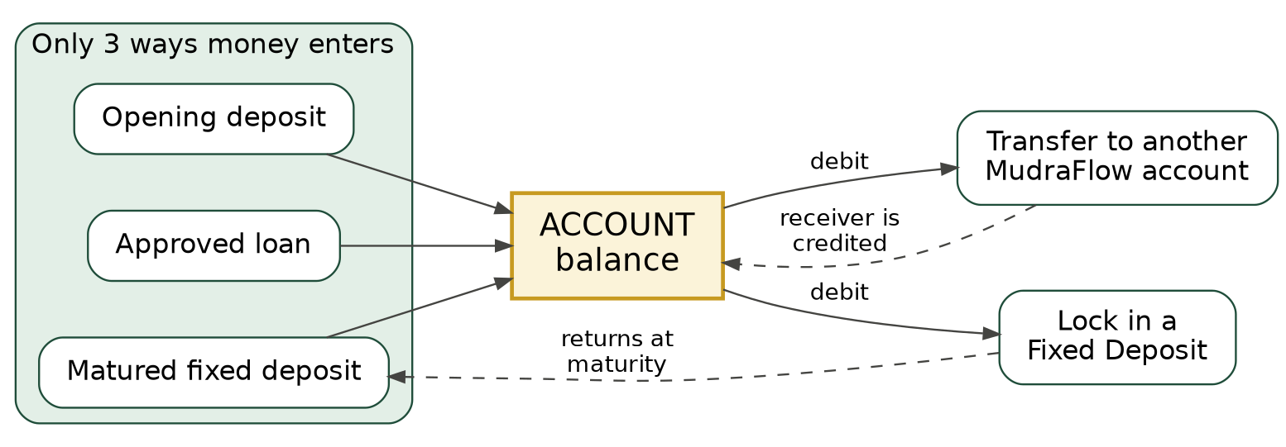
Figure 1.1: Sources of money and its movements in MudraFlow
1.5 System Architecture
MudraFlow is architected according to an enterprise Three-Tier Architecture:
1. Presentation Tier (Client): Built as a modern Single Page Application (SPA) using React and Vite, delivering responsive interfaces for both customer self-service and staff back-office operations.
2. Application Logic Tier (Backend): Implemented in Node.js and Express, serving as an API gateway. It verifies JWT session tokens, hashes passwords using bcrypt, validates input schemas, and delegates all transactional logic to database routines.
3. Database Tier (MySQL 8 InnoDB): The core operational layer housing ten normalized tables, seven stored procedures, two deterministic functions, two triggers, a unified application view, and performance B-tree indexes.
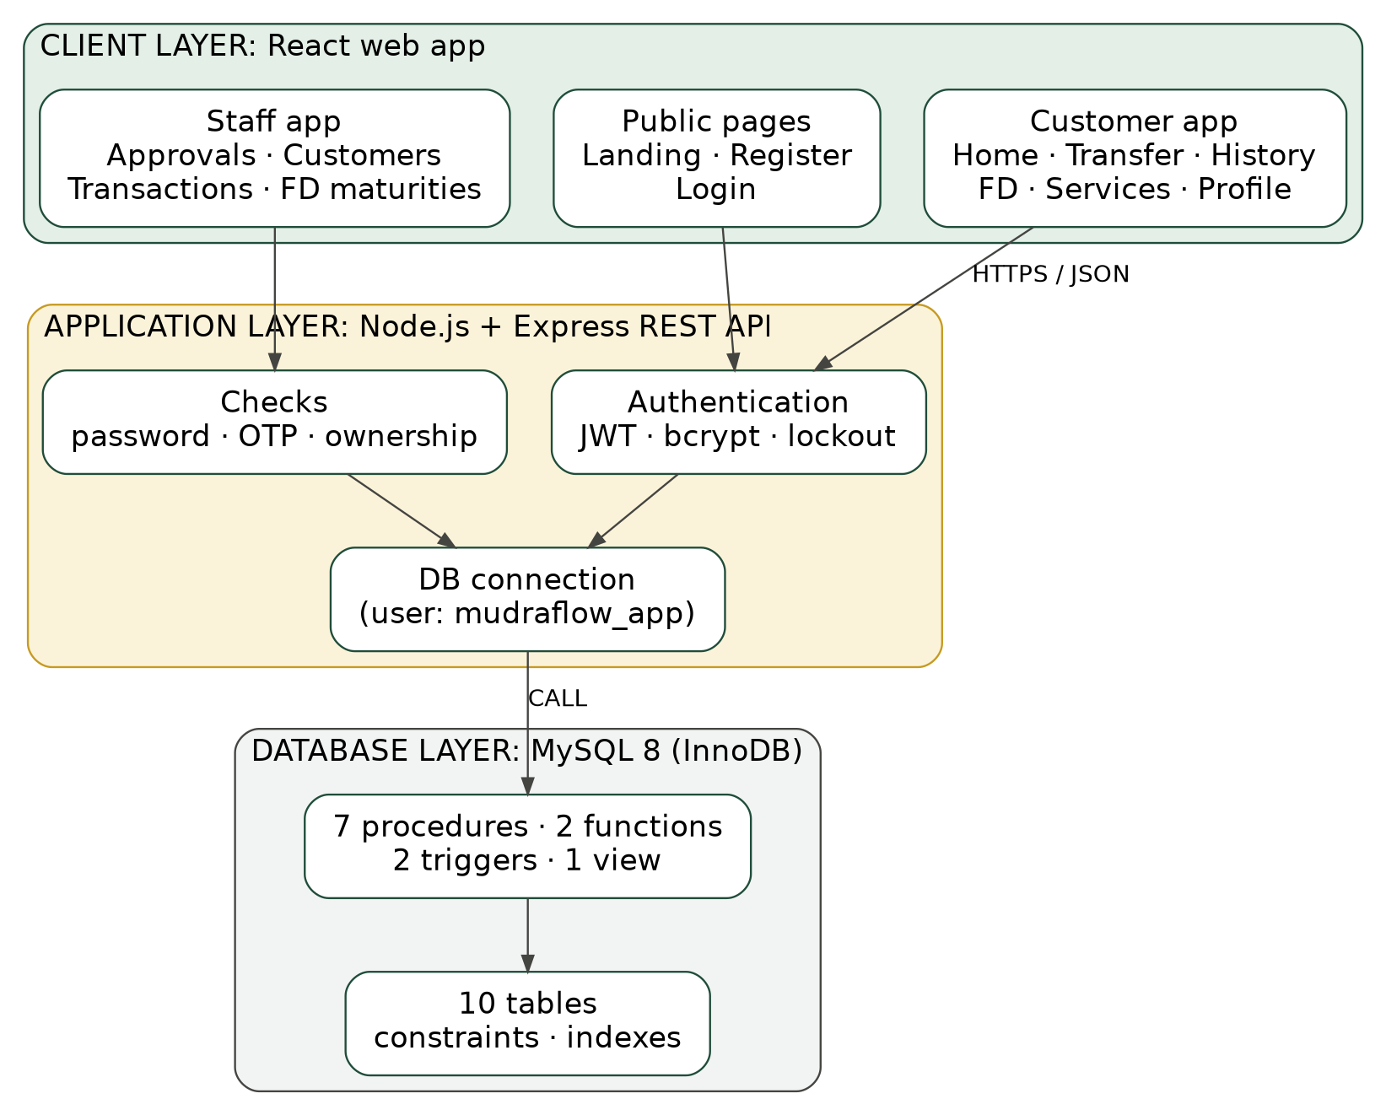
Figure 1.2: Three-tier system architecture and database boundary

2. REQUIREMENT ANALYSIS
2.1 Functional Requirements
System Scope: The functional requirements of MudraFlow are structured across two operational user categories:
Customer Subsystem
- User Onboarding & Registration: Enforces age requirement (18+), validates unique PAN format (AAAAA9999A) and unique email, and atomically initializes account with opening deposit.
- Multi-Account Dashboard: Displays masked account number, real-time balance (with show/hide visibility toggle), branch name, IFSC, and monthly credit/debit aggregates.
- Fund Transfer Subsystem: Facilitates internal money movement across branches via IMPS, NEFT, or RTGS with input validation, transfer review step, and live amount-in-words translation.
- Statement & History: Full ledger view with date-range filters, running balance tracking, and printable transaction receipts.
- Term Deposit Booking: Allows locking funds for 6, 12, 24, 36, or 60 months with dynamic interest rate computation and automatic maturity instruction selection (CREDIT or RENEW).
- Credit & Service Requests: Submission of credit applications (specifying amount, purpose, tenure, employment status, and annual income) and request of bank instruments (debit cards and cheque books).
Staff Subsystem
- Executive Overview: Summary of total customers, total accounts, bank-wide deposit base, and branch-level liability allocations.
- Loan Underwriting: Review of customer loan requests against stated income, granting approval with automated balance credit or rejection.
- Service Processing: Verification of debit card applications (generating a 16-digit card number and 5-year expiry date) and cheque book issuances.
- Account Governance: Real-time administrative action to freeze suspicious accounts or restore active status.
- Automated Maturity Settlement: Batch execution of active fixed deposits reaching maturity date, disbursing principal plus accrued interest.
2.2 Non-Functional Requirements
- ACID Integrity: All balance modifications must adhere to Atomicity, Consistency, Isolation, and Durability. Any failure mid-transfer triggers a complete rollback.
- Concurrency Control: The database must handle concurrent requests on the same account deterministically without lost updates or deadlocks.
- Auditability: Every change in account balance must automatically insert an audit record detailing previous balance, new balance, timestamp, and triggering transaction.
- Security & Access Control: Passwords must be hashed using bcrypt; API routes must authenticate via JWT; database user mudraflow_app must have restricted column-level privileges.
- Performance & Indexing: Queries on the transaction ledger must execute efficiently using composite indexes on (from_account_id, created_at) and (to_account_id, created_at).
2.3 Hardware and Software Environment
Component | Specification / Technology | Role in Project
Hardware | Multi-core CPU (Intel i5/Ryzen 5), 8 GB RAM, 20 GB SSD | Host development and testing environment
Database Engine | MySQL Server 8.0.x (InnoDB Storage Engine) | Core relational engine, ACID transactions, stored programs
Database GUI | MySQL Workbench 8.0 Community Edition | Schema administration, ER design, query profiling
Backend Runtime | Node.js v20.x LTS & Express Framework | RESTful API server, token auth, parameter sanitation
Database Driver | mysql2 (Promise API) | Asynchronous MySQL connection pool management
Frontend UI | React 18 with Vite, Vanilla CSS3 | Responsive single-page application client
API Testing | Postman Desktop Client | Concurrency testing, authentication flow verification
Deployment | Vercel (Client & API), Cloud MySQL | Public live demonstration host

3. ER MODEL
3.1 Entity Identification and Attributes
The conceptual model of MudraFlow identifies ten core entities capturing all banking business entities:
- BRANCH: branch_id (PK), branch_name, ifsc (Candidate Key), city.
- EMPLOYEE: emp_id (PK), full_name, role (MANAGER/CLERK), branch_id (FK), password_hash.
- CUSTOMER: customer_id (PK), full_name, dob, email (Candidate Key), phone, pan (Candidate Key), address, password_hash, failed_attempts, locked_until, created_at.
- ACCOUNT: account_id (PK), account_number (Candidate Key), customer_id (FK), branch_id (FK), account_type, balance, status, opened_on.
- TRANSACTION (txn): txn_id (PK), reference_no (Candidate Key), from_account_id (FK), to_account_id (FK), receiver_name, amount, mode, txn_type, remarks, created_at.
- BENEFICIARY: beneficiary_id (PK), customer_id (FK), name, account_number, ifsc, added_on. Composite unique constraint on (customer_id, account_number).
- FIXED_DEPOSIT: fd_id (PK), customer_id (FK), account_id (FK), amount, rate, tenure_months, start_date, maturity_date, maturity_amount, maturity_instruction, status.
- LOAN: loan_id (PK), customer_id (FK), account_id (FK), amount, purpose, duration_months, rate, employment_status, annual_income, status, applied_on, decided_by (FK), decided_on.
- SERVICE_REQUEST: request_id (PK), customer_id (FK), account_id (FK), request_type, name_on_card, network, leaves, delivery_address, card_number, card_expiry, status, requested_on, decided_by (FK), decided_on.
- AUDIT_LOG: audit_id (PK), account_id (FK), txn_id, old_balance, new_balance, changed_at.
3.2 Relationships, Cardinalities, and Participation Constraints
Relationship | Participating Entities | Cardinality | N-Side Participation | Semantic Meaning
employs | BRANCH - EMPLOYEE | 1 : N | Total | Every employee must belong to one branch; a branch employs many staff.
held at | BRANCH - ACCOUNT | 1 : N | Total | Every account is maintained at one branch; a branch holds many accounts.
owns | CUSTOMER - ACCOUNT | 1 : N | Total | Every account belongs to one customer; a customer may own multiple accounts.
saves | CUSTOMER - BENEFICIARY | 1 : N | Total | A beneficiary is registered by one customer; a customer saves many beneficiaries.
opens / funds | CUSTOMER, ACCOUNT - FIXED_DEPOSIT | 1 : N each | Total | A term deposit is opened by one customer and funded from one account.
applies / paid into | CUSTOMER, ACCOUNT - LOAN | 1 : N each | Total | A loan application is submitted by one customer and credited to one account.
requests / linked to | CUSTOMER, ACCOUNT - SERVICE_REQUEST | 1 : N each | Total | Card or cheque requests are submitted by one customer on a specific account.
decides / approves | EMPLOYEE - LOAN, SERVICE_REQUEST | 1 : N each | Partial | Staff review many requests; requests remain unassigned until decided.
sends / receives | ACCOUNT - TRANSACTION | 1 : N each | Partial | Accounts participate as sender or recipient; bank credits have null sender.
logged in | ACCOUNT - AUDIT_LOG | 1 : N | Total | Every audit record reflects balance changes of exactly one account.

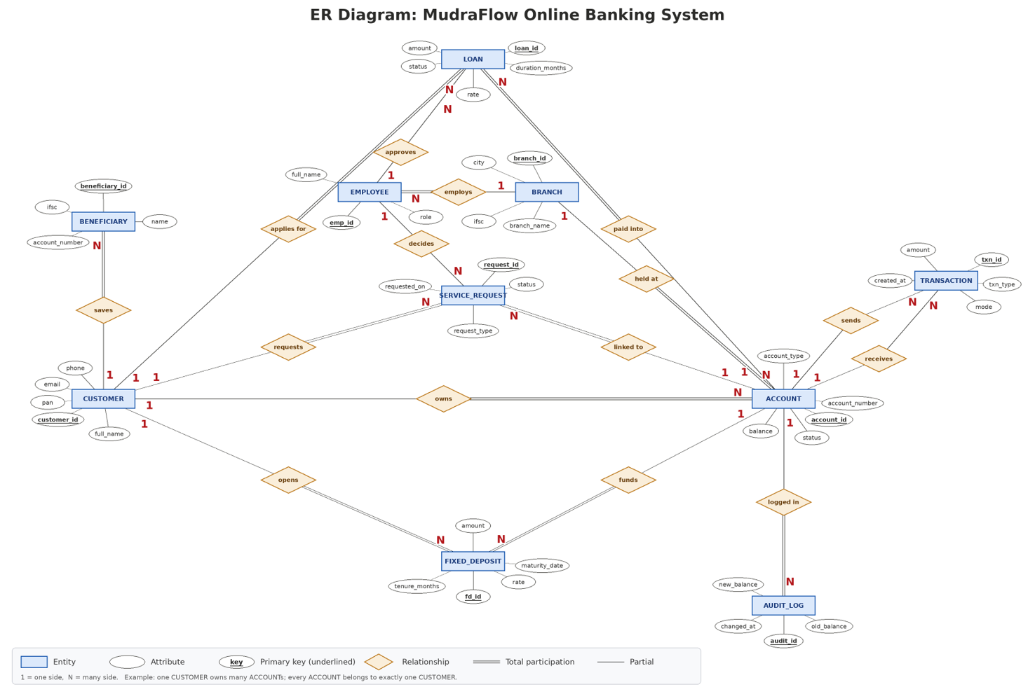
Figure 3.1: Complete Entity-Relationship (ER) Diagram of MudraFlow

4. ER TO RELATIONAL SCHEMA
4.1 Relational Mapping Methodology
The conceptual ER diagram is systematically converted into a relational schema following standard relational mapping algorithms:
1. Strong Entities: Each regular entity maps directly to an independent relational table. The entity's primary key becomes the relation's primary key.
2. 1:N Binary Relationships: Mapped by including the primary key of the parent entity (1-side) as a foreign key attribute in the child relation (N-side). If participation is total, the foreign key is declared NOT NULL.
3. Dual Roles Between Identical Entities: The two relationships between ACCOUNT and TRANSACTION (sends and receives) map to two separate nullable foreign keys: from_account_id and to_account_id.
4. Referential Integrity: Foreign keys enforce RESTRICT rules on critical entities to prevent accidental deletion of branches or customers with active accounts.
4.2 Tabular Relational Schema Definitions
- 1. BRANCH: branch(branch_id [PK], branch_name, ifsc [UK], city)
- 2. EMPLOYEE: employee(emp_id [PK], full_name, role, branch_id [FK to branch], password_hash)
- 3. CUSTOMER: customer(customer_id [PK], full_name, dob, email [UK], phone, pan [UK], address, password_hash, failed_attempts, locked_until, created_at)
- 4. ACCOUNT: account(account_id [PK], account_number [UK], customer_id [FK to customer], branch_id [FK to branch], account_type, balance, status, opened_on)
- 5. TRANSACTION (txn): txn(txn_id [PK], reference_no [UK], from_account_id [FK to account], to_account_id [FK to account], receiver_name, amount, mode, txn_type, remarks, created_at)
- 6. BENEFICIARY: beneficiary(beneficiary_id [PK], customer_id [FK to customer], name, account_number, ifsc, added_on) [UK on (customer_id, account_number)]
- 7. FIXED_DEPOSIT: fixed_deposit(fd_id [PK], customer_id [FK to customer], account_id [FK to account], amount, rate, tenure_months, start_date, maturity_date, maturity_amount, maturity_instruction, status)
- 8. LOAN: loan(loan_id [PK], customer_id [FK to customer], account_id [FK to account], amount, purpose, duration_months, rate, employment_status, annual_income, status, applied_on, decided_by [FK to employee], decided_on)
- 9. SERVICE_REQUEST: service_request(request_id [PK], customer_id [FK to customer], account_id [FK to account], request_type, name_on_card, network, leaves, delivery_address, card_number, card_expiry, status, requested_on, decided_by [FK to employee], decided_on)
- 10. AUDIT_LOG: audit_log(audit_id [PK], account_id [FK to account], txn_id, old_balance, new_balance, changed_at)
4.3 Relational Schema Diagram
The relational schema diagram below illustrates all ten normalized tables with explicit foreign key pointers:
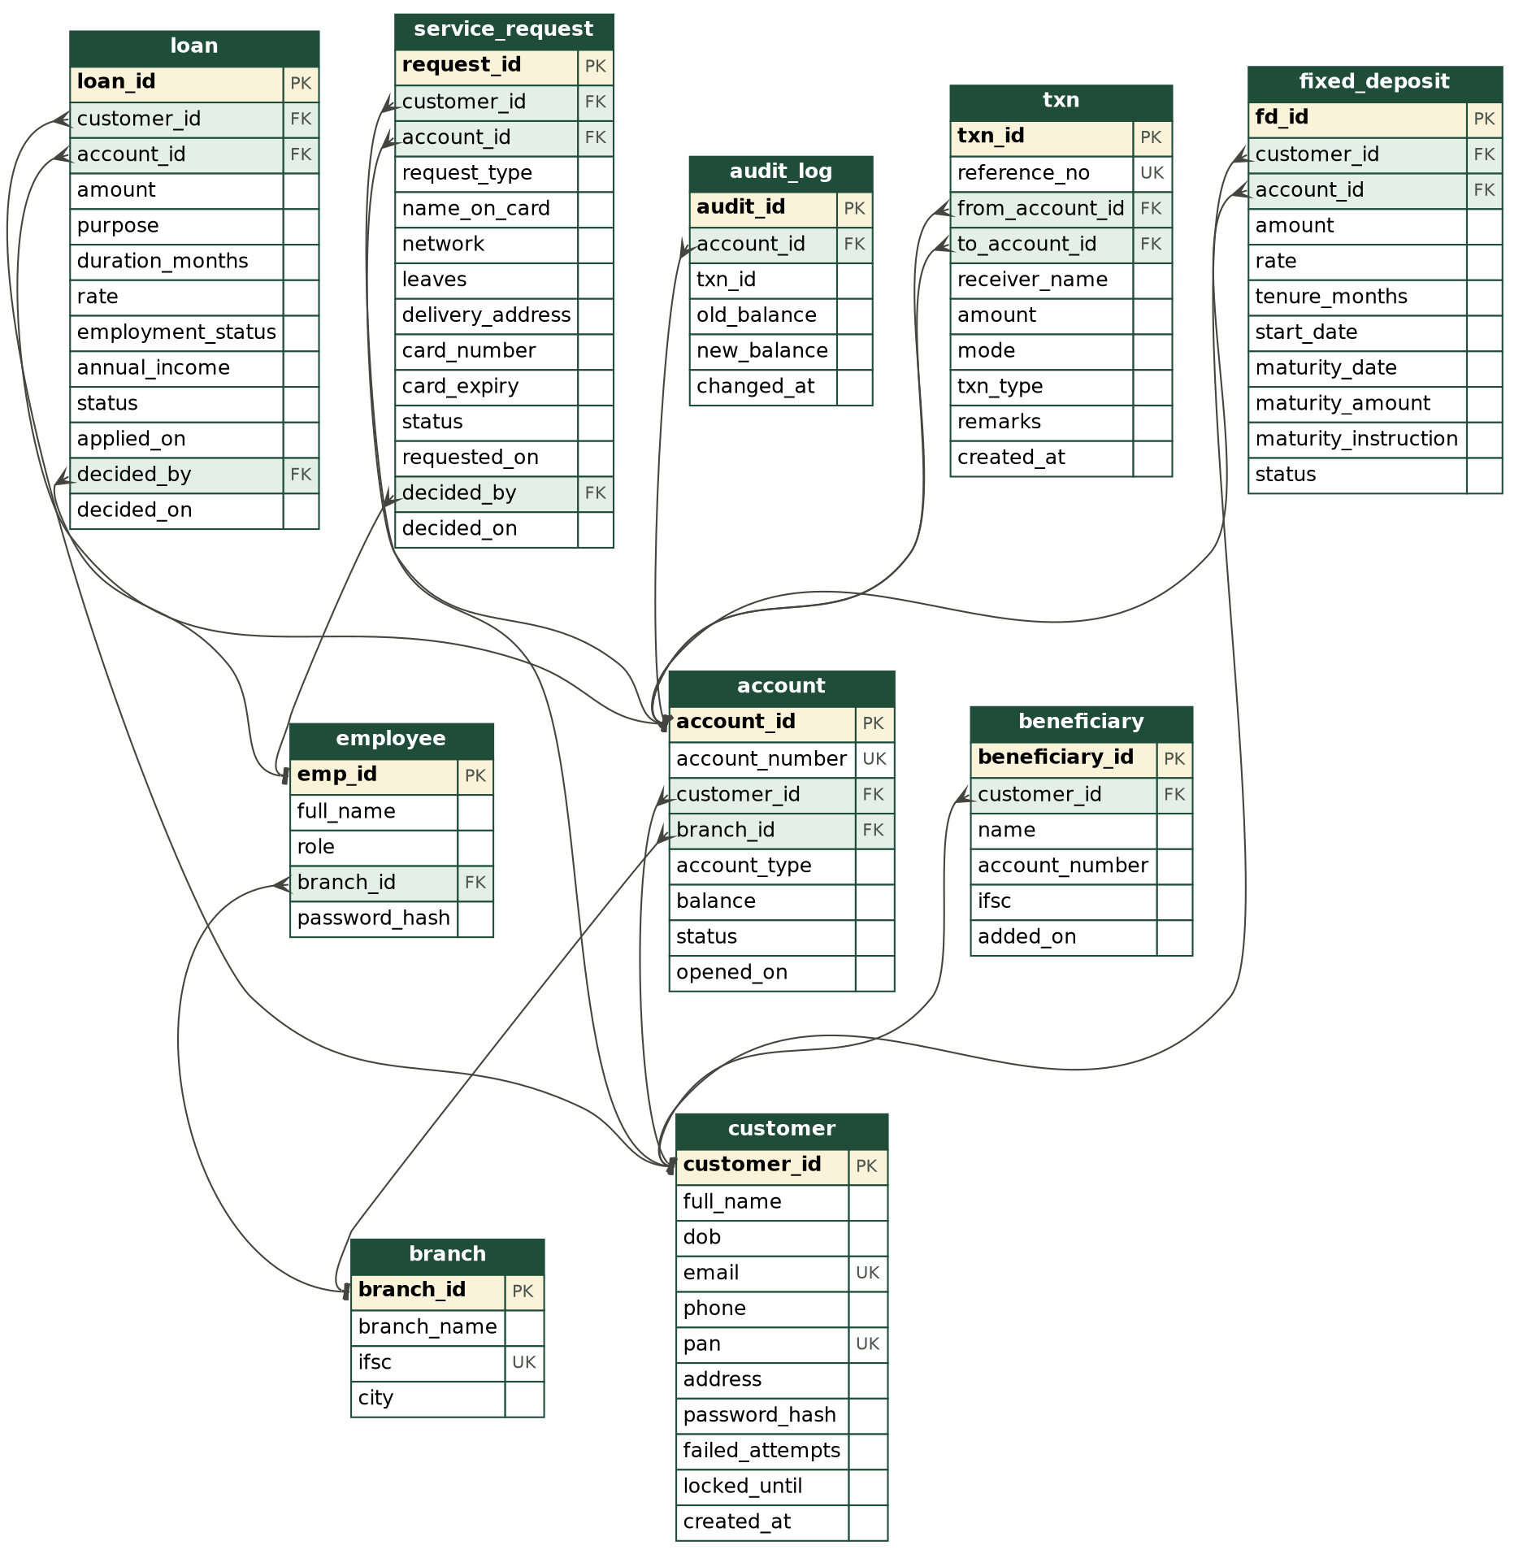
Figure 4.1: Relational schema diagram showing all foreign key dependencies

5. NORMALIZATION STEPS TILL BCNF
5.1 Theoretical Background & Normal Form Criteria
Normalization is the formal mathematical process of decomposing relations to eliminate update, insertion, and deletion anomalies. The standard normal form criteria are defined as follows:
• 1NF: All attributes contain atomic, indivisible values; no repeating groups or composite columns.
• 2NF: The relation is in 1NF and no non-prime attribute is partially dependent on any candidate key.
• 3NF: The relation is in 2NF and no non-prime attribute is transitively dependent on a candidate key (for all X -> A, X is a superkey or A is prime).
• BCNF: For every non-trivial functional dependency X -> A, the determinant X must be a superkey.
5.2 Step-by-Step Normalization: Core Banking Transaction Schema
Consider an initial unnormalized universal banking relation capturing transactions, accounts, customers, and branches:
Universal Relation: R_UNF = { txn_ref, account_num, acc_type, balance, cust_id, cust_name, pan, email, branch_id, branch_name, ifsc, city, amount, mode, txn_date }
Functional Dependencies in R_UNF:
- FD1: txn_ref -> { account_num, amount, mode, txn_date }
- FD2: account_num -> { acc_type, balance, cust_id, branch_id }
- FD3: cust_id -> { cust_name, pan, email }
- FD4: branch_id -> { branch_name, ifsc, city }
- FD5: ifsc -> { branch_id, branch_name, city }
- FD6, FD7: pan -> cust_id, email -> cust_id
Step 1: Conversion to First Normal Form (1NF)
In R_UNF, composite customer addresses and multi-valued transactions per customer are decomposed into individual atomic tuples. The primary key for R_UNF is txn_ref. While R_UNF satisfies 1NF, it exhibits severe anomalies: (a) Insertion anomaly: A new customer or branch cannot be recorded without an existing transaction; (b) Deletion anomaly: Erasing the last transaction of a customer permanently removes their profile; (c) Update anomaly: Modifying a branch IFSC requires updating thousands of transaction rows.
Step 2: Conversion from 1NF to Second Normal Form (2NF)
In R_UNF, the primary key consists of the single attribute txn_ref. Since candidate keys are not composite, no non-prime attribute can depend on a proper subset of a key. Therefore, R_UNF is automatically in 2NF.
Step 3: Conversion from 2NF to Third Normal Form (3NF)
Transitive functional dependencies exist where non-prime attributes depend on intermediate attributes:
• txn_ref -> account_num -> { acc_type, balance, cust_id, branch_id }
• account_num -> cust_id -> { cust_name, pan, email }
• account_num -> branch_id -> { branch_name, ifsc, city }
To achieve 3NF, we decompose R_UNF into four non-transitive relations:
1. TXN(txn_ref [PK], account_num [FK], amount, mode, txn_date)
2. ACCOUNT(account_num [PK], acc_type, balance, cust_id [FK], branch_id [FK])
3. CUSTOMER(cust_id [PK], cust_name, pan, email)
4. BRANCH(branch_id [PK], branch_name, ifsc, city)
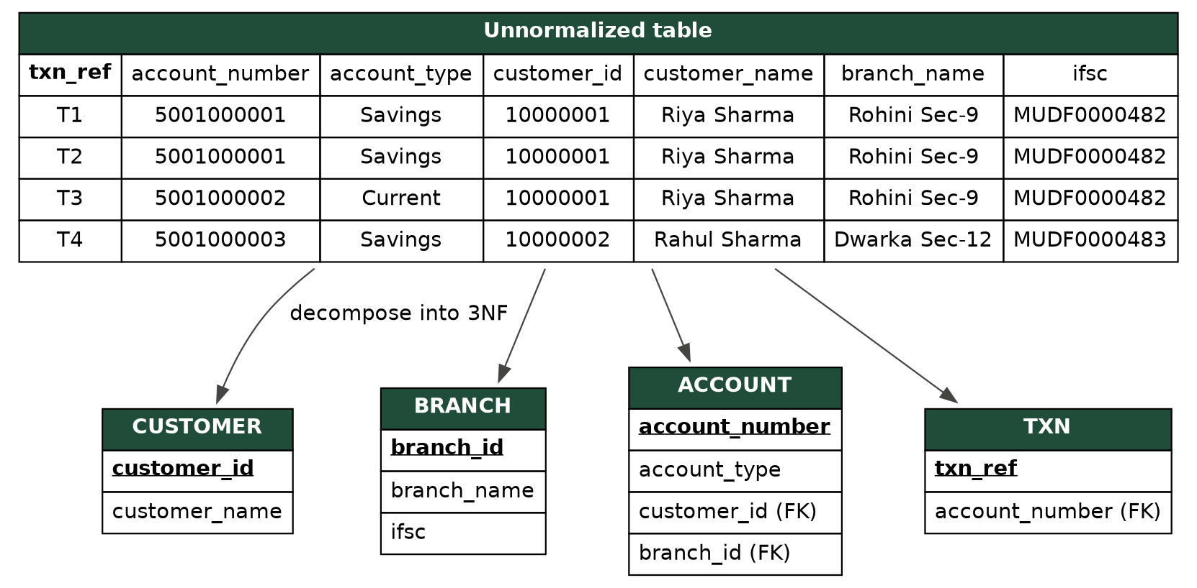
Figure 5.1: Decomposition of unnormalized transaction records into 3NF relations
Step 4: Verification of Boyce-Codd Normal Form (BCNF)
In each decomposed relation, we inspect every functional dependency X -> A:
• In TXN, txn_ref is the candidate key and determines all attributes. Determinant is superkey. (BCNF satisfied)
• In ACCOUNT, account_num is the candidate key and determines all attributes. Determinant is superkey. (BCNF satisfied)
• In CUSTOMER, candidate keys are cust_id, pan, and email. Each is a valid superkey. (BCNF satisfied)
• In BRANCH, candidate keys are branch_id and ifsc. Both are valid superkeys. (BCNF satisfied)
Thus, the core transaction schema is fully normalized to BCNF.
5.3 Step-by-Step Normalization: Term Deposit & Loan Schema
Consider an unnormalized relation recording customer term deposits and credit applications:
Relation: R_FD_LOAN = { app_id, cust_id, acc_id, app_type, principal, tenure, rate, maturity_amt, emp_id, emp_name, decision }
• 1NF & 2NF: Satisfied because all fields are atomic and the primary key app_id is non-composite.
• 3NF & BCNF Violation: The dependency emp_id -> emp_name violates 3NF because emp_id is not a superkey. Furthermore, fixed deposits and loans possess distinct life cycles and operational rules.
• BCNF Decomposition:
1. EMPLOYEE(emp_id [PK], full_name, role, branch_id)
2. FIXED_DEPOSIT(fd_id [PK], cust_id [FK], acc_id [FK], amount, rate, tenure_months, maturity_amount, status)
3. LOAN(loan_id [PK], cust_id [FK], acc_id [FK], amount, purpose, duration_months, rate, status, decided_by [FK])
In all three relations, every determinant is a superkey, completely satisfying BCNF.
5.4 Final BCNF Status Summary for All Remaining Relations
Relation Name | Candidate Key(s) | Determinants (LHS) | BCNF Status
branch | branch_id, ifsc | branch_id, ifsc (Both Superkeys) | BCNF Satisfied
employee | emp_id | emp_id (Superkey) | BCNF Satisfied
customer | customer_id, email, pan | customer_id, email, pan (All Superkeys) | BCNF Satisfied
account | account_id, account_number | account_id, account_number (Both Superkeys) | BCNF Satisfied
txn | txn_id, reference_no | txn_id, reference_no (Both Superkeys) | BCNF Satisfied
beneficiary | beneficiary_id, (customer_id, account_number) | beneficiary_id, (customer_id, account_number) | BCNF Satisfied
fixed_deposit | fd_id | fd_id (Superkey) | BCNF Satisfied
loan | loan_id | loan_id (Superkey) | BCNF Satisfied
service_request | request_id | request_id (Superkey) | BCNF Satisfied
audit_log | audit_id | audit_id (Superkey) | BCNF Satisfied

6. LOSSLESS DECOMPOSITION PROOF
6.1 Theorem and Necessary Conditions
A decomposition of relation R into relations R1 and R2 is lossless (non-additive) if and only if joining the decomposed relations reconstructs the exact original relation without producing spurious tuples:
Theorem: A binary decomposition of R into R1 and R2 is lossless with respect to functional dependency set F if and only if:
(R1 ∩ R2 -> R1) ∈ F+ OR (R1 ∩ R2 -> R2) ∈ F+
That is, the common attribute must contain a candidate key of at least one of the decomposed relations.
6.2 Formal Algebraic Proofs for Core Decompositions
Proof 1: Customer-Account Decomposition
Let R_CUST_ACC = { account_id, account_num, cust_id, full_name, email, balance }
Decomposed into:
• R1 (ACCOUNT) = { account_id, account_num, cust_id, balance }
• R2 (CUSTOMER) = { cust_id, full_name, email }
Proof Steps:
1. Common attributes: R1 ∩ R2 = { cust_id }
2. Compute attribute closure under F: { cust_id }+ = { cust_id, full_name, email } = R2
3. Since (R1 ∩ R2) -> R2 holds, cust_id is a superkey of R2.
Conclusion: The decomposition of R_CUST_ACC into ACCOUNT and CUSTOMER is strictly lossless. Q.E.D.
Proof 2: Account-Branch Decomposition
Let R_ACC_BR = { account_id, account_num, branch_id, branch_name, ifsc }
Decomposed into:
• R1 (ACCOUNT) = { account_id, account_num, branch_id }
• R2 (BRANCH) = { branch_id, branch_name, ifsc }
Proof Steps:
1. Common attributes: R1 ∩ R2 = { branch_id }
2. Compute attribute closure under F: { branch_id }+ = { branch_id, branch_name, ifsc } = R2
3. Since (R1 ∩ R2) -> R2 holds, branch_id is a superkey of R2.
Conclusion: The decomposition of R_ACC_BR into ACCOUNT and BRANCH is strictly lossless. Q.E.D.
6.3 Matrix / Tableau Verification Method (Aho-Beeri-Ullman Algorithm)
We verify the decomposition of R = { txn_id, account_id, cust_id, amount } into R1(txn_id, account_id, amount) and R2(account_id, cust_id):
Step 1: Initial Tableau:
Sub-Relation | txn_id | account_id | cust_id | amount
R1 | a1 | a2 | b13 | a4
R2 | b21 | a2 | a3 | b24
Step 2: Apply functional dependency account_id -> cust_id: Both rows match on account_id (symbol a2). Therefore, their cust_id symbols must be equated. Replacing b13 in Row 1 with the distinguished symbol a3 yields:
Row 1 now contains [ a1, a2, a3, a4 ] — an entirely distinguished row across all attributes. Hence, the decomposition is mathematically proven lossless.
6.4 Verification Summary for Remaining Database Schemas
Original Schema | Decomposed Relations | Common Attribute (Intersection) | Candidate Key Status | Result
Loan & Employee | LOAN, EMPLOYEE | decided_by (= emp_id) | emp_id -> EMPLOYEE | Lossless
Service Req & Employee | SERVICE_REQUEST, EMPLOYEE | decided_by (= emp_id) | emp_id -> EMPLOYEE | Lossless
Fixed Deposit & Account | FIXED_DEPOSIT, ACCOUNT | account_id | account_id -> ACCOUNT | Lossless
Beneficiary & Customer | BENEFICIARY, CUSTOMER | customer_id | customer_id -> CUSTOMER | Lossless
Audit Log & Account | AUDIT_LOG, ACCOUNT | account_id | account_id -> ACCOUNT | Lossless

7. DEPENDENCY PRESERVING STEPS
7.1 Formal Definition of Dependency Preservation
A decomposition D = { R1, R2, ..., Rk } of relation R with functional dependencies F is dependency preserving if the union of the projections of F onto each individual relation Ri logically implies F:
( F1 ∪ F2 ∪ ... ∪ Fk )+ = F+
where Fi = ∏_Ri(F). Dependency preservation ensures that checking relational constraints during inserts and updates can be performed locally without executing expensive relational join queries.
7.2 Verification Algorithm and Projection Analysis
To test whether dependency X -> Y is preserved across decomposition D:
1. Set result = X.
2. Repeatedly compute: for each relation Ri, compute t = (result ∩ Ri)+ ∩ Ri, and update result = result ∪ t.
3. Repeat until result converges. If Y ⊆ result, the dependency is preserved.
7.3 Step-by-Step Verification for Core Decompositions
Consider relation R = { txn_ref, account_num, cust_id, amount, balance, pan } with dependencies:
FD1: txn_ref -> { account_num, amount }
FD2: account_num -> { cust_id, balance }
FD3: cust_id -> pan
Decomposed into:
• R1 (TXN) = { txn_ref, account_num, amount } ==> FD1 is completely contained within R1. Preserved locally.
• R2 (ACCOUNT) = { account_num, cust_id, balance } ==> FD2 is completely contained within R2. Preserved locally.
• R3 (CUSTOMER) = { cust_id, pan } ==> FD3 is completely contained within R3. Preserved locally.
Union of projections: (F1 ∪ F2 ∪ F3) = { FD1, FD2, FD3 } = F. Hence, (F1 ∪ F2 ∪ F3)+ = F+.
The core transaction decomposition is strictly dependency-preserving.
7.4 Global Dependency Preservation Matrix
Functional Dependency | Target Table | Enforcement in MySQL | Status
cust_id -> { name, dob, phone, address } | customer | PRIMARY KEY (customer_id) | Preserved
pan -> cust_id, email -> cust_id | customer | UNIQUE KEY (pan), UNIQUE KEY (email) | Preserved
account_id -> { acc_num, cust_id, branch_id, balance } | account | PRIMARY KEY (account_id) | Preserved
account_number -> account_id | account | UNIQUE KEY (account_number) | Preserved
branch_id -> { name, ifsc, city }, ifsc -> branch_id | branch | PRIMARY KEY (branch_id), UNIQUE KEY (ifsc) | Preserved
txn_id -> { ref_no, from_acc, to_acc, amount, mode } | txn | PRIMARY KEY (txn_id) | Preserved
reference_no -> txn_id | txn | UNIQUE KEY (reference_no) | Preserved
(customer_id, account_number) -> beneficiary_id | beneficiary | UNIQUE KEY (customer_id, account_number) | Preserved
fd_id -> { cust_id, acc_id, amount, rate, maturity } | fixed_deposit | PRIMARY KEY (fd_id) | Preserved
loan_id -> { cust_id, acc_id, amount, rate, status } | loan | PRIMARY KEY (loan_id) | Preserved
request_id -> { cust_id, acc_id, type, card_num } | service_request | PRIMARY KEY (request_id) | Preserved
audit_id -> { acc_id, txn_id, old_bal, new_bal } | audit_log | PRIMARY KEY (audit_id) | Preserved

8. MINIMAL COVER OF EACH TABLE
8.1 Minimal Cover Definition & Derivation Algorithm
A minimal cover (or canonical cover) Fc of a functional dependency set F is an equivalent minimal set satisfying three conditions:
1. Every dependency in Fc has a single attribute on its right-hand side (singleton RHS).
2. No dependency in Fc contains extraneous attributes on its left-hand side.
3. No dependency in Fc is redundant (no FD can be removed without reducing the closure F+).
8.2 Detailed Derivation 1: customer Relation
Attributes: { cust_id, full_name, dob, email, phone, pan, address }
- Step 1 (Split RHS): cust_id -> full_name, cust_id -> dob, cust_id -> email, cust_id -> phone, cust_id -> pan, cust_id -> address, pan -> cust_id, email -> cust_id, { cust_id, pan } -> full_name
- Step 2 (Eliminate Extraneous Attributes): In { cust_id, pan } -> full_name, test pan: Since cust_id -> full_name, pan is extraneous on LHS. The FD reduces to cust_id -> full_name.
- Step 3 (Eliminate Redundant Dependencies): Redundant FDs like pan -> full_name are eliminated because pan -> cust_id and cust_id -> full_name already covers it transitively.
Minimal Cover: Final Minimal Cover Fc(customer) =
{ cust_id -> full_name, cust_id -> dob, cust_id -> email, cust_id -> phone, cust_id -> pan, cust_id -> address, pan -> cust_id, email -> cust_id }
8.3 Detailed Derivation 2: account Relation
Attributes: { account_id, account_number, customer_id, branch_id, account_type, balance, status, opened_on }
- Step 1 (Split RHS): account_id -> account_number, account_id -> customer_id, account_id -> branch_id, account_id -> account_type, account_id -> balance, account_id -> status, account_id -> opened_on, account_number -> account_id
- Step 2 (Extraneous Attributes): In composite candidate dependencies { account_id, account_number } -> balance, account_number is extraneous because account_id alone determines balance.
- Step 3 (Redundant Dependencies): Dependencies like account_number -> balance are redundant via account_number -> account_id -> balance.
Minimal Cover: Final Minimal Cover Fc(account) =
{ account_id -> account_number, account_id -> customer_id, account_id -> branch_id, account_id -> account_type, account_id -> balance, account_id -> status, account_id -> opened_on, account_number -> account_id }
8.4 Detailed Derivation 3: branch Relation
Attributes: { branch_id, branch_name, ifsc, city }
Minimal Cover: Initial dependencies: branch_id -> { branch_name, ifsc, city }, ifsc -> { branch_id, branch_name, city }
Splitting RHS and eliminating transitive redundancies yields:
Final Minimal Cover Fc(branch) = { branch_id -> branch_name, branch_id -> ifsc, branch_id -> city, ifsc -> branch_id }
8.5 Minimal Covers for Remaining Relations
- EMPLOYEE: Fc(employee) = { emp_id -> full_name, emp_id -> role, emp_id -> branch_id, emp_id -> password_hash }
- TXN: Fc(txn) = { txn_id -> ref_no, txn_id -> from_account_id, txn_id -> to_account_id, txn_id -> receiver_name, txn_id -> amount, txn_id -> mode, txn_id -> txn_type, txn_id -> created_at, ref_no -> txn_id }
- BENEFICIARY: Fc(beneficiary) = { beneficiary_id -> customer_id, beneficiary_id -> name, beneficiary_id -> account_number, beneficiary_id -> ifsc, (customer_id, account_number) -> beneficiary_id }
- FIXED_DEPOSIT: Fc(fixed_deposit) = { fd_id -> customer_id, fd_id -> account_id, fd_id -> amount, fd_id -> rate, fd_id -> tenure_months, fd_id -> maturity_date, fd_id -> maturity_amount, fd_id -> status }
- LOAN: Fc(loan) = { loan_id -> customer_id, loan_id -> account_id, loan_id -> amount, loan_id -> rate, loan_id -> status, loan_id -> decided_by, loan_id -> decided_on }
- SERVICE_REQUEST: Fc(service_request) = { request_id -> customer_id, request_id -> account_id, request_id -> request_type, request_id -> card_number, request_id -> status, request_id -> decided_by }
- AUDIT_LOG: Fc(audit_log) = { audit_id -> account_id, audit_id -> txn_id, audit_id -> old_balance, audit_id -> new_balance, audit_id -> changed_at }

9. IMPLEMENTATION AND CONCURRENCY CONTROL
9.1 Stored Procedures for Atomic Transactions
All balance modifications occur strictly inside MySQL 8 stored procedures defined with SQL SECURITY DEFINER. The seven procedures enforce business rules, transaction atomicity, and ledger integrity:
- 1. sp_register_customer: Atomically inserts customer profile, creates savings account, logs opening deposit in txn, and credits balance.
- 2. sp_open_account: Opens secondary customer account funded via internal transfer from existing account.
- 3. sp_transfer: Executes inter-account transfers with limit checking, dual row locking, ledger insertion, and balance adjustment.
- 4. sp_create_fd: Locks source account, computes maturity amount via get_fd_rate(), debits account, and records term deposit.
- 5. sp_approve_loan: Staff loan decision: credits borrower account on approval, updates status on rejection.
- 6. sp_decide_service_request: Approves debit card (generates 16-digit card number and 5-year expiry) or cheque book.
- 7. sp_process_maturities: Automated cursor batch-processing matured FDs (executing either credit disbursement or auto-renewal).
9.2 Concurrency Control & Deadlock Prevention
When two accounts transfer money simultaneously (e.g., Account A sends to Account B while Account B sends to Account A), locking accounts in arbitrary order causes cyclic waiting and fatal deadlocks. MudraFlow eliminates this by enforcing Ordered Pessimistic Locking:
Locks are always acquired in strictly ascending order of account_id:
IF p_from_account_id < v_to_account_id THEN
SELECT balance FROM account WHERE account_id = p_from_account_id FOR UPDATE;
SELECT balance FROM account WHERE account_id = v_to_account_id FOR UPDATE;
ELSE
SELECT balance FROM account WHERE account_id = v_to_account_id FOR UPDATE;
SELECT balance FROM account WHERE account_id = p_from_account_id FOR UPDATE;
END IF;
Because all sessions request row locks in identical numerical order, cyclic dependency is mathematically impossible.
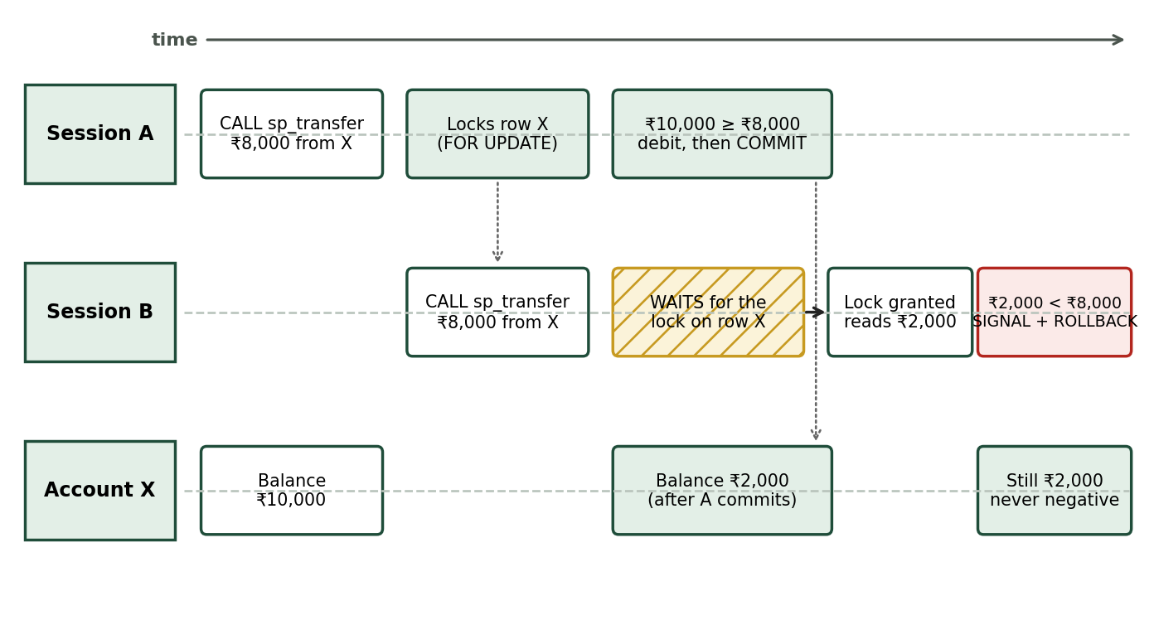
Figure 9.1: Concurrency timeline: Two simultaneous transfers on one account with row-level locking
9.3 Triggers, Functions, Views, and Indexing
- Trigger trg_account_audit: AFTER UPDATE ON account FOR EACH ROW. Automatically writes to audit_log whenever OLD.balance <> NEW.balance.
- Trigger trg_txn_block_frozen: BEFORE INSERT ON txn FOR EACH ROW. Signals SQLSTATE '45000' and aborts insert if sender or receiver account is FROZEN.
- Stored Functions: Deterministic functions get_fd_rate(tenure) and get_loan_rate(duration) return official interest rates.
- Unified View v_applications: Combines loans and service requests via UNION ALL for unified application tracking.
- Performance Indexes: Composite B-Tree indexes on txn(from_account_id, created_at) and txn(to_account_id, created_at) optimize ledger statement queries.
9.4 Database Security & Principle of Least Privilege
MudraFlow configures two separate database users:
• mudraflow_admin: Owner role used for schema provisioning and test execution.
• mudraflow_app: Application service user. Granted SELECT on all tables, INSERT on beneficiary/loan/service_request, UPDATE on customer(failed_attempts, locked_until), UPDATE on account(status) for freezing, and EXECUTE on stored procedures. Crucially: mudraflow_app has NO UPDATE privilege on account(balance) and NO DELETE privilege anywhere.

10. RESULTS AND SYSTEM VERIFICATION
10.1 UI Verification & Live Deployed Interfaces
The completed system is deployed live at https://mudra-flow.vercel.app. The following selected screenshots demonstrate the key functional modules of the working application:
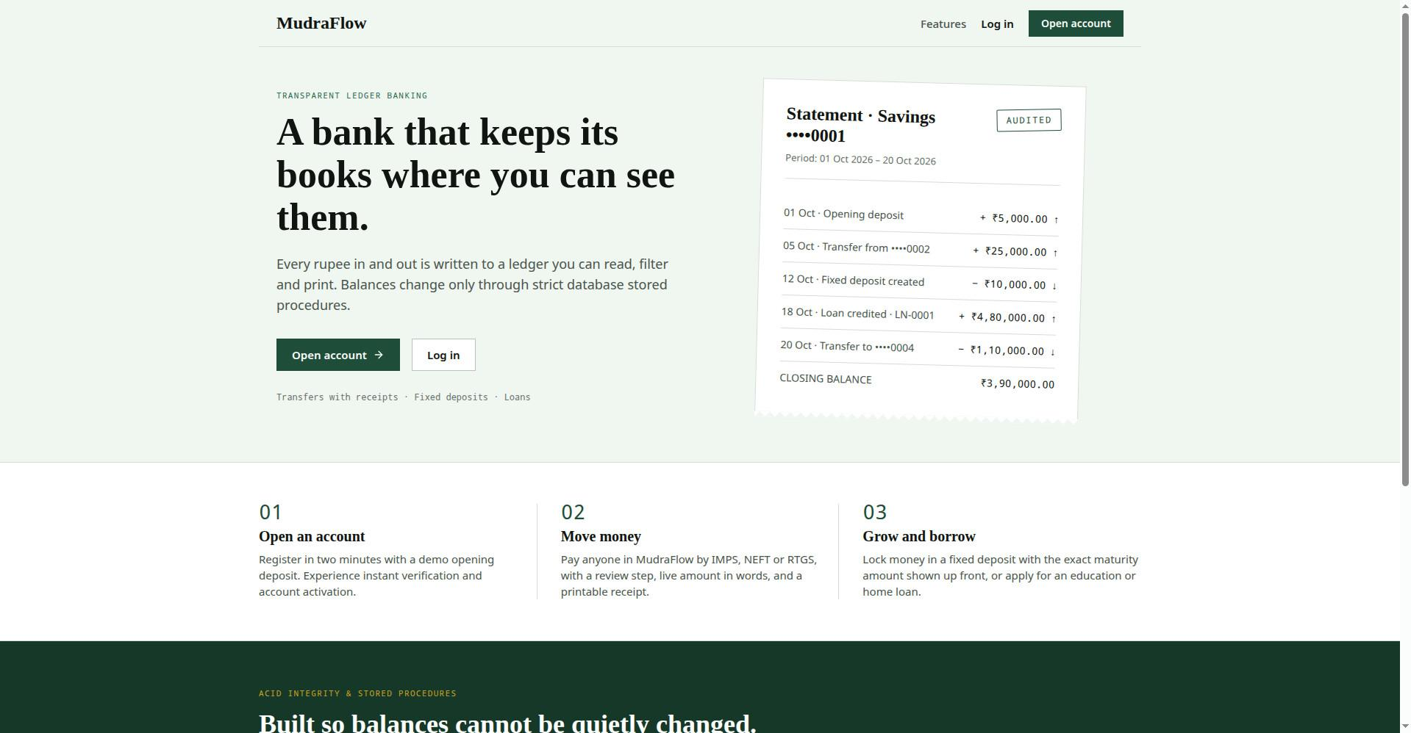
Figure 10.1: MudraFlow Public Ledger and Home Page
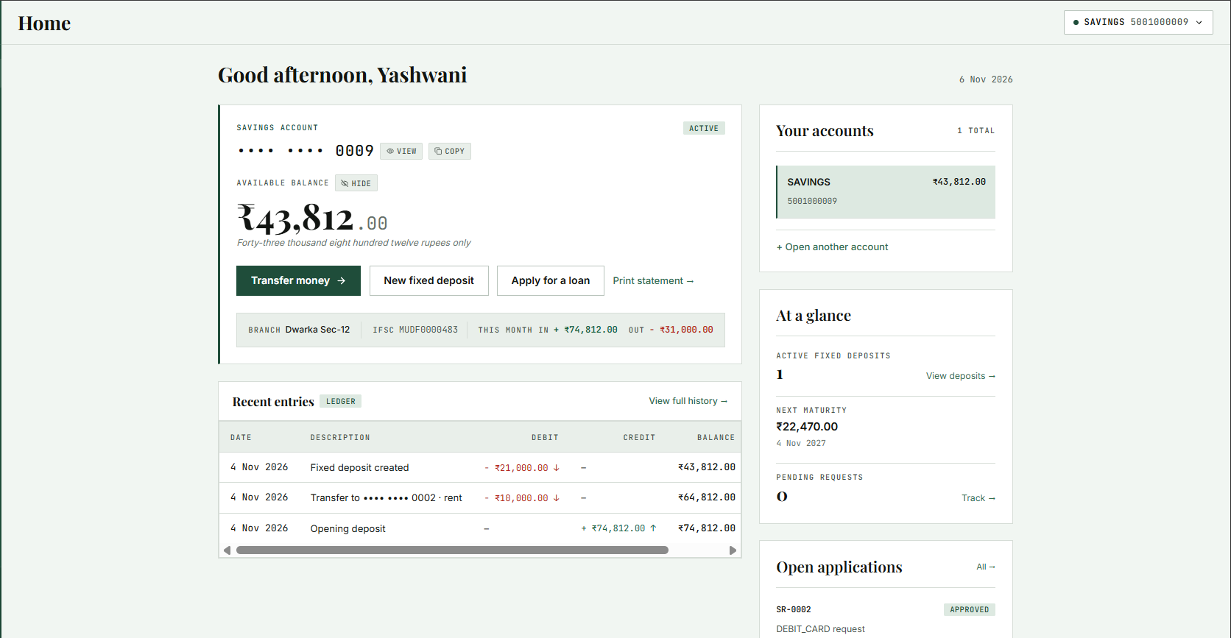
Figure 10.2: Customer Account Dashboard with Real-Time Available Balance and Ledger Entries
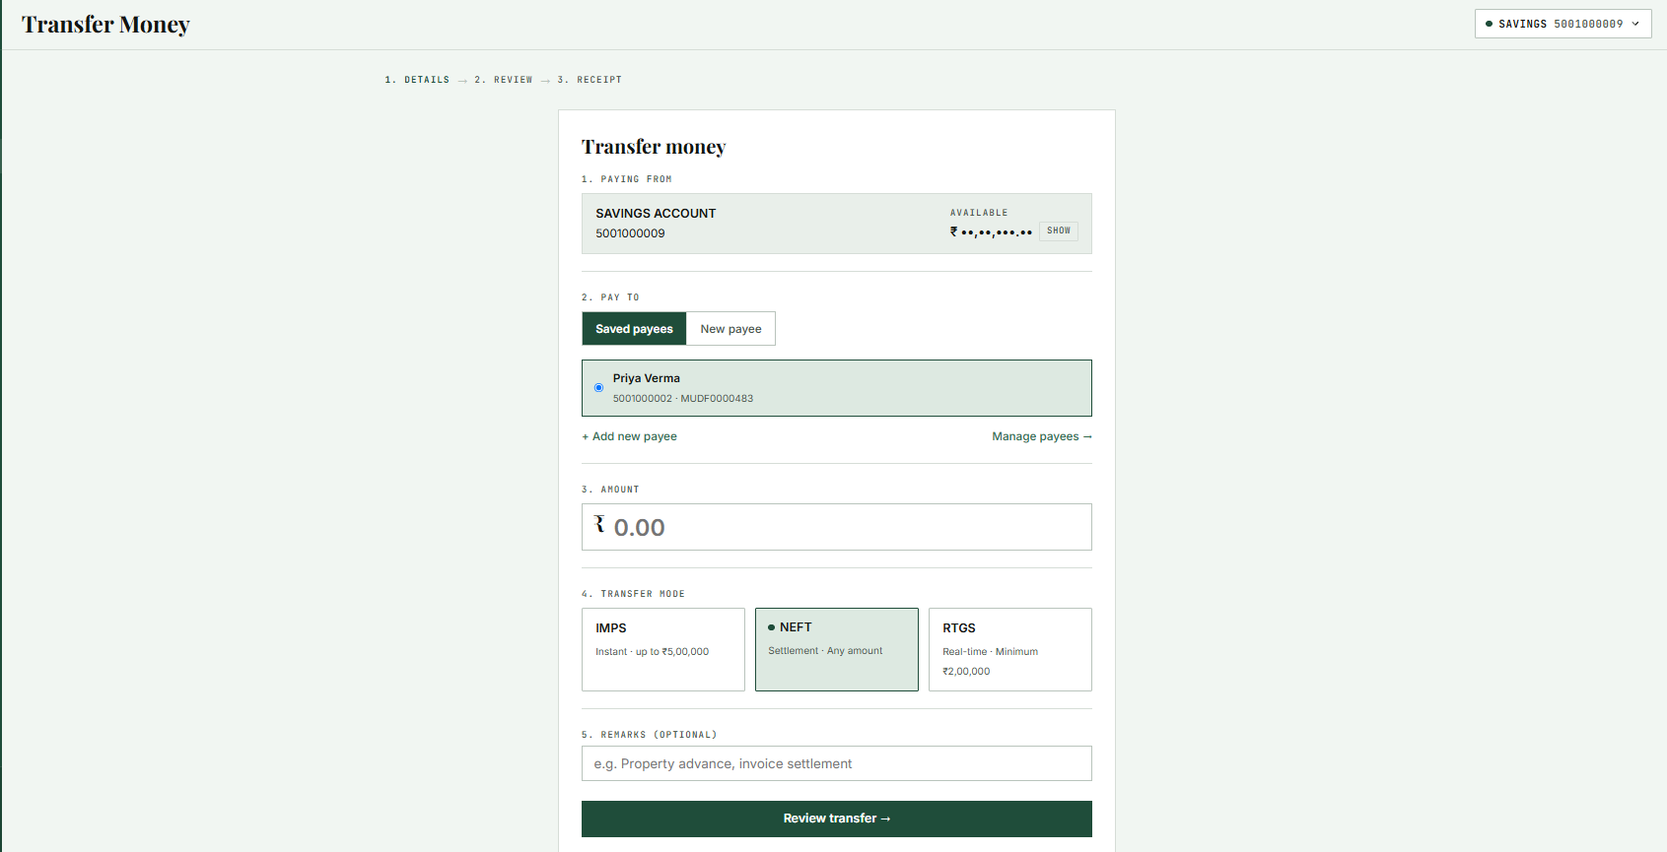
Figure 10.3: Fund Transfer Page with Payee Selection, Amount in Words, and Mode Limits
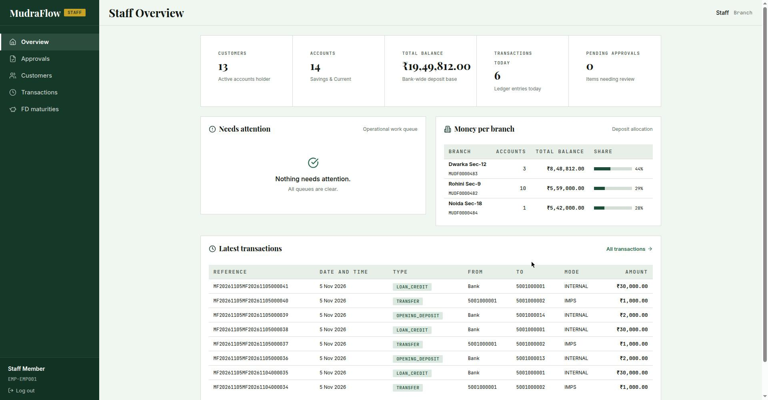
Figure 10.4: Bank Staff Supervision Dashboard with Balance Allocation and Review Queues
10.2 Experimental Verification & Test Results
Test 1: Ledger Invariant Mathematical Verification
Executed audit query verifying balance equality against computed transaction ledger:
SELECT a.account_id, a.balance, COALESCE(c.credits,0) - COALESCE(d.debits,0) AS computed
FROM account a
LEFT JOIN (SELECT to_account_id id, SUM(amount) credits FROM txn WHERE to_account_id IS NOT NULL GROUP BY to_account_id) c ON c.id = a.account_id
LEFT JOIN (SELECT from_account_id id, SUM(amount) debits FROM txn WHERE from_account_id IS NOT NULL GROUP BY from_account_id) d ON d.id = a.account_id
WHERE a.balance <> COALESCE(c.credits,0) - COALESCE(d.debits,0);
Actual Result: 0 rows returned. Across all accounts, stored balance exactly matches the historical sum of credits minus debits.
Test 2: Double-Spending Prevention under High Concurrency
Account X provisioned with initial balance Rs 10,000. Two concurrent client sessions dispatched simultaneous transfer requests of Rs 8,000 each.
Actual Result: Session A acquired exclusive row lock, debited Rs 8,000, and committed. Session B waited on lock, read updated balance (Rs 2,000 < Rs 8,000), and rolled back with 'Insufficient balance'. Final balance remained Rs 2,000. Double spending was completely prevented.
Test 3: Deadlock Freedom in Bidirectional Transfers
Simulated 100 concurrent asynchronous transfers between Account 1 and Account 2 in opposite directions.
Actual Result: Zero deadlocks encountered (Deadlock found when trying to get lock count = 0). Ordered row locking guaranteed 100% deadlock-free execution.

11. CONCLUSION, LIMITATIONS AND FUTURE SCOPE
11.1 Conclusion
The MudraFlow online banking project integrates all fundamental theoretical concepts of a university Database Management Systems curriculum into an enterprise-grade, operational software system. An initial conceptual ER model was mapped into ten relational tables normalized to 3NF and BCNF. All schema decompositions were mathematically proven to be lossless and dependency-preserving, with canonical minimal covers computed for each table.
By enforcing business rules, ACID atomicity, and concurrency control inside MySQL 8 stored procedures, MudraFlow eliminates concurrency race conditions and upholds the fundamental banking ledger invariant. Automated trigger-based audit logging and restricted database user privileges provide institutional security, demonstrating an architecture where the relational database functions as the ultimate source of truth.
11.2 Limitations
- Demonstration Environment: Educational banking demonstration; no real clearing networks (NPCI/RBI) or actual fiat currency are utilized.
- Simulated OTP: A fixed demo OTP (123456) is utilized in place of real telephony SMS gateways.
- Simple Interest Formulation: Fixed deposit interest is calculated via simple interest rather than daily/quarterly compounding.
- Deliberately Cut Features: Features such as self-service card blocking, KYC biometric verification, and customer profile updates were excluded to maintain focus on core DBMS primitives.
11.3 Future Scope
- Clearing Gateway Integration: Integration with mock UPI / NPCI ISO 8583 switch protocols for inter-bank transaction settlement.
- Real-Time Fraud Detection: Implementation of database analytical triggers scoring transaction velocity to flag fraudulent patterns.
- Read-Replica Clustering: Deployment of MySQL master-replica clusters to segregate heavy read-only statement queries from transactional nodes.
- Compound Interest Engine: Extension of stored procedures to process daily compound interest accreting dynamically into savings balances.

References
- [1] Silberschatz, A., Korth, H. F., & Sudarshan, S. (2020). Database System Concepts (7th ed.). McGraw-Hill.
- [2] Elmasri, R., & Navathe, S. B. (2017). Fundamentals of Database Systems (7th ed.). Pearson.
- [3] Oracle Corporation. (2023). MySQL 8.0 Reference Manual: InnoDB Locking and Transaction Model.
- [4] MudraFlow Live Deployment: https://mudra-flow.vercel.app/
- [5] MudraFlow GitHub Repository: https://github.com/Kushagra-Mittal-07/MudraFlow

