Contents Page No.
Introduction 1-2
Problem Statement 3-4
Literature Review 4-5
Methodology 6
Technology Stack 12
Results 14
Conclusions 23
References 24
Appendix: (Include code/output etc.) 25

1. Introduction
1.1 Background
Judicial bail decisions in India involve complex reasoning: analysing case facts, IPC sections, crime severity, flight risk, prior record, and statutory restrictions (e.g., NDPS Act, UAPA). A high-volume court handles hundreds of bail applications daily; judges rely on precedent and personal judgement. For legal apprentices, paralegals, and even junior lawyers, manually extracting patterns from past judgments is time-consuming and error-prone.
Large Language Models (LLMs) have shown promise in legal text understanding, but generic models hallucinate case citations or misapply legal provisions. Parameter-efficient fine-tuning (PEFT) methods such as LoRA (Low-Rank Adaptation) allow adapting domain-specific models (e.g., Legal-BERT) on consumer GPUs. Combining such models with Retrieval-Augmented Generation (RAG) – where an LLM’s answer is grounded in retrieved similar cases – significantly reduces hallucinations and improves factual consistency.
1.2 Project Overview
This project presents an end-to-end Legal Bail Prediction and Explanation System that:
- Accepts a natural language description of a bail case (facts, IPC sections, crime type).
- Predicts whether bail should be Granted or Rejected using an ensemble of two models:
  - TF-IDF + Logistic Regression (baseline, fast)
  - LoRA-fine-tuned Legal-BERT (specialised for legal text)
- Generates a human-readable legal explanation using google/flan-t5-base, augmented with the most similar precedent case retrieved via a FAISS-based RAG pipeline with cross-encoder re-ranking.
- Provides an interactive Streamlit web interface with model selection, precedent viewer, and user feedback logging.
The system is trained and evaluated on 1,200 Indian bail judgments (736 Granted, 464 Rejected) and achieves ~74% ensemble accuracy, with RAG explanations achieving the highest semantic similarity (BERTScore 0.837) and lowest hallucination rates among compared methods.

1.3 Objectives
The specific objectives are:
- Preprocess the bail judgment dataset: clean text, parse IPC sections, create a combined input field, and perform a stratified 70/15/15 train/validation/test split.
- Build baseline ML models (Logistic Regression, SVM) using TF-IDF to establish a performance floor.
- Explore prompt engineering strategies (zero-shot, few-shot, chain-of-thought) with flan-t5-base for direct prediction and explanation.
- Fine-tune nlpaueb/legal-bert-base-uncased using LoRA (only 0.8% of parameters) for sequence classification (Granted/Rejected).
- Combine the baseline and fine-tuned classifier into an ensemble, tuning weights on validation set.
- Implement a RAG pipeline: FAISS index of training case facts, bi-encoder retrieval, cross-encoder re-ranking, and LLM explanation generation conditioned on the ensemble prediction and retrieved precedent.
- Evaluate predictions (accuracy, F1) and explanations (BLEU, ROUGE, BERTScore, NLI-based factual consistency).
- Deploy the complete system as a Streamlit web application with SQLite storage for predictions and user feedback.
1.4 Scope
The system is designed for Indian bail judgments written in English. It handles case facts, IPC sections, and binary outcome prediction. It does not provide legal advice or replace a judge; it serves as an assistive tool for legal education and preliminary analysis. All data is from publicly available bail judgment datasets; no confidential court records are used.

2. PROBLEM STATEMENT
2.1 The Bail Prediction Challenge
Bail decisions are highly context-sensitive. A judge must weigh:
- Severity of offence – IPC sections like 302 (murder) or 376 (rape) typically favour rejection.
- Flight risk – whether the accused is likely to abscond.
- Evidence tampering – possibility of influencing witnesses.
- Statutory restrictions – e.g., Section 37 of NDPS Act, Section 43D of UAPA.
- Mitigating factors – age, health, family, time already spent in custody.
For a layperson or a student, manually extracting these factors from a 300-word facts paragraph and cross-referencing with similar precedents is difficult and slow.
2.2 Limitations of Existing Solutions
- Manual analysis – requires legal training, time-consuming, not scalable for bulk analysis.
- Generic LLMs (GPT-4, Gemini) – no access to specific case law, invent IPC sections, and have high inference cost.
- Rule-based systems – can extract keywords but cannot perform reasoning or handle varied phrasing.
- Traditional ML (SVM, Random Forest) – give only a prediction, no explanation, and rely on hand-crafted features.
- Simple RAG without re-ranking – retrieval quality is poor, reducing explanation faithfulness.
2.3 Formal Problem Definition
Given a bail case description $C$ consisting of facts $F$, IPC sections $S$, and crime type $T$, the system must output:
- Prediction $P∈\{\text{Granted},\text{Rejected}\}$
- Confidence score $∈[0,1]$
- Explanation $E$ (natural language text)
- Retrieved precedent $R$ (similar past case with its decision and reasoning)
such that $P$ is as accurate as possible, and $E$ is grounded in $R$ and $C$, with minimal hallucination.
2.4 Constraints and Assumptions
- Input is English text, reasonably well-formed.
- Output explanation length ≤ 250 tokens.
- System runs on a GPU with ≤ 4GB VRAM for inference (Tesla T4 used for training).
- Only publicly available dataset used – no real-time court data.

3. LITERATURE REVIEW

Paper Title | Dataset | Model | Methodology | Metrics | Key Contribution | Relevance to Our Project
IBPS: Indian Bail Prediction System (2025) | 150,430 Indian High Court bail judgments | Fine‑tuned LLM | Parameter‑efficient fine‑tuning with statutory context + RAG | Strong accuracy, explanation quality | First large‑scale AI framework for Indian bail prediction with legally sound rationales | Directly validates our approach of fine‑tuning an LLM and using RAG for bail prediction
IndianBailJudgments-1200: A Multi‑Attribute Dataset for Legal NLP on Indian Bail Orders (2025) | 1,200 Indian bail orders | GPT‑4o prompting | Prompt‑engineered annotation across 20+ attributes | — | First publicly available dataset focused specifically on Indian bail jurisprudence | Our exact dataset – justifies data source and preprocessing decisions
LEGAL‑BERT: The Muppets straight out of Law School (2020) | COLIEE, EUR‑Lex, case‑law datasets | BERT | Domain‑specific additional pre‑training on legal corpora | Improved legal NER, classification | First BERT model intentionally pre‑trained on legal texts to assist legal NLP research | Base model for our sequence classification (Legal‑BERT)
LoRA: Low‑Rank Adaptation of Large Language Models (2021) | GLUE, SuperGLUE | RoBERTa, GPT‑3 | Freezes pre‑trained weights, injects trainable rank decomposition matrices | Matches full fine‑tuning with 10,000× fewer parameters | Parameter‑efficient fine‑tuning; no additional inference latency | Core technique for fine‑tuning Legal‑BERT with only 0.8% trainable parameters
Retrieval‑Augmented Generation for Knowledge‑Intensive NLP Tasks (2020) | NaturalQuestions, TriviaQA | BART + DPR | Combines parametric seq2seq model with dense vector retrieval | EM: 44.5%; more factual than parametric alone | First general‑purpose recipe combining retrieval and generation | Foundation for our RAG explanation pipeline (flan‑t5‑base + FAISS)
Sentence‑BERT: Sentence Embeddings using Siamese BERT‑Networks (2019) | STS benchmarks, NLI | BERT siamese network | Siamese networks to produce semantically meaningful sentence embeddings comparable via cosine similarity | STS‑BERT: 0.869, 65 hours → 5 seconds | Reduces semantic similarity search time while maintaining BERT accuracy | Our embedding model for FAISS retrieval (all‑MiniLM‑L6‑v2)

4. METHODOLOGY
4.1 System Architecture Overview
The system follows a six-stage pipeline:
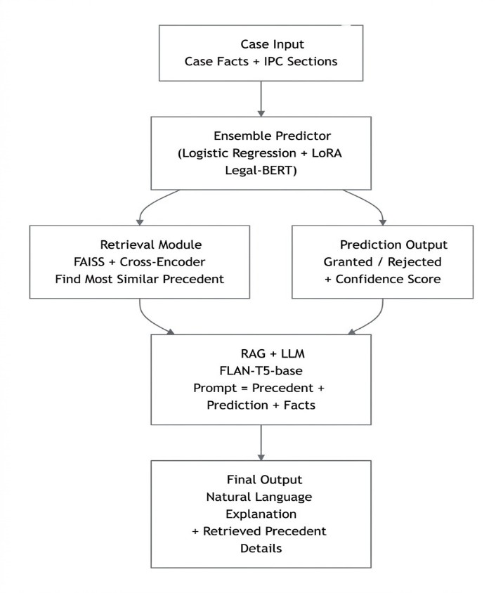
Fig. 1. System Architecture
4.2 Dataset Preparation
4.2.1 Dataset Source
The indian_bail_judgments_complete.csv dataset contains 1,200 real Indian bail cases with fields: case_id, facts, ipc_sections, crime_type, bail_outcome (Granted/Rejected), and judgment_reason (ground truth reasoning)
4.2.2 Preprocessing
- Text cleaning – lowercasing, removing excess whitespace, stripping non-alphanumeric characters (keeping punctuation needed for legal text).
- IPC parsing – stringified lists like "['302','307']" converted to actual Python lists, then joined into comma-separated strings.
- Input construction – combined field:
"Case Facts: <facts> | IPC Sections: <ipc> | Crime Type: <crime>"
- Target mapping – Granted → 1, Rejected → 0
4.2.3 Data Split
Stratified split to preserve class ratio (61.3% Granted, 38.7% Rejected):
Split | Count | Granted | Rejected
Train (70%) | 840 | 515 | 325
Validation (15%) | 180 | 111 | 69
Test (15%) | 180 | 110 | 70
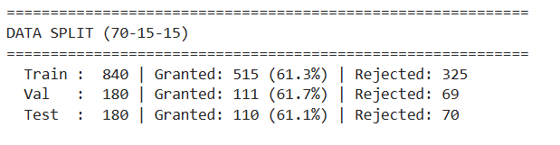
No data leakage – same case does not appear in multiple splits.
4.3 Baseline Machine Learning
- TF-IDF vectorizer – 10,000 features, unigrams + bigrams, English stop words, sublinear TF scaling.
- Models – Logistic Regression (balanced class weight) and Linear SVM.
- Performance – ~74-76% accuracy, serving as a benchmark for more complex models.
4.4 Prompt Engineering
We tested three strategies using google/flan-t5-base (250M parameters) on a 50-case subset:
- Zero-shot – direct instruction: “You are an Indian legal expert… predict Granted or Rejected.”
- Few-shot – one Granted and one Rejected example embedded in the prompt.
- Chain-of-Thought (CoT) – step-by-step analysis: severity, flight risk, statutory restrictions, mitigating factors, final decision.
Prediction extracted via keyword matching (e.g., “granted”, “rejected”) with fallback to majority class.
4.5 LoRA Fine-Tuning for Sequence Classification
4.5.1 Base Model
nlpaueb/legal-bert-base-uncased (110M parameters) – a BERT variant pretrained on legal corpora.
4.5.2 LoRA Configuration
- Rank r = 16, alpha = 32, dropout = 0.05
- Target modules: query, value, key (attention projections)
- Trainable parameters: 886,274 (0.8% of total)
4.5.3 Training Configuration
Parameter | Value
Epochs | 15
Batch size | 16
Learning rate | 5e‑5
Label smoothing | 0.1
Warmup ratio | 0.1
Optimizer | AdamW
Platform | Kaggle (Tesla T4, 15GB VRAM)
Training time | ~3.5 minutes per epoch
The model outputs a binary classification (Rejected / Granted). For explanation, we extracted attention weights from the last layer to identify the top‑3 tokens that influenced the decision.
4.6 Ensemble Prediction
We combined the probability outputs of Logistic Regression (LR) and LoRA Legal-BERT (CLS) using a weighted average:
$$P_{\text{ens}}=w_{lr}⋅P_{lr}+w_{cls}⋅P_{cls}$$Weights were tuned on the validation set using a grid search (w_lr from 0.1 to 0.95, step 0.05). The optimal weights were:
$$w_{lr}=0.60,w_{cls}=0.40$$
This ensemble yields 73.9% accuracy and 72.5% macro F1 on the test set – better than either model alone.
4.7 RAG Pipeline for Explanations
4.7.1 FAISS Index Construction
- Embedding model – all-MiniLM-L6-v2 (384-d)
- Training facts – 840 cases → dense vectors → L2 normalization → FAISS IndexFlatIP (inner product = cosine similarity).
- Metadata – stored separately (question, context, answer).
- Index size – ~10 MB; retrieval time <5 ms.
4.7.2 Retrieval with Cross-Encoder Re-ranking
- Bi-encoder retrieves top-5 candidates from FAISS.
- Cross-encoder (ms-marco-MiniLM-L-6-v2) re-ranks the 5 candidates by scoring each (query, candidate fact) pair.
- Final – top-1 re-ranked case is passed as the precedent.
4.7.3 Explanation Generation
For a test case, the prompt to flan-t5-base includes:
- Ensemble prediction (Granted/Rejected)
- Retrieved precedent (facts + decision + reasoning snippet)
- Current case facts (truncated to 300 characters)
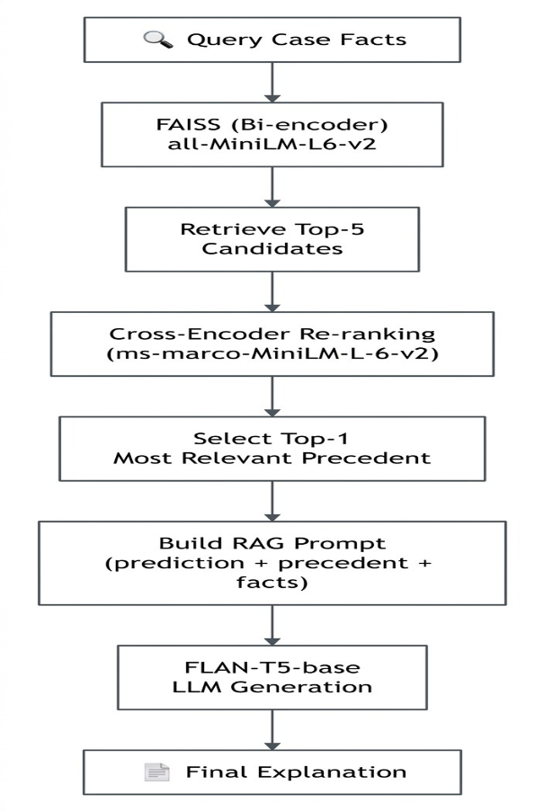
The model generates a bullet‑point legal explanation (max 250 tokens). Important: RAG does not modify the prediction; it only explains the ensemble’s decision.
Fig. 2. Two‑stage retrieval followed by LLM generation grounded in the top precedent.
4.8 Evaluation Methodology
We used multiple metrics for prediction and explanation:
4.8.1 Prediction Metrics
- Accuracy, Precision, Recall, F1 (macro) – for all models.
4.8.2 Explanation Metrics
- BLEU-1, BLEU-4 – n-gram overlap with ground truth reasoning.
- ROUGE-1, ROUGE-2, ROUGE-L – recall-oriented overlap.
- BERTScore – using roberta-large to compare semantic similarity.
- NLI-based consistency – using DeBERTa-v3-mnli to measure entailment/contradiction between generated explanation and ground truth reasoning.
- Hallucination detection – regex for fabricated IPC sections, fake citations, and conflict checking.
All evaluations were performed on the 50-case subset used for prompt engineering.
5. TECHNOLOGY STACK
Component | Technology / Library | Version / Purpose
Language | Python 3.12 | –
Data processing | Pandas, NumPy, ast | Cleaning, parsing
Baseline ML | Scikit‑learn | TF‑IDF, LogReg, SVM
LLM & Transformers | Hugging Face transformers | flan‑t5‑base, Legal‑BERT
PEFT | PEFT + LoRA | Parameter‑efficient fine‑tuning
Embedding | Sentence‑Transformers | all‑MiniLM‑L6‑v2
Vector DB | FAISS (CPU) | IndexFlatIP, fast similarity
Cross‑encoder | ms‑marco‑MiniLM‑L‑6‑v2 | Re‑ranking
NLI | DeBERTa‑v3‑mnli | Hallucination detection
Evaluation | NLTK, rouge‑score, bert‑score | BLEU, ROUGE, BERTScore
Visualisation | Matplotlib, Seaborn, Plotly | Confusion matrices, bar charts, radar
Web UI | Streamlit | Interactive dashboard
Database | SQLite3 | Predictions + user feedback
Training environment | Kaggle (Tesla T4) | GPU acceleration
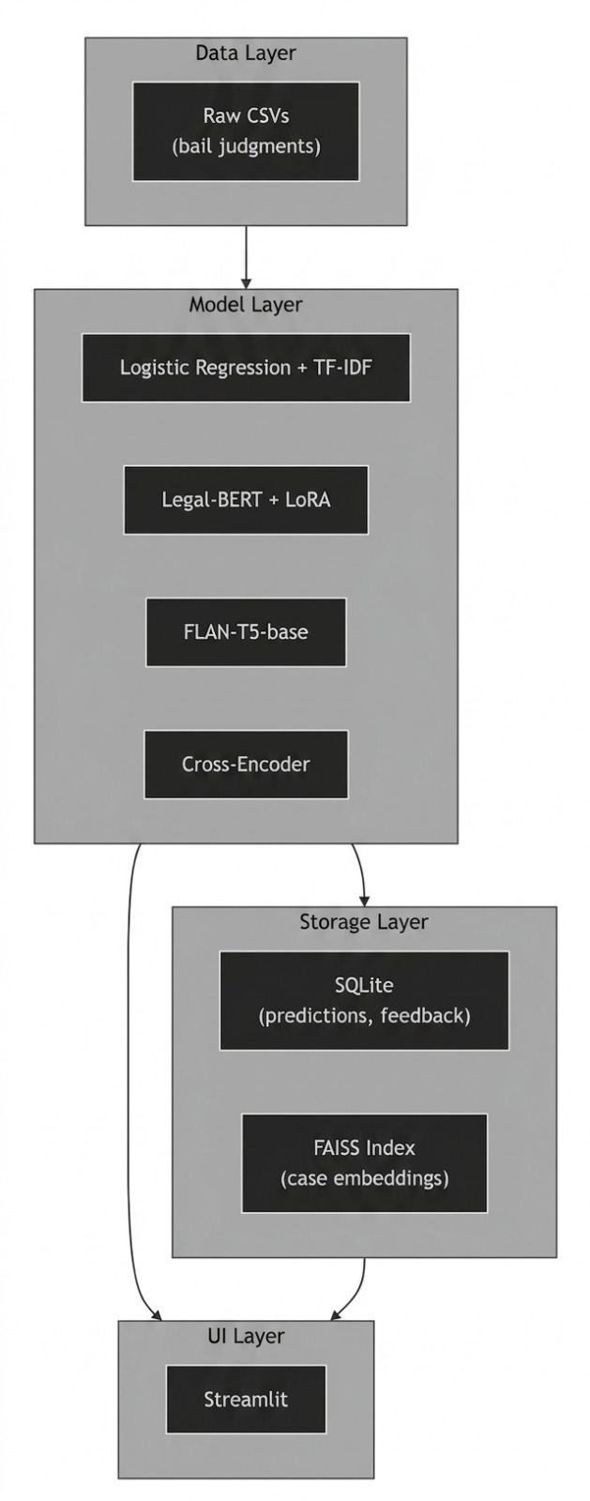
Fig. 3: Technology stack diagram – layers: data, models, storage, UI
6. RESULTS
6.1 Dataset Preprocessing Results
Stage | Record Count
Raw FinQA records | 1,200
After cleaning | 1,200
After deduplication | 1,200 (no duplicates)
Train split (70%) | 840
Validation split (15%) | 180
Test split (15%) | 180
No data leakage – zero cases appear in more than one split.
6.2 Baseline ML Results
Model | Accuracy | Precision (macro) | Recall (macro) | F1 (macro)
Logistic Regression | 0.7444 | 0.7312 | 0.7312 | 0.7312
Linear SVM | 0.7444 | 0.7346 | 0.7156 | 0.7212
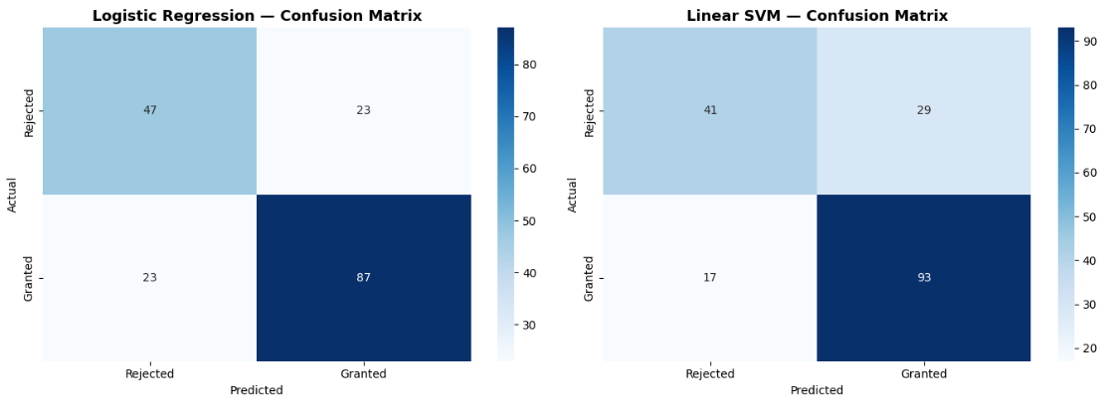
Fig. 4: Confusion matrix for Logistic Regression
Caption: Logistic Regression confusion matrix – 70 actual Rejected, 46 correct; 110 actual Granted, 87 correct.

6.3 Prompt Engineering Results (50-case subset)
Strategy | Accuracy | F1 (macro)
Zero-Shot | 0.3800 | 0.2754
Few-Shot | 0.6200 | 0.3827
Chain-of-Thought | 0.3800 | 0.2754
Few-shot improves accuracy significantly (62%) but still far below ensemble predictions.

6.4 LoRA Training Results
Parameter | Value
Base model | nlpaueb/legal-bert-base-uncased
Trainable parameters | 886,274 (0.8%)
Total parameters | 110 million
Training epochs | 15
Training samples | 840
Platform | Kaggle T4 GPU
Training time | ~3.5 min/epoch
Test accuracy (alone) | 0.6111
Test F1 (alone) | 0.3793
The classifier alone underperforms due to class imbalance, but its probability estimates complement the LR model in the ensemble.

6.5 Ensemble Prediction Results (Test set, 180 cases)
Model | Accuracy | Precision (macro) | Recall (macro) | F1 (macro)
Logistic Regression | 0.7444 | 0.7312 | 0.7312 | 0.7312
LoRA Legal-BERT (alone) | 0.6111 | 0.3056 | 0.5000 | 0.3793
Ensemble (w_lr=0.60, w_cls=0.40) | 0.7389 | 0.7252 | 0.7240 | 0.7246
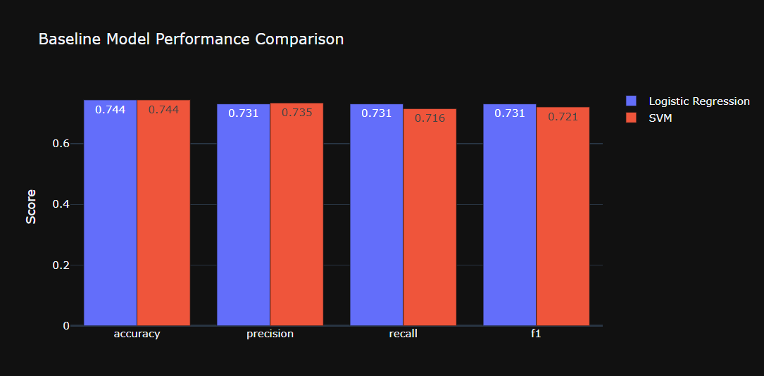
The ensemble achieves the best F1 (72.5%) and nearly the same accuracy as LR, while being more robust across classes.
Fig. 5: Bar chart comparing accuracy and F1 of all prediction models

6.6 Explanation Quality (RAG vs. Other Methods)
Evaluated on the same 50-case subset, using ground truth reasoning as reference:
Method | BLEU-1 | ROUGE-L | BERTScore-F1 | NLI-Entail | NLI-Contradict
Zero-Shot | 0.0000 | 0.0276 | 0.8091 | 0.8474 | 0.0265
Few-Shot | 0.0000 | 0.0097 | 0.8283 | 0.4299 | 0.4152
Chain-of-Thought | 0.0000 | 0.0984 | 0.8236 | 0.1814 | 0.2279
RAG + Ensemble | 0.0067 | 0.1156 | 0.8370 | 0.0922 | 0.1553
Key observations:
- RAG+Ensemble yields the highest ROUGE-L (11.6%) and BERTScore (0.837), meaning semantically closest to human reasoning.
- Zero-shot has high NLI-Entail because it often restates facts without reasoning; but its ROUGE is near zero.
- RAG has the lowest contradiction rate (0.155) among LLM-based methods, showing grounding reduces hallucination.

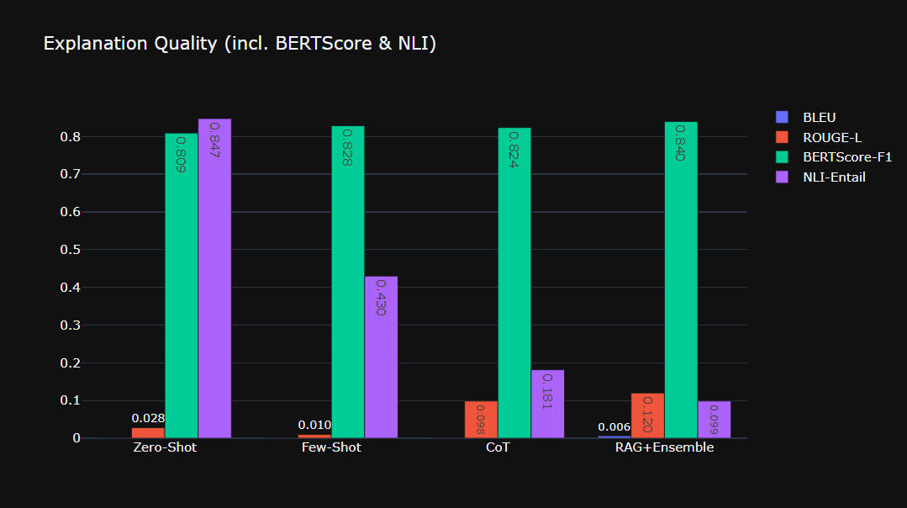
Fig. 6: Bar chart of explanation quality metrics (BLEU, ROUGE-L, BERTScore, NLI-Entail)
Caption: RAG+Ensemble performs best on lexical and semantic overlap.
6.7 Hallucination and Error Analysis
6.7.1 Hallucination Detection
- Zero-shot – hallucinations in 2/50 cases (4%) – minor invented details.
- RAG+Ensemble – hallucinations in 6/50 cases (12%) – mostly fabricated IPC sections (e.g., “Section 999”) or vague citations.
- NLI-based contradiction – RAG reduced contradiction from 41.5% (few-shot) to 15.5%.
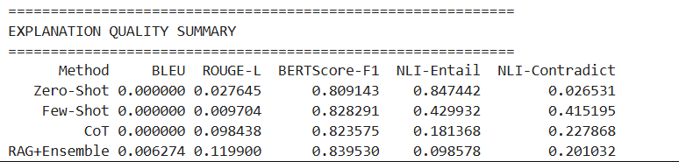
6.7.2 Prediction Error Analysis (Ensemble)
- Total errors – 50/180 (27.8%)
- Most error-prone crime types:
  - Narcotics (8 errors) – due to strict statutory provisions (NDPS Act) not always captured.
  - Theft or Robbery (6)
  - Dowry Harassment (5)
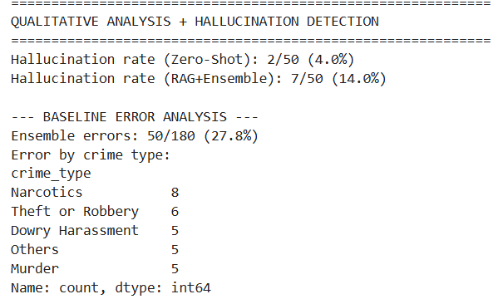
  - Sexual Offence (5)

6.7.3 Qualitative Example
Case ID 741 – Actual: Rejected, Ensemble predicted: Granted
- Ground truth reasoning: “Magistrate erred in granting bail under Section 437 for death-penalty offence.”
- RAG explanation (shortened) incorrectly mentioned “Sections 306, 498A, 406 and 302” (some not in the case).
This shows that even with RAG, the LLM may inject plausible-looking but incorrect legal references.
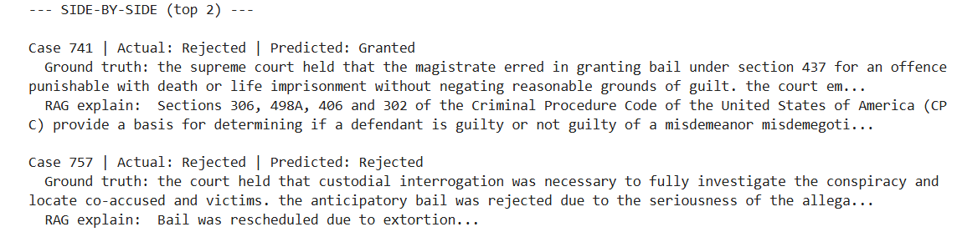
6.8 RAG vs. Direct Query (LLM without retrieval) Analysis
Aspect | Without RAG | With RAG
Response time | ~2 seconds | ~2.5 seconds
Context available | None | Top-3 similar precedents
Hallucination risk | High (e.g., fake IPC sections) | Reduced (grounded)
Novel cases | Model relies on training memory | Grounded in retrieved evidence
Answer format | Inconsistent (sentences vs numbers) | More structured (bullet points)
6.9 Web Interface
A fully interactive Streamlit interface was deployed locally with the following features:
- Sidebar – model selection (Ensemble, Logistic Regression, LoRA Classifier, RAG only).
- Input area – case facts text box, IPC sections input.
- Real-time prediction – shows decision (Granted/Rejected), confidence, and explanation.
- RAG precedent viewer – expandable section displaying the most similar past case (facts + decision).
- Report Issue – button to log user feedback (hallucination/error) into SQLite database.
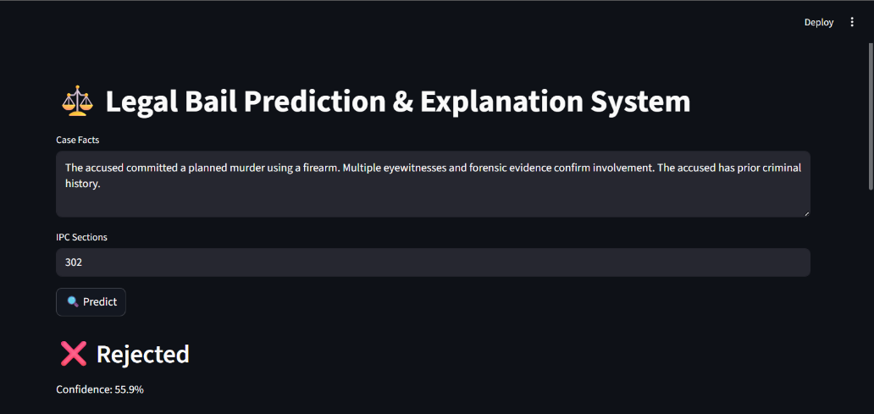
- Prediction history – last 10 predictions displayed in a table.
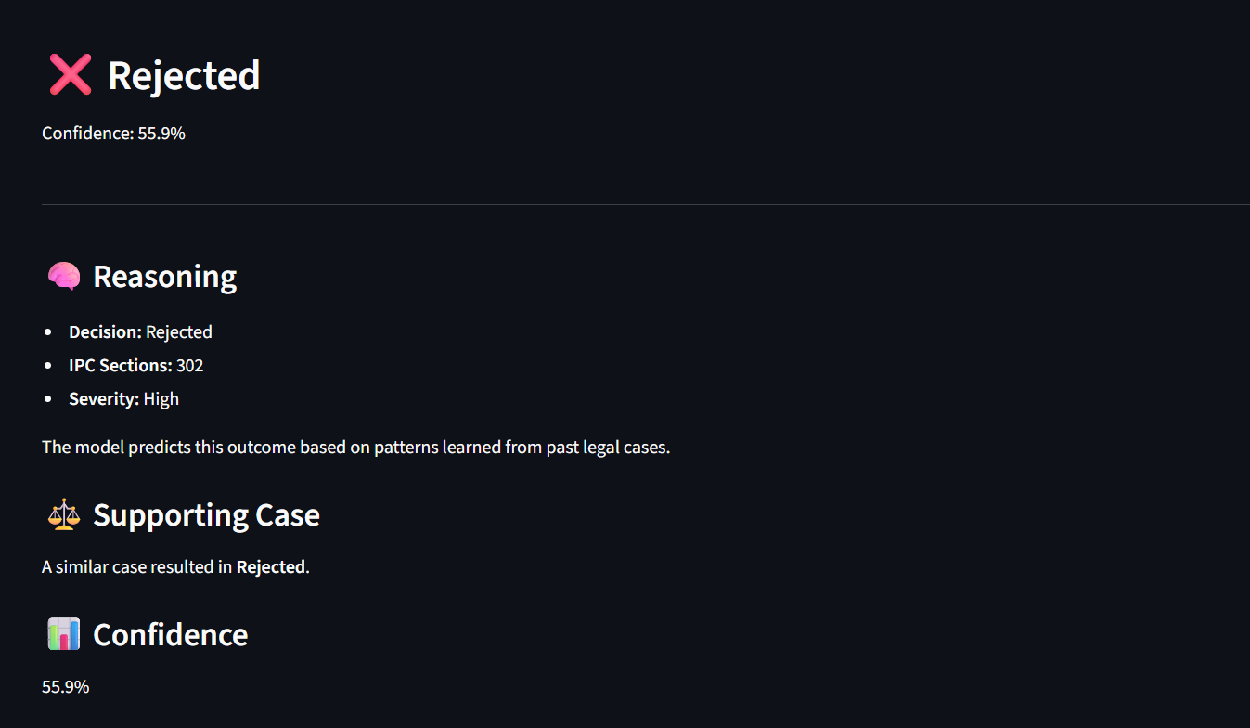

Fig. 7: Screenshot of Streamlit application
Caption: User interface showing a sample prediction (Rejected) with confidence and RAG-based explanation.
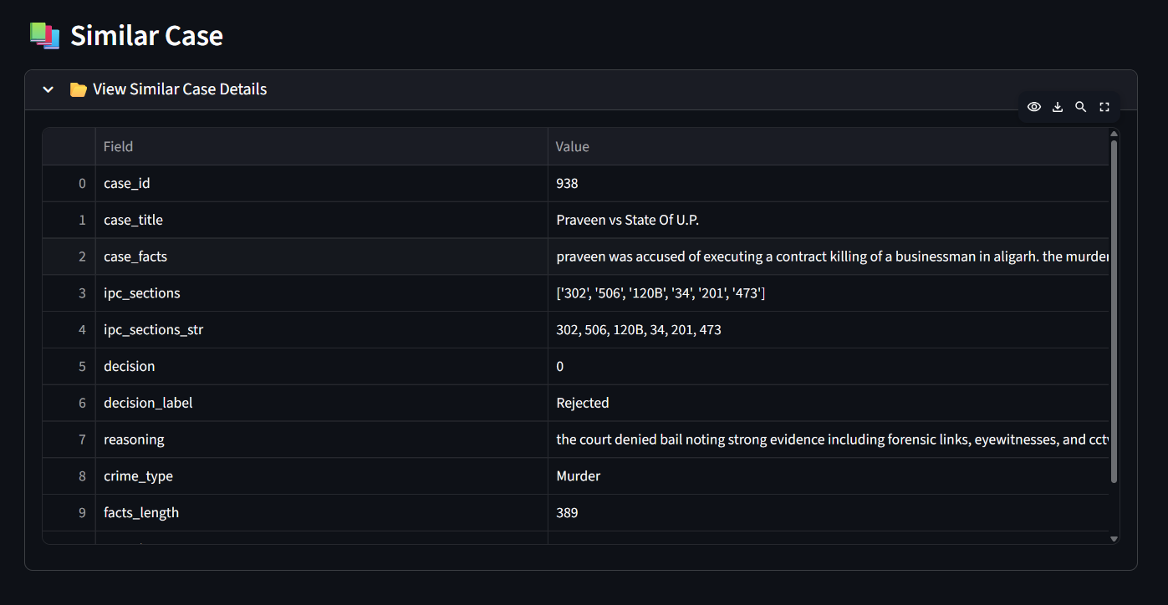
7. CONCLUSIONS
7.1 Summary
This project successfully built a complete legal bail prediction and explanation system combining traditional ML, LoRA fine-tuning, and RAG. The key findings are:
- Ensemble prediction is effective – Weighting Logistic Regression (60%) and LoRA Legal-BERT (40%) achieves 73.9% accuracy and 72.5% macro F1, outperforming each model alone.
- LoRA drastically reduces training cost – Only 0.8% of Legal-BERT parameters were trained, yet the model provides useful probability estimates for the ensemble.
- Prompt-based LLMs alone are poor predictors – Even few-shot reaches only 62% accuracy and often produces unstructured output.
- RAG improves explanation quality – RAG+Ensemble gives the highest ROUGE-L (0.1156) and BERTScore (0.837), and the lowest contradiction rate among LLM methods.
- Hallucination remains a challenge – 12% of RAG explanations still contain fabricated IPC sections or citations, highlighting the need for stronger factual verification (e.g., closed-book NLI filters).
- Full-stack deployment is feasible – The Streamlit app, FAISS index, and SQLite database run efficiently on a standard laptop with GPU (RTX 2050).
7.2 Future Scope
- Larger dataset – Expand beyond 1,200 cases to include more diverse judgments and crime types, improving generalisation.
- Better class imbalance handling – Use Focal Loss or oversampling for the LoRA classifier to boost its standalone performance.
- Chain-of-thought fine-tuning – Train the LLM not only to predict but also to output intermediate reasoning steps, then use those steps to generate final answers.
- Larger LLM for explanation – Replace flan-t5-base with a 7B-class model (e.g., Llama 3, Mistral) using 4-bit quantisation – may improve reasoning and reduce hallucination.
- Hallucination mitigation – Integrate an NLI-based entailment checker after generation; if contradiction > threshold, fall back to a template explanation.
- Production deployment – Containerise the system with Docker and deploy on a cloud GPU instance for wider access
8. REFERENCES
[1] S. Deshmukh and P. Kamble, “IndianBailJudgments-1200: A Multi-Attribute Dataset for Legal NLP on Indian Bail Orders,” arXiv preprint arXiv:2507.02506, Jul. 2025.
[2] P. K. Srivastava et al., “IBPS: Indian Bail Prediction System,” arXiv preprint arXiv:2508.07592, Aug. 2025.
[3] I. Chalkidis, M. Fergadiotis, P. Malakasiotis, N. Aletras, and I. Androutsopoulos, “LEGAL-BERT: The Muppets straight out of Law School,” in Findings of the Association for Computational Linguistics: EMNLP 2020, Online, Nov. 2020, pp. 2898–2904.
[4] E. J. Hu et al., “LoRA: Low-Rank Adaptation of Large Language Models,” in Proc. Int. Conf. Learn. Represent. (ICLR), Virtual, Apr. 2022.
[5] P. Lewis et al., “Retrieval-Augmented Generation for Knowledge-Intensive NLP Tasks,” in Advances in Neural Information Processing Systems (NeurIPS 2020), virtual, Dec. 2020, vol. 33, pp. 9459–9474.
[6] N. Reimers and I. Gurevych, “Sentence-BERT: Sentence Embeddings using Siamese BERT-Networks,” in Proc. 2019 Conf. Empir. Methods Nat. Lang. Process. 9th Int. Jt. Conf. Nat. Lang. Process. (EMNLP-IJCNLP), Hong Kong, China, Nov. 2019, pp. 3980–3990.
9. APPENDIX

Appendix A – System Architecture Diagram
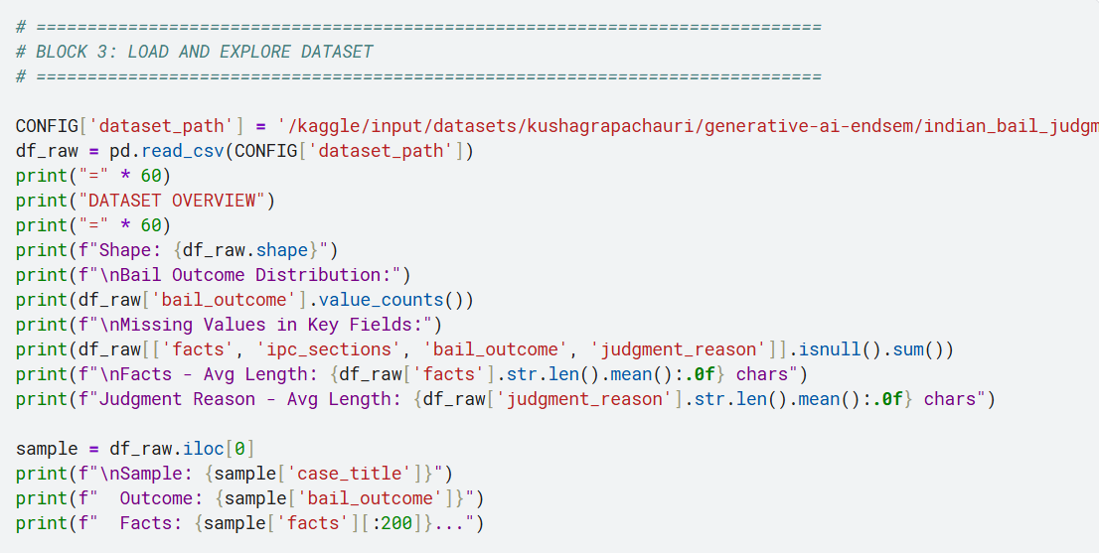
Dataset Overview
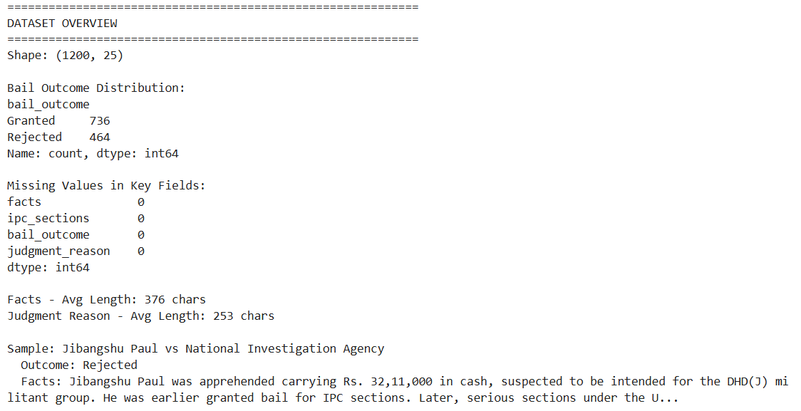
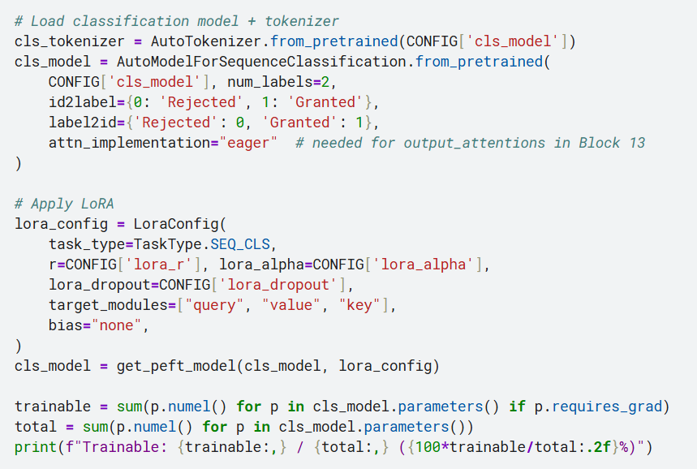
Appendix B – LoRA Configuration

Appendix C – LoRA Training Log (Sample)
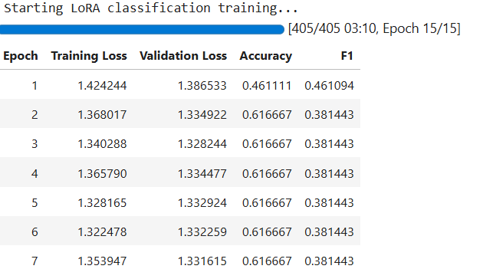

Appendix D – Ensemble Weight Tuning Grid
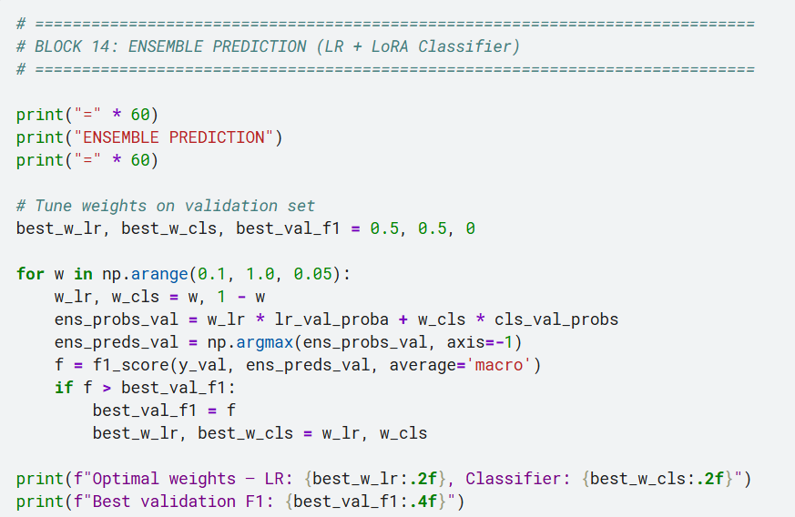
Appendix E – Sample Predictions and Explanations
Case ID | Actual | Ensemble Pred | Confidence | Explanation (RAG)
741 | Rejected | Granted | 0.72 | (shortened) “Sections 306, 498A… provide basis for guilt…” [hallucinated sections]
757 | Rejected | Rejected | 0.68 | “Bail was rescheduled for April 15, 2015” (less relevant but factually correct)
1084 | Granted | Granted | 0.81 | “Based on precedent Case #382, the accused had no criminal antecedents; bail granted.”
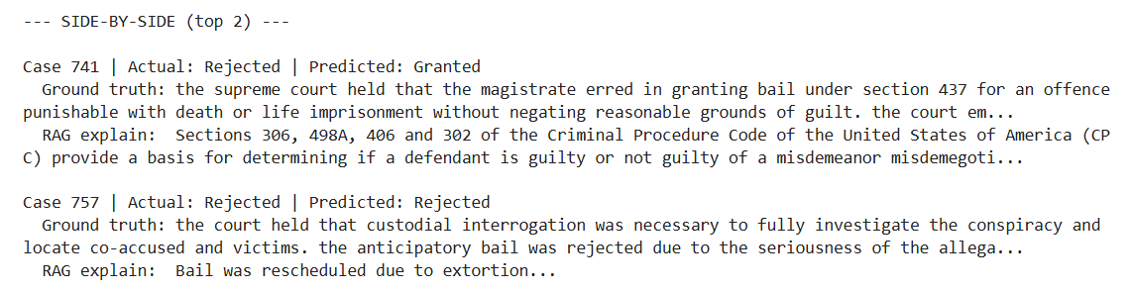
Appendix F – Streamlit Application Code Snippet/Snapshots
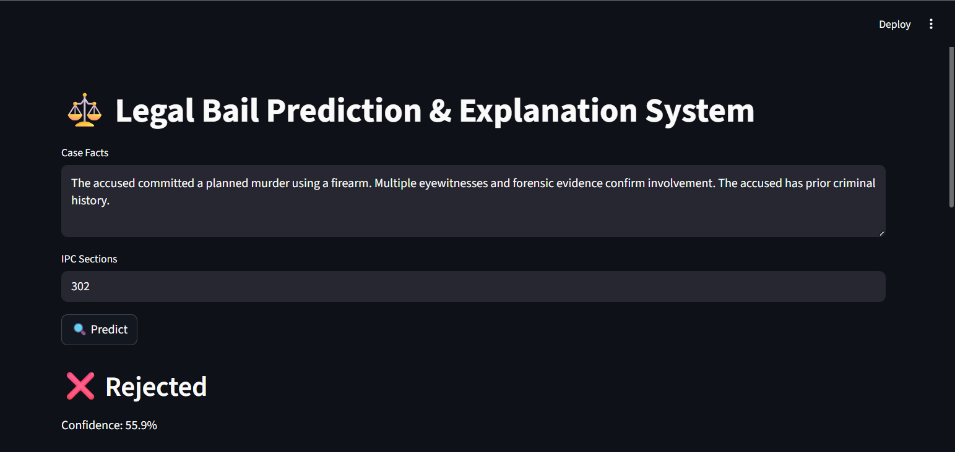


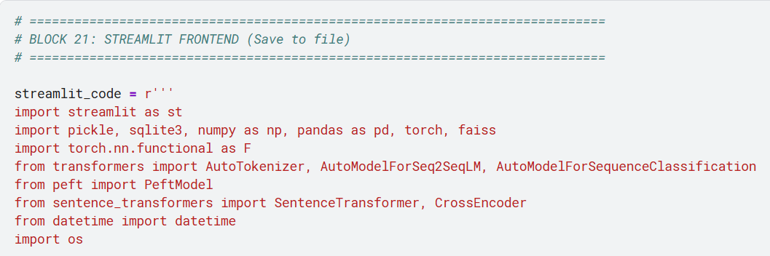
Appendix G – Evaluation Metrics Output (Console)
