YUVA INTERNSHIP — WEEK 4
TEXT ANALYTICS & SENTIMENT ANALYSIS
Sephora Skincare Customer Reviews

Project Detail | Value
Candidate | Kushagra Pandey
Dataset | Sephora Skincare Reviews
Analysis Records | 285,063 reviews
Final Dataset | 285,063 rows × 35 columns
Analysis Period | 28 August 2008 – 21 March 2023
Tools | Python, Pandas, NumPy, TextBlob, Matplotlib, Seaborn, Jupyter Notebook, Gen AI
Methods | NLP preprocessing, sentiment analysis, keyword/bigram analysis, correlation, product/brand/category analysis
Final report prepared from the completed Week 4 analytical workflow and validated outputs.

1. Executive Summary
This project applies Natural Language Processing (NLP) and exploratory data analysis to 285,063 Sephora skincare reviews. The analysis converts unstructured customer feedback into measurable sentiment, thematic, product, brand, category, skin-type and temporal insights.
Customer feedback is overwhelmingly positive: 257,177 reviews (90.22%) are Positive, 23,386 (8.20%) are Negative, and 4,500 (1.58%) are Neutral. The average rating is 4.33/5 and the median rating is 5/5.
Metric | Value
Total reviews | 285,063
Positive | 257,177 (90.22%)
Negative | 23,386 (8.20%)
Neutral | 4,500 (1.58%)
Average rating | 4.33 / 5
Median rating | 5 / 5
Average polarity | 0.2398
Average subjectivity | 0.5676
Average review length | 28.90 words
Pearson correlation | 0.3318
Spearman correlation | 0.2730

2. Project Objectives
- Prepare the skincare review data for NLP analysis.
- Classify review text into Positive, Negative and Neutral sentiment using TextBlob polarity.
- Measure polarity and subjectivity and compare text sentiment with star ratings.
- Identify frequent and disproportionately associated positive and negative words.
- Extract bigrams to identify contextual customer-feedback patterns.
- Compare negative-review rates across products, brands, categories, skin types and years.
- Validate the final analytical dataset and reconcile all major cross-analysis totals.

3. Dataset Overview
Attribute | Result
Final dataset shape | 285,063 × 35
Unique product IDs | 1,813
Duplicate product-ID rows | 0
Primary category | Skincare
Secondary categories | 13
Missing tertiary-category values | 54,004
Review dates | 2008-08-28 to 2023-03-21
Invalid/unparsed dates | 0
Rating range | 1–5
Polarity range | -1.00 to 1.00
Subjectivity range | 0.00 to 1.00
The skincare product-information table contains 1,813 unique products and 28 product attributes. Category information was merged into the review-level master dataset. The final analytical dataset contains review text, processed text, NLP token/lemma fields, ratings, sentiment metrics, product attributes and category fields.

4. Data Preparation and Methodology
- Combined the review partitions into a master review dataset.
- Loaded the skincare-specific product information and joined category attributes.
- Verified product identifiers and confirmed 1,813 unique product records with no duplicate product-ID rows.
- Prepared review text through tokenization, filtering and lemmatization.
- Calculated TextBlob polarity and subjectivity for every review.
- Assigned sentiment labels from the polarity-based classification workflow.
- Performed keyword-frequency, disproportionate-association and bigram analysis.
- Aggregated results by product, brand, category, skin type and review year.
- Performed final reconciliation and data-quality validation before exporting the dataset and report.
The final analytical CSV was saved as sephora_skincare_text_analysis_final.csv with 285,063 rows and 35 columns.

5. Overall Sentiment Analysis
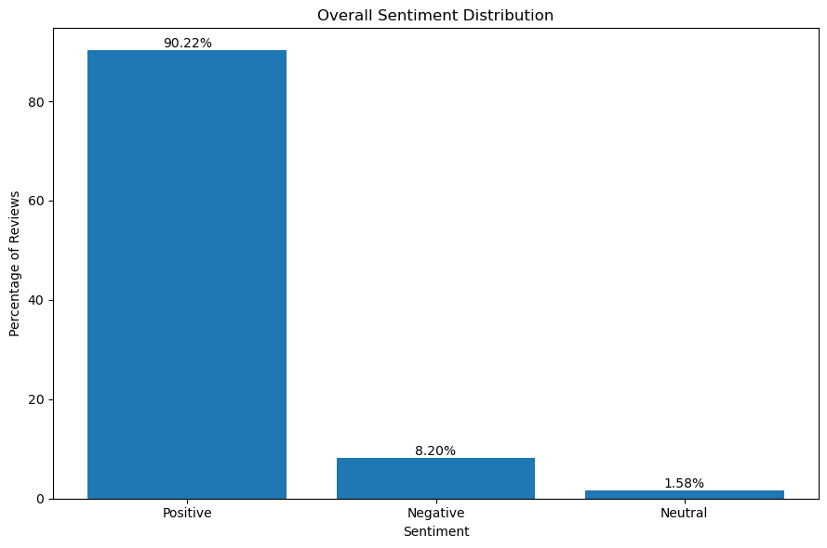
Figure 1. Overall Sentiment Distribution
Sentiment | Reviews | Percentage
Positive | 257,177 | 90.22%
Negative | 23,386 | 8.20%
Neutral | 4,500 | 1.58%
The dataset is heavily positive. Although Negative reviews represent only 8.20% of all reviews, the absolute volume is large enough to reveal recurring and actionable customer concerns.

6. Rating and TextBlob Polarity Analysis
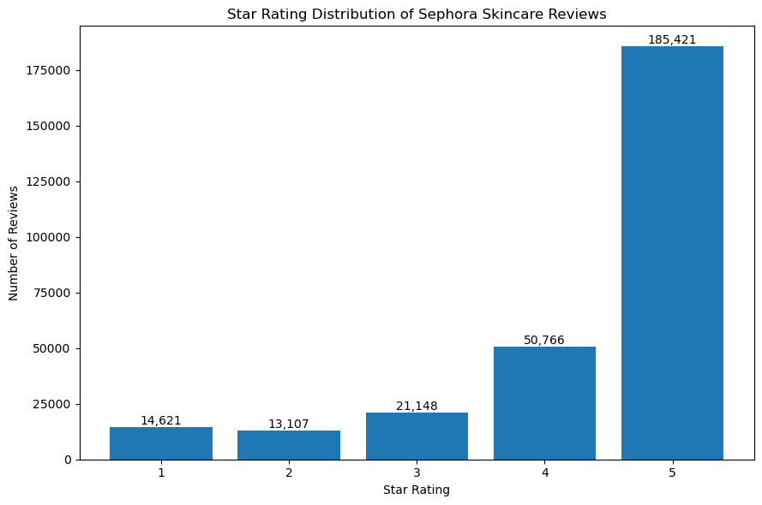
Figure 2. Star Rating Distribution
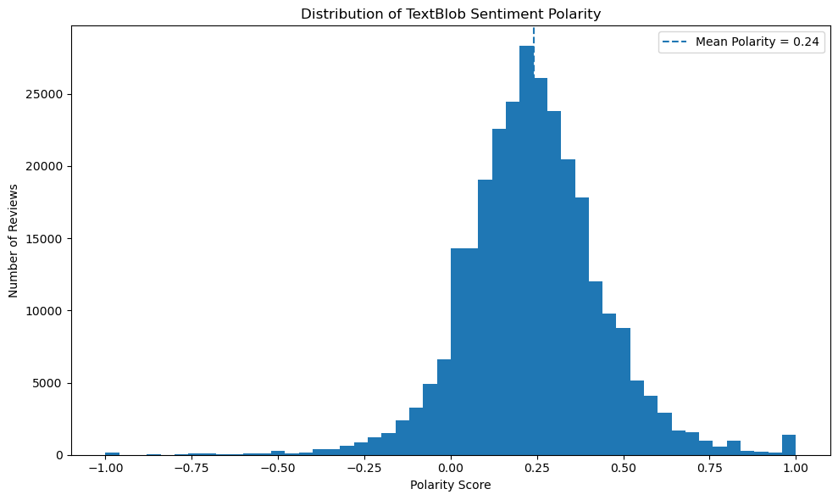
Figure 3. Distribution of TextBlob Polarity
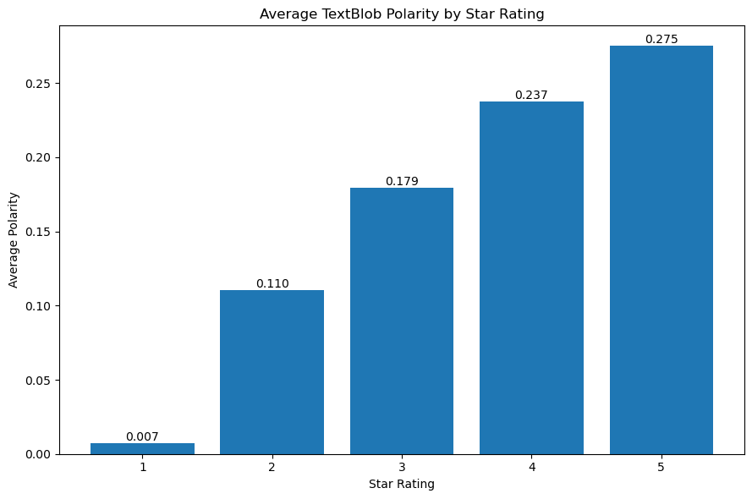
Figure 4. Average TextBlob Polarity by Star Rating
Star Rating | Average Polarity
1 | 0.007
2 | 0.110
3 | 0.179
4 | 0.237
5 | 0.275
Average polarity rises consistently from 1-star to 5-star reviews. This confirms that textual sentiment generally aligns with numerical ratings.

7. Sentiment–Rating Correlation
Measure | Coefficient
Pearson | 0.3318
Spearman | 0.2730
Both correlations are positive but moderate. Ratings and textual sentiment therefore capture related, but not identical, aspects of customer feedback.

8. Review-Length Analysis
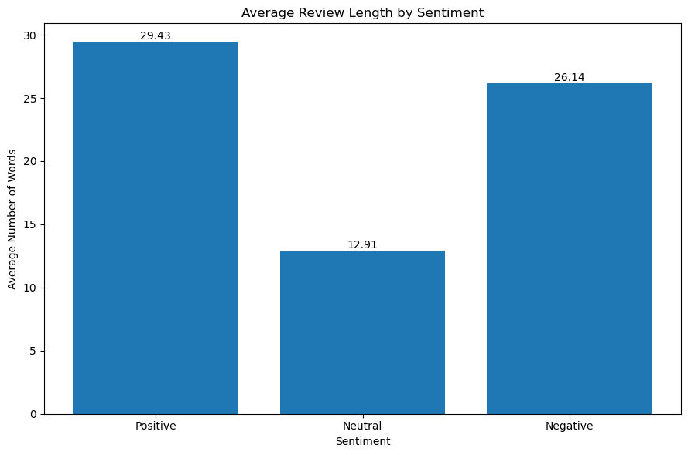
Figure 5. Average Review Length by Sentiment
Sentiment | Count | Average Words | Median | Min | Max
Positive | 257,177 | 29.43 | 24 | 1 | 511
Negative | 23,386 | 26.14 | 22 | 1 | 290
Neutral | 4,500 | 12.91 | 10 | 1 | 127
Positive reviews are longer on average than Negative reviews, while Neutral reviews are substantially shorter.

9. Positive Review Themes
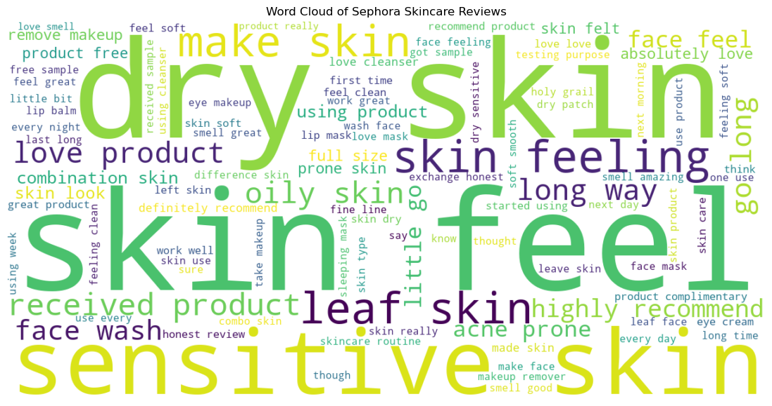
Figure 6. Word Cloud of Positive Sephora Skincare Reviews
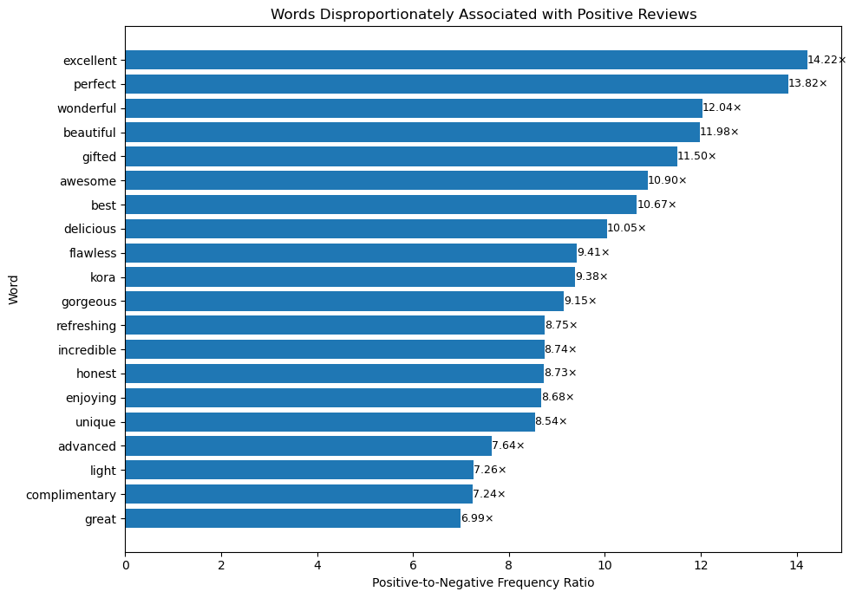
Figure 7. Words Disproportionately Associated with Positive Reviews
Word | Positive Count | Negative Count | Ratio
excellent | 1,877 | 12 | 14.22×
perfect | 13,066 | 86 | 13.82×
wonderful | 4,897 | 37 | 12.04×
beautiful | 3,952 | 30 | 11.98×
gifted | 4,934 | 39 | 11.50×
awesome | 3,595 | 30 | 10.90×
best | 19,709 | 168 | 10.67×
great | 54,765 | 712 | 6.99×
effective | 6,442 | 94 | 6.23×
fresh | 14,630 | 217 | 6.13×
Frequent positive themes include love, cleanser, mask, dry, great, smell, makeup, clean, good, lip, soft, sensitive and recommend. The language emphasizes satisfaction, product experience, cleanliness, softness, appearance and effectiveness.

10. Negative Review Themes
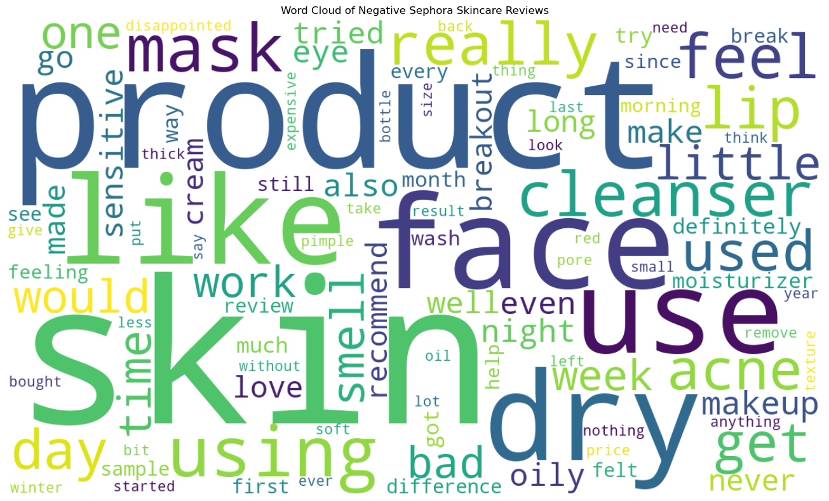
Figure 8. Word Cloud of Negative Sephora Skincare Reviews
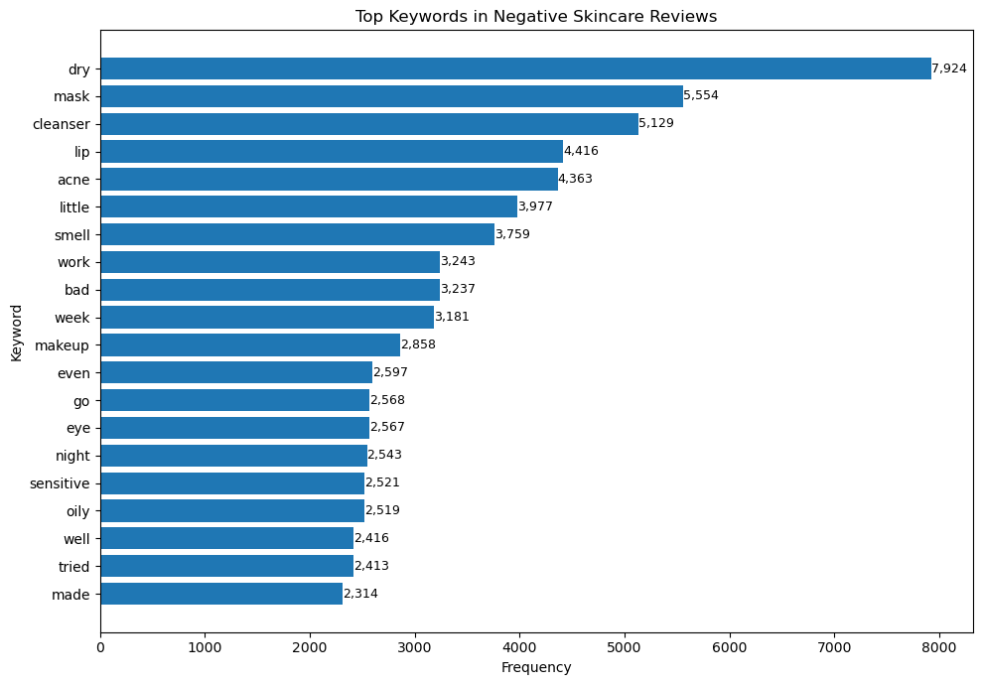
Figure 9. Top Keywords in Negative Skincare Reviews
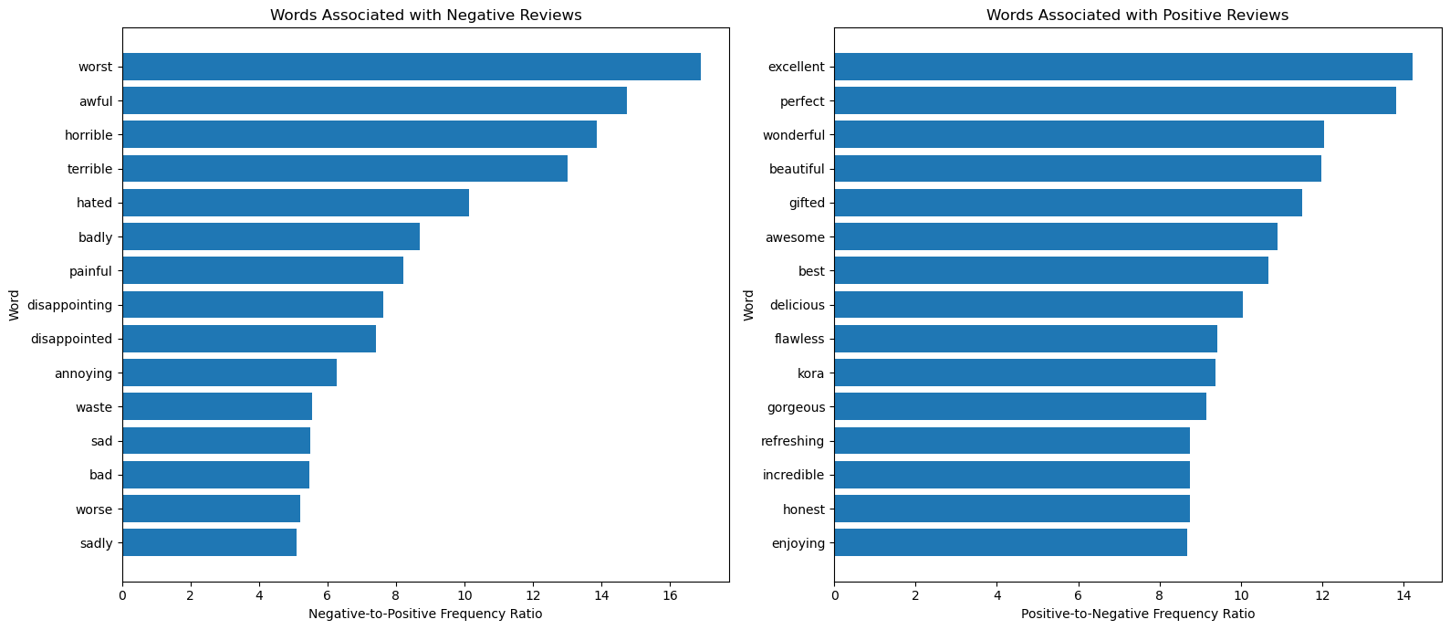
Figure 10. Words Associated with Negative and Positive Reviews
Word | Negative Count | Positive Count | Ratio
worst | 842 | 50 | 16.90×
disgusting | 120 | 8 | 15.17×
awful | 695 | 47 | 14.75×
horrible | 1,014 | 73 | 13.87×
terrible | 938 | 72 | 13.02×
hated | 244 | 24 | 10.13×
disappointing | 280 | 37 | 7.64×
bad | 3,237 | 591 | 5.48×
returned | 313 | 74 | 4.22×
dirty | 117 | 27 | 4.32×
Frequent negative themes include dryness, acne/breakouts, smell, product effectiveness, sensitivity and dissatisfaction with results.

11. Bigram Analysis
Bigrams provide contextual information beyond individual words.
Negative Bigram | Count | Negative/Positive Ratio
worst product | 69 | 58.37×
broke terribly | 50 | 30.55×
break bad | 67 | 23.03×
smell horrible | 117 | 19.20×
smell awful | 126 | 18.72×
smell terrible | 106 | 15.97×
really disappointed | 112 | 12.96×
waste money | 378 | 10.16×
bad acne | 169 | 7.20×
made worse | 60 | 7.17×
Positive Bigram | Count | Positive/Negative Ratio
best part | 755 | 68.65×
purpose opinion | 753 | 68.47×
nice clean | 700 | 63.65×
super easy | 640 | 58.20×
best makeup | 530 | 48.19×
cleanser perfect | 514 | 46.74×
super light | 489 | 44.47×
clean fresh | 1,300 | 39.40×
love ingredient | 424 | 38.56×
clean smooth | 815 | 37.06×
Negative combinations strongly reinforce smell, breakouts, product failure and disappointment. Positive combinations emphasize clean, smooth, light, effective and satisfying product experiences.

12. Product-Level Analysis
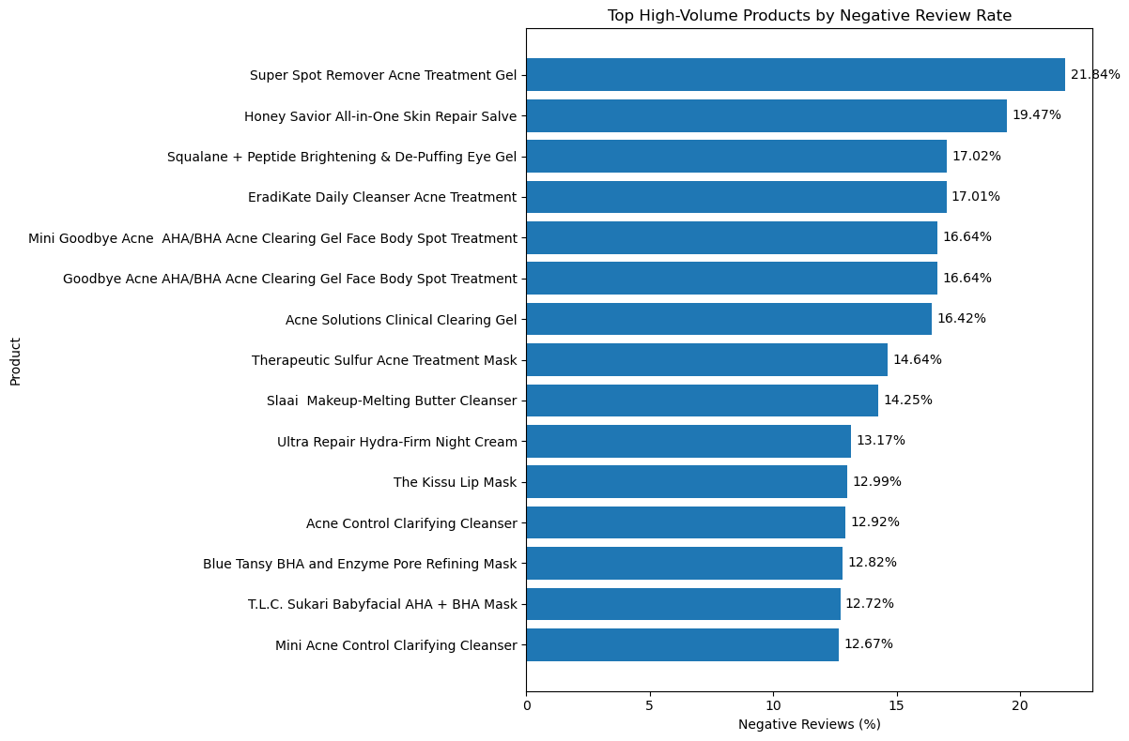
Figure 11. High-Volume Products by Negative Review Rate
Product | Brand | Reviews | Negative | Negative Rate
Super Spot Remover Acne Treatment Gel | Origins | 1,703 | 372 | 21.84%
Honey Savior All-in-One Skin Repair Salve | Farmacy | 529 | 103 | 19.47%
Squalane + Peptide Brightening & De-Puffing Eye Gel | Biossance | 652 | 111 | 17.03%
EradiKate Daily Cleanser Acne Treatment | Kate Somerville | 623 | 106 | 17.01%
Goodbye Acne AHA/BHA Acne Clearing Gel | Peter Thomas Roth | 625 | 104 | 16.64%
Acne Solutions Clinical Clearing Gel | CLINIQUE | 1,078 | 177 | 16.42%
Therapeutic Sulfur Acne Treatment Mask | Peter Thomas Roth | 1,216 | 178 | 14.64%
Slaai Makeup-Melting Butter Cleanser | Drunk Elephant | 1,523 | 217 | 14.25%
Among products with at least 500 analyzed reviews, Super Spot Remover Acne Treatment Gel has the highest negative-review rate at 21.84%. Several high-rate products are acne-focused treatments, suggesting that outcome-sensitive products can generate more polarized customer experiences.
Product | Brand | Reviews | Positive Rate
KateCeuticals Total Repair Cream | Kate Somerville | 91 | 100.00%
Liftwear Brightening Vitamin C Gel-Cream | FaceGym | 77 | 100.00%
Electro-Lite Enzyme Brightening Gel Cleanser | FaceGym | 71 | 100.00%
Equilibrium Rebalancing Cream Cleanser | Hourglass | 55 | 100.00%
GinZing Energizing Gel Cream | Origins | 119 | 99.16%

13. Brand-Level Analysis
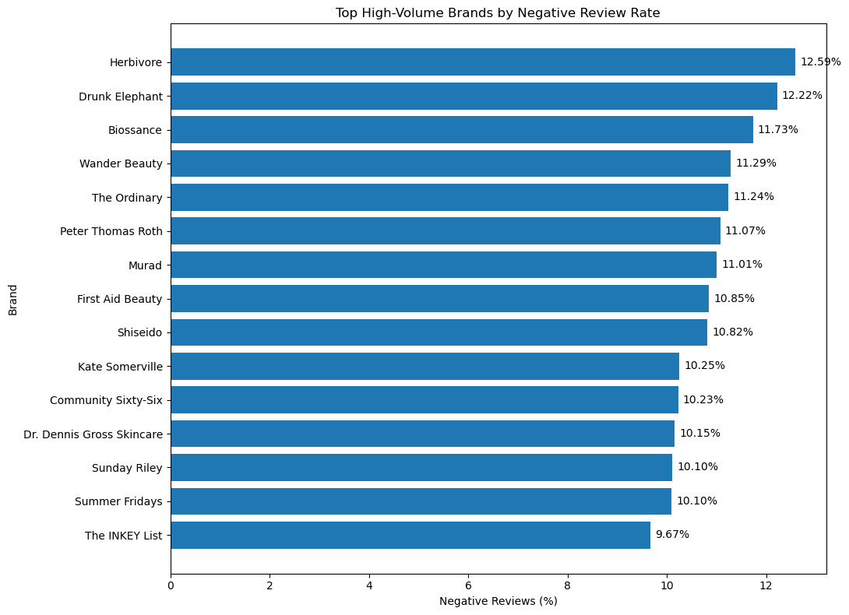
Figure 12. High-Volume Brands by Negative Review Rate
Brand | Reviews | Negative | Negative Rate | Avg Rating
Herbivore | 1,994 | 251 | 12.59% | 4.259
Drunk Elephant | 8,331 | 1,018 | 12.22% | 4.077
Biossance | 4,253 | 499 | 11.73% | 4.087
Wander Beauty | 558 | 63 | 11.29% | 4.084
The Ordinary | 1,014 | 114 | 11.24% | 4.004
Peter Thomas Roth | 12,805 | 1,418 | 11.07% | 4.373
Murad | 8,841 | 973 | 11.01% | 4.335
First Aid Beauty | 16,879 | 1,831 | 10.85% | 4.421
Shiseido | 693 | 75 | 10.82% | 4.323
Kate Somerville | 2,302 | 236 | 10.25% | 4.345
Among brands with at least 500 analyzed reviews, Herbivore has the highest negative-review rate at 12.59%. Brand-level rates should always be interpreted alongside review volume and average rating.

14. Category-Level Analysis
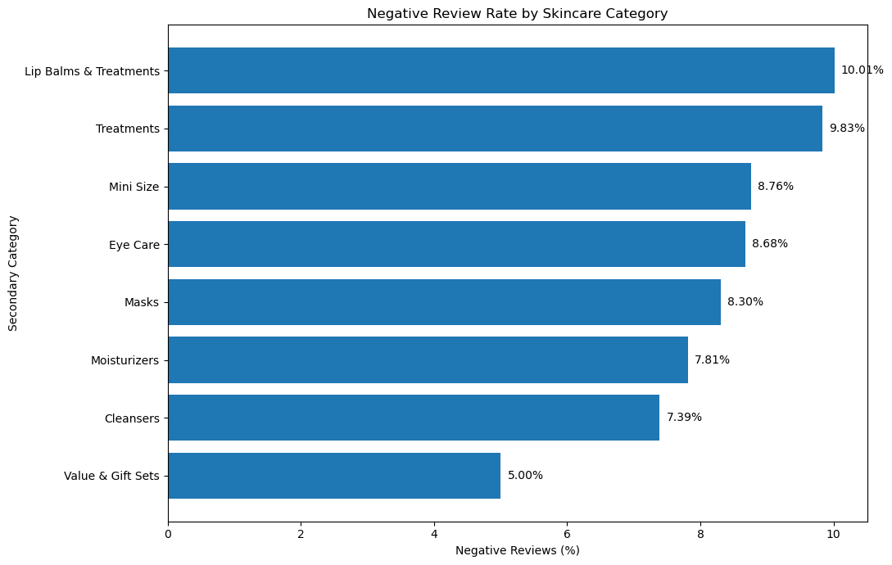
Figure 13. Negative Review Rate by Skincare Category
Category | Reviews | Positive Rate | Negative Rate | Avg Rating
Lip Balms & Treatments | 21,314 | 87.88% | 10.01% | 4.309
Treatments | 16,322 | 87.98% | 9.83% | 4.212
Mini Size | 31,205 | 89.61% | 8.76% | 4.315
Eye Care | 10,981 | 89.51% | 8.68% | 4.216
Masks | 69,386 | 90.07% | 8.30% | 4.344
Moisturizers | 42,931 | 90.88% | 7.81% | 4.403
Cleansers | 90,602 | 91.22% | 7.39% | 4.335
Value & Gift Sets | 1,339 | 93.58% | 5.00% | 4.258
Among secondary categories with at least 1,000 reviews, Lip Balms & Treatments have the highest negative rate at 10.01%, while Value & Gift Sets have the lowest at 5.00%.

15. Skin-Type Analysis
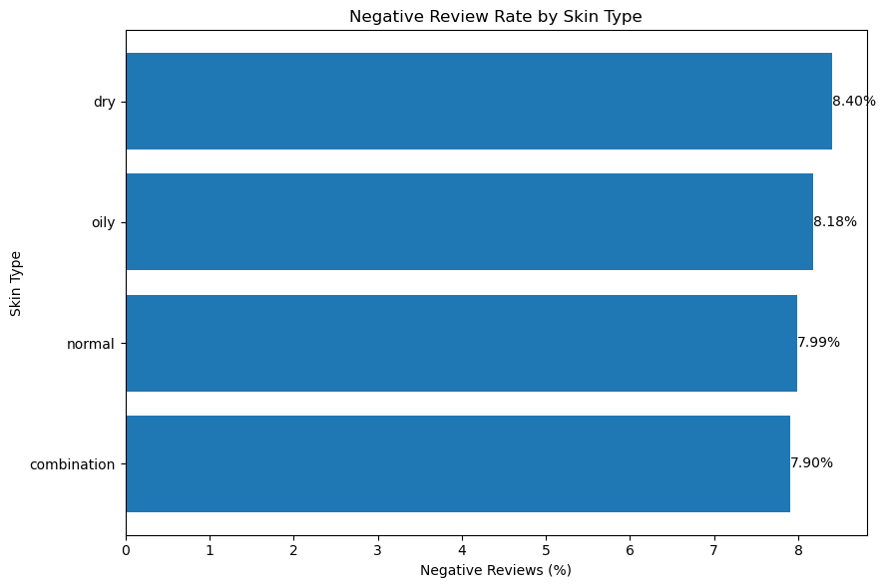
Figure 14. Negative Review Rate by Skin Type
Skin Type | Reviews | Positive Rate | Negative Rate | Avg Rating
Combination | 138,604 | 90.60% | 7.90% | 4.333
Dry | 45,523 | 90.15% | 8.40% | 4.319
Oily | 32,257 | 90.34% | 8.18% | 4.319
Normal | 31,815 | 90.55% | 7.99% | 4.306
Dry-skin reviews have the highest negative-review rate at 8.40%. The differences between skin types remain relatively small.

16. Year-wise Trends
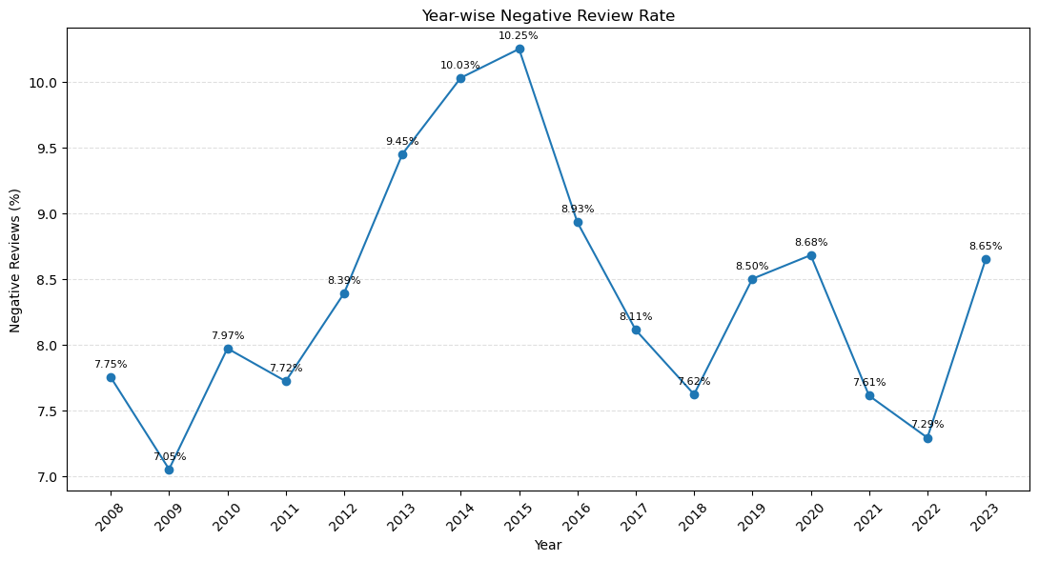
Figure 15. Year-wise Negative Review Rate
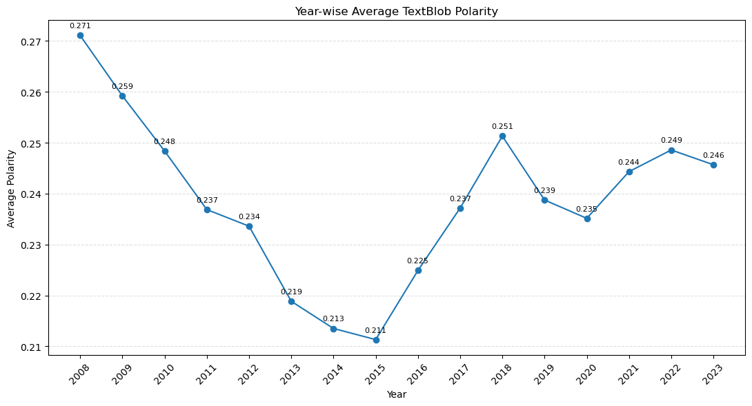
Figure 16. Year-wise Average TextBlob Polarity
Year | Reviews | Negative Rate | Avg Polarity
2008 | 903 | 7.75% | 0.271
2009 | 2,864 | 7.05% | 0.259
2010 | 3,990 | 7.97% | 0.248
2011 | 3,706 | 7.72% | 0.237
2012 | 3,649 | 8.39% | 0.234
2013 | 5,155 | 9.45% | 0.219
2014 | 6,980 | 10.03% | 0.213
2015 | 8,523 | 10.25% | 0.211
2016 | 11,898 | 8.93% | 0.225
2017 | 16,675 | 8.11% | 0.237
2018 | 31,826 | 7.62% | 0.251
2019 | 39,782 | 8.50% | 0.239
2020 | 55,076 | 8.68% | 0.235
2021 | 44,111 | 7.61% | 0.244
2022 | 39,161 | 7.29% | 0.249
2023 | 10,764 | 8.65% | 0.246
The negative-review rate peaked at 10.25% in 2015 and was lowest at 7.05% in 2009. Average polarity declined from 0.271 in 2008 to about 0.211 in 2015 before recovering.

17. Data Quality and Cross-Analysis Validation
Validation Check | Result
Master dataset reviews | 285,063
Sentiment analysis total | 285,063
Sentiment counts reconcile | True
Valid rating records | 285,063
Category analysis total | 285,063
Category counts reconcile | True
Year analysis total | 285,063
Year counts reconcile | True
Duplicate rows excluding list-valued columns | 0
Duplicate index values | 0
Invalid/unparsed dates | 0
Missing review text | 0
Missing processed text | 0
Missing lemmatized tokens | 0
Missing rating | 0
Missing sentiment | 0
Missing polarity | 0
Missing subjectivity | 0
Missing submission date | 0
The first full duplicate check produced a TypeError because token columns contain Python lists, which are unhashable. The check was corrected by excluding list-valued columns. The corrected validation returned zero duplicate rows and zero duplicate indices.

18. Key Business Insights
- 90.22% of reviews are Positive, with an average rating of 4.33/5.
- Negative feedback repeatedly highlights dryness, acne/breakouts, smell, effectiveness, sensitivity and dissatisfaction.
- Several high-volume products with elevated negative rates are acne treatments or blemish-focused products.
- Ratings and textual sentiment are positively related, but the moderate correlations show that they are not interchangeable.
- Product-level analysis reveals issues that can be hidden by overall brand averages.
- Lip Balms & Treatments and Treatments have the highest negative rates among sufficiently large categories.
- Cleansers have the largest review volume and a comparatively low negative rate of 7.39%.
- Dry-skin reviews have the highest negative rate among the four major skin-type groups.
- Negative-review rates rose to a peak in 2015, while average polarity reached its lowest point in the same year and then recovered.
- Positive language emphasizes excellence, perfection, cleanliness, softness, effectiveness and satisfaction; negative language emphasizes failure, unpleasant smell, breakouts and disappointment.

19. Limitations
- TextBlob is a general-purpose sentiment analyzer and may not fully understand skincare-specific language.
- Sentiment labels are polarity-derived rather than manually verified human labels.
- The dataset is heavily skewed toward Positive reviews.
- Unequal review volumes mean low-volume product rates can be unstable.
- Keyword frequency and association ratios do not capture full review context.
- Correlation does not establish causation.
- The dataset ends in March 2023 and does not represent later customer feedback.

20. Conclusion
The Week 4 Text Analytics and Sentiment Analysis task was completed on 285,063 Sephora skincare reviews. The workflow combines NLP preprocessing, TextBlob sentiment scoring, rating analysis, keyword and bigram extraction, product and brand benchmarking, category and skin-type comparisons, and year-wise trend analysis.
The results show strong overall customer satisfaction while also identifying recurring negative-feedback themes involving dryness, acne/breakouts, smell, effectiveness, sensitivity and specific product experiences. Combining textual sentiment with ratings and business dimensions provides a more complete view of customer experience than relying on any single metric.

