UML 602 Natural Language Processing

Assignment 3
(Minor Project)

Topic

TOXIC COMMENT CLASSIFIER



Name: Kushagra Thakral
Roll No: 101703301
Group: COE14
EmailId: kushagra.thakral@gmail.com
Contact: 9034199977
Instructions to execute code

Note: I have created a Jupyter notebook for better explanation of the project and visualization of data and techniques used. It is highly recommended to view that notebook on the github link provided below.
Github link: https://github.com/Kushagra7744/Toxic-Comment-Classifier

Note: All the dependencies should be installed on your local machine.

Dependencies:
1) python3
2) numpy
3) pandas
4) plotly
5) matplotlib
6) streamlit
7) keras
8) tensorflow

Also if you want to execute the GUI. Follow the steps below:

1) clone the the above repository.
2) open terminal inside the Toxic-Comment-Classifier directory
3) type ‘streamlit run app.py’ without quotes inside terminal
# a browser window will open directing to the GUI dashboard.

4) click generate random tweet checkbox
5) click process checkbox
6) click the ‘predict for random generated tweet’ button

CODE

#imports

import streamlit as st
import numpy as np
import pandas as pd
import plotly.graph_objects as go
import matplotlib.pyplot as plt
from keras.preprocessing.text import Tokenizer
from keras.preprocessing.sequence import pad_sequences
from keras.models import model_from_json
from keras.layers import Dense, Input, LSTM, Embedding, Dropout, Activation
from keras.layers import Bidirectional, GlobalMaxPool1D
from keras.models import Model

#display on dashboard
st.title('Toxic Comment Classifier')
st.sidebar.title('Toxic Comment Classifier')
st.markdown('## This dashboards visualizes the training data and predicts toxicity of the comments')
st.markdown('### Toxicity is divided into 6 classes: toxic, severe_toxic, obscene, threat, insult, identity_hate')

#loading data

@st.cache(persist=True)
def load_data(data_URL):
df=pd.read_csv(data_URL)
return df

if st.sidebar.checkbox('Load test data'):
data_URL='data/test.csv'
df=load_data(data_URL)
else:
data_URL="data/train.csv"
df=load_data(data_URL)

#Exploring data

st.sidebar.subheader('Explore data')
rows=st.sidebar.slider('Show tabular data ')
if(rows>0):
st.markdown('**DataFrame till %d rows: **' %rows)
st.write(df.head(rows))

if st.sidebar.button('Describe data'):
st.markdown('**Description:**')
st.write(df.describe())

if st.sidebar.button('Display Null values count'):
st.markdown('**Count of NULL values for all columns:**')
st.write(df[df.isna()==True].count())

st.sidebar.subheader('Visualize training data')

# processing data to create plots

toxic_counts={}
for i in range(6):
toxic_counts[df.columns[i+2]]=df[df[df.columns[i+2]]==1].count()[0]

if st.sidebar.checkbox('include normal comments'):
normal_comments_count=(df.count())[0]-sum(toxic_counts.values())
temp_dict={'normal':normal_comments_count}
chart_data= {**temp_dict,**toxic_counts}
else:
chart_data=toxic_counts
# creating plots
select= st.sidebar.selectbox('Visualization type',['None','Pie Chart', 'Histogram'],key=2)

if select=='Pie Chart':
fig_total= go.Figure([go.Pie(labels=list(chart_data.keys()),values=list(chart_data.values()))])
fig_total.show()
if select=='Histogram':
plot_val=go.Bar(x=list(chart_data.keys()),y=list(chart_data.values()))
fig= go.Figure(plot_val)
fig.show()

# generating random tweet
st.sidebar.subheader('Generate random tweet')
random_tweet=(df['comment_text'].sample(n=1))
if st.sidebar.checkbox('Generate random tweet',key=5):
st.markdown('### %s'%random_tweet.iloc[0])

st.sidebar.subheader('Process tweet for prediction')

#tokenization of random tweet
def tokenize(random_tweet):
max_features=20000
tokenizer= Tokenizer(num_words=max_features)
tokenizer.fit_on_texts(list(df['comment_text']))

tokenized_comment=tokenizer.texts_to_sequences(random_tweet)
tokenized_comment=pad_sequences(tokenized_comment,200)
return tokenized_comment

if st.sidebar.checkbox('Process'):

tokenized_comment=tokenize(random_tweet)
st.write(tokenized_comment)

#loading pre-trained deep learning model

st.sidebar.subheader('Deep Learning Model')
# @st.cache(persist=True)
def load_model(m='model.json',w='weights.h5'):
json_file=open(m,'r')
model=json_file.read()
json_file.close()
model=model_from_json(model)
model.load_weights(w)
model.compile(loss='binary_crossentropy',optimizer='adam',metrics=['accuracy'])
return model

model=load_model()

#summary of model(will be displayed in terminal running streamlit)
if st.sidebar.checkbox('Model Summary'):
st.markdown('### Check you streamlit terminal for summary')
st.write(model.summary())
#predicting toxicity for random tweet
if st.sidebar.button('Predict for random generated tweet'):
st.markdown('### Here 0 indicates comment being toxic and similarly 5 is prob of comment being identity_hate')
st.write(model.predict(tokenized_comment))

Note: Model is trained using the code in jupyter-notebook. Check the github link for the same. The same model is saved in json format and retrieved in ‘app.py’.

Screenshots

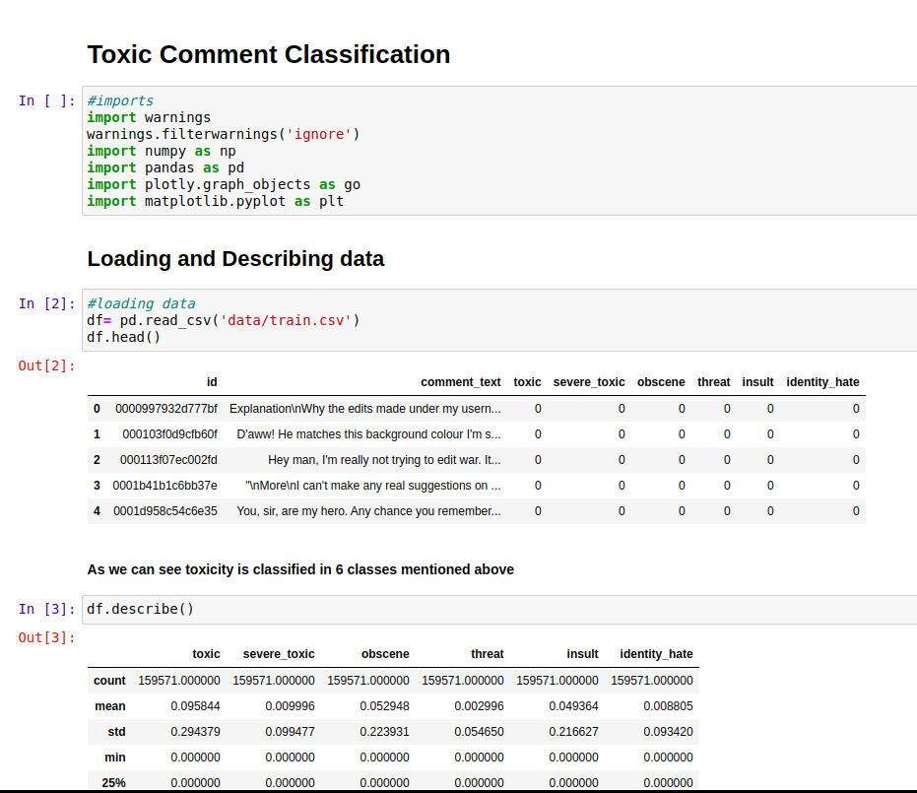
1) Jupyter-notebook

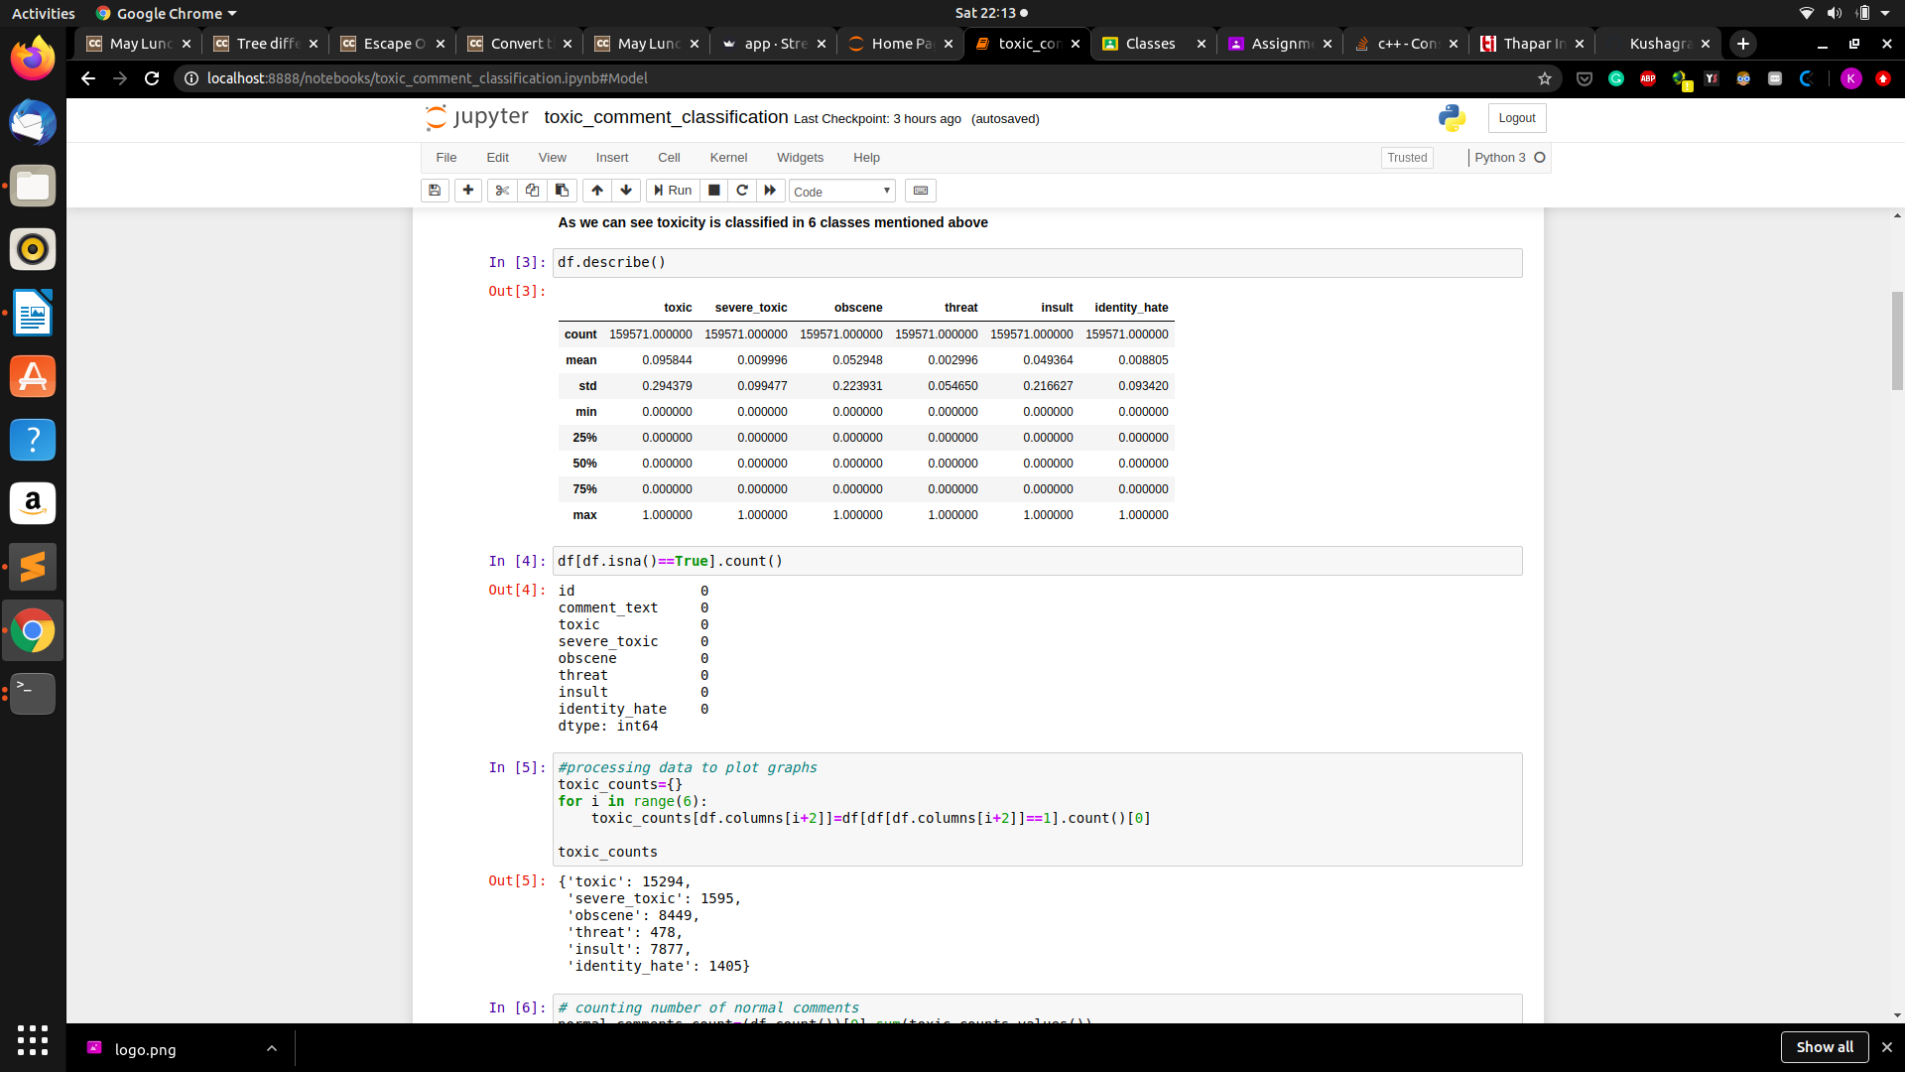

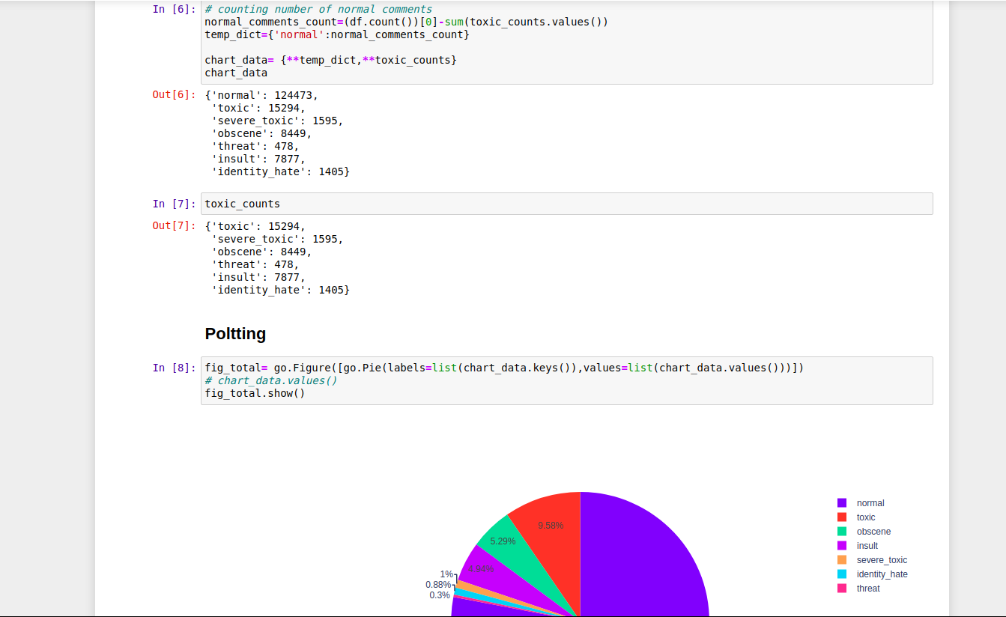

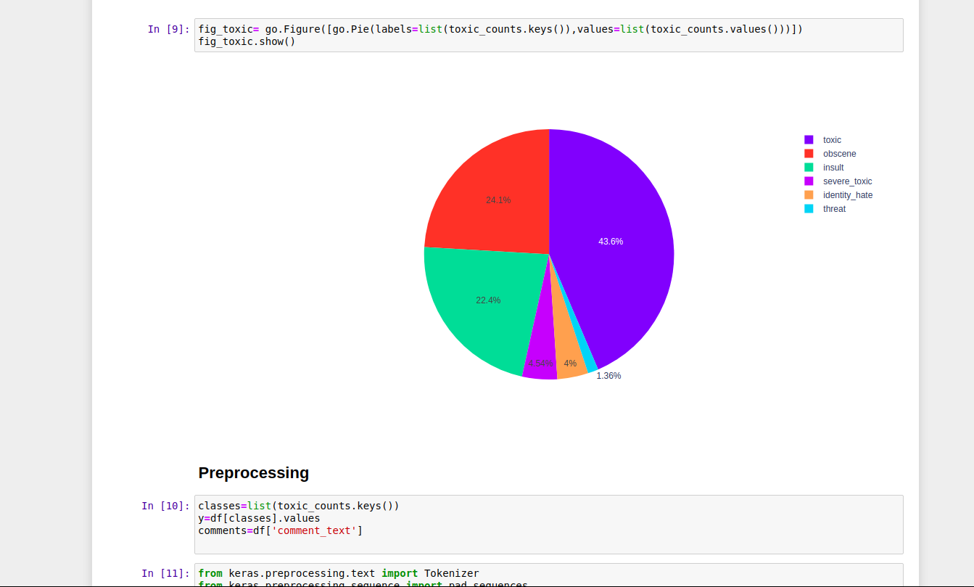

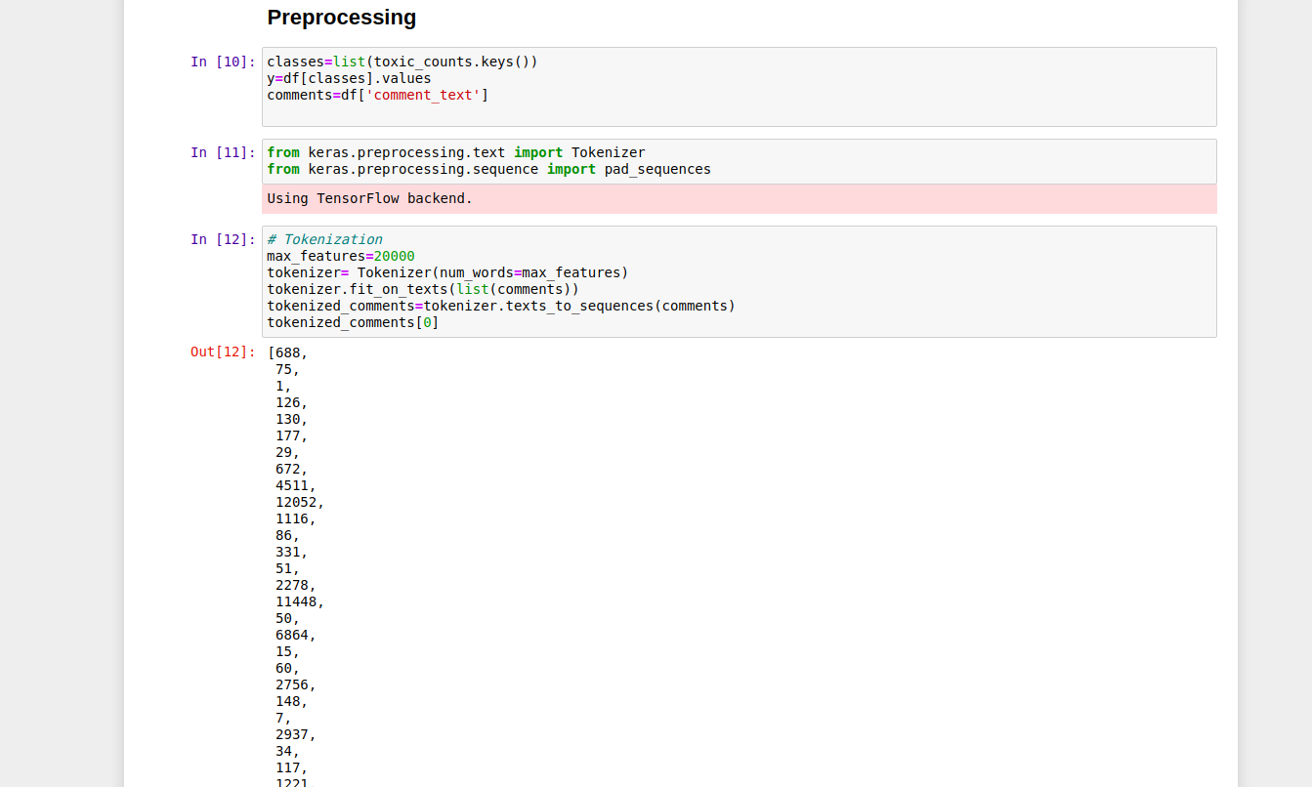

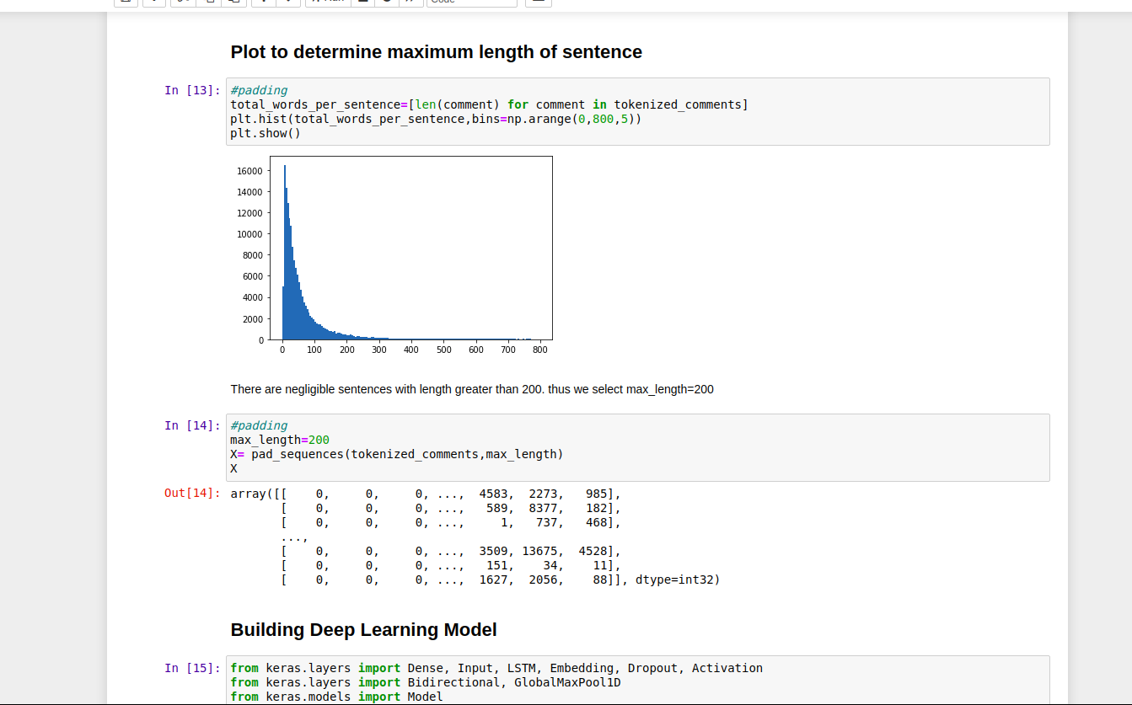

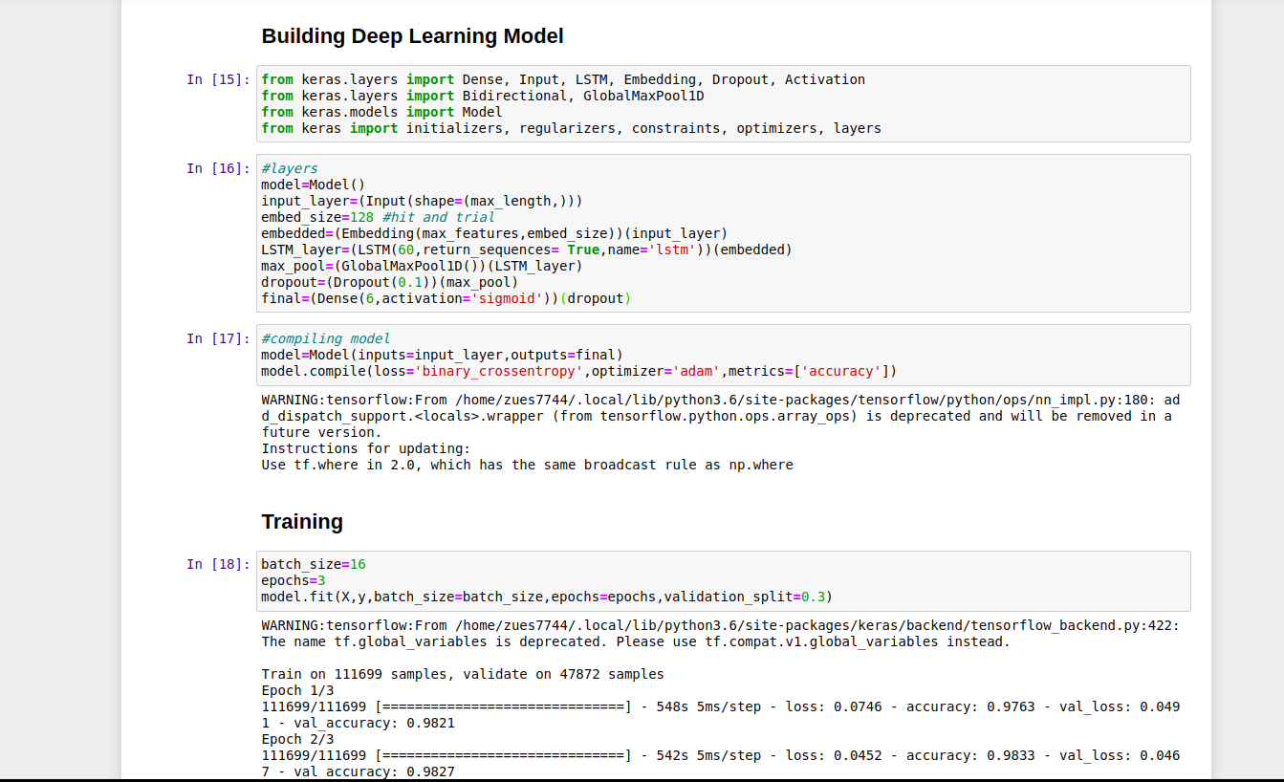

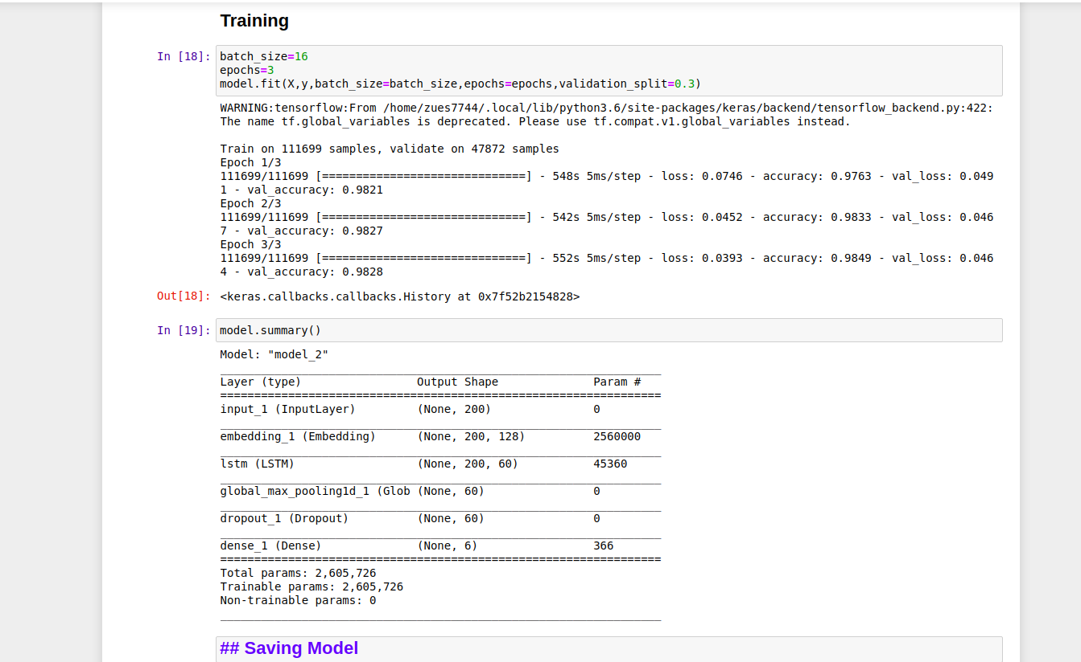
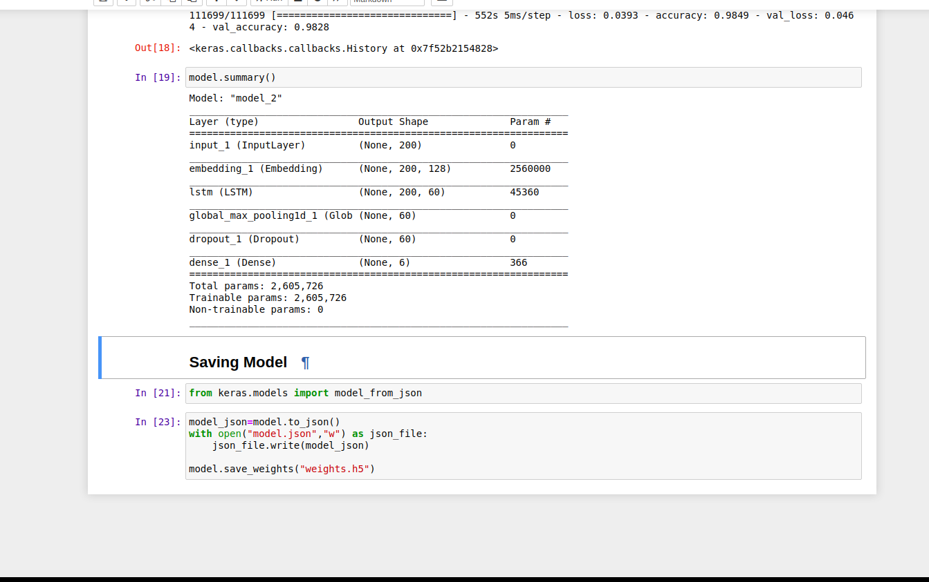

2) Dashboard

