Duo-Face App — Technical Documentation

Overview
One React Native (Expo) app serves two roles — Merchant and Delivery Partner — and picks the interface from the role on the logged-in account. It plugs into the client's live Customer App through its database and a shared Node.js API, so inventory changes and new orders show up across all three apps in real time.
In scope
- Merchant interface: store profile, catalog and inventory, order pipeline, financial analytics
- Delivery Partner interface: onboarding and KYC, online/offline toggle, order matching, navigation and OTP handoff, earnings wallet (optional)
- Backend additions: role-based auth, real-time event layer (Socket.io), payouts, notifications
- Integration with the existing Customer App database and API
- https://expo.dev/
Out of scope (unless the client adds it): changes to the Customer App UI, an admin/ops panel, web versions of either interface (Later ON).
Working assumptions
- Market is India, so prices are in INR and USD, payments use Razorpay (cashfree), and SMS follows India DLT rules.
- Framework is React Native with Expo, chosen over Flutter because the build team works in React and Node.js.
- Launch scale for cost estimates: about 50 merchants, 100 delivery partners, and 3,000 orders per month (roughly 100 per day). (5 merch, 10 del part.)

Architecture
All three apps go through one Node.js API; no app touches the database directly. That single gateway is what keeps inventory, orders and rider locations consistent everywhere.
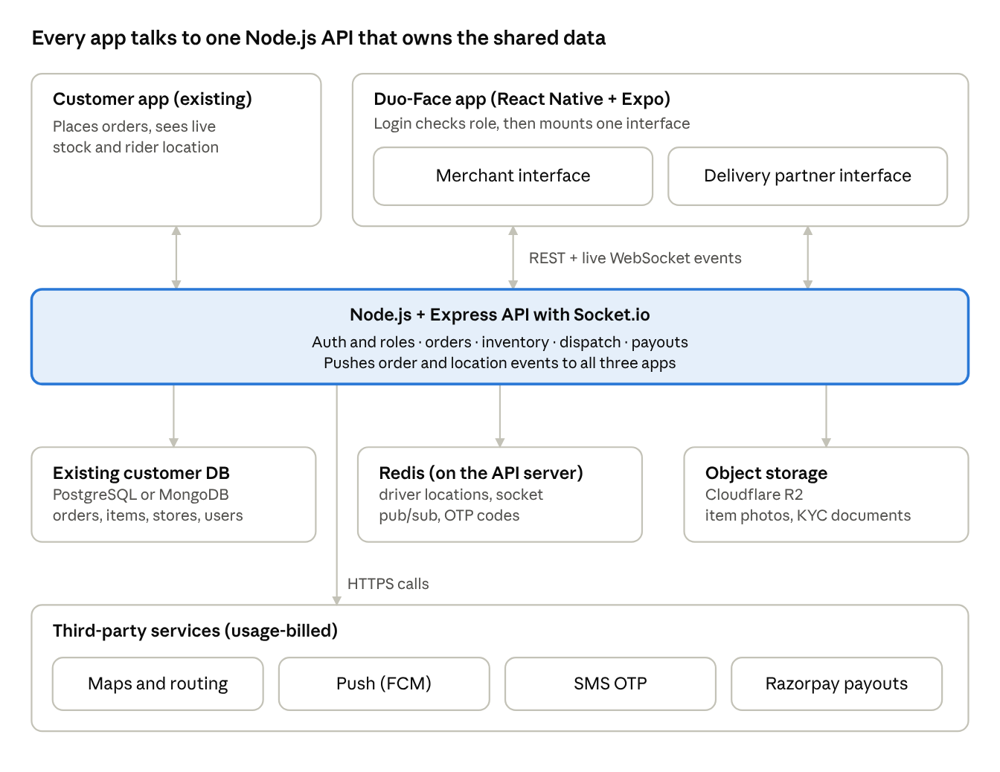
system architecture · 3 apps, 1 API, 3 data stores, 4 external services
Role-based router. After login the API returns a JWT carrying role: "merchant" | "driver". The app's root navigator reads it and mounts either MerchantStack or DriverStack; the other stack is never loaded. The API re-checks the role on every request, so a driver token can't call merchant endpoints.
Code layout. One Expo project with app/(merchant)/ and app/(driver)/ route groups (Expo Router), a shared components/, api/ and socket/ layer, and NativeWind for styling.

Integration with the Customer App
The new app reuses the Customer App's database and extends its existing API; it does not open a second connection that writes to the DB on its own. Two apps writing the same tables through different code paths is the fastest way to get oversold stock and ghost orders.
Preferred approach — extend the existing backend. New merchant and driver routes are added as modules to the current Node.js API (or a sibling service sharing its DB models). Inventory and order writes go through one service layer, used by all three apps.
Fallback — separate service. If the client won't allow changes to the Customer App backend, a new Node.js service connects to the same DB with a restricted DB user (read on customer tables, write only on stores, items, orders status, drivers, payouts). The Customer App then needs a webhook or DB change stream to hear about updates.
How "instant" sync works
- A merchant toggles an item out of stock → PATCH /merchant/items/:id writes the DB in a transaction.
- The API publishes inventory.updated to Redis pub/sub.
- Every Socket.io node forwards it to the store:<storeId> room, where browsing customers are subscribed.
- New orders follow the same path: order row written → order.created → merchant room + FCM push + nearby online drivers.
If the DB is MongoDB, change streams can replace step 2; on PostgreSQL, LISTEN/NOTIFY works for low volume, with Redis as the scalable default.
Stock safety. Stock is decremented at checkout with a conditional update (UPDATE items SET stock = stock - :q WHERE id = :id AND stock >= :q), so two customers can't buy the last unit.

Merchant interface
Four tabs — Orders, Catalog, Store, Earnings — with Orders as the home screen, since that is where money is made or lost.
Screen | What it does | Built with
Orders (home) | Live list of new, preparing and ready orders; loud looping alert on a new order until acted on; Accept → Preparing/Packing → Ready for Pickup buttons; auto-reject timer if not accepted | Socket.io room merchant:<storeId>, FCM for background alerts, expo-av for sound
Catalog | Add or edit item (title, category, description, images, price, stock); search and filter by category | Image upload to Cloudinary, compressed on device
Bulk upload | Upload CSV/Excel with a preview-and-fix step before saving; downloadable template | papaparse / xlsx parsing on server, validated row by row
AI image scan (optional) | Photo of a shelf or price board → draft item list for the merchant to confirm | Vision LLM API (optional, see open questions)
Stock toggles | Multi-select list with one switch per item plus "mark selected out of stock" | Single batch PATCH /merchant/items/stock
Store | Timings per weekday, banner, GPS pin on a map, Open/Closed switch | Map picker, store.status pushed to customers live
Earnings | Daily and weekly revenue charts, settlement history, invoice PDF per order or per week | Server-side PDF (pdfkit), Cashfree settlement data
Invoices follow GST invoice format if the merchant is GST-registered; this needs the merchant's GSTIN captured at onboarding.

Delivery partner interface
A driver can't go online until KYC is approved; after that the home screen is a map with one big Online/Offline switch.
Screen | What it does | Built with
Onboarding and KYC | Upload driving licence, vehicle RC, Aadhaar/PAN, selfie, bank or UPI details; status Pending → Approved/Rejected with reason | expo-image-picker, private storage bucket, manual approval by client's ops team
Home (online toggle) | Online sends GPS every 5–10 s; offline stops tracking and leaves the dispatch pool | expo-location background task, Redis GEO set of online drivers
Order request card | Pickup (store), drop (customer), distance, estimated earnings, 30 s countdown; Accept/Reject | Socket event order.offer, full-screen alert with sound
Active trip | Route to shop, then to customer; stepper Arrived at Shop → Picked Up → Arrived at Customer → Delivered | Map SDK + Directions; each step PATCH /driver/trips/:id/status
OTP handoff | Driver enters the 4-digit code the customer sees in their app; order closes only on a match | OTP generated at order creation, shown in Customer App, checked server-side
Earnings | Per-trip payout, tips, daily total, wallet balance (optional), withdraw to bank/UPI | Ledger table, Razorpay payouts
Dispatch logic (v1). On Ready for Pickup (or on accept, if the client wants riders to arrive early), the API picks the 5 nearest online, idle drivers from the Redis GEO set within 3 km and offers the order to one at a time, moving on after 30 s or a reject. Radius and batch size are config values.
Customer OTP delivery. The delivery OTP is shown inside the Customer App, not sent by SMS, which keeps SMS costs to login only.

Order lifecycle
The order status is one column in the shared orders table, and only the API changes it; every change is broadcast to the customer, the merchant and the assigned driver.
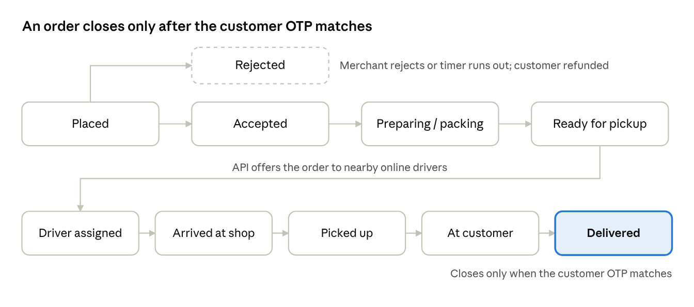
order lifecycle · 9 states, 1 rejection branch
Transitions are validated server-side against an allowed-next-state map, so a driver can't mark Delivered before Picked up. Each transition is also written to an order_events table for support and dispute history.

Data model
The app adds six tables and extends three the Customer App already has; names below assume PostgreSQL and will be mapped to the client's real schema once we see it.
Table | Status | Key columns
users | Extend | role (customer / merchant / driver), phone, is_active
stores | Extend or new | owner_id, name, lat, lng, timings (JSON per weekday), status (open/closed), banner_url, gstin
items | Extend | store_id, title, category, description, images[], price, stock, in_stock
orders | Extend | status, store_id, driver_id, delivery_otp_hash, accepted_at, ready_at, delivered_at, delivery_fee, driver_payout
order_events | New | order_id, from_status, to_status, actor_id, created_at
drivers | New | user_id, vehicle_type, vehicle_no, kyc_status, is_online, rating
kyc_documents | New | driver_id, doc_type, file_key (private bucket), status, reviewed_by, reject_reason
wallet_ledger | New | owner_id, owner_type (merchant/driver), order_id, type (earning/tip/payout/adjustment), amount_paise, balance_after
payouts | New | owner_id, amount_paise, razorpay_payout_id, status, requested_at, settled_at
Money is stored as integer paise, never floats. The wallet balance is always derived from the ledger, so it can be audited line by line. Live driver positions stay in Redis only; the DB keeps a trip's final route summary.

API and socket events
REST handles every write; Socket.io only pushes what changed. All routes need a JWT and check the role prefix.
REST endpoints
Method | Route | Role | Purpose
POST | /auth/otp/send, /auth/otp/verify | any | Phone login; returns JWT with role
GET / PATCH | /merchant/store | merchant | Read or update profile, timings, location, open/closed
GET / POST / PATCH | /merchant/items, /merchant/items/:id | merchant | List, add, edit items
PATCH | /merchant/items/stock | merchant | Batch in-stock toggle
POST | /merchant/items/bulk | merchant | CSV/Excel upload, returns preview with row errors
PATCH | /merchant/orders/:id/status | merchant | accept, reject, preparing, ready
GET | /merchant/earnings?range= | merchant | Revenue, settlements, invoice links
POST | /driver/kyc | driver | Upload documents
PATCH | /driver/availability | driver | Online / offline
POST | /driver/offers/:id/accept, /reject | driver | Respond to an order offer
PATCH | /driver/trips/:id/status | driver | at_shop, picked_up, at_customer
POST | /driver/trips/:id/deliver | driver | Submit customer OTP
GET / POST | /driver/wallet, /driver/wallet/withdraw | driver | Balance, ledger, cash-out
Socket events
Event | Direction | Room | Payload
order.created | server → merchant | merchant:<storeId> | order summary
order.status | server → all parties | order:<orderId> | new status, timestamp
order.offer | server → driver | driver:<driverId> | pickup, drop, distance, earnings, expires at
driver.location | driver → server | — | lat, lng, heading (every 5–10 s while on a trip or online)
trip.location | server → customer | order:<orderId> | driver lat, lng, ETA
inventory.updated | server → customers | store:<storeId> | item id, stock, in stock
store.status | server → customers | store:<storeId> | open / closed
Sockets run with the Redis adapter from day one, so the API can scale past one server without code changes.

Tech stack
Every paid service has a free-tier starting point that covers launch scale; the paid fallback is switched on only when a free limit is actually hit.
Layer | Free-tier choice | Free limit | Paid fallback
Mobile app | React Native + Expo, Expo Router, NativeWind, Lucide icons | Open source | PlayStore (Charges)
App builds | Expo EAS free plan | Limited monthly builds, slower queue | EAS paid plan, or local builds
Backend | Node.js + Express, Socket.io with Redis adapter | Open source | —
Server hosting | Oracle Cloud Always Free Ampere A1 VM, Mumbai or Hyderabad region | 2 OCPU, 12 GB RAM | DigitalOcean 2 GB droplet, Bangalore
Redis | Self-hosted on the same VM | Limited only by VM RAM | Upstash fixed plan
Database | Client's existing PostgreSQL/MongoDB | Already paid by client | —
File storage | Cloudflare R2 | 10 GB, 1M writes, 10M reads, free egress | R2 at $0.015 per GB-month
Maps and routing | Google Maps Platform, India pricing | Maps SDK unlimited; Compute Routes, Geocoding, Autocomplete 70,000 each per month | $1.50 per 1,000 routes beyond 70,000
Push notifications | Firebase Cloud Messaging | No usage charge | —
Login OTP (SMS) | Firebase Phone Auth | 10 SMS per day free (Logto summary of Google pricing) | MSG91 OTP, ₹0.25 per OTP + GST
Payouts | Manual weekly UPI/bank transfers from an admin export | ₹0, but manual work | CashFree
SSL | Let's Encrypt + Nginx | Free | —

Why not Upstash as the default Redis? Its free tier is 500,000 commands a month. Thirty drivers sending GPS every 7.5 seconds for 10 hours a day already produce about 4.3 million writes a month, so Redis lives on the server instead.
Why Oracle and not Render or Railway free tiers? Socket.io needs a server that never sleeps; free web-service tiers that spin down on idle would drop live order alerts. Note that Oracle halved its Always Free Arm allowance in mid-2026, so a paid fallback is planned from day one.
Why Firebase OTP only at first? Firebase's rate beyond the free 10 per day is about $0.07 per SMS in India, several times MSG91's price, so the switch to MSG91 happens as soon as daily logins pass 10.

Cost estimate
Total is about ₹20,260.
480 hr – 40/hr - team
Basis: 5 merchants, 10 delivery partners, 30 orders per month, weekly payouts,
Service | Free-tier plan (₹/month) | Paid fallback (₹/month) | How it's calculated
Server hosting | 0 | 1,020 | DigitalOcean 2 GB droplet, $12
Redis | 0 | 850 | Upstash fixed plan, from $10
File storage | 0 | 51 | R2, 50 GB stored: 40 GB over the free 10 GB × $0.015
Maps and routing | 0 | 0  (research) | ~3 route calls per order ≈ 9,000, under the 70,000 free
Push notifications | 0 | 0 | FCM has no usage charge
Login OTP | 0 | 89 | ~300 OTPs × ₹0.25 + 18% GST
Partner payouts | 0 (manual) | 4,248  (easySplit) | 600 payouts × ₹6 + 18% GST
Total | 0 | ≈ 6,258
One-time or yearly, not in the table: Apple Developer Program $99 per year (≈ ₹700 a month) and Google Play $25 once, only if the client doesn't already have these accounts for the Customer App.
Not in the table: the payment gateway's ~2% fee on customer payments (already part of the Customer App's costs), the client's existing database, and the optional AI image scan (priced once a model is chosen).
At 10× volume (30,000 orders/month): route calls reach about 90,000, adding roughly $30 (₹2,550) for the 20,000 over the free cap, and hosting moves to a 4 GB droplet ($24). Payout cost grows with the number of partners and payout frequency, not with orders.

Security and KYC
KYC documents and money movements are the two things that can hurt the client most, so both get stricter handling than the rest of the app.
- Auth: phone OTP login; short-lived access JWT (15 min) plus a 30-day refresh token stored in expo-secure-store. Role is set server-side only, never from the app.
- Authorization: middleware checks role and ownership on every route — a merchant can only touch their own store's items and orders, a driver only their assigned trips.
- KYC files: stored in a private R2 bucket; the app uploads through a pre-signed URL, and reviewers view them through URLs that expire in 5 minutes. Aadhaar numbers are masked to the last 4 digits in the DB and UI.
- Delivery OTP: stored as a hash, 5 wrong attempts lock the order and alert support.
- Payouts: withdrawals need an idempotency key; the ledger is append-only, and a payout is marked done only on cashfree’s webhook, not on the API response.
- Rate limits: OTP send limited per phone and per IP to block SMS-pumping fraud; socket connections authenticated with the same JWT.
- Data protection: personal data handled under India's DPDP Act — collect only what KYC needs, show a consent screen at onboarding, and support deletion requests.
- Location privacy: driver GPS is tracked only while online, and customers see the driver's position only during an active delivery.

Open questions for the client
These answers change the design or the cost, so they should be settled before the Foundation phase starts.
- Is the Customer App database PostgreSQL or MongoDB, where is it hosted, and can we add tables and API routes to its backend? - database
- How do customers pay today, and through which gateway? Is cash on delivery supported (drivers would then carry cash to reconcile)? - Cashfree
- Who approves driver KYC — the client's ops team manually, or an automated KYC API (paid, per check)? - Research
- Delivery fee and driver payout formula: flat per trip, per km, or both? Who pays tips? – customer / (client tip’s)
- Payout frequency for merchants and drivers: daily, weekly, or on-demand? Manual transfers at launch, or RazorpayX from day one? – daily basis
- Should drivers be dispatched when the merchant accepts the order, or only when it's ready for pickup? – Merchant accepts order
- Is the AI image scan for inventory a must-have for v1, and is there a budget for a vision model API? – optional (time dependent)
- Does the client already have Apple and Google Play developer accounts? (No)
- Are merchants GST-registered, and do invoices need to be GST-compliant? (Mostly GST glistereded)
- Expected numbers in the first 6 months: stores, drivers, orders per day, and cities? - Random

