Project Plan

Saturday, 8th March, 2104

All About Algorithms

An Interactive Website for learning algorithms

Table of Contents
Saturday, 8th March, 2104 1
All About Algorithms 1
An Interactive Website for learning algorithms 1
Introduction 3
Project Scope 3
Key Contacts and Stakeholders 3
Project Schedule 4
Gantt chart For Project 4
PERT Chart for Project 4
Project Time Line Chart 5
Project Resource Requirements 6
Hardware/Software Resource Requirements 6
Risk Management 7
Risk Management Strategy 7
Initial Risk List 7

Introduction
All About Algorithms is intended to be a comprehensive and convenient web based resource that would make learning and practicing algorithms easier.

Project Scope
This website is intended to provide a comprehensive, interactive and convenient platform to learn about algorithms, what they are, how they work, how to analyze them, and how to write one of our own.
It will serve as a gentle stepping stone for beginners as well as allow adept users to practice and test their skill. It will have text, animations, and practice problems to deepen the learner’s understanding.

Key Contacts and Stakeholders
Name | Registration Number | Phone Number
Kushagra | 11BCE0068

Project Schedule

Gantt chart For Project

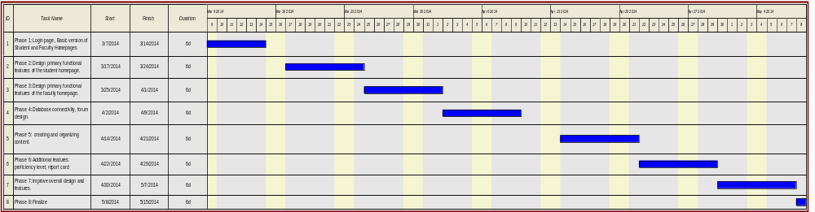

PERT Chart for Project

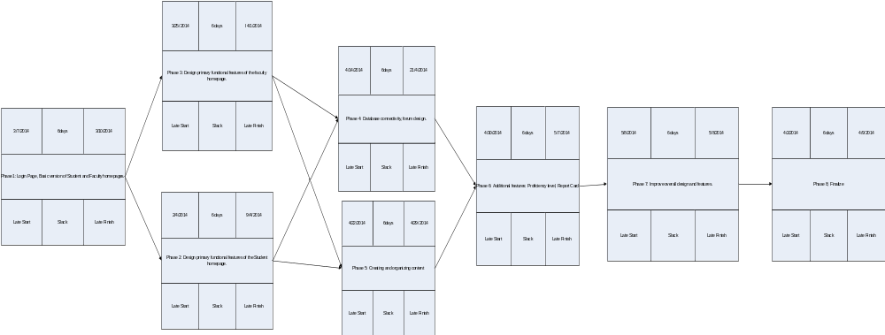

Project Time Line Chart

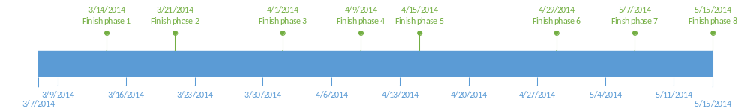

Project Resource Requirements

Hardware/Software Resource Requirements

Hardware Requirements
- Internet-enabled Devices

Software Requirements
- HTML5 supported web browser

Risk Management

Risk Management Strategy

Experimenting with alternatives to solve issues specific to hardware/software.

Initial Risk List

This is the initial risk list; the risks are listed in priority order from top to bottom. Descriptions are provided below the table. Risks with a pre-mitigation magnitude of 2.0 or below are not listed.

Risk  number | Risk Priority (H, M, L) | Likelihood  of  Occurrence | Risk name: brief description | Mitigation Strategy  “ACCEPTED” or “MITIGATED” with pointer to plan.
1 | M | Very low | DB connectivity issues | MITIGATED
2 | M | Low | Cross-browser compatibility issues | ACCEPTED
3

