Software Requirements Specification

For AllAboutAlgorithms

(An interactive website for learning algorithms)

### Team guide:

Lydia Jane

## Team members:

Kushagra (11BCE0068)

VIT Univeristy

Vellore

# Table of Contents

**1 Introduction** ..............................................................................................3

1.1 Purpose ..................................................................................................3

1.2 Scope ......................................................................................................3

1.3 Definitions, Acronyms, and Abbreviations ............................................3

1.4 References ..............................................................................................3

**2 Overall Description** ....................................................................................4

2.1 Product Perspective................................................................................4

2.2 Product Functions ..................................................................................4

2.3 User Characteristics ...............................................................................4

2.4 Stakeholders…………................................................................................5

2.5 Entity Relationships ...............................................................................6

**3 Specific Requirements** ..............................................................................7

3.1 System Features .................................................................................. ..7

3.2 Non Functional Requirements ...............................................................9

# Introduction:

This section is meant to give a general overview of this document and explain the purpose of each part of the document.

# 1.1 Purpose:

The purpose of the document is to lay out the functionalities, design and general description of a software project to create an interactive website for learning algorithms. It will also discuss the scope of the project, its requirements and the stakeholders involved.

# 1.2 Scope:

This website is intended to provide a comprehensive, interactive and convenient platform to learn about algorithms, what they are, how they work, how to analyze them, and how to write one of our own.

It will serve as a gentle stepping stone for beginners as well as allow adept users to practice and test their skill. It will have text, animations, and practice problems to deepen the learner’s understanding.

# **1.3** Definitions, Acronyms, and Abbreviations:

1. HTML (Hyper Text Markup Language): It is used to create static web pages.
2. CSS (Cascading Style Sheet): It is used to add styling information to a HTML document.
   * 1. WAMP (Windows Apache MySQL PHP): An integrated application package to host websites and provide easy database connectivity.
3. HTTP (Hyper Text Transfer Protocol): It is a transaction oriented client/ server protocol between a web browser and a web server.

# 1.4 References

1. **Electronic Stamp Project Software Requirements Specification from VIT SE lab uploaded materials.**

2. **SRS format from VIT SE lab uploaded materials.**

**3. SRS layout from VIT SE lab uploaded materials.**

# 2.0 Overall Description

## 2.1 Product perspective

AllAboutAlgorithms is a Web-site with the purpose of making the process of learning algorithms easy and interesting. It employs server-side applications to organize, display and interact with the content.

## 2.2 Product Functions

* Allows new users to register to create an account.
* Allows existing users to login via their email id and password.
* Allows users to retrieve their passwords via e-mail.
* A home page that shows introductory content.
* Navigation bar to conveniently navigate to other pages in the project.
* A list of categories and their associated topics.
* Each topic will contain textual descriptions, videos/animations, time and space analysis and associated exercises.
* A dashboard where the learner can plan out his learning, showing the topics he has covered and ones which he intends to cover in the future.
* A report card which the learner can view to gauge his expertise in various topics he has already taken.
* A forum in which users can interact with other users and also with the managing staff.

## 2.3 User Classes and Characteristics

### Learners

* + - * Beginners (users who are completely new to the world of algorithms).
      * Learners with previous experience (users who have done courses on algorithms in their school/college but would like to gain more expertise).
      * Experts (people quite familiar with algorithms and make use of them in their profession who would like to refine their skills and learn more advanced techniques)

### Managing staff

* + - * Maintenance and upgrade( People responsible for finding and fixing bugs and addition of new features)
      * DB administrator( Creating and managing the schema of the database(s))
      * Forum moderators(People responsible for monitoring, restricting and managing the content posted by the forum users)

## 2.4 Stakeholders

The following people are interact with and are affected by the system.

* Registered users.
* Moderators
* Administrators
* Maintenance staff.

## 2.5 Entity Relationship model

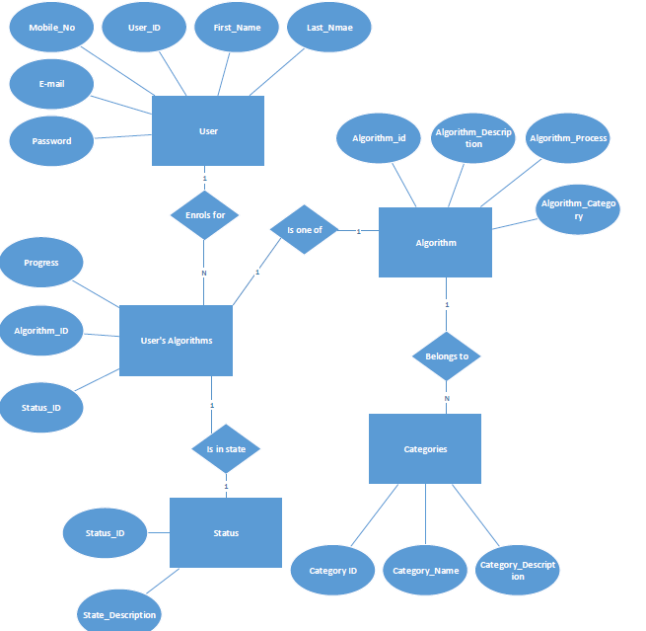

# 3.0 Specific requirements

## 3.1 System features

### Feature 1: Registration

Allows new users to create their accounts by filling a form requiring their personal details like alias name, e-mail address, mobile no, password and a security question.

### Stimulus Response sequence:

1. User accesses the website by typing its URL.
2. User is presented with a dialog box with fields name, password and a captcha and with buttons labeled ‘login’ , ‘new users register’, and ‘forgot password’.
3. User selects ‘new users register’ button.
4. User is redirected to a form with fields labeled ‘name’, ‘password’, ‘phone no.’, ‘email’, and ‘security question’ and buttons ‘register’ and ‘reset’.
5. User fills out the form.
6. Clicking on ‘reset’ clears all fields and clicking on ‘register’ will submit the information.
7. The submitted information is validated and I some information is missing or incorrect information has been entered then the form is displayed again with appropriate error messages. If the data is successfully validated then a new account is created and the form data is registered in the database and the message “Successfully registered” is displayed and an e-mail is sent to the user’s email-id for verification.
8. Once the user follows the e-mail sent to him, his account will marked as validated in the database.

### Feature 2: Login

Allows existing users to login into the website by entering their e-mail ids and passwords.

### Stimulus response Sequence:

1. User accesses the website by typing its URL.
2. User is presented with a dialog box with fields name, password and a captcha and with buttons labeled ‘login’ , ‘new users register’, and ‘forgot password’.
3. User enter his e-mail id, password and a matching captcha and clicks on ‘login’ button.
4. User is admitted into his homepage.

### Feature 3: Password recovery

Allows existing users to recover their forgotten passwords.

### Stimulus Response Sequence:

1. User accesses the website by typing its URL.
2. User is presented with a dialog box with fields name, password and a captcha and with buttons labeled ‘login’ , ‘new users register’, and ‘forgot password’.
3. Users selects the ‘forgot password’ button.
4. He is prompted to enter his e-mail id.
5. An e-mail is delivered to his e-mail id containing his password.

### Feature 4: Navigation Bar

Provides an easy mechanism for accessing different sections of the website.

### Stimulus Response Sequence

1. User successfully logs in to his ‘homepage’.
2. A navigation bar is positioned at the top of the homepage, containing a set of links arranged horizontally.
3. Clicking on a link redirects the user to a different section of the website (Each section of the website also contains the navigation bar at the same position).

### Feature 5: Dashboard

A dashboard where the learner can plan out his learning, showing the topics he has covered and ones which he intends to cover in the future.

### Stimulus Response Sequence

1. User clicks on ‘dashboard’ link in the main navigation bar.
2. User is redirected to his dashboard page with expandable sections ‘currently learning’, ‘finished’, ‘intend to learn’, and ‘Proficiency report’.
3. Clicking on ‘currently learning’ will show the topics the learner has started working on but hasn’t yet finished.
4. Clicking on ‘finished’ will show all topics that the user has already covered.
5. Clicking on ‘intend to learn’ will show all topics that the user intends to learn and will have a ‘edit’ button.
6. Clicking on ‘edit’ will add a ‘remove’ button against each topic, an ‘add new’ button and a ‘save change’ button.
7. Clicking on ‘remove’ will remove the corresponding topic from the list.
8. Clicking on ‘add new’ will show a menu showing topics which are not in his ‘currently studying’ or ‘finished list’ and allow selection of one topic.
9. Clicking on ‘save changes’ will commit the change made to the list to the database.

### Feature 6: Content Viewer

Allows users to access contents of topics.

### Stimulus Response Sequence

1. Users are presents with a list of categories under a ‘Categories’ a section.
2. Clicking on a category will expand that section and present a list of topics.
3. Clicking on a topic will display some introductory text about the topic and have links ‘next’ and ‘previous’.
4. Clicking on ‘next’ will direct the user to the next content in the topic.
5. Clicking on ‘previous’ will direct the user to the previous topic of the topic.

### Feature 7: Forum

Allows users to interact with other user and with the management staff

### Stimulus Response Sequence

1. User is presented with a link named ‘Forum’ on his Navigation bar.
2. Clicking on ‘Forum’ will direct the user to the forum page containing a list of categories.
3. Clicking on a category will expand the section to reveal the threads within the topic.
4. Clicking on a thread will direct the user to the thread page.
5. The thread page contains all posts, each post has a ‘comment’ button. Also buttons for ‘next’, ‘previous’, ‘reply’, and ‘subscribe’ are present.
6. Clicking on ‘comment’ add post by the user aside to the existing post.
7. Clicking on ‘reply’ will add a fresh post in the thread.
8. Clicking on ‘next’ will direct the user to the next page in the thread.
9. Clicking on previous will direct the user to the previous page in the thread.
10. Clicking on ‘subscribe’ will notify the user of any new activity in the thread via an e-mail.

## 3.2 Non-Functional requirements

* Responsive (clicking on a link should fetch the corresponding page within 5 seconds on a lightly loaded server).
* Efficient Data retrieval (Accessing and retrieving a data from the database should not take more than ~5s 95% of the time)
* Well organized content (Content separated in layout should be placed under separate markup tags).
* Visually appealing with good color mix, styling, animations, margins and border( Text should be clearly visible over the background. Text size should be sufficient to be viewed from a distance of 90cm from screen).
* Easy and hassle-free user interaction(No overlapping content, clearly identifiable and bold buttons and links).