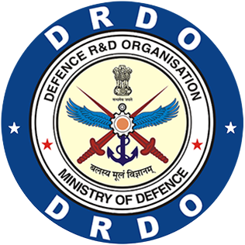

**Defense Research and Development Organisation**

**Metcalfe House, New Delhi-110054**

**Internship Report**

**Submitted By:**   **Submitted to:**

Kushagra Shukla Shri Vinay Verma

Trainee Scientist ‘E’

Bennett University DRDO

# Certificate:

# Acknowledgement:

I am incredibly grateful to my internship mentor, Shri Vinay Verma Scientist ‘E’, for their invaluable guidance and support throughout my internship. From the moment I started, Shri Vinay Verma Sir took the time to get to know me and understand my goals for the internship. He provided me with clear direction and expectations and were always available to answer my questions and provide valuable feedback.

Throughout the internship, Shri Vinay Verma Sir provided me with invaluable insights and advice that helped me to grow as a professional. His constructive feedback helped me to improve my skills and approach to my tasks, and the encouragement kept me motivated and focused. I am deeply thankful for Vinay Sir’s time and effort, and for their commitment to my success.

I would also like to thank DRDO for giving me this opportunity to learn and grow as a trainee in the field of cybersecurity and to my college, Bennett University, for providing me the letter of recommendation without which I wouldn’t be able to apply for this opportunity.

**Contents**

Certificate: 2

Acknowledgement: 3

Table of Figures 5

Acronyms: 6

About the Report: 7

Referenced Study 8

Introduction: 9

Problem Statement: 10

Software Analysis: 11

Requirement Analysis: 11

Risk Analysis: 11

Feasibility Analysis: 12

Solution: 13

Technologies Used: 14

Platform: 14

Programming Language: 15

Framework: 16

Database: 17

Development Requirements: 18

Deployment Requirements: 18

Introduction to the Application: 19

Description: 19

Features: 19

Screen Shots: 20

Challenges during Development: 29

Learning: 30

Summary: 32

References: 33

# Table of Figures

Figure 1: Login and Register Page 20

Figure 2: Dashboard (Default page after signing) 20

Figure 3: Responses Page 21

Figure 4: Response details according to their categories 21

Figure 5: Profile page 22

Figure 6: Change Password 22

Figure 7: Add Resources Page 23

Figure 8: Forms Page (All Forms Created by the Admin) 23

Figure 9: Create New Audit/Response 24

Figure 10: Fill Employee details to Audit 24

Figure 11: Form to Audit 25

Figure 12: Filling the form (Remarks are optional) 26

Figure 13: Create a Form (only Admin) 26

Figure 14: Edit the Form (Only Admin) 27

Figure 15: Category Management 27

Figure 16: Users Page 28

# Acronyms:

* ISO: **International Organization for Standardization.**
* DRDO: **Defense Research and Development Organization.**
* SAG: **Scientific Analysis Group.**
* MERN: **MongoDB ExpressJs ReactJs Node.**
* ISMS**: information security management systems**.

# About the Report:

The purpose of this report is to examine and explore the significant role of a software to achieve streamlined process of ISO Compliance Management System. International Organization for Standardization (ISO), a non-governmental and independent organization that develops and publishes standards that outlines best practices for quality management, environmental sustainability, and information security. The report explores the benefits of using software to achieve ISO compliance, including improved efficiency, greater accuracy, and reduced human error. This report provides an overview of myriad of software’s available for ISO compliance, such as document management software, quality management software, and environmental management software. Additionally, discusses about the software I created, it’s features and functionalities such as automated resource management, creating audit forms for auditors to quickly select from and perform audits in an effective and easy-to-handle way; and highlights the challenges associated with implementing ISO compliance software, such as the need for IT support and training.

# Referenced Study

1. [MUI."Docs”, https://mui.com/material-ui/getting-started/overview/](https://mui.com/material-ui/getting-started/overview/)
2. [MongoDB. "Docs", https://www.mongodb.com/docs/](MongoDB.%20%22Docs%22,%20https://www.mongodb.com/docs/)
3. <https://www.fdic.gov/regulations/resources/director/presentations/cms.pdf>
4. [React. https://react.dev/learn](https://react.dev/learn)
5. [Stack Overflow. https://stackoverflow.com](https://stackoverflow.com)
6. [W3schools. https://www.w3schools.com](https://www.w3schools.com)

# Introduction:

Information security is the practice of protecting information by mitigating information risks. It involves the protection of information systems and the information processed, stored and transmitted by these systems from unauthorized access, use, disclosure, disruption, modification or destruction.

**Importance of Information Security:**

Information security is paramount in safeguarding sensitive data and maintaining trust in digital systems. Breaches in information security can result in financial losses, reputational damage, and legal consequences. By implementing robust information security measures, organizations can protect their assets, preserve data integrity, and demonstrate compliance with regulatory requirements.

**Principles of Information Security:**

Information security is guided by fundamental principles that underpin its effectiveness. These principles include confidentiality, ensuring that information is accessible only to authorized individuals; integrity, maintaining the accuracy and trustworthiness of data; availability, ensuring that information and systems are accessible when needed; authentication, verifying the identity of users accessing information or systems; authorization, granting appropriate access rights based on user roles; and non-repudiation, providing evidence to prove the occurrence of actions or transactions.

**Significance of ISO Policies:**

ISO provides internationally recognized standards and guidelines for information security management systems (ISMS). Adhering to ISO policies enables organizations to establish a systematic approach to information security, identify risks, implement appropriate controls, and continuously improve their security posture. ISO 27001 outlines requirements for establishing, implementing, maintaining, and continually improving an ISMS.

In conclusion, information security is a critical aspect of today's digital landscape. By understanding its importance, adhering to fundamental principles, addressing common threats and vulnerabilities, implementing robust controls, and following ISO policies, organizations can enhance their information security posture and protect valuable data and systems from unauthorized access or misuse.

## Problem Statement:

An Audit system for Information Security of any organization is a must, but there are myriad of challenges that can impact the effectiveness and efficiency of the auditing process. Some of the common challenges faced during IS auditing are:

1. **Complexity of Information Systems:** Information systems have become increasingly complex, incorporating numerous technologies, platforms, and interconnected components. Auditors may face challenges in understanding the intricate systems and their interactions, making it difficult to assess risks and identify potential vulnerabilities. Auditors need to continually update their knowledge and skills to effectively evaluate new technologies and emerging risks.
2. **Lack of Documentation:** Inadequate or incomplete documentation of information systems and processes can hinder the auditing process. Without proper documentation, auditors may face difficulties in understanding system controls, data flows, and associated risks.
3. **Limited Access to Information:** Auditors often encounter challenges in obtaining access to relevant data and information necessary for conducting an audit. Limited access may hinder their ability to perform comprehensive assessments and identify potential control weaknesses.
4. **Time and Resource Constraints:** IS auditing requires significant time and resources to conduct thorough assessments. However, auditors may face challenges in allocating sufficient time and resources due to competing priorities or limited budgets, which may impact the depth and coverage of the audit.
5. **Keeping Pace with Regulatory and Compliance Requirements:** Auditors must stay updated with evolving regulatory and compliance requirements related to information security. Complying with various legal, industry-specific, and international standards can be challenging, especially when these requirements change frequently.

Overcoming these challenges can contribute to more effective and comprehensive IS auditing, enabling organizations to identify and mitigate information security risks and ensure the integrity of their systems and data.

## Software Analysis:

### **Requirement Analysis:**

The requirement analysis for ISO compliance software involves understanding the needs and expectations of businesses in managing their compliance efforts. Some of the key requirements of ISO compliance software include:

* **Document management:** The software should provide a centralized repository for policies, procedures, and records, making it easy for businesses to manage their documentation.
* **Auditing capabilities:** The software should provide tools to schedule, conduct, and track internal audits, helping businesses identify areas of non-compliance.
* **Change management:** The software should help businesses stay up to date with changes to ISO standards, providing tools to track changes and ensure that processes align with the latest standards.
* **User-friendly interface:** The software should be easy to use, with a user-friendly interface that makes it easy for businesses to manage their compliance efforts.

### **Risk Analysis:**

Risk analysis is an essential part of developing ISO compliance software. Some of the key risks involved in developing and implementing ISO compliance software include:

* **Security risks:** Compliance software will contain sensitive information about the business's compliance efforts, making it a potential target for cyber-attacks.
* **Data privacy risks:** Compliance software will contain personal data, including employee data and customer data, making it essential to ensure that the software complies with data privacy regulations.
* **Compliance risks:** The software must comply with ISO standards, making it essential to ensure that the software aligns with the latest standards.
* **Usability risks:** If the software is difficult to use, businesses may struggle to manage their compliance efforts effectively, leading to non-compliance issues.

### **Feasibility Analysis:**

Feasibility analysis is necessary to determine whether developing and implementing ISO compliance software is viable. Some of the key factors to consider in feasibility analysis include:

* **Technical feasibility:** The software must be technically feasible, with the necessary features and capabilities to meet the needs of businesses in managing their compliance efforts.
* **Financial feasibility:** Developing and implementing ISO compliance software will require significant investment, making it essential to assess the financial feasibility of the project.
* **Legal feasibility:** The software must comply with data privacy regulations and other legal requirements, making it essential to assess the legal feasibility of the project.
* **Market feasibility:** There is a growing demand for ISO compliance software, making it essential to assess the market feasibility of the project and determine whether there is a viable market for the software.

In conclusion, requirement analysis, risk analysis, and feasibility analysis are essential components of developing and implementing ISO compliance software. By conducting these analyses, businesses can ensure that the software meets their needs, complies with regulations, and is viable in the marketplace. ISO compliance software can help businesses manage their compliance efforts more efficiently, reducing the risk of non-compliance issues and improving overall compliance management.

## Solution:

In this modern era, where everything works around the concept of efficiency and effectiveness, the need of an automated or semi-automated system are hugely in demand and especially in the field Information technology where the ratio of data to its security is rather low even though there are plethora of Standards for them.

This is where an ISO Compliance Software comes in not only it can help people understand the importance of a centralized hub for its data secrecy and security but also can help in spreading awareness throughout the people collectively or individually. It can help in providing efficient ways of managing IT related problems and if we automate things, we can also increase our Network Securities by creating a network node health checker which can check for any issues or unrecognized activity anywhere in that network.

I created an ISO Compliance Software called ezComplaince, which is still under progress and a lot of testing. Currently the software has features such as: -

* **Physical Audit Questionnaire System:** This is a feature which works depending on the role-system i.e., Admins can create the Audit Forms (which follows latest ISO Compliance guidelines) and Auditors can access those forms for auditing.
* **Resource Management:** A feature to that stores information about the resources (generally IT) owned by that employee, this helps in efficiently managing the resource data and eliminates any mismatch or loss of important records about the all the resources that have been purchased or owned by an employee
* **Role-Based Authentication:** In a business management software it is a required feature to be able to authenticate according to the user role. Since, not every information is meant to be displayed for everyone in the organization and it also helps in regulating order and managing data privacy according to a basic hierarchal system.

The software can manage large databases easily due to MongoDB as a NOSQL database platform which offers high flexibility, scalability and somewhat easy-to-use platform which offers various operations like transactional, search, analytics abilities in a form of cloud-hosted, user-friendly platform.

The software is currently hosted on a cloud-based platform, but the main purpose or goal of this software will be fulfilled when it can be successfully hosted on an organization’s intranet network so that it can be personalized accordingly. The software is meant to be used in a private intranet network to ensure that the security of the data lies within that organization’s network only.

# Technologies Used:

## Platform:

* VS Code Editor:

Visual Studio Code (VS Code) is a widely used and highly regarded source code editor developed by Microsoft. It offers a range of features and functionalities that make it an indispensable tool for developers and programmers.

VS Code provides a streamlined code editing experience, supporting multiple programming languages with features such as syntax highlighting, auto-completion, and intelligent code suggestions. It also includes an integrated terminal, allowing developers to execute command-line tools and scripts within the editor itself, eliminating the need for switching between different applications.

One of the standout features of VS Code is its robust debugging capabilities. It offers breakpoints, step-through debugging, and variable inspection, enabling developers to identify and resolve issues efficiently. Additionally, VS Code seamlessly integrates with popular version control systems like Git, simplifying code management and facilitating collaboration.

Visual Studio Code (VS Code) is a versatile and powerful source code editor that offers an array of features, extensibility, and cross-platform support. Its integration with version control systems, debugging capabilities, and extensive marketplace of extensions make it an essential tool for developers in various domains.

## Programming Language:

* **HTML:** HTML is the backbone of web development and is used for structuring the content of web pages. It provides a set of predefined elements and tags that define the layout and organization of text, images, links, forms, and other media. With HTML, I was able to create the basic structure and semantic markup of the website, ensuring proper accessibility and search engine optimization.
* **CSS:** CSS is responsible for the presentation and visual styling of web pages. By using CSS, I could define the colors, fonts, layout, and overall design of the website. With CSS, I could apply styles to specific HTML elements or classes, making it easier to maintain a consistent look and feel across different pages of the website.
* **JavaScript:** JavaScript is a powerful scripting language that enables interactivity and dynamic behavior on web pages. With JavaScript, I could add functionality to the website, such as form validation, interactive elements, animations, and more. It allows for client-side scripting, meaning that the code is executed on the user's browser, providing a rich and interactive experience.
* **JSON Script:** JSON is a lightweight data interchange format that is often used to transmit data between a web server and a web application. It provides a structured way to represent and store data in a human-readable format. In the context of web development, JSON is commonly used for APIs (Application Programming Interfaces) to send and receive data asynchronously between the server and the client-side JavaScript code.

Since, **MongoDB** uses **JSON** script for incorporating it to backend to retrieve data, manipulate it, and dynamically update the website's content without requiring a full page reload. This allows for a seamless and efficient user experience, as data can be fetched and displayed in real-time.

## Framework:

In addition to the programming languages mentioned earlier, I also utilized certain frameworks to enhance the functionality and design of the website. The frameworks I incorporated are ReactJS, MUI (Material-UI), and ExpressJS.

* **ReactJs:** ReactJS is a popular JavaScript library for building user interfaces. It follows a component-based approach, allowing developers to create reusable UI components and efficiently manage the state of the application. By leveraging ReactJS, I could build a responsive and interactive website with ease. ReactJS utilizes a virtual DOM (Document Object Model) for efficient rendering, providing a seamless and efficient user experience.
* **MUI:** MUI, also known as Material-UI, is a UI component library that implements the Material Design principles. It offers a wide range of pre-designed and customizable components, such as buttons, inputs, cards, and navigation bars, to create a visually appealing and consistent user interface. By utilizing MUI, I could save development time and ensure a cohesive and professional look for the website.
* **ExpressJS:** ExpressJS is a fast and minimalist web application framework for Node.js. It simplifies the process of building robust and scalable web applications by providing a set of features and utilities. With ExpressJS, I could handle routing, manage server-side logic, and integrate with databases or other external services. This framework allowed me to create a backend infrastructure to support the website's functionality and handle various HTTP requests effectively.

By incorporating these frameworks, I could leverage their respective advantages to streamline development, enhance the user interface, and ensure efficient communication between the client and server. ReactJS provided a solid foundation for building dynamic and reusable components, while MUI contributed to a visually appealing and consistent design. ExpressJS empowered me to handle server-side operations seamlessly, making the website robust and scalable.

## Database:

* **MongoDB:**

To store and manage the website's data, I utilized MongoDB as the database system. MongoDB is a popular NoSQL database that provides a flexible and scalable approach to data storage. Unlike traditional relational databases, MongoDB uses a document-oriented model, where data is stored in JSON-like documents.

MongoDB's schema-less nature allows for dynamic and evolving data structures, making it well-suited for web applications where data requirements may change over time. This flexibility enables efficient handling of unstructured or semi-structured data, accommodating the needs of modern web development.

With MongoDB, I could store various types of data, such as user profiles, audit forms, resources, response data or any other relevant information for the website. The document-based structure of MongoDB allows for easy retrieval, manipulation, and querying of data, supporting efficient and scalable data operations.

Additionally, MongoDB's scalability features, such as sharding and replica sets, enable the database to handle high traffic and large data volumes effectively. This ensures that the website can accommodate growing user demands and maintain optimal performance.

By utilizing MongoDB as the database for the website, I could leverage its flexibility, scalability, and efficient data handling capabilities. It provides a reliable and robust foundation for storing and retrieving data, allowing the website to deliver a seamless and responsive experience to its users

# Development Requirements:

1. Efficiency in Full-Stack Development Languages especially in MERN stack.
2. A good system which can handle all the processes and running for larger and more heavy tasks.
3. Integrated development environment (IDE) or code editor (e.g., Visual Studio Code, Sublime Text).
4. Node.js and npm (Node Package Manager) for managing dependencies.
5. ExpressJS framework for server-side routing and API development.
6. Knowledge of MongoDB database for database management and it’s offline deployment services.

# Deployment Requirements:

1. **A System/ Virtual machine:** Set up a dedicated system or virtual machine within the intranet network to host the website. Ensure that the system meets the minimum requirements for running the website, including sufficient processing power, memory, and storage capacity.
2. **Server:** Install and configure a web server software, such as Apache or Nginx, on the system or virtual machine. The web server will handle incoming HTTP requests and serve the website content to clients within the intranet network.
3. **Local Network:** Ensure that the intranet network is properly set up and configured to allow access to the website. This includes configuring network devices, such as routers and firewalls, to enable traffic between the clients and the web server hosting the website.
4. **Website:** A private website which can only be accessed through company domains and servers.
5. **Maintenance:** Establish a maintenance plan for the website to ensure its continuous availability and optimal performance. This includes regular monitoring of the website, applying updates and patches to the underlying software and frameworks, performing backups of the website data, and addressing any issues or bugs that may arise.

# Introduction to the Application:

## Description:

A management system standard which sets out the requirements and provides guidelines for establishing, developing, implementing, evaluating, maintaining, and continually improving a compliance management system (CMS).

The International Organization for Standardization (ISO) is an international organization that sets worldwide proprietary, commercial, and industry standards. ISO has issued thousands of standards aimed to support organizations in delivering products and services that are of higher quality, safer, more secure, and environmentally friendly. ISO standards are important because they provide organizations and their customers with a shared benchmark of quality and safety of processes, services, products. Well-known ISO standards include ISO 9001 for quality management systems, ISO 20000 for IT service management systems, ISO 27001 for IT security management systems, ISO 14001 for environmental management systems, and ISO 45001 for occupational health and safety. While not required by law for all industries, ISO certifications are highly regarded and internationally recognized.

## Features:

1. **Compliance Management:** The core focus of the website is to provide compliance management solutions. It aims to help organizations streamline their compliance processes, maintain regulatory standards, and mitigate risks associated with non-compliance.
2. **Document Repository:** The platform offers a document repository where users can securely store and manage their compliance-related documents. This feature is designed to facilitate easy access and retrieval of important compliance documentation.
3. **Task and Workflow Management:** Users can create tasks, assign responsibilities, and track the progress of compliance-related workflows. This feature is intended to enhance collaboration and ensure that compliance activities are completed efficiently.
4. **Compliance Reporting:** The website claims to provide comprehensive reporting capabilities, allowing users to generate compliance reports and analyse compliance performance over time. This feature can be valuable for organizations seeking to monitor and evaluate their compliance efforts.

## Screen Shots:

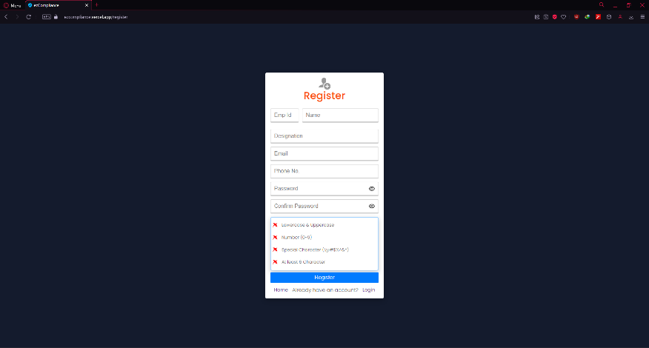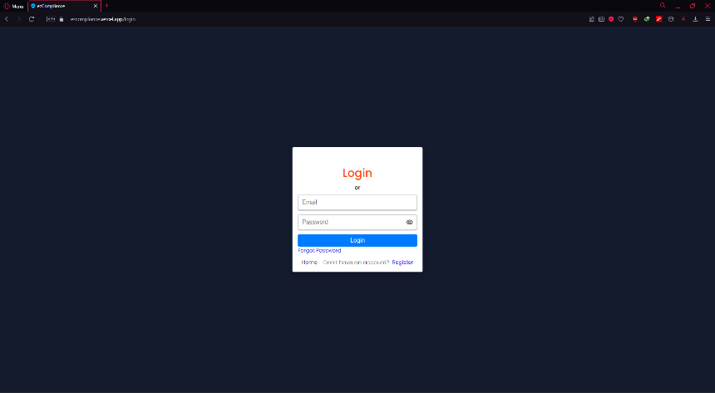

Figure 1: Login and Register Page

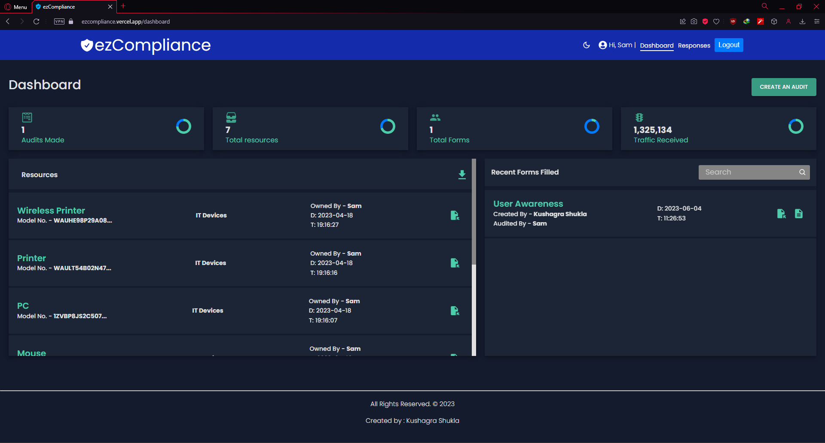

Figure 2: Dashboard (Default page after signing)

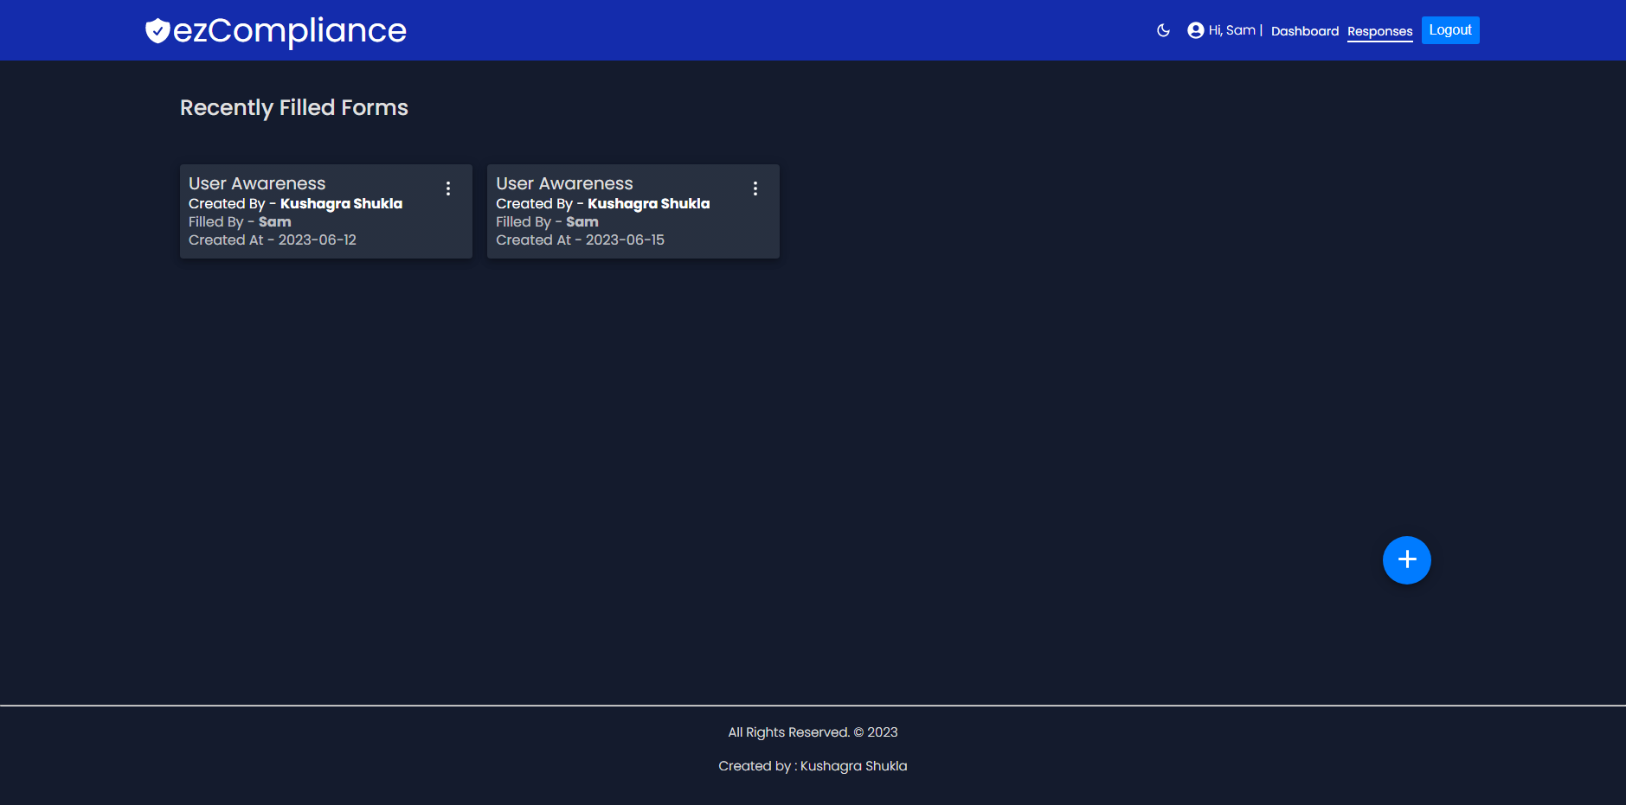

Figure 3: Responses Page

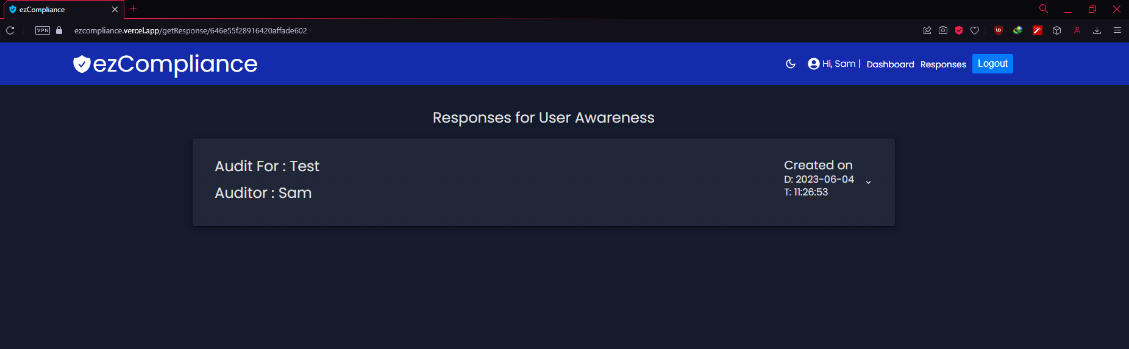

Figure 4: Response details according to their categories

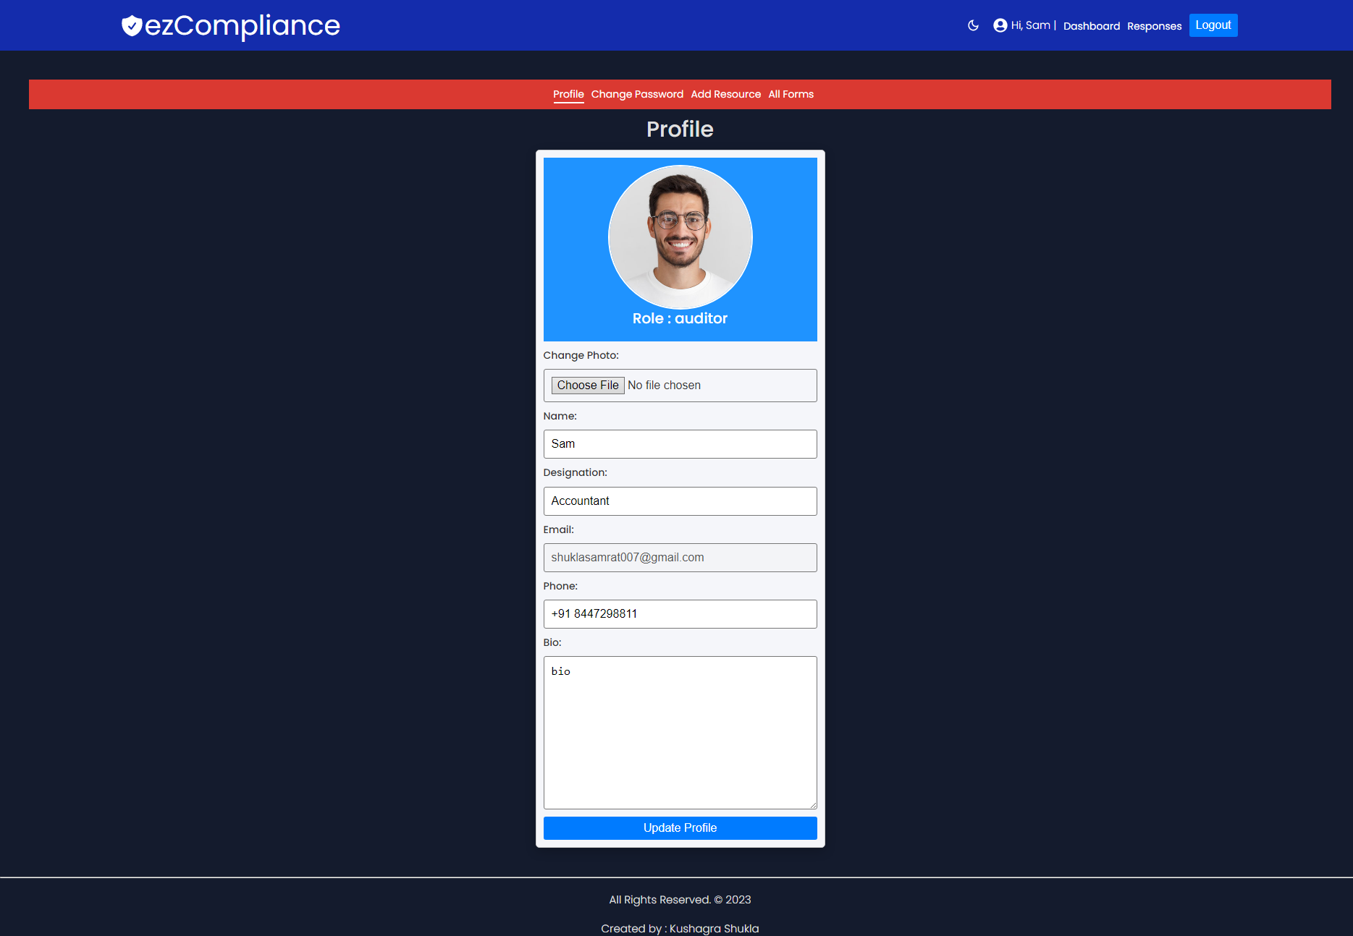

Figure 5: Profile page

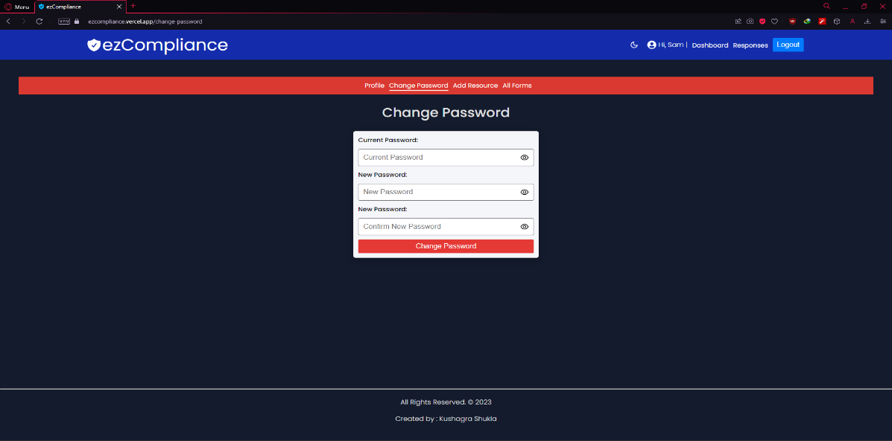

Figure 6: Change Password

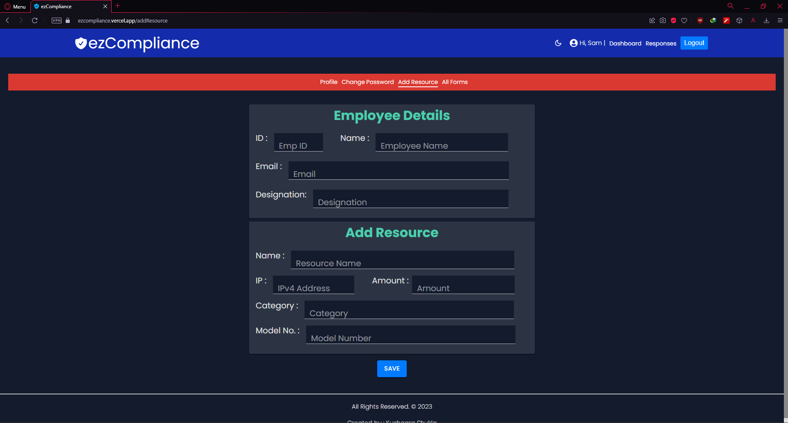

Figure 7: Add Resources Page

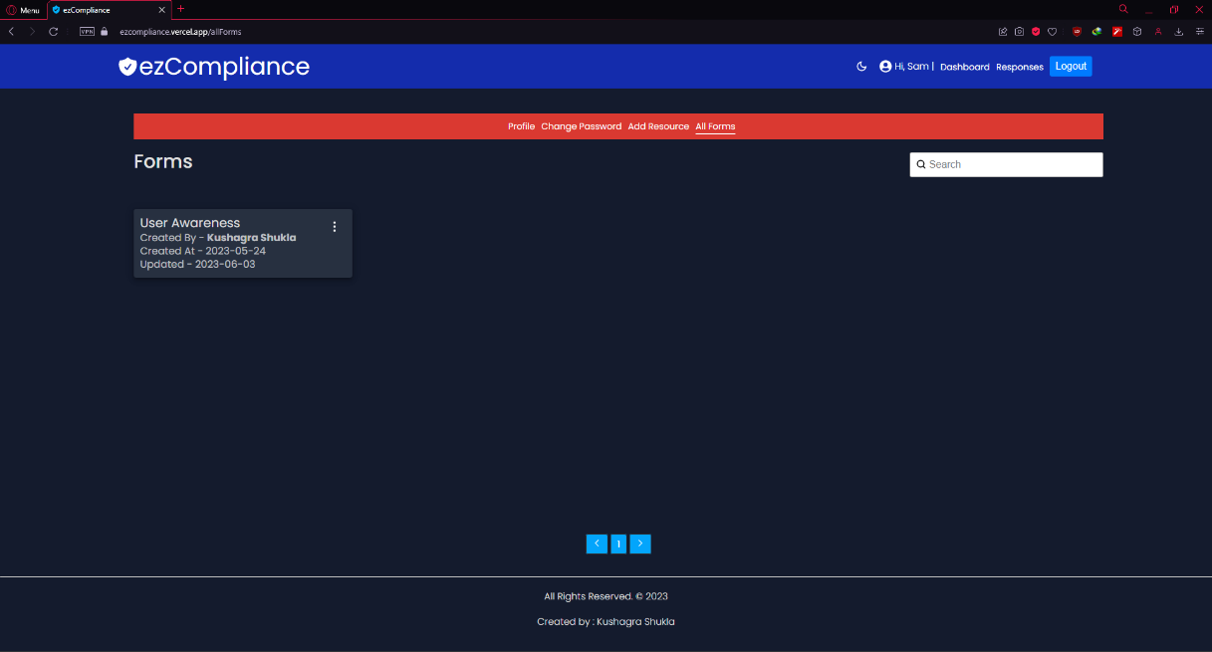

Figure 8: Forms Page (All Forms Created by the Admin)

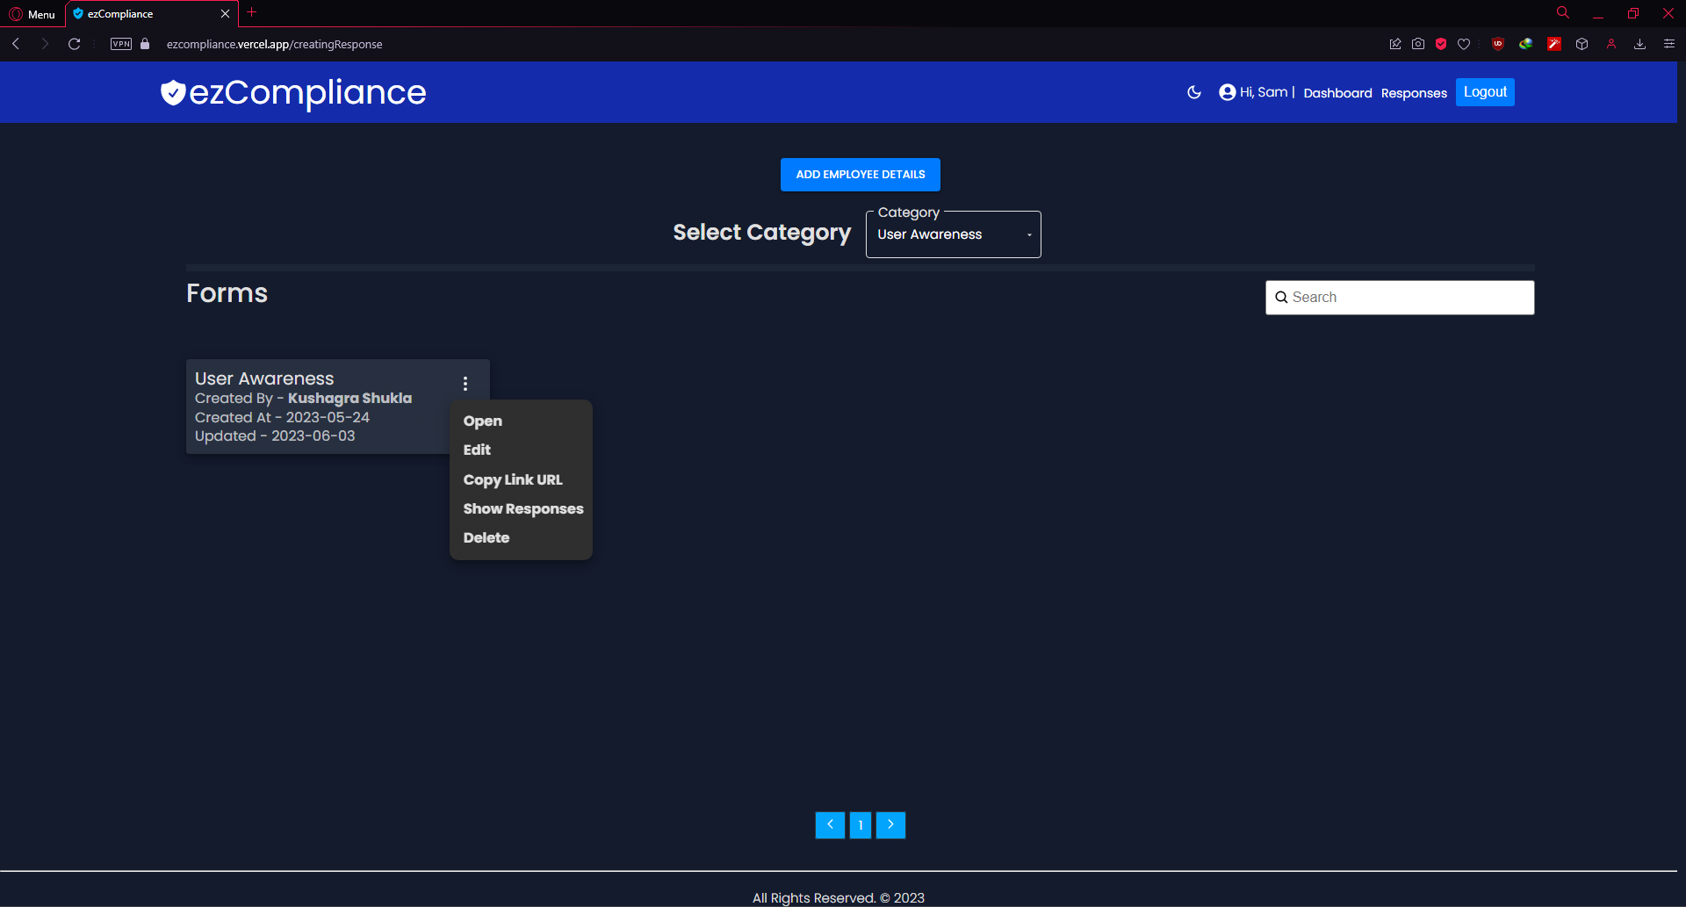

Figure 9: Create New Audit/Response

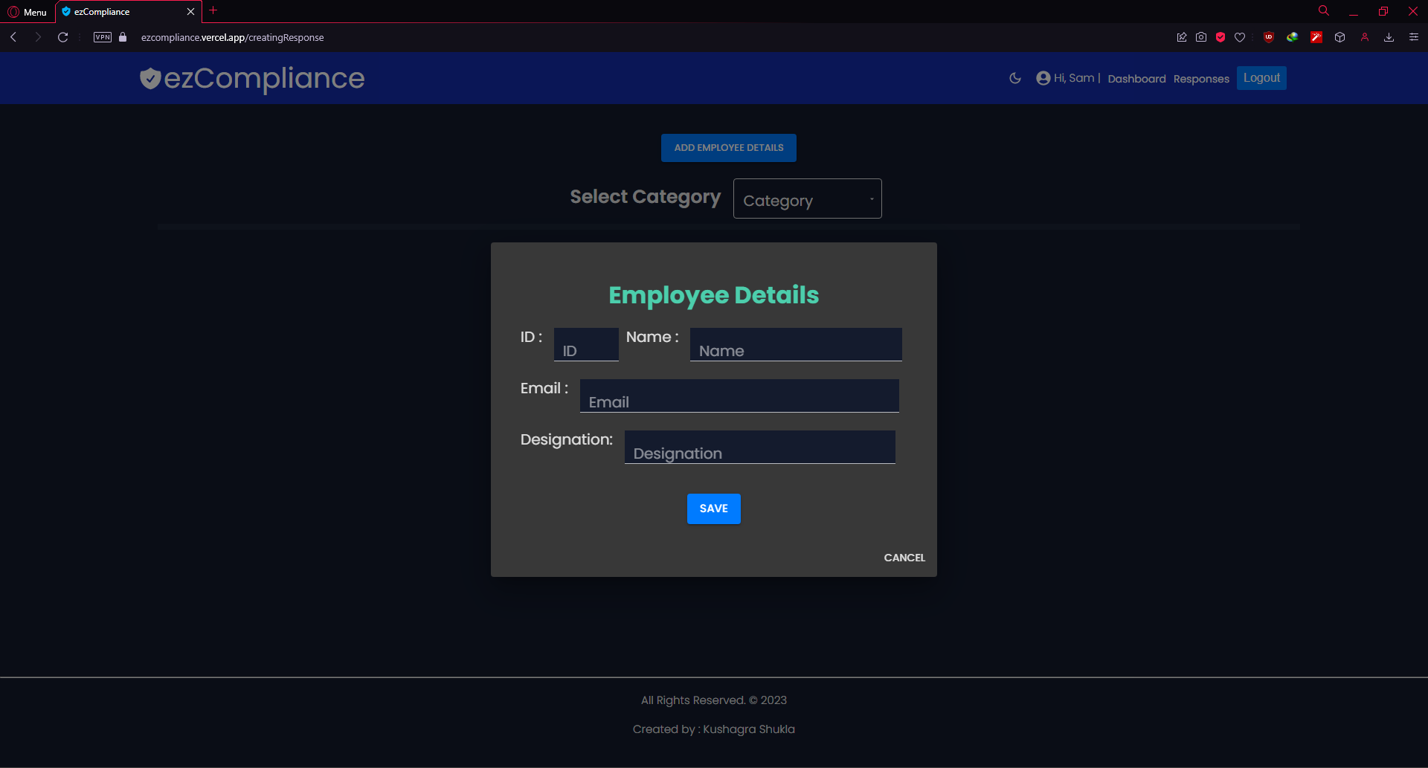

Figure 10: Fill Employee details to Audit

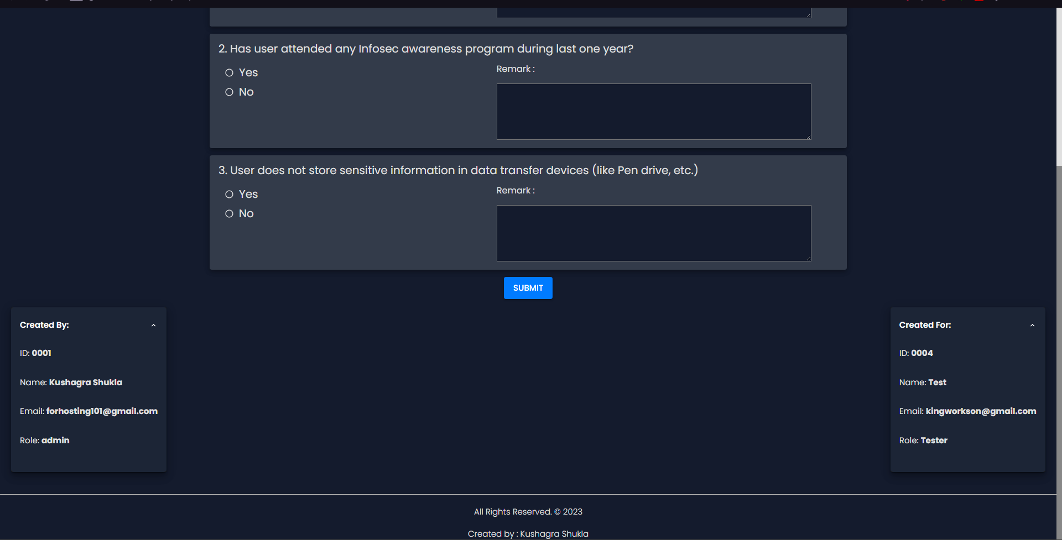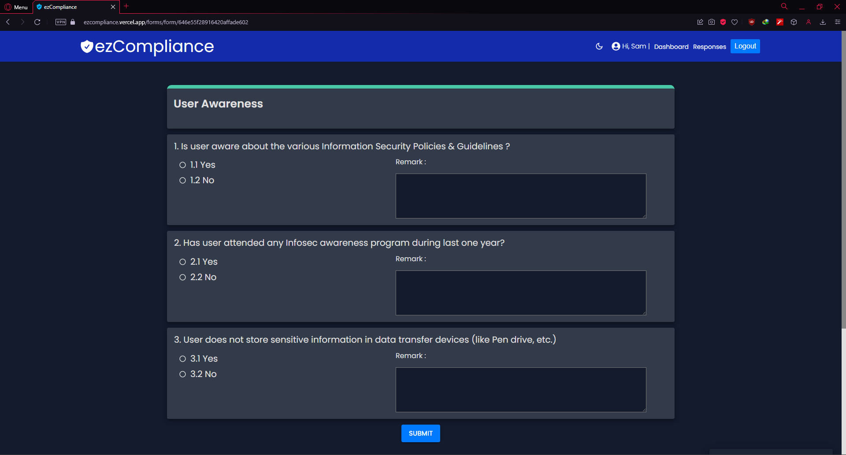

Figure 11: Form to Audit

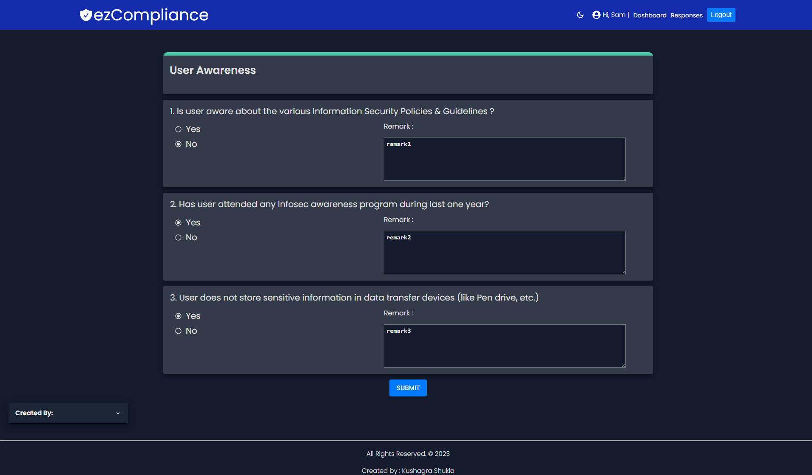

Figure 12: Filling the form (Remarks are optional)

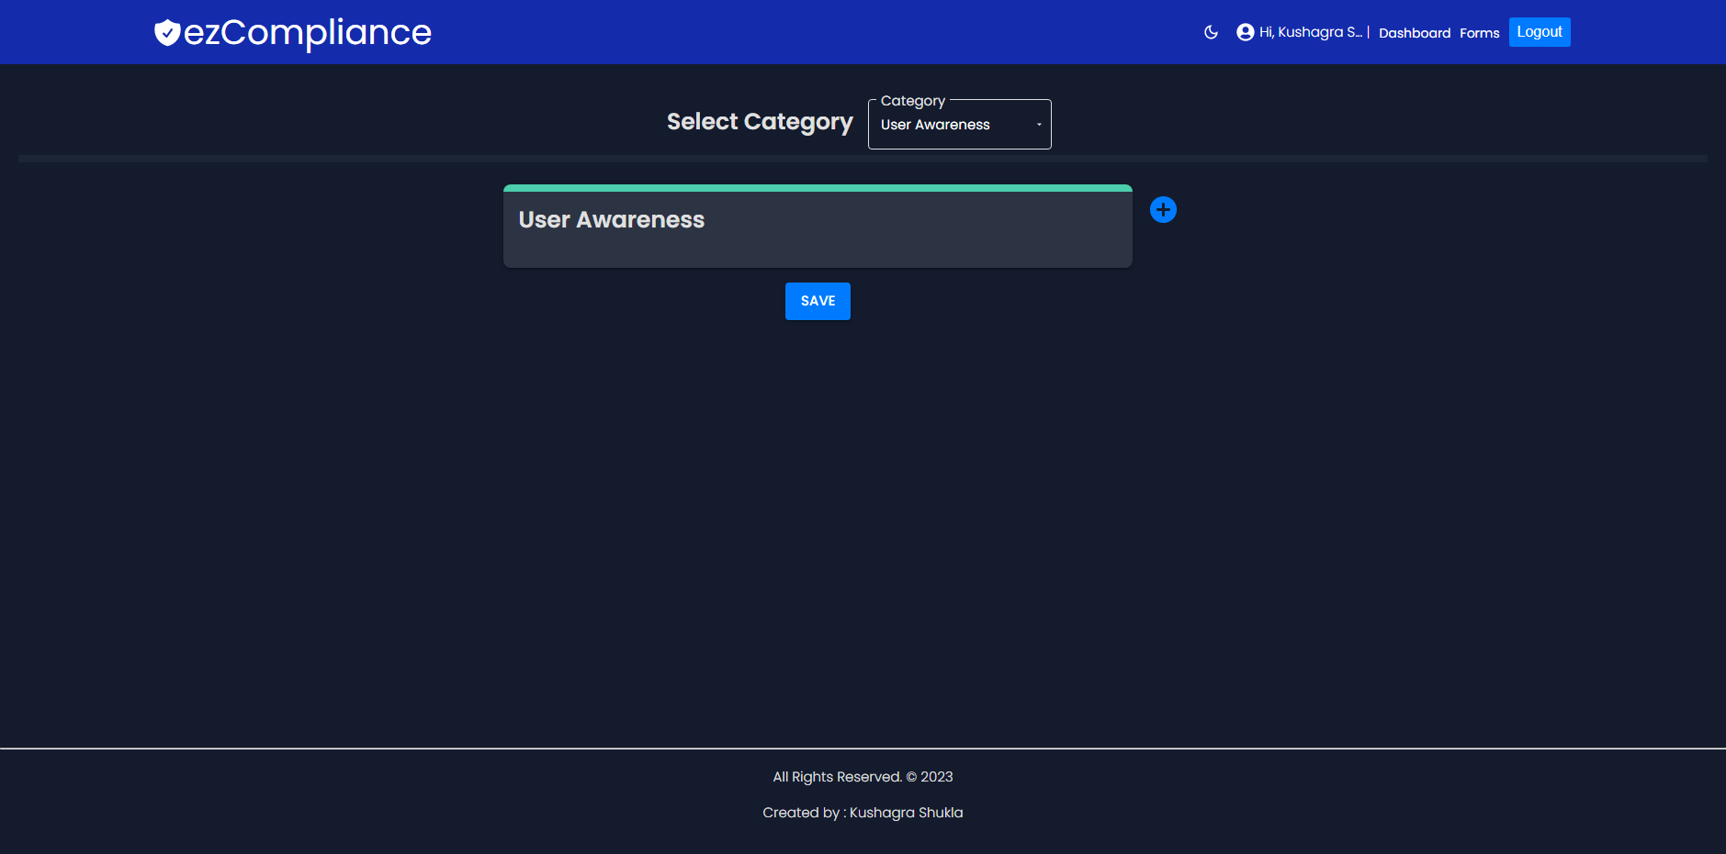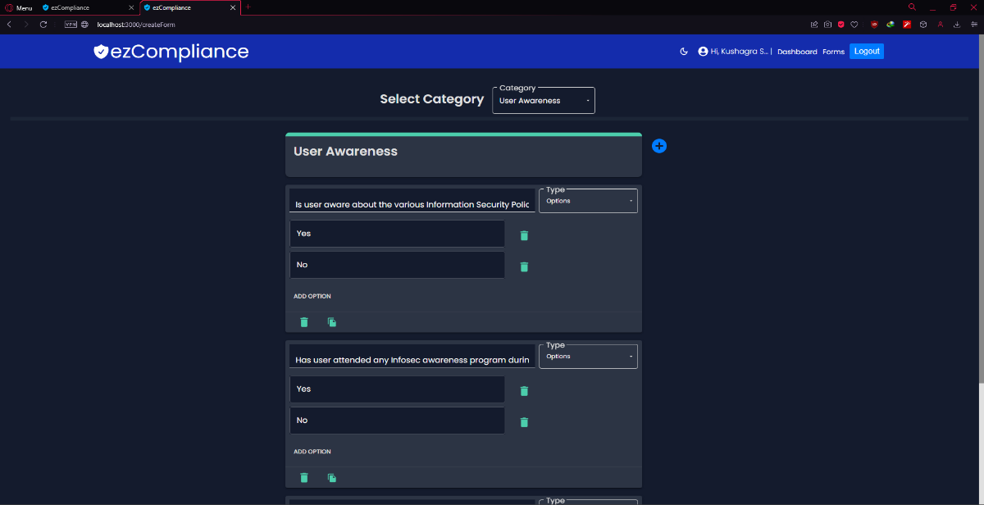

Figure 13: Create a Form (only Admin)

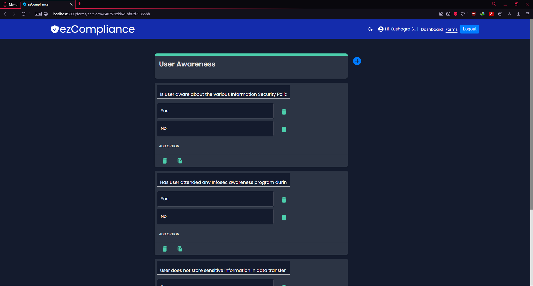

Figure 14: Edit the Form (Only Admin)

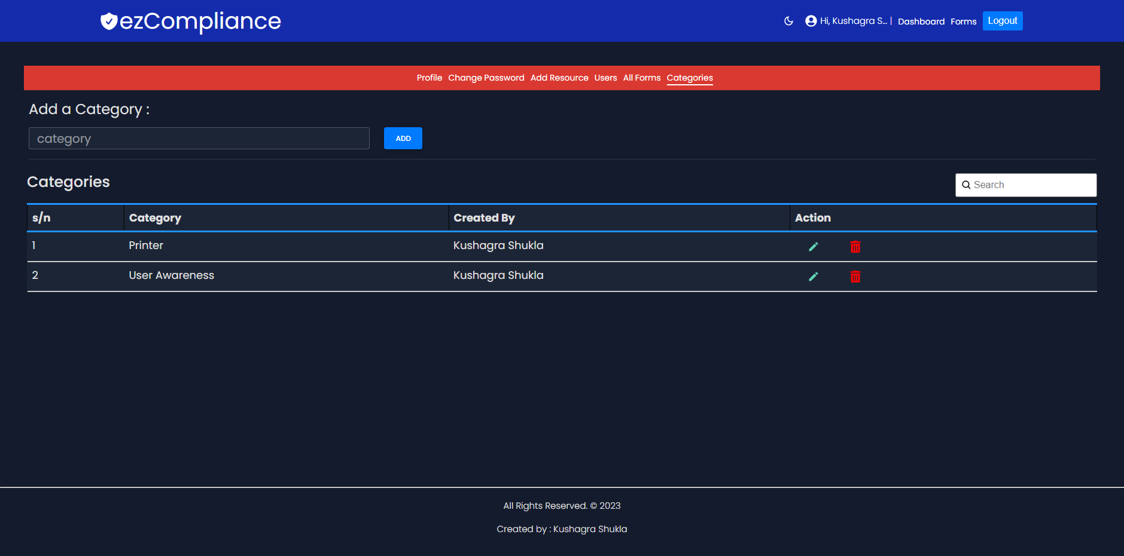

Figure 15: Category Management

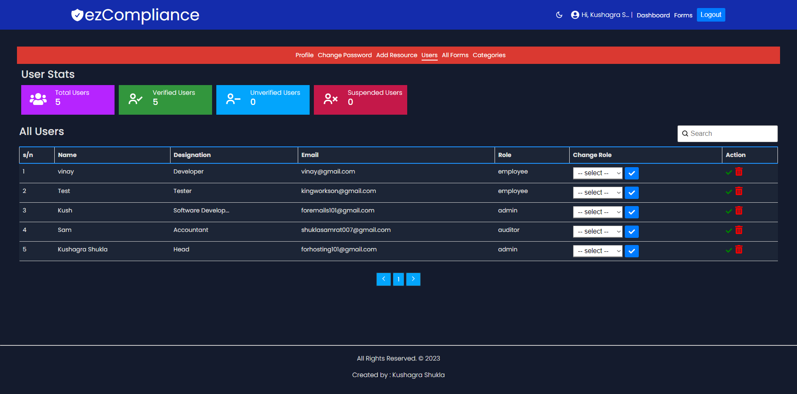

Figure : Users Page

# Challenges during Development:

During the development process of the website, I encountered several challenges that required extra effort and learning. These challenges included:

1. **No Prior Experience in Modular Programming:** One of the challenges I faced was the lack of prior experience in modular programming. This required me to understand and implement modular design patterns to ensure a well-organized and maintainable codebase. I had to invest additional time in learning and applying modular programming concepts effectively.
2. **No Prior Knowledge on CMS (Compliance Management Systems):** Another challenge I encountered was the lack of prior knowledge about Compliance Management Systems (CMS). I had to familiarize myself with the specific requirements and functionalities of a CMS to develop the compliance-related features of the website effectively. This required extensive research, understanding regulatory frameworks, and implementing compliance workflows within the application.
3. **In-depth Knowledge on MongoDB and its Features:** Since I chose MongoDB as the database for the website, I faced the challenge of gaining more in-depth knowledge of MongoDB and its features. I needed to understand its querying capabilities, data modelling, and indexing techniques to optimize the database performance and ensure efficient data storage and retrieval.
4. **Custom Intranet Integration for Enhanced Security:** To meet the requirement of deploying the website on an offline intranet network, I faced the challenge of implementing custom integration of back-end services. This involved configuring the network infrastructure and ensuring secure communication between different components of the application within the intranet environment. I had to carefully design and implement security measures to protect sensitive data and maintain the integrity of the system.

Despite these challenges, I persevered and successfully addressed them through continuous learning, research, and diligent effort. These challenges provided valuable opportunities for growth and expanding my expertise in various areas of development.

# Learning:

During the development process of the website, I had the opportunity to acquire valuable learning experiences that expanded my knowledge and skills in various areas of application development. Here are the key learnings I gained:

1. **Learned Various Techniques of Industry-level Application Development:** During the project, I had the opportunity to explore and implement various techniques used in industry-level application development. This included understanding and applying best practices, design patterns, and software development methodologies. I gained a deeper understanding of building scalable, efficient, and maintainable applications that meet industry standards.
2. **NoSQL Databases:** Working with MongoDB as a NoSQL database provided me with hands-on experience in leveraging its features and functionalities. I learned how to model data effectively, perform advanced queries, and optimize database performance. Understanding NoSQL databases expanded my knowledge beyond traditional relational databases and equipped me with the skills to work with diverse data storage solutions.
3. **Backend Server Integration for Private Network:** The project involved integrating the backend server with a private network, which required knowledge of network configurations and security protocols. I learned how to set up secure communication channels, implement encryption protocols, and ensure seamless integration within a private network environment. This experience deepened my understanding of network infrastructure and enhanced my ability to handle secure server integrations.
4. **Management Systems for Better Understanding:** Exploring Compliance Management Systems (CMS) provided me with insights into compliance frameworks, regulations, and workflows. I gained a better understanding of managing compliance-related processes and implementing compliance features within the website. This knowledge enabled me to develop functionalities that align with industry standards and regulatory requirements.
5. **Auditing and ISO Policies:** Throughout the development process, I familiarized myself with auditing practices and ISO policies. I learned about the importance of conducting audits, ensuring data integrity, and adhering to ISO standards. This understanding allowed me to implement robust auditing mechanisms and align the website with relevant ISO policies.
6. **Website Vulnerabilities and How to Handle Them:** As part of the development process, I encountered various website vulnerabilities and learned how to identify and address them. I gained knowledge about common security vulnerabilities, such as cross-site scripting (XSS) and SQL injection, and learned how to implement security measures to mitigate these risks. This experience heightened my awareness of security best practices and equipped me with the skills to handle potential vulnerabilities effectively.

These learnings have not only enhanced my technical skills but also broadened my perspective on real-world application development. They have equipped me with valuable insights and experiences that will positively impact my future projects and contribute to my professional growth.

# Summary:

During my six-month internship at **DRDO**, I had the opportunity to work in the **SAG** Department and gained valuable hands-on experience in the field of cybersecurity. The internship program aimed to provide practical exposure and allow me to apply the knowledge and skills acquired during my academic studies.

Throughout the internship, I was assigned various tasks and responsibilities, which included creating the Compliance Management System. I had the chance to work on this project, independently, which provided a well-rounded learning experience. While facing challenges along the way, I was able to overcome them through perseverance and seeking guidance from my mentor Shri Vinay Verma Scientist ‘E’.

The internship proved to be a significant period of growth and development. I acquired new skills, knowledge, and competencies, thanks to the opportunity provided by DRDO. Additionally, the mentoring sessions played a vital role in enhancing my professional capabilities. I also achieved notable milestones and received positive feedback from my mentor, which further motivated me to excel in my work.

Overall, this internship at DRDO was a transformative experience, both personally and professionally. It contributed significantly to my growth, providing a platform to apply theoretical knowledge in practical scenarios. I am grateful to the organization, mentor and other colleagues for their guidance and support throughout the internship. The experience has inspired me to pursue further career goals in the field of cybersecurity, armed with newfound skills, confidence, and a strong foundation in the field.

# References:

1. [ISO. "Standards", https://www.iso.org/standards.html](https://www.iso.org/standards.html)
2. [CMS. https://reciprocity.com/resources/what-is-a-compliance-management-system/](https://reciprocity.com/resources/what-is-a-compliance-management-system/)
3. [Auditing. https://www.helpnetsecurity.com/2019/10/17/it-audit-pros-challenges/](https://www.helpnetsecurity.com/2019/10/17/it-audit-pros-challenges/)
4. <https://www.isaca.org/resources/news-and-trends/newsletters/atisaca/2019/volume-22/the-top-challenges-facing-it-auditors>
5. <https://code.visualstudio.com/docs>
6. <https://www.w3schools.com/html/html_scripts.asp>
7. <https://cybeready.com/guide-to-compliance-management-systems>
8. <https://info.gartnerdigitalmarkets.com/arena-qms-gdm-lp/>