DATA ANALYTICS INTERNSHIP

Assignment 2: Python, NumPy, Pandas, Data Analysis & Visualisation

Name: Kushagra Tamang
Course/Internship: Data Analytics Internship
Assignment Number: Assignment 2

1. Task 1 — Python Basics & NumPy
1.1 Python Basics
    - Python Data Types
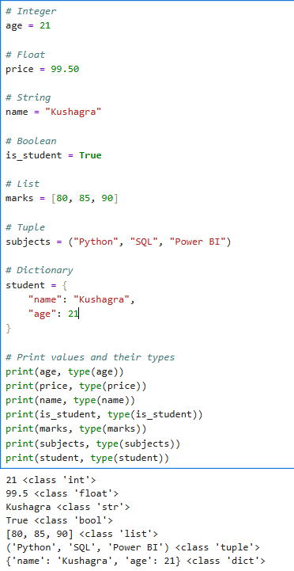

    - Arithmetic Operators
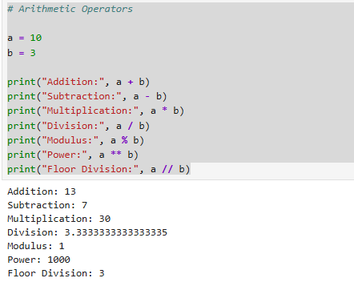

    - Comparison Operators
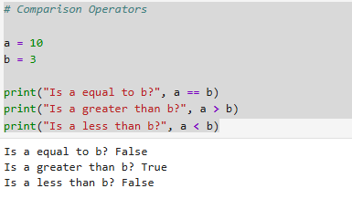

    - Logical Operators
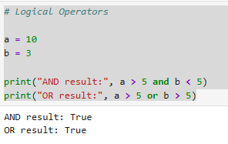
1.2 NumPy Operations
1.2.1 Creating the NumPy Array
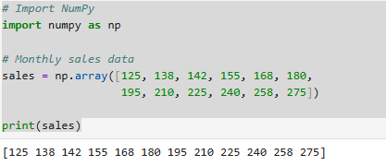

1.2.2 Shape, Size and Data Type
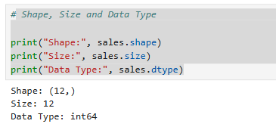

1.2.3 Sales Statistics
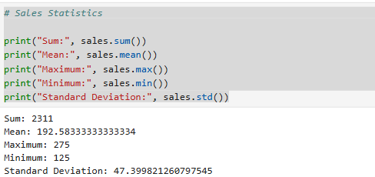

1.2.4 Reshaping the Sales Array
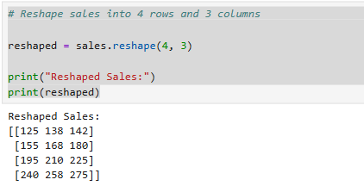

1.2.5 Finding Indices of Sales Greater Than 200
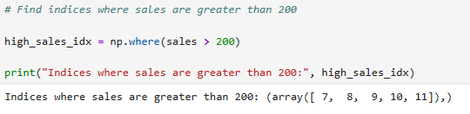

1.2.6 Month-over-Month Growth
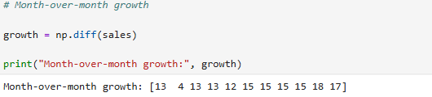

2. Task 2 — Pandas
2.1 Data Loading and Inspection
2.1.1 Customers DataFrame
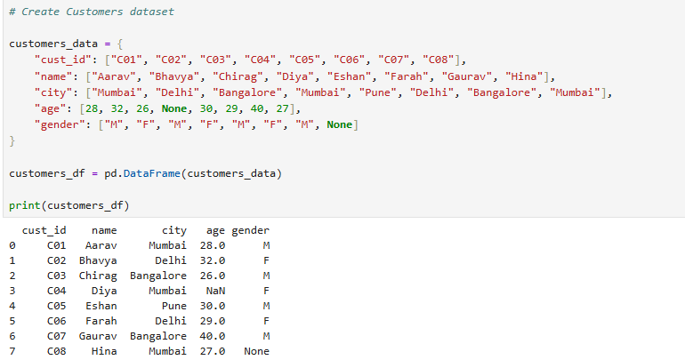

2.1.2 Purchases DataFrame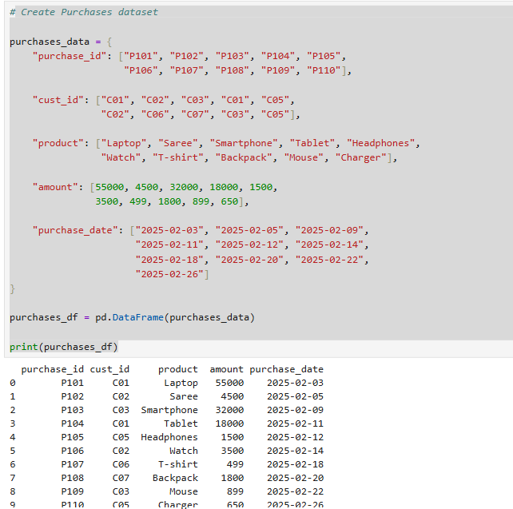
2.1.3 First 5 Rows of the DataFrames
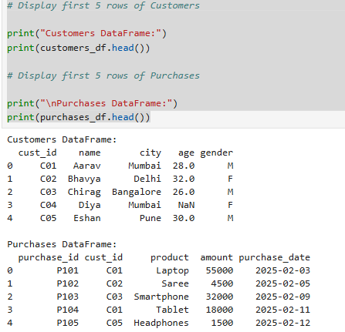

2.1.4 Shape and Data Types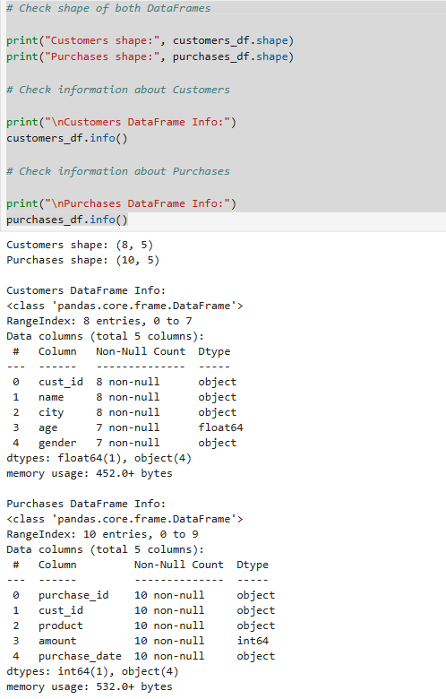
2.2 Data Cleaning
2.2.1 Checking Missing Values
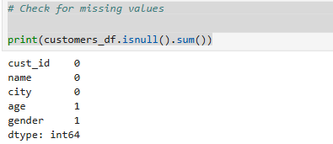

2.2.2 Filling Missing Age
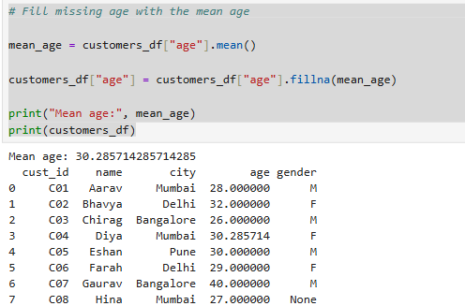

2.2.3 Filling Missing Gender
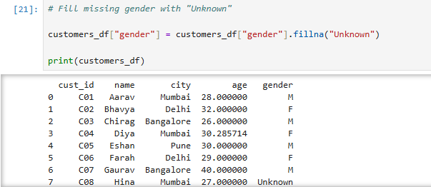

2.2.4 Converting Age to Integer
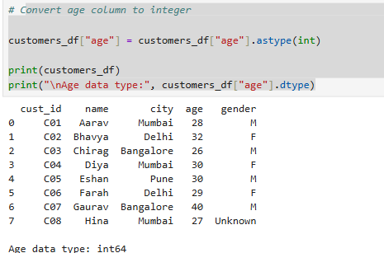

2.3 Data Merging
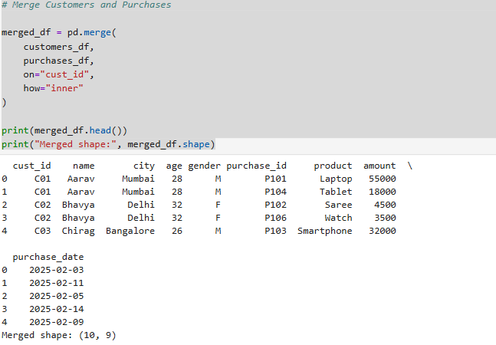

3. Task 3 — Data Analysis
3.1 Filtering Data
3.1.1 Filtering Mumbai Purchases
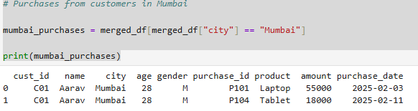

3.1.2 Filtering Purchases Above ₹5,000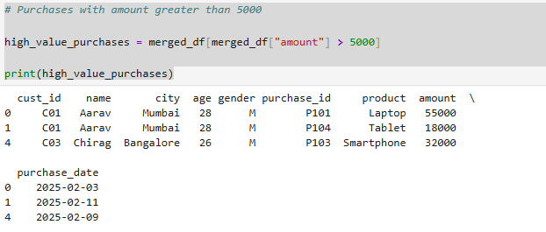

3.1.3 Filtering Male Customers
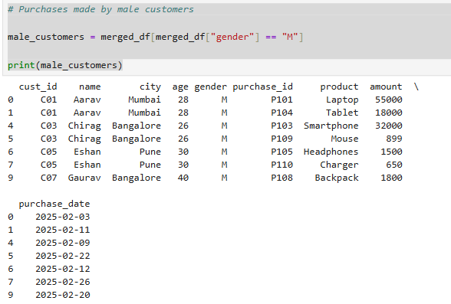
3.2 Grouping and Aggregation
3.2.1 Total Purchase Amount by City
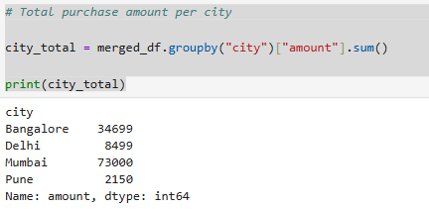

3.2.2 Average Purchase Amount by Gender
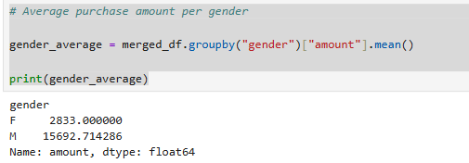

3.2.3 Purchase Count per Customer
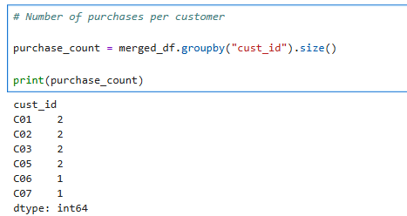

3.2.4 Top 3 Customers by Total Spending
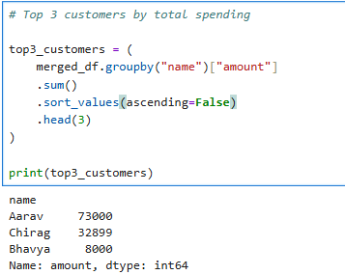

3.3 Data Visualisation
3.3.1 Total Purchase Amount by City
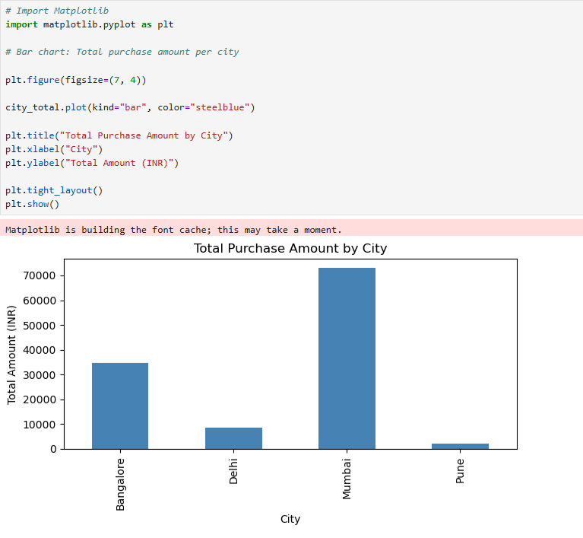
3.3.2 Share of Purchases by Gender
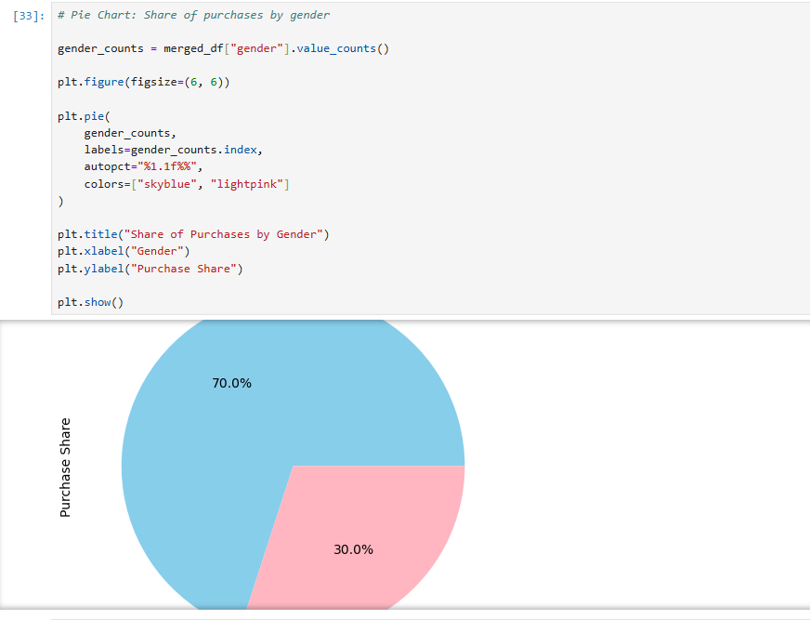

3.3.3 Top 3 Customers by Total Spending
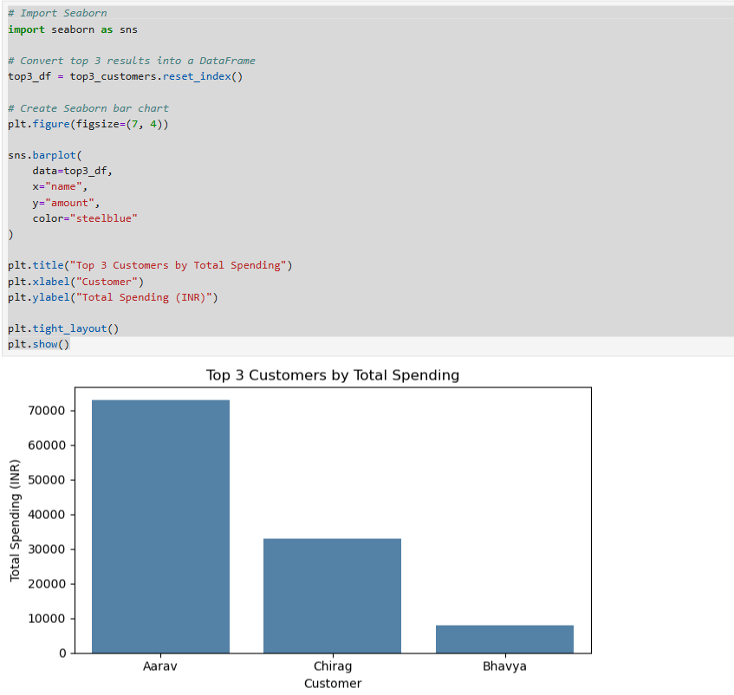

3.3.4 Purchase Amount Over Time
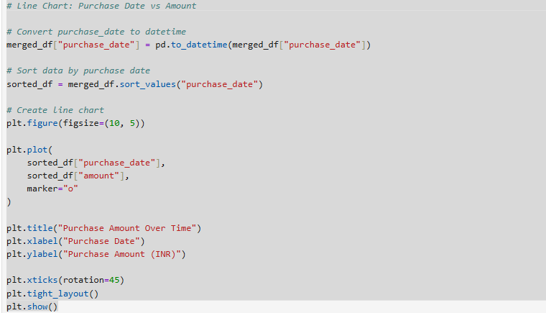
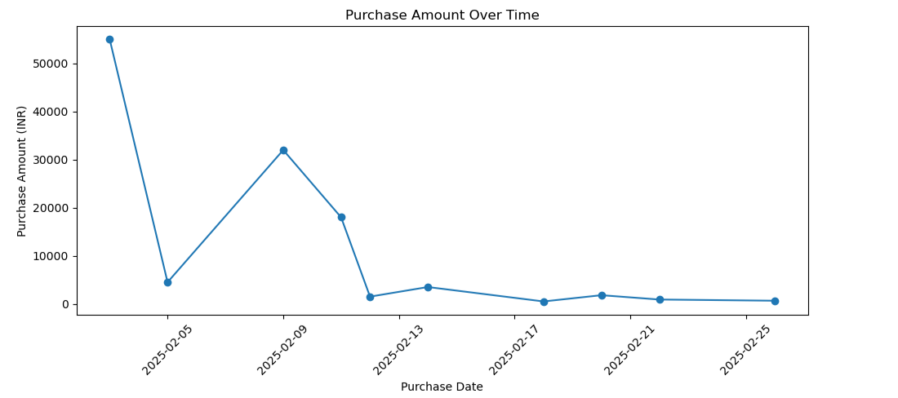

3.4 Conclusion

The analysis shows that Mumbai generated the highest total purchase amount of ₹73,000, followed by Bangalore with ₹34,699, Delhi with ₹8,499, and Pune with ₹2,150. Aarav, Bhavya, Chirag, and Eshan were the most active customers, with two purchases each. The overall average purchase amount was ₹11,834.80. Aarav was the highest-spending customer, with total purchases of ₹73,000 from a Laptop and Tablet. Male customers had a higher average purchase amount of approximately ₹15,692.71 compared with ₹2,833 for female customers. The highest individual purchase was ₹55,000 for a Laptop. Overall, the analysis highlights differences in customer activity, spending patterns, and revenue contribution across cities.

