KLE Society's

KLE Technological University



**A Mini Project Report**

**On**

**Performance Evaluation in Dynamic RAN Slicing of 5G Networks**

*submitted in partial fulfillment of the requirement for the degree of*

**Bachelor of Engineering**

**In**

**Computer Science and Engineering**

**Submitted By**

### Lavanya Shahapur 01FE20BCS185

### B Ajay Kushal 01FE20BCS289

### Pragathi Pujari 01FE20BCS189

### Kushagra Tomar 01FE20BCS063

### Ashwini Jannu 01FE20BCS208

**Under the guidance of**

**Prof. Parikshit P Hegde**

SCHOOL OF COMPUTER SCIENCE & ENGINEERING

HUBLI–580 031 (India).

Academic year 2022-23

KLE Society's

KLE Technological University

2022 - 2023



SCHOOL OF COMPUTER SCIENCE & ENGINEERING

**CERTIFICATE**

This is to certify that Mini Project entitled 5G Network Slicing is a bonafide work carried out by the student team Ms. Lavanya Shahapur - 01FE20BCS185, Mr. B Ajay Kushal 01FE20BCS289, Ms. Pragathi Pujari - 01FE20BCS189, Mr. Kushagra Tomar 01FE20BCS063, Ms. Ashwini Jannu - 01FE20BCS208 in partial fulfillment of completion of Fifth semester B. E. in Computer Science and Engineering during the year 2022 – 2023. The project report has been approved as it satisfies the academic requirement with respect to the project work prescribed for the above said programme.

**Guide Head, SoCSE**

**Mr. Parikshit P Hegde Dr. Meena S. M**

**External Viva:**

**Name of the Examiners Signature with date**

**1.**

**2.**

**ABSTRACT**

Access to the internet is growing exponentially due to its ease of usability, flexibility, and lowering data plans. The diverse network service requirements encourage mobile operators to look for mechanisms that facilitate efficient use of network infrastructure, so that it can reduce the operational and expenditure costs. Use cases like the video streaming services require high bandwidth, autonomous driving and remote medical surgery requires low latency, and various IoT applications work with low bandwidth to cater to the users needs. We simulate the RAN slicing using an emulator called eXP-RAN which effectively manages the allocation of different network resources to the created slices. The infrastructure, slicing, and service layers are the three distinct layers in the proposed system architecture. The isolation and abstraction of the network resources is also applied to the created slices by this emulator.

**ACKNOWLEDGEMENTS**

The sense of contentment and elation that accompanies the successful completion of our project and its report would be incomplete without mentioning the names of the people who helped us in accomplishing this.

We are indebted to our guide Mr.Parikshit Hegde who was nothing but a constant source of enthusiasm and whose profound guidance, valuable suggestions, and beneficent direction was mainly responsible for us to complete this project.

We take this opportunity to express our deep sense of gratitude and sincere thanks to our Head of the Department Dr. Meena S. M. for her tremendous source of inspiration and help in challenging our effort in the right direction.

We are extremely grateful for our Vice Chancellor Dr. Ashok Shettar and our Registrar Dr. Basavaraj Anami who have guided and been inspiring to us throughout this journey.

Last but not least we like to thank all the course faculty, teaching and non-teaching staff for helping us during the project.

LAVANYA SHAHAPUR

B AJAY KUSHAL

PRAGATHI PUJARI

KUSHAGRA TOMAR

ASHWINI JANNU

|  |  |  |  |  |  |  |  |  |
| --- | --- | --- | --- | --- | --- | --- | --- | --- |
| **Chapter No.** | **TABLE OF CONTENTS** | | | | | | **Page No.** | |
| **1.** | **INTRODUCTION** | | | | | | **7-10** | |
|  | 1.1 | Preamble | | | | |  | |
|  | 1.2 | Motivation | | | | |  | |
|  | 1.3 | Objectives of the project | | | | |  | |
|  | 1.4 | Literature Survey | | | | |  | |
|  | 1.5 | Problem Definition | | | | |  | |
| **2.** | **PROPOSED SYSTEM** | | | | | | **11-13** | |
|  | 2.1 | Description of Proposed System. | | | | |  | |
|  | 2.2 | Description of Target Users | | | | |  | |
|  | 2.3 | Advantages/Applications of Proposed System | | | | |  | |
|  | 2.4 | Scope | | | | |  | |
| **3.** | **SOFTWARE REQUIREMENT SPECIFICATION** | | | | | | **14-16** | |
|  | 3.1 | Overview of SRS | | | | |  | |
|  | 3.2 | Requirement Specifications(In brief write meaning of functional requirements) | | | | |  | |
|  |  | 3.2.1 | | Functional Requirements((In brief write meaning of functional requirements) | | |  | |
|  |  | 3.2.2 | | Use case diagrams | | |  | |
|  |  | 3.2.3 | | Use Case descriptions using scenarios | | |  | |
|  |  | 3.2.4 | Nonfunctional Requirements | | | |  | |
|  |  |  | | 3.2.4.1 | Performance requirements | |  | |
|  |  |  | | 3.2.4.2 | Security Requirements | |  | |
|  | 3.3 | Software and Hardware requirement specifications | | | | |  | |
| **4** | **SYSTEM DESIGN** | | | | | | **17-19** | |
|  | 4.1 | Architecture of the system | | | |  | |
|  | 4.2 | Class Diagram | | | |  | |
| **5** | **IMPLEMENTATION** | | | | | **20-23** | |
|  | 5.1 | Proposed Methodology | | | |  | |
|  | 5.2 | Description of Modules | | | |  | |
| **6** | **TESTING** | | | | | **24-25** | |
|  | 6.1 | Acceptance Testing and Unit Testing | | | |  | |
| **7** | **RESULTS & DISCUSSIONS** | | | | | **26-30** | |
| **8** | **CONCLUSION AND FUTURE SCOPE** | | | | | | **31** | |
| **9** | **REFERENCES** | | | | | | **32-34** | |
| **10** | **APPENDIX** | | | | | | **35-36** | |
|  | A | Gantt Chart | | | | |  | |
|  | B | Glossary | | | | |  | |
|  | C | Description of Tools & Technology used | | | | |  | |
|  | D | Blue Print | | | | |  | |

**1. INTRODUCTION**

**1.1 Preamble**

A major transformation is observed in the telecommunication sector with the evolution of 5G networks[27] in data rate. Trillions of sensors/network devices are connected intelligently to the core network based on the computation and delay sensitivity needs in 5G networks. 5G enables a new kind of network that is designed to connect virtually everyone and everything together including machines, objects, and devices which can provide high speeds, low latency and massive capacity, offering the potential to change what you experience with your mobile device, and much more. Several researches and discussions are going on across the world among technologists, researchers, academicians, vendors, operators, and governments about the innovations, implementation, viability, and security concerns of 5G.

**1.2 Motivation**

Abstraction is the key factor to optimize the security of the system so that they efficiently address all the issues of physical system by preventing one slice to know the resouces that are allocated to another slice. Static slicing lacks in allocating resources to different slices present on the same physical infrastructure on a dynamic basis based on changing resource requirements. Thus there is a need for dynamically creating new slices, deploying services on these slices, and customizing these slices in terms of the resource requirements.

**1.3 Problem Definition**

“Performance evaluation of varied Key Performance Indicators(KPIs) for dynamic RAN slice environment of 5G networks”

* Supports multiple logical networks over common infrastructure.
* To evaluate KPI’s with respect to the different video streaming use cases.
* To design and customize the network slices to meet the demands of all use cases dynamically.

**1.4 Objectives of the project**

* To simulate the dynamic slicing of 5G RAN
* To simulate resource allocation with tailored solutions to separate slices.
* To evaluate the performance of services running on 5G RAN slicing

**1.5 Literature Survey**

**5G RAN for verticals: Challenges and Enablers**

Challenges faced by mobile operators in 5G networks: The challenge is defining a slice that contains both the user information and individual service needs. Spectrum sharing, tiling, puncturing, and slice mapping are the concepts used for scheduling network resources. Based on the service latency requirements, the differentiation is provided by the slice manager[23].

**Impact of Networking Slicing on 5G Radio Access Network**

The radio resources can be shared in two types, dedicated and dynamic manner. The above requirements will impact protocol architecture, the design of Network Functions(NFs), and network management. To achieve the protocol architecture, selection of NFs per slice, slice awareness for QoS framework, and slice-tailored NFs optimization must be supported by RAN architecture. The radio NFs are impacted due to inefficient use of radio and transport network resources and inadequate sharing of RAN resources among different slices. Radio NFs of one slice is dependent on another slice[26].

**5G Radio Access Networks: A survey**

Evaluation of virtualized RAN(vRAN) experimentally using passive optical network(PON) in Fronthaul, which reduces network costs. 5G has enabled internet connectivity and connection of multiple devices through IoT. C-RAN which is a centralized cloud computing-based architecture for RAN which allows support to 2G, 3G, and 4G, and in the present generation, it will support 5G wireless communications[38].

**Impact of O-RAN on 5G Radio Access Networks**

The authors present dynamic network slicing using Software Defined Network(SDN). The customized network service is provided using the Ryu Controller with an example of an electronic Fence application. The network slices are formed dynamically based on the type of application. The resource configuration is adjusted dynamically as the user demand changes. The virtual network resources are formed dynamically by applying the network slicing algorithm at the controller using the underlying physical infrastructure[4][17].

**Towards operator-to-waveform 5G Radio access Network Slicing**

The method used for ran slicing is toward operator-to-waveform 5G RAN slicing. It is used to control a maximum number of users and MNO's selection of base stations the architecture used for this operator-to-waveform method is three tiers run slicing framework. The author's main objective in using this method is to improve signal interference and noise ratio (SINR) by up to 120 percent compared to other approaches and to provide waveform-level scheduling of resource blocks to a maximum number of users[9].

**Characterization of Radio Access Network Slicing Scenarios With 5G QoS Provisioning**

The radio resources can be shared in two types, dedicated and dynamic. The above requirements will impact protocol architecture, the design of Network Functions(NFs), and network management. To achieve the protocol architecture, selection of NFs per slice, slice awareness for QoS framework[26]

**End-to-End Quality of Service in 5G Networks: Examining the Effectiveness of a Network Slicing Framework**

RAN should be able to support the following efficient traffic management mechanism, minimizing of inter-slice effects, efficient management of infrastructure, and maximizing the utilization of RAN resources[3]

**Based IoT System Control Problems**

Evaluation of virtualized RAN(vRAN) experimentally using passive optical network(PON) in Fronthaul, which reduces network costs. 5G has enabled internet connectivity and connection of multiple devices through IoT. C-RAN which is a centralized cloud computing-based architecture[38]

**Data-Driven Network Slicing From Core to RAN for 5G Broadcasting Services**

Thus physical resources can be checked, which is equal to the process of solving virtual network mapping problems. 2) Dynamic slicing approach - Network slicing is performed dynamically based on user requirementsThe weights of nodes present in the topology are poorer than the nodes with uniform structure but have a good rate of performance which indicates that the system can increase its resource utilization rate. The goal of 5G RAN network slicing is to reduce the dimension of the network such that it can be allocated within a few physical networks. [30].

**2. PROPOSED SYSTEM**

**2.1 Proposed System.**

Figure. 1 depicts our proposed system. It shows the main steps to go through an emulation with eXP-RAN. The system supports three different ways of user interactions. The user can provide the output of an optimization model to the model adapter. This method is useful to perform sensitive analysis of optimization models. eXP-RAN, on the other hand, can be used in this situation to provide quick insights on different parameters of interest. The second method of interaction with eXP-RAN is by using the Topology Generator. This is a module of the system that generates random network topologies for experimenting with RAN and EC. This method is particularly interesting for users with limited knowledge of RAN/EC scenarios as well as to support educational purposes.

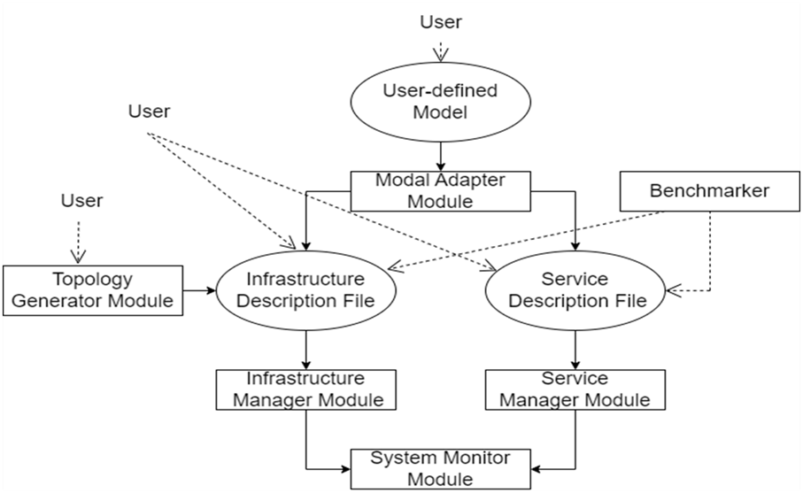

**Figure 1. Proposed system for RAN Network Slicing**

The third method of interaction is by the user providing its own infrastructure and services. In this case, the user describes the infrastructure and services by writing JSON files following the eXP-RAN notation. Alternatively, users can interact with eXP-RAN using the benchmarker module. Note that this step is an optional flow and is an user input.

This proposed system allows multiple networks to be created on top of common physical infrastructure. It enables service providers to build virtual end-to-end networks tailored to application requirements.

**2.2 Description of Target Users**

* Service providers – Creates new slices to deploy service and allocate tailored resources to slices.
* Network uses – Use 5G enabled services.
* Network operators – Deploy service on existing slice and allocate tailored resources to slices

**2.3** **Advantages of proposed system**

* It will allow Communication service providers(CSP’s) the ability to flexibly separate services in their 5G network
* It enhances the traffic steering to maximize the quality of service and quality of experience on a single device
* It supports multiple tailored slices to 5G devices.

**2.4** **Scope of the Project**

The Main intention behind working on this problem definition was to evaluate the performance of RAN Slicing in 5G.

* QoS(Quality of Service) evaluation in video streaming
* Packet loss tracing during emulation
* MEC/vRAN emulation
* Network Traffic Analysis

**2.5 Limitations of the Project**

The limitations of the project evolve due to the hardware and software requirements of the experimental setup.

* Expensive Hardware requirements
* Requires Extensive knowledge about the software
* Each Modules has independent specifications
* Benchmarker Execution
* Not all hardware resources are available easily

|  |  |  |  |
| --- | --- | --- | --- |
|  |  |  |  |
|  |  |  |  |
|  |  |  |  |

**3. SOFTWARE REQUIREMENT SPECIFICATION**

**3.1 Overview of SRS**

Software Requirement Specification (SRS) is complete specification and description of requirements of software that needs to be fulfilled for successful development of software systems. These requirements can be functional as well as non-functional depending upon the type of requirement. The interaction between different customers and contractors is done because it's necessary to fully understand the needs of customers.

**3.2 Requirements Specifications**

**3.2.1 Functional Requirements**

1. The network shall offer tailored solutions for each slice.
2. The network slices shall be completely isolated from each other.
3. The network shall get sliced dynamically according to requirements

**3.2.2 Use Case diagrams**

**Use case:** Dynamic ran slicing

**Primary Actor:** Network Service provider, Network user, Network operator

**Goal in content:** To create, operate and deploy 5g enabled services on custom network slices on common physical network

**Preconditions:** Proper Isolation of slices

**Trigger:** Creating multiple networks on top of common physical infrastructure.

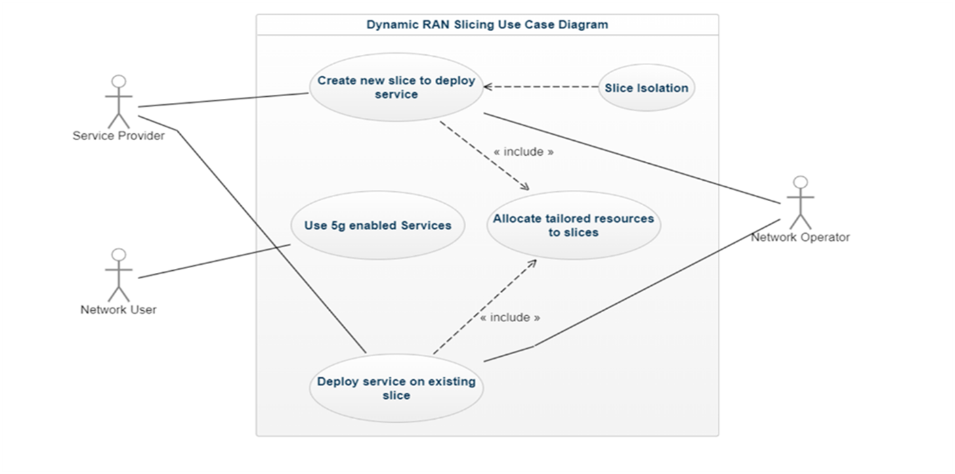

**Figure 2. Use Case Diagram for RAN Network Slicing**

**3.2.3 Use case description using scenarios**

**Scenario: 1.** Create a new slice.

**2.** Deploy service on existing slices.

**3.** Allocation of tailored resources to slices.

**Exceptions:** Different use cases have different requirements

**3.2.4 Non Functional Requirements**

**3.2.4.1 Performance requirements**

* The network should have latency less than 10ms.
* The network should allow a maximum of eight slices.
* The network should be able to offer data speed more than 1000mbps

**3.2.4.2 Security requirements**

* Isolation and abstraction of slices from each other so that one slice should not know what all resources are allocated to another slice.

**3.3 Software and Hardware requirement specifications**

* Software-Ubuntu 18.04LTS
* eXP-RAN Emulator

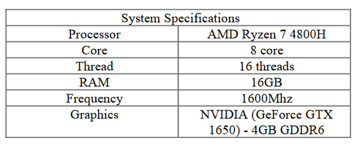

**4. SYSTEM DESIGN**

**4.1 Architecture of the system**

The eXP-RAN architecture is divided into three layers

* **The Infrastructure layer**
* **The Slicing layer**
* **The Service layer**

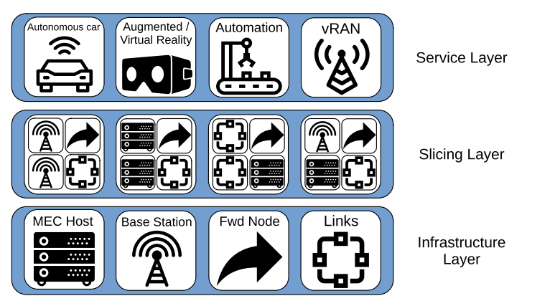

**Figure 3. System Design for RAN Network Slicing**

**The Infrastructure layer**

Virtual resources creation and emulation of physical resources[6] are done by this layer. This layer will emulate network components like forwarding nodes, base station nodes, edge computing resources, and links. Forwarding nodes helps in forwarding the traffic. Cell towers or cell sites are represented by the base station nodes. Cell tower needs to perform emulation of signal processing as done by RAN, and these have a very limited

computing capacity. Multi-access Edge Computing(MEC) hosts are the processing powerhouse of the RAN since they have a higher computing capacity[1]..

**The Slicing layer**

Virtual resources are partitioned and isolated by this layer by slicing the allocated resources, thus emulating the slices created upon the common infrastructure[35],. Virtual resources are emulated with the help of containers and links through eXP-RAN. Services of eXP-RAN are done by Virtualized Network Functions(VNFs) present in the containers.

**The Service layer**

The services created inside the network are emulated by this layer which is present as a set of network functions. The service layer performs virtual network functions with specific configurations inside the dockers, which helps them to serve as a whole unit of service.

**4.2 Class Diagram**

It represents the static view of an application. Moreover, it describes the modules and methods (operations) of a system and how it works with respect to input given. Fig. 3a shows the main steps to go through an emulation with eXP-RAN. The system currently supports three different ways of user interactions.

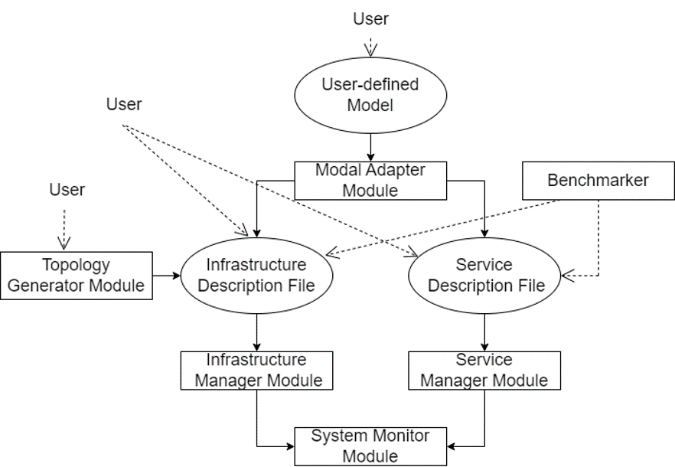

**Figure 4. eXP-RAN workflow and system modules.**

In the first method of interaction is with the model adapter, it can be used to perform sensitive analysis of optimization models, which can be time consuming when performed using the solver. The second method of interaction is by using the Topology Generator. This is a module of the system that generates random network topologies for experimenting with RAN and EC. The third method of interaction is by allowing the user to specify her own infrastructure and services where the user describes the infrastructure and services by writing JSON files following the eXP-RAN notation to infrastructure and service manager module.

**5. IMPLEMENTATION**

**5.1 Proposed Methodology**

There are three types of nodes available in eXP-RAN emulation tool which is used to emulate a network topology. Figure. 5 illustrates the main elements used to create each node.

1) Forwarding Node

Since forwarding nodes are only used to forward traffic, they have a single virtual switch. This virtual switch is implemented using OvS and configured using LTC and OpenFlow rules. LTC is needed in order to emulate the link restrictions, e.g., capacity (or bandwidth) and latency, while OpenFlow is used to route the traffic of the service.

2) Base Station Node

This node has some VMs to represent the limited computing capacity and a couple of virtual switches. The first switch works like the switch mentioned on the forwarding nodes, i.e., it does packet forwarding. The second one is used to connect the VMs inside the node. OvS, LTC and OpenFlow are used with the same purpose as in the forwarding nodes. We use Xen VMs to represent the physical servers and Docker containers to represent virtual resources.

3) MEC Host

MEC hosts are nodes with high computing capacity (i.e., multiple VMs) and two virtual switches that have the same functions as the switches of a base station node. Indeed the main difference between base station nodes and MEC hosts is the amount of (physical and virtual) computing resources in the node, i.e., the amount of VMs and Docker containers.

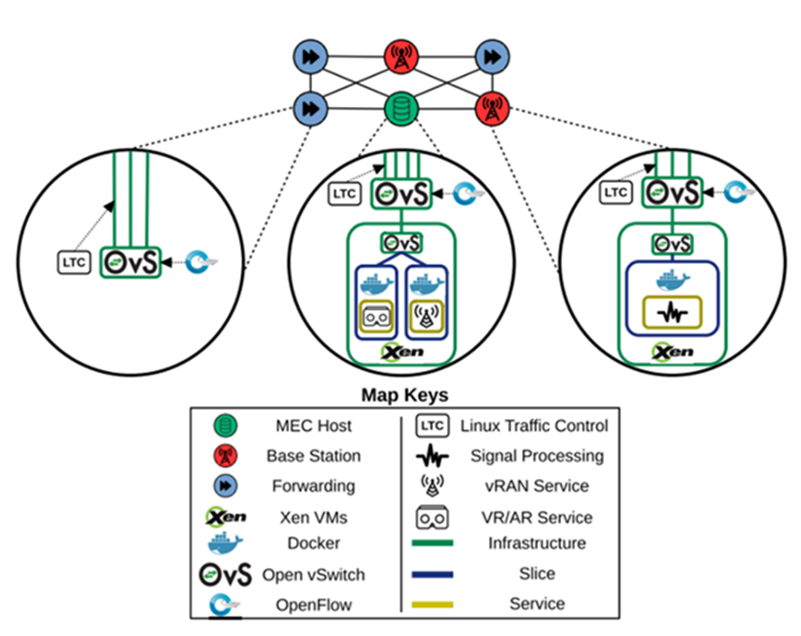

**Figure 5. Proposed Methodology for RAN Network Slicing**

**5.2 Description of Modules**

The different modules that are used in the proposed system are detailedly explained below:

**Model Adapter**: This module deals with processing the outcome of the optimization model and converting them into description files for working of eXP-RAN.

**Topology Generator**: It is used to create random RAN network topology. In creating new logical networks, this module takes the help of factors such as a variety of nodes, topology graphs, services, links, etc. And when the network is ready, nodes are classified as per the following ratios: forwarding nodes, base stations, MEC host nodes, and in a 65:30:5 ratio, respectively[1]. The final topology created is given as input into the infrastructure description file. The users can also provide their own topologies by mentioning the JSON file.

**Infrastructure Manager:** This module receives the input of the infrastructure description file from the model adapter module or topology generation module or given by users themselves. Thus, creating the nature of system service that emulates the created infrastructure accordingly. There arises the issue of network traffic between two modules and their routing. Thus, the eXP-RAN emulation tool includes a controller, which gives freedom to the users to create multiple ways in the network so that it becomes easy to route the network traffic and create restrictions[18]. This network controller allows the users to use network rules that manage the network traffic on each virtual switch and establish a virtual machine inside the containers present.

**Service Manager:** This module runs after infrastructure is created by the infrastructure manager module. This module applies the service-specific configuration required by some services to operate properly.

**System Monitor**: Setting of observation standards in relation to infrastructure description file and service description file are designed by this module[10][15]. The final results of system services are stored in the document and can easily be used for better analysis and research by plotting conclusions graphically.

**Benchmarker Module:** Finally, this module is an important built-in feature in software emulation tools which is a unique module found and is not relatable to any other tools. This module assures the necessary productive prerequisites used in altering the software relative to the hardware constraints of the system where it is running. As a result, this helps the users to decide the method of emulating the service.

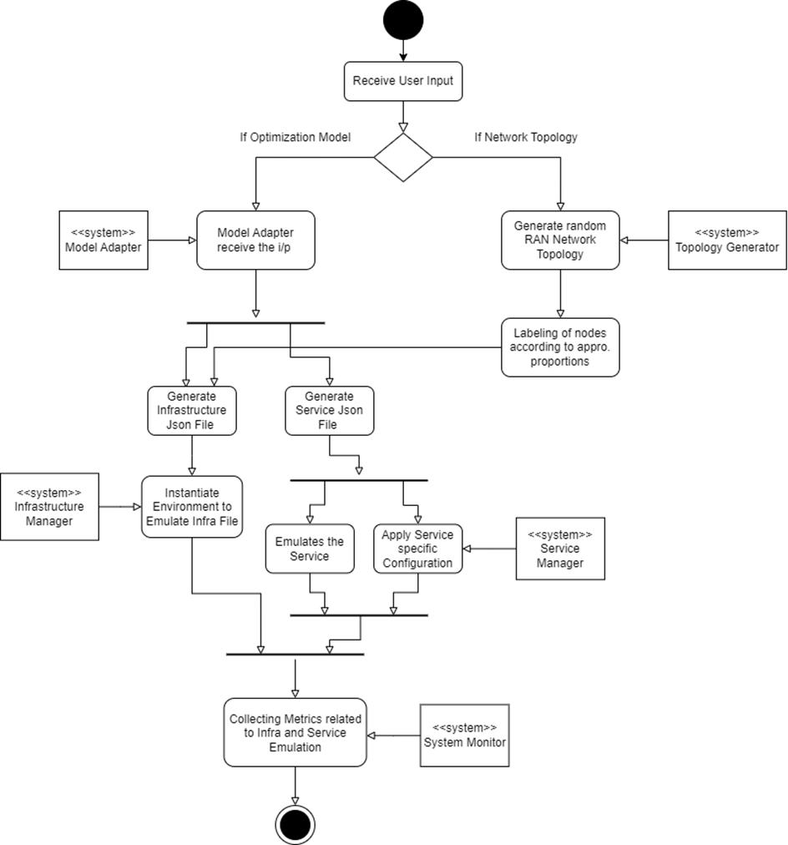

**Figure 6. Activity Diagram for RAN Network Slicing**

**6. TESTING**

**6.1 Acceptance Testing and Unit Testing**

Table 1: Acceptance test plan

|  |  |  |  |  |
| --- | --- | --- | --- | --- |
| **Test idi Id** | **Input Description** | **Expected output** | **Actual output** | **Pass/Fail** |
| 1. | Providing bandwidth and packet loss as input to the benchmarker module | Recommends proper hardware configuration (vCPU) for the given bandwidth and packet loss for both client and server to achieve better performance | Proper hardware configuration (vCPU) recommended for the given bandwidth and packet loss for both client and server. | Pass |
| 2. | Number of nodes and maximum distance between the nodes to the topology generator. | The topology generator should create a network topology which should contain Forwarding nodes, Base station and MEC host in the ratio 65:30:5 respectively. | The topology generator creates network topology which contains Forwarding nodes, Base station and MEC host in ratio 65:30:5 respectively. | Pass |

Table 2: Unit test for various system modules

|  |  |  |  |  |
| --- | --- | --- | --- | --- |
| **Id** | **Input Description** | **Expected output** | **Actual output** | **Pass/Fail** |
| 1 | Optimization model to model adapter module | Generating Infrastructure and Service Description JSON files. | Generated Infrastructure and Service Description files. | Pass |
| 2 | Infrastructure Description files from Model adapter module or topology generator module are provided to Infrastructure manager module | Should create system services that emulates the created infrastructure accordingly | It properly creates the system services that emulates the created infrastructure accordingly | Pass |
| 3 | Service Description files from Model adapter module or users to Service manager module | The module should apply the services specific configurations which are required by some services to work properly | The module applies the services specific configurations. | Pass |

**7. RESULTS & DISCUSSIONS**

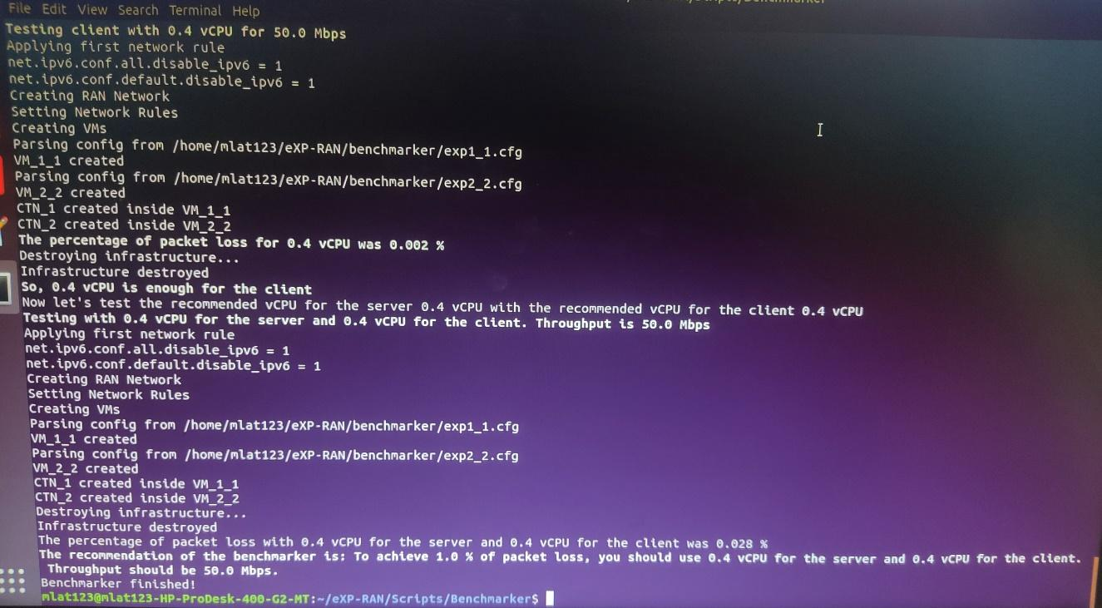**STEP 1:** Firstly, the Benchmarker Module described was successfully executed with required specifications. This module specifies the hardware requirements needed for the experimental setup.

**Figure 7. Emulation of BenchMarker Module.**

Figure. 7 is the snapshot of the result of the emulation of the Benchmarker Module. The module recommends the hardware requirements for the specification of minimal packet loss to occur in the network traffic. The Benchmarker module recommends that : To achieve 1% packet loss, we should use 0.4 vCPU for both server and client. Thus, throughput remains 50 Mbps.

**STEP 2 :** With the topology generator module and description, many random topologies were generated. Out of which the topology we chose to work on is :

The Blue Node - MEC Host

Green Nodes - Forwarding Nodes

Black Nodes - Base Stations

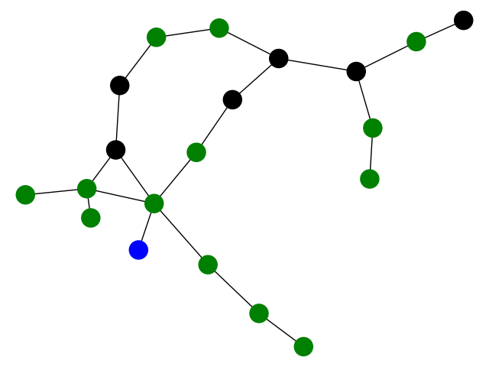

**Figure 8. Randomly generated network topologies**

The randomly generated topology is created with the topology generator Module. The total number of nodes in the network topology are distributed as follows :

* 5% of the nodes are MEC Host- Blue Colored Nodes.
* 30% of the nodes are Base Stations- Black Colored Nodes.
* 65% of the nodes are Forwarding Nodes- Green Colored Nodes.

The percentage of allocation of nodes is specified in the topology generator module with the prior study of standards already set up globally through different experiments[1].

**STEP 3 :** The infrastructure and service files were built for the topology generated. These files are basically the building blocks of the network generated.

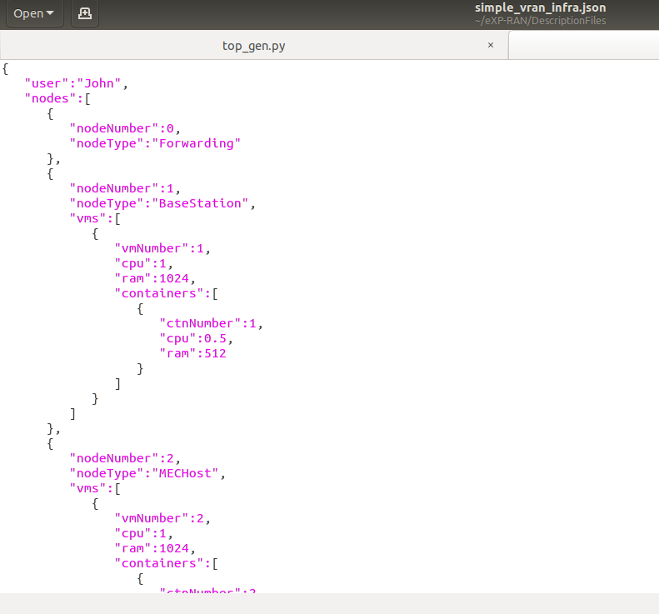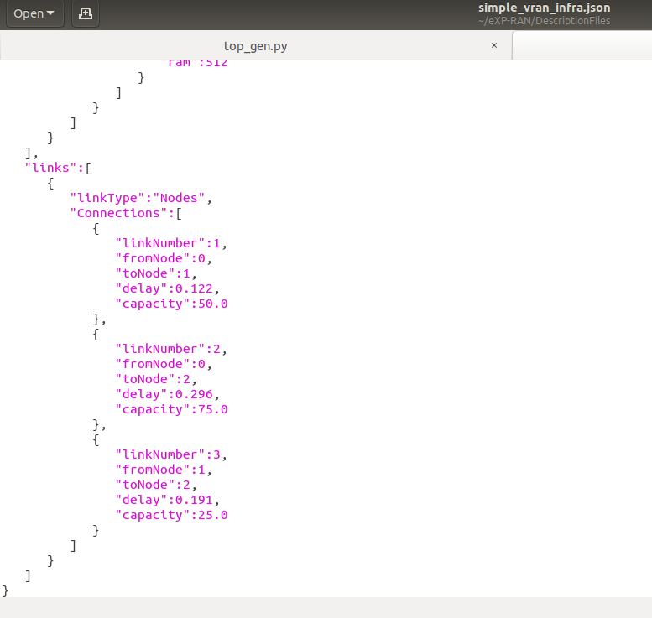

**Figure 8. Snapshot of infrastructure and Service JSON file**

Figure 8 shows the Infrastructure and Service Description files can support both vRAN/MEC and video streaming service files. These files are the configuration for the data flow to occur in the generated network topology. This designates the linking capacity between the nodes and its connection along with identifying the flow between the nodes.The files are of typical json description. These files form a major part for the emulation to occur.

**STEP 4:** All the modules were emulated for the chosen network traffic and thus, the emulation results were gethered using the system monitor module. The results bring out the variation of the Quality of Service(QoS) for different Users depending upon the subscription for Video Streaming Service.

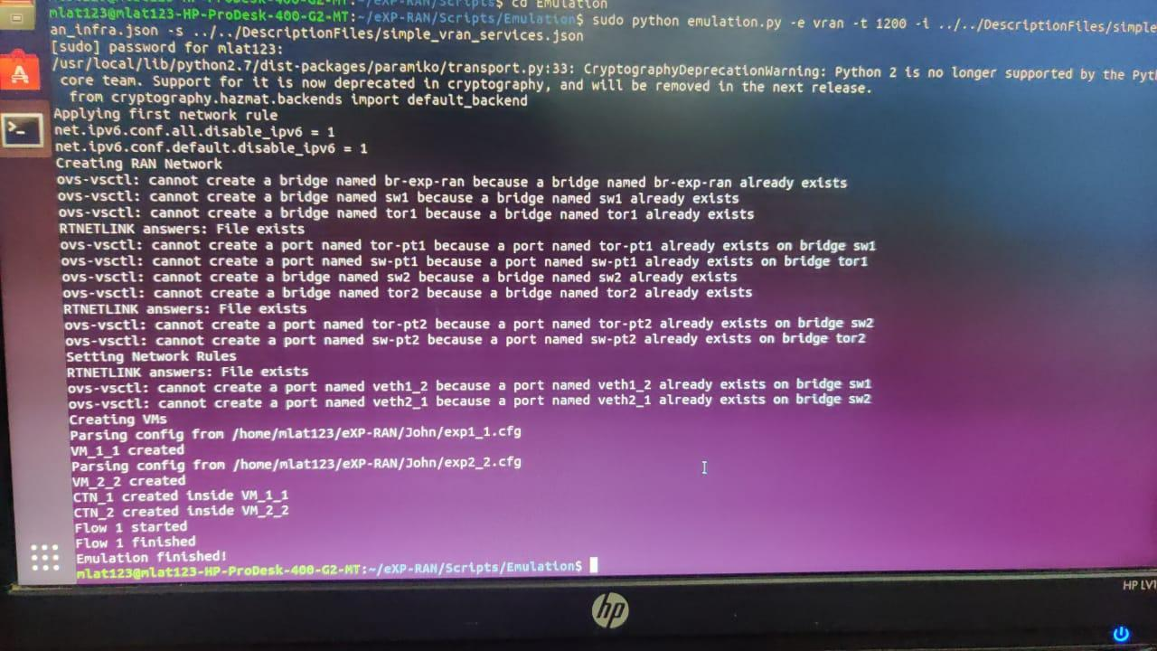

**Figure 9 : Snapshot of Emulation of the Video Stream service files created**

Figure 9 shows the emulation once executed for different clients successfully. Once, the execution is completed , it provides the net-stats of the network traffic occuring, which are later used for the generation of output graph. The graph shows the visualized difference of workload changes and its reflection of service streaming for the “high definition clients” and “standard definition clients”.

**STEP 5:** The output of the emulation is stored to generate the result as a graph for the video streaming service. The graph shows the quality of service for different users over the time window for the increase in the workload.

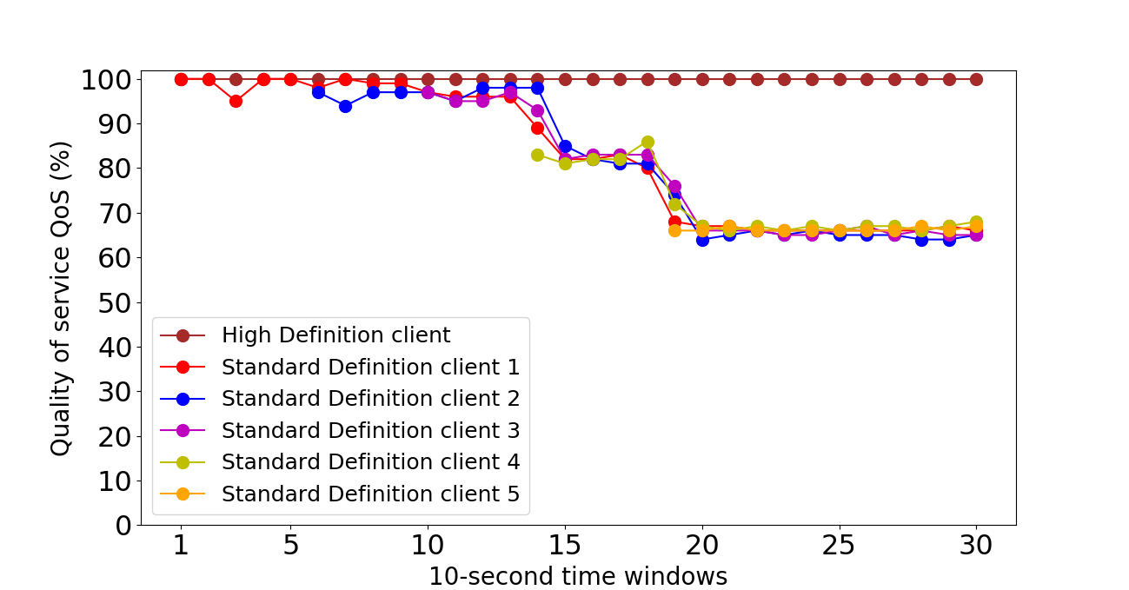

**Figure 10. QoS Analysis for RAN Network Slicing.**

The result of this experiment is shown in figure. 10. The horizontal axis depicts the time window, where the length of each time window is 10 seconds. The vertical axis depicts the QoS received by each user. High QoS ensures stable performance from the applications having very limited network capacity. Thus allowing organizations to modify their network traffic by prioritizing high-performance applications.

**8. CONCLUSION AND FUTURE SCOPE**

**Conclusion**

We thus conclude that the QoS of the slices that are provided to the users gets affected due to the workload present on the slices. In this experiment, when workload starts to increase, QoS being given to users belonging to ''High Definition'' remains unchanged, whereas for the user belonging to 'Standard Definition', the QoS starts to decrease, as the workload increases. Therefore, the created slices are able to meet their expected results[16][17].

**Future Scope**

The further scope of work that can be done are, addition of more use cases, allowing more number of network slices in accordance with 3GPP and enabling combination of network slicing and placement of vRAN network functions over the network, and also improving the existing support for automating the service deployment and the system monitoring[1].

**9. References**

1. Joao Paulo Esper, Abdallah S. Abdallah, Stuart Clayman, Waldir Moreira et al. "EXP-RAN - an Emulator for Gaining Experience with Radio Access Networks, Edge Computing, and Slicing" , IEEE Access, 2020.
2. B. Ojaghi, F. Adelantado, E. Kartsakli, A. Antonopoulos and C. Verikoukis, "Sliced-RAN: Joint Slicing and Functional Split in Future 5G Radio Access Networks," ICC 2019 - 2019 IEEE International Conference on Communications (ICC), 2019, pp. 1-6, doi: 10.1109/ICC.2019.8761081
3. Q. Ye, J. Li, K. Qu, W. Zhuang, X. S. Shen and X. Li, "End-to-End Quality of Service in 5G Networks: Examining the Effectiveness of a Network Slicing Framework," in IEEE Vehicular Technology Magazine, vol. 13, no. 2, pp. 65-74, June 2018, doi: 10.1109/MVT.2018.2809473.
4. J. -J. Chen et al., "Realizing Dynamic Network Slice Resource Management based on SDN networks," 2019 International Conference on Intelligent Computing and its Emerging Applications (ICEA), 2019, pp. 120-125, doi: 10.1109/ICEA.2019.8858288.
5. M. Dalgitsis, J. S. Vardakas and C. Verikoukis, "5G RAN resource slicing with flexible functional splits over multi-tenant environment," 2021 IEEE 26th International Workshop on Computer Aided Modeling and Design of Communication Links and Networks (CAMAD), 2021, pp. 1-6, doi: 10.1109/CAMAD52502.2021.9617786
6. C. M. Mohammed and S. Kheder Shaikhah, "A Survey and Analysis of Architecture and Models of Network Slicing in 5G," 2022 8th International Engineering Conference on Sustainable Technology and Development (IEC), 2022, pp. 192-198, doi: 10.1109/IEC54822.2022.9807564.
7. P. Hegde and S. M. Meena, "A survey on 5G Network Slicing-Epitome and opportunities for a novice," 2021 12th International Conference on Computing Communication and Networking Technologies (ICCCNT), 2021, pp. 1-5, doi: 10.1109/ICCCNT51525.2021.9579745.
8. Icaro da Silva, Gunnar Mildh, Alexandros Kaloxylos, Panagiotis Spapis et al. "Impact of network slicing on 5G Radio Access Networks" , 2016 European Conference on Networks and Communications (EuCNC), 2016
9. Salvatore D'Oro, Francesco Restuccia, Tommaso Melodia. "Toward Operator-toWaveform 5G Radio Access Network Slicing" , IEEE Communications Magazine, 2020
10. Parikshit P Hegde, Shreehari T Alagawadi, Usha S Savadatti, Sahana V Sanagoudar. "To Simulate RAN Slice in 5G Networks" , 2022 IEEE 7th International Conference for Convergence in Technology (I2CT), 2022
11. Sunday O. Oladejo, Olabisi E. Falowo. "Latency-Aware Dynamic Resource Allocation Scheme for Multi-Tier 5G Network: A Network Slicing-Multitenancy Scenario" , IEEE Access, 2020
12. A. A. Abdellatif, A. Mohamed, A. Erbad and M. Guizani, "Dynamic Network Slicing and Resource Allocation for 5G-and-Beyond Networks," 2022 IEEE Wireless Communications and Networking Conference (WCNC), 2022, pp. 262-267, DOI: 10.1109/WCNC51071.2022.9771877.
13. I. da Silva et al., "Impact of network slicing on 5G Radio Access Networks," 2016 European Conference on Networks and Communications (EuCNC), 2016, pp. 153-157, DOI: 10.1109/EuCNC.2016.7561023.
14. C. -Y. Chang, N. Nikaein and T. Spyropoulos, "Radio access network resource slicing for flexible service execution," IEEE INFOCOM 2018 - IEEE Conference on Computer Communications Workshops (INFOCOM WKSHPS), 2018, pp. 668-673, DOI: 10.1109/INFCOMW.2018.8407021.
15. A. Mathew, "Network Slicing in 5G and the Security Concerns," 2020 Fourth International Conference on Computing Methodologies and Communication (ICCMC), 2020, pp. 75-78, DOI: 10.1109/ICCMC48092.2020.ICCMC-00014.
16. H. D. R. Albonda and J. Pérez-Romero, "An Efficient RAN Slicing Strategy for a Heterogeneous Network With eMBB and V2X Services," in IEEE Access, vol. 7, pp. 44771-44782, 2019, DOI: 10.1109/ACCESS.2019.2908306.
17. S. Costanzo, I. Fajjari, N. Aitsaadi and R. Langar, "Dynamic Network Slicing for 5G IoT and eMBB services: A New Design with Prototype and Implementation Results," 2018 3rd Cloudification of the Internet of Things (IoT), 2018, pp. 1-7, DOI: 10.1109/CIOT.2018.8627115.
18. J. -J. Chen et al., "Realizing Dynamic Network Slice Resource Management based on SDN networks," 2019 International Conference on Intelligent Computing and its Emerging Applications (ICEA), 2019, pp. 120-125, DOI: 10.1109/ICEA.2019.8858288.
19. H. Yang et al., "Data-Driven Network Slicing From Core to RAN for 5G Broadcasting Services," in IEEE Transactions on Broadcasting, vol. 67, no. 1, pp. 23-32, March 2021, DOI: 10.1109/TBC.2020.3031742.
20. Y. Tsukamoto, R. K. Saha, S. Nanba and K. Nishimura, "Experimental Evaluation of RAN Slicing Architecture With Flexibly Located Functional Components of Base Station According to Diverse 5G Services," in IEEE Access, vol. 7, pp. 76470-76479, 2019, DOI: 10.1109/ACCESS.2019.2922251.
21. R. Liu, X. Hai, S. Du, L. Zeng, J. Bai and J. Liu, "Application of 5G network slicing technology in smart grid," 2021 IEEE 2nd International Conference on Big Data, Artificial Intelligence and Internet of Things Engineering (ICBAIE), 2021, pp. 740-743, DOI: 10.1109/ICBAIE52039.2021.9389979.
22. M. Nerini and D. Palma, "5G Network Slicing for Wi-Fi Networks," 2021 IFIP/IEEE International Symposium on Integrated Network Management (IM), 2021, pp. 633-637.
23. S. E. Elayoubi, S. B. Jemaa, Z. Altman and A. Galindo-Serrano, "5G RAN Slicing for Verticals: Enablers and Challenges," in IEEE Communications Magazine, vol. 57, no. 1, pp. 28-34, January 2019, DOI: 10.1109/MCOM.2018.1701319.
24. C. -Y. Chang, N. Nikaein and T. Spyropoulos, "Radio access network resource slicing for flexible service execution," IEEE INFOCOM 2018 - IEEE Conference on Computer Communications Workshops (INFOCOM WKSHPS), 2018, pp. 668-673, DOI: 10.1109/INFCOMW.2018.8407021.
25. W. -P. Lai, M. -J. Lai and H. -L. Lai, "A Semi-Empirical Data-Rate Estimation Method of 5G RAN Slicing," 2021 Asia-Pacific Signal and Information Processing Association Annual Summit and Conference (APSIPA ASC), 2021, pp. 1935-1941.
26. I. Vilà, J. Pérez-Romero, O. Sallent and A. Umbert, "Characterization of Radio Access Network Slicing Scenarios With 5G QoS Provisioning," in IEEE Access, vol. 8, pp. 51414-51430, 2020, doi: 10.1109/ACCESS.2020.2980685.
27. H. D. R. Albonda and J. Pérez-Romero, "An Efficient RAN Slicing Strategy for a Heterogeneous Network With eMBB and V2X Services," in IEEE Access, vol. 7, pp. 44771-44782, 2019, doi: 10.1109/ACCESS.2019.2908306.
28. J. Mei, X. Wang and K. Zheng, "An intelligent self-sustained RAN slicing framework for diverse service provisioning in 5G-beyond and 6G networks," in Intelligent and Converged Networks, vol. 1, no. 3, pp. 281-294, Dec. 2020, doi: 10.23919/ICN.2020.0019.
29. R. Liu, X. Hai, S. Du, L. Zeng, J. Bai and J. Liu, "Application of 5G network slicing technology in smart grid," 2021 IEEE 2nd International Conference on Big Data, Artificial Intelligence and Internet of Things Engineering (ICBAIE), 2021, pp. 740-743, doi: 10.1109/ICBAIE52039.2021.9389979.
30. H. Yang et al., "Data-Driven Network Slicing From Core to RAN for 5G Broadcasting Services," in IEEE Transactions on Broadcasting, vol. 67, no. 1, pp. 23-32, March 2021, doi: 10.1109/TBC.2020.3031742.
31. S. Costanzo, I. Fajjari, N. Aitsaadi and R. Langar, "Dynamic Network Slicing for 5G IoT and eMBB services: A New Design with Prototype and Implementation Results," 2018 3rd Cloudification of the Internet of Things (CIoT), 2018, pp. 1-7, doi: 10.1109/CIOT.2018.8627115.
32. Y. Tsukamoto, R. K. Saha, S. Nanba and K. Nishimura, "Experimental Evaluation of RAN Slicing Architecture With Flexibly Located Functional Components of Base Station According to Diverse 5G Services," in IEEE Access, vol. 7, pp. 76470-76479, 2019, doi: 10.1109/ACCESS.2019.2922251.
33. D. Marabissi and R. Fantacci, "Highly Flexible RAN Slicing Approach to Manage Isolation, Priority, Efficiency," in IEEE Access, vol. 7, pp. 97130-97142, 2019, doi: 10.1109/ACCESS.2019.2929732.
34. H. Yu, F. Musumeci, J. Zhang, M. Tornatore and Y. Ji, "Isolation-Aware 5G RAN Slice Mapping Over WDM Metro-Aggregation Networks," in Journal of Lightwave Technology, vol. 38, no. 6, pp. 1125-1137, 15 March15, 2020, doi: 10.1109/JLT.2020.2973311.
35. J. García-Morales, M. C. Lucas-Estañ and J. Gozalvez, "Latency-Sensitive 5G RAN Slicing for Industry 4.0," in IEEE Access, vol. 7, pp. 143139-143159, 2019, doi: 10.1109/ACCESS.2019.2944719.
36. M. A. Habibi, F. Z. Yousaf and H. D. Schotten, "Mapping the VNFs and VLs of a RAN Slice Onto Intelligent PoPs in Beyond 5G Mobile Networks," in IEEE Open Journal of the Communications Society, vol. 3, pp. 670-704, 2022, doi: 10.1109/OJCOMS.2022.3165000.
37. C. -Y. Chang and N. Nikaein, "RAN Runtime Slicing System for Flexible and Dynamic Service Execution Environment," in IEEE Access, vol. 6, pp. 34018-34042, 2018, doi: 10.1109/ACCESS.2018.2847610.
38. Sungwook Kim. "chapter 2 Cloud-Based IoT System Control Problems" , IGI Global, 2017
39. Salman A. AlQahtani, Waseem A. Alhomiqani. "A multi-stage analysis of network slicing architecture for 5G mobile networks" , Telecommunication Systems, 2019

**10. Appendix**

1. **GANTT CHART**

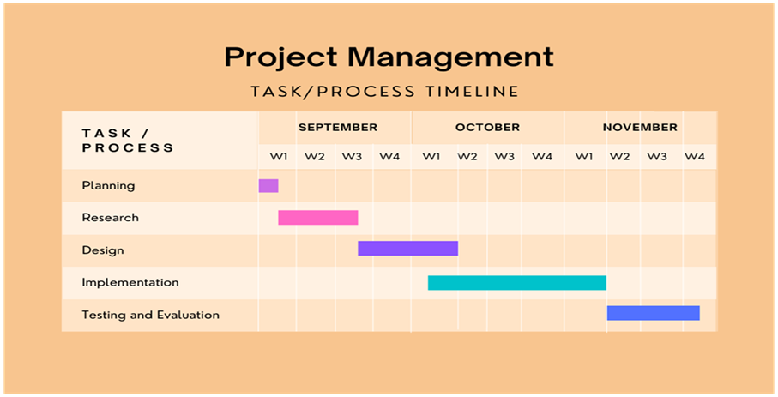

1. **Glossary**

Monitoring of services: slicing of networks needs to be monitored by this tool and should look after the security of slicing the networks which is a unique task of monitoring the independent slices.

Service Representation: Services offered to applications are maintained and managed by service providers provided by this tool.

Network Modeling: Deployment of all issues such as fronthaul, midhaul, backhaul on common infrastructure and virtual network are provided by network modeling.

Adaptability and Reusability: Services must be reusable and clearly understood by the new users for making the system more efficient.

Service Reconfigurability: Implementation of services on virtual networks should have the ability in order to modify the resources for system modules.

Computation Modeling :system requires processing of computer applications which when worked with network modeling functions virtual network.

Slicing Abstraction: Emulation of virtual resources need to be isolated and abstracted to deploy multiple services over a common infrastructure.

**C. Description of Tools & Technology used**

The exP-RAN is one of the open-source available emulator which is comparably more advantageous than its contemporary available tools. Basic requirements are compulsory to function all services and are available only in only a few software emulation tools which primarily concentrate on functioning of modules of the system present. eXP-RAN emulation tool allows us to use three different approaches to interacting with the user with the system. The first method is the eXP-RAN tool can be used to perform an analysis of optimization model output. The second-way approach of the system is with the help of a Topology Generator which generates random network topologies on its own with RAN, EC, or as modified by the user by modifying the number of nodes, links, services, and the type of each node. This is beneficial for those users who have minimum knowledge of RAN slicing, slice abstraction, and isolation. The third way of approach allows users to create their own infrastructure and services JSON file. It allows the user with freedom of moderation of describing the infrastructure file and service file by updating JSON files following eXP-RAN modules. This method is most advantageous, allowing the user to interact with the system and its services.The benchmarker module ensures predictable performance by modifying the tool according to the user's hardware. Xen Hypervisor is one of the tools that efficiently helps in bringing virtualization.

|  |  |
| --- | --- |
|  |  |
|  |  |

|  |  |
| --- | --- |
| Team Number | N20 |
| Guide | Mr. Parikshit P Hegde |
| Project title | Performance Evaluation in Dynamic RAN Slicing of 5G Networks |
| Industry name | – |
| Department vertical(either of Data/ Network/System) | Data Analytics |
| University/ Department Research group | Department Research group |