Orbit Social Network - Team Project Report
Python Console Front-End with Neo4j Graph Database

Team Info
Member Name | Email | Role / Contribution
Kushagra Bainsla | kushagra.bainsla@sjsu.edu | Development, testing, documentation
Kevin Ha | kevin.k.ha@sjsu.edu | Development, testing, documentation
Prudhvi Sai Raj Dasari | prudhvisairaj.dasari@sjsu.edu | Development,testing, documentation

Property Graph Schema
The application uses a simple directed social graph stored in Neo4j.
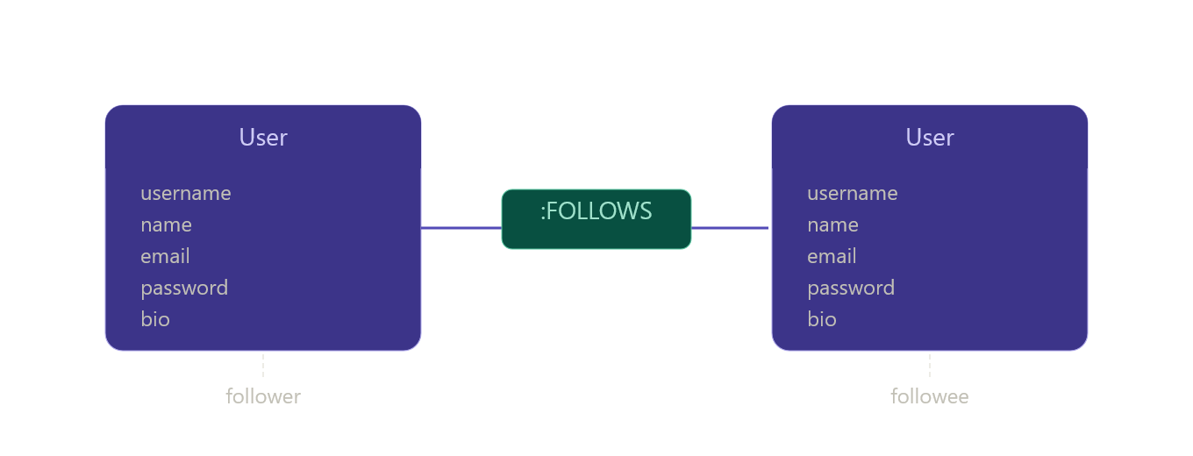
Conceptual model: (:User)-[:FOLLOWS]->(:User)
CREATE CONSTRAINT user_username_unique IF NOT EXISTS
FOR (u:User) REQUIRE u.username IS UNIQUE;

Dataset Information
Field | Details
Dataset name | Facebook Combined
Dataset URL | https://snap.stanford.edu/data/facebook_combined.txt.gz
Dataset file in project | data/facebook_combined.txt
Minimum requirement | At least 1,000 nodes and 5,000 relationships
Project dataset size | 4,039 user nodes and 88,234 relationship lines in the source file
The raw data contains user-id pairs representing Facebook friendship connections. The application processes each pair by creating two User nodes if they do not already exist and then creating a FOLLOWS relationship from the first user id to the second user id.
Cypher used during dataset loading:
MERGE (u:User {username: $id});
MATCH (f:User {username: $follower}), (e:User {username: $followee})
MERGE (f)-[:FOLLOWS]->(e);

UC-1: User Registration
A new user signs up with name, email, username, and password. Associated Cypher query:
MERGE (u:User {username: $username})
ON CREATE SET u.name = $name, u.email = $email, u.password = $password
RETURN u
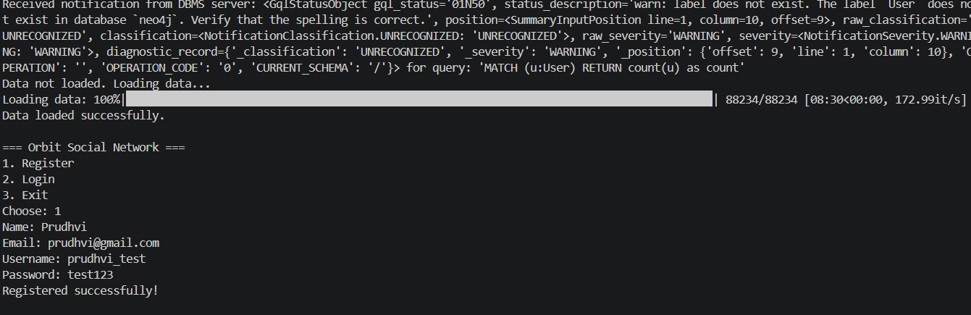

UC-2: User Login
A registered user logs in with username and password.
Associated Cypher query:
MATCH (u:User {username: $username, password: $password}) RETURN u
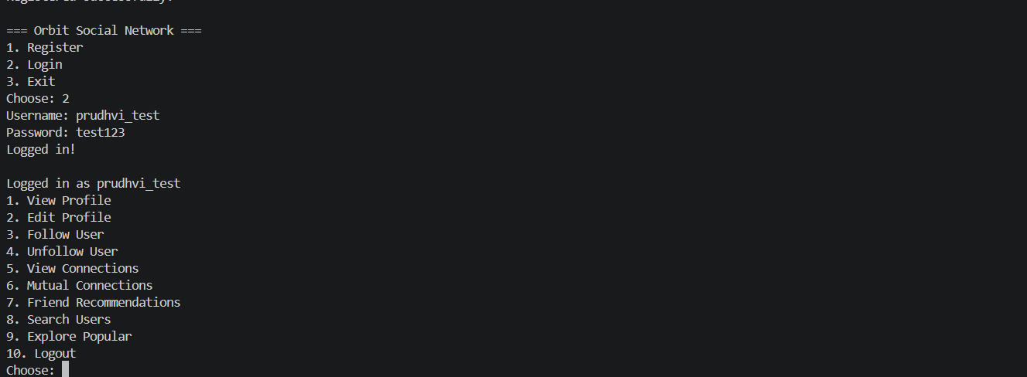

UC-3: View Profile
A logged-in user views their own profile.
Associated Cypher query:
MATCH (u:User {username: $username}) RETURN u
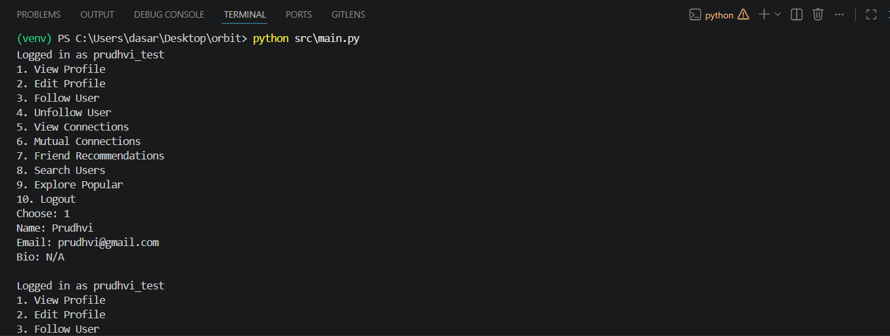

UC-4: Edit Profile
A logged-in user updates name and bio.
Associated Cypher query:
MATCH (u:User {username: $username})
SET u.name = COALESCE($name, u.name), u.bio = COALESCE($bio, u.bio)
RETURN u
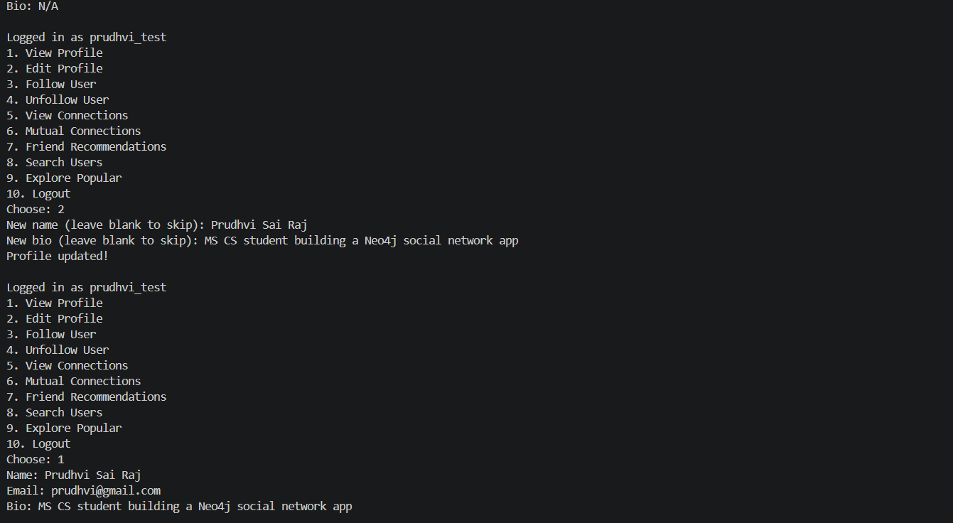

UC-5: Follow Another User
A user follows another user, creating a FOLLOWS edge.
Associated Cypher query:
MATCH (f:User {username: $follower}), (e:User {username: $followee})
MERGE (f)-[:FOLLOWS]->(e)
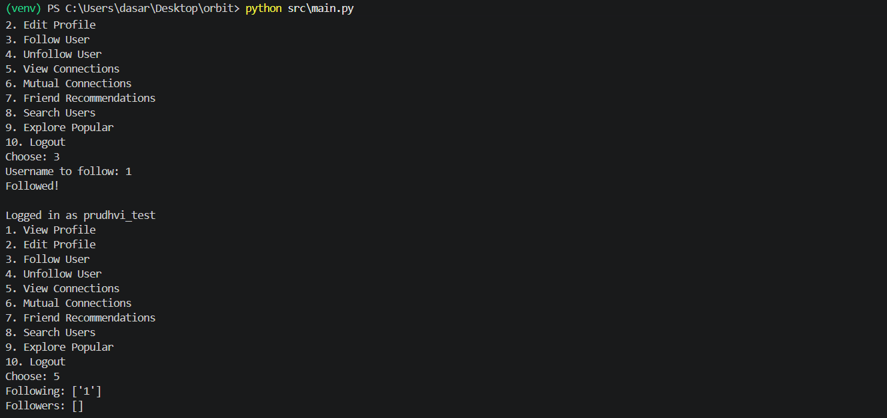

UC-6: Unfollow a User
A user unfollows another user, deleting the FOLLOWS edge.
Associated Cypher query:
MATCH (f:User {username: $follower})-[r:FOLLOWS]->(e:User {username: $followee})
DELETE r
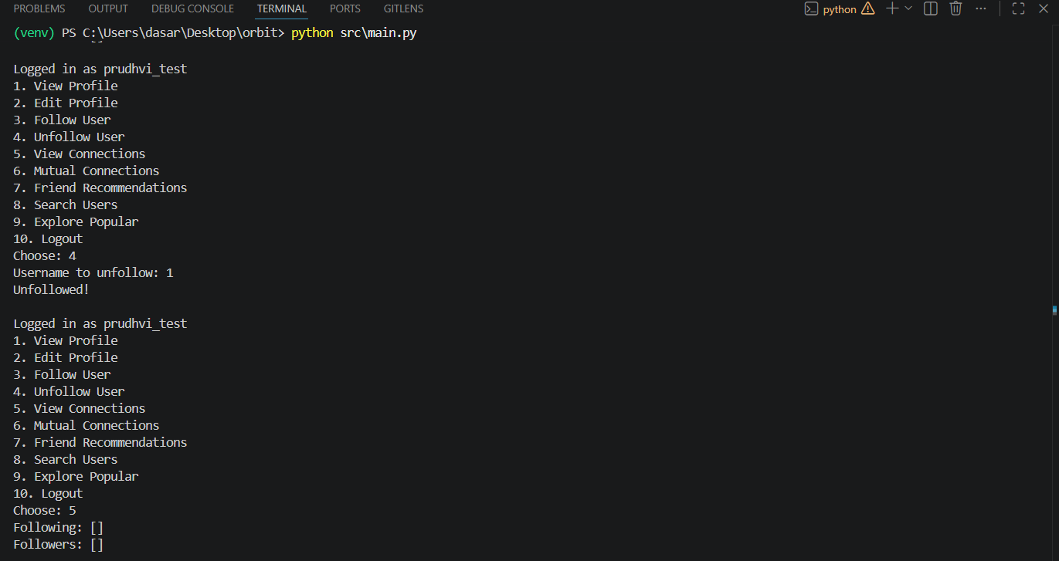

UC-7: View Friends / Connections
The system displays following and followers separately.
Associated Cypher query:
MATCH (u:User {username: $username})-[:FOLLOWS]->(f) RETURN f.username;
MATCH (f)-[:FOLLOWS]->(u:User {username: $username}) RETURN f.username;
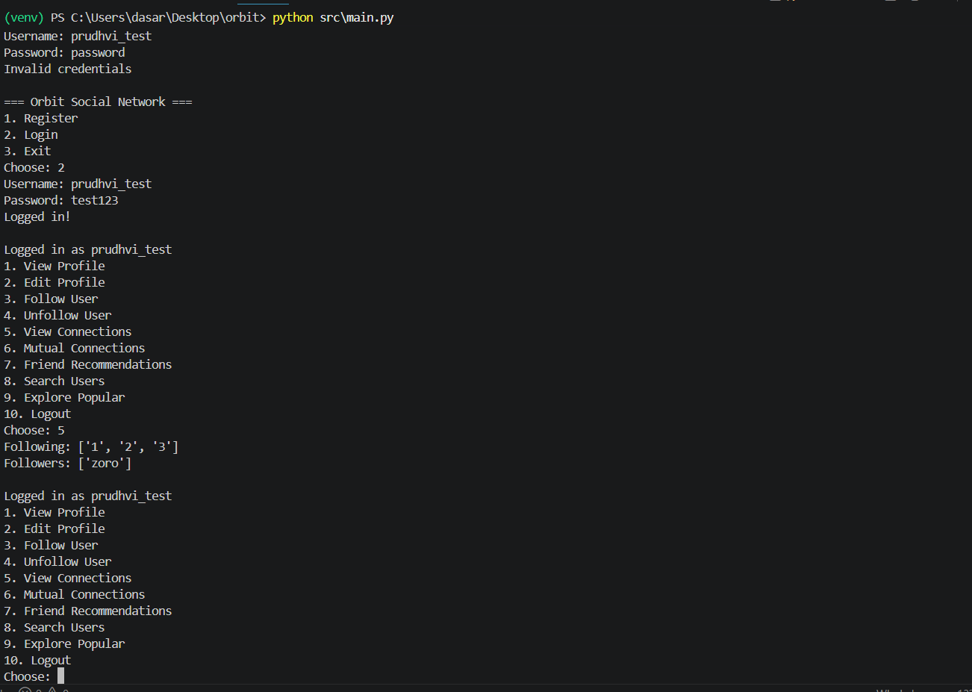

UC-8: Mutual Connections
The system displays mutual/common connections between two users.
Associated Cypher query:
MATCH (u1:User {username: $user1})-[:FOLLOWS]->(m:User)<-[:FOLLOWS]-(u2:User {username: $user2})
RETURN m.username
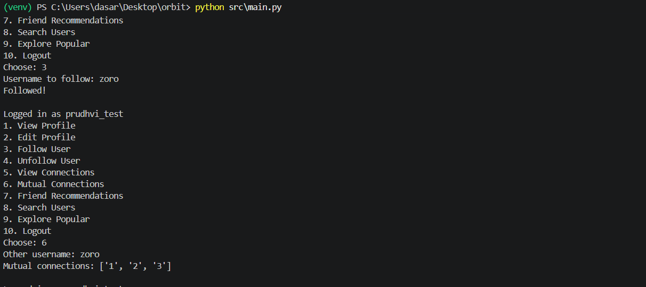

UC-9: Friend Recommendations
The system recommends users reachable through friends-of-friends traversal.
Associated Cypher query:
MATCH (u:User {username: $username})-[:FOLLOWS]->()-[:FOLLOWS]->(rec:User)
WHERE NOT (u)-[:FOLLOWS]->(rec) AND rec <> u
RETURN rec.username, COUNT(*) as score ORDER BY score DESC LIMIT 10
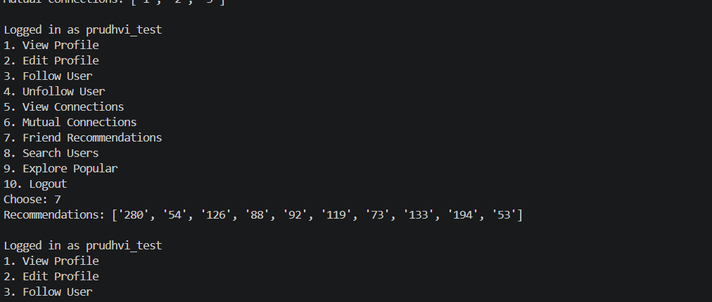

UC-10: Search Users
A user searches by name or username.
Associated Cypher query:
MATCH (u:User)
WHERE u.name CONTAINS $query OR u.username CONTAINS $query
RETURN u.username
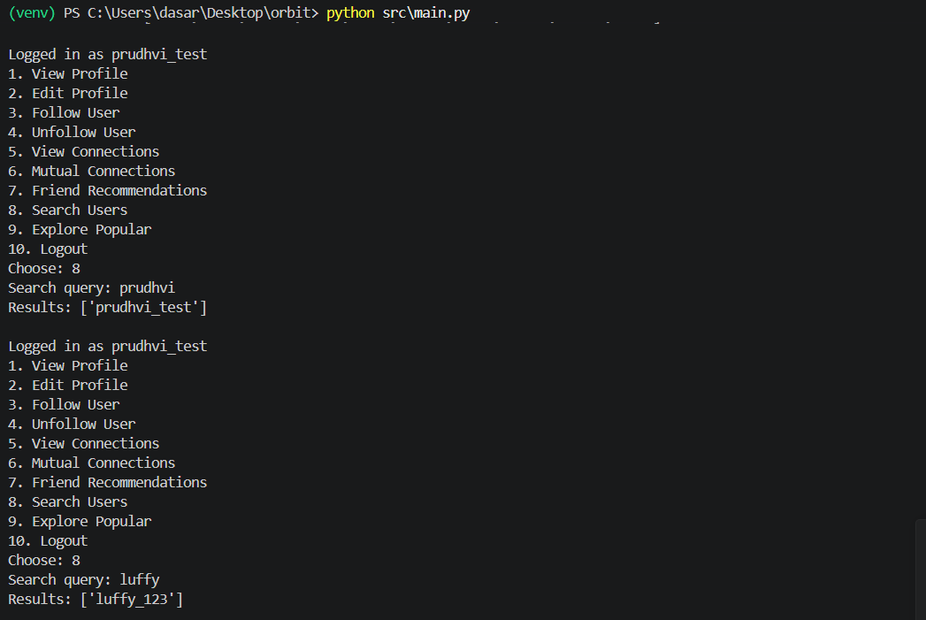

UC-11: Explore Popular Users
The system lists the most-followed users.
Associated Cypher query:
MATCH (u:User)<-[:FOLLOWS]-()
RETURN u.username, COUNT(*) as followers
ORDER BY followers DESC LIMIT $limit
