

Multiverseapp.com

On-page optimization refers to all measures that can be taken directly within the website in order to improve its position in the search rankings. Optimize the content or improve the Meta tags.

**On Page Analysis:**

These are the most important factors to be checked before optimizing a website. Proper implementation will help keyword ranking in search engine for your website.

**Note regarding New Page suggestion:** For some keywords we didn’t found relevant targeted page for some of the keyword so we are suggesting new pages for the keywords, please create new page accordingly and add relevant content information on website

**Page URL: https://multiverseapp.com/flutter-development-usa.html (suggested New Page)**   
**Suggested Keywords –** **flutter developer in USA, flutter developer USA**

**Page URL: https://multiverseapp.com/offshore-app-development.html (Suggested New Page)**   
**Suggested Keywords –** **offshore App Development Company**

**Page URL: https://multiverseapp.com/restaurant-app-development.html (Suggested New Page)**   
**Suggested Keywords –** **Restaurant App Development Company USA**

**Page URL: https://multiverseapp.com/enterprise-ios-solutions.html (Suggested New Page)**   
**Suggested Keywords –** **Enterprise iOS Solutions in USA**



**Page URL: https://multiverseapp.com/services-mobile-app-development.html**  
**Suggested Keywords –** iPhone app development company USA, iPhone/iOS Application Development Company, android app development company USA

**Page URL: https://multiverseapp.com/services-ui-ux.html**  
**Suggested Keywords –** UI and UX developer in USA

**Page URL: https://multiverseapp.com/flutter-development-usa.html**  
**Suggested Keywords –** flutter developer in USA, flutter developer in USA

**Page URL: https://multiverseapp.com/offshore-app-development.html**  
**Suggested Keywords –** offshore app development company

**Page URL: https://multiverseapp.com/restaurant-app-development.html**  
**Suggested Keywords –** Restaurant App Development Company USA

**Page URL: https://multiverseapp.com/enterprise-ios-solutions.html**  
**Suggested Keywords –** Enterprise iOS Solutions in USA



|  |  |
| --- | --- |
| **SEO Factors** | **On Page Analysis Information** |
| **Title Tag** | **Status**: Title Available. **Recommendation**: Your Title Tag should be optimized to make it more SEO and User friendly. Properly optimized web-page Title helps getting better positions in the SERPs. |

**Page URL: https://multiverseapp.com**  
**Current Title –** Multiverse Software

**Suggested Title –** Top Mobile App Development Company USA - Multiverse Software

**Page URL: https://multiverseapp.com/services-mobile-app-development.html**  
**Current Title –** Mobile App Development

**Suggested Title –** iPhone/ iOS Application Development Company | Android App Development Company USA - Multiverseapp.Com

**Page URL: https://multiverseapp.com/services-ui-ux.html**  
**Current Title –** Services

**Suggested Title –** UI and UX Developer in USA | UI/UX Design Company USA - Multiverseapp.Com

**Page URL: https://multiverseapp.com/flutter-development-usa.html**  
**Suggested Title –** Flutter Developer in USA | Flutter App Development Company in USA - Multiverseapp.Com

**Page URL: https://multiverseapp.com/offshore-app-development.html**  
**Suggested Title –** Offshore Mobile App Development Company - Multiverseapp.Com

**Page URL: https://multiverseapp.com/restaurant-app-development.html**  
**Suggested Title –** Restaurant App Development Company USA - Multiverseapp.Com

**Page URL: https://multiverseapp.com/enterprise-ios-solutions.html**  
**Suggested Title –** Enterprise iOS Solutions in USA - Multiverseapp.Com

**Page URL: https://multiverseapp.com/articles/covid-19-app**   
**Suggested Title –** COVID-19 Corona Tracker Mobile App - Multiverseapp.Com



|  |  |
| --- | --- |
| **SEO Factors** | **On Page Analysis Information** |
| **Description Tag** | **Status**: Your Description is available. **Recommendation**: Description Tag provides a short summary about any web-page and properly written snippet helps getting better CTR. It would be better if it is less than 160 chars. |

**Page URL: https://multiverseapp.com**  
**Current Description –** Multiverse Software is an app development Agency. Get your Mobile App Quote in a few minutes.

**Suggested Description –** Multiverse Software is one of the most promising mobile app development company in USA, offering the most suitable mobile app for the growth of your business

**Page URL: https://multiverseapp.com/services-mobile-app-development.html**  
**Current Description –** Mobile App Development service

**Suggested Description –** Multiverse Software is a leading Android and iPhone/iOS app development company in USA, Australia, India & UK, we offers native as well as hybrid apps for android and iOS

**Page URL: https://multiverseapp.com/services-ui-ux.html**  
**Current Description –** Lintor is a Mobile App Development Agency Template by tempload.

**Suggested Description –** We offer creative and exclusive UI/UX design and development services for our valuable clients across the globe, our team that helps you with creative UI/UX design for your applications

**Page URL: https://multiverseapp.com/flutter-development-usa.html**  
**Suggested Description –** Multiverse is a Flutter app development company in USA & India. We have professional flutter programmer to build next generation apps.

**Page URL: https://multiverseapp.com/offshore-app-development.html**  
**Suggested Description –** We are top offshore app Development Company in US. We deliver end-to-end solutions that fits both your requirements and your budget

**Page URL: https://multiverseapp.com/restaurant-app-development.html**  
**Suggested Description –** Multiverse is leading food delivery app Development Company. We offers food delivery app development services for your restaurant business in native android and IPhone platform

**Page URL: https://multiverseapp.com/enterprise-ios-solutions.html**  
**Suggested Description –** Multiverse is the most preferred iOS Development Company for US, We offer Enterprise level iOS Solutions for your app across to the Globe



|  |  |
| --- | --- |
| **SEO Factors** | **On Page Analysis Information** |
| **Heading Tags** | **Status**: Your website have HTML heading <H1>. **Recommendation**: Your important keyword should be exist in heading <h1> and H1 should not be placed more than one in a page. |

**Page URL: https://multiverseapp.com**  
**Current H1 –** Welcome to Multiverse Software

**Suggested H1 –** No changes required

**Page URL: https://multiverseapp.com/services-mobile-app-development.html**  
**Current H1 –** Mobile App Development

**Suggested H1 –** Android & iPhone/iOS Application Development Company

**Page URL: https://multiverseapp.com/services-ui-ux.html**  
**Current H1 –** Design and User Experience

**Suggested H1 –** UI and UX development Company in USA

**Page URL: https://multiverseapp.com/flutter-development-usa.html**  
**Suggested H1 –** Flutter Developer in USA

**Page URL: https://multiverseapp.com/offshore-app-development.html**  
**Suggested H1 –** Offshore App Development Company

**Page URL: https://multiverseapp.com/restaurant-app-development.html**  
**Suggested H1 –** Restaurant App Development Company in USA

**Page URL: https://multiverseapp.com/enterprise-ios-solutions.html**  
**Suggested H1 –** Enterprise iOS Solutions in USA



|  |  |
| --- | --- |
| **SEO Factors** | **On Page Analysis Information** |
| **Image ALT Tags** | **Status**: ALT Tags not Found. **Recommendation**: All the Used images should be optimized using proper ALT Attributes. Images should have relevant and useful text as ALT Attributes. |

**We have attached separate sheet for ALT tags, please check “Alt Tag” sheet for reference**



* **Fresh Content Required**: We didn’t find enough amount of keyword oriented content on target page. So we highly recommend you to add some unique and relevant content (about 180-200 words containing targeted keywords within it) in following pages-

**Page URL: https://multiverseapp.com/services-mobile-app-development.html**  
**Content required for –** iPhone app development company USA, iPhone/iOS Application Development Company, android app development company USA

**Page URL: https://multiverseapp.com/services-ui-ux.html**  
**Content required For –** UI and UX developer in USA

**Page URL: https://multiverseapp.com/flutter-development-usa.html**  
**Content required for –** flutter developer in USA, flutter developer in USA

**Page URL: https://multiverseapp.com/offshore-app-development.html**  
**Content required for –** offshore app Development Company

**Page URL: https://multiverseapp.com/restaurant-app-development.html**  
**Content required For –** Restaurant App Development Company USA

**Page URL: https://multiverseapp.com/enterprise-ios-solutions.html**  
**Content required For –** Enterprise iOS Solutions in USA



* **Robots.txt** is a regular text file that through its name has special meaning to the majority of "honorable" robots on the web. By defining a few rules in this text file, you can instruct robots to not crawl and index certain files, directories within your site, or at all.

**Result:** robots.txt file not found, please check attached robots.txt file



* **Sitemap:** A sitemap is a file where you can list the web pages of your site to tell Google and other search engines about the organization of your site content. Search engine web crawlers like Google bot read this file to more intelligently crawl your site.

**Result**: Sitemap not found, we’ll provide sitemap after creating the new pages and URL structure regarding changes



* Redirection issue found in the website. It is not good from search engine point of view. We have found multiple version of home <https://multiverseapp.com/index.html> and <https://multiverseapp.com/> and this will consider as content duplicity issue in search engine for solve this issue you need to redirect index.html page to main version with the help of 301 redirections method

[**https://multiverseapp.com/index.html**](https://multiverseapp.com/index.html) (301 Redirection) [**https://multiverseapp.com/**](https://multiverseapp.com/)



* A canonical problem occurs when a site is running in multiple versions like www version (http://www.yoursite.com), the non-www version (http://yoursite.com) and other versions (http://yoursite.com/index.html). In this case, content of website is considered as duplicate by the search engines and as a result one version is removed from their index. The problem arises when the wrong version is deleted (this is usually the non-www version) instead of preferred one. So to inform about genuine version of the page, we add canonical tag to that page in order to avoid any such problem or confusion. We also use canonical when there is no possibility of using 301 redirection method.  
    
  **Result**: Canonical tag not found in the website. It is not good from search engine point of view.
* **URL**: https://multiverseapp.com/

**Suggested Canonical**: <link rel=”canonical” href=” https://multiverseapp.com/” />

* **URL**: https://multiverseapp.com/our-apps.html

**Suggested Canonical**: <link rel=”canonical” href=” https://multiverseapp.com/our-apps.html” />

* **URL**: https://multiverseapp.com/services.html

**Suggested Canonical**: <link rel=”canonical” href=” https://multiverseapp.com/services.html” />

And so On…. Canonical tag need to update each and every page



* 13 External links found in the website. Some of seems harmful from search engine point of view. We suggest you to mark them as no follow , please check List which need to be no-follow

|  |  |  |
| --- | --- | --- |
| URL | Anchor | Current Status |
| https://medium.com/multiverse-software/resident-management-app-ix-case-study-a6cd0b2a66e9 | Resident Management App — UX Case Study | Do follow |
| https://medium.com/multiverse-software/resident-management-app-ix-case-study-a6cd0b2a66e9 | Read More | Do follow |
| https://medium.com/multiverse-software/anybooks-reading-app-ux-case-study-2648ed08a5ae | AnyBooks Reading App — UX Case Study | Do follow |
| https://medium.com/multiverse-software/anybooks-reading-app-ux-case-study-2648ed08a5ae | Read More | Do follow |
| https://medium.com/multiverse-software/flutter-the-first-ui-platform-designed-for-ambient-computing-5d60e332e05b | Flutter: the first UI platform designed for ambient computing | Do follow |
| https://medium.com/multiverse-software/flutter-the-first-ui-platform-designed-for-ambient-computing-5d60e332e05b | Read More | Do follow |



* We have found many broken links in the website. It is not good from search engine point of view. Please remove broken links from site, please check attached complete sheet for broken links ref.



* **Internal Linking:** Internal linking is called perfect when every live webpage is accessed/visited from every other live and available webpage in a website. Internal linking helps users to move freely and access every desired webpage or find every bit of desired information provided on the website without having any confusion on how to visit any other live Webpage.  
  **Result:** Internal linking structure of website is good and both SEO and user friendly.



* 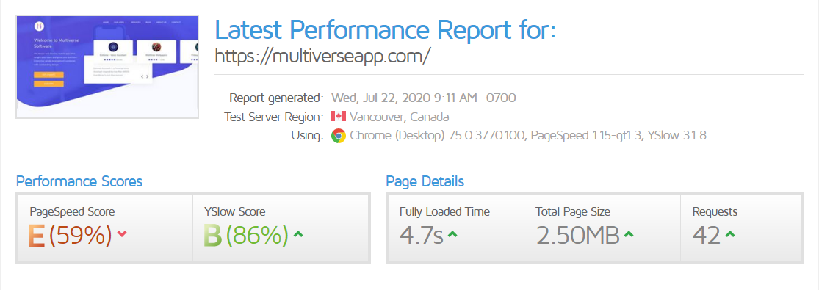**Page Optimization Score: (59/100)**

**Reference URL:** <https://gtmetrix.com/reports/multiverseapp.com/4lvfJiLP>



* **Result**: Your URL structure is Search Engine friendly but for more Keyword optimization we need to change some page URL structure.

**Recommendations**:

* **Current URL**: https://multiverseapp.com/services-mobile-app-development.html

**Suggested URL**: https://multiverseapp.com/iphone-android-app-development.html

* **Current URL**: https://multiverseapp.com/services-ui-ux.html

**Suggested URL**: https://multiverseapp.com/ui-ux-development.html

* **Current URL**: https://multiverseapp.com/services-social-media-marketing.html

**Suggested URL**: https://multiverseapp.com/social-media-marketing-services.html



* **Result**: Hyper-linking of the website is not good. It is not good from search engine point of view.

**Recommendations**: Hyperlinks are connections established between a word/phrase/image and a website/file. Effective hyper-linking between different pages can help a website secure a good position in the search engine result pages as well.

**Issue 1:**

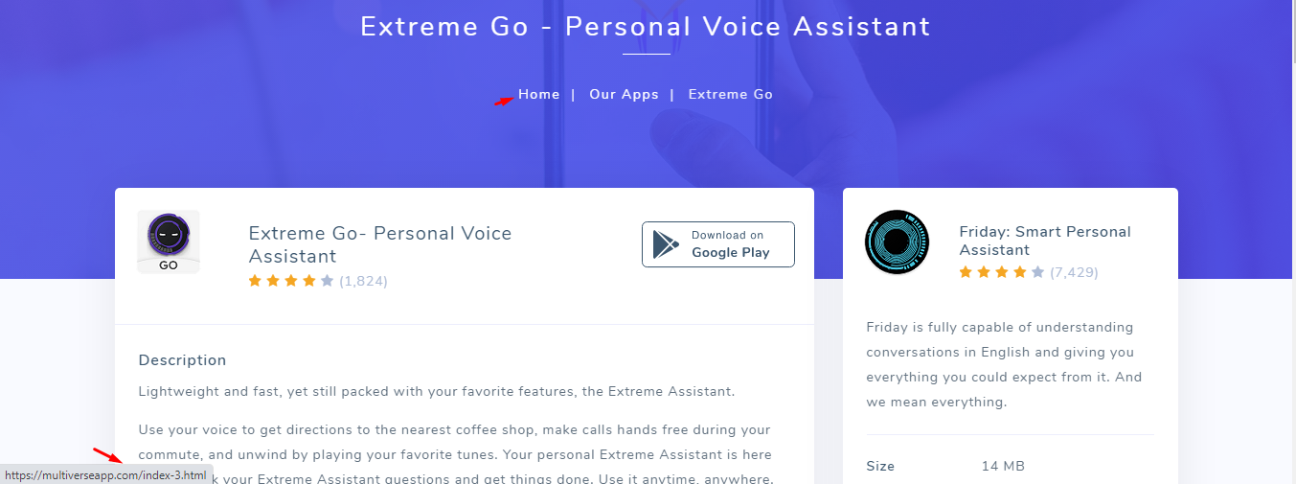

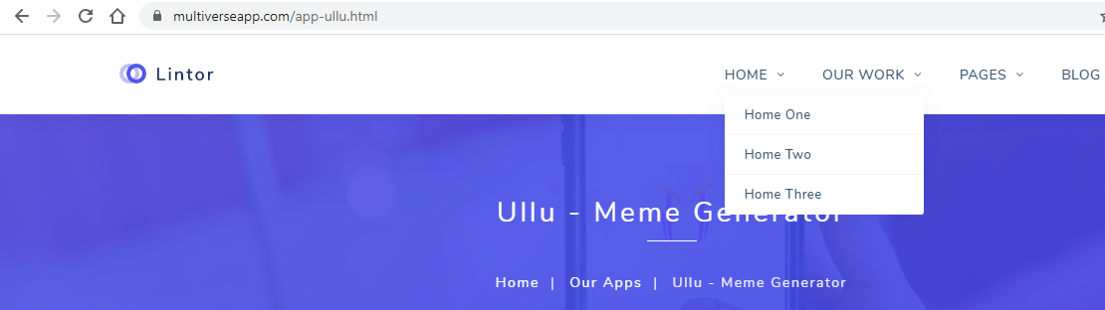**Issue 2:**