

multiverseapp.com

Hello, as you know we are continuously doing SEO workings for your website multiverseapp.com. We are working according to provided goals and getting improvement in ranking and traffic. We have created a brief report on how the website presence is improving in organic results.

**Traffic Status**

As you can see in the following screenshots that the organic traffic are gradually improving with the continuous working on the website. The improvement is as per expectations in organic SEO and it resembles that the website is now more frequently rankings and getting clicked in Google search results. We need to keep making our efforts to further improvise it.

**Organic Traffic overview in SEMRush**

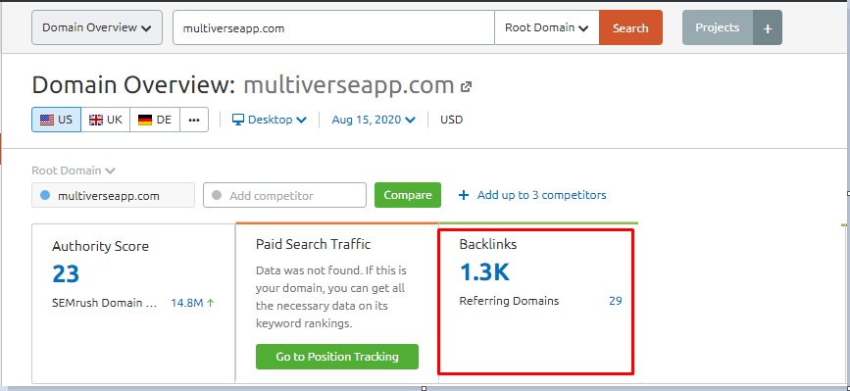

**Organic keyword overview in SEMRush**

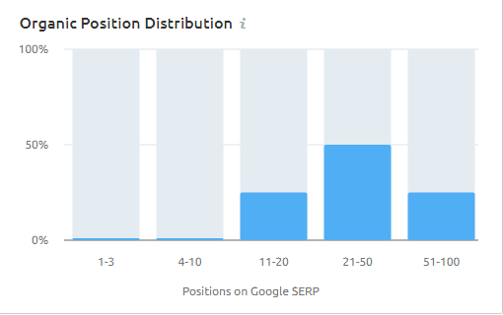

**Organic keyword overview in SE-Ranking**

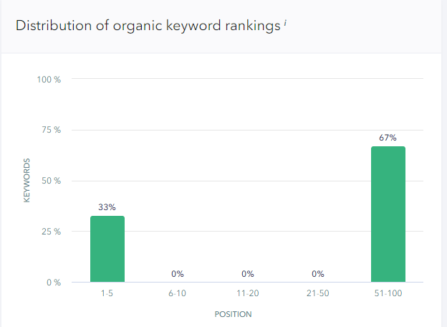

**Backlink Profile**

Backlinks are one of the most important factors that search engines consider to calculate the website worth. With the continuous workings we are getting improvements in referring domains. Please have a look at the following screenshots from Ahref.

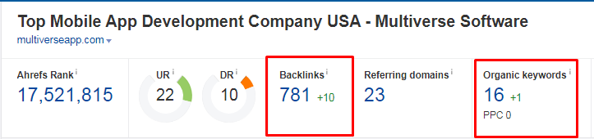

**Improving Referring Domian In Ahref**

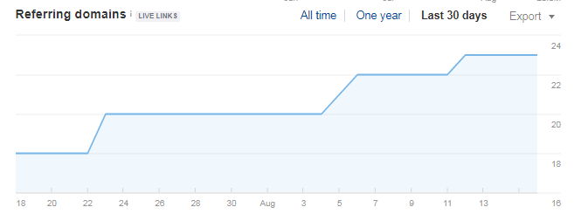

**Improving Referring Pages In Ahref**

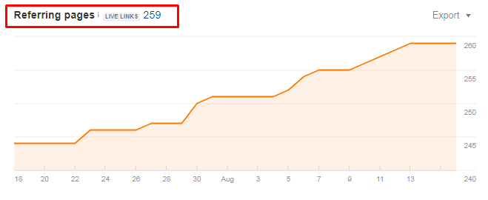

**Improving organic keyword In Ahref**

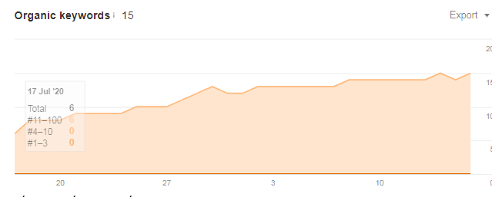

**CONCLUSIONS/RECOMMENDATIONS**

As you can see in provided traffic table above. There is some improvement in the Traffic on the website. We are working accordingly to get more improvement in traffic but as you know that SEO is an ongoing process which requires continuous efforts and time to maintain the positions in Search Engine and if we will stop working and making back-links slowly our web-page will be demoted as rest of the other websites will be working on theirs and also we will now be focusing mainly on creating quality back-links for the website which will help in improving the brand worth for the website both in the eyes of Search Engine and user. Thus, to get benefits of SEO we have to work on continuous basis. It`s a request not to breach our work regularity because as we discuss above SEO is an ongoing process and requires continue working to maintain/improve ranking and traffic as well as needs sufficient time to achieve desired results. We request you to please give us some more time to spend on your site to do more focused working. We will try harder to show you regular improvements in both the ranking and traffic of the website. Hope you are getting what we want to explain and will give us more time to work for your site. We are waiting for your valuable reply.