- Ergonomics : One of the biggest issues with potters, when they’re throwing clay, isn’t the actual technique of it. No, it’s back pain. One of the biggest injuries that you can get as a potter isn’t burning yourself with the kiln. It isn’t inhaling the particles. Nope, it’s back pain. Back pain happens because lots of times, potters don’t realize the importance of their posture and ergonomics. However, you’re about to find out a little bit more about why it’s important to have killer potter posture, and how it can prevent various issues from happening, including back pain. One of the biggest conditions that can happen is sciatica. This is actually a tingling sensation that goes from the sciatic nerve all the way down your back to the back of your legs.
- Raising if possible for standing up (https://www.youtube.com/watch?v=eGlRpclmmVM)
    - Least spinal Compression
    - Height Adjustable
    - In Line with Lower Abdomen (To apply proper force and centering)
2.

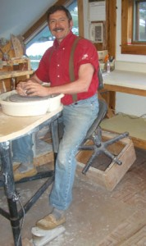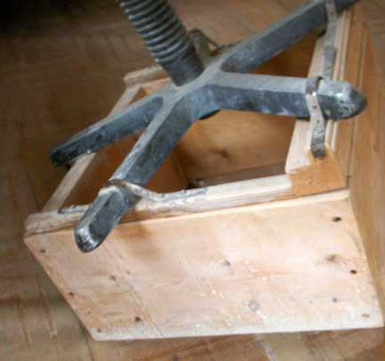
Robert added leg extensions to his potter’s wheels making them very comfortable to throw on. This particular wheel, a Pacifica, has a strong molded splash pan on which he rests his forearms for leverage. After a back injury, Robert taught himself good posture when at the wheel. He accomplishes this by keeping his back vertically aligned and his pelvis tilted. The unusual wooden platform he built under his chair is the key to a comfortable day’s work.
Even though this office chair has little padding, it is superior to the thickly padded seats that most potters use, since the more traditional seats require the potter to sit flat. This design tilts the potter’s pelvis, making an ergonomic alignment of the potters, back, legs and shoulders. Note that the wheel height is above the potter’s waist. In this position the potter has 30-60% of his weight on the seat. He or she can adjust this position up or down by shifting more or less weight to their legs.
https://robertcomptonpottery.com/index.php/forming-techniques-2/forming-methods-wheels/
- https://spinningpots.com/potter-posture-and-how-to-prevent-back-pain/
- Water Holding and Glazing pots

- Material (https://www.researchgate.net/post/What_are_the_alternate_materials_for_machine_bases_other_than_cast_Iron)
- Epoxy Granite : Epoxy granite is used instead of cast iron and steel for better vibration damping, longer tool life, and lower assembly cost.
- Polymeric concrete: Polymer concrete is dense, rigid, dimensionally and thermally stable, resistant to water and chemicals and will not twist or bend when stress is introduced. Most of all, it has superb vibration dampening qualities.
https://www.researchgate.net/figure/Comparison-of-the-properties-of-steel-cast-iron-and-polymer-concrete-2_tbl1_323753518
- Welded steel:
- Carbon fiber composites: They all have high strength and high stiffness. They have low density and strongly resist fatigue and creep. They have low coefficients of thermal expansion (CTE) and basically don’t corrode. Some composites also have extremely high thermal conductivity, high temperature capability, or both.

