Lab 6 – Exercise 1: Vehicles Database

Q1. Create / select the database 'vehicles'
Query:
use("vehicles")
Output:

Q2. Display all databases
Query:
db.adminCommand({ listDatabases: 1 })
Output:
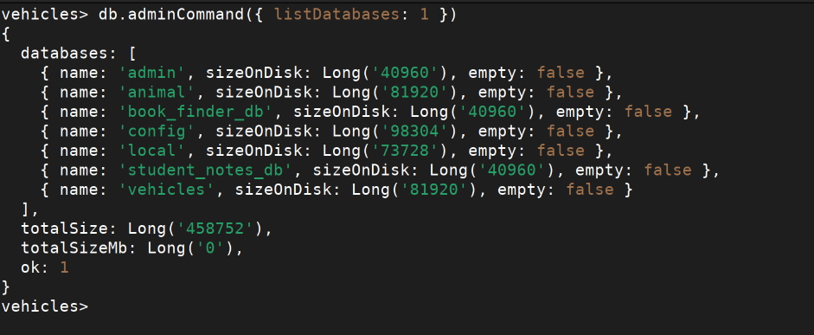

Q3. Create collections (two_wheelers as capped, four_wheelers as regular)
Query:
db.createCollection("two_wheelers", { capped: true, size: 1048576, max: 100 })
db.createCollection("four_wheelers")
Output:
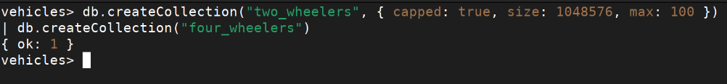

Q4. Insert 5 two-wheelers into the two_wheelers collection
Query:
db.two_wheelers.insertMany([
{ bike_name: "Honda Activa 6G", model: "gearless", category: "125cc", colors_available: ["red","black","blue","white"], manufacturer: "Honda", performance: 7, timestamp: new Date("2021-01-15"), price: 75000 },
{ bike_name: "Royal Enfield Classic 350", model: "gear", category: "350cc", colors_available: ["black","chrome silver","gunmetal grey"], manufacturer: "Royal Enfield", performance: 8, timestamp: new Date("2021-08-20"), price: 185000 },
{ bike_name: "Bajaj Pulsar NS200", model: "gear", category: "200cc", colors_available: ["black","red","blue"], manufacturer: "Bajaj", performance: 8, timestamp: new Date("2020-06-10"), price: 140000 },
{ bike_name: "TVS Jupiter", model: "gearless", category: "110cc", colors_available: ["red","white","blue","sport red"], manufacturer: "TVS", performance: 6, timestamp: new Date("2022-03-05"), price: 72000 },
{ bike_name: "Yamaha R15 V4", model: "gear", category: "150cc", colors_available: ["blue","black","sport red"], manufacturer: "Yamaha", performance: 9, timestamp: new Date("2022-11-01"), price: 175000 }
])
Output:
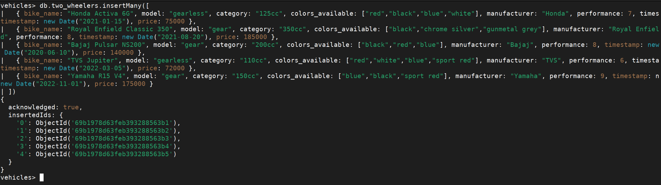

Q5. Insert 5 four-wheelers into the four_wheelers collection
Query:
db.four_wheelers.insertMany([
{ vehicle_name: "Maruti Suzuki Swift", model: "own", category: "car", variants: ["vxi","zxi","petrol","diesel"], manufacturer: "Maruti Suzuki", performance: 7, timestamp: new Date("2021-04-10"), price: 700000 },
{ vehicle_name: "Tata Ace", model: "commercial", category: "mini truck", variants: ["diesel","cng"], manufacturer: "Tata Motors", performance: 6, timestamp: new Date("2020-09-15"), price: 450000 },
{ vehicle_name: "Ashok Leyland Dost", model: "commercial", category: "heavy truck", variants: ["diesel"], manufacturer: "Ashok Leyland", performance: 7, timestamp: new Date("2019-12-01"), price: 1200000 },
{ vehicle_name: "Hyundai Creta", model: "own", category: "car", variants: ["petrol","diesel","vxi","zxi"], manufacturer: "Hyundai", performance: 8, timestamp: new Date("2022-06-20"), price: 1100000 },
{ vehicle_name: "Volvo B9R", model: "commercial", category: "bus", variants: ["diesel"], manufacturer: "Volvo", performance: 9, timestamp: new Date("2021-11-30"), price: 5000000 }
])
Output:
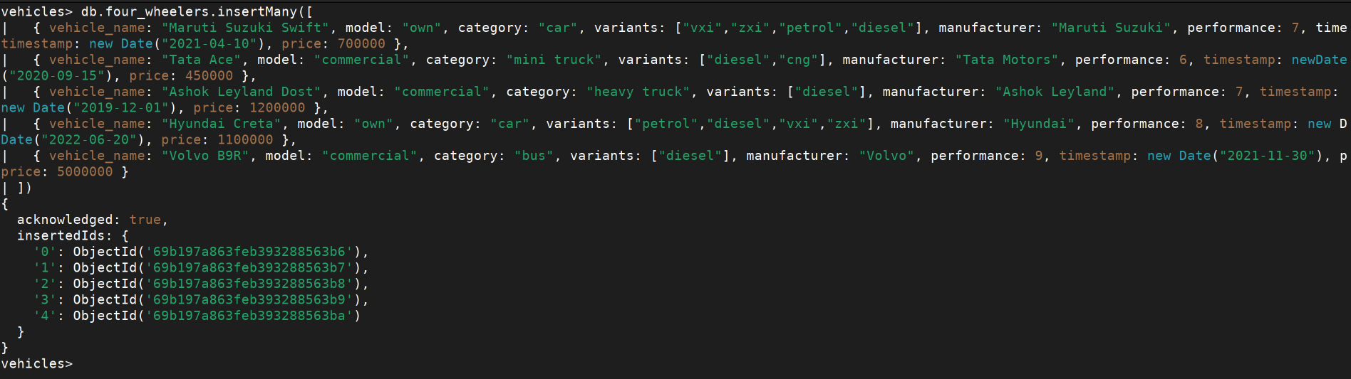

Q6. Display all documents in both collections
Query:
db.two_wheelers.find()
db.four_wheelers.find()
Output:
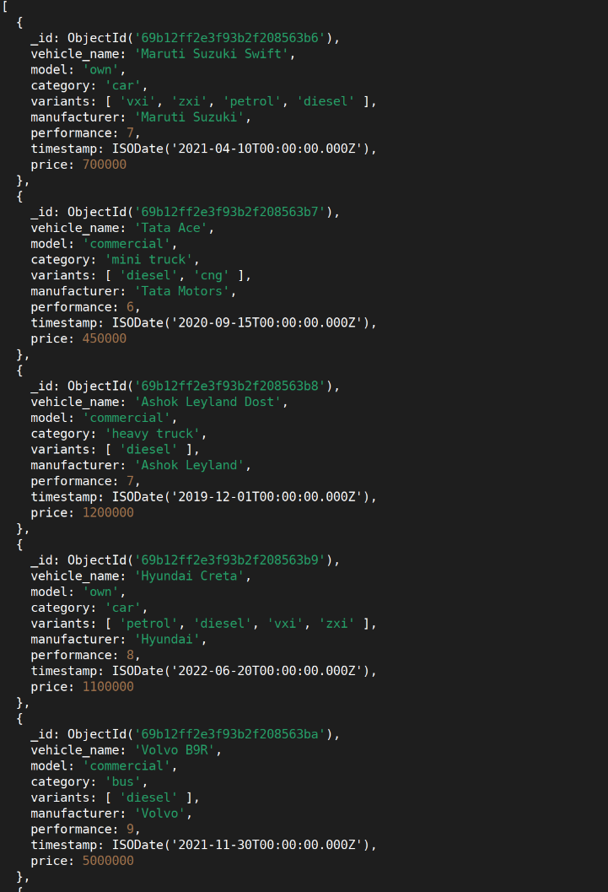

Q7. Display only vehicle name and price from both collections
Query:
db.two_wheelers.find({}, { bike_name: 1, price: 1, _id: 0 })
db.four_wheelers.find({}, { vehicle_name: 1, price: 1, _id: 0 })
Output:
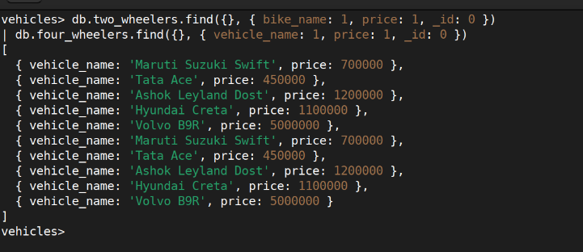

Q8. Display two-wheelers from a particular company (Honda)
Query:
db.two_wheelers.find({ manufacturer: "Honda" })
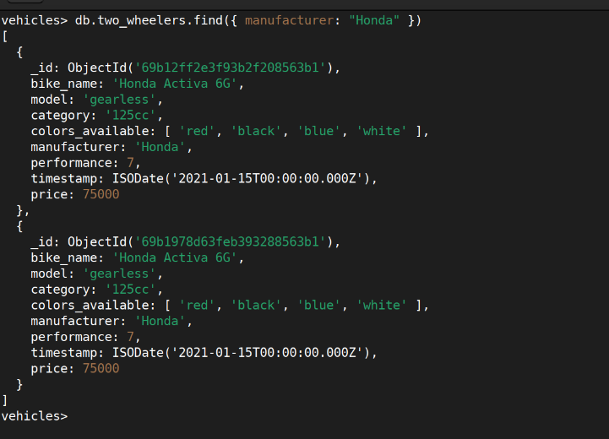

Q9. Display four-wheelers available in diesel variant
Query:
db.four_wheelers.find({ variants: "diesel" })

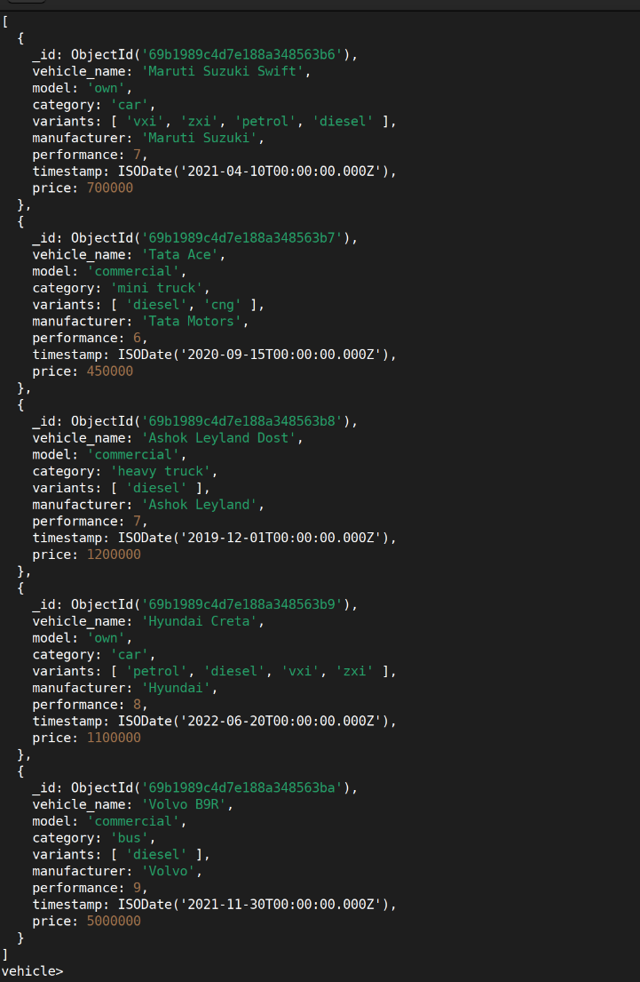

Q10. Display vehicles with performance rating greater than 5 (name, category, manufacturer)
Query:
db.two_wheelers.find(
{ performance: { $gt: 5 } },
{ bike_name: 1, category: 1, manufacturer: 1, _id: 0 }
)
db.four_wheelers.find(
{ performance: { $gt: 5 } },
{ vehicle_name: 1, category: 1, manufacturer: 1, _id: 0 }
)
Output:
