Lab 6 – Exercise 2: Zoo / Animal Database

Q1. Create / select the database 'animal'
Query:
use("animal")
Output:
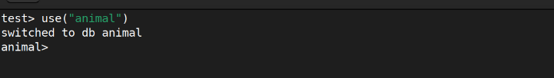

Q2. Display all databases
Query:
db.adminCommand({ listDatabases: 1 })
Output:
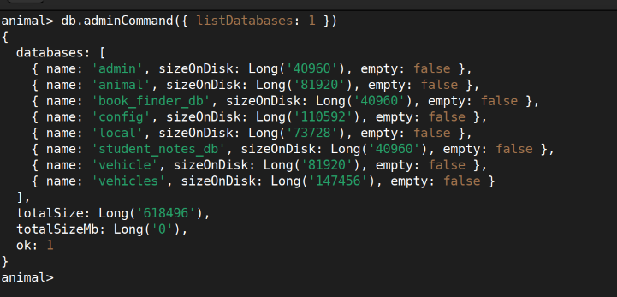

Q3. Create collections (wild_animals as capped, domestic_animals as regular)
Query:
db.createCollection("wild_animals", { capped: true, size: 1048576, max: 100 })
db.createCollection("domestic_animals")
Output:
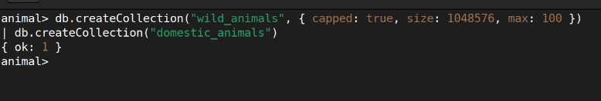

Q4. Insert 5 wild animals into the wild_animals collection
Query:
db.wild_animals.insertMany([
{ animal_name: "Bengal Tiger", nature: "harm", favorite_foods: ["deer","boar","rabbits"], care_taker_name: "Ramesh Kumar", life_span: 12, timestamp: new Date("2020-03-10"), expenses: 45000 },
{ animal_name: "African Elephant", nature: "harmless", favorite_foods: ["grass","fruits","bark"], care_taker_name: "Suresh Patel", life_span: 60, timestamp: new Date("2018-07-22"), expenses: 90000 },
{ animal_name: "King Cobra", nature: "harm", favorite_foods: ["rats","frogs","lizards"], care_taker_name: "Anita Sharma", life_span: 20, timestamp: new Date("2021-11-05"), expenses: 15000 },
{ animal_name: "White Rhinoceros", nature: "harmless", favorite_foods: ["grass","leaves","shrubs"], care_taker_name: "Ramesh Kumar", life_span: 40, timestamp: new Date("2019-04-18"), expenses: 75000 },
{ animal_name: "Snow Leopard", nature: "harm", favorite_foods: ["deer","goats","rabbits"], care_taker_name: "Priya Nair", life_span: 15, timestamp: new Date("2022-01-30"), expenses: 60000 }
])
Output:
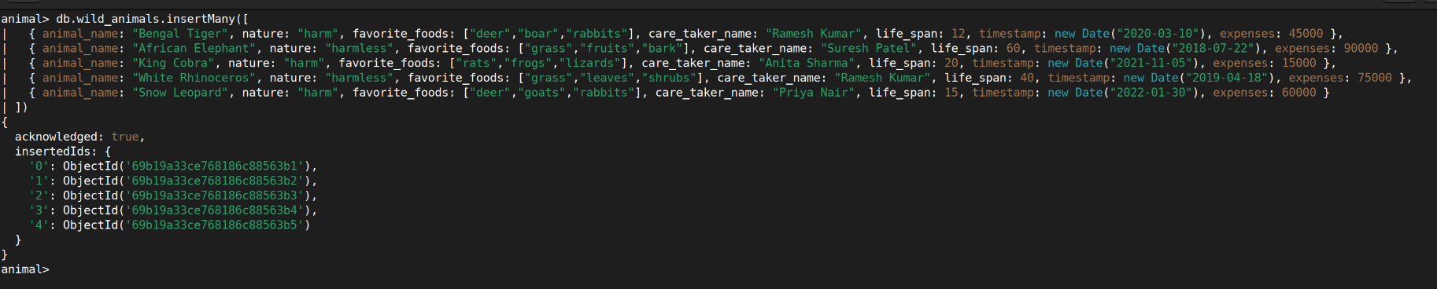

Q5. Insert 5 domestic animals into the domestic_animals collection
Query:
db.domestic_animals.insertMany([
{ animal_name: "Dog", gender: "male", favorite_foods: ["meat","biscuits","rice"], animal_petname: "Bruno", life_span: 13, timestamp: new Date("2021-06-15"), expenses: 8000 },
{ animal_name: "Cat", gender: "female", favorite_foods: ["fish","milk","meat"], animal_petname: "Whiskers", life_span: 15, timestamp: new Date("2020-09-01"), expenses: 5000 },
{ animal_name: "Parrot", gender: "male", favorite_foods: ["seeds","fruits","nuts"], animal_petname: "Mango", life_span: 30, timestamp: new Date("2022-03-20"), expenses: 3000 },
{ animal_name: "Rabbit", gender: "female", favorite_foods: ["carrots","leafy greens","hay"], animal_petname: "Snowball", life_span: 8, timestamp: new Date("2023-02-10"), expenses: 2000 },
{ animal_name: "Tortoise", gender: "male", favorite_foods: ["leafy greens","vegetables","fruits"], animal_petname: "Rocky", life_span: 100, timestamp: new Date("2019-11-25"), expenses: 1500 }
])
Output:
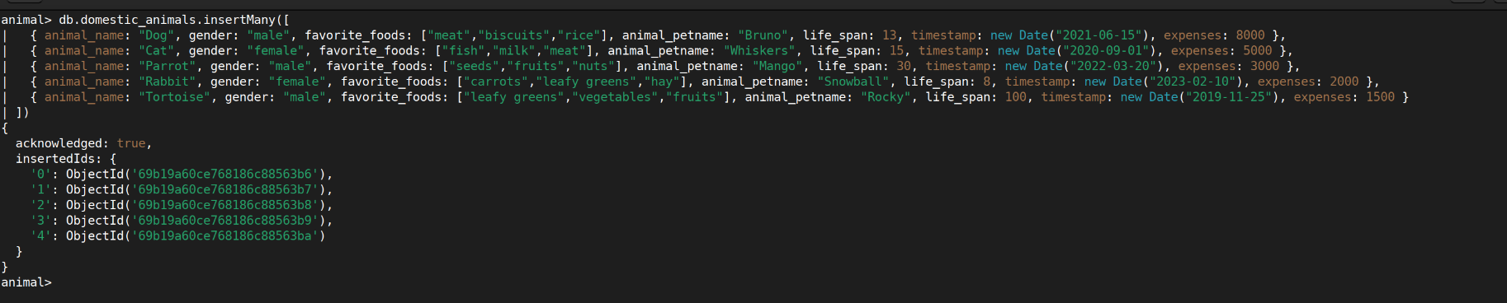

Q6. Display all documents in both collections
Query:
db.wild_animals.find()
db.domestic_animals.find()
Output:
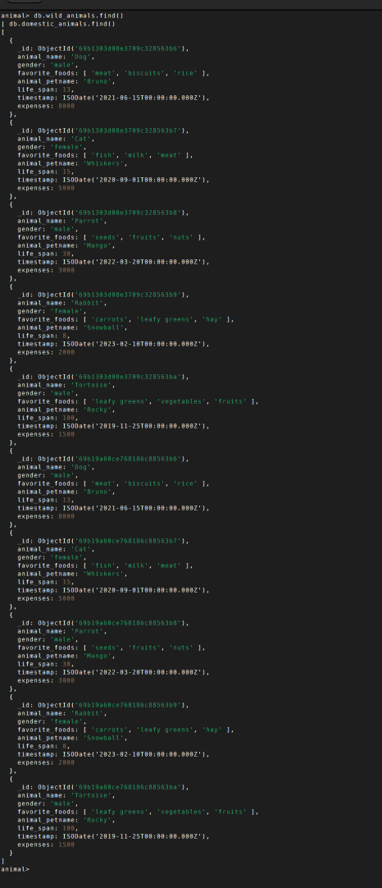
Q7. Display only animal name and expenses from both collections
Query:
db.wild_animals.find({}, { animal_name: 1, expenses: 1, _id: 0 })
db.domestic_animals.find({}, { animal_name: 1, expenses: 1, _id: 0 })
Output:
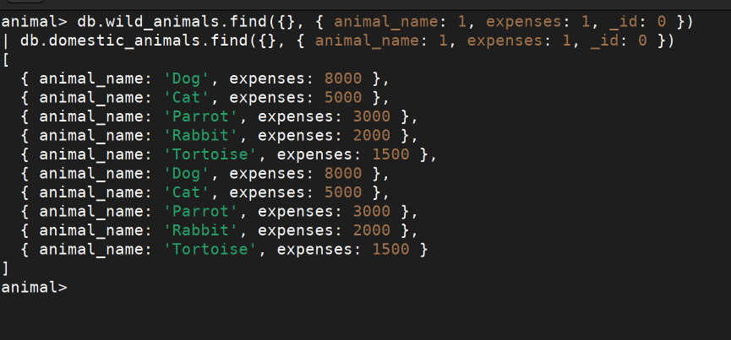

Q8. Display domestic animals whose life span is 13 years
Query:
db.domestic_animals.find({ life_span: 13 })
Output:
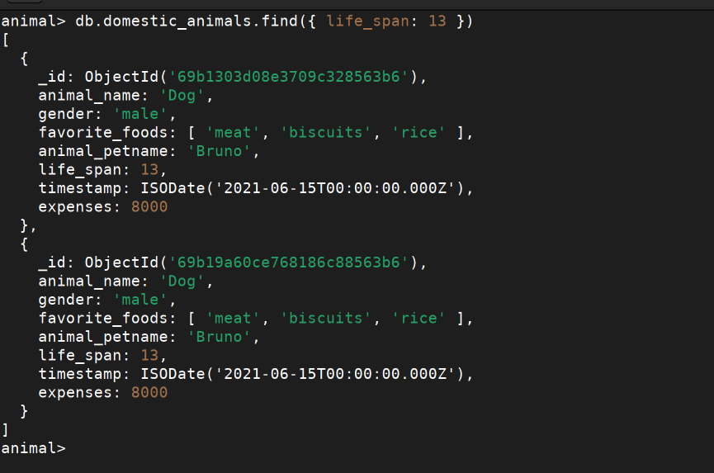

Q9. Display wild animals under a particular care taker (Ramesh Kumar)
Query:
db.wild_animals.find({ care_taker_name: "Ramesh Kumar" })
Output:
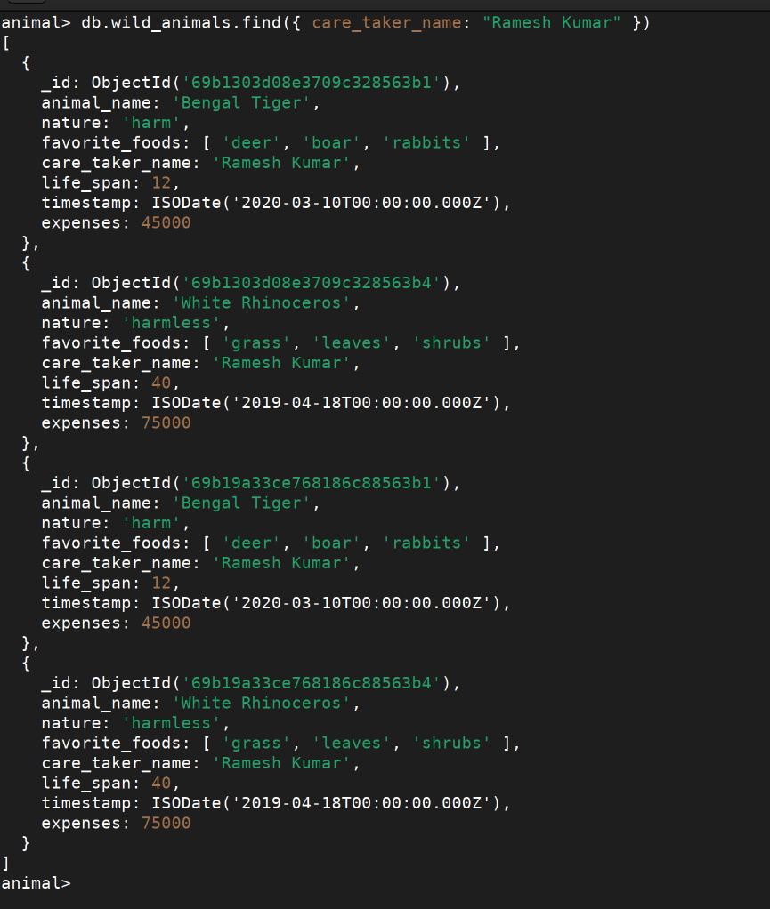
Q10. Display animals with life span greater than 5 years (name, favorite foods, expenses)
Query:
db.wild_animals.find(
{ life_span: { $gt: 5 } },
{ animal_name: 1, favorite_foods: 1, expenses: 1, _id: 0 }
)
db.domestic_animals.find(
{ life_span: { $gt: 5 } },
{ animal_name: 1, favorite_foods: 1, expenses: 1, _id: 0 }
)
Output:
