Name: Kushal Kishor Shankhapal

Group B, Assignment 6: Feature extraction in 2D color images
Problem Statement:
To Implement a program for feature extraction in 2D color images (any features like color,
texture etc. and to extract features from input image and plot histogram for the features.

Feature_Extraction.ipynb
import cv2
import matplotlib.pyplot as plt
from skimage.color import rgb2gray

img = cv2.imread("cat.jpeg")
plt.imshow(img)

<matplotlib.image.AxesImage at 0x7ebc4f53deb0>
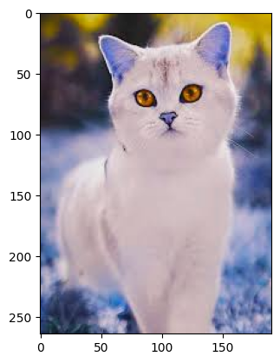
red, yellow = img.copy(), img.copy()
red[:, :, (1,2)] = 0
yellow[:, :, 2] = 0
f = plt.figure()
f.add_subplot(1,2, 1)
plt.imshow(red)
f.add_subplot(1,2, 2)
plt.imshow(yellow)
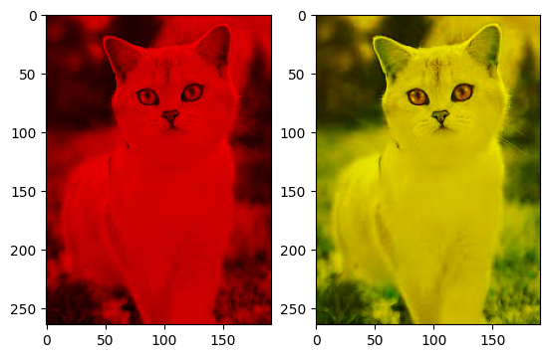
plt.show(block=True)

f = plt.figure()
f.add_subplot(1,2, 1)
plt.imshow(img)
f.add_subplot(1,2, 2)
plt.imshow(rgb2gray(img))
plt.show(block=True)

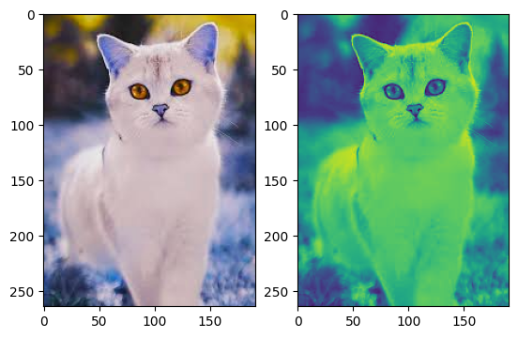

gimg = cv2.GaussianBlur(img,(105,105),cv2.BORDER_DEFAULT)
f = plt.figure()
f.add_subplot(1,2, 1)
plt.imshow(img)
f.add_subplot(1,2, 2)
plt.imshow(gimg)
plt.show(block=True)
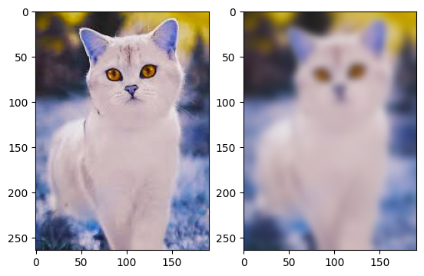

histg = cv2.calcHist([img],[0],None,[256],[0,256])
plt.plot(histg)

[<matplotlib.lines.Line2D at 0x7ebc4d942030>]
