Kushal H Pipaliya

202106100110129

Sem-6th Div-B

# Practical List 2

**PRACTICAL 1 :- XML FILE**

<?xml version="1.0" encoding="utf-8"?>

<LinearLayout xmlns:android="http://schemas.android.com/apk/res/android"

xmlns:app="http://schemas.android.com/apk/res-auto"

xmlns:tools="http://schemas.android.com/tools"

android:id="@+id/main"

android:layout_width="match_parent"

android:layout_height="match_parent"

android:orientation="vertical"

android:layout_margin="5dp"

tools:context=".MainActivity">

<TextView

android:layout_width="match_parent"

android:layout_height="wrap_content"

android:textSize="20dp"

android:text="Uka Tarsadia University"/>

<View

android:layout_width="fill_parent"

android:layout_height="1dp"

android:background="@color/black" />

<TextView

android:layout_width="match_parent"

android:layout_height="wrap_content"

android:textSize="20dp"

android:text="Maliba Campus,"/>

<TextView

android:layout_width="match_parent"

android:layout_height="wrap_content"

android:textSize="20dp"

android:text="Gopal Vidhyanagar,"/>

<TextView

android:layout_width="match_parent"

android:layout_height="wrap_content"

android:textSize="20dp"

android:text="Bardoli-Mahuva Road,"/>

<TextView

android:layout_width="match_parent"

android:layout_height="wrap_content"

android:textSize="20dp"

android:text="Tarsadi – 394 350."/>

<TextView

android:layout_width="match_parent"

android:layout_height="wrap_content"

android:textSize="20dp"

android:text="Tal: Mahuva "/>

<TextView

android:layout_width="match_parent"

android:layout_height="wrap_content"

android:textSize="20dp"

android:text="Dist: Surat"/>

<TextView

android:layout_width="match_parent"

android:layout_height="wrap_content"

android:textSize="20dp"

android:text="Gujarat, INDIA."/>

<View

android:layout_width="fill_parent"

android:layout_height="1dp"

android:background="@color/black" />

<TextView

android:layout_width="match_parent"

android:layout_height="wrap_content"

android:textSize="20dp"

android:text="+91 2625 290020, "/>

<TextView

android:layout_width="match_parent"

android:layout_height="wrap_content"

android:textSize="20dp"

android:text="+91 2625 290074 "/>

<View

android:layout_width="fill_parent"

android:layout_height="1dp"

android:background="@color/black" />

</LinearLayout>

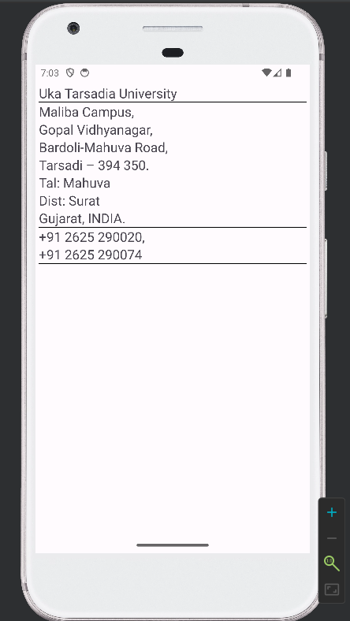

**PRACTICAL 2 :- 1- XML FILE**

<?xml version="1.0" encoding="utf-8"?>

<androidx.constraintlayout.widget.ConstraintLayout xmlns:android="http://schemas.android.com/apk/res/android"

xmlns:app="http://schemas.android.com/apk/res-auto"

xmlns:tools="http://schemas.android.com/tools"

android:id="@+id/main"

android:layout_width="match_parent"

android:layout_height="match_parent"

tools:context=".MainActivity">

<Button

android:id="@+id/button"

android:layout_width="wrap_content"

android:layout_height="wrap_content"

android:layout_centerHorizontal="true"

android:text="SACHIN"

android:textColor="#DCDCDC"

android:textSize="20sp"

android:textStyle="bold"

app:layout_constraintBottom_toBottomOf="parent"

app:layout_constraintEnd_toEndOf="parent"

app:layout_constraintHorizontal_bias="0.416"

app:layout_constraintStart_toStartOf="parent"

app:layout_constraintTop_toTopOf="parent"

app:layout_constraintVertical_bias="0.332" />

<Button

android:layout_width="145dp"

android:layout_height="wrap_content"

android:layout_alignParentEnd="true"

android:text="RAHUL"

android:textColor="#DCDCDC"

android:textSize="20sp"

android:textStyle="bold"

app:layout_constraintBottom_toBottomOf="parent"

app:layout_constraintEnd_toEndOf="parent"

app:layout_constraintHorizontal_bias="1.0"

app:layout_constraintStart_toStartOf="parent"

app:layout_constraintTop_toTopOf="parent"

app:layout_constraintVertical_bias="0.516" />

<Button

android:layout_width="wrap_content"

android:layout_height="wrap_content"

android:text="DHONI"

android:textColor="#DCDCDC"

android:textSize="20sp"

android:textStyle="bold"

app:layout_constraintBottom_toBottomOf="parent"

app:layout_constraintEnd_toEndOf="parent"

app:layout_constraintHorizontal_bias="0.0"

app:layout_constraintStart_toStartOf="parent"

app:layout_constraintTop_toTopOf="parent"

app:layout_constraintVertical_bias="0.333" />

<Button

android:layout_width="245dp"

android:layout_height="wrap_content"

android:layout_alignParentEnd="true"

android:text="HARBHAJAN"

android:textColor="#DCDCDC"

android:textSize="20sp"

android:textStyle="bold"

app:layout_constraintBottom_toBottomOf="parent"

app:layout_constraintEnd_toEndOf="parent"

app:layout_constraintHorizontal_bias="0.0"

app:layout_constraintStart_toStartOf="parent"

app:layout_constraintTop_toTopOf="parent"

app:layout_constraintVertical_bias="0.516" />

<Button

android:layout_width="191dp"

android:layout_height="wrap_content"

android:layout_alignParentEnd="true"

android:text="VIRAT"

android:textColor="#DCDCDC"

android:textSize="20sp"

android:textStyle="bold"

app:layout_constraintBottom_toBottomOf="parent"

app:layout_constraintEnd_toEndOf="parent"

app:layout_constraintHorizontal_bias="1.0"

app:layout_constraintStart_toStartOf="parent"

app:layout_constraintTop_toTopOf="parent"

app:layout_constraintVertical_bias="0.42" />

<Button

android:layout_width="194dp"

android:layout_height="wrap_content"

android:text="YUVRAJ"

android:textColor="#DCDCDC"

android:textSize="20sp"

app:layout_constraintBottom_toBottomOf="parent"

app:layout_constraintEnd_toEndOf="parent"

app:layout_constraintHorizontal_bias="0.0"

app:layout_constraintStart_toStartOf="parent"

app:layout_constraintTop_toTopOf="parent"

app:layout_constraintVertical_bias="0.42" />

</androidx.constraintlayout.widget.ConstraintLayout>

**PRACTICAL 2 :- 2 - XML FILE**

<?xml version="1.0" encoding="utf-8"?>

<androidx.constraintlayout.widget.ConstraintLayout xmlns:android="http://schemas.android.com/apk/res/android"

xmlns:app="http://schemas.android.com/apk/res-auto"

xmlns:tools="http://schemas.android.com/tools"

android:id="@+id/main"

android:layout_width="match_parent"

android:layout_height="match_parent"

tools:context=".Prectical2_1">

<ImageView

android:id="@+id/image1"

android:layout_width="169dp"

android:layout_height="169dp"

app:layout_constraintBottom_toBottomOf="parent"

app:layout_constraintEnd_toEndOf="parent"

app:layout_constraintHorizontal_bias="0.0"

app:layout_constraintStart_toStartOf="parent"

app:layout_constraintTop_toTopOf="parent"

app:layout_constraintVertical_bias="0.0"

app:srcCompat="@mipmap/ic_launcher_round" />

<ImageView

android:id="@+id/image2"

android:layout_width="178dp"

android:layout_height="166dp"

app:layout_constraintBottom_toBottomOf="parent"

app:layout_constraintEnd_toEndOf="parent"

app:layout_constraintHorizontal_bias="0.497"

app:layout_constraintStart_toStartOf="parent"

app:layout_constraintTop_toTopOf="parent"

app:layout_constraintVertical_bias="0.499"

app:srcCompat="@mipmap/ic_launcher_round" />

<ImageView

android:id="@+id/image3"

android:layout_width="178dp"

android:layout_height="169dp"

app:layout_constraintBottom_toBottomOf="parent"

app:layout_constraintEnd_toEndOf="parent"

app:layout_constraintHorizontal_bias="1.0"

app:layout_constraintStart_toStartOf="parent"

app:layout_constraintTop_toTopOf="parent"

app:layout_constraintVertical_bias="1.0"

app:srcCompat="@mipmap/ic_launcher_round" />

</androidx.constraintlayout.widget.ConstraintLayout>

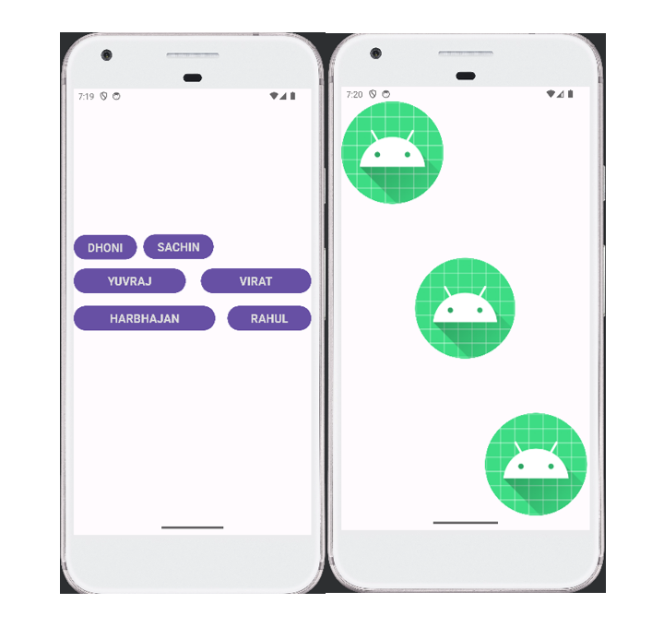

**PRACTICAL 3 :- XML FILE**

<?xml version="1.0" encoding="utf-8"?>

<androidx.constraintlayout.widget.ConstraintLayout xmlns:android="http://schemas.android.com/apk/res/android"

xmlns:app="http://schemas.android.com/apk/res-auto"

xmlns:tools="http://schemas.android.com/tools"

android:id="@+id/main"

android:layout_width="match_parent"

android:layout_height="match_parent"

tools:context=".MainActivity">

<EditText

android:id="@+id/txtStudentName"

android:layout_width="match_parent"

android:layout_height="wrap_content"

android:layout_marginHorizontal="16dp"

android:hint="Enter Student Name"

app:layout_constraintBottom_toBottomOf="parent"

app:layout_constraintEnd_toEndOf="parent"

app:layout_constraintHorizontal_bias="0.0"

app:layout_constraintStart_toStartOf="parent"

app:layout_constraintTop_toTopOf="parent"

app:layout_constraintVertical_bias="0.211" />

<Button

android:id="@+id/btnShow"

android:layout_width="190dp"

android:layout_height="59dp"

android:layout_below="@id/txtStudentName"

android:layout_centerHorizontal="true"

android:layout_marginHorizontal="16dp"

android:text="Show"

app:layout_constraintBottom_toBottomOf="parent"

app:layout_constraintEnd_toEndOf="parent"

app:layout_constraintHorizontal_bias="0.497"

app:layout_constraintStart_toStartOf="parent"

app:layout_constraintTop_toTopOf="parent"

app:layout_constraintVertical_bias="0.376" />

</androidx.constraintlayout.widget.ConstraintLayout>

**JAVA FILE :-**

package com.example.a129_prectical3;

import android.os.Bundle;

import android.view.View;

import android.widget.Button;

import android.widget.EditText;

import android.widget.Toast;

import androidx.activity.EdgeToEdge;

import androidx.appcompat.app.AppCompatActivity;

import androidx.core.graphics.Insets;

import androidx.core.view.ViewCompat;

import androidx.core.view.WindowInsetsCompat;

public class MainActivity extends AppCompatActivity {

EditText txtStudentName;

Button btnShow;

@Override

protected void onCreate(Bundle savedInstanceState) {

super.onCreate(savedInstanceState);

EdgeToEdge.enable(this);

setContentView(R.layout.activity_main);

ViewCompat.setOnApplyWindowInsetsListener(findViewById(R.id.main), (v, insets) -> {

Insets systemBars = insets.getInsets(WindowInsetsCompat.Type.systemBars());

v.setPadding(systemBars.left, systemBars.top, systemBars.right, systemBars.bottom);

return insets;});

txtStudentName = findViewById(R.id.txtStudentName);

btnShow = findViewById(R.id.btnShow);

btnShow.setOnClickListener(new View.OnClickListener() {

@Override

public void onClick(View view) {

String studentName =

txtStudentName.getText().toString();

Toast.makeText(getApplicationContext(), "Student Name: " + studentName, Toast.LENGTH_SHORT).show();

}

});

}

}

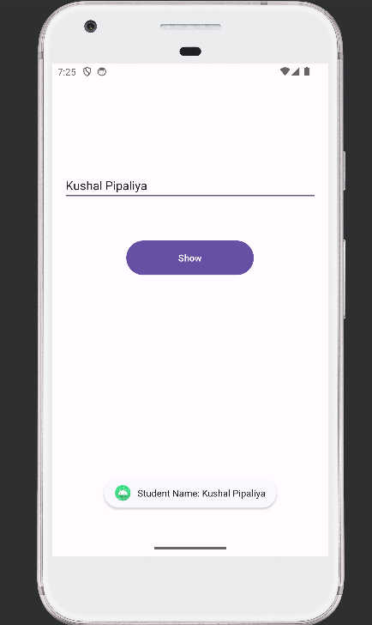

**PRACTICAL 4 :- XML FILE**

<?xml version="1.0" encoding="utf-8"?>

<androidx.constraintlayout.widget.ConstraintLayout xmlns:android="http://schemas.android.com/apk/res/android"

xmlns:app="http://schemas.android.com/apk/res-auto"

xmlns:tools="http://schemas.android.com/tools"

android:id="@+id/main"

android:layout_width="match_parent"

android:layout_height="match_parent"

tools:context=".MainActivity">

<RadioGroup

android:id="@+id/rgCourse"

android:layout_width="match_parent"

android:layout_height="wrap_content"

android:orientation="vertical"

app:layout_constraintBottom_toBottomOf="parent"

app:layout_constraintEnd_toEndOf="parent"

app:layout_constraintHorizontal_bias="0.0"

app:layout_constraintStart_toStartOf="parent"

app:layout_constraintTop_toTopOf="parent"

app:layout_constraintVertical_bias="0.073">

<RadioButton

android:id="@+id/rbBscIT"

android:layout_width="wrap_content"

android:layout_height="wrap_content"

android:text="B.sc (IT)"

android:textSize="15sp" />

<RadioButton

android:id="@+id/rbIntMscIT"

android:layout_width="wrap_content"

android:layout_height="wrap_content"

android:text="Integrated M.sc (IT)"

android:textSize="15sp" />

<RadioButton

android:id="@+id/rbMscIT"

android:layout_width="wrap_content"

android:layout_height="wrap_content"

android:text="M.sc (IT)"

android:textSize="15sp" />

</RadioGroup>

<Button

android:id="@+id/btnSubmit"

android:layout_width="255dp"

android:layout_height="68dp"

android:text="Submit"

app:layout_constraintBottom_toBottomOf="parent"

app:layout_constraintEnd_toEndOf="parent"

app:layout_constraintStart_toStartOf="parent"

app:layout_constraintTop_toTopOf="parent"

app:layout_constraintVertical_bias="0.34" />

</androidx.constraintlayout.widget.ConstraintLayout>

**Java File:-**

package com.example.a129_prectical4;

import android.os.Bundle;

import android.view.View;

import android.widget.Button;

import android.widget.RadioButton;

import android.widget.RadioGroup;

import android.widget.Toast;

import androidx.activity.EdgeToEdge;

import androidx.appcompat.app.AppCompatActivity;

import androidx.core.graphics.Insets;

import androidx.core.view.ViewCompat;

import androidx.core.view.WindowInsetsCompat;

public class MainActivity extends AppCompatActivity {

RadioGroup rgCourse;

Button btnSubmit;

@Override

protected void onCreate(Bundle savedInstanceState) {

super.onCreate(savedInstanceState);

EdgeToEdge.enable(this);

setContentView(R.layout.activity_main);

ViewCompat.setOnApplyWindowInsetsListener(findViewById(R.id.main), (v, insets) -> {

Insets systemBars = insets.getInsets(WindowInsetsCompat.Type.systemBars());

v.setPadding(systemBars.left, systemBars.top, systemBars.right, systemBars.bottom);

return insets;

});

rgCourse = findViewById(R.id.rgCourse);

btnSubmit = findViewById(R.id.btnSubmit);

btnSubmit.setOnClickListener(new View.OnClickListener() {

@Override

public void onClick(View v) {

int selectedId = rgCourse.getCheckedRadioButtonId();

if (selectedId != -1) {

RadioButton selectedRadioButton = findViewById(selectedId);

String selectedCourse = selectedRadioButton.getText().toString();

Toast.makeText(MainActivity.this, "Selected Course: " + selectedCourse, Toast.LENGTH_SHORT).show();

} else {

Toast.makeText(MainActivity.this, "Please select a course", Toast.LENGTH_SHORT).show();

}

}

});

}

}

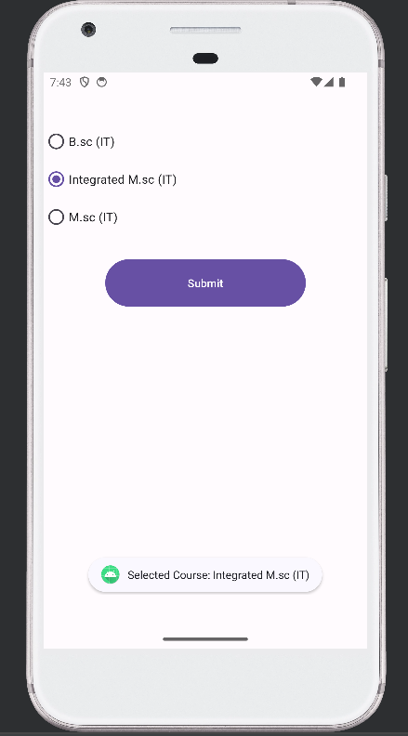

**PRACTICAL 5 :- XML FILE**

<?xml version="1.0" encoding="utf-8"?>

<androidx.constraintlayout.widget.ConstraintLayout xmlns:android="http://schemas.android.com/apk/res/android"

xmlns:app="http://schemas.android.com/apk/res-auto"

xmlns:tools="http://schemas.android.com/tools"

android:id="@+id/main"

android:layout_width="match_parent"

android:layout_height="match_parent"

tools:context=".MainActivity">

<CheckBox

android:id="@+id/iphoneCheckbox"

android:layout_width="wrap_content"

android:layout_height="wrap_content"

android:text="iPhone"

app:layout_constraintBottom_toBottomOf="parent"

app:layout_constraintEnd_toEndOf="parent"

app:layout_constraintHorizontal_bias="0.119"

app:layout_constraintStart_toStartOf="parent"

app:layout_constraintTop_toTopOf="parent"

app:layout_constraintVertical_bias="0.07" />

<CheckBox

android:id="@+id/androidCheckbox"

android:layout_width="wrap_content"

android:layout_height="wrap_content"

android:layout_below="@id/iphoneCheckbox"

android:text="Android"

app:layout_constraintBottom_toBottomOf="parent"

app:layout_constraintEnd_toEndOf="parent"

app:layout_constraintStart_toStartOf="parent"

app:layout_constraintTop_toTopOf="parent"

app:layout_constraintVertical_bias="0.07" />

<CheckBox

android:id="@+id/windowsCheckbox"

android:layout_width="wrap_content"

android:layout_height="wrap_content"

android:layout_below="@id/androidCheckbox"

android:text="Windows"

app:layout_constraintBottom_toBottomOf="parent"

app:layout_constraintEnd_toEndOf="parent"

app:layout_constraintHorizontal_bias="0.95"

app:layout_constraintStart_toStartOf="parent"

app:layout_constraintTop_toTopOf="parent"

app:layout_constraintVertical_bias="0.07" />

<Button

android:id="@+id/submitButton"

android:layout_width="211dp"

android:layout_height="63dp"

android:layout_below="@id/windowsCheckbox"

android:text="Submit"

app:layout_constraintBottom_toBottomOf="parent"

app:layout_constraintEnd_toEndOf="parent"

app:layout_constraintStart_toStartOf="parent"

app:layout_constraintTop_toTopOf="parent"

app:layout_constraintVertical_bias="0.218" />

</androidx.constraintlayout.widget.ConstraintLayout>

**Java File:-**

package com.example.a129_prectical5;

import android.os.Bundle;

import android.view.View;

import android.widget.Button;

import android.widget.CheckBox;

import android.widget.Toast;

import androidx.activity.EdgeToEdge;

import androidx.appcompat.app.AppCompatActivity;

import androidx.core.graphics.Insets;

import androidx.core.view.ViewCompat;

import androidx.core.view.WindowInsetsCompat;

public class MainActivity extends AppCompatActivity {

CheckBox iphoneCheckbox, androidCheckbox,

windowsCheckbox;

Button submitButton;

@Override

protected void onCreate(Bundle savedInstanceState) {

super.onCreate(savedInstanceState);

EdgeToEdge.enable(this);

setContentView(R.layout.activity_main);

ViewCompat.setOnApplyWindowInsetsListener(findViewById(R.id.main), (v, insets) -> {

Insets systemBars = insets.getInsets(WindowInsetsCompat.Type.systemBars());

v.setPadding(systemBars.left, systemBars.top, systemBars.right, systemBars.bottom);

return insets;

});

iphoneCheckbox = findViewById(R.id.iphoneCheckbox);

androidCheckbox = findViewById(R.id.androidCheckbox);

windowsCheckbox = findViewById(R.id.windowsCheckbox);

submitButton = findViewById(R.id.submitButton);

submitButton.setOnClickListener(new View.OnClickListener() {

@Override

public void onClick(View v) {

StringBuilder selectedOptions = new StringBuilder("Selected Options: ");

if (iphoneCheckbox.isChecked()) {

selectedOptions.append("iPhone, "); }

if (androidCheckbox.isChecked()) {

selectedOptions.append("Android, ");

}

if (windowsCheckbox.isChecked()) {

selectedOptions.append("Windows, ");

}

String result = selectedOptions.toString().trim();

if (result.endsWith(","))

{

result = result.substring(0, result.length() - 1);

}

Toast.makeText(MainActivity.this, result, Toast.LENGTH_SHORT).show();

}

}); } }

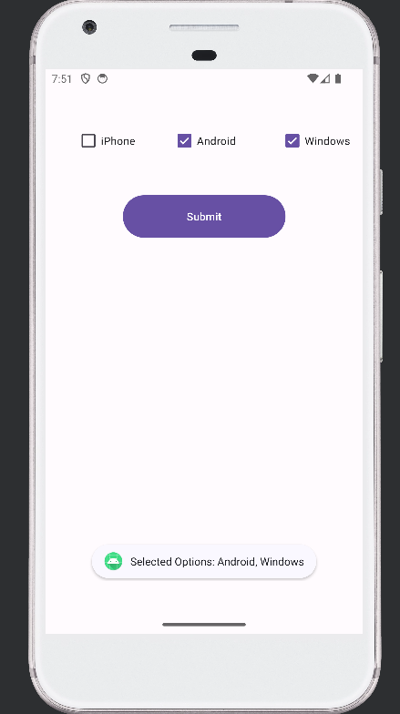

**PRACTICAL 5 :- XML FILE**

<?xml version="1.0" encoding="utf-8"?>

<LinearLayout xmlns:android="http://schemas.android.com/apk/res/android"

xmlns:app="http://schemas.android.com/apk/res-auto"

xmlns:tools="http://schemas.android.com/tools"

android:id="@+id/main"

android:layout_width="match_parent"

android:layout_height="match_parent"

android:orientation="vertical"

android:layout_margin="20dp"

tools:context=".MainActivity">

<TextView

android:layout_width="wrap_content"

android:layout_height="wrap_content"/>

<ListView

android:id="@+id/colorListView"

android:layout_width="match_parent"

android:layout_height="match_parent" />

</LinearLayout>

**Java File:-**

package com.example.a129_prectical6;

import android.graphics.Color;

import android.os.Bundle;

import android.view.View;

import android.widget.AdapterView;

import android.widget.ArrayAdapter;

import android.widget.LinearLayout;

import android.widget.ListView;

import androidx.activity.EdgeToEdge;

import androidx.appcompat.app.AppCompatActivity;

import androidx.core.graphics.Insets;

import androidx.core.view.ViewCompat;

import androidx.core.view.WindowInsetsCompat;

public class MainActivity extends AppCompatActivity {

ListView colorListView;

LinearLayout mainLayout;

@Override

protected void onCreate(Bundle savedInstanceState) {

super.onCreate(savedInstanceState);

EdgeToEdge.enable(this);

setContentView(R.layout.activity_main);

ViewCompat.setOnApplyWindowInsetsListener(findViewById(R.id.main), (v, insets) -> {

Insets systemBars = insets.getInsets(WindowInsetsCompat.Type.systemBars());

v.setPadding(systemBars.left, systemBars.top, systemBars.right, systemBars.bottom);

return insets;

});

colorListView = findViewById(R.id.colorListView);

mainLayout = findViewById(R.id.main);

ArrayAdapter<CharSequence> adapter = ArrayAdapter.createFromResource( this, R.array.color_names,android.R.layout.simple_list_item_1);

colorListView.setAdapter(adapter);

colorListView.setOnItemClickListener(new AdapterView.OnItemClickListener() {

@Override

public void onItemClick(AdapterView<?> parent, View view, int position, long id)

{

String selectedColor = (String) parent.getItemAtPosition(position);

changeBackgroundColor(selectedColor);

}

});

}

protected void changeBackgroundColor(String colorName) {

int colorValue;

switch (colorName.toLowerCase()) {

case "red":

colorValue = Color.RED;

break;

case "green":

colorValue = Color.GREEN;

break;

case "pink":

colorValue = Color.LTGRAY;

break;

case "blue":

colorValue = Color.BLUE;

break;

case "yellow":

colorValue = Color.YELLOW;

break;

default:

colorValue = Color.WHITE;

break;

}

mainLayout.setBackgroundColor(colorValue);

}

}

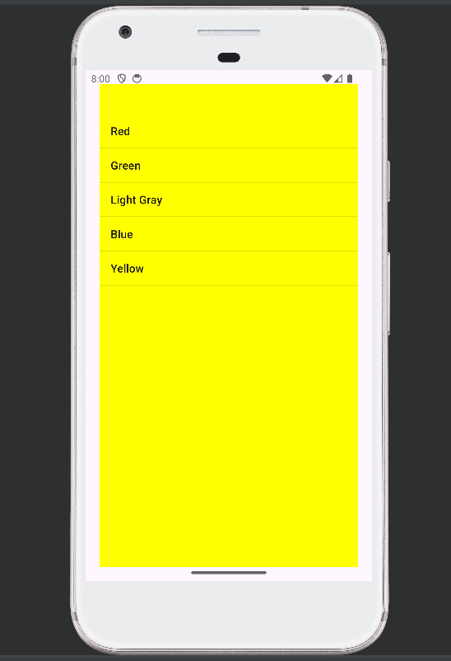

**PRACTICAL 7 :- XML FILE**

<?xml version="1.0" encoding="utf-8"?>

<androidx.constraintlayout.widget.ConstraintLayout xmlns:android="http://schemas.android.com/apk/res/android"

xmlns:app="http://schemas.android.com/apk/res-auto"

xmlns:tools="http://schemas.android.com/tools"

android:id="@+id/main"

android:layout_width="match_parent"

android:layout_height="match_parent"

tools:context=".MainActivity">

<Spinner

android:id="@+id/countrySpinner"

android:layout_width="411dp"

android:layout_height="39dp"

android:layout_centerHorizontal="true"

android:entries="@array/country"

app:layout_constraintBottom_toBottomOf="parent"

app:layout_constraintEnd_toEndOf="parent"

app:layout_constraintHorizontal_bias="0.0"

app:layout_constraintStart_toStartOf="parent"

app:layout_constraintTop_toTopOf="parent"

app:layout_constraintVertical_bias="0.115" />

<TextView

android:id="@+id/selectedCountryText"

android:layout_width="251dp"

android:layout_height="48dp"

android:layout_below="@id/countrySpinner"

android:layout_centerHorizontal="true"

android:text="Selected Country: "

android:textSize="18dp"

app:layout_constraintBottom_toBottomOf="parent"

app:layout_constraintEnd_toEndOf="parent"

app:layout_constraintHorizontal_bias="0.331"

app:layout_constraintStart_toStartOf="parent"

app:layout_constraintTop_toTopOf="parent"

app:layout_constraintVertical_bias="0.275" />

</androidx.constraintlayout.widget.ConstraintLayout>

**String.xml File:-**

<resources>

<string name="app_name">129_Prectical7</string>

<string-array name="country">

<item>Select Country</item>

<item>INDIA</item>

<item>RUSSIA</item>

<item>UK</item>

<item>GERMANY</item>

<item>USA</item>

<item>CANADA</item>

</string-array>

</resources>

**Java File:-**

package com.example.a129_prectical7;

import android.os.Bundle;

import android.view.View;

import android.widget.AdapterView;

import android.widget.ArrayAdapter;

import android.widget.Spinner;

import android.widget.TextView;

import androidx.activity.EdgeToEdge;

import androidx.appcompat.app.AppCompatActivity;

import androidx.core.graphics.Insets;

import androidx.core.view.ViewCompat;

import androidx.core.view.WindowInsetsCompat;

public class MainActivity extends AppCompatActivity {

Spinner countrySpinner;

TextView selectedCountryText;

@Override

protected void onCreate(Bundle savedInstanceState) {

super.onCreate(savedInstanceState);

EdgeToEdge.enable(this);

setContentView(R.layout.activity_main);

ViewCompat.setOnApplyWindowInsetsListener(findViewById(R.id.main), (v, insets) -> {

Insets systemBars = insets.getInsets(WindowInsetsCompat.Type.systemBars());

v.setPadding(systemBars.left, systemBars.top, systemBars.right, systemBars.bottom);

return insets;

});

countrySpinner = findViewById(R.id.countrySpinner);

selectedCountryText =

findViewById(R.id.selectedCountryText);

ArrayAdapter<CharSequence> adapter = ArrayAdapter.createFromResource(this, R.array.country, android.R.layout.simple_spinner_item);

adapter.setDropDownViewResource(android.R.layout.simple_spinner_dropdown_item);

countrySpinner.setAdapter(adapter);

countrySpinner.setOnItemSelectedListener(new AdapterView.OnItemSelectedListener() {

@Override

public void onItemSelected(AdapterView<?> parentView,View selectedItemView, int position, long id)

{

String selectedCountry = parentView.getItemAtPosition(position).toString();

selectedCountryText.setText("Selected Country: " + selectedCountry);

}

@Override

public void onNothingSelected(AdapterView<?> parent)

{ }

});

}

}

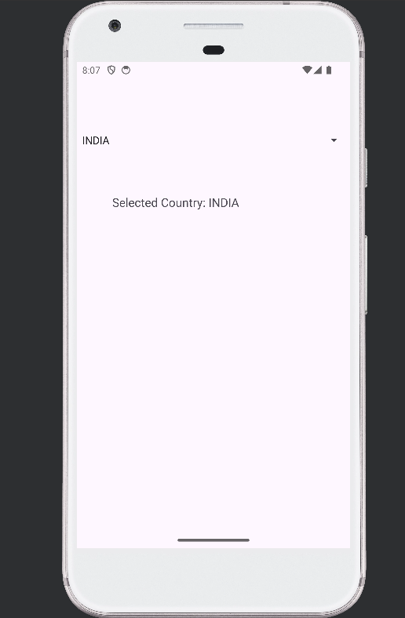

**PRACTICAL 8 :- XML FILE**

<?xml version="1.0" encoding="utf-8"?>

<androidx.constraintlayout.widget.ConstraintLayout xmlns:android="http://schemas.android.com/apk/res/android"

xmlns:app="http://schemas.android.com/apk/res-auto"

xmlns:tools="http://schemas.android.com/tools"

android:id="@+id/main"

android:layout_width="match_parent"

android:layout_height="match_parent"

android:layout_margin="10dp"

tools:context=".MainActivity">

<TextView

android:layout_width="wrap_content"

android:layout_height="wrap_content"

android:text=" mobile model’s"

android:textSize="20dp"

app:layout_constraintBottom_toBottomOf="parent"

app:layout_constraintEnd_toEndOf="parent"

app:layout_constraintHorizontal_bias="0.501"

app:layout_constraintStart_toStartOf="parent"

app:layout_constraintTop_toTopOf="parent"

app:layout_constraintVertical_bias="0.0" />

<GridView

android:id="@+id/gridView"

android:layout_width="392dp"

android:layout_height="612dp"

android:layout_margin="5dp"

android:columnWidth="100dp"

android:gravity="center"

android:horizontalSpacing="10dp"

android:numColumns="3"

android:verticalSpacing="10dp"

app:layout_constraintBottom_toBottomOf="parent"

app:layout_constraintEnd_toEndOf="parent"

app:layout_constraintHorizontal_bias="0.0"

app:layout_constraintStart_toStartOf="parent"

app:layout_constraintTop_toTopOf="parent"

app:layout_constraintVertical_bias="0.98" />

</androidx.constraintlayout.widget.ConstraintLayout>

**Java File:-**

package com.example.a129_prectical8;

import android.os.Bundle;

import android.widget.GridView;

import androidx.activity.EdgeToEdge;

import androidx.appcompat.app.AppCompatActivity;

import androidx.core.graphics.Insets;

import androidx.core.view.ViewCompat;

import androidx.core.view.WindowInsetsCompat;

public class MainActivity extends AppCompatActivity {

private GridView gridView;

private int[] Images = {

R.drawable.mobile1,

R.drawable.mobile2,

R.drawable.mobile3,

R.drawable.mobile4,

R.drawable.mobile5,

R.drawable.mobile6,

};

@Override

protected void onCreate(Bundle savedInstanceState) {

super.onCreate(savedInstanceState);

EdgeToEdge.enable(this);

setContentView(R.layout.activity_main);

ViewCompat.setOnApplyWindowInsetsListener(findViewById(R.id.main), (v, insets) -> {

Insets systemBars = insets.getInsets(WindowInsetsCompat.Type.systemBars());

v.setPadding(systemBars.left, systemBars.top, systemBars.right, systemBars.bottom);

return insets;

});

gridView = findViewById(R.id.gridView);

CustomAdapter ad = new CustomAdapter(this, Images);

gridView.setAdapter(ad);

}

}

**CustomAdapter.Java File:-**

package com.example.a129_prectical8;

import android.content.Context;

import android.database.DataSetObserver;

import android.view.View;

import android.view.ViewGroup;

import android.widget.BaseAdapter;

import android.widget.ImageView;

import android.widget.ListAdapter;

public class CustomAdapter extends BaseAdapter {

private Context context;

private int[] Images;

public CustomAdapter(Context context, int[] Images) {

this.context = context;

this.Images = Images;

}

@Override

public int getCount() {

return Images.length;

}

@Override

public Object getItem(int position) {

return null;

}

@Override

public long getItemId(int position) {

return 0;

}

@Override

public View getView(int position, View convertView,

ViewGroup parent) {

ImageView imageView;

if (convertView == null)

{

imageView = new ImageView(context);

imageView.setLayoutParams(new

ViewGroup.LayoutParams(300, 300));

imageView.setScaleType(ImageView.ScaleType.CENTER_CROP);

} else

{

imageView = (ImageView) convertView;

}

imageView.setImageResource(Images[position]);

return imageView;

}

}

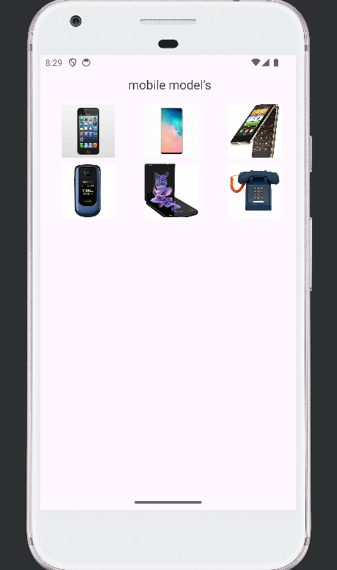

**PRACTICAL 9 :- XML FILE**

<?xml version="1.0" encoding="utf-8"?>

<androidx.constraintlayout.widget.ConstraintLayout xmlns:android="http://schemas.android.com/apk/res/android"

xmlns:app="http://schemas.android.com/apk/res-auto"

xmlns:tools="http://schemas.android.com/tools"

android:id="@+id/main"

android:layout_width="match_parent"

android:layout_height="match_parent"

tools:context=".MainActivity">

<Button

android:id="@+id/downloadButton"

android:layout_width="wrap_content"

android:layout_height="wrap_content"

android:layout_centerHorizontal="true"

android:layout_centerVertical="true"

android:text="Download"

app:layout_constraintBottom_toBottomOf="parent"

app:layout_constraintEnd_toEndOf="parent"

app:layout_constraintHorizontal_bias="0.498"

app:layout_constraintStart_toStartOf="parent"

app:layout_constraintTop_toTopOf="parent"

app:layout_constraintVertical_bias="0.115" />

<ProgressBar

android:id="@+id/progressBar"

android:layout_width="match_parent"

android:layout_height="wrap_content"

android:layout_below="@id/downloadButton"

android:layout_centerHorizontal="true"

android:visibility="invisible"

app:layout_constraintBottom_toBottomOf="parent"

app:layout_constraintEnd_toEndOf="parent"

app:layout_constraintHorizontal_bias="0.0"

app:layout_constraintStart_toStartOf="parent"

app:layout_constraintTop_toTopOf="parent"

app:layout_constraintVertical_bias="0.219" />

</androidx.constraintlayout.widget.ConstraintLayout>

**Java File:-**

package com.example.a129_prectical9;

import android.os.AsyncTask;

import android.os.Bundle;

import android.view.View;

import android.widget.Button;

import android.widget.ProgressBar;

import androidx.activity.EdgeToEdge;

import androidx.appcompat.app.AppCompatActivity;

import androidx.core.graphics.Insets;

import androidx.core.view.ViewCompat;

import androidx.core.view.WindowInsetsCompat;

public class MainActivity extends AppCompatActivity {

Button downloadButton;

ProgressBar progressBar;

@Override

protected void onCreate(Bundle savedInstanceState) {

super.onCreate(savedInstanceState);

EdgeToEdge.enable(this);

setContentView(R.layout.activity_main);

ViewCompat.setOnApplyWindowInsetsListener(findViewById(R.id.main), (v, insets) -> {

Insets systemBars = insets.getInsets(WindowInsetsCompat.Type.systemBars());

v.setPadding(systemBars.left, systemBars.top, systemBars.right, systemBars.bottom);

return insets;

});

downloadButton = findViewById(R.id.downloadButton);

progressBar = findViewById(R.id.progressBar);

downloadButton.setOnClickListener(new View.OnClickListener() {

@Override

public void onClick(View v) {

new DownloadTask().execute();

}

});

}

private class DownloadTask extends AsyncTask<Void, Integer,

Void> {

@Override

protected void onPreExecute() {

super.onPreExecute();

progressBar.setVisibility(View.VISIBLE);

}

@Override

protected Void doInBackground(Void... voids) {

for (int progress = 0; progress <= 100; progress += 10) {

try {

Thread.sleep(500);

publishProgress(progress);

} catch (InterruptedException e) {

e.printStackTrace();

}

}

return null;

}

@Override

protected void onProgressUpdate(Integer... values) {

super.onProgressUpdate(values);

progressBar.setProgress(values[0]);

}

@Override

protected void onPostExecute(Void aVoid) {

super.onPostExecute(aVoid);

progressBar.setVisibility(View.INVISIBLE);

}

}

}

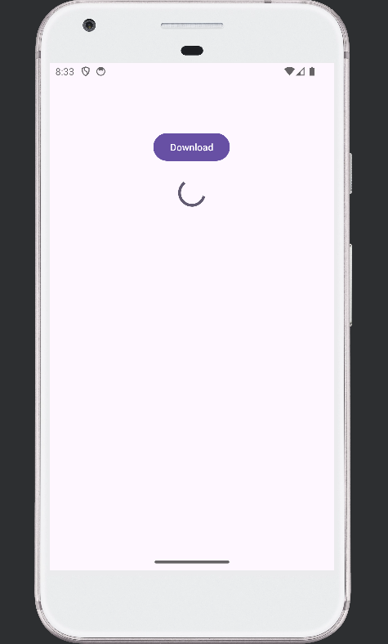

**PRACTICAL 10 :- XML FILE**

<?xml version="1.0" encoding="utf-8"?>

<androidx.constraintlayout.widget.ConstraintLayout xmlns:android="http://schemas.android.com/apk/res/android"

xmlns:app="http://schemas.android.com/apk/res-auto"

xmlns:tools="http://schemas.android.com/tools"

android:id="@+id/main"

android:layout_width="match_parent"

android:layout_height="match_parent"

tools:context=".MainActivity">

<AutoCompleteTextView

android:id="@+id/autoCompleteTextView"

android:layout_width="match_parent"

android:layout_height="wrap_content"

android:layout_marginStart="8dp"

android:hint="Type a course"

app:layout_constraintBottom_toBottomOf="parent"

app:layout_constraintStart_toStartOf="parent"

app:layout_constraintTop_toTopOf="parent"

app:layout_constraintVertical_bias="0.16" />

<TextView

android:id="@+id/selectedCourseTextView"

android:layout_width="match_parent"

android:layout_height="wrap_content"

android:layout_below="@id/autoCompleteTextView"

android:textSize="20sp"

app:layout_constraintBottom_toBottomOf="parent"

app:layout_constraintEnd_toEndOf="parent"

app:layout_constraintHorizontal_bias="0.0"

app:layout_constraintStart_toStartOf="parent"

app:layout_constraintTop_toTopOf="parent"

app:layout_constraintVertical_bias="0.278" />

</androidx.constraintlayout.widget.ConstraintLayout>

**Java File:-**

package com.example.a129_prectical10;

import android.os.Bundle;

import android.view.View;

import android.widget.AdapterView;

import android.widget.ArrayAdapter;

import android.widget.AutoCompleteTextView;

import android.widget.TextView;

import androidx.activity.EdgeToEdge;

import androidx.appcompat.app.AppCompatActivity;

import androidx.core.graphics.Insets;

import androidx.core.view.ViewCompat;

import androidx.core.view.WindowInsetsCompat;

public class MainActivity extends AppCompatActivity {

AutoCompleteTextView autoCompleteTextView;

TextView selectedCourseTextView;

String[] courses = {

"B.Sc (IT)",

"M.Sc (IT)",

"5 Years Integrated M.Sc (IT)",

};

@Override

protected void onCreate(Bundle savedInstanceState) {

super.onCreate(savedInstanceState);

EdgeToEdge.enable(this);

setContentView(R.layout.activity_main);

ViewCompat.setOnApplyWindowInsetsListener(findViewById(R.id.main), (v, insets) -> {

Insets systemBars = insets.getInsets(WindowInsetsCompat.Type.systemBars());

v.setPadding(systemBars.left, systemBars.top, systemBars.right, systemBars.bottom);

return insets;

});

autoCompleteTextView = findViewById(R.id.autoCompleteTextView);

selectedCourseTextView = findViewById(R.id.selectedCourseTextView);

ArrayAdapter<String> adapter = new ArrayAdapter<>(this, android.R.layout.simple_dropdown_item_1line, courses);

autoCompleteTextView.setAdapter(adapter);

autoCompleteTextView.setOnItemClickListener(new AdapterView.OnItemClickListener()

{

@Override

public void onItemClick(AdapterView<?> parent, View view, int position, long id)

{

String selectedCourse = (String) parent.getItemAtPosition(position);

selectedCourseTextView.setText("Selected Course: " + selectedCourse);

} } ); } }

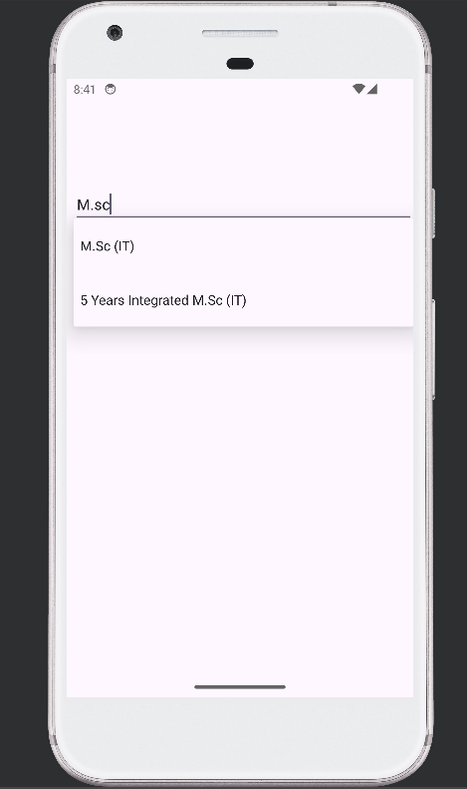

**PRACTICAL 11 :- XML FILE**

<?xml version="1.0" encoding="utf-8"?>

<androidx.constraintlayout.widget.ConstraintLayout xmlns:android="http://schemas.android.com/apk/res/android"

xmlns:app="http://schemas.android.com/apk/res-auto"

xmlns:tools="http://schemas.android.com/tools"

android:id="@+id/main"

android:layout_width="match_parent"

android:layout_height="match_parent"

tools:context=".MainActivity">

<LinearLayout

android:layout_width="match_parent"

android:layout_height="wrap_content"

android:orientation="horizontal">

<DatePicker

android:id="@+id/datePicker"

android:layout_width="190dp"

android:layout_height="wrap_content"

app:layout_constraintBottom_toBottomOf="parent"

app:layout_constraintEnd_toEndOf="parent"

app:layout_constraintHorizontal_bias="0.0"

app:layout_constraintStart_toStartOf="parent"

app:layout_constraintTop_toTopOf="parent"

app:layout_constraintVertical_bias="0.0" />

<TimePicker

android:id="@+id/timePicker"

android:layout_width="219dp"

android:layout_height="match_parent"

android:layout_below="@id/datePicker"

app:layout_constraintBottom_toBottomOf="parent"

app:layout_constraintEnd_toEndOf="parent"

app:layout_constraintHorizontal_bias="0.0"

app:layout_constraintStart_toStartOf="parent"

app:layout_constraintTop_toTopOf="parent"

app:layout_constraintVertical_bias="1.0" />

</LinearLayout>

<Button

android:id="@+id/showButton"

android:layout_width="178dp"

android:layout_height="49dp"

android:layout_below="@id/timePicker"

android:text="Show"

app:layout_constraintBottom_toBottomOf="parent"

app:layout_constraintEnd_toEndOf="parent"

app:layout_constraintHorizontal_bias="0.497"

app:layout_constraintStart_toStartOf="parent"

app:layout_constraintTop_toTopOf="parent"

app:layout_constraintVertical_bias="0.728" />

<TextView

android:id="@+id/displayDateTimeTextView"

android:layout_width="match_parent"

android:layout_height="wrap_content"

android:layout_below="@id/showButton"

android:textSize="30sp"

app:layout_constraintBottom_toBottomOf="parent"

app:layout_constraintEnd_toEndOf="parent"

app:layout_constraintHorizontal_bias="1.0"

app:layout_constraintStart_toStartOf="parent"

app:layout_constraintTop_toTopOf="parent"

app:layout_constraintVertical_bias="0.818" />

</androidx.constraintlayout.widget.ConstraintLayout>

**Java File:-**

package com.example.a129_prectical11;

import android.os.Bundle;

import android.view.View;

import android.widget.Button;

import android.widget.DatePicker;

import android.widget.TextView;

import android.widget.TimePicker;

import androidx.activity.EdgeToEdge;

import androidx.appcompat.app.AppCompatActivity;

import androidx.core.graphics.Insets;

import androidx.core.view.ViewCompat;

import androidx.core.view.WindowInsetsCompat;

public class MainActivity extends AppCompatActivity {

DatePicker datePicker;

TimePicker timePicker;

Button showButton;

TextView displayDateTimeTextView;

@Override

protected void onCreate(Bundle savedInstanceState) {

super.onCreate(savedInstanceState);

EdgeToEdge.enable(this);

setContentView(R.layout.activity_main);

ViewCompat.setOnApplyWindowInsetsListener(findViewById(R.id.main), (v, insets) -> {

Insets systemBars = insets.getInsets(WindowInsetsCompat.Type.systemBars());

v.setPadding(systemBars.left, systemBars.top, systemBars.right, systemBars.bottom);

return insets;

});

datePicker = findViewById(R.id.datePicker);

timePicker = findViewById(R.id.timePicker);

showButton = findViewById(R.id.showButton);

displayDateTimeTextView = findViewById(R.id.displayDateTimeTextView);

showButton.setOnClickListener(new View.OnClickListener()

{

@Override

public void onClick(View v) {

int day = datePicker.getDayOfMonth();

int month = datePicker.getMonth() + 1;

int year = datePicker.getYear();

int hour = timePicker.getCurrentHour();

int minute = timePicker.getCurrentMinute();

String dateTime = "Selected Date and Time: " + day +

"/" + month + "/" + year + " " + hour + ":" + minute;

displayDateTimeTextView.setText(dateTime);

} } ); } }

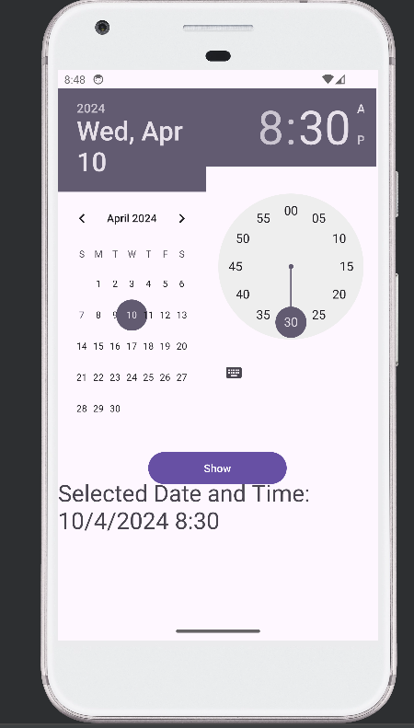

**PRACTICAL 12 :- XML FILE**

<?xml version="1.0" encoding="utf-8"?>

<androidx.constraintlayout.widget.ConstraintLayout xmlns:android="http://schemas.android.com/apk/res/android"

xmlns:app="http://schemas.android.com/apk/res-auto"

xmlns:tools="http://schemas.android.com/tools"

android:id="@+id/main"

android:layout_width="match_parent"

android:layout_height="match_parent"

tools:context=".MainActivity">

<Button

android:id="@+id/setDateButton"

android:layout_width="wrap_content"

android:layout_height="wrap_content"

android:text="Set Date"

app:layout_constraintBottom_toBottomOf="parent"

app:layout_constraintEnd_toEndOf="parent"

app:layout_constraintHorizontal_bias="0.498"

app:layout_constraintStart_toStartOf="parent"

app:layout_constraintTop_toTopOf="parent"

app:layout_constraintVertical_bias="0.166" />

<TextView

android:id="@+id/dateTextView"

android:layout_width="match_parent"

android:layout_height="wrap_content"

android:hint="DATE"

android:textSize="20dp"

app:layout_constraintBottom_toBottomOf="parent"

app:layout_constraintEnd_toEndOf="parent"

app:layout_constraintHorizontal_bias="0.0"

app:layout_constraintStart_toStartOf="parent"

app:layout_constraintTop_toTopOf="parent"

app:layout_constraintVertical_bias="0.099" />

<Button

android:id="@+id/setTimeButton"

android:layout_width="wrap_content"

android:layout_height="wrap_content"

android:text="Set Time"

app:layout_constraintBottom_toBottomOf="parent"

app:layout_constraintEnd_toEndOf="parent"

app:layout_constraintHorizontal_bias="0.503"

app:layout_constraintStart_toStartOf="parent"

app:layout_constraintTop_toTopOf="parent"

app:layout_constraintVertical_bias="0.361" />

<TextView

android:id="@+id/timeTextView"

android:layout_width="match_parent"

android:layout_height="wrap_content"

android:hint="TIME"

android:textSize="20dp"

app:layout_constraintBottom_toBottomOf="parent"

app:layout_constraintEnd_toEndOf="parent"

app:layout_constraintHorizontal_bias="0.0"

app:layout_constraintStart_toStartOf="parent"

app:layout_constraintTop_toTopOf="parent"

app:layout_constraintVertical_bias="0.264" />

<Button

android:id="@+id/setNameButton"

android:layout_width="wrap_content"

android:layout_height="wrap_content"

android:text="Set Name"

app:layout_constraintBottom_toBottomOf="parent"

app:layout_constraintEnd_toEndOf="parent"

app:layout_constraintHorizontal_bias="0.511"

app:layout_constraintStart_toStartOf="parent"

app:layout_constraintTop_toTopOf="parent"

app:layout_constraintVertical_bias="0.563" />

<TextView

android:id="@+id/nameTextView"

android:layout_width="match_parent"

android:layout_height="wrap_content"

android:hint="Name"

android:textSize="20dp"

app:layout_constraintBottom_toBottomOf="parent"

app:layout_constraintEnd_toEndOf="parent"

app:layout_constraintHorizontal_bias="0.0"

app:layout_constraintStart_toStartOf="parent"

app:layout_constraintTop_toTopOf="parent"

app:layout_constraintVertical_bias="0.471" />

</androidx.constraintlayout.widget.ConstraintLayout>

**custom_dialog.xml File:-**

<?xml version="1.0" encoding="utf-8"?>

<LinearLayout xmlns:android="http://schemas.android.com/apk/res/android"

xmlns:app="http://schemas.android.com/apk/res-auto"

xmlns:tools="http://schemas.android.com/tools"

android:layout_width="match_parent"

android:layout_height="match_parent"

android:orientation="vertical"

android:gravity="center">

<EditText

android:id="@+id/inputName"

android:layout_width="match_parent"

android:layout_height="wrap_content"

app:layout_constraintBottom_toBottomOf="parent"

app:layout_constraintEnd_toEndOf="parent"

app:layout_constraintHorizontal_bias="0.0"

app:layout_constraintStart_toStartOf="parent"

app:layout_constraintTop_toTopOf="parent"

app:layout_constraintVertical_bias="0.148" />

<Button

android:id="@+id/submitButton"

android:layout_width="wrap_content"

android:layout_height="wrap_content"

android:text="Submit"

app:layout_constraintBottom_toBottomOf="parent"

app:layout_constraintEnd_toEndOf="parent"

app:layout_constraintStart_toStartOf="parent"

app:layout_constraintTop_toTopOf="parent"

app:layout_constraintVertical_bias="0.251" />

</LinearLayout>

**Java File:-**

package com.example.a129_prectical12;

import android.app.DatePickerDialog;

import android.app.Dialog;

import android.app.TimePickerDialog;

import android.os.Bundle;

import android.view.View;

import android.widget.Button;

import android.widget.DatePicker;

import android.widget.TextView;

import android.widget.TimePicker;

import androidx.activity.EdgeToEdge;

import androidx.appcompat.app.AppCompatActivity;

import androidx.core.graphics.Insets;

import androidx.core.view.ViewCompat;

import androidx.core.view.WindowInsetsCompat;

import java.util.Calendar;

public class MainActivity extends AppCompatActivity {

Button setDateButton, setTimeButton, setNameButton;

TextView dateTextView, timeTextView, nameTextView;

int mYear, mMonth, mDay, mHour, mMinute;

@Override

protected void onCreate ( Bundle savedInstanceState ) {

super.onCreate (savedInstanceState);

EdgeToEdge.enable (this);

setContentView (R.layout.activity_main);

ViewCompat.setOnApplyWindowInsetsListener (findViewById (R.id.main), ( v, insets ) -> {

Insets systemBars = insets.getInsets (WindowInsetsCompat.Type.systemBars ());

v.setPadding (systemBars.left, systemBars.top, systemBars.right, systemBars.bottom);

return insets;

});

setDateButton = findViewById (R.id.setDateButton);

setTimeButton = findViewById (R.id.setTimeButton);

setNameButton = findViewById (R.id.setNameButton);

dateTextView = findViewById (R.id.dateTextView);

timeTextView = findViewById (R.id.timeTextView);

nameTextView = findViewById (R.id.nameTextView);

setDateButton.setOnClickListener (new View.OnClickListener () {

@Override

public void onClick ( View v ) {

showDatePickerDialog ();

}

});

setTimeButton.setOnClickListener (new View.OnClickListener () {

@Override

public void onClick ( View v ) {

showTimePickerDialog ();

}

});

setNameButton.setOnClickListener (new View.OnClickListener () {

@Override

public void onClick ( View v ) {

showNameInputDialog ();

}

});

}

protected void showDatePickerDialog () {

final Calendar c = Calendar.getInstance ();

mYear = c.get (Calendar.YEAR);

mMonth = c.get (Calendar.MONTH);

mDay = c.get (Calendar.DAY_OF_MONTH);

DatePickerDialog datePickerDialog = new DatePickerDialog (this, new DatePickerDialog.OnDateSetListener () {

@Override

public void onDateSet (

DatePicker view, int year, int

monthOfYear, int dayOfMonth

) {

dateTextView.setText ("Selected Date: " + dayOfMonth + "-" + ( monthOfYear + 1 ) + "-" + year);

}

}, mYear, mMonth, mDay);

datePickerDialog.show ();

}

protected void showTimePickerDialog () {

final Calendar c = Calendar.getInstance ();

mHour = c.get (Calendar.HOUR_OF_DAY);

mMinute = c.get (Calendar.MINUTE);

TimePickerDialog timePickerDialog = new TimePickerDialog (this, new TimePickerDialog.OnTimeSetListener () {

@Override

public void onTimeSet (

TimePicker view, int

hourOfDay,

int minute

) {

timeTextView.setText ("Selected Time: " + hourOfDay + ":" + minute);

}

}, mHour, mMinute, false);

timePickerDialog.show ();

}

protected void showNameInputDialog () {

final Dialog dialog = new Dialog (this);

dialog.setTitle ("Enter Name:");

dialog.setContentView (R.layout.custom_dialog);

Button submitButton =

dialog.findViewById (R.id.submitButton);

final TextView inputName =

dialog.findViewById (R.id.inputName);

submitButton.setOnClickListener (new View.OnClickListener () {

@Override

public void onClick ( View v ) {

String name = inputName.getText ().toString ();

nameTextView.setText ("Entered Name: " + name);

dialog.dismiss ();

}

});

dialog.show ();

}

}

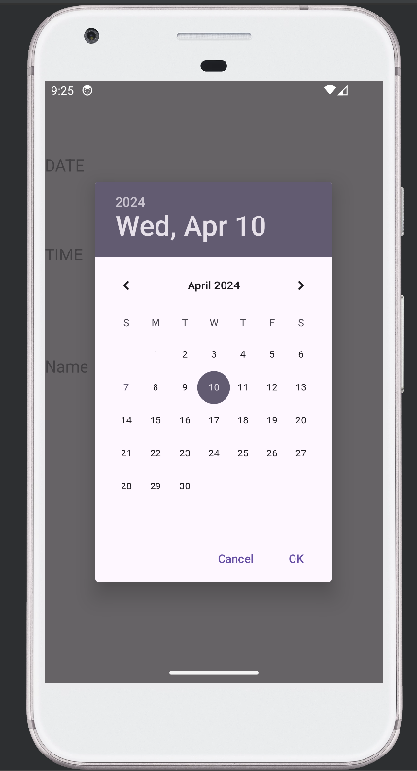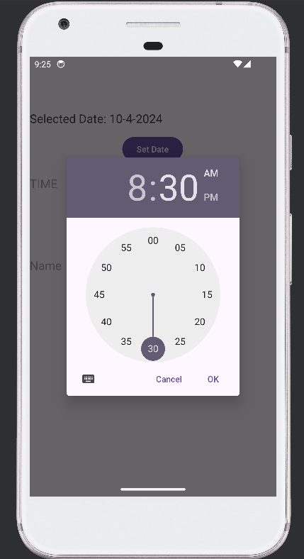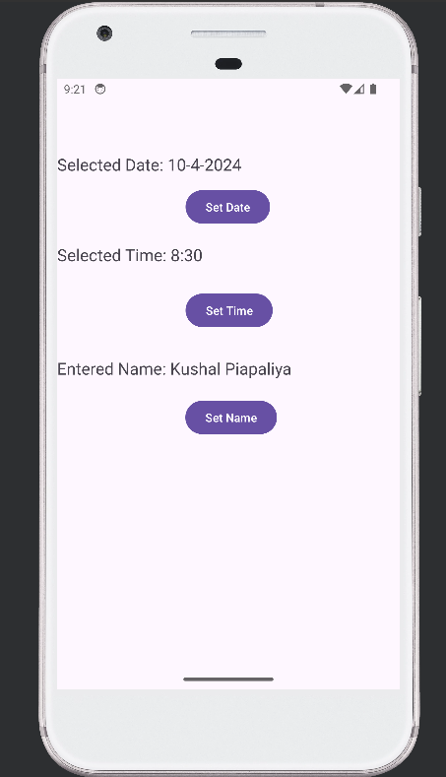

**PRACTICAL 13 :- XML FILE**

<?xml version="1.0" encoding="utf-8"?>

<LinearLayout xmlns:android="http://schemas.android.com/apk/res/android"

xmlns:app="http://schemas.android.com/apk/res-auto"

xmlns:tools="http://schemas.android.com/tools"

android:id="@+id/main"

android:layout_width="match_parent"

android:layout_height="match_parent"

android:orientation="vertical"

android:layout_margin="20dp"

tools:context=".MainActivity">

<EditText

android:id="@+id/editTextNo1"

android:layout_width="match_parent"

android:layout_height="wrap_content"

android:hint="No1"

android:inputType="numberDecimal"

app:layout_constraintBottom_toBottomOf="parent"

app:layout_constraintEnd_toEndOf="parent"

app:layout_constraintHorizontal_bias="0.0"

app:layout_constraintStart_toStartOf="parent"

app:layout_constraintTop_toTopOf="parent"

app:layout_constraintVertical_bias="0.096" />

<EditText

android:id="@+id/editTextNo2"

android:layout_width="match_parent"

android:layout_height="wrap_content"

android:hint="No2"

android:inputType="numberDecimal"

app:layout_constraintBottom_toBottomOf="parent"

app:layout_constraintEnd_toEndOf="parent"

app:layout_constraintHorizontal_bias="0.0"

app:layout_constraintStart_toStartOf="parent"

app:layout_constraintTop_toTopOf="parent"

app:layout_constraintVertical_bias="0.192" />

<TextView

android:id="@+id/resultTextView"

android:layout_width="match_parent"

android:layout_height="wrap_content"

android:text="Result: "

android:textSize="20dp"

app:layout_constraintBottom_toBottomOf="parent"

app:layout_constraintEnd_toEndOf="parent"

app:layout_constraintHorizontal_bias="1.0"

app:layout_constraintStart_toStartOf="parent"

app:layout_constraintTop_toTopOf="parent"

app:layout_constraintVertical_bias="0.325" />

</LinearLayout>

**option_menu.xml FILE :-**

<?xml version="1.0" encoding="utf-8"?>

<menu xmlns:android="http://schemas.android.com/apk/res/android">

<item

android:id="@+id/menuAddition"

android:title="Addition"/>

<item

android:id="@+id/menuSubtraction"

android:title="Subtraction"/>

<item

android:id="@+id/menuMultiplication"

android:title="Multiplication"/>

</menu>

**Java File:-**

package com.example.a129_prectical13;

import android.os.Bundle;

import android.view.Menu;

import android.view.MenuItem;

import android.widget.EditText;

import android.widget.TextView;

import androidx.activity.EdgeToEdge;

import androidx.annotation.NonNull;

import androidx.appcompat.app.AppCompatActivity;

import androidx.core.graphics.Insets;

import androidx.core.view.ViewCompat;

import androidx.core.view.WindowInsetsCompat;

public class MainActivity extends AppCompatActivity {

EditText editTextNo1, editTextNo2;

TextView resultTextView;

@Override

protected void onCreate ( Bundle savedInstanceState ) {

super.onCreate (savedInstanceState);

EdgeToEdge.enable (this);

setContentView (R.layout.activity_main);

ViewCompat.setOnApplyWindowInsetsListener (findViewById (R.id.main), ( v, insets ) -> {

Insets systemBars = insets.getInsets (WindowInsetsCompat.Type.systemBars ());

v.setPadding (systemBars.left, systemBars.top, systemBars.right, systemBars.bottom);

return insets;

});

editTextNo1 = findViewById(R.id.editTextNo1);

editTextNo2 = findViewById(R.id.editTextNo2);

resultTextView = findViewById(R.id.resultTextView);

}

@Override

public boolean onCreateOptionsMenu(Menu menu) {

getMenuInflater().inflate(R.menu.option_menu, menu);

return true;

}

@Override

public boolean onOptionsItemSelected(@NonNull MenuItem item) {

int id = item.getItemId();

String strNo1 = editTextNo1.getText().toString();

String strNo2 = editTextNo2.getText().toString();

double no1 = Double.parseDouble(strNo1);

double no2 = Double.parseDouble(strNo2);

double result = 0;

if (id == R.id.menuAddition) {

result = no1 + no2;

} else if (id == R.id.menuSubtraction) {

result = no1 - no2;

} else if (id == R.id.menuMultiplication) {

result = no1 * no2;

}

resultTextView.setText(String.valueOf(result));

return super.onOptionsItemSelected(item);

}

}

