### Generating a new SSH key

1. Open Git Bash.
2. Paste the text below, substituting in your GitHub email address.
3. ssh-keygen -t rsa -b 4096 -C "*your_email@example.com*"
4. # Creates a new ssh key, using the provided email as a label
5. Generating public/private rsa key pair.
6. When you're prompted to "Enter a file in which to save the key," press Enter. This accepts the default file location.
7. Enter a file in which to save the key (/Users/*you*/.ssh/id_rsa): *[Press enter]*
8. At the prompt, type a secure passphrase. For more information, see ["Working with SSH key passphrases"](https://help.github.com/articles/working-with-ssh-key-passphrases).
9. Enter passphrase (empty for no passphrase): *[Type a passphrase]*
10. Enter same passphrase again: *[Type passphrase again]*

**Adding your SSH key to the ssh-agent**

Before adding a new SSH key to the ssh-agent, you should have [checked for existing SSH keys](https://help.github.com/articles/checking-for-existing-ssh-keys) and[generated a new SSH key](https://help.github.com/articles/generating-a-new-ssh-key-and-adding-it-to-the-ssh-agent#generating-a-new-ssh-key).

If you have [GitHub for Windows](https://windows.github.com/) installed, you can use it to clone repositories and not deal with SSH keys. It also comes with the Git Bash tool, which is the preferred way of running git commands on Windows.

1. Ensure ssh-agent is enabled:
   * **If you are using Git Bash**, turn on ssh-agent:
   * # start the ssh-agent in the background
   * eval "$(ssh-agent -s)"
   * Agent pid 59566
   * **If you are using another terminal prompt**, such as [Git for Windows](https://git-for-windows.github.io/), turn on ssh-agent:
   * # start the ssh-agent in the background
   * eval $(ssh-agent -s)
   * Agent pid 59566
2. Add your SSH key to the ssh-agent. If you used an existing SSH key rather than [generating a new SSH key](https://help.github.com/articles/generating-a-new-ssh-key-and-adding-it-to-the-ssh-agent#generating-a-new-ssh-key), you'll need to replace *id_rsa* in the command with the name of your existing private key file.
3. $ ssh-add ~/.ssh/id_rsa

**Adding your SSH key to the GitHub Account**

1. Copy the SSH key to your clipboard.

If your SSH key file has a different name than the example code, modify the filename to match your current setup. When copying your key, don't add any newlines or whitespace.

$ clip < ~/.ssh/id_rsa.pub

# Copies the contents of the id_rsa.pub file to your clipboard

**Tip:** If clip isn't working, you can locate the hidden .ssh folder, open the file in your favorite text editor, and copy it to your clipboard.



1. In the top right corner of any page, click your profile photo, then click **Settings**.

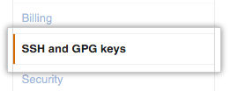

1. In the user settings sidebar, click **SSH and GPG keys**.

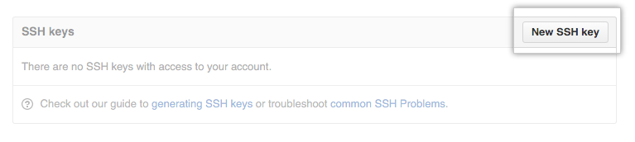

1. Click **New SSH key** or **Add SSH key**.
2. In the "Title" field, add a descriptive label for the new key. For example, if you're using a personal Mac, you might call this key "Personal MacBook Air".

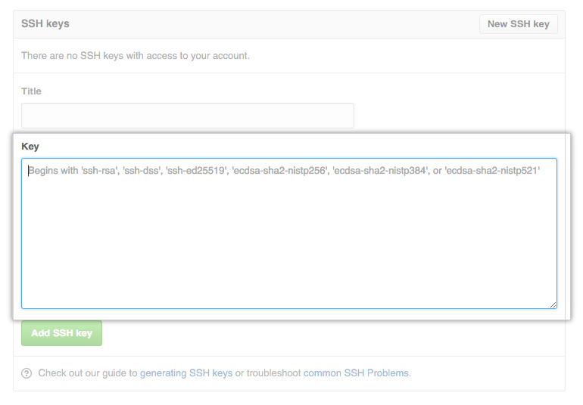

1. Paste your key into the "Key" field.



1. Click **Add SSH key**.

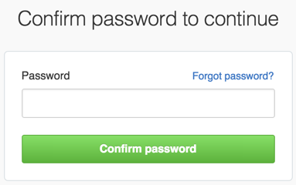

1. If prompted, confirm your GitHub password.
2. Test if it works by following command-

ssh -T git@github.com