Commands:

1. Pwd :

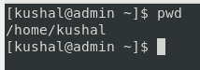

1. Dir:

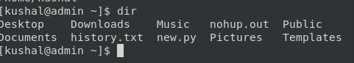

1. Ls

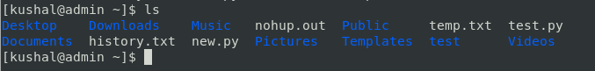

Ls -al

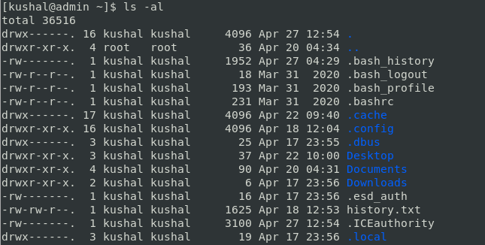

Ls -R:

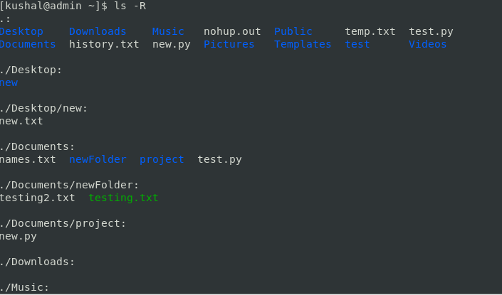

Ls -a:

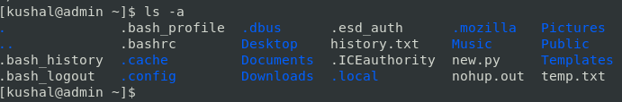

1. Cd :

cd

1. Touch :

touch1

touch2

1. cat :

cat

Cat file.txt file2.txt > output.txt

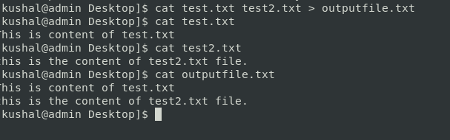

1. Mkdir :

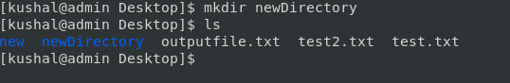

1. Rm :

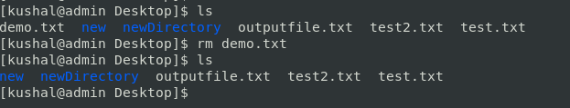

1. CP:

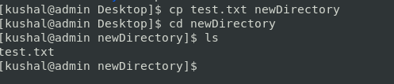

1. Mv :

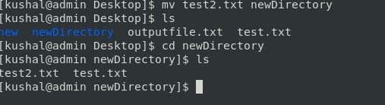

1. Head:

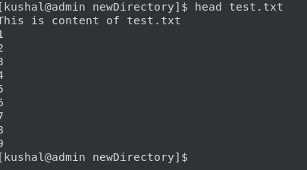

1. Tail.

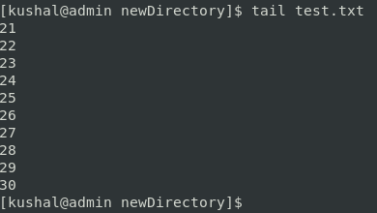

1. uname:

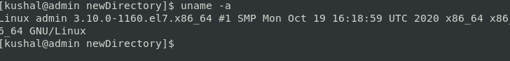

1. Wget:

wget

1. Apt-get or -apt : to install packages .

Sudo apt install vlc

Sudo apt remove vlc

1. History :

