# 9060_Foo_sim_wo_cst

# 9060_Foot_simple_wo_cst

# (Siemens Flash)

|  |
| --- |
| **CHARGES:**  73700C CT Lower Ext WO/CST Left  73700D CT Lower Ext WO/CST Right |

|  |  |
| --- | --- |
| **SET UP & INSTRUCTIONS** | |
| **Scout length: 256**  **Zero location: above joint**  **Scan Type: Spiral** | Patient Position: SupineBreathing Technique: None |
| INSTRUCTIONS: *DO NOT SCAN BOTH EXTREMITIES TOGETHER* *--If ordered bilateral, scan separately, BB on right* | |
| **Protocol Overview and Instructions:**   1. Supine, Ankle neutral at 90º, toes up. 2. Tape foot to foam block to keep fixed 3. Flex opposite knee to pull other foot out of scan plane 4. Place foot as close to middle of gantry as possible   This protocol includes forefoot and midfoot  **IMPORTANT: For all “metal” protocols, You MUST include all of the prosthesis, tip to tip.**  **If you have *any* questions regarding z-axis coverage, please feel free to contact the CT MSK rad of the day.** | |
| **Make sure you indicate right or left in the scout images.**  **Place “R” or “L” non-metallic marker in scan field for scout.** | |
| ***ESTIMATED CTDI: 36.4 (Metal 51.85)*** | |

***Foot: Scan***

|  |  |  |  |  |
| --- | --- | --- | --- | --- |
| ***ROUTINE TAB:*** | |  | ***RECON TAB:*** | |
| **Eff. mAs:** | 250  300 Metal |  | **Slice:** | 0.4 MM |
| **kV:** | 120  140 Metal |  | **Safire:** *(On or Off)* | √ Off |
| **Delay:** | 2 seconds |  | **Strength (SAFIRE):** | N/A |
| **Slice:** | 0.4 mm  Acq 16 x 0.3 mm |  | **Kernel:** | U70u Sharp |
| **Dose Notification Value:** | 60 |  | **FAST:** |  |
|  |  |  | **Window:** | 2000 / 500 |
| ***SCAN TAB:*** | |  | **FoV** | 120 |
| **CARE Dose4D:** *(On or Off)* | √ Off |  | **Mirroring:** | None |
| (If CARE Dose 4D is “*OFF”*) |  |  | **Image order:** | Caudocranial |
| Change: Effective mAs |  |  | **Increment:** | 0.2 mm |
| Change: kV |  |  |  |  |
| **Scan Time:** | 17.9 s |  |  |  |
| **CARE kV:** *(On or Off)* | √ Off |  |  |  |
| **Rotation Time:** | 1.0 sec |  |  |  |
| **Pitch:** | 0.8 |  |  |  |
| **Direction:** | Caudocranial |  |  |  |
| **Ref QRM** | 240 |  |  |  |
| **Ref kV** | 120  140 Metal |  |  |  |
| **Dose optimized level** |  |  |  |  |
| **API:** | None |  |  |  |

|  |
| --- |
| ***Series Information and Reformats: Foot simple no vrt*** |

|  |  |  |  |
| --- | --- | --- | --- |
|  | **Recon 1** | **Recon 2** | **Recon 3** |
| **Series Description:** | Foo bon l060 :-D  (axial) | Foo bon l060  (axial) | Foo :-D  (axial) |
| **Slice:** | 0.6 mm | 2.0 mm | 0.6 mm |
| **SAFIRE:** | √ Off | √ Off | √ On |
| **SAFIRE Strength:** | N/A | N/A | 3 |
| **Algorithm** | U70u | U70u | U30u |
| **FAST:** | √ On | √ On | √ On |
| **Window:** | Bone | Bone | 400 / 40 Abd |
| **FoV** | 120 | 120 | 120 |
| **Recon job type:** | Axial | Axial | Axial |
| **Recon Region** | Wide | Wide | Wide |
| **Recon axis: for 3D** | N/A | N/A | N/A |
| **Type: 3D** | N/A | N/A | N/A |
| **Image order:** | Caudocranial | Caudocranial | Caudocranial |
| **Increment:** | 0.4 mm | 2.0 mm | 0.4 mm |
| **Destination:** | PACS  Use for MPR | PACS | PACS |

|  |
| --- |
| ***Series Information and Reformats: Foot simple no vrt*** |

|  |  |  |  |
| --- | --- | --- | --- |
|  | **Recon 4** | **Tech to make** | **Tech to make** |
| **Series Description:** | Foo  (axial) | Foo obl bon  (axial oblique) | Foo obl cor bon  (coronal) |
| **Slice:** | 2.0 mm | 2.0 mm | 2.0 mm |
| **SAFIRE:** | √ On | √ Off | √ Off |
| **SAFIRE Strength:** | 3 | N/A | N/A |
| **Algorithm** | U30u | U70u | U70u |
| **FAST:** | √ On | √ On | √ On |
| **Window:** | 400 / 40 Abd | Bone | Bone |
| **FoV** | 120 | 120 | 120 |
| **Recon job type:** | Axial | Axial | coronal |
| **Recon axis:** | Wide | Wide | Wide |
| **Type:** | N/A | N/A | N/A |
| **Image order:** | Caudocranial | Caudocranial | Anterior to posterior |
| **Increment:** | 2.0 mm | 2.0 mm | 2.0 mm |
| **Destination:** | PACS | PACS | PACS |

|  |
| --- |
| ***Series Information and Reformats: Foot simple no vrt*** |

|  |  |  |  |
| --- | --- | --- | --- |
|  | **Tech to make** |  |  |
| **Series Description:** | Foo obl sag bon  (oblique sagittal) |  |  |
| **Slice:** | 2.0 mm |  |  |
| **SAFIRE:** | √ On |  |  |
| **SAFIRE Strength:** | 3 |  |  |
| **Algorithm** | U30u |  |  |
| **FAST:** | √ On |  |  |
| **Window:** | Bone |  |  |
| **FoV** | 120 |  |  |
| **Recon job type:** | Sagittal |  |  |
| **Recon axis:** | Wide |  |  |
| **Type:** | N/A |  |  |
| **Image order:** | Left to right |  |  |
| **Increment:** | 2.0 mm |  |  |
| **Destination:** | PACS |  |  |

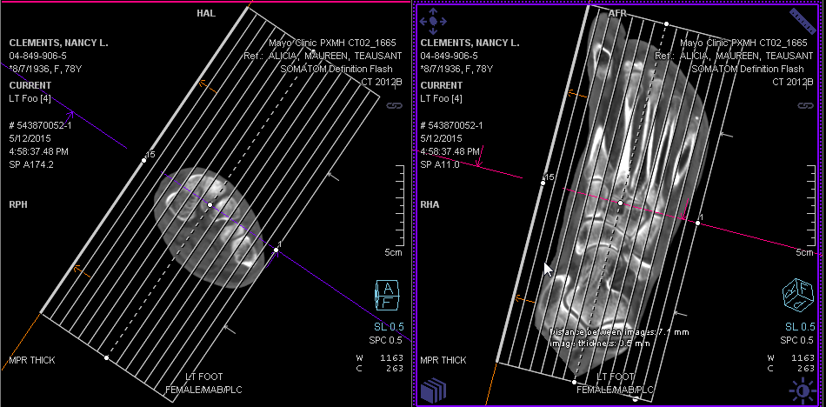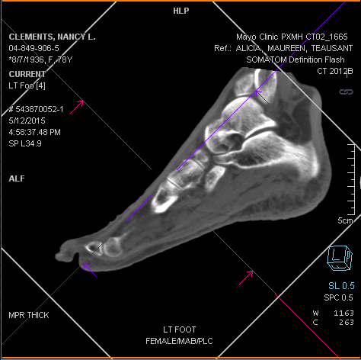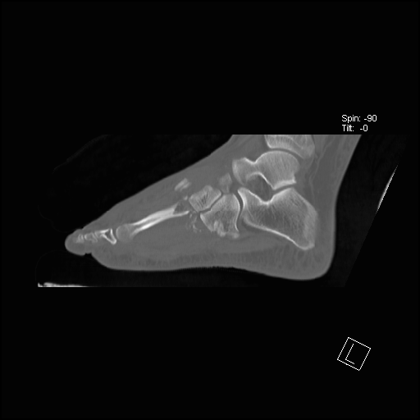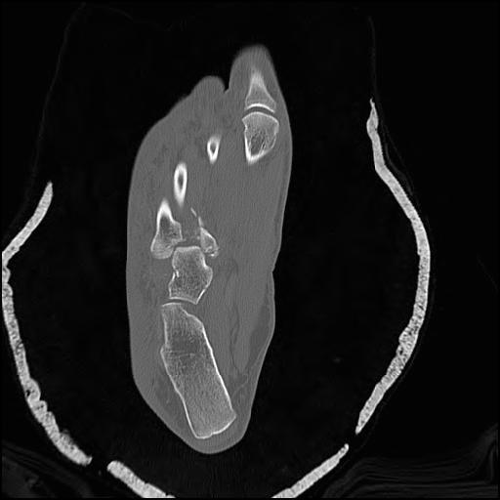

Resulting in Sagittal image

Sagittal Plane. Use axial image, align Sag. Plane with long axis of 2nd metatarsal

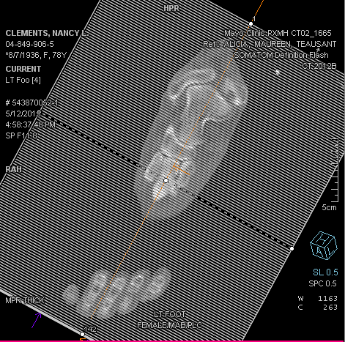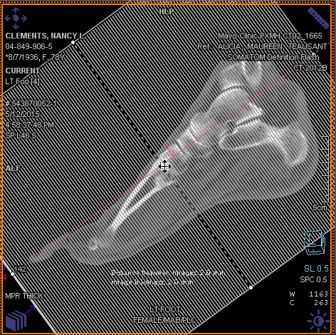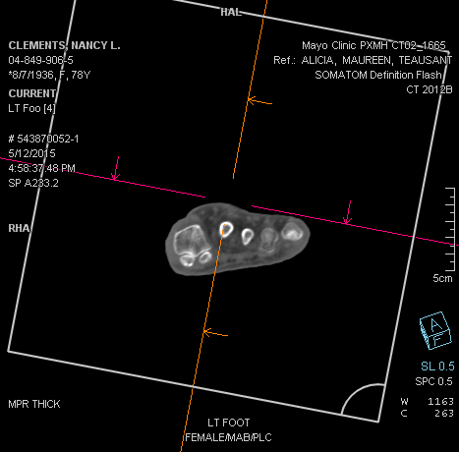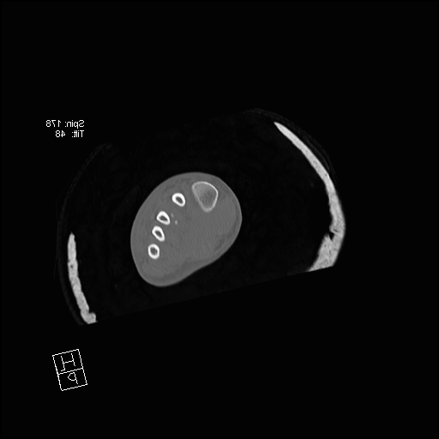

To create Coronal Plane: Use Sagittal image

Resulting in Coronal Image.

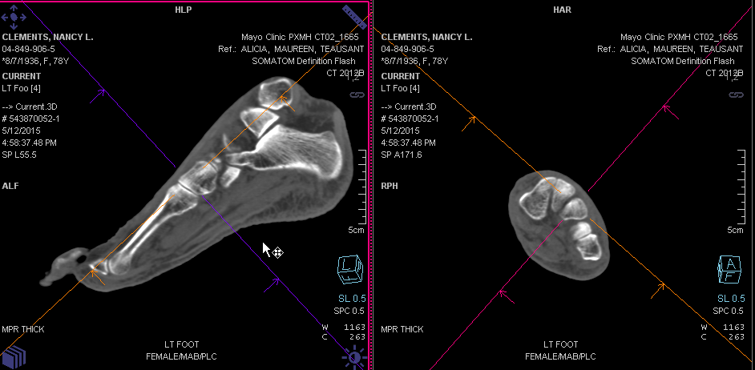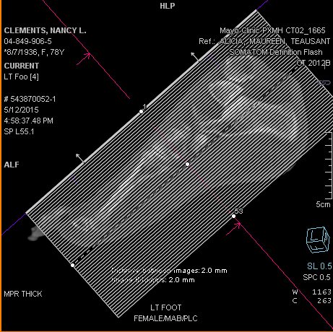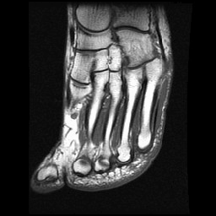

Resulting in Axial Oblique Image. The 2nd through 4th metatarsals are fully visualized on one image

Axial Oblique Plane. Use Coronal and Sagittal images to align image plane with (orange) line through 2nd to 5th metatarsals

True axial image

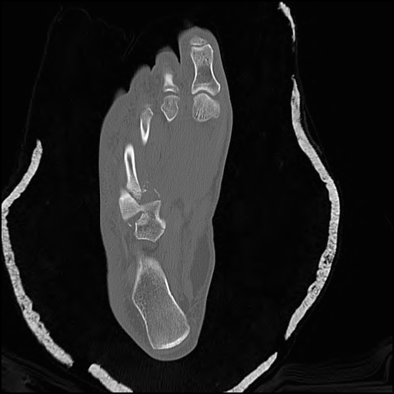

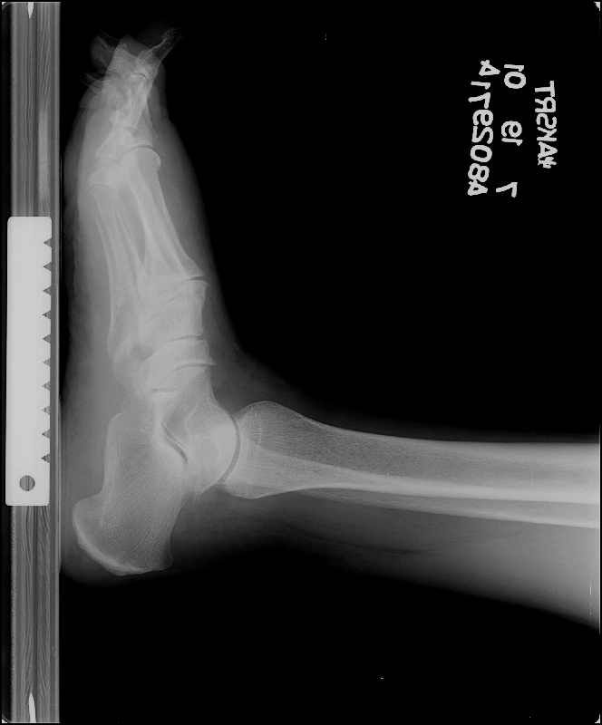

Coverage: (Note: cover top of talus to bottom of foot)

Position to the right will result in a True Axial scan. Note that only small portions of the metatarsals are visible on any one slice because they are angled