# 9060_Foo_sim_wo_cst

# 9060_Foot_simple_wo_cst

# (Siemens Flash)

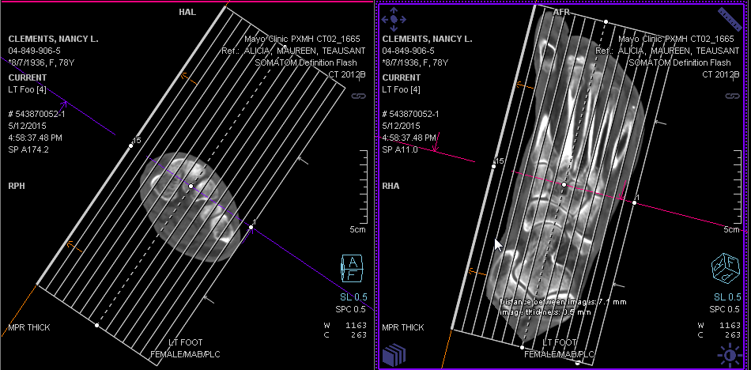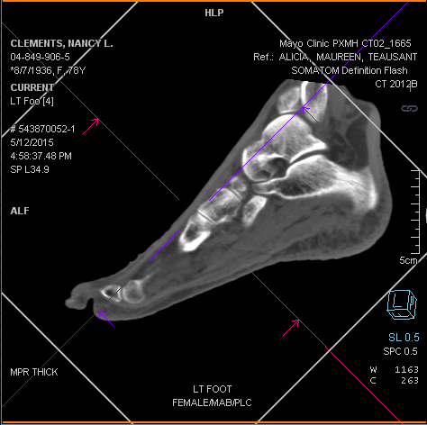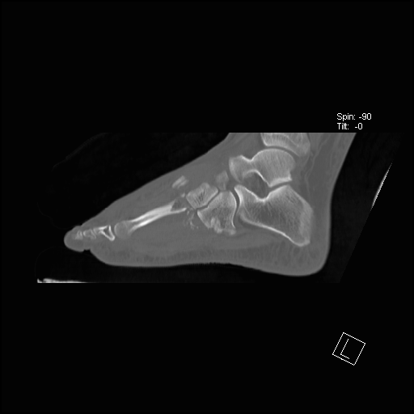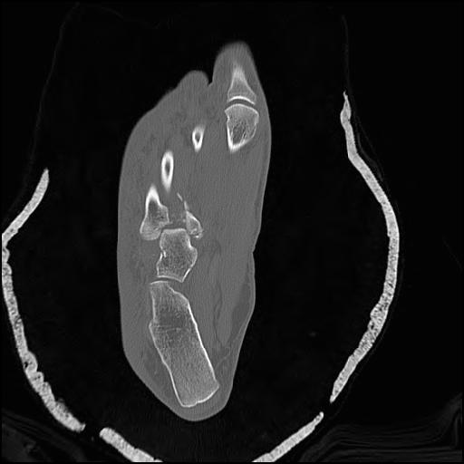

Resulting in Sagittal image

Sagittal Plane. Use axial image, align Sag. Plane with long axis of 2nd metatarsal

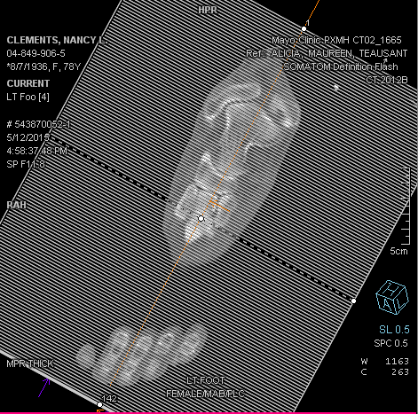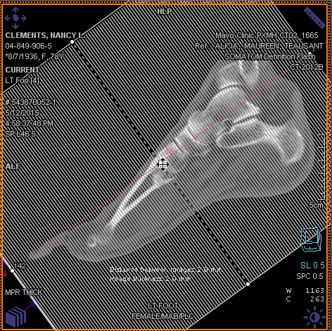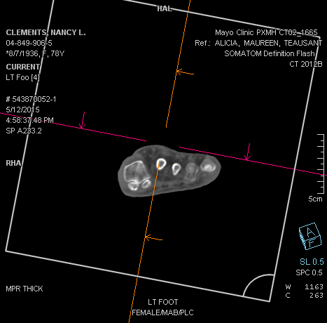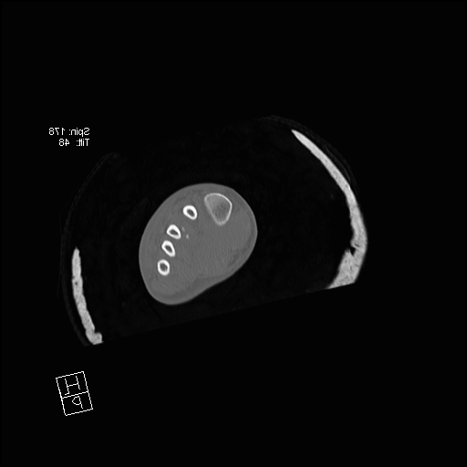

To create Coronal Plane: Use Sagittal image

Resulting in Coronal Image.

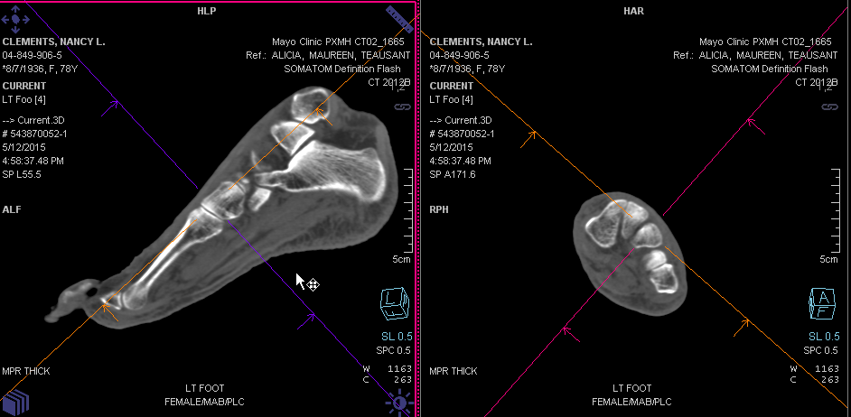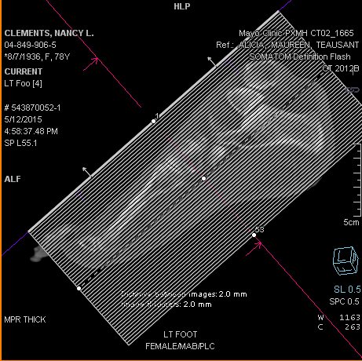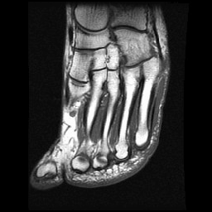

Resulting in Axial Oblique Image. The 2nd through 4th metatarsals are fully visualized on one image

Axial Oblique Plane. Use Coronal and Sagittal images to align image plane with (orange) line through 2nd to 5th metatarsals

True axial image

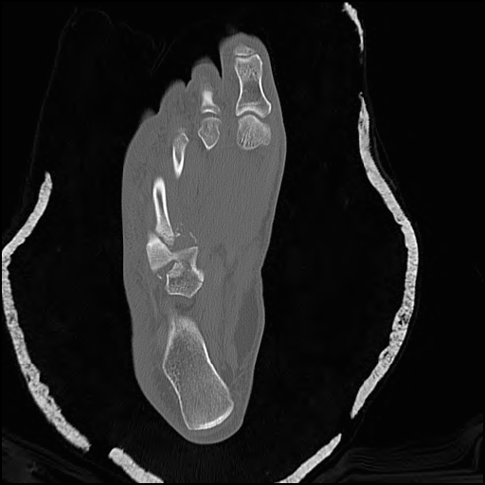

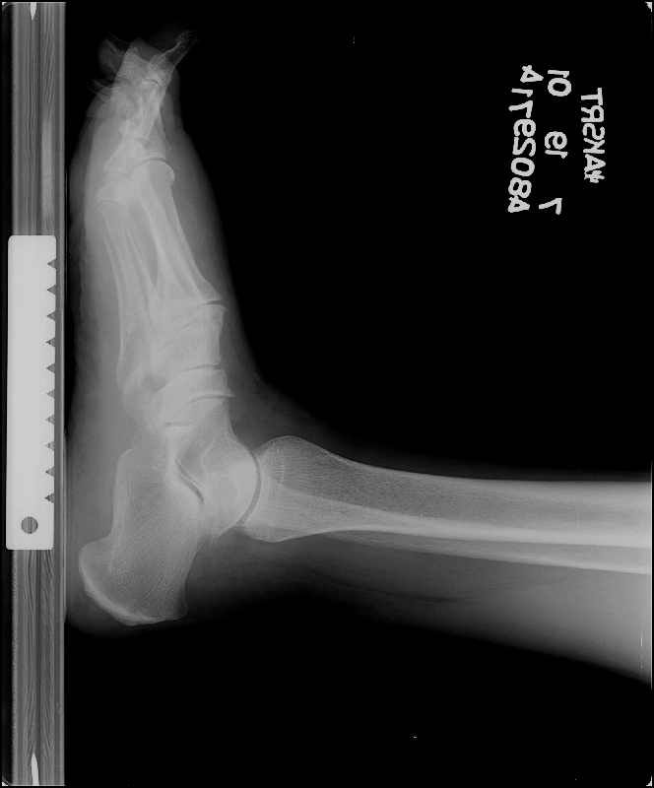

Coverage: (Note: cover top of talus to bottom of foot)

Position to the right will result in a True Axial scan. Note that only small portions of the metatarsals are visible on any one slice because they are angled