Write a HTML code for the following web page

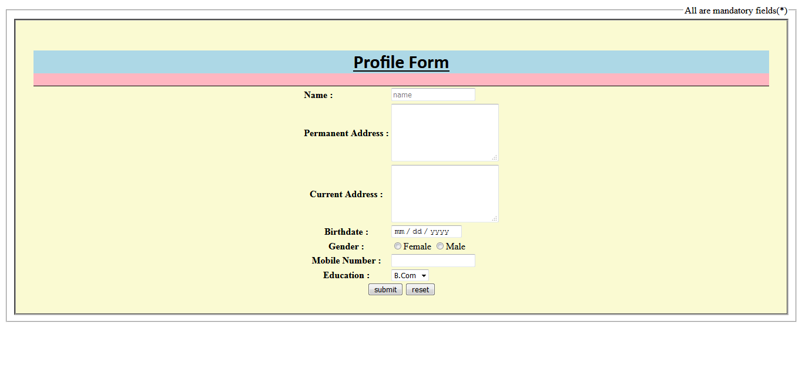

<!doctype html>

<html>

<head>

<title>profile form</title>

<meta name="description" content="blocks">

<script language=javascript src = "function.js" >

</script>

<style>

.test

{

display:block;

background-color:lightpink;

border-bottom:1px solid;

}

.Demo

{

display:inner-block;

background-color:lightblue;

}

.a

{

text-align:center;

background:lightgoldenrodyellow;

border: 3px groove black;

padding:30px;

}

</style>

</head>

<body>

<li> <label for = "name" >

<!-- Legend tag....................................... -->

<form>

<fieldset>

<legend align="right">All are mandatory fields(\*)</legend>

<div class="a">

<!-- INNER/INLINE BLOCK............................................... -->

<div class="test">

<header class="Demo">

<strong><h1 style="font-family:calibri;text-align:center"><u>Profile Form</u></h1></strong>

</header>

</div>

<table align="center">

<tr>

<td><b><label>Name :</label></b></td>

<td><input type="text" name="name" ></td>

</tr>

<tr>

<th>Permanent Address :</th>

<td><textarea rows="5" columns="5"></textarea></td>

</tr>

<tr>

<th>Current Address :</th>

<td><textarea rows="5" columns="5"></textarea></td>

</tr>

<tr>

<th>Birthdate :</th>

<td><input type="date"></td>

</tr>

<tr>

<th>Gender :</th>

<td><input type="radio" name="gender" value="f">Female <input type="radio" name="gender" value="m">Male</td>

</tr>

<tr>

<th>Mobile Number :</th>

<td><input type="mobile"></td>

</tr>

<tr>

<th>Education :</th>

<td><select>

<option>B.Com</option>

<option>BE</option>

<option>BCA</option>

<option>BA</option>

<option>BCS</option>

<option>BSC</option>

</select>

</tr>

</table>

<script language="javascript" src = "function.js" >

function allletter(placeholder);

</script>

<input type="submit" name="submit" value="submit">

<input type="reset" name="reset" value="reset">

</div>

</fieldset>

</form>

</body>

</html>