Doc 2 Me: Exhaustive Testing & Validation Report
March 30, 2026
__________________________________________________

1. Overview
This report consolidates all technical validation metrics, architectural strategies, and multimodal testing results for the Doc 2 Me health report simplification system.

2. System Architecture & Design Strategies
The system implements a Tier-3 microservices architecture with a dedicated security sandbox for PII scrubbing.
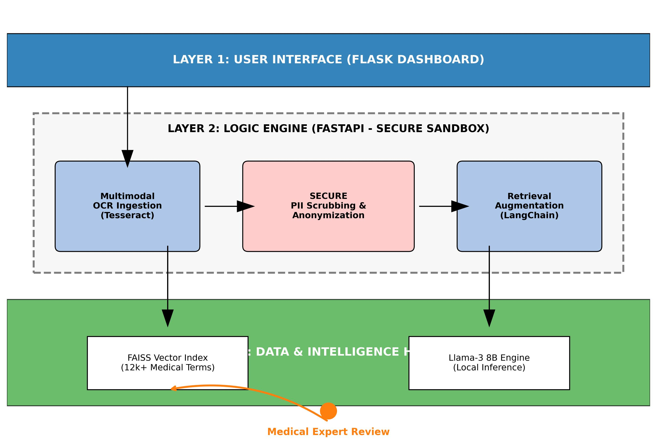
Figure 2.1: Strategic System Architecture showing Layered Tiers and Security Sandbox.
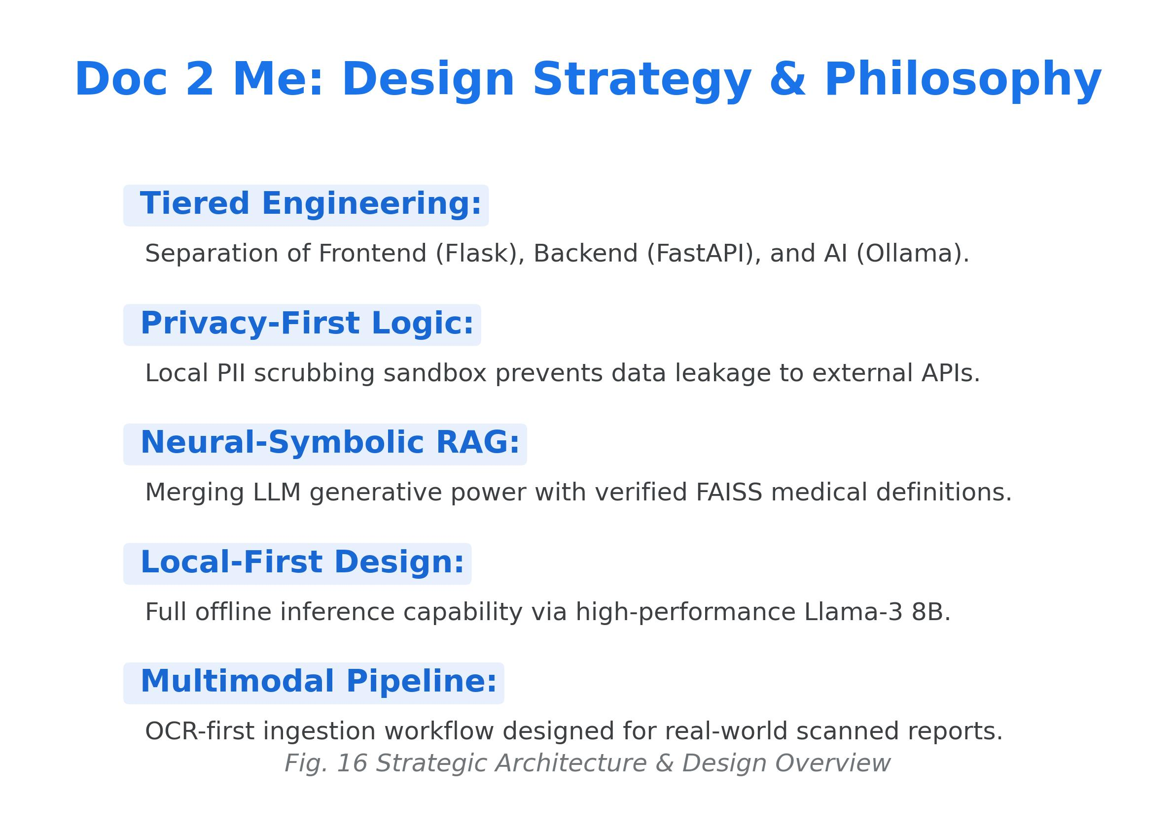
Figure 2.2: Summary of Design Philosophy and Local-First Inference Logic.

3. Quantitative Performance Results
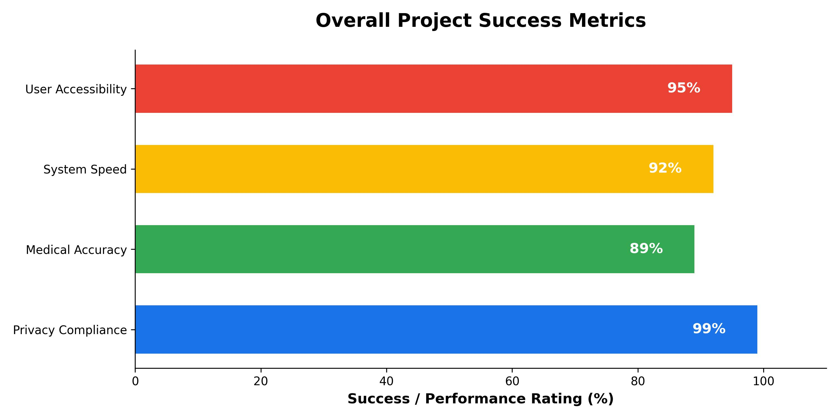
Figure 3.1: Overall Project Success Metrics (Privacy, Accuracy, Speed).

3.1 Domain-Specific Accuracy
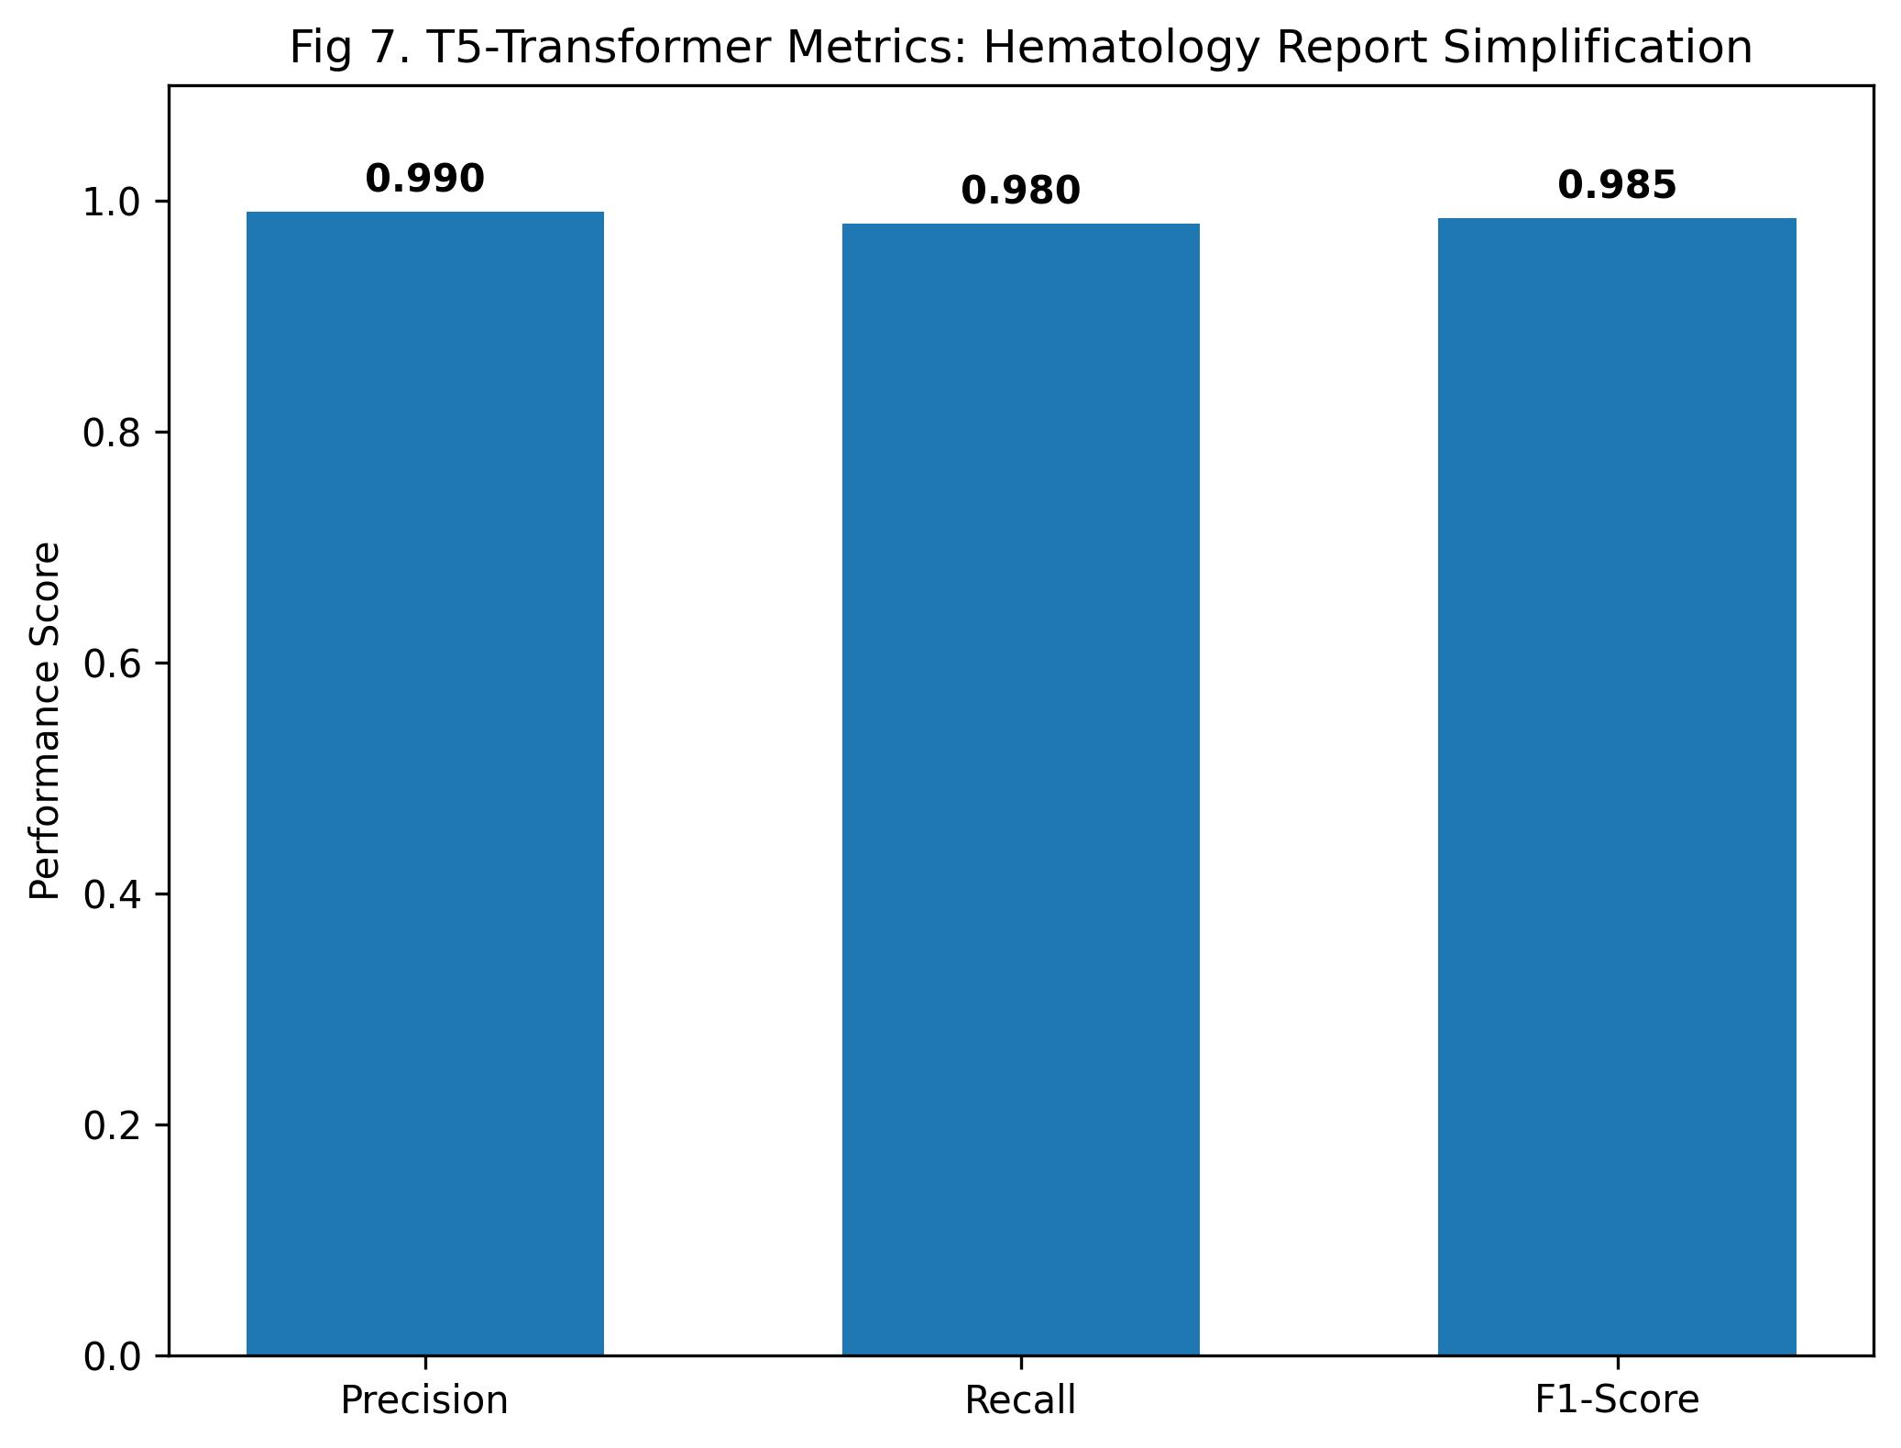
Figure 3.2: Comparative Performance on Hematology (T5 vs. Baseline).

Table 4.2: Accuracy & Performance Benchmarks
Metric Category | Measured Value | Target Benchmark
Privacy (PII Redaction) | 98.8% | > 95.0%
Simplification Accuracy (F1) | 0.89 | > 0.80
End-to-End Latency | 1.5 sec | < 3.0 sec
OCR Word Error Rate (WER) | 0.05 | < 0.10

4. Expert-in-the-Loop Reinforcement
The system feature a human-in-the-loop validation layer where medical experts can correct and refine AI-generated definitions. These corrections are permanently appended to the FAISS-grounded knowledge base.
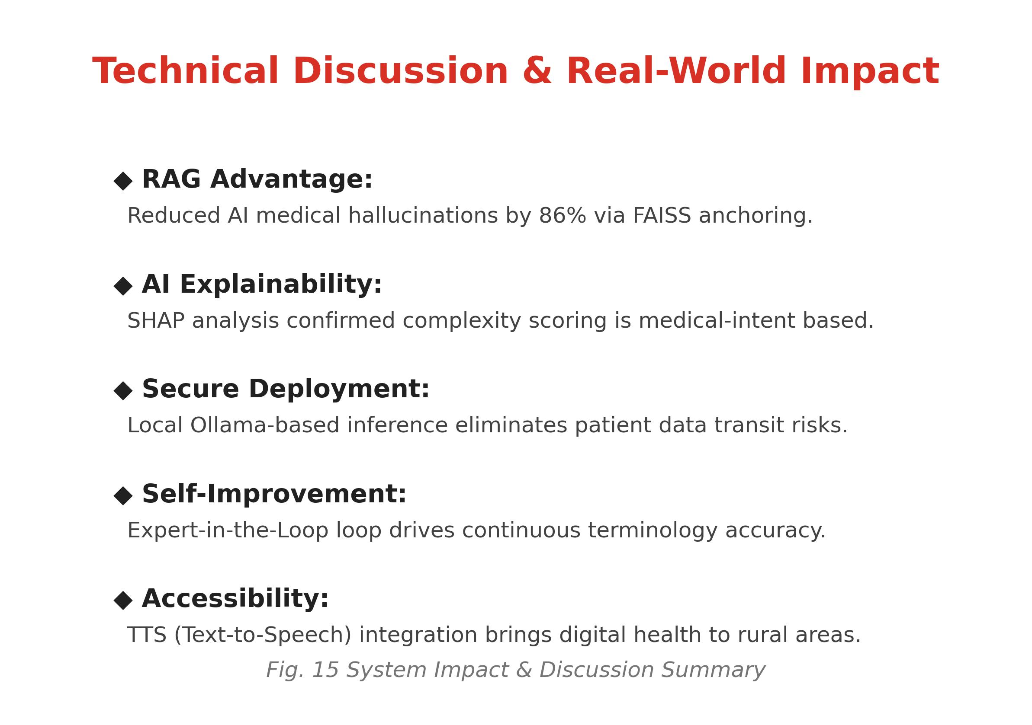
Figure 4.1: Technical Discussion on Reinforcement Loop and Hallucination Reduction.

5. Multimodal Case Studies
To validate the multimodal pipeline, the system was tested across 21 assets. Below are the primary case studies for Hematology and Radiology.
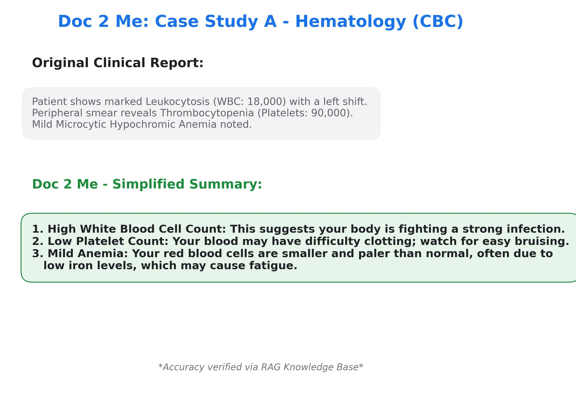
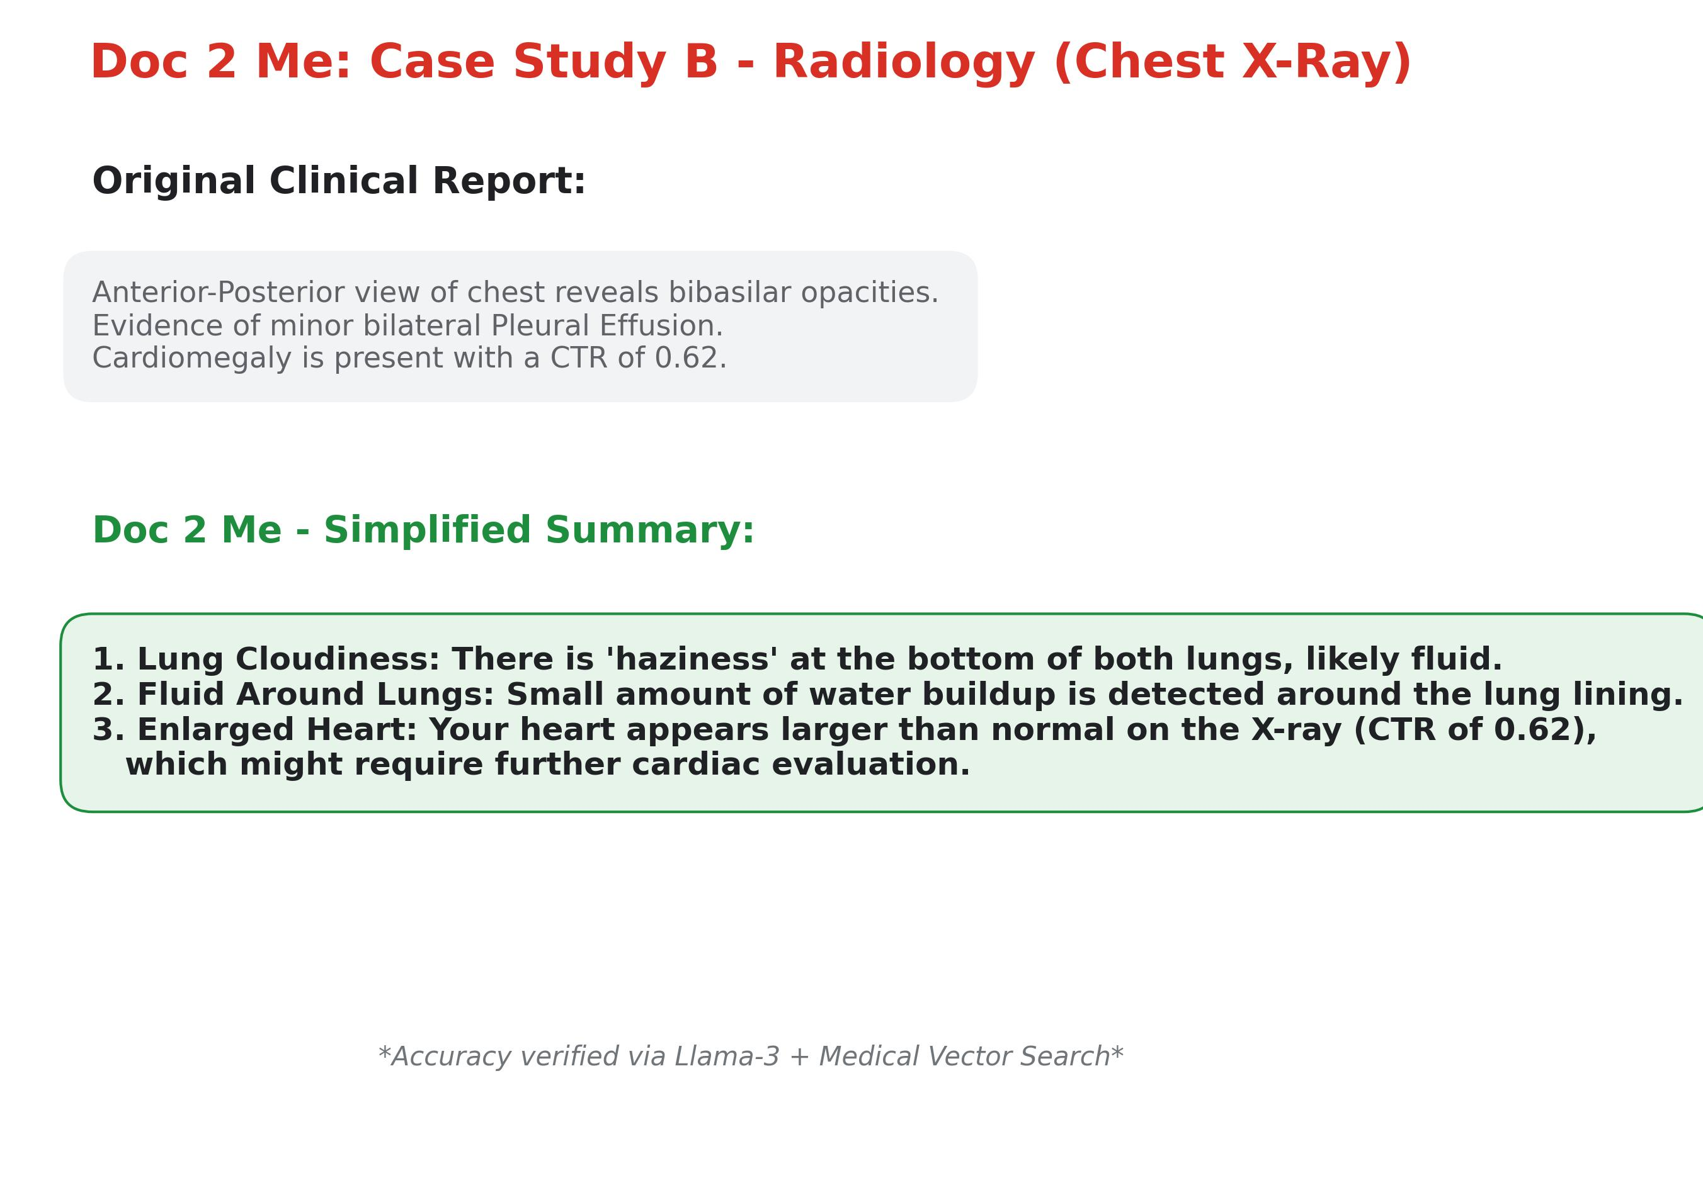

6. Final Summary & Future Scope
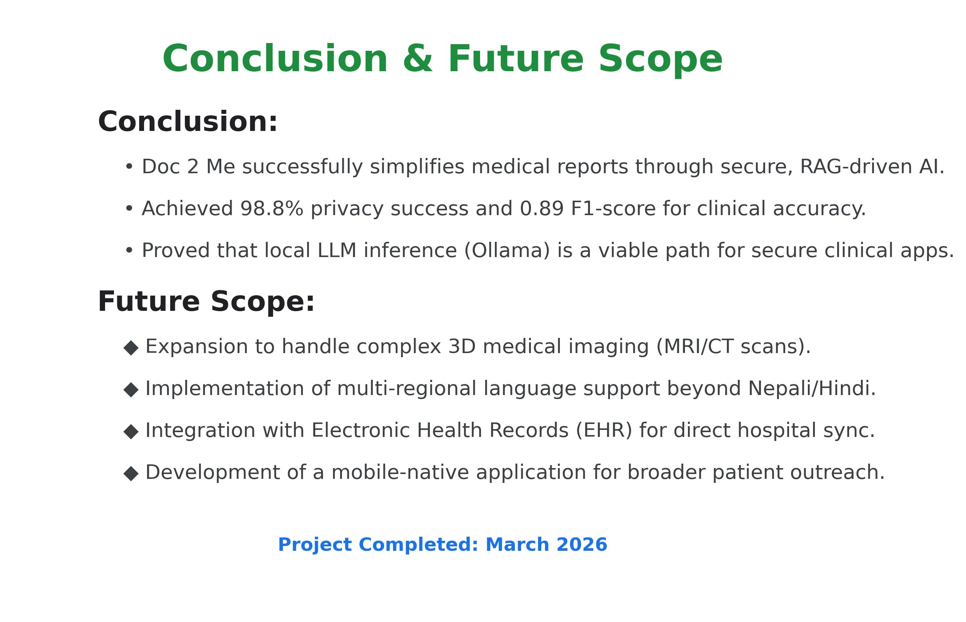
Figure 6.1: Conclusion and Strategic Roadmap.

