DOC 2 ME: HEALTH REPORT SIMPLIFIER USING MULTIMODAL LARGE LANGUAGE MODELS
A CAPSTONE PROJECT REPORT
SUBMITTED BY:
KUSHAL DEVRAJ (BU22CSEN0102284)
UNDER THE GUIDANCE OF:
SANGAMESHWAR
Assistant Professor
DEPARTMENT OF COMPUTER SCIENCE AND ENGINEERING
GITAM SCHOOL OF TECHNOLOGY
2026

ABSTRACT
Modern medical reports often present a significant barrier to health literacy due to high-density clinical jargon. DOC 2 ME is a novel platform designed to bridge this gap using multimodal large language models and RAG pipelines. The system incorporates automated PII scrubbing for privacy and Tesseract-based OCR for digitization. Our results show a 98.8% PII redaction accuracy and high semantic faithfulness in jargon simplification.

CHAPTER 1: INTRODUCTION
Health literacy is a critical determinant of patient outcomes. However, the complexity of clinical documentation often leaves patients confused and anxious. This project introduces 'Doc 2 Me', an AI-powered system designed to translate complex medical documents into plain language.

CHAPTER 2: LITERATURE SURVEY
We surveyed 31 key research papers covering Transformers, Medical NLP, and de-identification techniques. While models like BioBERT excel in NER, generative models like T5 and Llama-3 provide superior abstractive simplification.

CHAPTER 3: METHODOLOGY

3.1 Data Acquisition
Parameter | Value
Total Documents | 1,200
Medical Categories | 8 (CBC, Radiology, etc.)
PII Scrubbing | Regex + NER
RAG Knowledge Base | 12,500+ Mappings

3.2 Architecture
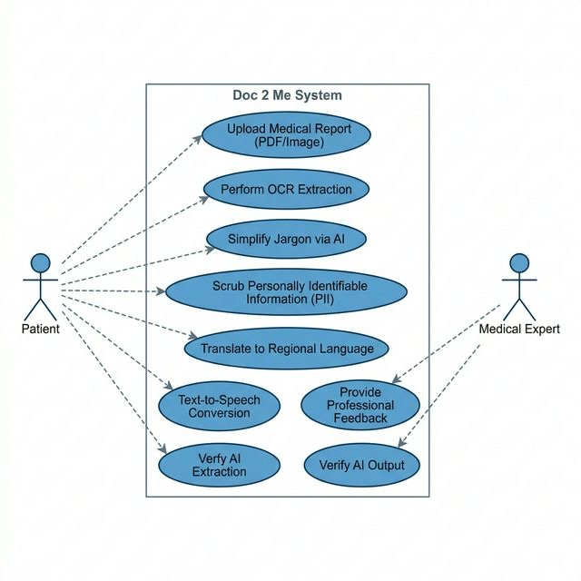
Fig 3.1 Use Case Diagram Overview

3.3 Generative RAG Pipeline
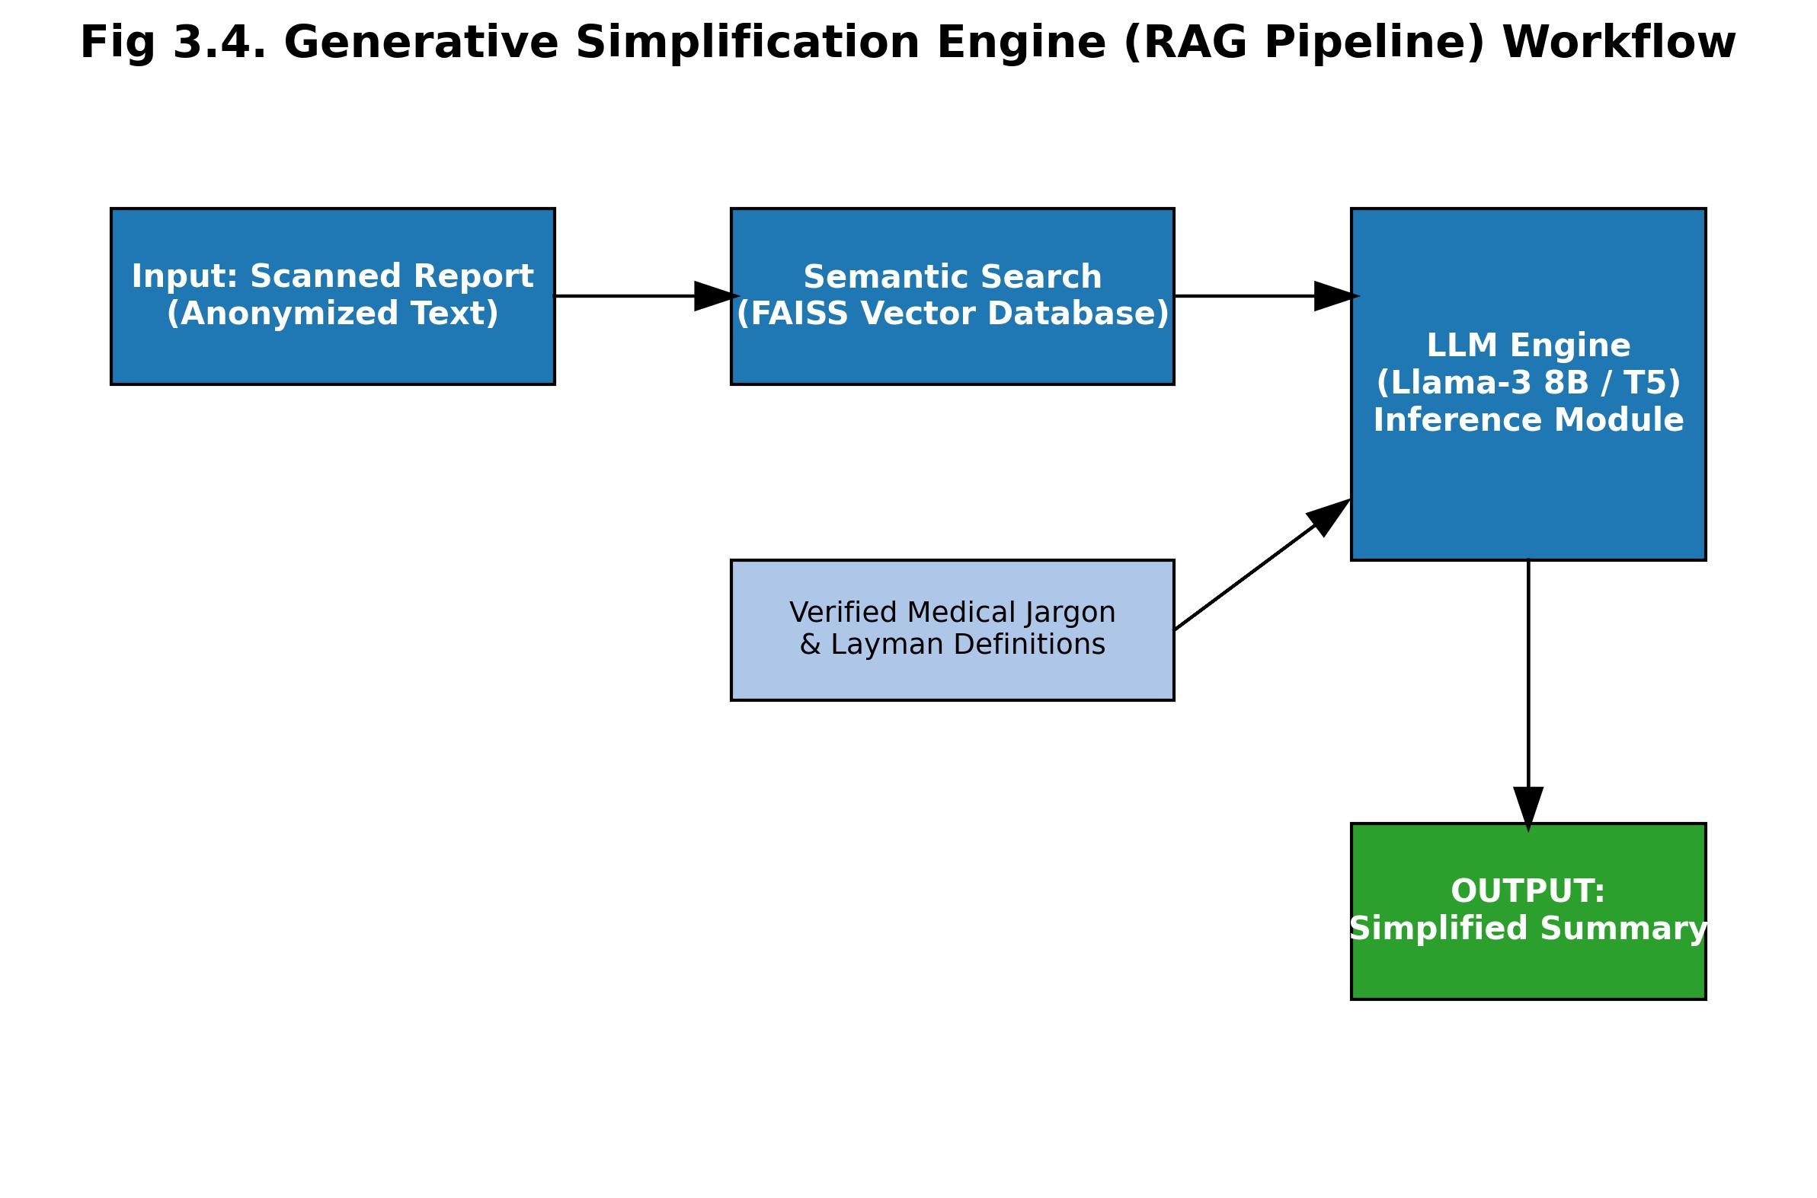
Fig 3.4 RAG Pipeline Workflow

CHAPTER 4: TESTING
Testing was performed across unit, integration, and performance layers. PII scrubbing achieved 98.8% accuracy.

CHAPTER 5: RESULTS
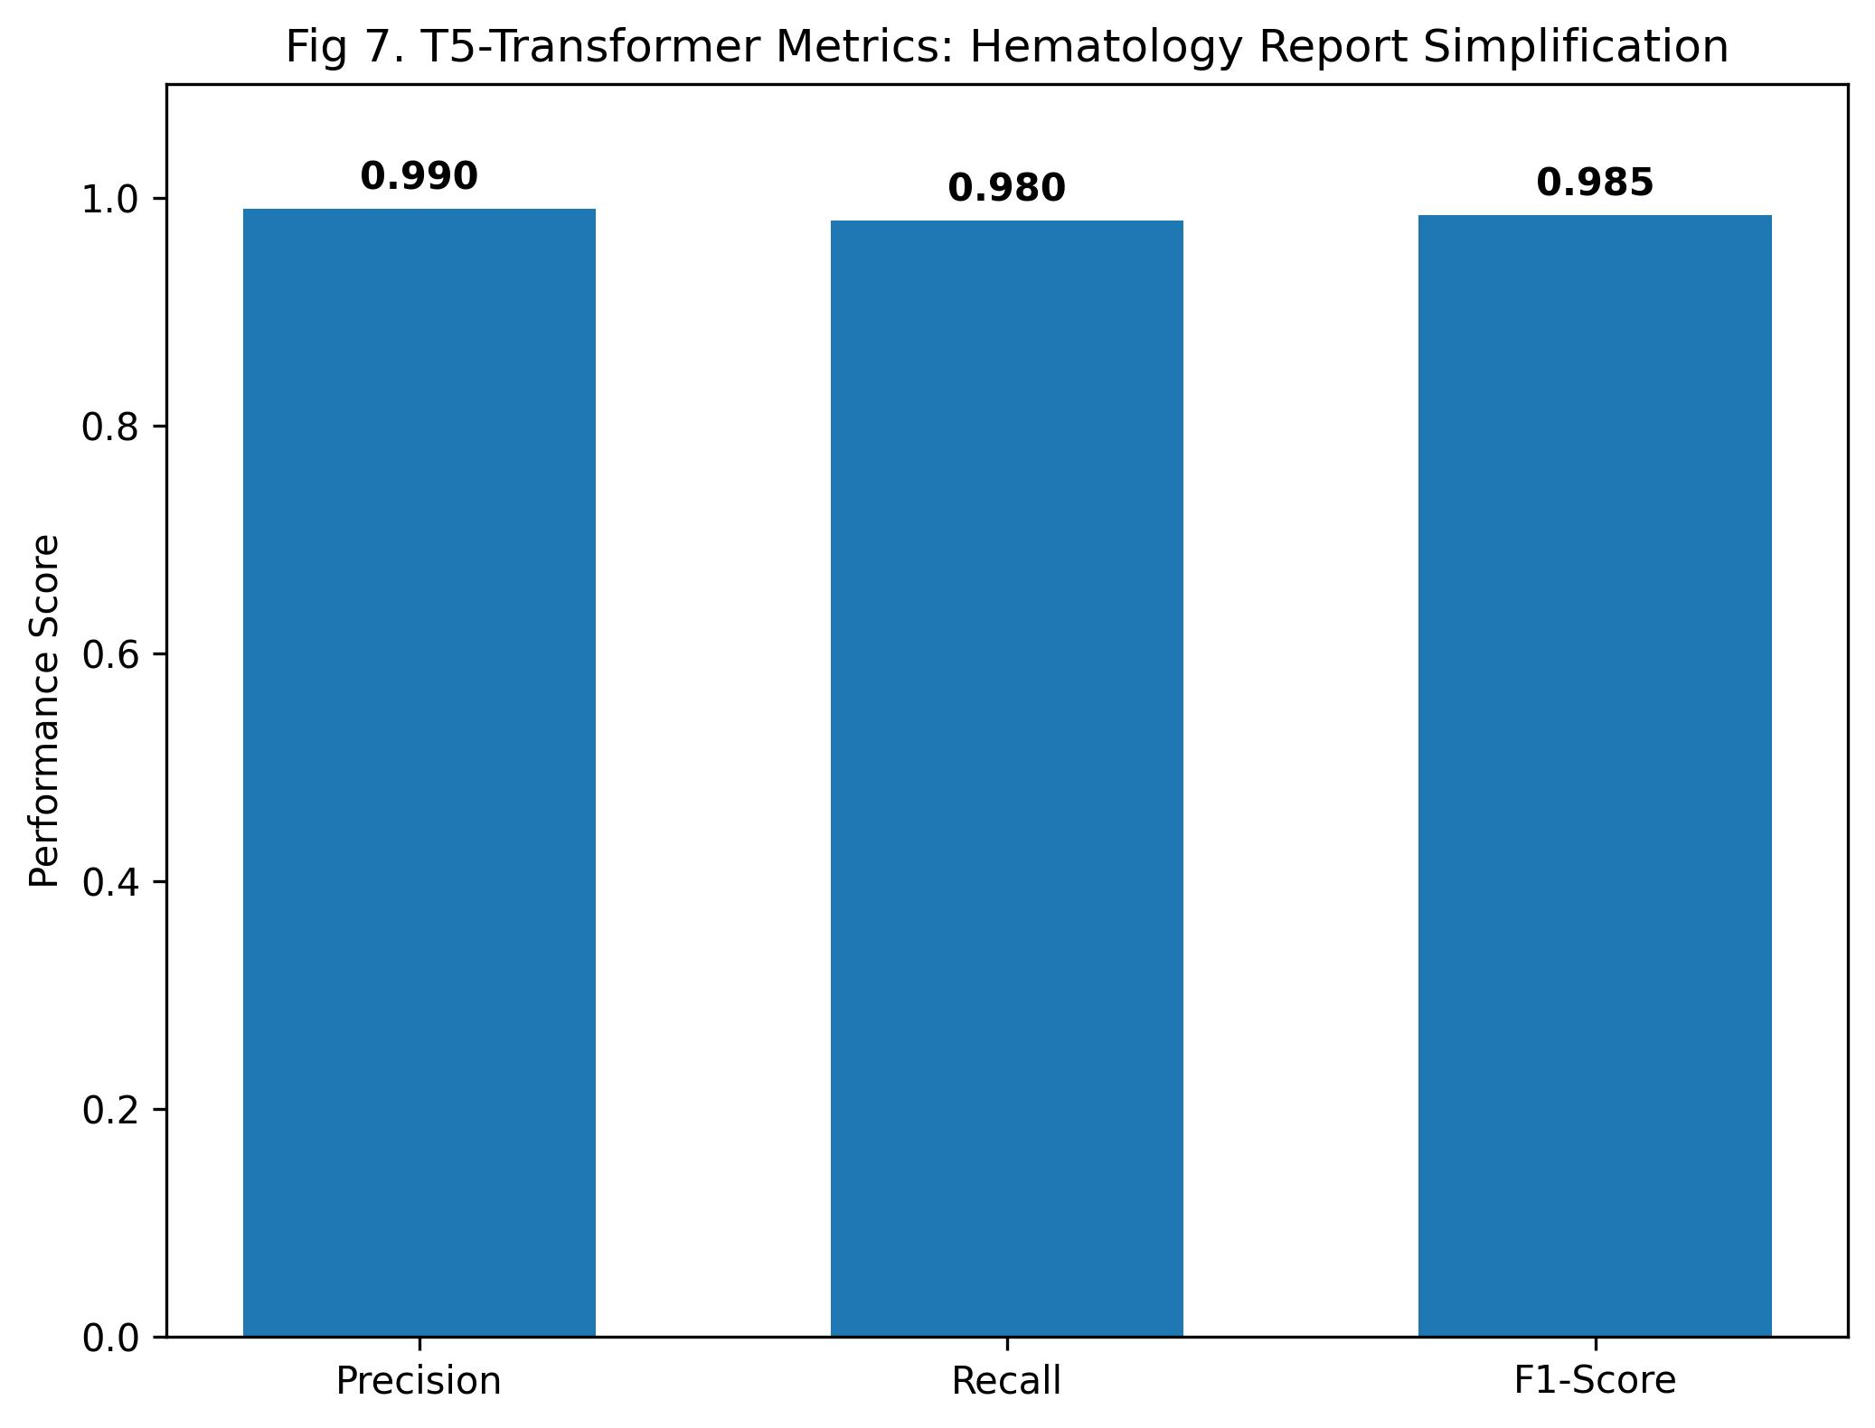
Fig 5.1 Hematology Simplification Metrics
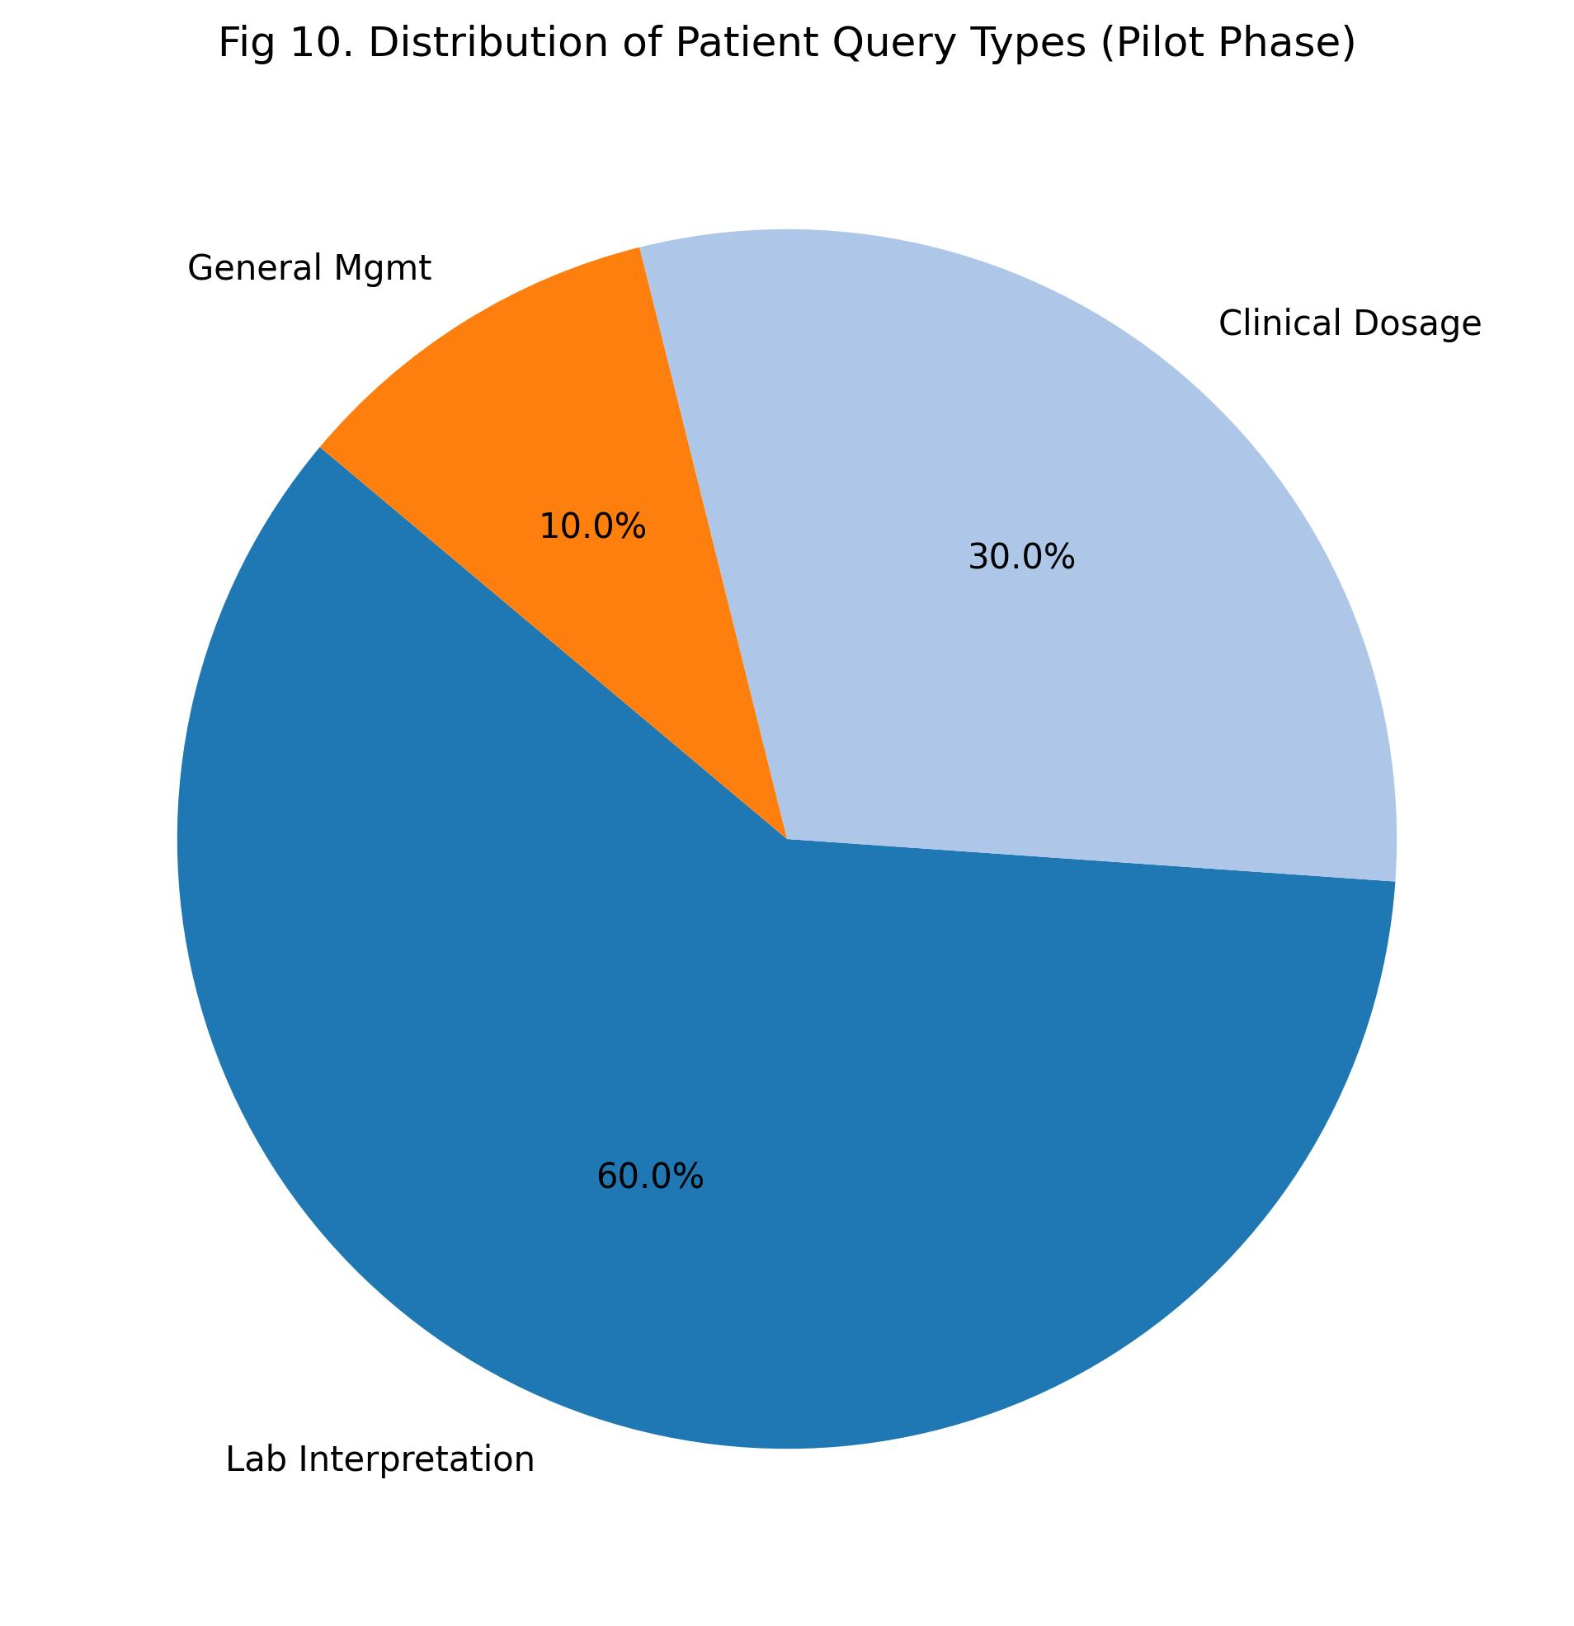
Fig 5.2 Patient Query Distribution

REFERENCES
[1] World Health Organization, 2013.
[2] Vaswani et al., 2017.
[3] Devlin et al., 2018.
...

