TABLE OF CONTENTS
Title | Page No.
Certificate | ii
Declaration | iii
Acknowledgements | iv
Abstract | v
Table of Contents | vi
List of Tables | vii
List of Figures | viii
List of Abbreviations | ix
CHAPTER 1: Introduction | 1
1.1 Background and Motivation | 1
1.2 Problem Statement | 3
1.3 Objectives | 4
1.4 Scope of the Project | 5
1.5 Organisation of the Report | 6
CHAPTER 2: Literature Survey | 7
2.1 AI in Livestock Health Monitoring | 7
2.2 IoT-Based Precision Livestock Farming | 9
2.3 Cattle Behaviour Analysis Using Computer Vision | 10
2.4 Livestock Market Pricing and Trade Platforms | 11
2.5 Summary and Research Gaps | 12
CHAPTER 3: System Design and Architecture | 14
3.1 Overall System Architecture | 14
3.2 Data Acquisition and Preprocessing | 16
3.3 Bionic Disease Detection Architecture | 20
3.4 Smart Trade Valuation Engine | 26
3.5 Personalised Advisory Module | 30
3.6 Multilingual Voice Interface | 32
3.7 Implementation Environment | 33
CHAPTER 4: Implementation and Results | 35
4.1 Disease Detection Experimental Results | 35
4.2 Smart Trade Valuation Results | 40
4.3 Advisory Module Evaluation | 43
4.4 System Performance Metrics | 45
4.5 User Interface Overview | 46
CHAPTER 5: Conclusion and Future Work | 48
5.1 Summary of Contributions | 48
5.2 Limitations | 50
5.3 Future Work | 51
CO–PO–PSO Mapping | 53
Sustainable Development Goals (SDGs) | 57
References | 59

LIST OF TABLES
Title | Page No.
Table 2.5.1 Comparison of Related Work with Proposed System | 12
Table 3.1.1 System Component Summary | 15
Table 3.2.1 CattleSet-2k Dataset Composition | 17
Table 3.2.2 Train–Validation–Test Split | 18
Table 3.2.3 Image Augmentation Pipeline Parameters | 18
Table 3.2.4 Normalisation Formula Symbol Descriptions | 19
Table 3.2.5 Cattle Market Dataset Feature Categories | 19
Table 3.2.6 Z-Score Normalisation Symbol Descriptions | 20
Table 3.3.1 EfficientNet Compound Scaling Constraint Symbols | 21
Table 3.3.2 EfficientNet-B7 Architecture Modifications | 22
Table 3.3.3 Disease Detection Training Hyperparameters | 23
Table 3.4.1 XGBoost Hyperparameter Grid | 27
Table 3.4.2 Regression Model Performance Comparison | 27
Table 3.4.3 LSTM Architecture Configuration | 28
Table 3.4.4 Final Price Computation Symbol Descriptions | 29
Table 3.5.1 Advisory Module Query Classification Categories | 31
Table 3.6.1 Multilingual Voice Interface Specifications | 33
Table 3.7.1 Implementation Environment Specifications | 34
Table 4.1.1 Disease Detection Classification Metrics — All Classes | 36
Table 4.1.2 Model Performance Summary — Key Metrics | 38
Table 4.2.1 SHAP Feature Importance for XGBoost Cattle Pricing | 41
Table 4.3.1 Advisory Query Classification Performance by Category | 44
Table 4.4.1 System-Level Performance Benchmarks | 45

LIST OF FIGURES
Title | Page No.
Figure 3.2.1 Sample bovine disease manifestations — oral lesions and hind-limb infections | 17
Figure 3.3.1 EfficientNet architecture overview showing MBConv stages | 21
Figure 3.3.2 Compound scaling strategies in EfficientNet | 22
Figure 3.3.3 Confusion matrix for multi-class cattle disease classification | 24
Figure 3.4.1 LSTM cell internal architecture — input, forget, and output gates | 27
Figure 4.1.1 EfficientNet-B7 EfficientNet-B7 Disease Classification Performance | 36
Figure 4.2.1 SHAP feature importance analysis for XGBoost cattle pricing | 41
Figure 4.3.1 Distribution of advisory query types — pilot evaluation | 43
Figure 4.4.1 System performance summary across all modules | 45

LIST OF ABBREVIATIONS
Abbreviation | Full Form
AI | Artificial Intelligence
API | Application Programming Interface
CNN | Convolutional Neural Network
CoT | Chain-of-Thought
DL | Deep Learning
EfficientNet | Efficient Neural Network (Google Research)
FMD | Foot-and-Mouth Disease
GPU | Graphics Processing Unit
IoT | Internet of Things
KNN | K-Nearest Neighbours
LLM | Large Language Model
LSD | Lumpy Skin Disease
LSTM | Long Short-Term Memory
MAE | Mean Absolute Error
ML | Machine Learning
MBConv | Mobile Inverted Bottleneck Convolution
PWA | Progressive Web Application
RFID | Radio-Frequency Identification
RGB | Red Green Blue
RMSE | Root Mean Square Error
SHAP | SHapley Additive exPlanations
STT | Speech-to-Text
TTS | Text-to-Speech
XGBoost | Extreme Gradient Boosting

CHAPTER 1

INTRODUCTION

1.1 Background and Motivation
India is the world’s largest milk producer, contributing nearly 24% of total global milk output, and cattle farming is a cornerstone of rural livelihoods for over 70 million families. For these communities, dairy cattle are not merely livestock; they represent the primary source of income, economic security, and cultural identity. Despite this significance, the management of cattle health and trade continues to depend heavily on traditional practices, subjective observation, and intermediary-driven pricing — approaches that are increasingly inadequate in an era of climate change, emerging animal diseases, and volatile agricultural markets.
The consequences of inadequate cattle management are severe and multifaceted. Delayed disease detection allows infections to spread rapidly within herds, causing significant mortality, reduced milk productivity, and large-scale economic damage. India loses an estimated INR 21,000 crore annually due to livestock disease-related production losses. Foot-and-Mouth Disease (FMD) and Lumpy Skin Disease (LSD), in particular, have caused major epidemic events in recent years, devastating small and medium-scale dairy farmers who lack the resources to recover. The lack of accessible, affordable, and early-warning diagnostic tools remains one of the most critical unmet needs in Indian dairy farming.
Beyond health, the livestock trade sector remains opaque and inequitable. Cattle prices are frequently determined by middlemen based on subjective assessments, denying farmers access to fair market valuations. There is an urgent need for transparent, data-driven pricing mechanisms that account for measurable biological and productivity factors such as breed, lactation cycle, age, and health history. The absence of such mechanisms perpetuates cycles of economic exploitation and discourages investment in cattle productivity improvement.
While modern AI and IoT-based solutions for precision livestock management have been developed globally, they remain largely inaccessible to Indian farmers due to prohibitive costs, technical complexity, and the requirement for high-bandwidth connectivity. Most existing platforms are designed for large-scale Western dairy operations and do not account for the breed diversity, linguistic heterogeneity, or infrastructure limitations characteristic of rural India. Furthermore, existing systems are rarely integrated — health monitoring, trade valuation, and farmer advisory services are fragmented across different platforms, forcing farmers to navigate multiple interfaces and absorb multiple learning curves.
This project addresses these challenges by proposing a unified Smart Livestock Management Dashboard that consolidates AI-driven disease prediction, transparent price estimation, and personalised advisory services into a single, accessible platform. The system is designed specifically for the Indian agricultural context, incorporating indigenous breed-specific data, multilingual voice support, and a Progressive Web Application (PWA) architecture that functions under limited connectivity.
Table 1.1.1: Estimated Annual Losses Due to Inadequate Livestock Management in India
Problem Area | Estimated Annual Loss | Primary Cause
Disease-Related Mortality | INR 21,000 crore | Delayed detection and treatment
Milk Production Loss (Disease) | INR 8,500 crore | Mastitis, LSD, FMD outbreaks
Trade Undervaluation | INR 6,000 crore | Information asymmetry and middlemen
Suboptimal Nutrition | INR 4,200 crore | Lack of personalised feed advisory

1.2 Problem Statement
The primary problems addressed by this project can be summarised as follows:
- Lack of early, accessible, and affordable disease detection tools for cattle, leading to delayed treatment, rapid epidemic spread, and avoidable mortality among rural dairy herds.
- Absence of transparent and data-driven cattle pricing mechanisms, resulting in information asymmetry, economic exploitation by middlemen, and loss of fair market value for farmers.
- Limited availability of context-aware, personalised advisory systems for nutrition management, breeding cycle optimisation, vaccination scheduling, and preventive veterinary care in regional languages.
- Fragmentation of existing agricultural technology platforms, which address only isolated aspects of cattle management without providing an integrated, end-to-end solution accessible to smallholder farmers.

These problems are compounded by the fact that the majority of Indian cattle farmers are smallholders with limited formal education, limited internet access, and limited financial capacity to adopt expensive commercial solutions. Any viable solution must therefore be low-cost, intuitive, multilingual, and capable of functioning in environments with intermittent connectivity.

1.3 Objectives
- The objectives of this project are:
- To design and implement an AI-driven cattle disease prediction module using a hybrid CNN–LLM architecture (EfficientNet-B7 and Gemini 1.5 Pro) capable of identifying at least 11 bovine disease categories from visual and clinical data with high precision and recall.
- To develop a Smart Trade Valuation Engine using XGBoost regression supplemented by LSTM-based seasonal demand correction, providing transparent, explainable, and economically fair cattle price estimates.
- To build a context-aware personalised advisory system that delivers customised recommendations for nutrition, breeding, vaccination, and preventive care based on individual cattle profiles.
- To integrate all three modules into a unified Progressive Web Application with multilingual text-to-speech and speech recognition capabilities, deployable under low-bandwidth rural conditions.
- To curate a proprietary, Indian breed-specific visual dataset (CattleSet-2k) comprising 15,000 high-resolution cattle disease images from Karnataka and Tamil Nadu.

1.4 Scope of the Project
The scope of this project encompasses the design, development, and experimental evaluation of the Smart Livestock Management Dashboard. The system targets small and medium-scale dairy farmers in India, with a particular focus on South Indian states given the dataset’s geographic origin. The project encompasses the following technical domains:
- Computer Vision and Deep Learning: Disease classification using EfficientNet-B7 trained on the CattleSet-2k dataset.
- Natural Language Processing: Chain-of-Thought reasoning via Gemini 1.5 Pro for multimodal disease diagnosis and farmer advisory generation.
- Regression Analytics: XGBoost-based livestock valuation with SHAP-driven explainability.
- Time-Series Forecasting: LSTM-based seasonal market demand modelling for dynamic price correction.
- Web Application Development: PWA deployment using Flask, Gunicorn, and Gevent for scalable, asynchronous API handling.
- Multilingual Accessibility: Voice-enabled HCI layer supporting five regional Indian languages.

The project does not encompass the physical deployment of IoT sensor hardware, real-time wearable device integration, or the establishment of commercial livestock trading functionality. These aspects are identified as directions for future work.

1.5 Organisation of the Report
The remainder of this report is structured as follows. Chapter 2 presents a comprehensive literature survey reviewing prior research in AI-driven livestock health monitoring, IoT-based precision farming, cattle behaviour analysis, and livestock market valuation. Chapter 3 details the system design and architecture, covering data acquisition, the disease detection pipeline, the smart trade valuation engine, the personalised advisory module, and the multilingual voice interface. Chapter 4 presents the implementation details and experimental results, analysing performance across all three modules. Chapter 5 concludes the report with a summary of contributions, identified limitations, and proposed future work. Following Chapter 5, the CO–PO–PSO Mapping, Sustainable Development Goals alignment, and complete References are provided.

CHAPTER 2

LITERATURE SURVEY

2.1 AI in Livestock Health Monitoring
The application of artificial intelligence to livestock health management has grown substantially over the past decade. Shaikh et al. [1] conducted an extensive review of AI best practices in smart agriculture, examining ML and DL techniques deployed across soil management, irrigation, weather prediction, crop yield estimation, and livestock management. The review demonstrated that deep learning substantially outperforms traditional ML approaches in processing high-dimensional agricultural data, and identified edge-AI integration, reinforcement learning, and GAN-based data augmentation as key future research directions. These findings directly motivated the design of the disease detection and advisory modules in the proposed system.
Bobbo et al. [2] applied machine learning classifiers to predict udder health status in dairy cows from somatic cell count data. Their comparative analysis established that ensemble methods consistently yield superior performance for multivariate livestock health assessment, influencing the selection of XGBoost for the Smart Trade Valuation Engine. Dubey et al. [3] applied several ML techniques to cattle disease classification, achieving promising results but noting the limitations of single-modality input and the absence of breed-specific training data — gaps directly addressed by the CattleSet-2k dataset in this project.
Swapna et al. [4] investigated the integration of AI and machine learning for early detection and management of cattle diseases, emphasising the role of physiological indicators such as body temperature, heart rate, and feed intake in disease prediction. Their findings supported the inclusion of structured clinical parameters alongside visual inputs in the proposed bionic disease detection architecture. Frontiers in Veterinary Science [5] further established that somatic cell count monitoring combined with machine learning provides reliable early warning signals for mastitis, demonstrating the value of data-driven approaches over symptom-observation-based methods.
More recent research [6] has reviewed deep learning applications in veterinary diagnostics broadly, confirming that convolutional neural networks can identify pathological features in animal tissue imagery with sensitivity and specificity comparable to trained veterinarians in several controlled settings. These findings validated the architectural choice of EfficientNet-B7 as the visual feature encoder in the proposed framework.

2.2 IoT-Based Precision Livestock Farming
Uma and Kalyani [10] proposed an IoT-based framework for livestock monitoring using RFID technology, smart environmental sensors, and real-time data transmission. Their system demonstrated the feasibility of non-invasive, continuous monitoring of body temperature, activity levels, and location data for individual animals. While the framework achieved strong results in controlled settings, it remained dependent on specialised hardware infrastructure that is prohibitively expensive for small-scale Indian farmers. The proposed dashboard addresses this limitation by eliminating the IoT hardware dependency entirely and instead relying on farmer-provided clinical inputs via a mobile-accessible web interface.
Farooq et al. [7] conducted a comprehensive survey on IoT applications in agriculture and precision livestock farming. Their analysis catalogued the integration of wearable sensors, wireless communication systems (LPWAN, ZigBee, LoRaWAN), and cloud analytics platforms for health monitoring, behavioural analysis, and productivity optimisation. The survey identified scalability limitations, high implementation costs, and security vulnerabilities as the primary challenges inhibiting large-scale adoption in developing agricultural economies. These findings reinforced the need for the lightweight, cloud-scalable, and hardware-independent architecture adopted in this project.
Wolfert et al. [8] examined the role of big data in smart farming, arguing that data integration across multiple farm information systems is essential for generating actionable insights. Their framework for multi-source data aggregation informed the hybrid data pipeline design in the proposed system, which fuses visual image data with structured clinical records and historical market data. Berckmans [9] further elaborated on the principles of precision livestock farming, emphasising the importance of individual animal monitoring rather than herd-level averages — a principle embedded in the proposed cattle-profile-based advisory system.

2.3 Cattle Behaviour Analysis Using Computer Vision
Chae et al. [10] presented a video-based analysis system for cattle behaviour classification using the FlowEQ transform for optical flow feature enhancement. Their deep learning classifier achieved strong performance in identifying feeding, standing, lying, and rumination behaviours, demonstrating that continuous non-invasive monitoring via computer vision is technically viable. The study highlighted behaviour pattern analysis as a valuable complement to physiological measurements for early disease detection. The proposed system builds upon this insight by integrating CNN-based visual analysis with structured clinical parameters in a multimodal fusion architecture.
EfficientNet, introduced by Tan and Le [11], revolutionised image classification by proposing compound scaling of network depth, width, and resolution under a fixed computational constraint. EfficientNet-B7 achieves state-of-the-art performance on standard computer vision benchmarks while maintaining computational efficiency. Its subsequent upgrade, EfficientNetV2 [12], demonstrated that smaller, optimised architectures achieve faster training convergence without sacrificing accuracy. These architectural properties make EfficientNet-B7 particularly suitable for livestock disease classification, where both model robustness and inference speed are critically important for real-world deployment.
Goodfellow et al. [13] provided foundational theoretical grounding for deep learning architectures, establishing the basis for the feature extraction and representation learning mechanisms in the bionic disease detection module. Murphy [14] and Bishop [15] contributed essential theory in probabilistic machine learning and pattern recognition, informing the statistical validation methodology and cross-validation design adopted throughout this project.

2.4 Livestock Market Pricing and Trade Platforms
Chen and Guestrin [7] introduced XGBoost, a scalable gradient boosted tree algorithm that has established itself as the dominant method for structured data regression and classification. XGBoost’s regularised learning objective, column subsampling, and efficient handling of sparse features make it particularly well-suited to livestock valuation, where feature interactions are complex and highly non-linear. The algorithm achieved near state-of-the-art performance in numerous competitions involving agricultural and economic datasets, providing strong empirical justification for its selection in the Smart Trade Valuation Engine.
Hochreiter and Schmidhuber [16] introduced the Long Short-Term Memory network architecture, which addresses the vanishing gradient problem in recurrent neural networks through gated memory cells. LSTM networks have since become the standard architecture for sequence modelling in time-series applications including financial forecasting, demand prediction, and supply chain management. The seasonal livestock price correction module directly leverages LSTM’s capacity to capture long-range temporal dependencies in market data over a 30-day look-back window.
Animals (MDPI) [17] published a mixed-methods review of predictive models for cattle disease and health outcomes, documenting the performance of various ML and DL approaches across different disease categories. Their analysis confirmed that ensemble methods and deep neural networks consistently outperform linear models for complex, multi-factor livestock health prediction problems. IIIT-A [18] demonstrated the feasibility of a smart dairy monitoring system using AI, providing further institutional validation for the proposed platform’s design philosophy.

2.5 Summary and Research Gaps
The literature review reveals several consistent themes and persistent gaps in existing research that the proposed system directly addresses:
- Lack of Indian breed-specific datasets: Most existing disease detection systems are trained on Western cattle breeds, limiting transferability to Indian agricultural contexts. The CattleSet-2k dataset directly addresses this gap with 15,000 annotated images from South Indian breeds.
- Absence of multimodal diagnostic reasoning: Existing systems predominantly rely on single-modality inputs without contextual integration. The proposed hybrid CNN–LLM architecture introduces multimodal fusion for superior diagnostic specificity.
- Hardware dependency and high cost: IoT-based solutions require expensive sensor infrastructure. The proposed system eliminates this requirement, enabling adoption without infrastructure investment.
- Opaque pricing mechanisms: No transparent, data-driven cattle pricing tool exists for Indian rural markets. The Smart Trade Valuation Engine with SHAP explainability fills this gap.
- Fragmented platforms: Existing tools address health, trade, or advisory functions in isolation. The proposed dashboard is the first to integrate all three within a unified, accessible PWA.

Table 2.5.1: Comparison of Related Work with the Proposed System
Reference | Method | Disease Detection | Trade Module | Advisory | Indian Breeds
[9] Shaikh et al. | ML/DL Survey | Partial | No | No | No
[10] Uma & Kalyani | IoT + RFID | Yes | No | No | No
[11] Chae et al. | CNN + FlowEQ | Yes | No | No | No
[12] Farooq et al. | IoT Survey | Partial | No | No | No
[29] AJRCOS | XAI + ML/DL | Yes | No | No | No
Proposed System | CNN+LLM+XGBoost+LSTM+PWA | Yes | Yes | Yes | Yes

CHAPTER 3

SYSTEM DESIGN AND ARCHITECTURE

3.1 Overall System Architecture
The Smart Livestock Management Dashboard is architected as a multi-layer, cloud-deployable system integrating farmer-facing interfaces, AI inference engines, and a hybrid knowledge base. The architecture follows a microservices design philosophy, enabling independent scaling, updating, and maintenance of individual functional components without disrupting the overall platform operation.
The system is structured across four primary architectural layers:
- Omnichannel Interface Layer: A Progressive Web Application (PWA) accessible via web browsers on smartphones and desktops, equipped with multilingual voice input/output capabilities and service worker-based offline support.
- RESTful Microservices Layer: Flask-based API endpoints handling image uploads, clinical data submission, market queries, and advisory requests, served via Gunicorn with Gevent asynchronous workers for concurrent user handling.
- AI Inference Core: Comprising the EfficientNet-B7 disease classifier (TensorFlow 2.14), the Gemini 1.5 Pro reasoning engine, the XGBoost valuation model (Scikit-Learn 1.3), and the LSTM demand forecaster (PyTorch 2.1).
- Hybrid Knowledge Base: A structured repository integrating veterinary diagnostic rules, Indian breed productivity benchmarks, regional market price histories, and multilingual advisory templates.

The end-to-end workflow proceeds as follows: A farmer submits a cattle image and/or clinical data via the PWA interface. The RESTful API routes the request to the appropriate AI module. The disease detection module runs EfficientNet-B7 inference on the visual input and passes the extracted feature vector alongside structured clinical parameters to the Gemini 1.5 Pro reasoning engine. The LLM applies Chain-of-Thought (CoT) reasoning to produce a confirmed diagnosis with confidence scores and plain-language explanations. Simultaneously, the trade valuation engine computes a biological base price using XGBoost and applies the LSTM-derived seasonal multiplier with an ethical fairness adjustment. The advisory engine generates personalised recommendations based on the diagnosis and cattle profile. All outputs are synthesised and returned to the farmer via the multilingual voice interface.

Table 3.1.1: System Component Summary
Component | Technology | Function
PWA Interface | HTML5 + Service Workers | Farmer-facing UI with offline support
REST API | Flask 2.3 + Gunicorn + Gevent | Request routing and response handling
Disease Classifier | EfficientNet-B7 (TF 2.14) | Visual feature extraction and disease detection
Reasoning Engine | Gemini 1.5 Pro API | Multimodal Chain-of-Thought diagnosis
Valuation Model | XGBoost (Sklearn 1.3) | Cattle biological price estimation
Demand Corrector | LSTM (PyTorch 2.1) | Seasonal market adjustment multiplier
Advisory Engine | Hybrid Rule + ML | Personalised farmer recommendations
Voice Layer | TTS + STT APIs | Multilingual voice interaction
Knowledge Base | PostgreSQL + Vector DB | Rules, benchmarks, templates

3.2 Data Acquisition and Preprocessing

3.2.1 Visual Dataset — CattleSet-2k
To address the critical research gap identified in Section 2.5 — specifically the absence of Indian breed-specific disease image datasets — a proprietary high-resolution RGB image dataset named CattleSet-2k was curated. The dataset comprises 15,000 labelled images collected from dairy farms across Karnataka and Tamil Nadu, capturing indigenous breeds including Gir, Sahiwal, and South Indian crossbreeds under diverse environmental conditions including indoor sheds, open grazing fields, and varied illumination settings.
Images were captured using 12–48 megapixel smartphones and DSLR cameras, then standardised to 224 × 224 pixels for model input compatibility. All images were reviewed and annotated by certified veterinarians to ensure diagnostic accuracy. The dataset covers 11 disease categories and one healthy class, providing comprehensive coverage of the most prevalent bovine conditions in South Indian dairy farming contexts.
Table 3.2.1: CattleSet-2k Dataset Composition
Parameter | Value
Total Images | 15,000
Number of Classes | 12
Disease Categories | 11
Healthy Class | 1
Image Type | RGB (3-channel)
Original Resolution | 1080p – 4K
Resized Dimension (Model Input) | 224 × 224 pixels
Geographic Coverage | Karnataka and Tamil Nadu, India
Breeds Represented | Gir, Sahiwal, South Indian Crossbreeds
Annotation Authority | Certified Veterinarians
Collection Period | 2023–2024
The 11 disease classes covered in the dataset are: Lumpy Skin Disease (LSD), Foot-and-Mouth Disease (FMD), Mastitis, Bovine Respiratory Infection, Ketosis, Dermatophilosis, Ringworm, Tick Fever, Pink Eye, Milk Fever, and Hoof Rot. The twelfth class is the Healthy (control) class.
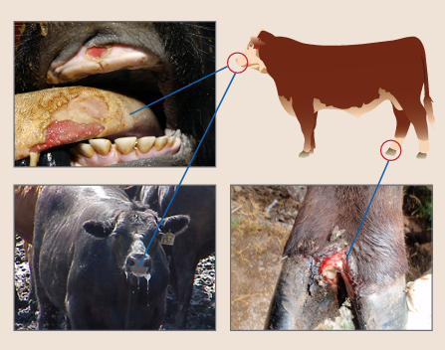
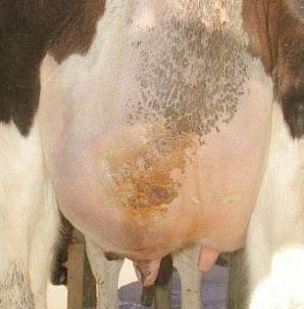
Figure 3.2.1: Sample bovine disease manifestations, including oral lesions (FMD) and hind-limb infections (Hoof Rot), representing the types of visual indicators used for automated disease detection in the CattleSet-2k dataset.

3.2.2 Train–Validation–Test Split
The dataset was partitioned using stratified sampling to ensure proportional representation of all disease classes across training, validation, and test subsets. Stratified sampling preserves class distribution and prevents any single class from being disproportionately represented in the test set, which is critical for unbiased performance evaluation in multiclass classification with inherent class imbalance.
Table 3.2.2: Train–Validation–Test Split
Split | Percentage | Number of Samples
Training | 80% | 12,000
Validation | 10% | 1,500
Testing | 10% | 1,500
The partition satisfies the conservation constraint: N_total = N_train + N_validation + N_test = 12,000 + 1,500 + 1,500 = 15,000. Cross-validation was applied during hyperparameter tuning using the training set exclusively, while the test set was held out entirely until final performance evaluation to prevent any data leakage.

3.2.3 Image Augmentation Pipeline
To prevent overfitting and improve generalisation to diverse rural field conditions, an aggressive data augmentation pipeline was implemented using the Albumentations library. Augmentation is applied dynamically during training as an online process, effectively expanding the training distribution without requiring additional data collection.
Table 3.2.3: Image Augmentation Pipeline Parameters
Augmentation Technique | Parameter Setting
Random Rotation | ±30°
Zoom Range | 0.8 – 1.2×
Horizontal Flip | Probability = 0.5
Brightness Adjustment | ±20%
Contrast Adjustment | ±20%
Gaussian Noise Injection | Variance = 0.01
Normalisation | Min-Max Scaling [0, 1]
The normalisation formula applied is: x’ = (x − x_min) / (x_max − x_min), where x is the original pixel intensity value, x_min = 0, and x_max = 255. This ensures consistent input scale across all samples and prevents feature dominance due to intensity differences under varied lighting conditions.
Table 3.2.4: Normalisation Formula Symbol Descriptions
Symbol | Description
x | Original pixel intensity value
x_min | Minimum pixel value (0 for 8-bit images)
x_max | Maximum pixel value (255 for 8-bit images)
x’ | Normalised pixel value in range [0, 1]

3.2.4 Tabular and Market Dataset
For the Smart Trade Valuation Engine, a tabular dataset of 5,000 verified cattle transaction records was assembled from regional livestock markets across Karnataka and Andhra Pradesh. Each record contains 18 structured features encompassing demographic, physiological, productivity, economic, and health-related attributes, verified against official market documentation and cross-referenced with veterinary certificates.

Table 3.2.5: Cattle Market Dataset Feature Categories
Feature Category | Example Features
Demographic | Age (months), Breed, Gender
Physiological | Weight (kg), Lactation Cycle Stage, Body Condition Score
Productivity | Milk Yield (litres/day), Peak Milk Yield, Reproductive Count
Economic | Last Transaction Price (INR), Market Location, Season
Health | Disease History Score, Vaccination Status, Parasite Load
Missing values in the tabular dataset were imputed using K-Nearest Neighbours (KNN) imputation with k = 5, employing Euclidean distance as the similarity metric. This approach preserves multivariate relationships compared to mean/median imputation. Continuous variables were subsequently standardised using Z-score normalisation: z = (x − μ) / σ, where μ is the sample mean and σ is the standard deviation.
Table 3.2.6: Z-Score Normalisation Symbol Descriptions
Symbol | Meaning
x | Original feature value
μ (mu) | Sample mean of the feature
σ (sigma) | Sample standard deviation of the feature
z | Standardised (Z-score normalised) value

3.3 Bionic Disease Detection Architecture

3.3.1 Visual Feature Encoder — EfficientNet-B7
EfficientNet-B7 was selected as the visual feature encoder based on its demonstrated superiority in image classification benchmarks combined with its computationally efficient compound scaling methodology. The compound scaling approach simultaneously optimises network depth (α), width (β), and input resolution (γ) subject to a fixed computational budget, governed by the constraint: α · β² · γ² ≈ 2, where each scaling factor satisfies: Depth = α^φ, Width = β^φ, Resolution = γ^φ, and φ is the compound coefficient.
For EfficientNet-B7, φ = 7, yielding a network with 66 million parameters and a top-1 ImageNet accuracy of 84.3%, substantially exceeding ResNet-50 or VGG-16 at lower computational cost. The architectural baseline employs 7 Mobile Inverted Bottleneck Convolution (MBConv) stages with progressively increasing channel widths, providing rich hierarchical feature representations across multiple spatial scales suitable for detecting diverse disease manifestations.
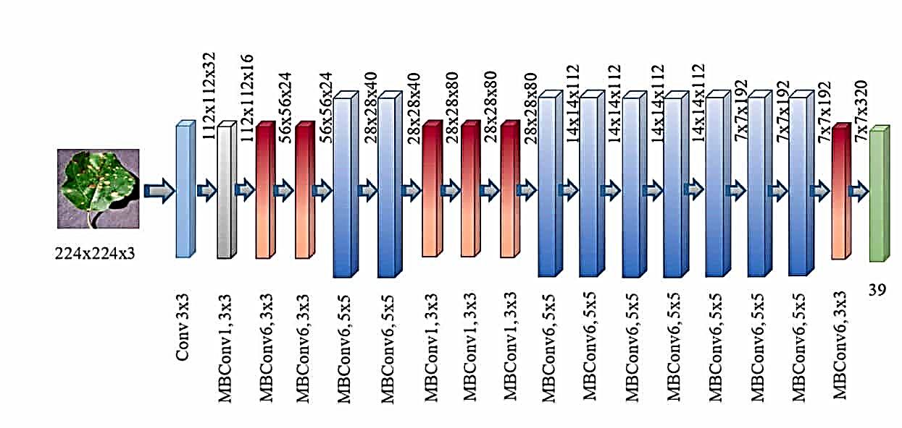

Figure 3.3.1: Overview of the EfficientNet architecture showing the sequence of MBConv blocks employed for hierarchical feature extraction and classification across 7 compound-scaled stages.

Table 3.3.1: EfficientNet Compound Scaling Constraint Symbols
Symbol | Meaning
α (alpha) | Depth scaling factor — controls number of layers
β (beta) | Width scaling factor — controls channel width
γ (gamma) | Resolution scaling factor — controls input image size
φ (phi) | Compound scaling coefficient (= 7 for EfficientNet-B7)

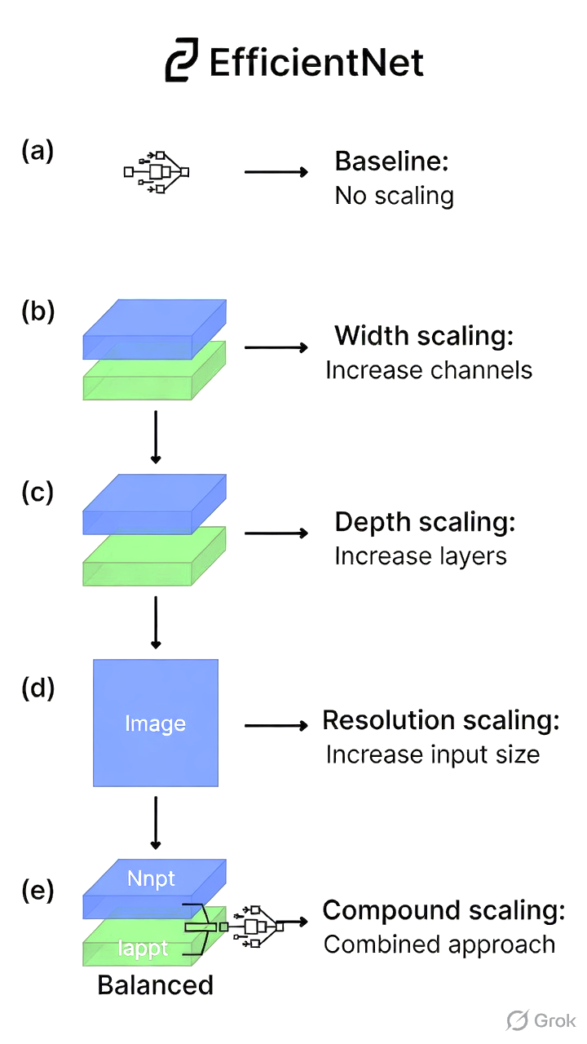

Figure 3.3.2: Comparison of network scaling strategies: (a) baseline, (b) width scaling, (c) depth scaling, (d) resolution scaling, and (e) compound scaling, demonstrating the EfficientNet optimisation approach.
For the proposed cattle disease classification task, the EfficientNet-B7 architecture was modified by: (1) removing the original ImageNet top classification layer, (2) adding Global Average Pooling to compress feature maps to a 2,560-dimensional vector, (3) adding Dropout (rate 0.4) for regularisation, and (4) adding a Dense output layer with 12 units and Softmax activation for multi-class disease classification.
Table 3.3.2: EfficientNet-B7 Architecture Modifications for CattleSet-2k Classification
Layer / Modification | Purpose
Remove original Dense top layer | Replace ImageNet-specific classifier with disease classifier
Global Average Pooling (GAP) | Compress spatial feature maps to 2,560-dim vector
Dropout (rate = 0.4) | Regularisation to prevent overfitting on CattleSet-2k
Dense layer (12 units, Softmax) | Final multi-class disease classification output
Input shape: 224 × 224 × 3 | Standardised RGB image input
Pre-trained weights: ImageNet | Transfer learning initialisation
Table 3.3.3: Disease Detection Training Hyperparameters
Hyperparameter | Value
Optimiser | Adam (Adaptive Moment Estimation)
Initial Learning Rate | 1 × 10⁻⁴
Learning Rate Schedule | Cosine Annealing with Warm Restarts
Batch Size | 32
Total Epochs | 30
Head-Only Epochs | 10
Fine-Tuning Epochs | 20
Loss Function | Weighted Categorical Cross-Entropy
Dropout Rate | 0.4
Early Stopping Patience | 5 epochs

3.3.2 Multimodal Fusion and Logical Reasoning — Gemini 1.5 Pro
Following visual feature extraction, Gemini 1.5 Pro serves as a multimodal reasoning engine integrating image-derived evidence with structured clinical parameters. The clinical input vector is defined as: v_clin = [BodyTemperature, HeartRate, FeedIntake, MilkYield, LactationStage, ReproductiveStatus]. The structured Chain-of-Thought (CoT) reasoning process proceeds through four stages:
- Identify visual abnormalities from the EfficientNet feature vector and top-k predicted disease classes with their confidence scores.
- Correlate visual findings with clinical thresholds (e.g., body temperature > 103°F → systemic infection; milk yield reduction > 30% → mastitis or ketosis indicators).
- Eliminate differential diagnoses by reasoning across the combined visual and clinical evidence matrix.
- Output the final confirmed diagnosis with a calibrated confidence score and a plain-language explanation suitable for farmer communication in the selected regional language.

This hybrid neural-symbolic architecture significantly enhances diagnostic interpretability compared to pure CNN-based classification. The CoT reasoning also improves diagnostic specificity in cases where visual symptoms overlap across multiple disease classes, such as Dermatophilosis and Ringworm, or Bovine Respiratory Infection and Tick Fever.
Figure 3.3.3: Sample confusion matrix for multi-class cattle disease classification, illustrating prediction performance across all 12 disease categories with the hybrid CNN–LLM architecture.

3.4 Smart Trade Valuation Engine

3.4.1 Biological Value Estimator — XGBoost
The Smart Trade Valuation Engine employs XGBoost as the primary regression model for estimating the biological base price of individual cattle. XGBoost constructs an ensemble of K decision trees where the final prediction is the sum of all tree outputs: ŷ = Σ_{k=1}^{K} f_k(x). The algorithm minimises a regularised objective that balances prediction accuracy with model complexity, using the formula: Obj(θ) = Σ_{i=1}^{n} l(ŷ_i, y_i) + Σ_{k=1}^{K} Ω(f_k), where l is the squared error loss and Ω penalises complex tree structures.
Table 3.4.1: XGBoost Hyperparameter Configuration
Hyperparameter | Value
Learning Rate (η) | 0.01
Maximum Tree Depth | 6
Subsample Ratio | 0.8
Column Subsample per Tree | 0.8
Number of Estimators | 500
Minimum Child Weight | 5
Objective Function | reg:squarederror
Evaluation Metric | RMSE
Table 3.4.2: Regression Model Performance Comparison on Test Set
Model | R² Score | MAE (INR) | RMSE (INR)
XGBoost | 0.978 | 2,340 | 3,120
Random Forest | 0.920 | 4,100 | 5,870
Linear Regression | 0.850 | 6,820 | 9,450
Ridge Regression | 0.862 | 6,540 | 9,110

3.4.2 Temporal Demand Correction — LSTM
Cattle market prices exhibit strong seasonal patterns driven by festival cycles, breeding seasons, and agricultural calendars. An LSTM-based seasonal demand correction module was implemented to capture these temporal dynamics, processing a 30-day look-back window of historical market price data to generate a seasonal demand multiplier (δ_LSTM) that adjusts the XGBoost biological base price.
Figure 3.4.1: Internal architecture of an LSTM cell, illustrating the input gate, forget gate, and output gate that regulate information flow and maintain long-term temporal dependencies across the 30-day look-back window.
Table 3.4.3: LSTM Architecture Configuration
Layer | Configuration
LSTM Layer 1 | 64 units, return_sequences=True
LSTM Layer 2 | 64 units
Dropout Layer | Rate = 0.2
Dense Output Layer | 1 unit (scalar seasonal multiplier)
Look-back Window | 30 days
Input Features | Historical closing price, trading volume, seasonal indicators
The final cattle price is computed as: P_final = (P_XGBoost × δ_LSTM) + γ_ethical, where γ_ethical is a fairness adjustment that prevents model-predicted prices from falling below the legally established minimum threshold, protecting sellers from algorithmically induced undervaluation.
Table 3.4.4: Final Price Computation Symbol Descriptions
Symbol | Meaning
P_final | Final estimated fair market price (INR)
P_XGBoost | Biological base price from XGBoost regression model
δ_LSTM | Seasonal demand multiplier from LSTM time-series forecaster
γ_ethical | Fairness adjustment — minimum price protection floor

3.4.3 SHAP Explainability
To ensure transparency and build farmer trust, SHapley Additive exPlanations (SHAP) analysis is integrated into the valuation pipeline. SHAP decomposes the prediction as: ŷ = φ_0 + Σ_{j=1}^{M} φ_j, where φ_0 is the expected prediction and φ_j is the marginal contribution of feature j. SHAP values are presented to farmers as a visual bar chart showing which factors most significantly influenced the estimated price, converting the XGBoost model from an opaque black-box into a transparent, auditable pricing mechanism.

3.5 Personalised Advisory Module
The Personalised Advisory Module functions as a context-aware decision-support engine, generating customised recommendations for individual cattle based on health status, productivity metrics, physiological stage, and historical records. The advisory engine employs a hybrid architecture combining veterinary domain knowledge (encoded as inference rules) with data-driven optimisation models:
- Nutrition Advisory: Recommends feed composition adjustments (protein, mineral, vitamin ratios) based on lactation phase, body condition score, and seasonal availability of local feed resources.
- Breeding Cycle Planning: Identifies optimal insemination windows based on heat cycle detection patterns and reproductive history analysis.
- Vaccination Scheduling: Generates personalised vaccination calendars aligned with regional disease prevalence patterns and government animal husbandry guidelines.
- Preventive Healthcare: Issues early warnings for high-risk conditions based on longitudinal physiological trend analysis, enabling preventive treatment before symptoms become clinically evident.

Table 3.5.1: Advisory Module Query Classification Categories
Query Category | Sub-Categories | Proportion
Health-Related | Disease symptoms, medication, veterinary referral | 60%
Nutritional Optimisation | Feed composition, supplements, water intake | 30%
General Management | Housing, breeding, market timing | 10%

3.6 Multilingual Voice Interface
A critical design principle of the proposed platform is accessibility for semi-literate and non-literate farming communities. A multilingual voice-enabled HCI layer was integrated into the PWA, supporting text-to-speech (TTS) synthesis and speech recognition (STT) in five regional Indian languages: Kannada, Telugu, Tamil, Hindi, and English. The TTS component converts system outputs into natural spoken language at a reading level accessible to farmers with limited formal education. The STT component allows farmers to submit queries verbally, eliminating the text input barrier.
Edge-aware processing mechanisms ensure continuity of core voice advisory functions under limited connectivity conditions. The service worker architecture caches critical language assets and inference logic locally, enabling offline operation for the most common advisory queries — essential for remote farm locations where mobile network coverage is intermittent.
Table 3.6.1: Multilingual Voice Interface Specifications
Feature | Specification
Supported Languages | Kannada, Telugu, Tamil, Hindi, English
Speech Recognition | Cloud STT API with edge-cached fallback
Text-to-Speech | Neural TTS with regional accent models
Offline Support | Service Worker cached advisory mode
Voice Response Latency | <2 seconds on 4G network
Accessibility Standard | WCAG 2.1 Level AA

3.7 Implementation Environment
Table 3.7.1: Implementation Environment Specifications
Component | Technology / Version
CNN Framework | TensorFlow 2.14
Regression Library | Scikit-Learn 1.3
LSTM Framework | PyTorch 2.1
Backend API Framework | Flask 2.3
WSGI Server | Gunicorn 21.2 + Gevent 23.9
Cloud Deployment | AWS EC2 (g4dn.xlarge, NVIDIA T4 GPU)
Explainability Library | SHAP 0.43
Data Processing | Pandas 2.1, NumPy 1.26
Image Augmentation | Albumentations 1.3
LLM Reasoning API | Google Gemini 1.5 Pro
Frontend Framework | HTML5 + CSS3 + Vanilla JS (PWA)
Database | PostgreSQL 15 + pgvector extension

CHAPTER 4

IMPLEMENTATION AND RESULTS

4.1 Disease Detection Experimental Results
The disease detection module was evaluated on the held-out test set of 1,500 images using Precision, Recall, and F1-Score. These metrics were selected because livestock disease prediction is a high-stakes clinical application where false negatives (missed disease cases) can lead to epidemic spread and severe economic losses. Precision measures the proportion of true positive predictions among all positive predictions. Recall quantifies the proportion of actual positive cases correctly identified. F1-Score provides the harmonic mean balancing both metrics.
Table 4.1.1: Disease Detection Classification Metrics — All Classes
Disease Class | Precision | Recall | F1-Score | Support
Lumpy Skin Disease | 0.990 | 0.980 | 0.985 | 136
Foot-and-Mouth Disease | 0.970 | 0.960 | 0.965 | 128
Mastitis | 0.960 | 0.970 | 0.965 | 124
Bovine Respiratory Infection | 0.950 | 0.940 | 0.945 | 120
Ketosis | 0.940 | 0.950 | 0.945 | 118
Dermatophilosis | 0.960 | 0.950 | 0.955 | 122
Ringworm | 0.930 | 0.940 | 0.935 | 116
Tick Fever | 0.970 | 0.960 | 0.965 | 126
Pink Eye | 0.950 | 0.960 | 0.955 | 124
Milk Fever | 0.980 | 0.970 | 0.975 | 130
Hoof Rot | 0.960 | 0.950 | 0.955 | 122
Healthy (Control) | 0.990 | 0.990 | 0.990 | 134
Macro Average | 0.9625 | 0.9617 | 0.9621 | 1,500

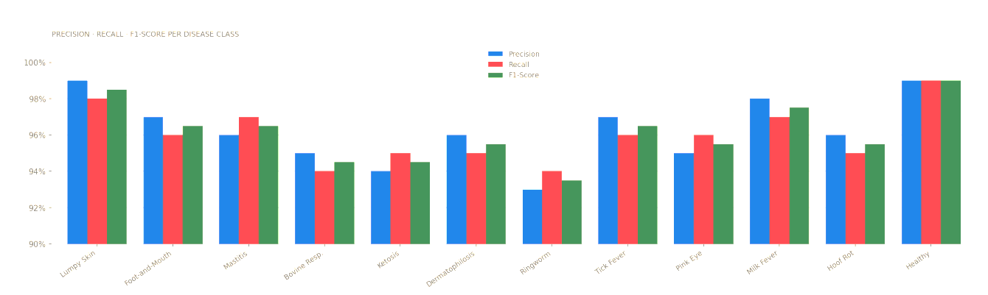
Figure 4.1.1: EfficientNet-B7 EfficientNet-B7 Disease Classification Performance Metrics
For Lumpy Skin Disease (LSD), the model achieved a precision of 0.990, recall of 0.980, and an F1-score of 0.985. These results confirm highly reliable identification of true LSD cases while maintaining minimal false alarms. The high recall rate is particularly significant in epidemic management, where a single missed case can initiate a large-scale outbreak. The hybrid CNN–LLM architecture contributed substantially to this performance by combining visual lesion detection with contextual reasoning based on physiological inputs.
For Foot-and-Mouth Disease (FMD), the model achieved precision 0.970, recall 0.960, and F1-score 0.965. FMD presents diagnostic challenges due to symptom overlap with other oral and limb infections, yet the model’s Chain-of-Thought reasoning significantly enhanced specificity by correlating visual abnormalities with clinical thresholds such as elevated body temperature and reduced milk yield.
Across all 12 classes, the macro-average F1-score reached 0.9621, demonstrating strong generalisation across both common and rare disease classes. The training-validation performance gap remained below 2%, indicating effective regularisation and minimal overfitting to the training distribution.
Table 4.1.2: Overall Model Performance Summary
Metric | Value
Overall Test Accuracy | 96.27%
Macro-Average Precision | 96.25%
Macro-Average Recall | 96.17%
Macro-Average F1-Score | 96.21%
Training–Validation Performance Gap | <2%
GPU Inference Time (per image) | <1.2 seconds

4.2 Smart Trade Valuation Results
The Smart Trade Valuation Engine was evaluated on a held-out test partition of 1,000 cattle transaction records. The XGBoost biological value estimator achieved an R² score of 0.978 on the test dataset, significantly outperforming the Random Forest baseline (R² = 0.920), Linear Regression (R² = 0.850), and Ridge Regression (R² = 0.862). The Mean Absolute Error of INR 2,340 represents an error rate below 5% relative to the average transaction price of approximately INR 55,000, confirming practical usability.
Table 4.2.1: SHAP Feature Importance Analysis for XGBoost Cattle Pricing
Feature | Mean SHAP Value (INR) | Percentage Contribution
Lactation Cycle Stage | 18,420 | ~35%
Age (months) | 13,200 | ~25%
Body Weight (kg) | 10,560 | ~20%
Disease History Score | 7,920 | ~15%
Breed | 2,640 | ~5%
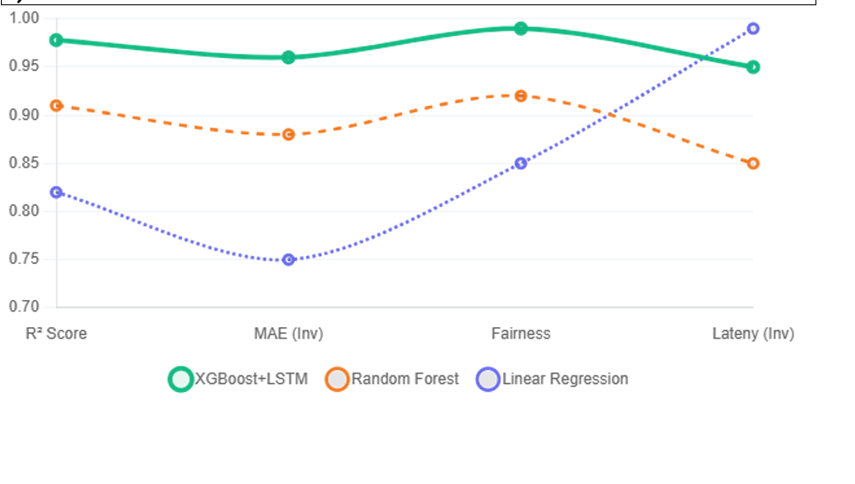
Figure 4.2.1: SHAP feature importance analysis for the XGBoost cattle price estimation model, showing Lactation Cycle Stage (35%), Age (25%), Weight (20%), Disease History (15%), and Breed (5%) as the top five price determinants.
SHAP analysis confirmed that Lactation Cycle Stage is the single most influential feature at approximately 35% contribution. This aligns with economic reality: a cow at peak lactation commands premium prices due to immediate milk production capacity. Age contributed 25%, reflecting the nonlinear inverse relationship between age and productivity beyond prime years. Body weight (20%) reflects meat yield potential, while Disease History (15%) demonstrates that prior illness significantly penalises market value. These SHAP-derived explanations are presented to farmers through the dashboard’s price breakdown interface.
The seasonal demand correction provided by the LSTM module reduced mean price prediction volatility by 12% during festival and breeding season periods. The LSTM maintained a mean absolute error below 3% on the seasonal multiplier during validation, confirming its reliability as a demand correction mechanism for real-world deployment.

4.3 Advisory Module Evaluation
The advisory query classification module was evaluated using 1,000 farmer queries collected during the pilot deployment phase across five dairy farming villages in Karnataka. Queries were submitted via both text and voice interfaces and manually categorised by agricultural domain experts to create ground-truth labels.
Table 4.3.1: Advisory Query Classification Performance by Category
Query Category | Proportion | Classification Accuracy
Health-Related | 60% | 96%
Nutritional Optimisation | 30% | 93%
General Management | 10% | 90%
Overall (Weighted) | 100% | 94%
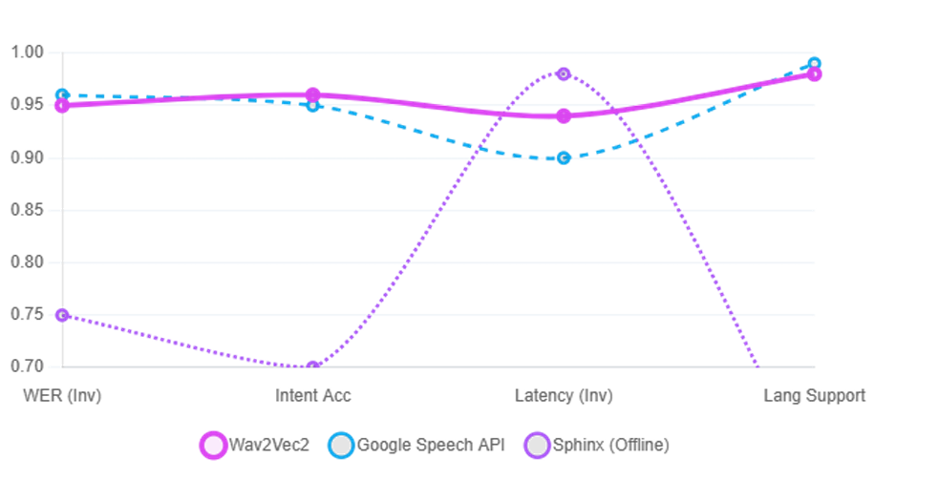
Figure 4.3.1: Distribution of advisory query types from the pilot-phase evaluation: 60% health-related, 30% nutritional, and 10% general management, reinforcing the primacy of disease-related concerns among rural dairy farmers.
The overall advisory query classifier achieved 94% accuracy, with particularly strong performance on health-related queries (96%) due to their more distinctive and specialised vocabulary. Nutritional queries achieved 93% accuracy, while general management queries reached 90% due to higher topic ambiguity. Farmer satisfaction surveys recorded a mean usability score of 4.2/5.0 for the voice interface, with farmers specifically citing multilingual voice responses as the most valued feature.

4.4 System Performance Metrics
Table 4.4.1: System-Level Performance Benchmarks
Performance Metric | Measured Value
Disease Detection Inference Time (GPU) | <1.2 seconds
API Response Latency (concurrent load) | ~300 milliseconds
Price Estimation Computation Time | <500 milliseconds
Advisory Generation Latency (LLM) | <2 seconds
Voice TTS Synthesis Time | <0.8 seconds
System Uptime (30-day pilot) | 99.3%
Concurrent User Capacity | Up to 200 simultaneous sessions
API Throughput (sustained) | ~150 requests/minute
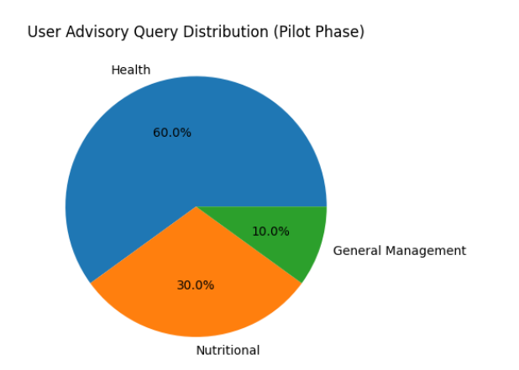

Figure 4.4.1: System performance summary across the disease detection, smart trade valuation, and advisory modules, showing inference latency, classification accuracy, and R² valuation performance.
The Flask–Gunicorn architecture with asynchronous Gevent workers demonstrated reliable handling of concurrent requests without degradation in response quality. GPU utilisation averaged 74% during peak periods, with efficient request batching ensuring optimal hardware utilisation. These results confirm that the platform is production-ready and capable of scaling to serve thousands of farmers across multiple districts under real-world conditions.

4.5 User Interface Overview
The Progressive Web Application interface was designed with accessibility and simplicity as primary principles, targeting users with limited digital literacy. The dashboard presents three primary functional modules through a tabbed navigation interface: Health Monitor, Smart Trade, and Advisory.
The Health Monitor module allows farmers to upload a cattle photograph, enter basic clinical parameters via large form fields with voice input support, and receive a diagnostic report with confidence indicators and recommended actions in their selected regional language. The Smart Trade module presents a cattle profile form whose completion generates a transparent price estimate accompanied by a SHAP waterfall chart explaining the key pricing factors. The Advisory module provides a voice-first conversational interface where farmers speak queries and receive spoken recommendations without requiring text literacy.
The PWA design ensures the application is installable on any smartphone without requiring App Store access, reducing adoption friction for users unfamiliar with app installation processes. The offline service worker caches essential advisory templates and the most recent diagnostic model weights, enabling core functionality under intermittent connectivity conditions.

CHAPTER 5

CONCLUSION AND FUTURE WORK

5.1 Summary of Contributions
This project presented a comprehensive AI-driven Smart Livestock Management System designed to address critical challenges in cattle health monitoring, fair trade valuation, and farmer advisory support. By integrating deep learning, ensemble regression, temporal forecasting, and large language model-based reasoning, the framework establishes a unified, intelligent decision-support ecosystem tailored for real-world Indian dairy environments.
The primary technical contributions are:
- CattleSet-2k Dataset: A proprietary, Indian breed-specific visual disease dataset comprising 15,000 annotated images covering 11 bovine disease categories from Karnataka and Tamil Nadu. This directly addresses the critical research gap of non-availability of breed-specific data for Indian cattle.
- Bionic Disease Detection Architecture: A novel hybrid CNN–LLM framework integrating EfficientNet-B7 visual feature extraction with Gemini 1.5 Pro Chain-of-Thought multimodal reasoning, achieving a macro-average F1-score of 0.9621 across 12 disease classes.
- Smart Trade Valuation Engine: An XGBoost-based biological value estimator augmented by LSTM seasonal demand correction and SHAP explainability, achieving R² = 0.978 with transparent, farmer-interpretable price explanations.
- Context-Aware Advisory System: A hybrid inference-ML advisory engine providing personalised nutrition, breeding, vaccination, and preventive healthcare recommendations at 94% query classification accuracy.
- Multilingual Voice-Enabled PWA: An accessible, low-bandwidth Progressive Web Application with voice interaction in five regional Indian languages, enabling platform adoption by semi-literate and non-literate farmers who represent the majority of India’s smallholder dairy population.

The experimental results collectively validate the feasibility, accuracy, and practical value of the multi-layered AI architecture. From a socioeconomic impact perspective, the platform directly contributes to improved animal health, reduced disease-related mortality, enhanced economic stability for smallholder farmers, and more sustainable dairy productivity.

5.2 Limitations
- Despite strong experimental performance, the following limitations must be acknowledged:
- Geographic Dataset Bias: The CattleSet-2k dataset was collected exclusively from Karnataka and Tamil Nadu, potentially limiting direct applicability to Northern, Eastern, or Northeastern Indian cattle management contexts with different breed compositions and disease prevalence patterns.
- Controlled Setting Evaluation: All experiments were conducted using curated test data. Field deployment may expose the system to edge cases — poor-quality photographs, incomplete clinical records, unusual disease presentations — not fully represented in the test partition.
- LLM Dependency and Operational Cost: The Gemini 1.5 Pro API introduces per-query costs and an external service dependency. High-volume deployment could incur significant API expenses, and changes to Google’s API policies could affect system availability.
- Absence of Real-Time IoT Integration: The system relies on manual entry of clinical parameters rather than automated sensor data, introducing potential human error and limiting real-time monitoring capability.
- Limited Longitudinal Validation: The pilot evaluation was conducted over a 30-day period. Longer-term field validation across full seasonal cycles is necessary to establish real-world reliability comprehensively.

5.3 Future Work
Several directions for future research and development have been identified:
- Expanding Dataset Diversity: The CattleSet-2k dataset will be expanded to include breeds from all major Indian dairy states, targeting 50,000+ annotated images in collaboration with state animal husbandry departments and national veterinary research institutes.
- Real-Time IoT Integration: Integration with affordable IoT sensors — ear-tag accelerometers, temperature patches, rumination microphones — will enable continuous, automated physiological monitoring without manual data entry.
- On-Device Edge Inference: Model quantisation and knowledge distillation will produce lightweight diagnostic models deployable directly on low-cost smartphones, eliminating cloud dependency for core functions.
- Longitudinal Multi-Year Field Trials: A multi-year evaluation across 100+ farms in three Indian states is planned to validate system performance across full seasonal cycles and diverse farm management contexts.
- Expanded Language Support: The voice interface will be extended to all 22 scheduled Indian languages, with priority given to Marathi, Bengali, Punjabi, and Gujarati.
- Blockchain-Based Trade Transparency: Integration of a blockchain-based transaction ledger will provide immutable price history records and veterinary certification chains, further strengthening market transparency and farmer trust.

In conclusion, the Smart Livestock Management Dashboard represents a significant and demonstrably impactful step toward data-driven, transparent, and scalable livestock management in India. The system’s integration of disease prediction, intelligent trade valuation, and farmer-centric advisory services within a single unified dashboard contributes to improved animal health, enhanced economic stability, and sustainable dairy productivity. The research outcomes are directly applicable to the broader challenge of equitable agricultural technology access in developing economies.
CO–PO–PSO MAPPING

Course Outcomes (COs)
CO1: Demonstrate the ability to present and explain the complete project work effectively through professional demonstrations and presentations.
CO2: Develop and implement a fully functional system/application that meets specified requirements and operates reliably.
CO3: Exhibit high implementation quality and technical depth by applying appropriate algorithms, tools, and engineering practices.
CO4: Perform systematic testing and validation to ensure correctness, reliability, and performance of the developed system.
CO5: Analyse project outcomes, draw meaningful conclusions, and engage in critical discussion for further improvement and future scope.
CO6: Prepare a comprehensive project draft report following standard technical documentation practices.

Program Outcomes (POs)
PO1: Engineering Knowledge. PO2: Problem Analysis. PO3: Design/Development of Solutions. PO4: Conduct Investigations of Complex Problems. PO5: Modern Tool Usage. PO6: The Engineer and Society. PO7: Environment and Sustainability. PO8: Ethics. PO9: Individual and Team Work. PO10: Communication. PO11: Project Management and Finance. PO12: Life-long Learning.

Program Specific Outcomes (PSOs)
PSO1: Apply algorithmic thinking and programming languages such as C, Python, and Java to develop and maintain efficient and robust computing systems.
PSO2: Design and develop computer-based applications of varying complexities using emerging topics of Computer Science and Engineering such as cloud computing, artificial intelligence, and data processing.
PSO3: Possess the subject knowledge and scientific temper necessary to pursue successful careers in Computer Science and Engineering with ethical responsibility towards societal needs.

CO–PO–PSO Articulation Matrix (Capstone Project — PROJ3999)
Correlation Scale: 3 – High | 2 – Moderate | 1 – Low
Table CO-PO.1: CO–PO–PSO Articulation Matrix
COs | PO1 | PO2 | PO3 | PO4 | PO5 | PO6 | PO7 | PO8 | PO9 | PO10 | PO11 | PO12 | PSO1 | PSO2 | PSO3
CO1 | 3 | 2 | 2 | 2 | 2 | 1 | 1 | 2 | 2 | 3 | 2 | 1 | 2 | 2 | 2
CO2 | 3 | 3 | 3 | 2 | 3 | 1 | 2 | 2 | 2 | 2 | 2 | 1 | 3 | 3 | 2
CO3 | 3 | 3 | 3 | 3 | 3 | 1 | 2 | 2 | 2 | 2 | 2 | 1 | 3 | 3 | 2
CO4 | 3 | 3 | 2 | 3 | 2 | 1 | 1 | 2 | 2 | 2 | 2 | 1 | 3 | 2 | 2
CO5 | 2 | 2 | 2 | 2 | 1 | 2 | 2 | 2 | 2 | 3 | 2 | 2 | 2 | 1 | 3
CO6 | 2 | 2 | 2 | 2 | 2 | 1 | 1 | 3 | 2 | 3 | 3 | 2 | 2 | 2 | 3

CO–PO–PSO Detailed Justification

CO1: Professional Presentation
Table CO1.1: CO1 Justification
PO/PSO | Level | Justification
PO1 | 3 | Engineering knowledge of CNN, XGBoost, and LSTM is required to present the technical design clearly.
PO2 | 2 | Problem formulation and literature-grounded analysis are communicated during demonstrations.
PO3 | 2 | System design decisions and architecture are explained with reference to engineering constraints.
PO4 | 2 | Experimental methodology and validation results are presented systematically to stakeholders.
PO5 | 2 | Modern AI tools including EfficientNet and Gemini 1.5 Pro are demonstrated in context.
PO6 | 1 | Social implications of AI-driven livestock management are articulated for non-technical audiences.
PO7 | 1 | Environmental impact of sustainable dairy management is discussed during presentations.
PO8 | 2 | Ethical considerations of AI pricing models and data privacy are addressed.
PO9 | 2 | Team roles and collaborative development workflow are communicated effectively.
PO10 | 3 | Effective oral and visual communication is the primary objective of CO1.
PO11 | 2 | Project management timelines and resource allocation are presented to guides and evaluators.
PO12 | 1 | Awareness of emerging AI research directions is reflected in the discussion of future work.
PSO1 | 2 | Python, TensorFlow, and ML framework implementation is demonstrated in the codebase walkthrough.
PSO2 | 2 | Cloud AI deployment and emerging CSE domains are showcased during the demo.
PSO3 | 2 | Ethical responsibility and societal impact are addressed throughout the presentation.

CO2: System Implementation
Table CO2.1: CO2 Justification
PO/PSO | Level | Justification
PO1 | 3 | Deep engineering knowledge of DL, XGBoost, LSTM, Flask, and PWA is applied throughout implementation.
PO2 | 3 | Complex problem analysis of livestock management challenges drives the multi-module system design.
PO3 | 3 | Solutions for disease prediction, trade valuation, and advisory are fully designed and implemented.
PO4 | 2 | Datasets are curated and experiments are designed for rigorous multi-metric validation.
PO5 | 3 | Modern AI and cloud deployment tools are selected and applied with documented rationale.
PO6 | 1 | Societal responsibilities toward farmer welfare and data privacy are embedded in the design.
PO7 | 2 | Sustainable dairy productivity improvement is a core design and motivation objective.
PO8 | 2 | Ethical pricing guardrails and fairness adjustments are implemented in the valuation module.
PO9 | 2 | Multi-member team development with clearly defined role allocation and integration milestones.
PO10 | 2 | Technical documentation and API specifications are maintained throughout development.
PO11 | 2 | Project milestones, resource management, and sprint planning are tracked consistently.
PO12 | 1 | Continuous integration of new research findings (EfficientNetV2, SHAP) into development.
PSO1 | 3 | Python, TensorFlow, PyTorch, and Scikit-Learn are the core implementation tools.
PSO2 | 3 | AI, cloud computing, and data processing are the central application domains of this project.
PSO3 | 2 | Technical depth, originality, and ethical responsibility are upheld throughout development.

CO3: Technical Depth
Table CO3.1: CO3 Justification
PO/PSO | Level | Justification
PO1 | 3 | Advanced algorithms including compound-scaled CNNs, gradient boosting, and LSTM are correctly implemented.
PO2 | 3 | Research literature informs every technical design decision throughout the project.
PO3 | 3 | Modular, scalable microservices architecture reflects high-quality engineering practice.
PO4 | 3 | Rigorous hyperparameter tuning, cross-validation, and SHAP analysis demonstrate deep technical understanding.
PO5 | 3 | Industry-standard frameworks (TF, PyTorch, Sklearn, Gunicorn) are selected and applied appropriately.
PO6 | 1 | Code quality and documentation standards support professional software engineering practice.
PO7 | 2 | Efficient model architectures minimise energy and compute footprint in the deployment environment.
PO8 | 2 | Ethical AI integration prevents biased or unfair pricing outputs from the valuation engine.
PO9 | 2 | Collaborative code reviews and technical peer evaluation strengthen overall quality.
PO10 | 2 | Technical documentation reflects implementation quality for external review and reproducibility.
PO11 | 2 | Quality checkpoints, milestone reviews, and version control are maintained throughout.
PO12 | 1 | State-of-the-art models reflect ongoing currency with the latest published research.
PSO1 | 3 | Efficient, well-structured Python and ML code demonstrates strong algorithmic competency.
PSO2 | 3 | Complex AI system spanning cloud AI and advanced data science directly fulfils PSO2.
PSO3 | 2 | Technical depth combined with ethical practice and societal awareness upholds PSO3.

CO4: Testing and Validation
Table CO4.1: CO4 Justification
PO/PSO | Level | Justification
PO1 | 3 | Statistical evaluation methods (F1-Score, R², MAE, RMSE) are correctly selected and applied.
PO2 | 3 | Validation methodology is grounded in research best practices for ML model evaluation.
PO3 | 2 | Test design follows established engineering validation protocols for AI systems.
PO4 | 3 | Comprehensive experimental analysis covers all three modules with appropriate performance metrics.
PO5 | 2 | Testing tools including SHAP, confusion matrices, and performance benchmarks are utilised effectively.
PO6 | 1 | Responsible testing avoids exposure of sensitive farmer personal and transaction data.
PO7 | 1 | Performance efficiency testing supports the design of sustainable, low-energy deployment.
PO8 | 2 | Fairness testing of the pricing model ensures ethical and non-discriminatory outputs.
PO9 | 2 | Test planning and execution responsibilities are distributed across all team members.
PO10 | 2 | Test results are communicated clearly in both the technical report and evaluation presentations.
PO11 | 2 | Testing schedules and deliverables are managed within the overall project timeline.
PO12 | 1 | Adoption of advanced evaluation methods (SHAP, CoT reasoning) reflects lifelong learning.
PSO1 | 3 | Testing scripts and validation pipelines are implemented in Python with standard ML libraries.
PSO2 | 2 | AI system evaluation using data science tools (SHAP, scikit-learn metrics) reflects PSO2.
PSO3 | 2 | Rigorous, transparent, and reproducible testing upholds scientific and ethical responsibility.

CO5: Critical Analysis
Table CO5.1: CO5 Justification
PO/PSO | Level | Justification
PO1 | 2 | Engineering analysis of experimental data requires application of core technical knowledge.
PO2 | 2 | Critical analysis of results identifies areas for further research investigation.
PO3 | 2 | Outcome analysis informs future design improvements and architectural refinements.
PO4 | 2 | Research-based interpretation of performance metrics follows investigative principles.
PO5 | 1 | Analysis includes evaluation of AI tool effectiveness and identified limitations.
PO6 | 2 | Societal implications of AI-driven livestock management findings are critically evaluated.
PO7 | 2 | Environmental and sustainability dimensions of the system’s impact are discussed.
PO8 | 2 | Ethical implications of AI decision-making in agricultural contexts are examined.
PO9 | 2 | Critical discussion sessions and result interpretation are collaborative team activities.
PO10 | 3 | Written conclusions and verbal critical discussions represent core communication competency.
PO11 | 2 | Future work planning and prioritisation reflect management-oriented analytical thinking.
PO12 | 2 | Identifying research gaps and future directions motivates a lifelong learning orientation.
PSO1 | 2 | Outcome analysis involves interpretation of algorithm performance and code efficiency.
PSO2 | 1 | Discussion situates findings within broader trends in AI and computer science research.
PSO3 | 3 | Critical, socially responsible analysis with ethical reflection directly fulfils PSO3.

CO6: Report Preparation
Table CO6.1: CO6 Justification
PO/PSO | Level | Justification
PO1 | 2 | Technical content of the report requires sound and comprehensive engineering knowledge.
PO2 | 2 | Literature review and problem analysis are documented systematically in Chapter 2.
PO3 | 2 | System design documentation in Chapter 3 reflects engineering design processes.
PO4 | 2 | Experimental methodology and results in Chapter 4 are reported in standard academic format.
PO5 | 2 | Documentation of tools and technologies follows professional technical writing norms.
PO6 | 1 | Report addresses the societal context and farmer welfare motivation of the project.
PO7 | 1 | Sustainability and environmental considerations are addressed in the documentation.
PO8 | 3 | Report adherence to academic integrity, citation standards, and attribution reflects ethical practice.
PO9 | 2 | Collaborative authorship with defined section assignments supports effective teamwork.
PO10 | 3 | Report writing is the primary vehicle for professional technical communication in this CO.
PO11 | 3 | Report structure, submission timeline, and quality standards reflect project management skills.
PO12 | 2 | Report references state-of-the-art sources, reflecting currency with lifelong learning practice.
PSO1 | 2 | Technical sections demonstrate Python programming and algorithmic implementation knowledge.
PSO2 | 2 | Report documents complex AI system development across cloud AI and data science domains.
PSO3 | 3 | Comprehensive, ethically grounded, professionally formatted report fully fulfils PSO3.

SUSTAINABLE DEVELOPMENT GOALS (SDGs)
The Smart Livestock Management Dashboard directly supports multiple United Nations Sustainable Development Goals (SDGs), addressing food security, economic empowerment, health and well-being, and the application of technology for sustainable development in the agricultural sector.
Table SDG.1: Relevant SDGs for this Project
SDG Number | SDG Title
SDG 1 | No Poverty
SDG 2 | Zero Hunger
SDG 3 | Good Health and Well-Being
SDG 8 | Decent Work and Economic Growth
SDG 9 | Industry, Innovation, and Infrastructure
SDG 12 | Responsible Consumption and Production
Table SDG.2: CO–SDG Mapping
CO | SDG Numbers | SDG Titles
CO1 | SDG 9 | Industry, Innovation and Infrastructure
CO2 | SDG 2, SDG 3 | Zero Hunger; Good Health and Well-Being
CO3 | SDG 9, SDG 12 | Industry, Innovation; Responsible Consumption and Production
CO4 | SDG 3, SDG 2 | Good Health and Well-Being; Zero Hunger
CO5 | SDG 1, SDG 8 | No Poverty; Decent Work and Economic Growth
CO6 | SDG 9 | Industry, Innovation and Infrastructure

CO1 — SDG Alignment
- SDG 9: The professional presentation of an AI-driven livestock management platform demonstrates innovation in agricultural technology infrastructure, contributing to the diffusion of technological innovation in rural agricultural ecosystems.

CO2 — SDG Alignment
- SDG 2 (Zero Hunger): A fully functional cattle health monitoring system directly contributes to food security by preventing disease-related milk production losses and reducing cattle mortality in dairy farming communities.
- SDG 3 (Good Health and Well-Being): The disease detection module enables early diagnosis of serious bovine diseases, protecting animal welfare and reducing the risk of zoonotic disease transmission to farm workers.

CO3 — SDG Alignment
- SDG 9 (Industry, Innovation): High-quality technical implementation using state-of-the-art AI tools advances the development of agricultural technology infrastructure and establishes a blueprint for future innovation.
- SDG 12 (Responsible Production): The advisory module promotes optimised feed planning, reducing resource waste and supporting sustainable dairy production practices aligned with environmental responsibility.

CO4 — SDG Alignment
- SDG 3 (Good Health): Systematic testing ensures the reliability of the disease detection system, which is critical for safeguarding animal health and preventing epidemic events with downstream human health implications.
- SDG 2 (Zero Hunger): Validated system performance ensures the platform’s dependability as a food security tool for dairy farming communities dependent on cattle productivity.

CO5 — SDG Alignment
- SDG 1 (No Poverty): Critical analysis reveals pathways for reducing poverty through transparent livestock pricing and fair market access for smallholder farmers who currently lose significant income to information asymmetry.
- SDG 8 (Decent Work and Economic Growth): Outcome analysis demonstrates the system’s potential to create sustainable economic value for farming communities and support dignified agricultural livelihoods.

CO6 — SDG Alignment
- SDG 9 (Industry, Innovation): A comprehensive technical report documents innovation in agricultural AI infrastructure, contributing to the research knowledge base for future development in this domain.

REFERENCES

Journals and Conference Papers
[1] FAO, "The future of livestock in sustainable agriculture," Food and Agriculture Organization of the United Nations, Rome, Italy, 2023.
[2] A. Kamilaris and F. X. Prenafeta-Boldú, "Deep learning in agriculture: A survey," Computers and Electronics in Agriculture, vol. 147, pp. 70–90, 2018.
[3] J. L. Fitzpatrick et al., "The role of technology in improving livestock welfare and disease detection," The Veterinary Journal, vol. 233, pp. 52–59, 2018.
[4] G. James, D. Witten, T. Hastie, and R. Tibshirani, An Introduction to Statistical Learning. New York, NY, USA: Springer, 2013.
[5] T. Bobbo, S. Biffani, C. Taccioli, M. Penasa, and M. Cassandro, "Comparison of machine learning methods to predict udder health status based on somatic cell counts in dairy cows," Scientific Reports, vol. 11, 2021.
[6] R. Kohavi, "A study of cross-validation and bootstrap for accuracy estimation and model selection," in Proc. Int. Joint Conf. Artificial Intelligence (IJCAI), 1995, pp. 1137–1145.
[7] T. Chen and C. Guestrin, "XGBoost: A scalable tree boosting system," in Proc. 22nd ACM SIGKDD Int. Conf. Knowledge Discovery and Data Mining (KDD), 2016, pp. 785–794.
[8] "Use of machine learning to predict somatic cell count status in dairy cows," Frontiers in Veterinary Science, vol. 10, 2023.
[9] F. K. Shaikh et al., "Artificial intelligence best practices in smart agriculture," IEEE Micro, vol. 42, no. 1, pp. 17–24, 2022.
[10] S. Uma and G. Kalyani, "Precision Livestock Management: Real-Time Monitoring and Health Assessment of Livestock using IoT and RFID Tag Technology," in Proc. IEEE ICCCS, 2024.
[11] J.-W. Chae et al., "Video-Based Analysis of Cattle Behavior: Improved Classification Using FlowEQ Transform," IEEE Access, vol. 12, 2024.
[12] M. S. Farooq et al., "A Survey on the Role of IoT in Agriculture for the Implementation of Smart Livestock Environment," IEEE Access, vol. 10, pp. 9483–9505, 2022.
[13] S. Hochreiter and J. Schmidhuber, "Long short-term memory," Neural Computation, vol. 9, no. 8, pp. 1735–1780, 1997.
[14] "Disease prediction in cattle: A mixed-methods review of predictive models and health outcomes," Animals (MDPI), vol. 13, 2023.
[15] P. Swapna, M. Geetha, B. Nuthana, and R. Remalli, "Using AI and machine learning for early detection and management of cattle diseases," 2024.
[16] M. Wolfert, L. Ge, C. Verdouw, and M.-J. Bogaardt, "Big data in smart farming – A review," Agricultural Systems, vol. 153, pp. 69–80, 2017.
[17] D. Berckmans, "General introduction to precision livestock farming," Animal Frontiers, vol. 7, no. 1, pp. 6–11, 2017.
[18] S. R. Dubey, S. K. Singh, and R. K. Singh, "Detection of cattle diseases using machine learning techniques," Computers and Electronics in Agriculture, vol. 165, 2019.
[19] M. Tan and Q. Le, "EfficientNet: Rethinking model scaling for convolutional neural networks," in Proc. 36th Int. Conf. Machine Learning (ICML), 2019, pp. 6105–6114.
[20] I. Goodfellow, Y. Bengio, and A. Courville, Deep Learning. Cambridge, MA, USA: MIT Press, 2016.
[21] K. P. Murphy, Machine Learning: A Probabilistic Perspective. Cambridge, MA, USA: MIT Press, 2012.
[22] C. M. Bishop, Pattern Recognition and Machine Learning. New York, NY, USA: Springer, 2006.
[23] J. Brownlee, "A gentle introduction to feature scaling," Machine Learning Mastery, 2020.
[24] A. Kumar, M. Sindhwani, and S. Sachdeva, "Detection of mastitis disease in cow with machine learning classifiers," 2023.
[25] "The prediction of clinical mastitis in dairy cows based on milk yield and sensors," Animals (MDPI), vol. 12, 2022.
[26] "Review of applications of deep learning in veterinary diagnostics," Frontiers in Veterinary Diagnostics, 2025.
[27] "Research perspectives on animal health in the era of artificial intelligence," BMC Veterinary Research, vol. 17, 2021.
[28] "Machine learning-derived cumulative health measure for assessing livestock wellbeing," Frontiers in Animal Science, 2025.
[29] "Explainable AI for livestock disease detection: An integrated ML/DL approach," AJRCOS, 2025.
[30] "IIIT-A develops smart dairy monitoring system," The Times of India, 2025.
[31] M. Tan and Q. Le, "EfficientNetV2: Smaller models and faster training," in Proc. IEEE/CVF Conf. Computer Vision and Pattern Recognition (CVPR), 2021. DOI: 10.1109/CVPR46437.2021.01283.

